Sacrament of the Sick
Anointing of the Sick should be given if an individual is gravely ill or near death. If possible, the Sacrament should also be administered for serious illness, before major surgery or when one is initially hospitalized.

Sacrament of Holy Matrimony
Diocesan policy requires 12 months of preparation for Marriage. Contact the parish as soon as possible after engagement. No venue reservations or other arrangements should be made prior to consultation with the pastor.

Sacrament of Penance
Wednesday ~ 6:00 – 6:45PM; or by appointment.

Sacrament of Baptism
Parents must be registered members of the parish and attend a Baptism preparation class prior to the Baptism if this is your first child baptized. Requirements for godparents are established by the Catholic Church. Please call the parish office for Information and to register your child for Baptism.

Parish Registration
All Catholics should be registered in their local parish. Please contact the parish office to obtain registration forms, or if you are uncertain of the parish where you should register.

Parish Staff & Ministries Directory
stignatiusofloyola@hbgdiocese.org | Office: 717-677-8012
Financial Manager ~ Richard Deardorff ~ 717- 677-8012 or 717-420-3464 (cell)
rdeardorff@hbgdiocese.org
Director of Religious Education ~ Deacon Steve Huete ~ shuete@hbgdiocese.org
Parish Secretary ~ Kristen DiDio ~ kdidio@hbgdiocese.org
Buildings & Grounds ~ Donnie Althoff ~ 717-677-8012
Music Ministry ~ Phil Mobley ~ 717-677-8012
Parish Council Members
Phil Mobley – Chair 571-236-7580 pmmobley@gmail.com
Bicky Redman – Vice Chair 677-8592 feetintheair7@gmail.com
Joanne Riedel - Secretary 398-2021 sterj221@aol.com
Kathi Allwein 677-8984 allweint@comcast.net
Charlie Baker 677-9536 dcbake@embarqmqil.com
Kathy Dietsch 352-4558 kdiet2@juno.com
Dr. BobTernes rjtmd46@gmail.com

Finance Council Members
Richard Deardorff (Ex Officio)
Greg Ernst - Chair
Christy Hemler - Secretary
Ali Morris
Terri Pendlelton
Bill Pulig

Altar Flowers
OCIA
Order of Christian Initiation for Adults
Contact Fr. Dominic

Soup Kitchen
Please send donations
directly to the
“Gettysburg Soup Kitchen”

Website Development
Kristen DiDio
Life After Loss
Dodie Huete

Prayer Chain
CONTACT THE PARISH OFFICE

Picnic Co-Chairs
Wally Kane
Mark Schur

Pro-Life Ministry
Jeanette Backus
Knights of Columbus
SK Bob Ternes
- Grand Knight

CONTACT THE PARISH OFFICE

Bereavement Ministry
Ginny Bittle / Dodie Huete

Catholic Communications/EWTN
Anna Kane

Cemetery
CONTACT THE PARISH OFFICE
THEOSIS Ministry
Kathy Dietsch 717-352-4558
Bicky Redman 717-677-8592

Diocese of Harrisburg Youth Protection Program
www.YouthProtectionHBG.com

Abuse Reporting Contact Information:
First – Call the toll-free PA Child Abuse Hotline at 800-932-0313
Then – Call the Diocesan toll-free hotline at 800-626-1608

“If one member suffers,
all suffer together with it.” (1 Cor 12:26)

St. Ignatius Loyola RC Church

1095 Church Road, Orrtanna, Pennsylvania 17353
www.stignatiusofloyola.org | Office: 717-677-8012

November 26, 2023: SOLEMNITY OF CHRIST THE KING
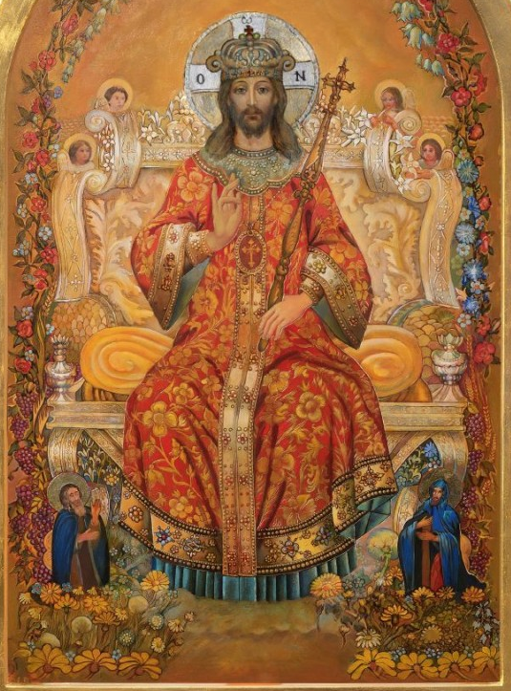

PLEASE Pray to END THE KILLING in the Holy Land!

Most Rev. Timothy C. Senior, Bishop of Harrisburg
Rev. Dominic M. DiBiccaro, Pastor
Deacon Steve Huete, Pastoral Associate

Mass Schedule, Intentions, and Events
Please Pray for these in need:
Jeanie Kline & the Kline Family, Dick & Deb Deardorff, John Baker, Ginny Hoctor, Brenda Wolf, Sr. Thelma Steiger HSF, Sr. Miriam Ukeritis CSJ , Peter Hackney, Lucas Christiansen, Dale Kaplan, Jerry Smith, Wade Sprankle, Dulcie Perry, Ron Formosa, Gavin Crumbacker, Anna Kane, Sherry Dennis & Family, Remi Peters, Terry Ahn, K. Grance, Lori McFadden & Family, Mike & Lisa Poole, Mervin Weikert, Chastity Rudisill, Mary Ellen Wilson, Terry & Bernie Cabana, Ed & Aggie Sherensky & Family, Bob Raffensberger, Jerry & Ginny Miller, Adeline Lienard, Kaylee Henry, Nancy Wuller, Dr. Mike Colli, Mrs. Kelly Kump, Gabriel Singer, Sharon McCormley, Ron Thumma, Joe Wisotzkey, Leo Hockensmith, Erika McKissick, Jean "Heather" O'Shea, Scott Moore & Sally Moore, Mary Wyatt, Jim & Joyce Deardorff, Amy Weatherup, Sophia Joy Ernst, Deacon Richard Wentzel, Deacon Frank Enderle, Paul & Carolyn Topper, Kathleen Thompson, Rachel Wonders, Amy Edwards, Jean O’Connor, Jen Baldwin, Ursula Kaley, Deb Bennet, Larry Endy, Laura Lee, Marwa Abdelrahman, Donna Singley, Tim McGinn, Jane Kump, Peggy Neiderer, Chris Kimple, Robert Riquet, Gene & Jo-Ann McDannell, Bob Doxzen, Kimberly Mears, Gabriella Angello, Paul Angello, Mark & Kate Morrow, Mark Morris, Linda Fogleman, Paul Knight, George & Barbara Erstila, Jeff Carpenter, Lana & Nelson Harmon, Diane Slothour, Sue McDannell, Larry Schneider, Joe & Lisa Grasel, Ange Pena, Julie Barnhart, the Shaffer Family, Heather & Emma Dickerson, Brad Peabody, Paul Ward, Aiden Tyler Schneider, Dorothy Vega, Karrie McCall & daughter, George Shahid, Denise Navlyt, Drew Schneider & Family, Ida Bloomfield, Janie Singley, Mary Beth Greenstreet, Rick Benedict, Jan Patla, Kathey Fogleman, Sam Sheffler, Kate Hemmis, Bill & Mary Lou Graham, Andy Graham, Joanna Hodges, John Varones, Joan O’Sullivan, Martha Klinger, Lisa Dionne Lauretti, Jim Gleason, Sue Gustafson, Joe & Michelle Cleary, Kim Johnson, Helen Mills, Kathy Haber, Haley Detman, Joe Durovey, Bev Smith, Donald Sheppard, Linda Mumaugh, Alison Haring, Janet Hartman, Edward Johnson, Angela Galeone, Juliete Lang, Chris MacBeth, Harry Graham, Donald Howard, Armond Binni, Elizabeth Stansky, Pat Johnson, Chris Morris, Faud Doaney, Patrick Glass, Helen Lagasse, Nancy Kewisnek, Bill & Maureen Collins, Rosemary McGilloway, Anji Eisenhart, Monica Manner, Denny Borbonus, Dr. Paul Scarlata, Mary Hawthorne, Ed Washington,JoshKempinski, NancyBaltzey, Spencer Propts, Karlton Smith & Cheryl Sobun, James & Marylyn Sobun, Marlene Webster, Yvette Stoklosa, Andy Consiglio, Bill & Michelle Cloonan, Nelson Salem, Bill & Deb McClintock, nursing home residents & shut-ins, the victims of war, violence, disease, disaster, & all private intentions.
Also in your prayers, please remember all our men
& women currently serving in our Armed Forces:

Lt. Col. Nathan Jeffcoat – US Marine Corps
Lt. Joseph Cleary – US Navy
Michael C. Kenney IV – US Coast Guard
Lt. Joshua Kimple – US Army
Lt. Sarah Fogleman, M.D. – US Navy
A1C Ian Bellinger ‒ PA Air National Guard

PRAYER CHAIN: Contact the Office

for the Week of November 25 to December 3, 2023

SATURDAY, Nov. 25 - VIGIL OF CHRIST THE KING

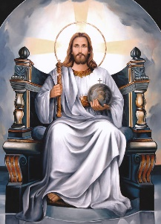
Ez 34:11-12, 15-17/1 Cor 15:20-26, 28/Mt 25:31-46
5:00PM + ALL SOULS

SUNDAY,Nov. 26 – CHRIST THE KING

Ez 34:11-12, 15-17/1 Cor 15:20-26, 28/Mt 25:31-46

8:00AM ⁓ People of the Parish

10:30AM + Phillip Sanzano

Monday, November 27 (Last weekdays in OT)
Dn 1:1-6, 8-20 / Lk 21:1-4
Parish Office Closed

Tuesday, November 28 (Last weekdays in OT)
Dn 2:31-45 / Lk 21:5-11

8AM – 3PM ~ Office Open

10:00AM + ALL SOULS

Wednesday, November 29 (Last weekdays in OT)
Dn 5:1-6, 13-14, 16-17, 23-28 / Lk 21:12-19
11AM: Mature Spirituality Group
7:00PM + Jack Ryff
6 to 6:45PM - Confessions; 7:40PM - Adoration & Benediction
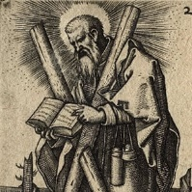
Thursday, November 30 – ST. ANDREW,
Rom 10:9-18 / Mt 4:18-22 APOSTLE

8AM – 3PM ~ Office Open
10:00AM + Mickie Schneider

Friday, December 1 (Last weekdays in OT)  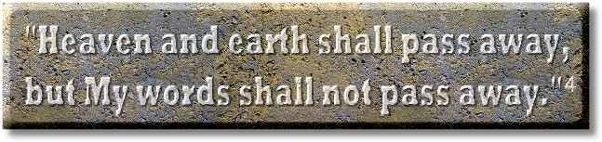  Dn 7:2-14 / Lk 21:29-33  10:00AM + Sylvia Tobara  Parish Office CLOSED | THE LORD

SATURDAY, December 2 (Last weekdays in OT)

MORNING: Dn 7:15-27 / Lk 21:34-36

SATURDAY, Dec. 2 - VIGIL 1ST SUNDAY OF ADVENT

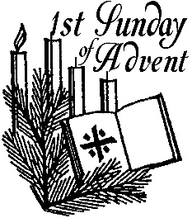
Is 63:16b-17, 19b; 64:2-7/1 Cor 1:3-9/Mk 13:33-37
5:00PM + James Bucci

SUNDAY, Dec. 3 – 1ST SUNDAY OF ADVENT

Is 63:16b-17, 19b; 64:2-7/1 Cor 1:3-9/Mk 13:33-37
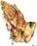
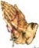
8:00AM ⁓ People of the Parish
10:30AM + Rogene R. Blocher & Cora Jane Miller
Sanctuary Candle offered for DECEMBER: In Loving Memory of Donald Redding & Teresa Quigley

When the End Comes: Scott Hahn Reflects

on the Solemnity of Christ the King

The Church year ends today with a vision of the end of time. The scene in the Gospel is stark and resounds with Old Testament echoes.

The Son of Man is enthroned over all nations and peoples of every language (see Daniel 7:13–14). The nations have been gathered to see His Glory and receive His Judgment (see Isaiah 66:18; Zephaniah 3:8). The King is the Divine Shepherd Ezekiel foresees in today’s First Reading, judging as a shepherd separates sheep from goats.

Each of us will be judged upon our performance of the simple works of mercy we hear in the Gospel today.

These works, as Jesus explains today, are reflections or measures of our love for Him, our faithfulness to His commandment that we love God with all our might and our neighbor as ourselves (see Matthew 22:36–40).

Our faith is dead, lifeless, unless it is expressed in works of love (see James 2:20; Galatians 5:6). And we cannot say we truly love God, whom we cannot see, if we don’t love our neighbor, whom we can (see 1 John 4:20).

The LORD is our shepherd, as we sing in today’s Psalm. And we are to follow His lead, to imitate His example (see 1 Peter 2:21; Ephesians 5:1).

He healed our sickness (see Luke 6:19), freed us from the prison of sin and death (see Romans 8:2, 21), welcomed us who were once strangers to His Covenant (see Ephesians 2:12, 19). He clothed us in Baptism (see Revelation 3:5; 2 Corinthians 5:3–4), and feeds us with the food and drink of His own Body and Blood.

At “the end,” He will come again to hand over His Kingdom to His Father, as Paul says in today’s Epistle.

Let us strive to be following Him in right paths, that this Kingdom might be our inheritance, that we might enter into the Eternal Rest promised for the People of God (see Hebrews 4:1, 9–11).

Readings: Ezekiel 34:11–12, 15–17; Psalm 23:1–3, 5–6
1 Corinthians 15:20–26, 28; Matthew 25:31–46

Sunday Collection Summary for Nov. 18 & 19

Weekend Collections
Regular Offering $ 2,593.00
Immaculate Conception $ 10.00
TOTAL OFFERINGS $ 2,603.00

‒ WEEKLY BUDGETARY NEEDS $ 4,494.00
+Overage or (Shortfall) for the week $ (1,891.00)

Other Income
Christmas Flowers $ 20.00
Thanksgiving $ 260.00
Turkey Bingo $ 2,777.61
Total Other Offerings $ 3,057.61

Diocesan Second Collections
Matthew 25 [25% rebated back to parish] $ 1,062.00
Retirement for Religious $ 10.00
World Mission Sunday $ 60.00
Total Diocesan Offerings $ 1,132.00

A Prayer of Gratitude

Thank You, LORD, for all Your gifts of love, especially
for those we often overlook.
Thank You for friends – to increase our love for You.
Thank You for enemies – to increase our tolerance.
Thank You for joys and happiness – to strengthen
our faith in You.
Thank You for trials and tribulations – to strengthen
our trust and perseverance.
Thank You for the times when all goes well – to
teach us serenity.
Thank You for the days when things are rough – to
teach us patience.
Thank You for our successes – to increase our
confidence.
Thank You for our failures – to increase our humility.
Thank You, LORD, for the “ups” and “downs” of life.
Thank You, LORD, for the precious gift of life itself.
Help us to continue to grow and to learn, to love
and to be grateful.
Comfort us when we are disturbed; disturb us when
we become too comfortable.
Thank You, LORD, for being by our side.

⁓ Leo M. Koseny and Father Mike Hanson, OMI

POPE FRANCIS’ PRAYER INTETNION
FOR THE MONTH OF NOVEMBER
~ For the Pope
We pray for the Holy Father; as he fulfills his mission, may he continue to accompany the flock entrusted to him, with the help of the Holy Spirit.

