Sacrament of the Sick
Anointing of the Sick should be given if an individual is gravely ill or near death. If possible, the Sacrament should also be administered for serious illness, before major surgery or when one is initially hospitalized.

Sacrament of Holy Matrimony
Diocesan policy requires 12 months of preparation for Marriage. Contact the parish as soon as possible after engagement. No venue reservations or other arrangements should be made prior to consultation with the pastor.

Sacrament of Penance
Wednesday ~ 6:00 – 6:45PM; or by appointment.

Sacrament of Baptism
Parents must be registered members of the parish and attend a Baptism preparation class prior to the Baptism if this is your first child baptized. Requirements for godparents are established by the Catholic Church. Please call the parish office for Information and to register your child for Baptism.

Parish Registration
All Catholics should be registered in their local parish. Please contact the parish office to obtain registration forms, or if you are uncertain of the parish where you should register.

Parish Staff & Ministries Directory
stignatiusofloyola@hbgdiocese.org
Financial Manager ~ Richard Deardorff ~ 717- 677-8012 or 717-420-3464 (cell)
rdeardorff@hbgdiocese.org
Director of Religious Education ~ Deacon Steve Huete ~ shuete@hbgdiocese.org
Parish Secretary ~ Kristen DiDio ~ kdidio@hbgdiocese.org
Buildings & Grounds ~ Donnie Althoff ~ 717-677-8012
Music Ministry ~ Phil Mobley ~ 717-677-8012
Parish Council Members
Phil Mobley – Chair 571-236-7580 pmmobley@gmail.com
Bicky Redman – Vice Chair 677-8592 feetintheair7@gmail.com
Joanne Riedel - Secretary 398-2021 sterj221@aol.com
Kathi Allwein 677-8984 allweint@comcast.net
Charlie Baker 677-9536 dcbake@embarqmqil.com
Mike McTighe 729-6239 mike0432@aol.com
Dr. BobTernes rjtmd46@gmail.com

Finance Council Members
Richard Deardorff (Ex Officio)
Greg Ernst - Chair
Alix Haller
Christy Hemler - Secretary
Terri Pendlelton
Bill Pulig

Altar Flowers
Prayer Chain
Lynne Mobley at LMOBLEY509@gmail.com
or 703-876-4901

Soup Kitchen
Please send donations directly to “Soup Kitchen”

Website Development
Kristen DiDio
Life After Loss
Dodie Huete

OCIA
Contact Fr. Dominic

Picnic Co-Chairpersons
John Neiderer
Wally Kane

Pro-Life Ministry
OPEN – Contact office if you are interested

Knights of Columbus
SK Bob Ternes
- Grand Knight

Judy Wilson / Janice Meligakes

Bereavement Ministry
Ginny Bittle / Dodie Huete

Catholic Communications/EWTN
Open - Contact office if you are interested

Cemetery
Contact Parish Office
THEOSIS Ministry
Kathy Dietsch 717-352-4558
Bicky Redman 717-677-8592

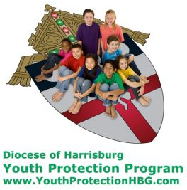
Diocese of Harrisburg Youth Protection Program
www.YouthProtectionHBG.com

Abuse Reporting Contact Information:
First – Call the toll-free PA Child Abuse Hotline at 800-932-0313
Then – Call the Diocesan toll-free hotline at 800-626-1608

“If one member suffers,
all suffer together with it.” (1 Cor 12:26)

St. Ignatius Loyola RC Church

1095 Church Road, Orrtanna, Pennsylvania 17353
www.stignatiusofloyola.org

JULY 2, 2023: 13th SUNDAY IN ORDINARY TIME
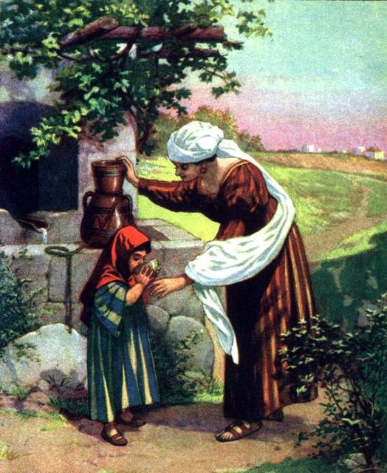

… Amen I say to you,
he will surely not lose his reward!

Most Rev. Timothy C. Senior, Bishop of Harrisburg
Rev. Dominic M. DiBiccaro, Pastor
Deacon Steve Huete, Pastoral Associate

Mass Schedule, Intentions, and Events
Please Pray for:
Those who are ill, Jeanie Kline & the Kline Family, Christy Hemler, Terry Ahn, K. Grance, Lori McFadden & Family, Mike & Lisa Poole, Mervin Weikert, Chastity Rudisill, Mary Ellen Wilson, Terry & Bernie Cabana, Ed & Aggie Sherensky and Family, Bob Raffensberger, Jerry & Ginny Miller, Adeline Lienard, Kaylee Henry, Chuck & Nancy Wuller, Dr. Mike Colli, Mrs. Kelly Kump, Kevin & Brittany Groff, Gabriel Singer, Sharon McCormley, Ron Thumma, Joe Wisotzkey, Leo Hockensmith, Erika McKissick, Jean "Heather" O'Shea, Scott Moore and Sally Moore, Mary Wyatt, Jim & Joyce Deardorff, Brandon & Michelle Gilbert, Amy Weatherup, Sophia Joy Ernst, Deacon Richard Wentzel, Deacon Frank Enderle, Kathleen Thompson, Deb & Kathy McLintock and Family, Rachel Wonders, Amy Edwards, Jean O’Connor, Art Lazar, Sr., Paul Angello, Jen Baldwin, Ursula Kaley, Deb Bennet, Fr. Bill Sullivan, Larry Endy, Mary Beth McCarthy, Laura Lee, Marwa Abdelrahman, Cathy Gates, Donna Singley, Jack Ryff, Tim McGinn, Jane Kump, Peggy Neiderer, Chris Kimple, Robert Riquet, Gene & Jo-Ann McDannell, Bob Doxzen, Kimberly Mears, Gabriella Angello, Mark & Kate Morrow, Mark Morris, Linda Fogleman, Paul Knight, George & Barbara Erstila, Jeff Carpenter, Lana & Nelson Harmon, Diane Slothour, Sue McDannell, Larry Schneider, Joe & Lisa Grasel, Ange Pena, Julie Barnhart, the Shaffer Family, Heather & Emma Dickerson, Brad Pabody, Paul Ward, Aiden Tyler Schneider, Dorothy Vega, Karrie McCall & daughter, George Shahid, Denise Navlyt, Drew Schneider & Family, Ida Bloomfield, Linda McDannell, Janie Singley, Mary Beth Greenstreet, Rick Benedict, Jan Patla, Kathe Fogleman, Sam Sheffler, Kate Hemmis, Bill & Mary Lou Graham, Joanna Hodges, John Varones, Joan O’Sullivan, Martha Klinger, Lisa Dionne Lauretti, Sue Orndorff, Jim Gleason, Sue Gustafson, Joe & Michelle Cleary, Kim Johnson, Helen Mills, Kathy Haber, Haley Detman, Joe Durovey, Bev Smith, Donald Sheppard, Linda Mumaugh, Alison Haring, Janet Hartman, Edward Johnson, Angela Galeone, Juliete Lang, Chris MacBeth, Harry Graham, Donald Howard, Armond Binni, Elizabeth Stansky, Pat Johnson, Chris Morris, Faud Doaney, Wilson & Rae Harman, Patrick Glass, Helen Lagasse, Nancy Kewisnek, Andy Graham, Bill & Maureen Collins, Rosemary McGilloway, Anji Eisenhart, Monica Manner, Denny Borbonus, Dr. Paul Scarlata, Mary Hawthorne, Ed Washington, Josh Kempinski, Nancy Baker Baltzey, Spencer Propts, Karlton Smith & Cheryl Sobun, James & Marylyn Sobun, Marlene Webster, Yvette Stoklosa, Andy Consiglio, Bill & Michelle Cloonan, Nelson Salem, Janet Shunnarah, George Shunnarah, Bill & Deb McClintock nursing home residents & shut-ins, the victims of war, violence, disease, disaster, & all private intentions.
Also in your prayers, please remember all
our men and women currently serving in
our Armed Forces:
Maj. Nathan Jeffcoat – US Marine Corps
Lt. Joseph Cleary – US Navy
Michael C. Kenney IV – US Coast Guard
Lt. Joshua Kimple – US Army
Lt. Sarah Fogleman, M.D. – US Navy

PRAYER CHAIN: Contact Lynne Mobley at 703-876-4901 or LMOBLEY509@gmail.com

for the Week of July 1 to July 9, 2023

SATURDAY, July 1 –VIGIL MASS 13TH SUNDAY IN ORD.TIME

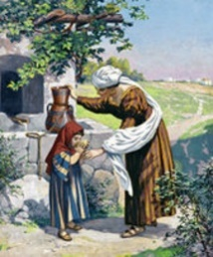
2 Kgs 4:8-11, 14-16a / Rom 6:3-4, 8-11 / Mt 10:37-42
5:00PM ‒ Spec. Int. for Karlton Smith

SUNDAY, July 2 – 13TH SUNDAY IN OT

2 Kgs 4:8-11, 14-16a / Rom 6:3-4, 8-11 /
8:00AM + Christopher DiDio
10:30AM ~ People of the Parish

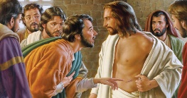
Monday, July 3 - ST. THOMAS, APOSTLE
Eph 2:19-22 / Jn 20:24-29
Parish Office Closed

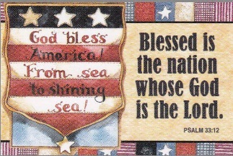
Tuesday, July 4 (Weekday in OT)
Gn 19:15-29 / Mt 8:23-27

8:00AM - 3:00 PM ~ Office Open
10:00AM - Private Intention

“Something More” Group – NO MEETING

Wednesday, July 5 – St. Anthony Zaccaria, Priest; St. Elizabeth
Gn 21:5, 8-20a / Mt 8:28-34 of Portugal

8:00AM - 3:00 PM ~ Office Open
10AM: Senior Spirituality Group
7:00PM + Dominic DeToma
Confessions heard 6 to 6:45PM; Adoration at 7:40PM
Thursday, July 6 – St. Maria Goretti, Virgin
Gn 21:5, 8-20a / Mt 8:28-34 and Martyr

8:00AM – 3:00PM ~ Office Open
10:00AM + Dolores Y. Gillelan
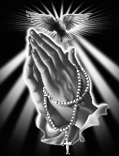  Friday, July 7 (Weekday in OT)  Gn 23:1-4, 19; 24:1-8, 62-67/Mt 9:9-13  Parish Office CLOSED | THE LORD
10:00AM + Rev. Chester P. Snyder

SATURDAY, July 8 (Weekday in OT)

MORNING: Gn 27:1-5, 15-29/Mt 9:14-17

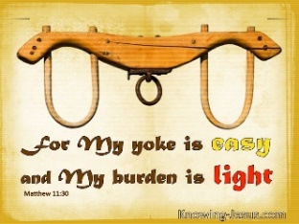
SATURDAY, July 8 –VIGIL MASS 14TH SUNDAY IN ORD.TIME

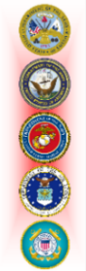
Zec 9:9-10 / Rom 8:9, 11-13 / Mt 11:25-30
5:00PM ⁓ People of the Parish

SUNDAY, July 9 – 14TH SUNDAY IN OT

Zec 9:9-10 / Rom 8:9, 11-13 / Mt 11:25-30
8:00AM + Margaret and Paul McDannel & Family
10:30AM - Spec. Int. for Ed & Aggie Sherensky
Honoring their 60th Wedding Anniversary
Sanctuary Candle offered for JULY: In Loving Memory of Donald Redding from Edna Redding.
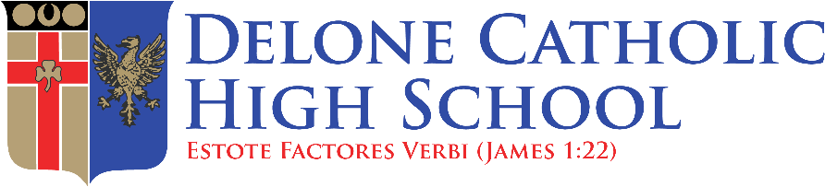

Save the Date for Delone Catholic High School's Annual Bonfire, Thursday, Aug. 24 at J.T. Flaherty Field. New this year will be the addition of food trucks and games for our Little Squires and Future Squires! The gate by the concession stand on South Street will open at 5:30 p.m. The program will begin at 7 p.m. The program will include performances by the Marching Squires and the DCHS cheerleaders, a Rosary rally, the blessing of our fall teams, and of course, a bonfire. Parents and community members are welcome to attend.

Delone Catholic High School in McSherrystown, Pa. is now hiring for part-time school cashier/food service workers and dishwashers for the 2023-24 school year. Apply today at bit.ly/DCHSjobs, contact Mrs. Donna Tompkins at dtompkins@delonecatholic.org or call 717-673-5969.

EWTN will be broadcasting BISHOP SENIOR’S INSTALLATION MASS next Friday, June 30 at 3:00PM this weekend and throughout next week. This is especially helpful for those who were not able to view the live stream – although it is still available on the DIOCESE
OF HARRISBURG CHANNEL.

Sunday Collection Summary
June 24 and 25

Weekend Collection
Regular Offering $ 2,829.11
Altar Flowers $ 5.00
Candles $ 102.65
Corpus Christi (additional) $ 50.00
Local Poor $ 100.00
TOTAL OFFERINGS $ 3,086.76

‒WEEKLY BUDGETARY NEEDS $ 5,819.68
+Overage or (Shortfall) for the week ($ 2,732.92)

Other Income
Paver Memorial Bricks $ 140.00
Total Other Offerings $ 140.00
_____________________________________________

DONATIONS ACCEPTED
JULY 9-23,
at the Office or
in the basket in the Narthex.

Coats will be purchased
in October at Boscov’s
and then donated to
the Interfaith Shelter in Harrisburg,
and to SCCAP in Gettysburg.

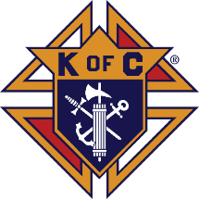
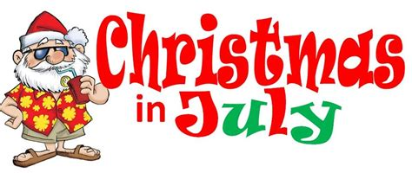

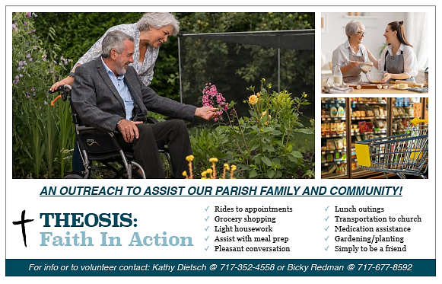

Gallup poll: Church attendance sees slight uptick;

still below pre-pandemic levels

By Tyler Arnold | Washington, D.C. Newsroom, Jun 28, 2023

Although church attendance in the United States saw a slight uptick in 2023, fewer Americans are going to church than they did before the start of the COVID-19 pandemic and lockdowns, according to a Gallup poll released June 26.

Gallup surveyed more than 1,000 Americans between May 1 and May 24, asking them whether they had attended church, synagogue, mosque, or temple within the last seven days. The results found that only 31% of respondents said they had. About 84% of worshippers were attending in person, but about 16% were still attending remotely.

The 31% attendance rate was the highest found by the pollsters since the start of the COVID-19 pandemic. The 2020 survey found that only 30% of respondents attended a service within the week they were polled, which dropped to 29% in 2021 and rose again to 30% in 2022.

Despite the slight uptick, the poll found that attendance was still three percentage points lower than the 34% attendance rate found in 2019, the year before the COVID-19 pandemic began. However, the attendance was only one percentage point lower than the 32% rate found by pollsters in 2018, which was, prior to the COVID-19 pandemic, the lowest-ever attendance rating found by pollsters.

The average rate of attendance from 2016 through 2019 was 34% and the average rate of attendance from 2020 through 2023 was 30%.

Post-pandemic church attendance rates declined more sharply among Catholics than it did among Protestants. The 2016-2019 average among Catholics was 37%, compared with a 2020-2023 average of only 30%. Protestants in the same time frame fell from 44% to 40%.

“It is not clear if the pandemic is the cause of the reduced attendance or if the decline is a continuation of trends that were already in motion,” Gallup Senior Editor Jeffrey M. Jones said in a news release accompanying the data. “However, the temporary closure of churches and ongoing COVID-19 avoidance activities did get many Americans out of the habit of attending religious services weekly.”

Church attendance is also substantially lower than the attendance rates found in the 1990s and the 2000s by Gallup pollsters. In the ’90s, church attendance fluctuated between 43% at its highest point and 38% at its lowest point. In the 2000s, attendance fluctuated between 44% at its highest point and 39% at its lowest point.

The poll showed that church attendance has generally been on the decline since 2009, when 42% of respondents said they had attended a service in the past week. After 2009, attendance rates have mostly been in the 30s, with only two exceptions: 40% attendance in 2012 and 29% attendance in 2021.

Church attendance was at its height in the mid- to late-1950s. The highest points were 49% in 1955 and 49% again in 1958. Gallup’s data goes back to 1939, but it did not conduct regular annual polls until the late 1980s.

Post-pandemic church attendance declined among Republicans, Democrats, and Independents, according to the recent poll. From 2016 through 2019, about 45% of Republicans answered that they had attended a church service, compared with 40% from 2020 through 2023. In that same time frame, Independents declined from 30% to 25% and Democrats declined from 28% to 25%.

The margin of sampling error for the poll was plus or minus 4% with a 95% confidence level.

Tyler Arnold is a staff reporter for the National Catholic Register. He previously worked at The Center Square and has been published in a variety of outlets, including The Associated Press, National Review, The American Conservative and The Federalist.
The Holy Father, Pope Francis’ Prayer Intentions for 2023
Entrusted to His Worldwide Prayer Network
JULY ⁓ For a Eucharistic Life

We pray that Catholics may place the celebration of the Eucharist at the heart of their lives, transforming human relationships in a very deep way and opening to the encounter with God and all their brothers and sisters.
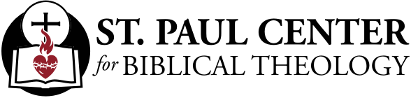

To Find Our Lives: Scott Hahn Reflects

on the Thirteenth Sunday of Ordinary Time

The liturgy this week continues to instruct us in the elements of discipleship. We’re told that even the most humble among us have a share in the Mission that Christ gives to His Church.

We’re not all called to the ministry of the Apostles or to be Prophets like Elisha in today’s First Reading. But each of us is called to a holy life (see 2 Timothy 1:9; 1 Thessalonians 4:3).

At Baptism, our lives were joined forever to the Cross of Christ, as Paul tells us in today’s Epistle. Baptized into His Death, we’re to renounce sin and live for God in Christ Jesus.

We are to follow Him, each of us taking up our personal cross, as Jesus says in today’s Gospel. That doesn’t mean we will all be asked to suffer a martyr’s death. But each of us is called to self-denial, to the offering of our lives in service of God’s Plan.

Jesus must be elevated to first place in our lives — above even our closest bonds of kinship and love. By Baptism, we’ve been made part of a new family: the Kingdom of God, the Church. We are to proclaim that kingdom with our lives, bringing our fathers, our mothers, and all men and women to live as little ones under the fatherhood of God and the kingship of the Holy One.

We do this by opening our hearts and homes to the service of the LORD, following the Shunnamite woman’s example in today’s First Reading. As Jesus tells us, we’re to receive others — not only Prophets but also little children, the poor, and the imprisoned — as we would receive Christ Himself (see Matthew 18:5; 25:31–46).

As we sing in today’s Psalm, we are to testify to His favors and kindness in our lives.

We’re to hold fast to the Promise — that if we have died with Christ, we shall also live, that if we lose our lives for His sake, we shall find our reward and walk forever in His countenance!

Readings: 2 Kgs 4:8–11, 14–16; Ps 89:2–3, 16–19; Rom 6:3–4, 8–11; Mt 10:37–42

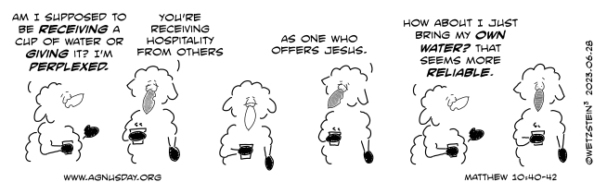

‘God Is Trans’ church no longer hosting ‘Pride Mass’

at gay monument, cites security concerns

By Joe Bukuras | Boston, Mass., Jun 22, 2023

A Catholic parish in New York City that planned to have a “Pride Mass” on Thursday at a federal monument with sculptures of two same-sex couples and groups of gay and transgender pride flags has announced a change of location.

The Church of St. Paul the Apostle said in a Wednesday email to parishioners that the National Parks Service informed it that the Stonewall National Monument, which commemorates a June 1969 LGBT uprising against a police raid, “will not be open to the public tomorrow due to concerns over the security of events in the area.”

“Because of this, we will not have access to the park to celebrate our annual Pride Mass scheduled for tomorrow,” the church said in its email.

The Mass will still be held at the Church of St. Paul the Apostle at 6:30 p.m., the email said.
CNA called the Stonewall National Monument to inquire about the security concerns but was unable to reach anyone.

The change of venue comes amid criticism against the parish for its decision to hold a “Pride Mass” and for its choice of location, with some calling it “blasphemous.”

The Church of St. Paul the Apostle is the same church that hosted a controversial art display earlier this year called “God Is Trans,” which also received severe criticism.

Paul Snatchko, a spokesperson for the Paulist Fathers — who run the church — told CNA in June that the point of hosting the “Pride Mass” at Stonewall was to evangelize in the public square by singing hymns and proclaiming the word of God during the liturgy.

The Church of St. Paul the Apostle held a Mass at the Stonewall National Monument in 2019 and a video shows a visiting priest, Father Gil Martinez, celebrating the Mass, saying “Sisters, brothers, siblings, Christ called us here today to this sacred space to commemorate the sacrifice of those who came before us.”

“50 years ago, queers, considered the lowliest of the low, made a stand for their dignity. And though they were beaten by police, they were not broken. Their hope, faith, and rage built the revolution on which we stand. Take a moment to pause and look around you, see their legacy in the faces of those around you. See what God is doing in our world.”
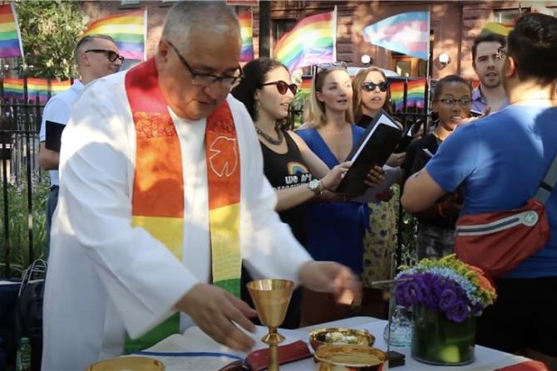

Father Gil Martinez celebrates Mass at the Stonewall National Monument on June 17, 2019.
Credit: YouTube/Religion Unplugged 2019

Stonewall National Monument is a 7.7-acre park in the West Village neighborhood of Greenwich Village in Lower Manhattan, New York City, dedicated to “LGBT rights” and history. It was designated as a national monument by President Barack Obama on June 24, 2016.

Father Thomas Petri, OP, a moral theologian and president of the Dominican House of Studies in Washington, D.C., spoke with CNA on June 14 about the parish’s decision, saying that the Mass should not be used to make a political statement.

“Certainly it’s understandable and it’s part of our tradition to celebrate Mass in repentance for our sinfulness, which includes any unjust discrimination against a person or a group,” he said.

“However, it would be inappropriate for any Mass to be celebrated with a political end, and with political flags or campaign posters flying in the sanctuary or among the congregation,” Petri said.

“It would be impious and possibly sacrilegious because it profanes the very purpose of the Mass: The worship of God by the participation in the body and blood of Christ himself.”

Petri said that the Mass is meant to “turn our minds and hearts to things that are above and not to things below.”

“All the more is this the case for the Mass at Stonewall, where the monument, the statues, and the flags carry a meaning that most people rightly identify with a lifestyle, sexual activity, and an ideology that are all contrary both to the Christian understanding of the human person and to a life of chastity and virtue,” he said.

“Insisting upon this is not to say that those who experience same-sex attraction or gender dysphoria are not discriminated against or are unjustified in their pain or anger,” he said.
“Rather, it is to say that reveling in any identity and lifestyle that we know is contrary to living in the freedom of the children of God ultimately damages the soul and can destroy one’s relationship with God,” Petri said.

“It’s not pastoral to facilitate anyone walking that path. There are much better ways to seek justice in the world.

Joseph Bukuras is a journalist at the Catholic News Agency. Joe has prior experience working in state and federal government, in non-profits, and Catholic education. He has contributed to an array of publications and his reporting has been cited by leading news sources, including the New York Times and the Washington Post. He holds a bachelor’s degree in political science from the Catholic University of America. He is based out of the Boston area.

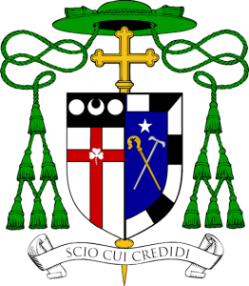
Bishop Senior’s Coat of Arms

The Bishop’s coat of arms is composed of a shield with its symbols, a motto, scroll, and the external
ornaments. In the United States, Roman Catholic residential bishops traditionally join their arms, in a
heraldic practice known as impalement, with the existing arms of their new diocese. Keeping with this
custom, the arms of Bishop Senior are now joined to those of Harrisburg.

The heraldic device of the See of Harrisburg, seen on the left, is a compilation of the arms of William
Penn’s family, the founders of Pennsylvania, and the family of John Harris of Yorkshire, England, who,
in 1712, first settled the area on the Susquehanna River, called Harris Ferry, which later took the name
Harrisburg.

The shield appears in silver and is divided by a Latin Cross in red. Upon this cross appears a silver
shamrock in honor of the titular cathedral of Harrisburg: Saint Patrick of Ireland.

In a chief sable (a black field in the shape of a bar that appears at the top of the Harrisburg arms) are two plates, or silver balls, known as roundels, assumed from the Penn family arms. Between them appears a silver crescent from the Harris family, which in Catholic heraldry also represents the image of the Blessed Virgin under the title of the Immaculate Conception, a title for Our Lady entrusted to the Church in America.

The personal arms of Bishop Senior, seen on the right side of the shield, reflect his life and his heritage. The colors—called tinctures—that Bishop Senior has chosen for his coat of arms allude to the arms of the Archdiocese of Philadelphia, where the primary tinctures are also white (argent) and blue (azure). The star in the top center of the shield (in chief) represents the Blessed Virgin Mary.

Bishop Senior has long had a love for music, and acknowledges that he began to hear and understand the Lord calling him to the priesthood while studying piano and organ. The roots of Bishop Senior’s vocation are symbolized in a divided border (bordure compony) around the shield, painted alternately white and black (sable), reminiscent of piano keys.

The central charges on the shield are placed saltirewise; that is, they cross each other diagonally in the form of an “X.” Each is a type of staff, and each refers to a passage in the New Testament Letters which begins (in the Latin Vulgate version of the Scriptures) with the word senior, which is translated “elder.” As such, they are an example of “canting arms”- a design which incorporates a pun on the bearer’s name.

In his First Letter, Saint Peter addresses the leaders of the Church: “To the elders (seniores) among you, I, a fellow elder . . . make this appeal: God’s flock is in your midst. Give it a shepherd’s care” (1 Peter 5:1–2). The responsibility of the bishop to tend Christ’s sheep is aptly represented by the crosier, or pastoral staff, which is derived from a shepherd’s crook, and is depicted here in gold (Or). When he receives the crosier, a newly-ordained bishop is exhorted to “keep watch over the whole flock in which the Holy Spirit has placed you as Bishop to govern the Church of God.”

Saint Paul wrote two letters to his disciple and companion Saint Timothy, the baptismal patron for Bishop Senior. He appointed Timothy the first Bishop of Ephesus, and in the first of his letters Saint Paul advises him regarding his care of the faithful. “Do not rebuke an older man (seniorem),” he writes, “but appeal to him as a father. Treat younger men as brothers, older women as mothers, and younger women as sisters with complete purity” (1 Timothy 5:1–2). The bishop’s role to provide support and encouragement for all the members of the community, especially those who are vulnerable and weak in body or spirit, is symbolized by the pilgrim’s staff or walking stick. Depicted here in silver (argent), the staff represents not only Saint Timothy, but also the years of leadership and service that Bishop Senior has given to Catholic Human Services of the Archdiocese of Philadelphia, as well as numerous other Catholic healthcare and social service ministries in this region.

Taken together, the two staves may be seen to signify the necessary connection between the spiritual and corporal works of mercy—the responsibility of the bishop to tend to all of the needs of the people he is called to serve. The painting of the crossed staves in gold and silver alludes to the crossed keys of Saint Peter, long recognized as a symbol of the Holy Father, and speaks of the bishop’s fidelity to the Bishop of Rome, the successor of Saint Peter and Saint Paul.

The motto, placed on a scroll below the shield, is a phrase from the Second Letter of Saint Paul to Timothy. The apostle writes now from Rome, where he has been imprisoned by Imperial officials because of his preaching of the Gospel. But he has not lost hope even in these dire circumstances, he insists, for “scio cui credidi” – “I know him in whom I have believed” (2 Timothy 1:12). Reading the motto in the light of the charges on the shield, it becomes clear that the Christian comes to know the Lord through acts of faith, hope and love of God, which are in turn made concrete in acts of charity to the poor and the weak, whom the Lord himself calls his brothers and sisters (cf. Matthew 25:40).

The shield is ensigned with external elements that identify the bearer as a bishop. A gold processional cross appears behind the shield. The galero or “pilgrim’s hat” is used heraldically in various colors and with specific numbers of tassels to indicate the rank of a bearer of a coat of arms. A bishop uses a green galero with three rows of green tassels.

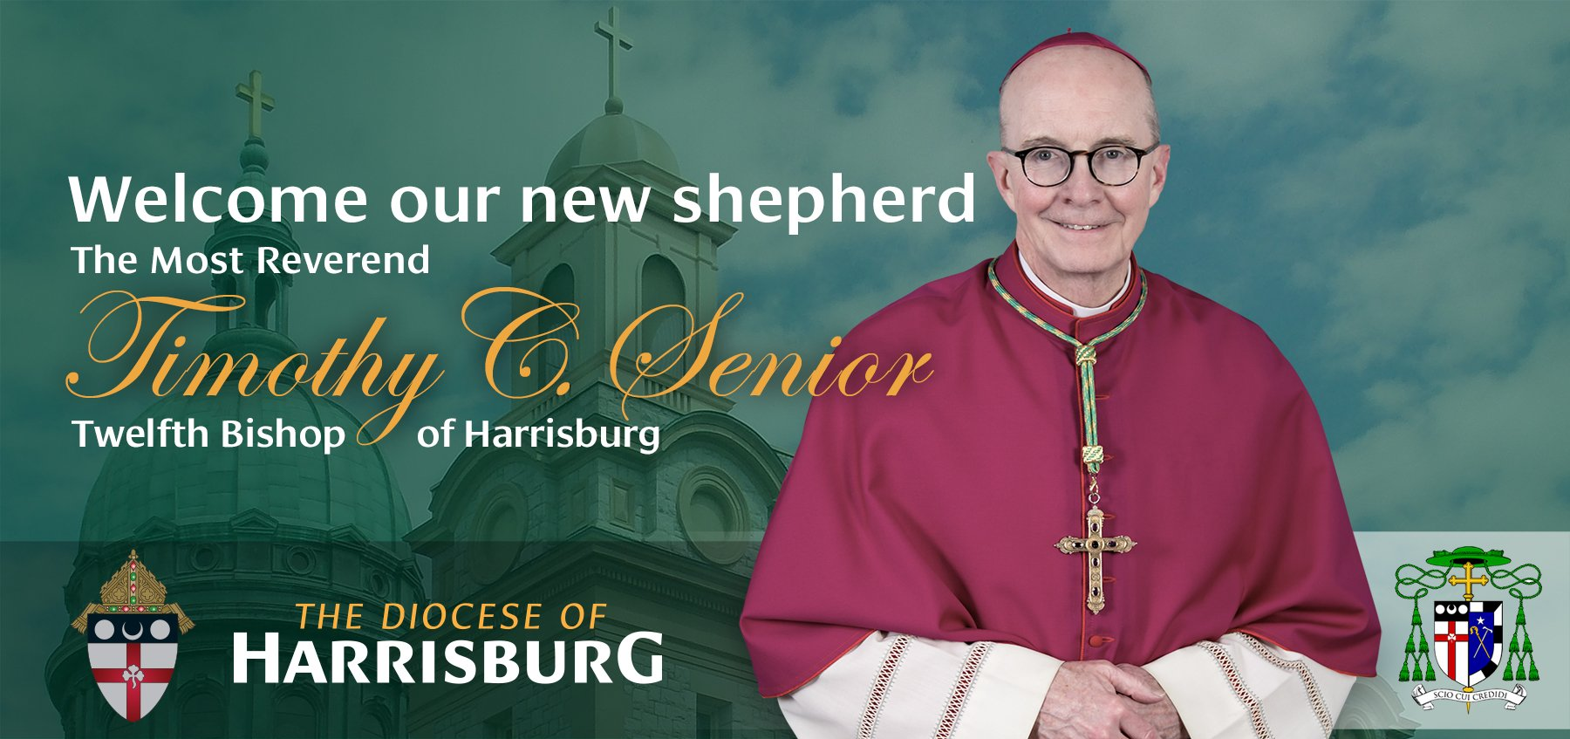

Installation of the Twelfth Bishop of Harrisburg
Homily
Bishop Timothy Senior
Cathedral of Saint Patrick / Harrisburg, Pennsylvania
21 June 2023
(Memorial of Saint Aloysius Gonzaga)

Praised be Jesus Christ!

Archbishop Perez, Archbishop Pierre, our Apostolic Nuncio and the representative of Pope Francis with us; Archbishop Chaput; Archbishops, brother bishops, priests, deacons, consecrated religious, seminarians, lay men and women; dear family and friends who have come to Harrisburg to celebrate this occasion and those who join us via live stream; ecumenical and interfaith representatives who have joined us today, as well as elected and other government officials who serve in the Diocese of Harrisburg and throughout the Commonwealth of Pennsylvania. Welcome and thank you so much for your presence here!

I would be remiss if I did also again thank Bishop Ronald Gainer, the 11th Bishop of Harrisburg. Bishop Gainer and I have known each other for quite a few years. I could never have imagined that I would one day be in this position, but I do say that he has left a wonderful example and a great legacy in his leadership here in the diocese. Bishop Gainer, you have served the Church so very generously throughout your life as a priest and bishop. As Archbishop Pierre mentioned, you recently marked the fiftieth anniversary of your Ordination to the Priesthood! You have guided this local Church in Harrisburg for over nine years, through some challenging times, with great effectiveness, pastoral charity, wisdom and great love for those entrusted to your care. We are all blessed that you will be continuing to be active in ministry in the Diocese in your retirement. God has more work for you to do among us! Thank you Bishop Gainer! Ad Multos Annos!

To my brother priests of Harrisburg; as I mentioned in my remarks on the day of the announcement of my appointment, I am fortunate to know some of you already, both from our time together in formation in the Seminary many years ago, and others, ordained in the last ten years, who had me as your Rector at Saint Charles Borromeo Seminary. I have to say, that I hope that you are has happy about my becoming your bishop as I am! I very much look forward to getting to know ALL of you. You are my principal collaborators in the mission of our Diocese. As priests serving the Church so faithfully, you have been through some difficult times in recent years. It hasn’t been easy to be on the front lines as priests during those times. Thank you for your ministry dear brothers and for giving your lives so generously. I have much to learn from you, and will work hard with you and for you in the mission that is entrusted to us.

Though these have been difficult years for those who serve in the Church, and in some ways for all Catholics, it is imperative that we also call to mind the painful experience of those who are survivors of sexual abuse.
I stand ready to do my part in accompanying and assisting survivors, and I want to reaffirm the commitment of the Church in Harrisburg to do all that we can to provide care and support for survivors of sexual abuse by clergy, and to ensure that the policies and procedures that are in place to protect children and to work with law enforcement to respond to allegations of sexual abuse, will remain in force, and will continue to be reviewed and strengthen as needed.

Our Church is also blessed with the ministry of our permanent deacons, consecrated religious women and men, and so many lay faithful who are dedicated to the Church’s mission. While I still have so much to learn about my new home and new Church community, I already know that we are blessed in so many ways and I am blessed to be among you.

While many in our Diocese have responded generously to the call of God in their lives, I ask you to join me in a renewed commitment to prayer for vocations in all forms in the Church, but especially at this time for vocations to the Priesthood. Please encourage young men whom you may believe could have a vocation to the Priesthood to
think about it – to be open to it. If you know such a young man, tell him why you think God might be calling him. Your encouragement can make a great difference in a young man’s discernment of a call. Today the Church observes the Memorial of Saint Aloysius Gonzaga the young Jesuit seminarian from the 16th century, who is the patron of youth and young people. It is with this in mind that, even as we continue to pray for our seminarians who are already in formation for the Priesthood, I asked that a prayer for vocations be on the holy card to mark this occasion, and to serve as a reminder to all of us to keep this intention in our prayers. As Jesus said to His disciples: “The harvest is abundant but the laborers are few; so ask the master of the harvest to send out laborers for his harvest.” (Matthew 9, 37-38).

También quiero extender un saludo especial a la creciente comunidad hispana de la Diócesis. Como tantos otros de diversas culturas que son parte de nuestra diócesis, ustedes aportan mucho a nuestra Iglesia local. ¡Nuestra diversidad cultural es una gran bendición! Espero conocerlos, apoyarlos y alentarlos en la vida de fe.
¡Pero, por favor, tengan paciencia conmigo cuando hable en español! ¡Muchas gracias!

As I begin my service as bishop in Harrisburg, my primary desire is to be a good pastor; to be a leader who is servant first and so to announce the Gospel of Jesus Christ with integrity and fidelity. I will endeavor each day to give myself completely to this service. Please do not hesitate to let me know when I fall short of that goal. So, I ask you again to pray for me, that I may be the bishop that the Church in Harrisburg needs me to be. I hear the words of Saint Paul to my patron, Timothy, in the second reading today very personally in my heart. Paul was writing to Timothy and encouraging him in his leadership of the Church in Ephesus; “for this reason, I remind you to stir into flame the gift of God that you have through the imposition of my hands....do not be ashamed of your testimony to our LORD…(and) bear your share of hardship for the Gospel with the strength that comes from God.” In the Gospel for this Mass, we heard again the names of the twelve Apostles, who were given authority and sent on mission by Jesus. Like them a bishop is given authority and sent to serve the Church entrusted to his care. Archbishop Pierre reminded me of this mission when he informed me that Pope Francis had appointed me Bishop of Harrisburg. He said quite simply: “you are being sent!” The mission is to proclaim Jesus Christ – the timeless power of His Gospel, and the amazing and transforming love and mercy that flows from His death and resurrection. The model for this ministry is Jesus Himself, who, as the Son of God, the Word made flesh, fulfills the promise God made through the Prophet Ezekiel, and heard in our first reading: “I myself will look after and tend my sheep. As a shepherd tends his flock when he finds himself among his scattered sheep, so will I tend my sheep. I will rescue them out from every place where they were scattered when it was cloudy and dark…. In good pastures will I pasture them…The lost I will seek out, the strayed I will bring back, the injured I will bind up, the sick I will heal.”

My brother and sisters, while a bishop, together with his priests and deacons, has a unique role in this ministry, the responsibly for the proclamation of the Gospel – the Joy of the Gospel as Pope Francis reminds us so often – is shared by all the Baptized. We are all called by God to make the presence of Jesus evident through our lives, accord with our own vocation. We must not allow the tragic scandals in the Church, or other challenges that we have faced to impede us in living our faith in Jesus Christ. I already know that so many of you live that faith so vibrantly in this Diocese. We hear Saint Paul to Timothy, “Do not be ashamed of your testimony to our LORD”

Saint Paul says. But rather, allow the Holy Spirit to work in and through us and to “stir into flame the gift of God” that we have all received in our Baptism and Confirmation. Paul goes on to say why he is not ashamed, and is even willing to endure suffering. It is because, as he says, “I know Him in whom I have believed.” Paul is convinced of the power of the Gospel because he knows Jesus Christ. Jesus is the center of His life.
His intimate friendship with Jesus sets the direction of His life, and He could not possibly be ashamed of Jesus and the power of the Gospel. We also are invited to enter ever more deeply into our friendship with Jesus. To come to know and to love Him “in whom we have believed.” In this way, Jesus will be recognized and known in us.

Jesus, whom we believe lives in us also works through us. Jesus, whom we believe is so present with us in His precious Body and Blood in the Eucharist. He feeds us with Himself, so that we might be ever more configured to His likeness and to be Christians who radiate the Joy of the Gospel to others; especially those who are lost, on the margins, not connected to the Church, who do not know God – let alone know how much they are loved by God, and that even when it is “cloudy and dark” that the loving gaze of the Father is always upon them – longing for them to turn and be embraced in His mercy.

I was fortunate to have the opportunity to concelebrate Mass in Saint Peter’s Basilica in Rome on Pentecost Sunday several weeks ago, with Pope Francis presiding and preaching. In his homily, the Holy Father said this: “In our world today, there is so much discord, such great division. We are all “connected”, yet find ourselves disconnected from one another, anesthetized by indifference and overwhelmed by solitude.” Recalling the outpouring of the Holy Spirit at Pentecost, Pope Francis continued saying “hence, the LORD, at the culmination of his Passover from death to life, at the culmination of salvation, pours out upon the created world his good Spirit: The Holy Spirit, who opposes the spirit of division because he is harmony, the Spirit of unity, the bringer of peace. Let us invoke the Spirit daily upon our whole world, upon our lives and upon any kind of division!”

My sisters and brothers, if we are attentive to the Spirit we can be instruments of the action of the Spirit and, as faithful disciples of Jesus, collaborate in building the “culture of encounter” that Pope Francis envisions for our world. In his Encyclical Letter, “Fratelli Tutti” – “Brother and Sisters All,” written in 2020 while much of the world remained under restrictions resulting from the COVID 19 pandemic, the Holy Father wrote these words: “it is my desire that, in this our time, by acknowledging the dignity of each human person we can contribute to the rebirth of a universal aspiration to fraternity…..Let us dream, then, as a single human family, as fellow travelers sharing the same flesh, as children of the same earth which is our common home, each of us bringing the richness of his or her beliefs and convictions, each of us with his or her own voice, brothers and sisters all.”

Friends, it is with this dream of the Holy Father in mind, that I chose the image on the Holy Card for this Installation; the image of the stained glass window here in our Cathedral of Saint Patrick which depicts Saint Patrick, the patron of our Diocese, preaching and engaging the Druid Irish King and Queen prior to their conversion to Christianity. At great personal cost, and with tremendous humility and an openness to forgiveness, Saint Patrick engaged those who not only disagreed with him, but actually had persecuted him.

This window provides and image for how we, Catholics of the Church in Harrisburg, gathered as we are in the shadow of the Capital building of the Commonwealth of Pennsylvania, need to be looking outward, and to engage the culture with a desire to encounter others, to listen, to discern and to act, always guided by the Holy Spirit, and the positive and redemptive message of the Gospel. The dream of Pope Francis has found a practical expression in his encouraging the development of “synodality” as the normative manner in which the Church is to function. We need to be open to how the Spirit will speak to us through one another in our encounters, that together, having listened, we might then discern what the Spirit is calling us to do, and so then act accordingly.

This is a challenge to each of us to live our faith more actively; to be Christians in whom Jesus is recognized.

My brothers and sisters of the Church in Harrisburg, on this day that I have assumed the responsibility of being your bishop, I invite you to please join me in the work of renewing and strengthening our faith; in opening our hearts anew to the power of the Holy Spirit who will stir into flame the gift of God that we have received, and in centering our lives on our relationship with Jesus Christ.

To paraphrase the words of Cardinal Joseph Bernardin many years ago, when the day comes when my name falls from mention in the Eucharistic Prayer at Mass, may we all have come ever more fully to “know Him in whom we have believed.”

