Sacrament of the Sick
Anointing of the Sick should be given if an individual is gravely ill or near death. If possible, the Sacrament should also be administered for serious illness, before major surgery or when one is initially hospitalized.

Sacrament of Holy Matrimony
Diocesan policy requires 12 months of preparation for Marriage. Contact the parish as soon as possible after engagement. No venue reservations or other arrangements should be made prior to consultation with the pastor.

Sacrament of Penance
Wednesday ~ 6:00 – 6:45PM; or by appointment.

Sacrament of Baptism
Parents must be registered members of the parish and attend a Baptism preparation class prior to the Baptism if this is your first child baptized. Requirements for godparents are established by the Catholic Church. Please call the parish office for Information and to register your child for Baptism.

Parish Registration
All Catholics should be registered in their local parish. Please contact the parish office to obtain registration forms, or if you are uncertain of the parish where you should register.

Parish Staff & Ministries Directory
stignatiusofloyola@hbgdiocese.org
Financial Manager ~ Richard Deardorff ~ 717- 677-8012 or 717-420-3464 (cell)
rdeardorff@hbgdiocese.org
Director of Religious Education ~ Deacon Steve Huete ~ shuete@hbgdiocese.org
Administrative Assistant ~ Kristen DiDio ~ kdidio@hbgdiocese.org
Buildings & Grounds ~ JB Groff ~ 717-677-8012
Music Ministry ~ Phil Mobley ~ 717-677-8012
Parish Council Members
*Walt Wilson – Chair 401-0570 (h) wwilson1198@comcast.net
Joanne Riedel - Secretary 398-2021 (h) sterj221@aol.com
Kathi Allwein 677-8984 (h) allweint@comcast.net
*Donnie Althoff 339-6527 (c) dalthoff53@gmail.com
Charlie Baker 677-9536 (h) dcbake@embarqmqil.com
*Jim Bittle 677-6711 (h) ginnybittle@comcast.net
Mike McTighe 729-6239 (c) mike0432@aol.com

Finance Council Members
Richard Deardorff (Ex Officio)
Greg Ernst - Chair
Alix Haller
Christy Hemler - Secretary
Terri Pendlelton
Bill Pulig

Altar Flowers
Prayer Chain
Lynne Mobley at LMOBLEY509@gmail.com
or 703-876-4901

Soup Kitchen
Please send donations directly to “Soup Kitchen”

Website Development
Kristen DiDio
Life After Loss
Dodie Huete

OCIA
Contact Fr. Dominic

Picnic Co-Chairpersons
John Neiderer
Wally Kane

Pro-Life Ministry
OPEN – Contact office if you are interested

Knights of Columbus
SK Bob Ternes
- Grand Knight

Judy Wilson / Janice Meligakes

Bereavement Ministry
Ginny Bittle / Dodie Huete

Catholic Communications/EWTN
Open - Contact office if you are interested

Cemetery
Contact Parish Office
THEOSIS Ministry
Kathy Dietsch 717-352-4558
Bicky Redman 717-677-8592

Diocese of Harrisburg Youth Protection Program
www.YouthProtectionHBG.com

Abuse Reporting Contact Information:
First – Call the toll-free PA Child Abuse Hotline at 800-932-0313
Then – Call the Diocesan toll-free hotline at 800-626-1608

“If one member suffers,
all suffer together with it.” (1 Cor 12:26)

St. Ignatius Loyola RC Church

1095 Church Road, Orrtanna, Pennsylvania 17353
www.stignatiusofloyola.org

JUNE 18, 2023: 11th SUNDAY IN ORDINARY TIME

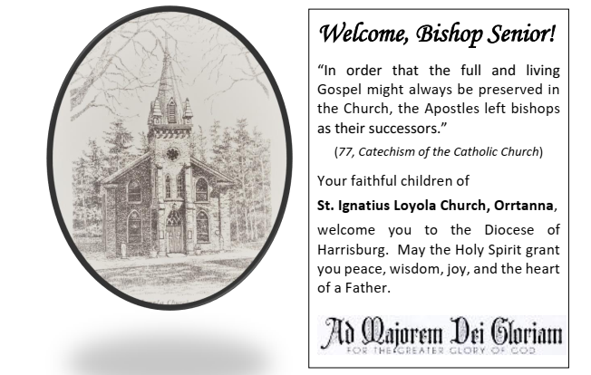

Installation Mass of His Excellency the Most Reverend Timothy Christian Senior

as the

Twelfth Bishop of Harrisburg

Wednesday, June 21, 2PM,

at the Cathedral Parish of St. Patrick
212 State Street, Harrisburg

The Installation Mass for the Most Reverend Timothy Christian Senior is by invitation only, due to limited seating in the Cathedral. The Mass will be live streamed on the Diocesan YouTube channel, www.YouTube.com/hbgdiocese,
so all can participate in this joyous event. Please check the Diocesan website for information on additional broadcasting and live streaming platforms that will carry the Mass.

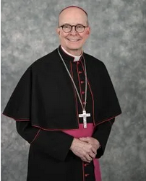

Most Rev. Ronald W. Gainer, Bishop Emeritus & Apostolic Administrator
Rev. Dominic M. DiBiccaro, Pastor / Deacon Steve Huete, Pastoral Associate
Mass Schedule, Intentions, and Events
Please Pray for:
Those who are ill, Jeanie Kline & the Kline Family, Terry Ahn, K. Grance, Lori McFadden & Family, Mike & Lisa Poole, Mervin Weikert, Chastity Rudisill, Mary Ellen Wilson, Terry & Bernie Cabana, Ed & Aggie Sherensky and Family, Bob Raffensberger, Jerry & Ginny Miller, Adeline Lienard, Kaylee Henry, Chuck & Nancy Wuller, Dr. Mike Colli, Mrs. Kelly Kump, Kevin & Brittany Groff, Gabriel Singer, Sharon McCormley, Ron Thumma, Joe Wisotzkey, Leo Hockensmith, Erika McKissick, Jean "Heather" O'Shea, Scott Moore and Sally Moore, Mary Wyatt, Jim & Joyce Deardorff, Brandon & Michelle Gilbert, Amy Weatherup, Sophia Joy Ernst, Deacon Richard Wentzel, Deacon Frank Enderle, Kathleen Thompson, Deb & Kathy McLintock and Family, Rachel Wonders, Amy Edwards, Jean O’Connor, Art Lazar, Sr., Mark & Michelle Huete, Paul Angello, Jen Baldwin, Ursula Kaley, Deb Bennet, Fr. Bill Sullivan, Larry Endy, Mary Beth McCarthy, Laura Lee, Marwa Abdelrahman, Cathy Gates, Donna Singley, Jack Ryff, Tim McGinn, Jane Kump, Peggy Neiderer, Chris Kimple, Robert Riquet, Gene & Jo-Ann McDannell, Bob Doxzen, Kimberly Mears, Gabriella Angello, Mark & Kate Morrow, Mark Morris, Linda Fogleman, Paul Knight, George & Barbara Erstila, Jeff Carpenter, Lana & Nelson Harmon, Diane Slothour, Sue McDannell, Larry Schneider, Joe & Lisa Grasel, Ange Pena, Julie Barnhart, the Shaffer Family, Heather & Emma Dickerson, Brad Pabody, Paul Ward, Aiden Tyler Schneider, Dorothy Vega, Karrie McCall & daughter, George Shahid, Denise Navlyt, Drew Schneider & Family, Ida Bloomfield, Linda McDannell, Janie Singley, Mary Beth Greenstreet, Rick Benedict, Jan Patla, Kathe Fogleman, Sam Sheffler, Kate Hemmis, Bill & Mary Lou Graham, Joanna Hodges, John Varones, Joan O’Sullivan, Martha Klinger, Lisa Dionne Lauretti, Sue Orndorff, Jim Gleason, Sue Gustafson, Joe & Michelle Cleary, Kim Johnson, Helen Mills, Kathy Haber, Haley Detman, Joe Durovey, Bev Smith, Donald Sheppard, Linda Mumaugh, Alison Haring, Janet Hartman, Edward Johnson, Angela Galeone, Juliete Lang, Chris MacBeth, Harry Graham, Donald Howard, Armond Binni, Elizabeth Stansky, Pat Johnson, Chris Morris, Faud Doaney, Wilson & Rae Harman, Patrick Glass, Helen Lagasse, Nancy Kewisnek, Andy Graham, Bill & Maureen Collins, Rosemary McGilloway, Anji Eisenhart, Monica Manner, Denny Borbonus, Dr. Paul Scarlata, Mary Hawthorne, Ed Washington, Josh Kempinski, Nancy Baker Baltzey, Spencer Propts, Karlton Smith & Cheryl Sobun, James & Marylyn Sobun, Marlene Webster, Yvette Stoklosa, Andy Consiglio, Bill & Michelle Cloonan, Nelson Salem, Janet Shunnarah, George Shunnarah, Bill & Deb McClintock nursing home residents & shut-ins, the victims of war, violence, disease, disaster, & all private intentions.
Also in your prayers, please remember all
our men and women currently serving in
our Armed Forces:
Maj. Nathan Jeffcoat – US Marine Corps
Lt. Joseph Cleary – US Navy
Michael C. Kenney IV – US Coast Guard
Lt. Joshua Kimple – US Army
Lt. Sarah Fogleman, M.D. – US Navy

PRAYER CHAIN: Contact Lynne Mobley at 703-876-4901 or LMOBLEY509@gmail.com

for the Week of June 17 to June 25, 2023

SATURDAY, June 17–VIGIL MASS 11TH SUNDAY IN ORD.TIME

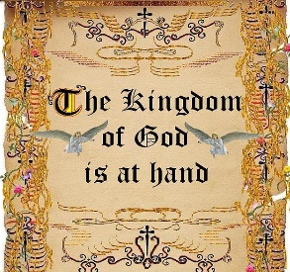
Ex 19:2-6a / Rom 5:6-11 / Mt 9:36—10:8
5:00PM + Bill Rollins

SUNDAY, June 18 – 11TH SUNDAY IN OT

Ex 19:2-6a / Rom 5:6-11 / Mt 9:36—10:8

8:00AM + Franklin, Berneda & David Walter
10:30AM ~ People of the Parish
Monday, June 19 – St. Romuald, Abbot
2 Cor 6:1-10 / Mt 5:38-42
Parish Office Closed

Tuesday, June 20 (Weekday in OT)
2 Cor 8:1-9 / Mt 5:43-48
Parish Office CLOSED
7PM + Rev. Chet Snyder

“Something More” Faith Group meets OFFSITE again this week!
Wednesday, June 21 – St. Aloysius Gonzaga, Religious
2 Cor 9:6-11 / Mt 6:1-6, 16-18

8:00AM - 3:00 PM ~ Office Open

10AM: Senior Spirituality Group
NO DAILY MASS
NO Confessions; NO Adoration

Thursday, June 22
St. Paulinus of Nola, Bishop;
St. John Fisher, Bishop, and St. Thomas More, Martyrs

2 Cor 11:1-11 / Mt 6:7-15

8AM - 3PM ~ Office Open

10:00AM - Private Intention

Friday, June 23 (Weekday in OT)  2 Cor 11:18, 21-30 / Mt 6:19-23 | THE LORD
8AM – 2PM Office OPEN (THIS WEEK ONLY)
10:00AM + Spec. Int. Mary Ellen Wilson
VIGIL MASS NATIVITY OF ST. JOHN THE BAPTIST
7:00PM - Spec. Int. for Bishop Emeritus Gainer & Bishop Senior

SATURDAY, June 24 - NATIVITY OF ST. JOHN THE BAPTIST

MORNING: Is 49:1-6 / Acts 13:22-26 / Lk 1:57-66, 80

SATURDAY, June 24–VIGIL MASS 12TH SUNDAY IN ORD.TIME

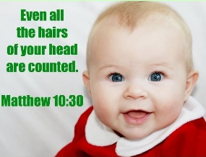
Jer 20:10-13 / Rom 5:12-15 / Mt 10:26-33
5:00PM + Patricia Sobun
SUNDAY, June 25 – 12TH SUNDAY IN OT

Jer 20:10-13 /Rom 5:12-15 / Mt 10:26-33

8:00AM + Carl Leinbach
10:30AM ~ People of the Parish
Sanctuary Candle offered for JUNE: In Loving Memory of Amy Weatherup from Doug & Terry Edwards
Sunday Collection Summary
June 10 and 11

Weekend Collection
Corpus Christi $ 3,024.00
Altar Flowers $ 15.00
Assumption $ 10.00
Candles $ 40.50
Local Poor $ 20.00
TOTAL OFFERINGS $ 3,109.50

‒WEEKLY BUDGETARY NEEDS $ 5,819.68
+Overage or (Shortfall) for the week ($ 2,710.18)

Diocesan Second Collections
Catholic Communications Campaign $ 120.00
Pentecost $ 50.00
TOTAL DIOCESAN OFFERINGS $ 170.00

Parish Council Meeting Summary
June 6, 2023

• After an opening prayer, the meeting was convened welcoming the 3 new elected members to the council; Bicky Redman, Phil Mobley and Dr. Bob Ternes. All members and Ex-officio members (one excused) were present. Minutes of the May 2, 2023, meeting was approved.

• Conducted an orientation for the new council members reviewing key elements of the council’s By-laws and Norms and Guidelines for Parish Pastoral Councils. Reviewed plans for council’s installation ceremony at the 8:00 AM Mass, June 11.

• Elected Phil Mobley as Council Chair and Bicky Redman as Vice-Chair, and Joanne Riedel agreed to continue as Secretary.

• Our PCCD Security Grant request was denied. All funding is being directed to schools and those facilities that have received actual threats. We will still move ahead with the camera/ security system installation on campus. The 25K cost will come from savings. Greg Ernst and Jim Bittle will continue providing oversight on this project. Plans are moving forward to repair/restore the church doors, repairs to the metal exterior doors in the Loyola building, repair the Crucifix in the graveyard, and the other items that were noted by our general liability insurance company’s Risk & Safety Report requiring attention. (The 13-page report identifies items such as safety railings in the church balcony and stairs.) All items are being addressed. Leaf gutter guards will also be installed on the church, rectory & Loyola building. The parking lot is going to be resealed and repainted on June 12/13.

• On May 29, Father was informed by Willet and Hauser via e-mail that the restoration of our three church windows was behind schedule and would not be installed till August. After several intense telephone conversations, the VP of Operations committed to have the restored windows completed and installed as originally scheduled.to be blessed by Bishop gainer on July 30. Father insisted that weekly status reports be provided which they agreed.

• Discussed the Six Areas of Mission and reorganizing the Parish Council functioning along those Missions and moving ahead to conduct a parish-wide meeting/spiritual workshop, the two unfinished Synodal initiatives from the Prior FY. More to come.

• Brief discussion on developing support for new mothers (gift package, diapers, etc.), and an initiative to reach out to non-active parishioners. Next meeting will be September 5, 2023, at 6:30 PM.

(A copy of the full minutes is available for review in the Parish Office.)

Kingdom of Priests: Scott Hahn Reflects

on the Eleventh Sunday of Ordinary Time

The words God speaks to Isra-el in today’s First Reading are intended for us as well.

The Church is the fulfillment of God’s covenant promises to Isra-el — a kingdom of priests and a holy nation (see Deuteronomy 26:19; Isaiah 62:12).

In the Church, we have been gathered as the new “Isra-el of God” (see Galatians 6:16). He has made us His own people, the flock He tends, as we sing in today’s Psalm.

Moses was Isra-el’s first shepherd (see Exodus 3:1). With the Promised Land in view, he prayed that God would raise up a successor so that God’s people would not be left as sheep without a shepherd (see Numbers 27:17).

These same words are used in today’s Gospel to describe Jesus’ pity for the crowds, who are “troubled and abandoned, like sheep without a shepherd.”

Isra-el’s shepherds — the Pharisees and scribes — had abandoned and misled the people through their hypocrisy and spiritual blindness (see Matthew 23:1–36; Jeremiah 50:6).

But God had long before promised that He Himself would come and save His sheep — searching over the whole earth where they had been scattered “for lack of a shepherd” (see Ezekiel 34:1–24).

Jesus is the new Moses and new David promised by the Prophets, a Divine Shepherd-King sent to restore God’s priestly kingdom (see John 10:11).

As Moses commissioned Joshua as his successor, so we see Jesus today giving the Twelve His powers and authority (see Matthew 9:35; 10:1). In God’s plan, they are to seek out the lost sheep of Isra-el first and then bring all nations into the fold (see Acts 13:46; Romans 1:16).

Together we have been saved and reconciled to God, as we hear in today’s Epistle. As He delivered Isra-el, He has also made us a kingdom of priests in the Church (see Revelation 1:6).

So we come in this Mass to serve Him with gladness, to praise His kindness, which endures forever!

Readings: Exodus 19:2–6; Psalm 100:1–2, 3, 5;
Romans 5:6–11; Matthew 9:36–10:8

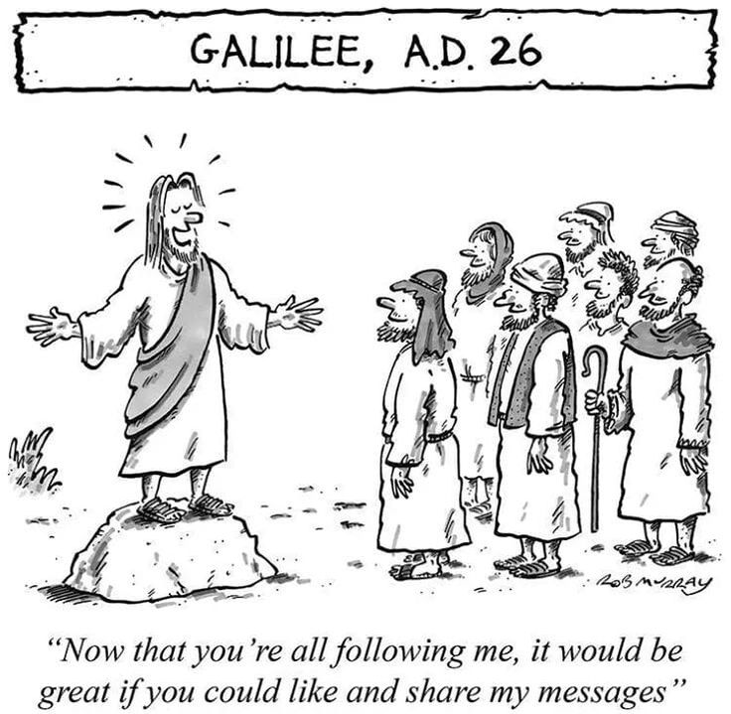

The Holy Father, Pope Francis’ Prayer Intentions for 2023
Entrusted to His Worldwide Prayer Network
JUNE ⁓ FOR THE ABOLISHMENT OF TORTURE

We pray that the international community may commit in a concrete way to ensuring the abolition of torture, and guarantee support to victims and their families.

Kingdom of Priests: Scott Hahn Reflects

on the Eleventh Sunday of Ordinary ATime

The words God speaks to Isra-el in today’s First Reading are intended for us as well.

The Church is the fulfillment of God’s covenant promises to Isra-el — a kingdom of priests and a holy nation (see Deuteronomy 26:19; Isaiah 62:12).

In the Church, we have been gathered as the new “Isra-el of God” (see Galatians 6:16). He has made us His own people, the flock He tends, as we sing in today’s Psalm.

Moses was Isra-el’s first shepherd (see Exodus 3:1). With the Promised Land in view, he prayed that God would raise up a successor so that God’s people would not be left as sheep without a shepherd (see Numbers 27:17).

These same words are used in today’s Gospel to describe Jesus’ pity for the crowds, who are “troubled and abandoned, like sheep without a shepherd.”

Isra-el’s shepherds — the Pharisees and scribes — had abandoned and misled the people through their hypocrisy and spiritual blindness (see Matthew 23:1–36; Jeremiah 50:6).

But God had long before promised that He Himself would come and save His sheep — searching over the whole earth where they had been scattered “for lack of a shepherd” (see Ezekiel 34:1–24).

Jesus is the new Moses and new David promised by the Prophets, a Divine Shepherd-King sent to restore God’s priestly kingdom (see John 10:11).

As Moses commissioned Joshua as his successor, so we see Jesus today giving the Twelve His powers and authority (see Matthew 9:35; 10:1). In God’s plan, they are to seek out the lost sheep of Isra-el first and then bring all nations into the fold (see Acts 13:46; Romans 1:16).

Together we have been saved and reconciled to God, as we hear in today’s Epistle. As He delivered Isra-el, He has also made us a kingdom of priests in the Church (see Revelation 1:6).

So we come in this Mass to serve Him with gladness, to praise His kindness, which endures forever!

Readings: Exodus 19:2–6; Psalm 100:1–2, 3, 5; Romans 5:6–11; Matthew 9:36–10:8

