Sacrament of Penance
Wednesday ~ 6:00 - 7:00 pm; or by appointment.

Sacrament of the Sick
Anointing of the Sick should be given if an individual is gravely ill or near death. If possible, the Sacrament should also be administered before major surgery or when one is initially hospitalized.

Sacrament of Holy Matrimony
Diocesan policy requires 12 months of preparation for Marriage. Contact the parish as soon as possible after engagement. No arrangements should be made prior to consultation with the pastor.

Sacrament of Baptism
Parents must be registered members of the parish and attend a Baptism preparation class prior to the Baptism if this is your first child baptized. Requirements for godparents are established by the Catholic Church. Please call the parish office for Information and to register your child for Baptism.

Parish Registration
All Catholics should be registered in their local parish. Please contact the parish office to obtain registration forms, or if you are uncertain of the parish where you should register.

Parish Staff & Ministries Directory
stignatiusofloyola@hbgdiocese.org
Financial Manager ~ Richard Deardorff ~ 717- 677-8012 or 717-420-3464 (cell)
rdeardorff@hbgdiocese.org
Director of Religious Education ~ Deacon Steve Huete ~ shuete@hbgdiocese.org
Administrative Assistant ~ Kristen DiDio ~ kdidio@hbgdiocese.org
Buildings & Grounds ~ JB Groff ~ 717-677-8012
Music Ministry ~ Phil Mobley ~ 717-677-8012
Parish Council Members
*Walt Wilson – Chair 401-0570 (h) wwilson1198@comcast.net
Joanne Riedel - Secretary 398-2021 (h) sterj221@aol.com
Kathi Allwein 677-8984 (h) allweint@comcast.net
*Donnie Althoff 339-6527 (c) dalthoff53@gmail.com
Charlie Baker 677-9536 (h) dcbake@embarqmqil.com
*Jim Bittle 677-6711 (h) ginnybittle@comcast.net
Mike McTighe 729-6239 (c) mike0432@aol.com

Finance Council Members
Richard Deardorff (Ex Officio)
Greg Ernst - Chair
Alix Haller
Christy Hemler - Secretary
Terri Pendlelton
Bill Pulig

Altar Flowers
Prayer Chain
Lynne Mobley at LMOBLEY509@gmail.com
or 703-876-4901.

Soup Kitchen
Please send donations directly to “Soup Kitchen”

Website Development
Kristen DiDio
Life After Loss
Dodie Huete

OCIA
Contact Fr. Dominic

Picnic Co-Chairpersons
John Neiderer
Wally Kane

Pro-Life Ministry
OPEN – Contact office if you are interested

Knights of Columbus
SK Bob Ternes
- Grand Knight

Covid-19 Task Force
Walt Wilson - Coordinator
Health Advisors:
Dr. Robert Ternes and
Joanne Cochran
(Keystone Health System)

OPEN - Contact office if you are interested

Bereavement Ministry
Ginny Bittle / Dodie Huete

Catholic Communications/EWTN
Open - Contact office if you are interested

Cemetery
Contact Parish Office
THEOSIS Ministry
Kathy Dietsch 717-352-4558
Bicky Redman 717-677-8592

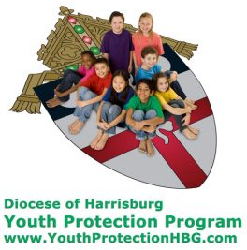
Diocese of Harrisburg Youth Protection Program
www.YouthProtectionHBG.com

Abuse Reporting Contact Information:
First – Call the toll-free PA Child Abuse Hotline at 800-932-0313
Then – Call the Diocesan toll-free hotline at 800-626-1608

“If one member suffers,
all suffer together with it.” (1 Cor 12:26)

St. Ignatius Loyola RC Church

1095 Church Road, Orrtanna, Pennsylvania 17353
www.stignatiusofloyola.org

April 9, 2023: EASTER SUNDAY of the RESURRECTION

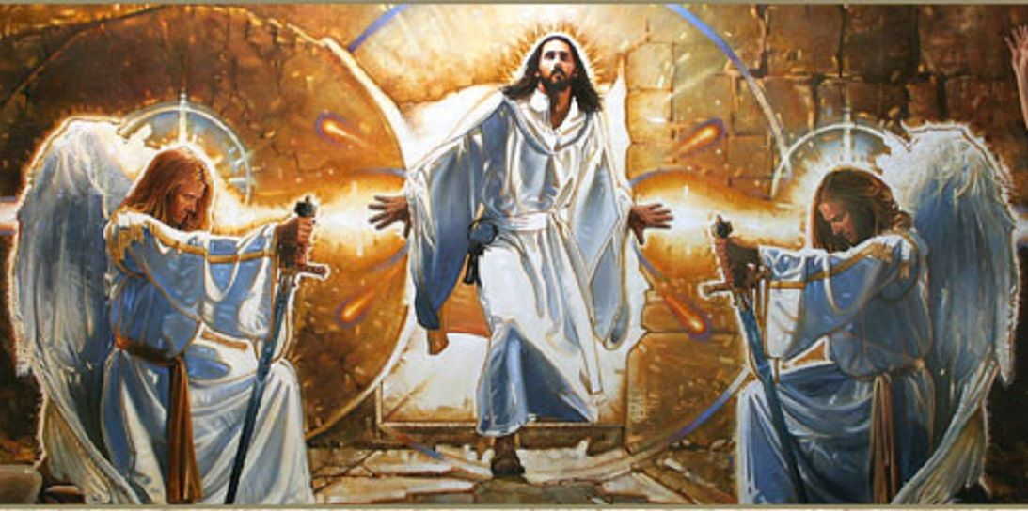

Most Reverend Ronald W. Gainer, Bishop of Harrisburg;
Rev. Dominic M. DiBiccaro, Pastor / Deacon Steve Huete, Pastoral Associate
Mass Schedule, Intentions, and Events
Please Pray for:
Coronavirus victims and those who are ill, Jeanie Kline, Adeline Lienard, Kaylee Henry, Chuck & Nancy Wuller, Dr. Mike Colli, Mrs. Kelly Kump, Kevin & Brittany Groff, Gabriel Singer, Sharon McCormley, Ron Thumma, Joe Wisotzkey, Leo Hockensmith, Erika McKissick, Jean "Heather" O'Shea, Scott Moore and Sally Moore, Mary Wyatt, Jim & Joyce Deardorff, Brandon & Michelle Gilbert, Amy Weatherup, Sophia Joy Ernst, Deacon Richard Wentzel, Deacon Frank Enderle, Kathleen Thompson, Deb & Kathy McLintock and Family, Rachel Wonders, Amy Edwards, Jean O’Connor, Art Lazar, Sr., Mark & Michelle Huete, Paul Angello, Jen Baldwin, Ursula Kaley, Deb Bennet, Fr. Bill Sullivan, Fr. Chet Snyder, John Larry Endy, Mary Beth McCarthy, Laura Lee, Marwa Abdelrahman, Cathy Gates, Donna Singley, Jack Ryff, Tim McGinn, Jane Kump, Gary, Bill, Jerry, Andy, Colleen, Baby Addie, Peggy Neiderer, Chris Kimple, Robert Riquet, Gene & Jo-Ann McDannell, Bob Doxzen, Kimberly Mears, Gabriella Angello, Mark & Kate Morrow, Mark Morris, Linda Fogleman, Paul Knight, George & Barbara Erstila, Jeff Carpenter, Lana & Nelson Harmon, Cole & Connor, Diane Slothour, Sue McDannell, Larry Schneider, Joe & Lisa Grasel, Ange Pena, Julie Barnhart, the Shaffer Family, Heather & Emma Dickerson, Brad Pabody, Paul Ward, Aiden Tyler Schneider, Dorothy Vega, Karrie McCall & daughter, George Shahid, Denise Navlyt, Drew Schneider & Family, Ida Bloomfield, Linda McDannell, Janie Singley, Mary Beth Greenstreet, Rick Benedict, Jan Patla, Kathe Fogleman, Sam Sheffler, Kate Hemmis, Bill & Mary Lou Graham, Joanna Hodges, John Varones, Joan O’Sullivan, Martha Klinger, Lisa Dionne Lauretti, Sue Orndorff, Jim Gleason, Sue Gustafson, Joe & Michelle Cleary, Kim Johnson, Helen Mills, Kathy Haber, Haley Detman, Joe Durovey, Bev Smith, Donald Sheppard, Linda Mumaugh, Alison Haring, Janet Hartman, Edward Johnson, Angela Galeone, Juliete Lang, Chris MacBeth, Harry Graham, Donald Howard, Armond Binni, Elizabeth Stansky, Pat Johnson, Chris Morris, Faud Doaney, Wilson & Rae Harman, Patrick Glass, Helen Lagasse, Nancy Kewisnek, Andy Graham, Bill & Maureen Collins, Rosemary McGilloway, Anji Eisenhart, Monica Manner, Denny Borbonus, Dr. Paul Scarlata, Mary Hawthorne, Ed Washington, Josh Kempinski, Nancy Baker Baltzey, Spencer Propts, Karlton Smith & Cheryl Sobun, James & Marylyn Sobun, Marlene Webster, Yvette Stoklosa, Andy Consiglio, Bill & Michelle Cloonan, Nelson Salem, Janet Shunnarah, George Shunnarah, Bill & Deb McClintock, Mary Pekich, nursing home residents & shut-ins, the victims of war, violence, disease, disaster, & all private intentions.
Also in your prayers, please remember all
our men and women currently serving in
our Armed Forces:
Maj. Nathan Jeffcoat – US Marine Corps
Lt. Joseph Cleary – US Navy
Michael C. Kenney IV – US Coast Guard
Lt. Joshua Kimple – US Army
Lt. Sarah Fogleman, M.D. – US Navy

PRAYER CHAIN: Contact Lynne Mobley at
703-876-4901 or LMOBLEY509@gmail.com

for the Week of April 8 to April 16, 2023

SATURDAY, April 8 – EASTER VIGIL IN THE HOLY NIGHT

Gn 1:1—2:2 / Ex 14:15—15:1 / Is 55:1-11 / / Rom 6:3-11 / Mt 28:1-10
8:00PM + Anna and Anthony Gatto

SUNDAY, April 9 – THE RESURRECTION OF THE LORD

Acts 10:34a, 37-43 / Col 3:1-4 or 1 Cor 5:6b-8 / Jn 20:1-9

8:00AM + Jim and Delores Gilbert
10:30AM ~ People of the Parish

Monday in the Octave of EASTER, April 10

Acts 2:14, 22-33 / Mt 28:8-15
Parish Office Closed

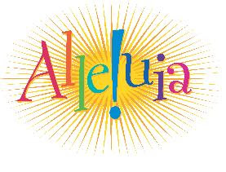
Tuesday in the Octave of EASTER, April 11
Acts 2:36-41 / Jn 20:11-18
8:00AM - 3:00 PM~Office Open
10:00AM + Mickie Schneider

NO “Something More” Faith Group

Wednesday in the Octave of EASTER, April 12
Acts 3:1-10 / Lk 24:13-35

8:00AM - 3:00 PM ~ Office Open

NO Senior Spirituality Group

7:00PM + Jim Kline and a Special intention for Jeanie Kline
Confessions heard 6-6:45PM; Adoration 7:40PM
Thursday in the Octave of EASTER, April 13
Acts 3:11-26 / Lk 24:35-48
8:00AM - 3:00 PM ~ Office Open
10:00AM + Jim Lauritsen
Friday in the Octave of EASTER, April 14 | PASSION OF THE LORD
Acts 4:1-12 / Jn 21:1-14
Parish Office Closed
10:00AM + Sr. Mary Michelle Shuda, CSSF & + Rev, Paul Shuda

Saturday in the Octave of EASTER, April 15

MORNING: Acts 4:13-21 / Mk 16:9-15

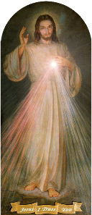
SATURDAY, April 15 – VIGIL FOR DIVINE MERCY SUNDAY

Acts 2:42-47 / 1 Pt 1:3-9 / Jn 20:19-31
8:00PM - Special Intention for the Kline Family

SUNDAY, April 16 - SUNDAY OF DIVINE MERCY

Acts 2:42-47 / 1 Pt 1:3-9 / Jn 20:19-31

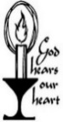
8:00AM ~ People of the Parish
10:30AM + Jim and Delores Gilbert
3:00PM: Exposition, Chaplet of Divine Mercy, Confessions
A PLENARY INDULGENCE may be obtained on this day with Eucharist, Confession, Chaplet & Prayers for the Holy Father

Sanctuary Candle offered for APRIL: In Loving Memory of Jim & Delores Gilbert from their loving Children

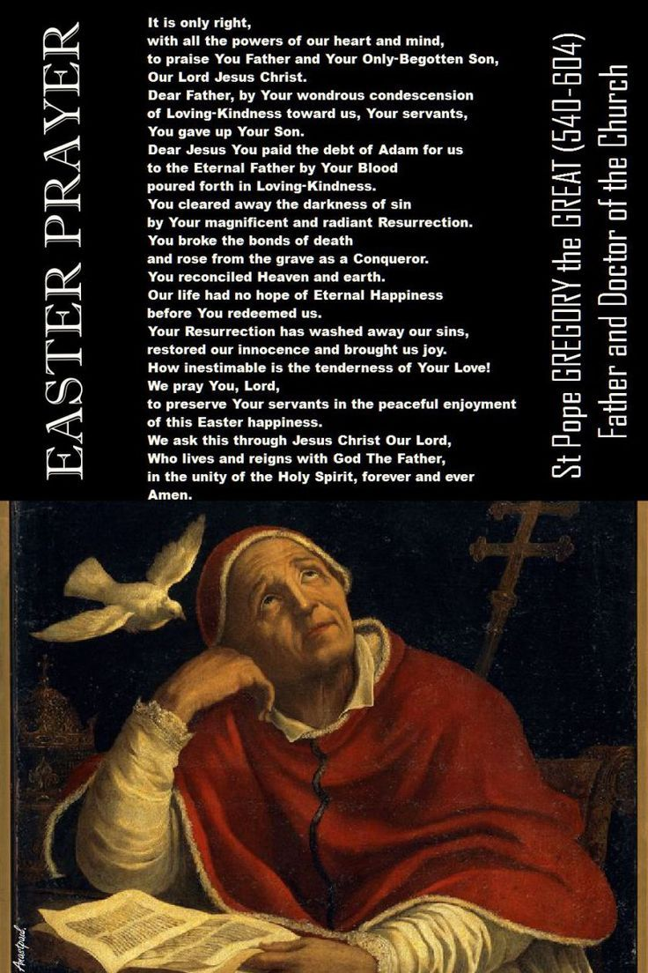

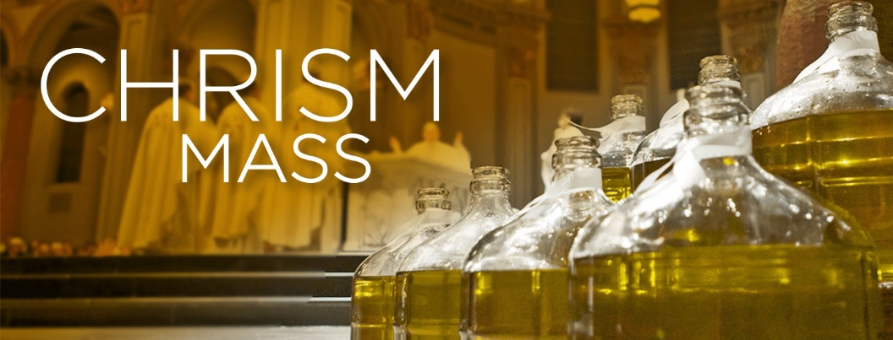

RENEWAL OF COMMITMENT TO PRIESTLY SERVICE
AT THE CHRISM MASS OF HOLY WEEK
The Bishop addresses the priests with questions that call on them to renew their commitment to priestly service.
(Priests stand)
Bishop Gainer: Beloved sons, on the anniversary of that day when Christ our LORD conferred His
Priesthood on His Apostles and on us, are you resolved to renew in the presence of your Bishop
and God’s Holy People, the promises you once made?
Priests of the Diocese: I am.
Bishop Gainer: Are you resolved to be more united with the LORD Jesus and more closely conformed to
Him, denying yourselves and confirming those promises about sacred duties towards Christ’s
Church which, prompted by love of Him, you willingly and joyfully pledged on the day of your
priestly ordination?
Priests of the Diocese: I am.
Bishop Gainer: Are you resolved to be faithful stewards of the Mysteries of God in the Holy Eucharist
and the other liturgical rites and to discharge faithfully the sacred office of teaching, following
Christ the Head and Shepherd, not seeking any gain, but moved only by zeal for souls?
Priests of the Diocese: I am.
Then the Bishop addresses the people:
(All rise)
As for you, dearest sons and daughters, pray for your Priests, that the LORD may pour out His
gifts abundantly upon them, and keep them faithful as ministers of Christ, the High Priest, so that
they may lead you to Him, who is the Source of Salvation.
People of the Diocese: Christ hear us. Christ, graciously hear us.
Bishop Gainer: And pray also for me, that I may be faithful to the Apostolic Office entrusted to me in my
lowliness and that in your midst, I may be made, day by day, a living and more perfect image of
Christ, the Priest, the Good Shepherd, the Teacher, and the Servant of all.
People of the Diocese: Christ, hear us. Christ, graciously hear us.
Bishop Gainer: May the LORD keep us all in His Charity and lead all of us, shepherds and flock, to Eternal
Life.
All: Amen.
The Holy Father, Pope Francis’ Prayer Intentions for 2023
Entrusted to His Worldwide Prayer Network

APRIL ⁓ For a culture of peace and non-violence
We pray for the spread of peace and non-violence, by decreasing the use of weapons by States and citizens.
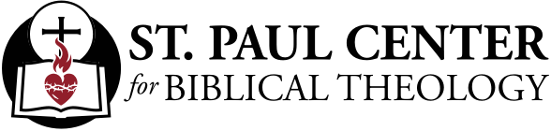

They Saw and Believed!: Scott Hahn Reflects

on Easter Sunday

Jesus is nowhere visible. Yet, today’s Gospel tells us that Peter and John “saw and believed.”

What did they see? Burial shrouds lying on the floor of an Empty Tomb. Maybe that convinced them that He hadn’t been carted off by grave robbers, who usually stole the expensive burial linens and left the corpses behind.

But notice the repetition of the word “tomb” — seven times in nine verses. They saw the Empty Tomb and they believed what He had promised: that God would raise Him on the third day.

Chosen to be His “witnesses,” today’s First Reading tells us, the Apostles were “commissioned . . . to preach . . . and testify” to all that they had seen — from His Anointing with the Holy Spirit at the Jordan to the Empty Tomb.

More than their own experience, they were instructed in the Mysteries of the Divine Economy, God’s Saving Plan: to know how “all the Prophets bear witness” to Him (see Luke 24:27, 44).

Now they could “understand the Scripture” and teach us what He had told them: that He was “the Stone which the builders rejected,” the one whom today’s Psalm prophesies will be resurrected and exalted (see Luke 20:17; Matthew 21:42; Acts 4:11).

We are the children of the apostolic witnesses. That is why we still gather early in the morning on the first day of every week to celebrate this feast of the Empty Tomb, to give thanks for “Christ our life,” as today’s Epistle calls Him.

Baptized into His Death and Resurrection, we live the heavenly life of the Risen Christ, our lives “hidden with Christ in God.” We are now His witnesses, too. But we testify to things we cannot see but only believe; we seek in earthly things what is above.

We live in memory of the Apostles’ witness, like them eating and drinking with the Risen LORD at the Altar. And we wait in hope for what the Apostles told us would come — the Day when we too “will appear with Him in glory.”
Readings: Acts 10:34, 37–43; Psalm 118:1–2, 16–17, 22–23; Colossians 3:1–4; John 20:1–9

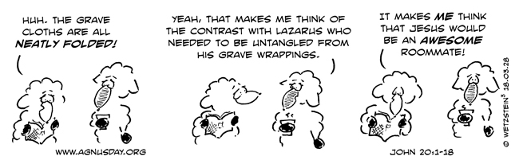

10 years as Pope: Pushing the Church to bring the Gospel to the world
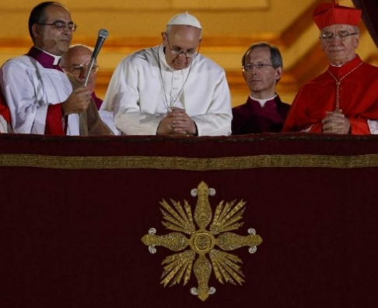
The Catholic Church will celebrate the 10th anniversary of Pope Francis'
election March 13. Here is an overview of some of what he has done in
those 10 years, and the opinion of several experts about what role the
Second Vatican Council, his experience as a Latin American pastor and
his vision of "synodality" have played and are playing in his papal ministry.

Cindy Wooden | March 7, 2023 | VATICAN CITY (CNS) -- For a decade, even when
discussing the internal workings of the Vatican, Pope Francis has insisted the Church is
not the Church of Christ if it does not reach out, sharing the "joy of the Gospel" and
placing the poor at the center of its attention.

Signals that his papacy would be different started the moment he stepped out on the balcony of St. Peter's Basilica the evening of March 13, 2013: He was not wearing a red, ermine-trimmed cape, and he bowed as he asked the crowd to pray that God would bless him.

His decision not to live in the Apostolic Palace, his invitations to Vatican trash collectors and gardeners and other employees to join him for his daily morning Mass, his insistence on going to the Italian island of Lampedusa to celebrate Mass and pray for migrants who had drowned in the Mediterranean captivated the attention of the media.

But not everyone was pleased with the seeming ease with which he set aside pomp and protocol. And tensions within the Catholic community grew as he expressed openness to LGBTQ Catholics and to those living in what the Church considers irregular marriage situations and when he said in an interview in 2013 that the Church cannot talk only about abortion, gay marriage and contraception.

One kind of summary of his first 10 years as pope can be found in numbers: He has made 40 trips abroad, visiting 60 countries; in eight consistories he created 95 cardinals under the age of 80 and eligible to vote in a conclave and paid tribute to 26 Churchmen over the age of 80; and he has presided over the canonizations of 911 new saints, including a group of more than 800 martyrs, but also Sts. John Paul II, John XXIII and Paul VI.

In his first major document, the apostolic exhortation "The Joy of the Gospel," he laid out a program for his papacy, looking inside the Church and outside at the world to see what needed to be done to "encourage and guide the whole Church in a new phase of evangelization, one marked by enthusiasm and vitality."

The document included a discussion of the need to reform Church institutions to highlight their missionary role; to encourage pastoral workers to listen to and stand with the people they were ministering to -- his famous line about having "the smell of the sheep"; to deepen an understanding of the Church as "the entire people of God" and not as an institution or, worse, a club of the elect; to integrate the poor into the Church and society, rather than simply see them as objects of assistance; and to promote peace and dialogue.

For Canadian Cardinal Michael Czerny, prefect of the Dicastery for Promoting Integral Human Development, the agenda of Pope Francis is the original agenda of the Second Vatican Council.

Unlike St. John Paul II and the late Pope Benedict XVI, Pope Francis did not attend any of the Council sessions. And, in fact, because he was ordained to the priesthood Dec. 13, 1969, he is the first pope to be ordained a priest after Vatican II.

"After Scripture and Tradition, the Council is the significant foundation, and I would say, characteristic orientation of this papacy," the cardinal told Catholic News Service. "He has taken the Council not from a collection of decrees, but from the lived experience of the Council as implemented, as lived, as tested, as developed, you might say, in the Church of Latin America."

St. John XXIII launched the Council with a pastoral focus on what it means to be the Church in the modern world, he said. The papacies of St. John Paul and Pope Benedict, he said, "reverted to a more doctrinal understanding of the Council" with "some very good results and with some massive, unfinished business."
While the work of Pope Francis' predecessors was important, he said, "I don't think it picked up the primary agenda (of the Council), which was implementing a new understanding of Church in the modern world, a new way of evangelizing because the world is so different from how it was, let's say, at the end of World War II."

Emilce Cuda, an Argentine theologian and secretary of the Pontifical Commission for Latin America, agreed that a key to understanding Pope Francis' pontificate is knowing how Vatican II was lived in Latin America with respect for popular piety and culture, and trust in the "sensus fidei," the notion that the baptized together have a "sense of faith" and an ability "to understand what God says to us, to his people, in every moment."

"There in the popular culture, in the peripheries, and in all the people of God, we can hear what God wants from us, or what God tells us to do in response to social problems and in the Church in each moment," she said. "We are in history and history is a movement, and the situation is not the same (as) in the 20th century or in the 21st century."

As for disagreements with or even controversies about the papacy of Pope Francis, Cardinal Czerny warned against confusing "loud with representative or loud with majority. Loud doesn't mean any of those things; it means loud."

But, he said, "the patience of Pope Francis" leads him and encourages others to recognize that the pope's critics "are not 100% off beam," or off track; there usually is a grain of truth in what they say or an important value they hold dear that is being overlooked.

Cardinal Joseph W. Tobin of Newark, New Jersey, told CNS he believes the first 10 years of Pope Francis' pontificate have been preparation for "what's happening right now, and that's the synodal conversation."

The Second Vatican Council called Catholics to read the "signs of the times" and respond. And, the cardinal said, "this notion that we don't have automatically prepared prescriptions for every challenge that faces us leads us to a fundamental tenet of our belief," which is belief "in the Holy Spirit, the LORD and giver of life."

The synod process, which began with listening to people around the globe and will move toward two assemblies mainly of bishops, is about listening to the Holy Spirit.

While the synod involves meetings, Cardinal Tobin said, "synodality is a way of being Church. It's an ancient way of being Church that is being recovered and lived in the circumstances in which we face ourselves today. And so, to my mind, that's sort of the capstone of what Pope Francis has been working for over the last decade."

"I've called synodality his long game," the cardinal said. "He's convinced that the changed circumstances of our world and our world going forward demand a new appreciation for the role of the Holy Spirit and a way to access that gift that is given to all of us by virtue of our baptism."

Pope Francis has been laying the foundation for the new synod process since the beginning of his pontificate, said Cardinal Blase J. Cupich of Chicago. "There's an organic whole to all of this."

"I just wonder if, from the very beginning, he had in his mind that this would be the trajectory of his pontificate, and the synod on synodality I think is, in some way, the opportunity for him to pull everything together," he said. "There are people who want him to go faster, but he wants things to be held together and the Church to be held together."

Asked what he thought was the most significant aspect of Pope Francis' pontificate, the cardinal cited his predecessor, the late Cardinal Francis E. George, who participated in the 2013 conclave, and said the best description of Pope Francis was "He's free."

"He's free in the sense of wanting to listen to different voices in the life of the Church," Cardinal Cupich said. "He's free in being imaginative, but also he has the kind of freedom that really allows him to be joyful in this ministry."

"John Paul II told us what we should do. Benedict told us why we should do it. And Francis is saying, 'Do it,'" the cardinal said. Pope Francis is leading by example in how he cares for the poor, sees God at work in people's real lives and reaches out to people often overlooked by the Church.

"I think history will look back on this pontificate as historic, as pivotal in the life of the Church," Cardinal Cupich said.

