Sacrament of the Sick
Anointing of the Sick should be given if an individual is gravely ill or near death. If possible, the Sacrament should also be administered for serious illness, before major surgery or when one is initially hospitalized.

Sacrament of Holy Matrimony
Diocesan policy requires 12 months of preparation for Marriage. Contact the parish as soon as possible after engagement. No venue reservations or other arrangements should be made prior to consultation with the pastor.

Sacrament of Penance
Wednesday ~ 6:00 – 6:45PM; or by appointment.

Sacrament of Baptism
Parents must be registered members of the parish and attend a Baptism preparation class prior to the Baptism if this is your first child baptized. Requirements for godparents are established by the Catholic Church. Please call the parish office for Information and to register your child for Baptism.

Parish Registration
All Catholics should be registered in their local parish. Please contact the parish office to obtain registration forms, or if you are uncertain of the parish where you should register.

Parish Staff & Ministries Directory
stignatiusofloyola@hbgdiocese.org
Financial Manager ~ Richard Deardorff ~ 717- 677-8012 or 717-420-3464 (cell)
rdeardorff@hbgdiocese.org
Director of Religious Education ~ Deacon Steve Huete ~ shuete@hbgdiocese.org
Administrative Assistant ~ Kristen DiDio ~ kdidio@hbgdiocese.org
Buildings & Grounds ~ JB Groff ~ 717-677-8012
Music Ministry ~ Phil Mobley ~ 717-677-8012
Parish Council Members
*Walt Wilson – Chair 401-0570 (h) wwilson1198@comcast.net
Joanne Riedel - Secretary 398-2021 (h) sterj221@aol.com
Kathi Allwein 677-8984 (h) allweint@comcast.net
*Donnie Althoff 339-6527 (c) dalthoff53@gmail.com
Charlie Baker 677-9536 (h) dcbake@embarqmqil.com
*Jim Bittle 677-6711 (h) ginnybittle@comcast.net
Mike McTighe 729-6239 (c) mike0432@aol.com

Finance Council Members
Richard Deardorff (Ex Officio)
Greg Ernst - Chair
Alix Haller
Christy Hemler - Secretary
Terri Pendlelton
Bill Pulig

Altar Flowers
Prayer Chain
Lynne Mobley at LMOBLEY509@gmail.com
or 703-876-4901

Soup Kitchen
Please send donations directly to “Soup Kitchen”

Website Development
Kristen DiDio
Life After Loss
Dodie Huete

OCIA
Contact Fr. Dominic

Picnic Co-Chairpersons
John Neiderer
Wally Kane

Pro-Life Ministry
OPEN – Contact office if you are interested

Knights of Columbus
SK Bob Ternes
- Grand Knight

Judy Wilson / Janice Meligakes

Bereavement Ministry
Ginny Bittle / Dodie Huete

Catholic Communications/EWTN
Open - Contact office if you are interested

Cemetery
Contact Parish Office
THEOSIS Ministry
Kathy Dietsch 717-352-4558
Bicky Redman 717-677-8592

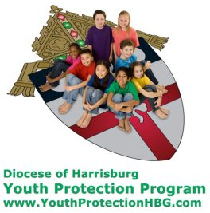
Diocese of Harrisburg Youth Protection Program
www.YouthProtectionHBG.com

Abuse Reporting Contact Information:
First – Call the toll-free PA Child Abuse Hotline at 800-932-0313
Then – Call the Diocesan toll-free hotline at 800-626-1608

“If one member suffers,
all suffer together with it.” (1 Cor 12:26)

St. Ignatius Loyola RC Church

1095 Church Road, Orrtanna, Pennsylvania 17353
www.stignatiusofloyola.org

JUNE 11, 2023: CORPUS CHRISTI SUNDAY

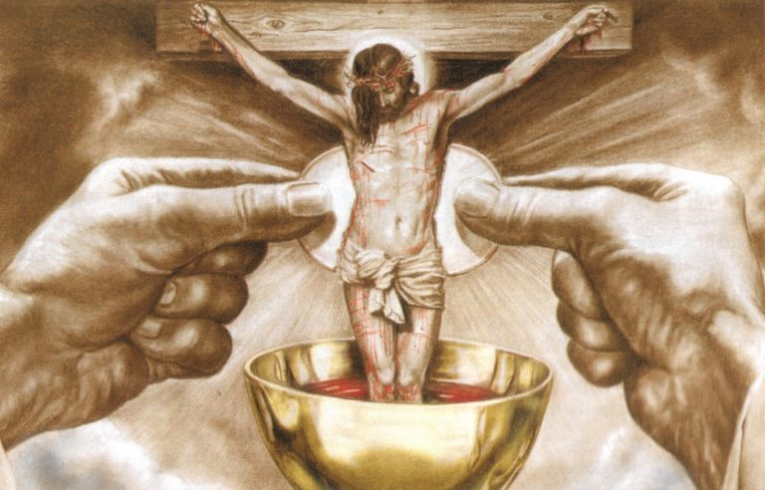

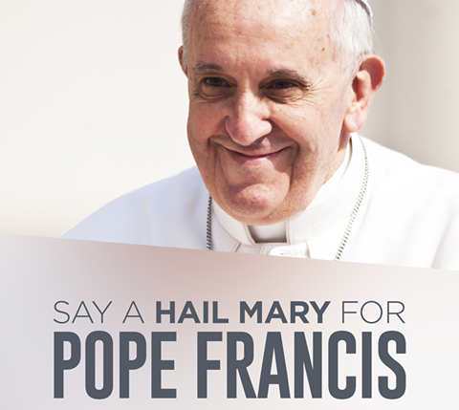
Let us JOYFULLY WELCOME our 3 New Priests ordained for the Diocese of Harrisburg by the Holy Spirit and the Imposition of Hands by
Bishop Emeritus Ronald Gainer on June 3, 2023:

• Reverend Richard A. Groff, assigned as Parochial Vicar, Sacred Heart
of Jesus Parish, Lewistown and Saint Jude Thaddeus Parish, Mifflintown.
• Reverend Kevin M. Key, assigned as Parochial Vicar, Saint Joan of Arc
Parish, Hershey and Chaplain, Bishop McDevitt High School, Harrisburg.
• Reverend Chiedozie F. Ononuju, assigned as Parochial Vicar, Saint
Patrick Parish, Carlisle and Chaplain, Dickinson College, Carlisle.

MAY GOD GRANT THEM MUCH GOOD FRUIT IN THEIR NEW MINISTIRIES !

Most Rev. Ronald W. Gainer, Bishop Emeritus & Apostolic Administrator
Rev. Dominic M. DiBiccaro, Pastor / Deacon Steve Huete, Pastoral Associate
Mass Schedule, Intentions, and Events
Please Pray for:
Those who are ill, Jeanie Kline & the Kline Family, Lori McFadden & Family, Mike & Lisa Poole, Mervin Weikert, Chastity Rudisill, Mary Ellen Wilson, Terry & Bernie Cabana, Ed & Aggie Sherensky and Family, Bob Raffensberger, Jerry & Ginny Miller, Adeline Lienard, Kaylee Henry, Chuck & Nancy Wuller, Dr. Mike Colli, Mrs. Kelly Kump, Kevin & Brittany Groff, Gabriel Singer, Sharon McCormley, Ron Thumma, Joe Wisotzkey, Leo Hockensmith, Erika McKissick, Jean "Heather" O'Shea, Scott Moore and Sally Moore, Mary Wyatt, Jim & Joyce Deardorff, Brandon & Michelle Gilbert, Amy Weatherup, Sophia Joy Ernst, Deacon Richard Wentzel, Deacon Frank Enderle, Kathleen Thompson, Deb & Kathy McLintock and Family, Rachel Wonders, Amy Edwards, Jean O’Connor, Art Lazar, Sr., Mark & Michelle Huete, Paul Angello, Jen Baldwin, Ursula Kaley, Deb Bennet, Fr. Bill Sullivan, Fr. Chet Snyder, John Larry Endy, Mary Beth McCarthy, Laura Lee, Marwa Abdelrahman, Cathy Gates, Donna Singley, Jack Ryff, Tim McGinn, Jane Kump, Gary, Bill, Jerry, Andy, Colleen, Baby Addie, Peggy Neiderer, Chris Kimple, Robert Riquet, Gene & Jo-Ann McDannell, Bob Doxzen, Kimberly Mears, Gabriella Angello, Mark & Kate Morrow, Mark Morris, Linda Fogleman, Paul Knight, George & Barbara Erstila, Jeff Carpenter, Lana & Nelson Harmon, Cole & Connor, Diane Slothour, Sue McDannell, Larry Schneider, Joe & Lisa Grasel, Ange Pena, Julie Barnhart, the Shaffer Family, Heather & Emma Dickerson, Brad Pabody, Paul Ward, Aiden Tyler Schneider, Dorothy Vega, Karrie McCall & daughter, George Shahid, Denise Navlyt, Drew Schneider & Family, Ida Bloomfield, Linda McDannell, Janie Singley, Mary Beth Greenstreet, Rick Benedict, Jan Patla, Kathe Fogleman, Sam Sheffler, Kate Hemmis, Bill & Mary Lou Graham, Joanna Hodges, John Varones, Joan O’Sullivan, Martha Klinger, Lisa Dionne Lauretti, Sue Orndorff, Jim Gleason, Sue Gustafson, Joe & Michelle Cleary, Kim Johnson, Helen Mills, Kathy Haber, Haley Detman, Joe Durovey, Bev Smith, Donald Sheppard, Linda Mumaugh, Alison Haring, Janet Hartman, Edward Johnson, Angela Galeone, Juliete Lang, Chris MacBeth, Harry Graham, Donald Howard, Armond Binni, Elizabeth Stansky, Pat Johnson, Chris Morris, Faud Doaney, Wilson & Rae Harman, Patrick Glass, Helen Lagasse, Nancy Kewisnek, Andy Graham, Bill & Maureen Collins, Rosemary McGilloway, Anji Eisenhart, Monica Manner, Denny Borbonus, Dr. Paul Scarlata, Mary Hawthorne, Ed Washington, Josh Kempinski, Nancy Baker Baltzey, Spencer Propts, Karlton Smith & Cheryl Sobun, James & Marylyn Sobun, Marlene Webster, Yvette Stoklosa, Andy Consiglio, Bill & Michelle Cloonan, Nelson Salem, Janet Shunnarah, George Shunnarah, Bill & Deb McClintock nursing home residents & shut-ins, the victims of war, violence, disease, disaster, & all private intentions.
Also in your prayers, please remember all
our men and women currently serving in
our Armed Forces:
Maj. Nathan Jeffcoat – US Marine Corps
Lt. Joseph Cleary – US Navy
Michael C. Kenney IV – US Coast Guard
Lt. Joshua Kimple – US Army
Lt. Sarah Fogleman, M.D. – US Navy

PRAYER CHAIN: Contact Lynne Mobley at 703-876-4901 or LMOBLEY509@gmail.com

for the Week of June 10 to June 18, 2023

SATURDAY, June 10– VIGIL MASS CORPUS CHRISTI SUNDAY

Dt 8:2-3, 14b-16a / 1 Cor 10:16-17 / Jn 6:51-58
5:00PM + Mary and John Wedland
SUNDAY, June 11 – SUNDAY OF THE HOLY
BODY & PRECIOUS BLOOD OF CHRIST

Dt 8:2-3, 14b-16a / 1 Cor 10:16-17 / Jn 6:51-58

8:00AM ~ People of the Parish
10:30AM + Salvatore Rendina

Monday, June 12 (Weekday in OT)
2 Cor 1:1-7 / Mt 5:1-12
Parish Office Closed

Tuesday, June 13 – St. Anthony of Padua, Priest &
2 Cor 1:18-22 / Mt 5:13-16 Doctor of the Church
Office CLOSED
7PM + Frances Shriver

“Something More” Faith Group meets OFFSITE this week!
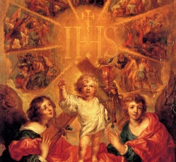
Wednesday, June 14 (Weekday in OT)
2 Cor 3:4-11 / Mt 5:17-19

8:00AM - 3:00 PM ~ Office Open

10AM: Senior Spirituality Group
7:00PM + Ray Deardorff
Confessions: 6 - 6:45PM; Adoration: 7:40 - 8PM

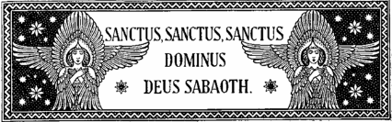
Thursday, June 15 (Weekday in OT)
2 Cor 3:15—4:1, 3-6 / Mt 5:20-26

8:00AM - 3:00 PM ~ Office Open

10:00AM + Mickie Schneider

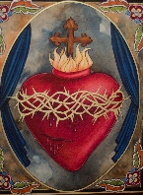
Friday, June 16 - THE MOST SACRED HEART OF JESUS  Dt 7:6-11 / 1 Jn 4:7-16 / Mt 11:25-30 | THE LORD
8:OOAM – 2:00PM Office OPEN (THIS WEEK ONLY)
10:00AM + Ruth Ann Robinson

SATURDAY, June 17 - The Immaculate Heart of the BVM

MORNING: 2 Cor 5:14-21 / Lk 2:41-51

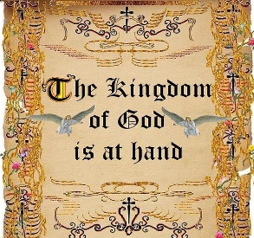
SATURDAY, June 17–VIGIL MASS 11TH SUNDAY IN ORD.TIME

Ex 19:2-6a / Rom 5:6-11 / Mt 9:36—10:8
5:00PM + Bill Rollins

SUNDAY, June 18 – 11TH SUNDAY IN OT

Ex 19:2-6a / Rom 5:6-11 / Mt 9:36—10:8

8:00AM + Franklin, Berneda & David Walter
10:30AM ~ People of the Parish
Sanctuary Candle offered for JUNE: In Loving Memory of Amy Weatherup from Doug & Terry Edwards

A Prayer for the Summer
Collection Summary for the Month of May 2023
Number of Collection Weeks in the Month 4

Weekend Collections
Sunday Offering (not including Pentecost*) $ 12,140.91
Alter Flowers $ 26.00
Candles $ 177.55
Easter (additional) $ 20.00
Local Poor $ 1,640.00
Ascension $ 1,242.35
TOTAL OFFERINGS $ 15,246.81

‒MONTHLY BUDGETARY NEEDS $ 23,278.68
+(Overage) or (Shortfall) for the month ($ 8,031.87)

Other Income
Individual Contributions $ 9,000.00
Stewardship Bookcase $ 103.00
Cemetery Lot $ 300.00
Paver Memorial Bricks $ 215.00
Total Other Income $ 9,618.00

Diocesan Second Collections
Catholic Communications $ 5.00
Catholic Home Missions $ 120.00
Pentecost (*Seminarians & Retired Priests) $ 3,449.00
TOTAL DIOCESAN OFFERINGS $ 3,574.00
---------------------------------------------------------------------
Sunday Collection Summary
June 3 and 4

Weekend Collection
Regular Offering $ 4,786.00
Altar Flowers $ 25.00
Ascension $ 20.00
Candles $ 80.00
Corpus Christi $ 310.00
Local Poor $ 100.00
TOTAL OFFERINGS $ 5,321.00

‒WEEKLY BUDGETARY NEEDS $ 5,819.68
+Overage or (Shortfall) for the week ($ 498.68)

Other Income
Cemetery Lot $ 2,785.72
Pavers $ 215.00
Total Other Offerings $ 3,000.72

Diocesan Second Collections
Catholic Communications Campaign $ 315.00
Pentecost $ 100.00
TOTAL DIOCESAN OFFERINGS $ 415.00

2023 RAFFLE TICKETS ARE HERE!
Please pick up a packet or two outside church
on the weekends. You may return any sold tickets and money in the collection basket.

As we are about to begin the Summer Season, let's
put ourselves into the Hands of the LORD, and
pray that God will bless us and our families during
the wonderful months of Summer.

LORD God, Creator of all things,
this Summer, help us to make our homes
a place of relaxation, joy, love, peace, and safety.

May we be generous and considerate,
not thinking only about ourselves,
but helping others to also enjoy
the blessings of summertime.

Guide our steps,
and strengthen our hearts,
protect us from the evil one,
and keep us and our loved ones free of all harm,
during these months of Summer travel and
vacation days.

Grant us refreshment of mind, body, and spirit,
so that we may continue to give glory
to Your Holy Name
in all that we think, say, and do!

We ask this through Christ our LORD.

Amen.

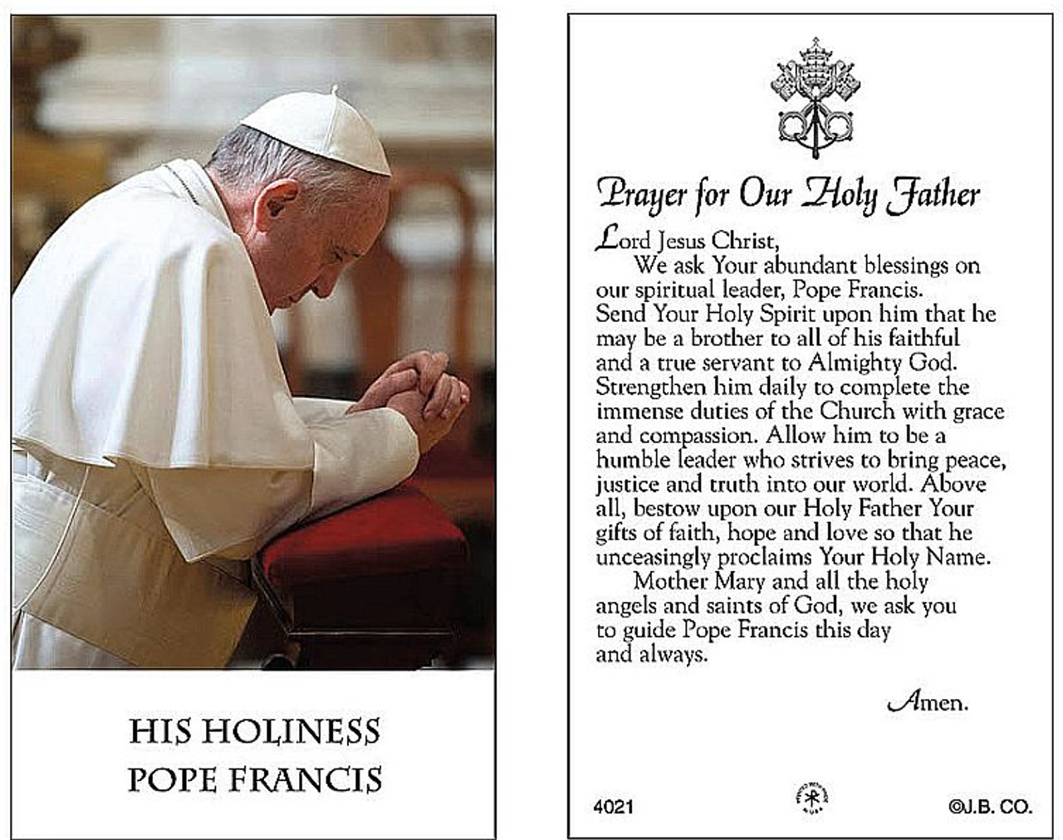

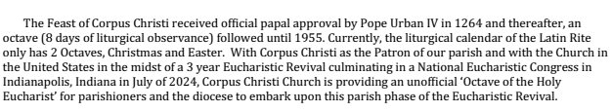

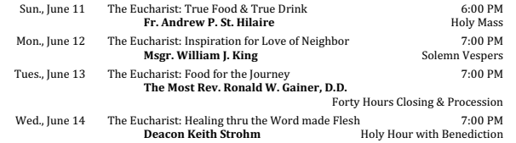

The Holy Father, Pope Francis’ Prayer Intentions for 2023
Entrusted to His Worldwide Prayer Network
JUNE ⁓ FOR THE ABOLISHMENT OF TORTURE

We pray that the international community may commit in a concrete way to ensuring the abolition of torture, and guarantee support to victims and their families.

Word of the “Living Father”: Scott Hahn Reflects

on the Sunday of the Most Holy Body and Blood of Christ (Corpus Christi)

The Eucharist is given to us as a challenge and a promise. That’s how Jesus presents it in today’s Gospel.

He doesn’t make it easy for those who hear Him. They are repulsed and offended at His words. Even when they begin to quarrel, He insists on describing the eating and drinking of His Flesh and Blood in starkly literal terms.

Four times in today’s reading, Jesus uses a Greek word — trogein — that refers to a crude kind of eating, almost a gnawing or chewing (see John 6:54, 56, 57, 58).

He is testing their faith in His Word, as today’s First Reading describes God testing Isra-el in the desert.

The heavenly manna was not given to satisfy the Isra-elites’ hunger, as Moses explains. It was given to show them that man does not live by bread alone but by every word that comes from the mouth of God.

In today’s Psalm, too, we see a connection between God’s Word and the Bread of Life. We sing of God filling us with “finest wheat” and proclaiming His Word to the world.

In Jesus, “the living Father” has given us His Word come down from Heaven, made flesh for the life of the world.

Yet, as the Isra-elites grumbled in the desert, many in today’s Gospel cannot accept that Word. Even many of Jesus’ own followers abandon Him after this discourse (see John 6:66). But His words are Spirit and life, the words of Eternal Life (see John 6:63, 67).

In the Eucharist we are made one flesh with Christ. We have His life in us and have our life because of Him. This is what St. Paul means in today’s Epistle when he calls the Eucharist a “participation” in Christ’s Body and Blood. We become in this Sacrament, partakers of the Divine Nature (see 1 Peter 2:4).

This is the mystery of the faith that Jesus asks us believe. ,And He gives us His promise: that, sharing in His Flesh and Blood that was raised from the dead, we too will be raised up on the Last Day!

Readings: Deuteronomy 8:2–3, 14–16; Psalm 147:12–15, 19–20; 1 Corinthians 10:16–17; John 6:51–58

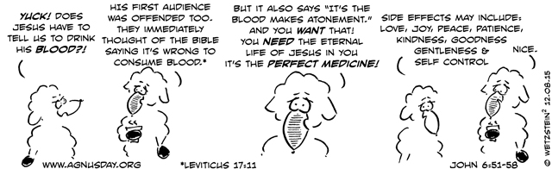

The Dark Side of the Rainbow

By Dr. Matthew Petrusek | June 8, 2023

The month of June is Pride Month. You may have noticed. For thirty days, corporations, universities, local businesses, community organizations, and government institutions take a break from their perennial praise of the LGBTQ+ movement to demonstrate (especially to those surveilling online) that they are really, really — really — committed to the cause. Although the symbol of Pride has struggled to keep up with the exponential growth of qualifying identities, celebrants communicate their fidelity in the form of rainbow-saturated company logos, sidewalk displays, oversize billboards, and even Pride-themed onesies, pick-up trucks, and ice-cream.

But what, precisely, is being celebrated? There are numerous bumper-sticker responses: “love is love,” “acceptance,” “being who you are,” and even, incongruously given the corresponding statistics, “joy.” But how does any of this relate to pride—pride in what exactly? Examining the assumptions and implications of the Pride movement leads to some unsettling conclusions.

Before digging deeper, it’s important to separate Pride ideology—a system of thought that seeks to advance specific cultural and political goals—from individuals who do not fit traditional sexual and gender categories. It’s likely you know someone, are related to someone, or maybe even a parent to someone who’s in this group. You likely love them very much and they may, indeed, be exceptionally lovable. You certainly don’t want to hurt them, and, in fact, that may be the reason you’ve hesitated to say anything about their professed identity.

Setting aside the scurrilous knee-jerk accusations of “hatred” and “phobia” that inevitably accompany any skepticism, or even, ironically, curiosity about the meaning of the Pride movement, the search for clarity should recognize that addressing the topic honestly may cause real, even if unintended, pain to good people. And so it goes without saying, to draw on Pope Benedict XVI’s encyclical, that truth must never be separated from charity.

But who I am to say anything about the “truth” of Pride? Though this question is usually taken as a blow in defense of the movement (Who are you to judge?), it, in fact, opens the first line of critique: What separates Pride from traditional hetero-centric morality? In other words, what makes Pride ideology true, or at least truer, than competing worldviews in such a way that its advocates are not merely imposing their values on society because they have the power to do so?

It’s important to keep in mind that there are only two possible responses to the question of moral truth: either (a) it doesn’t exist (thus all truth is relative), or (b) it does exist, meaning that there are moral principles that are universally, objectively true. Pride ideology often finds itself in the first category, moral relativism, under the declarations, “This is my truth” or “This is our truth.” Those may sound like objective truth claims on the surface; however, if there is no “the truth” lying beneath “my/our truth,” then there is no way to distinguish it from an expression of emotive preference. If this is the case, then the whole Pride movement would be based on an irrational (or at least a-rational) imposition of will on those who disagree with it—which, in turn, would render it analogous, in both method and substance, to how tyrants and bullies operate (“Obey and celebrate me because I say so”).

To escape this assessment, the Pride movement must make the case that they are advocating for something that everyone ought to believe not because they are saying it but because it is, in fact, true. In this case, those who disagree with Pride ideology would be wrong to do so because they would be holding false beliefs. What might those truth claims look like and what implications would they have? Let’s return to some of the bumper-stickers.

“Love is Love”

It’s not clear what this statement means, but it seems to imply at least two things: (1) All individuals’ internal sexual attractions should be considered equally morally valid (if not praiseworthy), no matter who or what the object of desire is (if the movement were only advocating for non-sexual relationships then it would not find opposition, certainly not from traditional morality); (2) All individuals ought to be able to act on those internal attractions whenever and however they desire, provided there is mutual consent and no subjectively defined “harm” occurs—indeed, such sexual expression is to be encouraged and feted.

Are these two statements about love true? That’s a complex question, but let’s assume that Pride ideology affirms them as such. If that’s the case, however, then, given the variety of human beings’ empirically observed (which is not to say natural) sexual proclivities and behaviors, these conclusions necessarily follow: (1) Pride ideology believes that we should celebrate individuals’ freedom to engage in hetero- and homosexual relationships with immediate biological family members; (2) Pride ideology believes that we should celebrate individuals’ freedom to express their desires to have sexual relationships with children (now rebranded as “Minor Attracted Persons”), even if they are not currently free to act on those desires legally; and (3) Pride ideology believes that we should celebrate individuals’ freedom to have sexual relationships with non-human animals, provided they don’t violate anti-cruelty laws. These are the implications of believing “love is love” is true, even if we don’t see them represented on parade floats yet.

“Be who you are”

Drawing on the meaning of “love is love,” this claim implies that individuals’ subjective feelings morally authorize them to (attempt to) appear on “the outside” what they experience themselves to be on “the inside.” This tenet of Pride lies at the heart of transgenderism and, in general, being “queer,” which includes a justification (and celebration) of surgically slicing off healthy breast and genital tissue and forcing women to compete against men in sporting events. However, if it’s true that individuals should be celebrated for making their outside look like their inside—and everyone else must accommodate their wishes—then Pride must also affirm that we praise trans-abled individuals for snipping their healthy spinal cords, trans-species individuals (also known as “Furries”) for demanding societal respect for non-ironically donning animal costumes in public, and even trans-age individuals for dictating that they be cared for like infants, including while in prison. (It is crucial to note that once age, like biological sex, becomes subjective, the moral prohibition against practicing pedophilia dissolves). All this, too, follows from the ideology’s internal logic.

“Acceptance”

Though this word sounds especially innocuous, Pride ideology transforms its meaning into “Shut up and don’t ask questions, bigot.” To “accept” is not to tolerate; it is to recognize as normal. “Acceptance” thus mainstreams the movement’s definitions of the nature of the human body, the purpose of human sexuality, and the rights of individuals to do as they please according to the dictates of Pride’s principles. At the same time, and consequently, it both stigmatizes what was once considered normal as “abnormal” and marks anyone who critically questions the new normal as a bigot (for only a bigot would be against “acceptance”). In other words, “acceptance” is both the shield and weapon of Pride: it protects the movement from scrutiny by tarring all objections, a priori, as prejudiced.

Holding tight to the distinction between ideologies and individuals, it’s important to highlight that there are some people who, though they fall outside traditional gender and sexual typologies for various reasons (though most likely not genetic ones), are resisting elements of the Pride movement. (One such group is called “Gays against Groomers.”) Yet Pride ideology still remains dominant in the US and most of the West, despite the fact that, according to its own assertions, it is either (a) a subjective, relativistic morality that imposes itself on the Pride-nonconforming by the brute force of its cultural and political power, or (b) a putatively universal morality that, based on the logic of its own principles, permits and encourages incest, bodily mutilation (including of children), pedophiliac attraction (if not practice), bestiality, and the silencing of dissent.

In short, a candid assessment of Pride reveals it to be either dictatorially arbitrary or fiendishly depraved. There is no amount of kaleidoscopic fanfare, corporate-sponsored enthusiasm, or coercively moralizing legislation that can wish this conclusion away. To embrace the Rainbow!™ necessarily entails embracing its shadow.

Pretending otherwise, fantasizing that we can dethrone heterosexuality and reality-based biology as natural and normative without letting the full panoply of Pandora’s Box of perversion out into the world, is, itself, to be bigoted — against reason and the evidence of our own eyes.

Matthew R. Petrusek, PhD is the Fr. Servais Pinckaers Fellow of Catholic Ethics at the Word on Fire Institute. He has authored/edited several books, including Evangelization and Ideology: How to Understand and Respond to the Political Culture (forthcoming); Jordan Peterson, God, and Christianity, The Search for a Meaningful Life; Ethics and Advocacy: Bridges and Boundaries; and Value and Vulnerability: An Interfaith Dialogue on Human Dignity. Petrusek lectures broadly in both English and Spanish on moral philosophy/theology, politics, social issues, and the Catholic intellectual tradition.

