Sacrament of the Sick
Anointing of the Sick should be given if an individual is gravely ill or near death. If possible, the Sacrament should also be administered for serious illness, before major surgery or when one is initially hospitalized.

Sacrament of Holy Matrimony
Diocesan policy requires 12 months of preparation for Marriage. Contact the parish as soon as possible after engagement. No venue reservations or other arrangements should be made prior to consultation with the pastor.

Sacrament of Penance
Wednesday ~ 6:00 – 6:45PM; or by appointment.

Sacrament of Baptism
Parents must be registered members of the parish and attend a Baptism preparation class prior to the Baptism if this is your first child baptized. Requirements for godparents are established by the Catholic Church. Please call the parish office for Information and to register your child for Baptism.

Parish Registration
All Catholics should be registered in their local parish. Please contact the parish office to obtain registration forms, or if you are uncertain of the parish where you should register.

Parish Staff & Ministries Directory
stignatiusofloyola@hbgdiocese.org | Office: 717-677-8012
Financial Manager ~ Richard Deardorff ~ 717- 677-8012 or 717-420-3464 (cell)
rdeardorff@hbgdiocese.org
Director of Religious Education ~ Deacon Steve Huete ~ shuete@hbgdiocese.org
Parish Secretary ~ Kristen DiDio ~ kdidio@hbgdiocese.org
Buildings & Grounds ~ Donnie Althoff ~ 717-677-8012
Music Ministry ~ Phil Mobley ~ 717-677-8012
Parish Council Members
Phil Mobley – Chair 571-236-7580 pmmobley@gmail.com
Bicky Redman – Vice Chair 677-8592 feetintheair7@gmail.com
Joanne Riedel - Secretary 398-2021 sterj221@aol.com
Kathi Allwein 677-8984 allweint@comcast.net
Charlie Baker 677-9536 dcbake@embarqmqil.com
Kathy Dietsch 352-4558 kdiet2@juno.com
Dr. BobTernes rjtmd46@gmail.com

Finance Council Members
Richard Deardorff (Ex Officio)
Greg Ernst - Chair
Christy Hemler - Secretary
Ali Morris
Terri Pendlelton
Bill Pulig

Altar Flowers
OCIA
Order of Christian Initiation for Adults
Contact Fr. Dominic

Soup Kitchen
Please send donations
directly to the
“Gettysburg Soup Kitchen”

Website Development
Kristen DiDio
Life After Loss
Dodie Huete

Prayer Chain
CONTACT THE PARISH OFFICE

Picnic Co-Chairs
Wally Kane
Mark Schur

Pro-Life Ministry
Jeanette Backus
Knights of Columbus
SK Bob Ternes
- Grand Knight
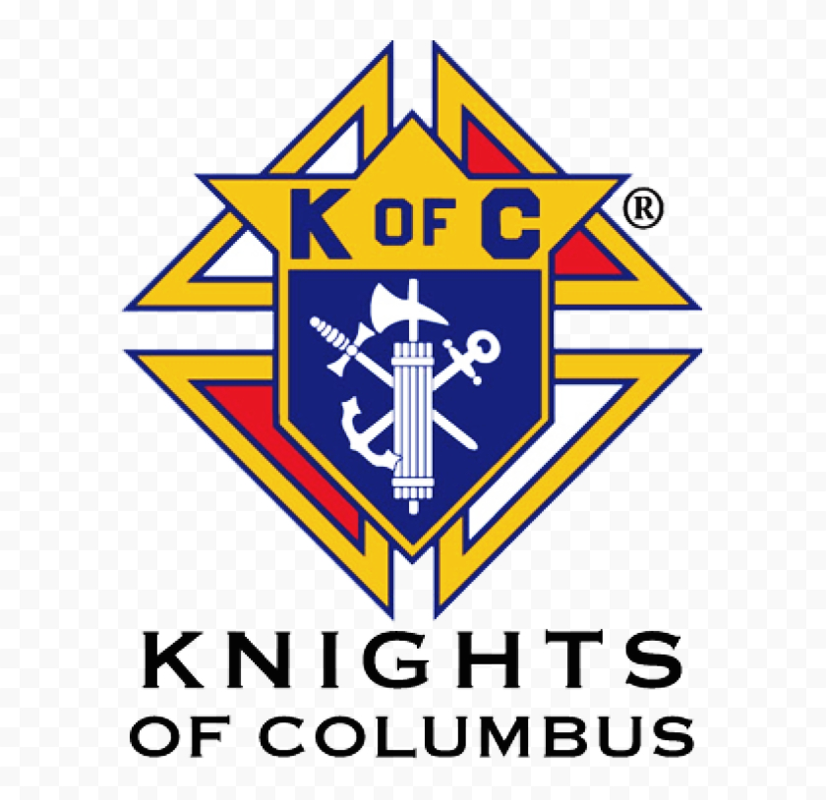

CONTACT THE PARISH OFFICE

Bereavement Ministry
Ginny Bittle / Dodie Huete

Catholic Communications/EWTN
Anna Kane

Cemetery
CONTACT THE PARISH OFFICE
THEOSIS Ministry
Kathy Dietsch 717-352-4558
Bicky Redman 717-677-8592

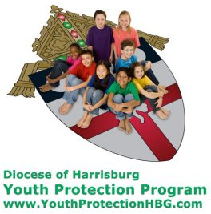
Diocese of Harrisburg Youth Protection Program
www.YouthProtectionHBG.com

Abuse Reporting Contact Information:
First – Call the toll-free PA Child Abuse Hotline at 800-932-0313
Then – Call the Diocesan toll-free hotline at 800-626-1608

“If one member suffers,
all suffer together with it.” (1 Cor 12:26)

St. Ignatius Loyola RC Church

St. Ignatius Loyola Roman Catholic Church
1095 Church Road, Orrtanna, Pennsylvania 17353
www.stignatiusofloyola.org | Office: 717-677-8012

March 17, 2024: FIFTH SUNDAY OF LENT

St. Patrick’s Day
Primary Patron Saint of
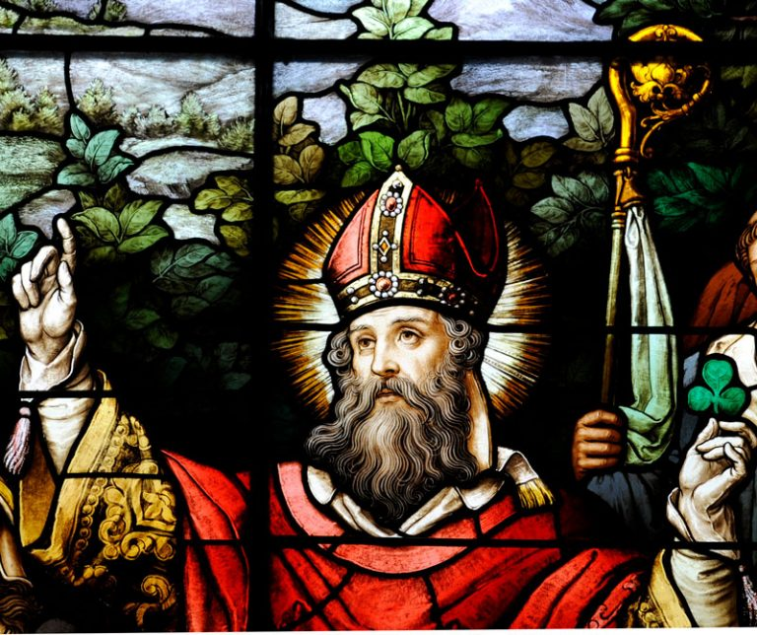

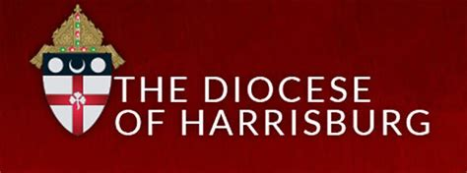

May the PENANCES we do this LENT
be offered to bring PEACE in the Holy Land!

Most Rev. Timothy C. Senior, Bishop of Harrisburg
Rev. Dominic M. DiBiccaro, Pastor
Deacon Steve Huete, Pastoral Associate

Mass Schedule, Intentions, and Events
Please Pray for these in need:
Jeanie Kline & the Kline Family, Dick & Deb Deardorff, Fred Dietsch, Terri Sanders, Greg Ernst, Jacob Long, Shell Edwards, Corona Naylor, Chris & Mary Rebscher, John Baker, Ginny Hoctor, Brenda Wolf, Sr. Thelma Steiger HSF, Sr. Miriam Ukeritis CSJ , Peter Hackney, Lucas Christiansen, Dale Kaplan, Jerry Smith, Dulcie Perry, Ron Formosa, Gavin Crumbacker, Anna Kane, Sherry Dennis & Family, Remi Peters, Terry Ahn, K. Grance, Lori McFadden & Family, Mike & Lisa Poole, Mervin Weikert, Chastity Rudisill, Mary Ellen Wilson, Terry & Bernie Cabana, Ed & Aggie Sherensky & Family, Bob Raffensberger, Jerry & Ginny Miller, Adeline Lienard, Kaylee Henry, Nancy Wuller, Dr. Mike Colli, Mrs. Kelly Kump, Gabriel Singer, Sharon McCormley, Ron Thumma, Joe Wisotzkey, Leo Hockensmith, Erika McKissick, Jean "Heather" O'Shea, Scott Moore & Sally Moore, Mary Wyatt, Amy Weatherup, Sophia Joy Ernst, Deacon Richard Wentzel, Deacon Frank Enderle, Carolyn Topper, Kathleen Thompson, Rachel Wonders, Amy Edwards, Jean O’Connor, Jen Baldwin, Ursula Kaley, Deb Bennet, Larry Endy, Laura Lee, Marwa Abdelrahman, Donna Singley, Tim McGinn, Jane Kump, Peggy Neiderer, Chris Kimple, Robert Riquet, Gene & Jo-Ann McDannell, Bob Doxzen, Kimberly Mears, Gabriella Angello, Paul Angello, Mark & Kate Morrow, Mark Morris, Linda Fogleman, Paul Knight, George & Barbara Erstila, Jeff Carpenter, Lana & Nelson Harmon, Diane Slothour, Sue McDannell, Larry Schneider, Joe & Lisa Grasel, Ange Pena, Julie Barnhart, Shaffer Family, Heather & Emma Dickerson, Brad Peabody, Paul Ward, Aiden Tyler Schneider, Dorothy Vega, Karrie McCall & daughter, George Shahid, Denise Navlyt, Drew Schneider & Family, Ida Bloomfield, Janie Singley, Mary Beth Greenstreet, Rick Benedict, Jan Patla, Kathey Fogleman, Sam Sheffler, Kate Hemmis, Bill & Mary Lou Graham, Andy Graham, Joanna Hodges, John Varones, Joan O’Sullivan, Martha Klinger, Lisa Dionne Lauretti, Jim Gleason, Sue Gustafson, Joe & Michelle Cleary, Kim Johnson, Helen Mills, Kathy Haber, Haley Detman, Joe Durovey, Bev Smith, Donald Sheppard, Linda Mumaugh, Alison Haring, Janet Hartman, Edward Johnson, Angela Galeone, Juliete Lang, Chris MacBeth, Harry Graham, Donald Howard, Armond Binni, Elizabeth Stansky, Pat Johnson, Chris Morris, Faud Doaney, Patrick Glass, Helen Lagasse, Nancy Kewisnek, Bill & Maureen Collins, Rosemary McGilloway, Anji Eisenhart, Monica Manner, Denny Borbonus, Dr. Paul Scarlata, Mary Hawthorne, Ed Washington, Josh Kempinski, Nancy Baltzey, Spencer Propts, Karlton Smith & Cheryl Sobun, James & Marylyn Sobun, Marlene Webster, Yvette Stoklosa, Andy Consiglio, Bill & Michelle Cloonan, Nelson Salem, Bill & Deb McClintock, nursing home residents & shut-ins, the victims of war, violence, disease, disaster, & all private intentions.
Also in your prayers, please remember all our men
& women currently serving in our Armed Forces:

Lt. Col. Nathan Jeffcoat – US Marine Corps
Lt. Joseph Cleary – US Navy
Michael C. Kenney IV – US Coast Guard
Lt. Joshua Kimple – US Army
Lt. Sarah Fogleman, M.D. – US Navy
A1C Ian Bellinger ‒ PA Air National Guard

PRAYER CHAIN: Contact the Office

for the Week of March 16 to March 24, 2024

SATURDAY, March 16 – Vigil 5th SUNDAY OF LENT

Jer 31:31-34/Heb 5:7-9/Jn 12:20-33
5:00PM + Everlyn Grace Topper,
+ Daniel Eugene Topper, and
+ Paul Topper
SUNDAY, March 17 – 5th SUNDAY OF LENT

Jer 31:31-34/Heb 5:7-9/Jn 12:20-33
8:00AM + Marie Trimmer
10:30AM ⁓ The People of the Parish
MONDAY, March 18 – St. Cyril of Jerusalem, Bishop
Dn 13:41c-62 / Jn 8:1-11 & Doctor of the Church
Parish Office CLOSED
Penance Service, 7PM at St. Mark’s in Green Castle

TUESDAY, March 19 –ST. JOSEPH, Spouse of the BVM
2 Sm 7:4-5a, 12-14a, 16/Rom 4:13, 16-18, 22/

8AM – 3PM ~ Office Open Lk 2:41-51a

10:00AM -Spec. Int. for Pope Francis: 11th Anniv. of Installation
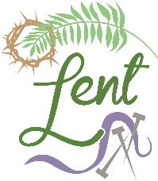
WEDNESDAY, March 20
Dn 3:14-20, 91-92, 95 / Jn 8:31-42

8AM – 3PM ~ Office Open
10:00AM + Joan & Eugene Schott
Penance Service, 7PM at Corpus Christi
NO Confessions; NO Adoration in Chambersburg
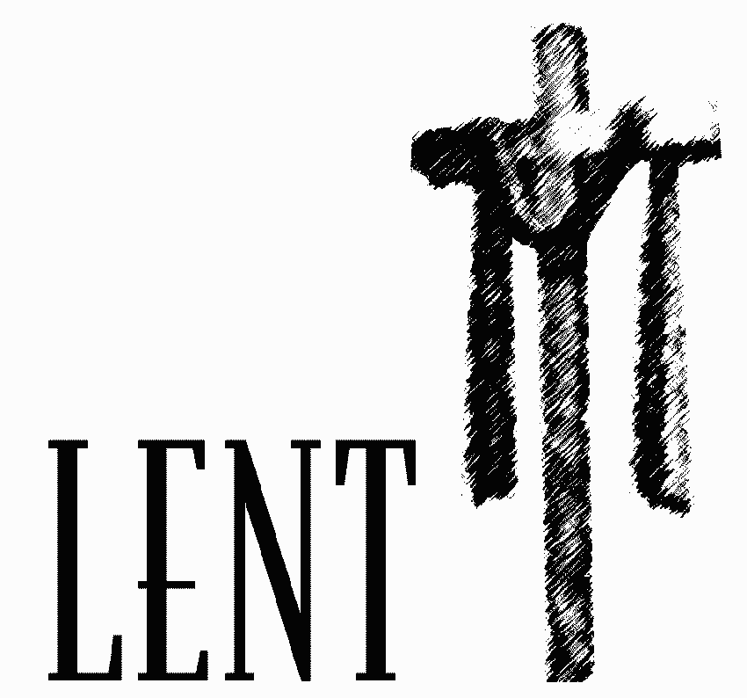
THURSDAY, March 21
Gn 17:3-9 / Jn 8:51-59

8AM – 3PM ~ Office Open
10:00AM ⁓ Special Intention for Caleb Keener
FRIDAY, March 22  Jer 20:10-13 / Jn 10:31-42  7:00  PM  10:00AM + Joanne Esham  Parish Office CLOSED  7:00PM Stations of the Cross | THE LORD

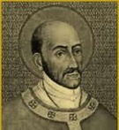
SATURDAY, March 23 – St. Turibius of Mogrovejo,
MORNING: Ez 37:21-28 / Jn 11:45-56 Bishop

SATURDAY, March 23 – VIGIL of PALM SUNDAY
Mk 11:1-10/Is 50:4-7/Phil 2:6-11/Mk 14:1—15:47
5:00PM + Jack Hoctor

SUNDAY, March 24 – PALM SUNDAY OF THE

Mk 11:1-10/Is 50:4-7/Phil 2:6-11/Mk 14:1—15:47 PASSION OF
8:00AM + Joseph Ziegler III THE LORD THE LORD
10:30AM ⁓ The People of the Parish
The Sanctuary Candle for MARCH is offered: In Loving Memory of Marilyn Cole from Kenneth Cole

Sunday Collection Summary for March 9 & 10

Weekend Collections
Regular Offering $ 3,655.00
Ash Wednesday $ 25.00
Easter $ 535.00
Holy Thursday $ 140.00
TOTAL OFFERINGS $ 4,355.00

- WEEKLY BUDGETARY NEEDS $ 4,494.00
+Overage or (Shortfall) for the week ($ 139.00)

Other Income
Altar Flowers $ 325.00
Candles/Living Faith $ 185.50
Burial Revenue $ 125.00
Local Poor $ 10.00
Total Other Offerings $ 645.50

Diocesan Second Collections
Catholic Relief Services $ 315.00
Holy Land (Good Friday) $ 215.00
Total Diocesan Offerings $ 530.00
----------------------------------------------------------------------------------------------

“Cabrini” is the story of St. Frances Xavier Cabrini and her advocacy for the equality, health and well being of Italian immigrants in the late 19th century. For tickets and showtimes, visit https://www.angel.com/tickets/cabrini.

“Having seen this film, I can say that it is inspiring and very well done. This Lenten season, I encourage all the faithful of the Diocese to experience the story of St. Frances Cabrini, the first American citizen to be canonized a saint.” ⁓ Bishop Timothy Senior

The “Hour” Comes: Scott Hahn Reflects

on the Fifth Sunday of Lent

Our readings today are filled with anticipation. The days are coming, Jeremiah prophesies in today’s First Reading. The hour has come, Jesus says in the Gospel. The New Covenant that God promised to Jeremiah is made in the “hour” of Jesus — in His Death, Resurrection, and Ascension to the Father’s Right Hand.
The Prophets said this New Covenant would return Isra-el’s exiled tribes from the ends of the world (see Jeremiah 31:1, 3–4, 7–8). Jesus too predicted His Passion would gather the dispersed children of God (see John 11:52). But today He promises to draw to Himself not only Isra-elites, but ALL men and women.
The New Covenant is more than a political or national restoration. As we sing in today’s Psalm, it is a universal spiritual restoration. In the “hour” of Jesus, sinners in every nation can return to the Father — to be washed of their guilt and given new hearts to love and serve Him.
In predicting He will be “lifted up,” Jesus isn’t describing only His coming Crucifixion (see John 3:14–15). Isaiah used the same word to tell how the Messiah, after suffering for Isra-el’s sins, would be raised high and greatly exalted (see Isaiah 52:3). Elsewhere the term describes how kings are elevated above their subjects (see 1 Maccabees 8:13).
Troubled in His Agony, Jesus doesn’t pray to be saved. Instead, as we hear in today’s Epistle, He offers himself to the Father on the Cross — as a living prayer and supplication. For this, God gives Him dominion over Heaven and earth (see Acts 2:33; Philippians 2:9).
Where He has gone we can follow — if we let Him lead us. To follow Jesus means a hating of our lives of sin and selfishness. It means trusting in the Father’s Will, the Law that He has written in our hearts. Jesus’ “hour” continues in the Eucharist, where we join our sacrifices to His, giving God our lives in reverence and obedience — confident He will raise us up to bear fruits of holiness.
Readings: Jeremiah 31:31–34;
Psalm 51:3–4, 12–13, 14–15; Hebrews 5:7–9;
John 12:20–33

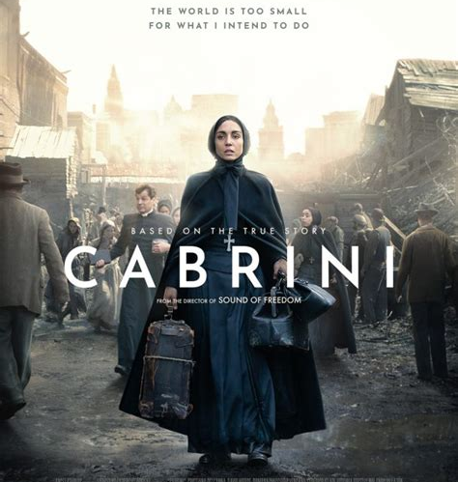

But embryonic testing and grading is not the only step in which embryos die, according to Meaney: “Some of them die in the thawing process” and “some of them fail to implant.”
Even after implantation, Meaney noted that women have a “higher miscarriage rate than average with IVF babies.” In the case of successful implantation — if there are more preborn children than the mother wants to give birth to, the least healthy ones in the womb are aborted through a process called “selective reduction,” he noted.
“At every stage in the process, there’s a mortality rate,” Meaney said.
Embryos that survive the testing, grading, and thawing process but are not chosen for implantation are normally discarded, which ends a human life. Some are donated for scientific research and suffer the same fate. Even if they are frozen, Meaney said they “are basically orphans there” and “they’re essentially abandoned in cold storage.”

Politicians treat IVF differently than abortion
Despite the exorbitant destruction of human life integral to the IVF process, the public and its elected officials treat the subject very differently than they do the deaths caused by abortion.
After the Alabama Supreme Court ruling, which forced some IVF clinics to suspend services, the court received backlash from Democrats and Republicans. In Alabama, the Republican-led legislature adopted a law to shield IVF clinics from civil or criminal liability, which self-identified pro-life Gov. Kay Ivey immediately signed. Ivey and other Republicans who supported the bill claimed that protecting IVF is pro-life.
Michael New, a professor of social research at The Catholic University of America and pro-life activist, told CNA that IVF is “a thorny issue for us politically.” He said that no one could get elected on banning IVF, but “if you can’t ban something … [at least] stop promoting it.”
“It’s wrong to create embryos without the intent of seeing to it they’re carried to term,” New said.
Moschella also recognized the uphill political battle. “It can be difficult to see the harms of IVF because the harms are inflicted on very tiny human beings,” he said, adding that anyone who respects the right to life should at least “prevent the creation of spare embryos beyond the number that is safe to implant.”
“Embryos created through IVF should receive the same protections as any human beings — mainly protection from assault [and] protection from intentional killing or destruction,” Moschella said.

Meaney echoed the same sentiment, saying a preborn life created through IVF is just as valuable as one conceived naturally: “No matter how it’s done … that individual is a member of our species [and] is a new human being.”
“Our human nature comes to us from our DNA,” and “the beginning of that process happens at conception — at fertilization,” he said.
The Catholic Church opposes IVF because it separates the marriage act from procreation and destroys embryonic human life. Acknowledging the advances in science available today to those seeking help having children, the U.S. Conference of Catholic Bishops warns Catholics on its website of the ethical issues involved.
“The many techniques now used to overcome infertility also have profound moral implications, and couples should be aware of these before making decisions about their use,” the guidance reads.

Social conservatives celebrate solid victory in Irish constitutional referendum
By Michael Kelly | Dublin, Ireland, Mar 12, 2024
“The best possible present ahead of Mother’s Day.”
That’s how pro-family campaigner David Quinn described the March 8 defeat of two referendums in Ireland that would have broadened the definition of the family and deleted the mention of mothers from Ireland’s 1937 constitution.
Like neighboring Britain, Ireland celebrates Mother’s Day on the fourth Sunday of Lent, which fell this year on March 10.
Despite opinion polls showing a clear majority favoring the Irish government’s plan to widen the definition of the family to include other “durable relationships” as well as marriage, when votes were counted March 9, 67.7% of citizens rejected the amendment, while just 32.3% supported it.
A second amendment proposed removing a provision from the constitution that said women should not be forced by economic necessity to take a job to the “neglect of their duties in the home.”
Again, polls showed it was likely to pass, but this proposal was rejected by an even wider margin, 73.9% to 26.1%. It is the highest-ever “no” vote in Irish referendum history.
Irish Prime Minister (known as the Taoiseach) Leo Varadkar quickly conceded that his government was defeated “comprehensively” when voters rejected the amendments that the country’s bishops warned would have weakened supports from marriage and undermined the institution of motherhood.
The bishops stopped short of a direct call for a “no” vote on either of the latest proposed amendments, but in a statement read at Masses the weekend before the vote, they said the family is the foundational cell of society and is essential to the common good because it is based on “the exclusive, lifelong, and life-giving public commitment of marriage.”
The prelates had warned that the second amendment would have had “the effect of abolishing all reference to motherhood in the constitution” and left “the particular and incalculable societal contribution” that mothers in the home have made, and continue to make, in Ireland unacknowledged.
The amendments had been supported by all political parties except the small Aontú (Unity) party, which has only one member in the national Parliament, known as the Oireachtas.
Maria Steen, a Catholic lawyer who campaigned against both proposals, described the result as “a great victory for common sense.”
She said it was also a “rejection of a government that seems more concerned with social media plaudits than actually getting on with the business of governing the country.”
Steen described the outcome as an “expression by the Irish people of gratitude and of love — gratitude to women for the work that they do in their homes that is often unseen and unsung.”
“Gratitude to mothers for the unique and irreplaceable role that they play in their children’s lives, and in the lives of their families, and a recognition of the special place that marriage has in our constitution and that they want to retain there,” she added, speaking to the National Catholic Register, CNA’s sister news partner, at the national ballot count center in Dublin Castle.
Speaking to reporters March 9, Varadkar said he was disappointed by the results. But, he acknowledged, “the people were asked questions, the debates happened, the arguments were heard.”
“The public comprehensively took the view they did not want to make changes to the constitution that we proposed. We accept that we respect that, and we take responsibilities for the results,” he said.
[continues over]

The referendums were held to coincide with International Women’s Day.

Quinn, who is the director of the pro-marriage think tank The Iona Institute, told the Register that “the government asked voters to remove the word ‘mother’ from the constitution and they answered with a resounding ‘no.’ They also rejected by a huge margin the attempt to foist the extremely nebulous term ‘durable relationships’ on the constitution.”

He insisted that “the government must now do more to allow mothers to stay at home with their children if that is their wish. This must include ending the current favoring of day care over home. Instead, the government should give the money allocated towards day care directly to mothers of young children so they can spend it either on day care or to make it easier to stay at home according to their wish.”

The weekend results were a welcome bit of good news for social conservatives who previously have been on the losing end of recent referendum campaigns.

Adopted in 1937, Ireland’s constitution has been subject to proposed amendment 40 times, with 20 of those proposed amendments occurring in its first 63 years and 20 more since the year 2000.

In 2015, Ireland became the first country in the world to legalize same-sex civil marriage by way of a popular vote, when the constitution was amended by 62% in favor to 37% opposing. In 2018, voters opted to remove the right to life of unborn children from the constitution, legalizing abortion by a margin of 68% to 33%.

Sen. Rónán Mullen — an independent member of Seanad Éireann, the upper house of the national Parliament — who campaigned against the amendments, said he was gratified by the result.

Asked by the Register if he felt the result could be the beginning of a revival of a conservative movement, he said: “You would hope so.”
However, he said in the current climate it was important for conservatives to build a wider alliance.

“In this referendum defeat there was an unusual new coalition between what would be termed people with a traditional outlook on social values and people with a broader social outlook,” Mullen said. “There are many people who find common ground in the need to challenge some of the dangerous new ideologies around gender, who don’t necessarily share the same point of view even on issues as important as abortion.”

“It would be a great thing if there was a new front in politics which was going to at least try to put a stop to some of the damage that the ‘woke’ agenda is doing within government,” he said.

There are some signs that even some members of the government itself share this sentiment.

Willie O’Dea, a senior member of the Fianna Fáil, the party that leads the current government, took to social media in the wake of the results to warn that his party needs to rethink direction and reject another controversial plan that campaigners warn will limit free speech.

“Fianna Fáil needs to get back to basics and abandon the Hate Speech Bill, etc. Focus on housing, health, and law and order and stop playing to the woke gallery,” he said. “Start listening to the people, stop talking down to them, and stop listening to the out-of-touch Greens and NGOs.”

Indeed, the influence of nongovernmental organizations has come into sharp focus following the result.

Minister of State Peter Burke admitted that the government will “have to assess how in touch with ordinary people the NGO sector is.” Ireland funds such organizations to the tune of 6.2 billion euros ($6.8 billion) a year, six times what it spends on defense, and they were the driving force behind the referendums.

Peadar Tóibin, the leader of the Aontú party that opposed the referendum, told the Register that “many NGOs are significantly dependent on the government for funding and many made decisions on the referendum that were completely at odds with the people they are meant to represent. This I believe fed into the groupthink and herd mentality, which is such a dangerous aspect of the political system in Ireland.”
“We need an audit into funding of NGOs in receipt of government funding,” Tóibin added. “Is this funding creating a government echo chamber? Why are some NGOs so out of touch with the people they claim to represent?”

More human embryos destroyed through IVF than abortion every year
By Tyler Arnold | Washington, D.C. Newsroom, Mar 13, 2024
An Alabama Supreme Court ruling that recognized the personhood of embryonic life sparked a nationwide debate about in vitro fertilization (IVF) over the last three weeks — but some people might be unaware that the industry’s death toll for preborn life is likely higher than that of abortion.
IVF is a fertility treatment in which doctors extract eggs from the woman and fertilize the eggs with sperm to create human embryos in a laboratory without a sexual act. IVF can cost the couple between $20,000 and $30,000 for a single treatment.
Because IVF treatments have a low success rate — about 50% for women under the age of 35 but significantly lower as women get older — clinics create far more human embryos than they intend to bring to term. Although this is meant to maximize the chance of the woman bearing one healthy child, it has also resulted in killing or indefinitely freezing millions of excess embryos.
IVF clinics do not report the exact number of embryos that are killed in their care, but clinics normally extract between 10 and 15 eggs for one treatment. According to the IVF clinic chain Illume Fertility, if the clinic extracts 12 eggs, about 80% — nine or 10 eggs — will be viable and about 80% of viable eggs will successfully fertilize to create embryos — making about seven or eight embryos per patient.
The CDC estimates that more than 238,000 patients attempted IVF in 2021. If clinics created between seven and eight embryos for every patient, that would yield about 1.6 million to 1.9 million over a year. Despite these high numbers, fewer than 100,000 embryos were brought to term, which suggests that somewhere between 1.5 million and 1.8 million embryos created through IVF were never born.
Alternatively, the abortion industry claimed about 985,000 lives from July 2022 through June 2023 — suggesting that the IVF industry could be ending nearly twice as many human lives every year.
Patients can freeze excess embryos for future use or adoption by other couples — but freezing the embryos can cost the couple thousands of additional dollars. Even when they are frozen, most end up abandoned. From 2004 to 2019, there were fewer than 8,500 live births from donated embryos. The United States has permitted IVF treatments since the early 1980s and estimates suggest there are between several hundred thousand and 1.5 million embryos currently frozen.
The substantial majority of embryos were either intentionally killed or died at some point in the IVF process.

Intentional and unintentional embryo deaths
When clinics determine which embryos get to live and which are assigned to death, the clinics perform tests to “screen out genetic diseases that the couple wants to ensure the embryo doesn’t have,” Melissa Moschella, a professor of medical ethics at The Catholic University of America, told CNA.
After those tests, the embryos are “graded in accordance with their quality,” she said. “Those that are deemed healthiest are the ones that are chosen for initial implantation.”
Joseph Meaney, the president of the National Catholic Bioethics Center, told CNA that when clinics detect “genetic anomalies or other health conditions,” those embryos are “immediately taken aside and killed.”
“Essentially what they’re trying to do is sell a product … [and] anything other than [a healthy baby] — they are eliminated [through] a quality control process,” Meaney said.
[continues over]

