Sacrament of the Sick
Anointing of the Sick should be given if an individual is gravely ill or near death. If possible, the Sacrament should also be administered for serious illness, before major surgery or when one is initially hospitalized.

Sacrament of Holy Matrimony
Diocesan policy requires 12 months of preparation for Marriage. Contact the parish as soon as possible after engagement. No venue reservations or other arrangements should be made prior to consultation with the pastor.

Sacrament of Penance
Wednesday ~ 6:00 – 6:45PM; or by appointment.

Sacrament of Baptism
Parents must be registered members of the parish and attend a Baptism preparation class prior to the Baptism if this is your first child baptized. Requirements for godparents are established by the Catholic Church. Please call the parish office for Information and to register your child for Baptism.

Parish Registration
All Catholics should be registered in their local parish. Please contact the parish office to obtain registration forms, or if you are uncertain of the parish where you should register.

Parish Staff & Ministries Directory
stignatiusofloyola@hbgdiocese.org
Financial Manager ~ Richard Deardorff ~ 717- 677-8012 or 717-420-3464 (cell)
rdeardorff@hbgdiocese.org
Director of Religious Education ~ Deacon Steve Huete ~ shuete@hbgdiocese.org
Parish Secretary ~ Kristen DiDio ~ kdidio@hbgdiocese.org
Buildings & Grounds ~ Donnie Althoff ~ 717-677-8012
Music Ministry ~ Phil Mobley ~ 717-677-8012
Parish Council Members
Phil Mobley – Chair 571-236-7580 pmmobley@gmail.com
Bicky Redman – Vice Chair 677-8592 feetintheair7@gmail.com
Joanne Riedel - Secretary 398-2021 sterj221@aol.com
Kathi Allwein 677-8984 allweint@comcast.net
Charlie Baker 677-9536 dcbake@embarqmqil.com
Mike McTighe 729-6239 mike0432@aol.com
Dr. BobTernes rjtmd46@gmail.com

Finance Council Members
Richard Deardorff (Ex Officio)
Greg Ernst - Chair
Alix Haller
Christy Hemler - Secretary
Terri Pendlelton
Bill Pulig

Altar Flowers
Prayer Chain
Lynne Mobley at LMOBLEY509@gmail.com
or 703-876-4901

Soup Kitchen
Please send donations directly to “Soup Kitchen”

Website Development
Kristen DiDio
Life After Loss
Dodie Huete

OCIA
Contact Fr. Dominic

Picnic Co-Chairpersons
John Neiderer
Wally Kane

Pro-Life Ministry
OPEN – Contact office if you are interested

Knights of Columbus
SK Bob Ternes
- Grand Knight

Judy Wilson / Janice Meligakes

Bereavement Ministry
Ginny Bittle / Dodie Huete

Catholic Communications/EWTN
Open - Contact office if you are interested

Cemetery
Contact Parish Office
THEOSIS Ministry
Kathy Dietsch 717-352-4558
Bicky Redman 717-677-8592

Diocese of Harrisburg Youth Protection Program
www.YouthProtectionHBG.com

Abuse Reporting Contact Information:
First – Call the toll-free PA Child Abuse Hotline at 800-932-0313
Then – Call the Diocesan toll-free hotline at 800-626-1608

“If one member suffers,
all suffer together with it.” (1 Cor 12:26)

St. Ignatius Loyola RC Church

1095 Church Road, Orrtanna, Pennsylvania 17353
www.stignatiusofloyola.org

JULY 9, 2023: 14th SUNDAY IN ORDINARY TIME

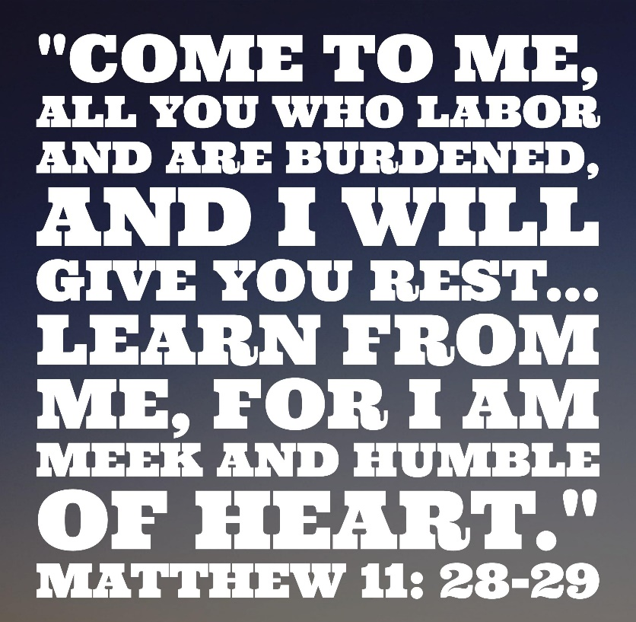

Most Rev. Timothy C. Senior, Bishop of Harrisburg
Rev. Dominic M. DiBiccaro, Pastor
Deacon Steve Huete, Pastoral Associate

Mass Schedule, Intentions, and Events
Please Pray for:
Those who are ill, Jeanie Kline & the Kline Family, Christy Hemler, Terry Ahn, K. Grance, Lori McFadden & Family, Mike & Lisa Poole, Mervin Weikert, Chastity Rudisill, Mary Ellen Wilson, Terry & Bernie Cabana, Ed & Aggie Sherensky and Family, Bob Raffensberger, Jerry & Ginny Miller, Adeline Lienard, Kaylee Henry, Nancy Wuller, Dr. Mike Colli, Mrs. Kelly Kump, Kevin & Brittany Groff, Gabriel Singer, Sharon McCormley, Ron Thumma, Joe Wisotzkey, Leo Hockensmith, Erika McKissick, Jean "Heather" O'Shea, Scott Moore and Sally Moore, Mary Wyatt, Jim & Joyce Deardorff, Brandon & Michelle Gilbert, Amy Weatherup, Sophia Joy Ernst, Deacon Richard Wentzel, Deacon Frank Enderle, Kathleen Thompson, Deb & Kathy McLintock and Family, Rachel Wonders, Amy Edwards, Jean O’Connor, Art Lazar, Sr., Paul Angello, Jen Baldwin, Ursula Kaley, Deb Bennet, Fr. Bill Sullivan, Larry Endy, Mary Beth McCarthy, Laura Lee, Marwa Abdelrahman, Cathy Gates, Donna Singley, Jack Ryff, Tim McGinn, Jane Kump, Peggy Neiderer, Chris Kimple, Robert Riquet, Gene & Jo-Ann McDannell, Bob Doxzen, Kimberly Mears, Gabriella Angello, Mark & Kate Morrow, Mark Morris, Linda Fogleman, Paul Knight, George & Barbara Erstila, Jeff Carpenter, Lana & Nelson Harmon, Diane Slothour, Sue McDannell, Larry Schneider, Joe & Lisa Grasel, Ange Pena, Julie Barnhart, the Shaffer Family, Heather & Emma Dickerson, Brad Pabody, Paul Ward, Aiden Tyler Schneider, Dorothy Vega, Karrie McCall & daughter, George Shahid, Denise Navlyt, Drew Schneider & Family, Ida Bloomfield, Linda McDannell, Janie Singley, Mary Beth Greenstreet, Rick Benedict, Jan Patla, Kathe Fogleman, Sam Sheffler, Kate Hemmis, Bill & Mary Lou Graham, Joanna Hodges, John Varones, Joan O’Sullivan, Martha Klinger, Lisa Dionne Lauretti, Sue Orndorff, Jim Gleason, Sue Gustafson, Joe & Michelle Cleary, Kim Johnson, Helen Mills, Kathy Haber, Haley Detman, Joe Durovey, Bev Smith, Donald Sheppard, Linda Mumaugh, Alison Haring, Janet Hartman, Edward Johnson, Angela Galeone, Juliete Lang, Chris MacBeth, Harry Graham, Donald Howard, Armond Binni, Elizabeth Stansky, Pat Johnson, Chris Morris, Faud Doaney, Wilson & Rae Harman, Patrick Glass, Helen Lagasse, Nancy Kewisnek, Andy Graham, Bill & Maureen Collins, Rosemary McGilloway, Anji Eisenhart, Monica Manner, Denny Borbonus, Dr. Paul Scarlata, Mary Hawthorne, Ed Washington, Josh Kempinski, Nancy Baker Baltzey, Spencer Propts, Karlton Smith & Cheryl Sobun, James & Marylyn Sobun, Marlene Webster, Yvette Stoklosa, Andy Consiglio, Bill & Michelle Cloonan, Nelson Salem, Janet Shunnarah, George Shunnarah, Bill & Deb McClintock nursing home residents & shut-ins, the victims of war, violence, disease, disaster, & all private intentions.
Also in your prayers, please remember all
our men and women currently serving in
our Armed Forces:
Maj. Nathan Jeffcoat – US Marine Corps
Lt. Joseph Cleary – US Navy
Michael C. Kenney IV – US Coast Guard
Lt. Joshua Kimple – US Army
Lt. Sarah Fogleman, M.D. – US Navy

PRAYER CHAIN: Contact Lynne Mobley at 703-876-4901 or LMOBLEY509@gmail.com

for the Week of July 8 to July 16, 2023

SATURDAY, July 8 –VIGIL MASS 14TH SUNDAY IN ORD.TIME

Zec 9:9-10 / Rom 8:9, 11-13 / Mt 11:25-30
5:00PM ⁓ People of the Parish

SUNDAY, July 9 – 14TH SUNDAY IN OT

Zec 9:9-10 / Rom 8:9, 11-13 / Mt 11:25-30
8:00AM + Margaret and Paul McDannel & Family
10:30AM-Spec. Int.-Ed & Aggie Sherensky’s 60th Wedding Anniv.

Monday, July 10 (Weekday in OT)
Gn 28:10-22a / Mt 9:18-26
Parish Office Closed

Tuesday, July 11 – St. Benedict, Abbot
Gn 32:23-33 / Mt 9:32-38

8:00AM - 3:00 PM ~ Office Open
10:00AM + William Bridy

“Something More” Group
Wednesday, July 12 (Weekday in OT)
Gn

8:00AM - 3:00 PM ~ Office Open
10AM: Senior Spirituality Group
7:00PM + Ruth Ann Robinson
Confessions heard 6 to 6:45PM; Adoration at 7:40PM
Thursday, July 13 - Saint Henry
Gn 44:18-21, 23b-29; 45:1-5 / Mt 10:7-15

8:00AM – 3:00PM ~ Office Open
10:00AM + Joan and Eugene Schott
Friday, July 14 – St. Kateri Tekakwitha  Gn 46:1-7, 28-30 / Mt 10:16-23  Parish Office CLOSED | THE LORD
10:00AM + Maria Diocelina Cuero-Caicedo

SATURDAY, July 15- St. Bonaventure, Bishop & Doctor of the

MORNING: Gn 49:29-32; 50:15-26a/Mt 10:24-33 Church

SATURDAY, July 15 –VIGIL MASS 15TH SUNDAY IN ORD.TIME

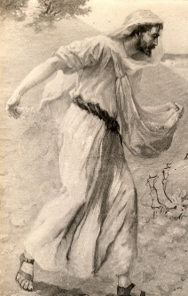
Is 55:10-11 / Rom 8:18-23 / Mt 13:1-23 or 13:1-9
5:00PM + Evelyn Grace Topper

SUNDAY, July 16 – 15TH SUNDAY IN OT

Is 55:10-11 / Rom 8:18-23 / Mt 13:1-23 or 13:1-9
8:00AM ⁓ People of the Parish
10:30AM + Salvatore Rendina, Jr.
Sanctuary Candle offered for JULY: In Loving Memory of Donald Redding from Edna Redding.
Sunday Collection Summary
July 1 and 2
Weekend Collections
Regular Offering $ 6,278.00
Candles $ 41.00
Parish Second Collection
Altar Flowers $ 795.67
TOTAL OFFERINGS $ 7,114.67

‒WEEKLY BUDGETARY NEEDS $ 4,494.00
+Overage or (Shortfall) for the week +$ 2,620.67

Other Income
Assumption (additional) $ 30.00
Local Poor $ 120.00
Parish Picnic $ 200.00
Picnic Raffle Tickets $ 890.00
Total Other Offerings $ 1,240.00

Collection Summary for the Month of JUNE 2023
Number of Collection Weeks in the Month: 4

Weekend Collections
Sunday Offering $ 14,136.11
Alter Flowers $ 60.00
Candles $ 275.65
Local Poor $ 260.00
Assumption $ 10.00
Corpus Christi $ 427.00
Ascension $ 40.00
TOTAL OFFERINGS $ 15,208.76

‒TOTAL BUDGETARY NEEDS $ 23,278.68
+(Overage) or (Shortfall) for the month ($ 8,069.92)

Other Income
Individual Contributions $ 5,000.00
Stewardship Bookcase $ 169.00
Cemetery Lot $ 2,785.72
Paver Memorial Bricks $ 355.00
Total Other Income $ 8,309.72

Diocesan Second Collections
Catholic Communications $ 1,096.00
Catholic Home Missions $ 170.00
TOTAL DIOCESAN OFFERINGS $ 1,266.00

Sunday Collection Summary
June 24 and 25

Weekend Collection
Regular Offering $ 2,829.11
Altar Flowers $ 5.00
Candles $ 102.65
Corpus Christi (additional) $ 50.00
Local Poor $ 100.00
TOTAL OFFERINGS $ 3,086.76

‒WEEKLY BUDGETARY NEEDS $ 5,819.68
+Overage or (Shortfall) for the week ($ 2,732.92)

Other Income
Paver Memorial Bricks $ 140.00
Total Other Offerings $ 140.00
_____________________________________________

DONATIONS ACCEPTED
JULY 9-23,
at the Office or
in the basket in the Narthex.

Coats will be purchased
in October at Boscov’s
and then donated to
the Interfaith Shelter in Harrisburg,
and to SCCAP in Gettysburg.

Be transformed by the Eucharist, Pope asks Catholics

The pope's prayer intention for July is "For a Eucharistic life," and he encouraged Catholics to be "transformed" by participating in the Eucharist.

Justin McLellan | July 5, 2023

VATICAN CITY (CNS) -- Catholics must place the Eucharist at the center of their lives to transform their relationships with God and their neighbors, Pope Francis said.

"If you are the same at the end of Mass as you were at the beginning, something is wrong," the pope said in a video message released July 3 for his prayer intention for the month of July: "For a Eucharistic life."

"The Eucharist is the presence of Jesus, it is deeply transforming. Jesus comes and must transform you," he said.

The video, different versions of which are released with the pope's monthly prayer intention, also showed people attending Mass, helping the homeless and visiting the elderly.

By offering himself in the Eucharist, Christ "invites us so that our lives may be nourished by him and may nourish the lives of our brothers and sisters," the pope said.

"The Eucharistic celebration is an encounter with the Risen Jesus," Pope Francis said. "At the same time, it is a way of opening ourselves to the world as he taught us."

Each time Catholics participate in the Eucharist, "Jesus comes and gives us the strength to love like he loved," the pope said, because the Eucharist "gives us the courage to encounter others, to go out of ourselves and to open ourselves to others with love."

Pope Francis prayed that Catholics may place at the center of their lives the Eucharistic celebration which " which transforms human relationships and opens up an encounter with God and their brothers and sisters."
The Holy Father, Pope Francis’ Prayer Intentions for 2023
Entrusted to His Worldwide Prayer Network
JULY ⁓ For a Eucharistic Life

We pray that Catholics may place the celebration of the Eucharist at the heart of their lives, transforming human relationships in a very deep way and opening to the encounter with God and all their brothers and sisters.

A Yoke for the Childlike: Scott Hahn Reflects

on the Fourteenth Sunday of Ordinary Time

Jesus is portrayed in today’s Gospel as a new and greater Moses.

Moses, the meekest man on earth (see Numbers 12:3), was God’s friend (see Exodus 34:12, 17). Only he knew God “face to face” (see Deuteronomy 34:10). And Moses gave Isra-el the yoke of the Law, through which God first revealed Himself and how we are to live (see Jeremiah 2:20; 5:5).

Jesus, too, is meek and humble. But He is more than God’s friend. He is the Son who alone knows the Father. He is more also than a law-giver, presenting Himself today as the yoke of a new Law and as the revealed Wisdom of God.

As Wisdom, Jesus was present before creation as the Firstborn of God, the Father and LORD of Heaven and earth (see Proverbs 8:22; Wisdom 9:9). And He gives knowledge of the holy things of the Kingdom of God (see Wisdom 10:10).

In the gracious Will of the Father, Jesus reveals these things only to the “childlike” — those who humble themselves before Him as little children (see Sirach 2:17). These alone can recognize and receive Jesus as the just Savior and meek king promised to daughter Zion, Isra-el, in today’s First Reading.

We, too, are called to childlike faith in the Father’s goodness as sons and daughters of the New Kingdom, the Church.

We are to live by the Spirit we received in Baptism (see Galatians 5:16), putting to death our old ways of thinking and acting, as Paul exhorts in today’s Epistle. Our “yoke” is to be His new law of love (see John 13:34), by which we enter into the “rest” of His Kingdom.

As we sing in today’s Psalm, we joyously await the day when we will praise His Name forever in the Kingdom that lasts for all ages. This is the sabbath rest promised by Jesus — the rest first anticipated by Moses (see Exodus 20:8-11), but which still awaits the People of God (see Hebrews 4:9).

Readings: Zechariah 9:9–10; Psalm 145:1–2, 8–11, 13–14; Romans 8:9, 11–13; Matthew 11:25–30

Vatican offers plenary indulgence for third annual Grandparents’ Day this month

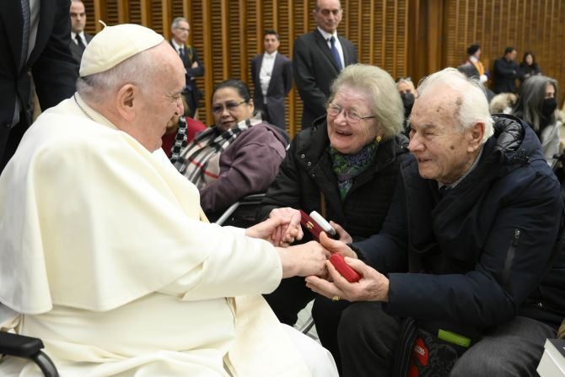
Pope Francis greets an elderly couple at his general audience on Jan. 11, 2023 | Vatican Media

By Hannah Brockhaus | Vatican City, Jul 5, 2023

The Vatican will again offer a plenary indulgence to mark the third World Day for Grandparents and the Elderly on July 23.

The indulgence can be received by grandparents, the elderly, and all Catholics who, “motivated by the true spirit of penance and charity,” participate in Pope Francis’ July 23 Mass in St. Peter’s Basilica or another Grandparents’ Day celebration, or who visit the elderly, the Vatican said.

Chosen by Pope Francis, the theme of Grandparents’ Day 2023 comes from a verse in the Gospel of Luke: “His mercy is from age to age.”

It will be marked this year on July 23, the Sunday before the Feast of Saints Anne and Joachim, the grandparents of Jesus.

The concession of the plenary indulgence for Grandparents’ Day 2023 was granted by a July 5 decree from Cardinal Mauro Piacenza, the head of the Vatican’s Apostolic Penitentiary, a tribunal of the Apostolic See with jurisdiction over indulgences and the absolution of the gravest sins.

An indulgence is defined by the Catechism of the Catholic Church as “a remission before God of the temporal punishment due to sins whose guilt has already been forgiven.”

The usual conditions for a plenary indulgence require the individual to be in a state of grace, have complete detachment from sin, and pray for the pope's intentions.

The person must also sacramentally confess their sins and receive Communion, up to about 20 days before or after the prayers for the indulgence.

In his decree, Piacenza asked priests to be more available to hear confessions in light of the possible indulgence.

“So that, therefore, this opportunity to attain divine grace through the power of the Keys of the Church may more easily be implemented through pastoral charity, this Penitentiary firmly requests priests equipped with the appropriate faculties to hear confessions to make themselves available, with a ready and generous spirit, for the celebration of the Sacrament of Penance,” he said.

The July 5 decree stipulated that one way to receive the plenary indulgence for Grandparents' Day is by dedicating time on July 23 to visiting the elderly, particularly those who are sick, disabled, or abandoned. A phone or video call can also count, the Vatican said.

Another way is to attend Pope Francis’ Grandparents’ Day Mass at the Vatican or another Grandparents’ Day Mass.

Those who would like to participate in the indulgence but are unable to leave their homes due to sickness, age, or another serious reason, the decree said, can unite themselves spiritually to the celebrations of the day through “offering to the Merciful God their prayers, pain, and the suffering of their lives” while watching the pope's Mass or another celebration on TV or online.

The event will take place this year on July 23, the Sunday before the feast of Sts. Anne and Joachim, the grandparents of Jesus, and the theme for the day, selected by the pope, will be “His mercy is from age to age” (Lk 1:50).

According to the Vatican Dicastery for Laity, Family, and Life, the theme is linked to the theme for World Youth Day 2023, which also comes from the first chapter of the Gospel of Luke: “Mary arose and went with haste” (Lk 1:39).

Pope Francis will preside over a special Mass in St. Peter’s Basilica to mark the grandparents’ day and has invited parishes, dioceses, associations, and communities around the world to celebrate the day “in their own pastoral context.”

The pope, who is 86 years old, has been an advocate for the dignity of the aging and has often emphasized the important role of grandparents in passing on the Catholic faith. He established the World Day for Grandparents and the Elderly in 2021. Last year’s theme came from Psalm 92:15: “In old age they will still bear fruit.”

CATECHISM OF THE CATHOLIC CHURCH
SECOND EDITION
-------------------------------------------------------------------------------------------------------------
1471 The doctrine and practice of indulgences in the Church are closely linked to the effects of the Sacrament of Penance.

What is an indulgence?

"An indulgence is a remission before God of the temporal punishment due to sins whose guilt has already been forgiven, which the faithful Christian who is duly disposed gains under certain prescribed conditions through the action of the Church which, as the minister of redemption, dispenses and applies with authority the treasury of the satisfactions of Christ and the Saints."

"An indulgence is partial or plenary according as it removes either part or all of the temporal punishment due to sin." The faithful can gain indulgences for themselves or apply them to the dead.

