Sacrament of the Sick
Anointing of the Sick should be given if an individual is gravely ill or near death. If possible, the Sacrament should also be administered for serious illness, before major surgery or when one is initially hospitalized.

Sacrament of Holy Matrimony
Diocesan policy requires 12 months of preparation for Marriage. Contact the parish as soon as possible after engagement. No venue reservations or other arrangements should be made prior to consultation with the pastor.

Sacrament of Penance
Wednesday ~ 6:00 – 6:45PM; or by appointment.

Sacrament of Baptism
Parents must be registered members of the parish and attend a Baptism preparation class prior to the Baptism if this is your first child baptized. Requirements for godparents are established by the Catholic Church. Please call the parish office for Information and to register your child for Baptism.

Parish Registration
All Catholics should be registered in their local parish. Please contact the parish office to obtain registration forms, or if you are uncertain of the parish where you should register.

Parish Staff & Ministries Directory
stignatiusofloyola@hbgdiocese.org | Office: 717-677-8012
Financial Manager ~ Richard Deardorff ~ 717- 677-8012 or 717-420-3464 (cell)
rdeardorff@hbgdiocese.org
Director of Religious Education ~ Deacon Steve Huete ~ shuete@hbgdiocese.org
Parish Secretary ~ Kristen DiDio ~ kdidio@hbgdiocese.org
Buildings & Grounds ~ Donnie Althoff ~ 717-677-8012
Music Ministry ~ Phil Mobley ~ 717-677-8012
Parish Council Members
Phil Mobley – Chair 571-236-7580 pmmobley@gmail.com
Bicky Redman – Vice Chair 677-8592 feetintheair7@gmail.com
Joanne Riedel - Secretary 398-2021 sterj221@aol.com
Kathi Allwein 677-8984 allweint@comcast.net
Charlie Baker 677-9536 dcbake@embarqmqil.com
Kathy Dietsch 352-4558 kdiet2@juno.com
Dr. BobTernes rjtmd46@gmail.com

Finance Council Members
Richard Deardorff (Ex Officio)
Greg Ernst - Chair
Christy Hemler - Secretary
Ali Morris
Terri Pendlelton
Bill Pulig

Altar Flowers
OCIA
Order of Christian Initiation for Adults
Contact Fr. Dominic

Soup Kitchen
Please send donations
directly to the
“Gettysburg Soup Kitchen”

Website Development
Kristen DiDio
Life After Loss
Dodie Huete

Prayer Chain
CONTACT THE PARISH OFFICE

Picnic Co-Chairs
Wally Kane
Mark Schur

Pro-Life Ministry
Jeanette Backus
Knights of Columbus
SK Bob Ternes
- Grand Knight

CONTACT THE PARISH OFFICE

Bereavement Ministry
Ginny Bittle / Dodie Huete

Catholic Communications/EWTN
Anna Kane

Cemetery
CONTACT THE PARISH OFFICE
THEOSIS Ministry
Kathy Dietsch 717-352-4558
Bicky Redman 717-677-8592

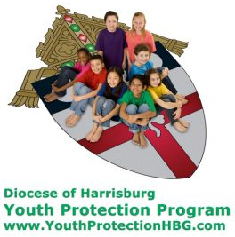
Diocese of Harrisburg Youth Protection Program
www.YouthProtectionHBG.com

Abuse Reporting Contact Information:
First – Call the toll-free PA Child Abuse Hotline at 800-932-0313
Then – Call the Diocesan toll-free hotline at 800-626-1608

“If one member suffers,
all suffer together with it.” (1 Cor 12:26)

St. Ignatius Loyola RC Church

St. Ignatius Loyola Roman Catholic Church
1095 Church Road, Orrtanna, Pennsylvania 17353
www.stignatiusofloyola.org | Office: 717-677-8012

February 18, 2024: FIRST SUNDAY OF LENT
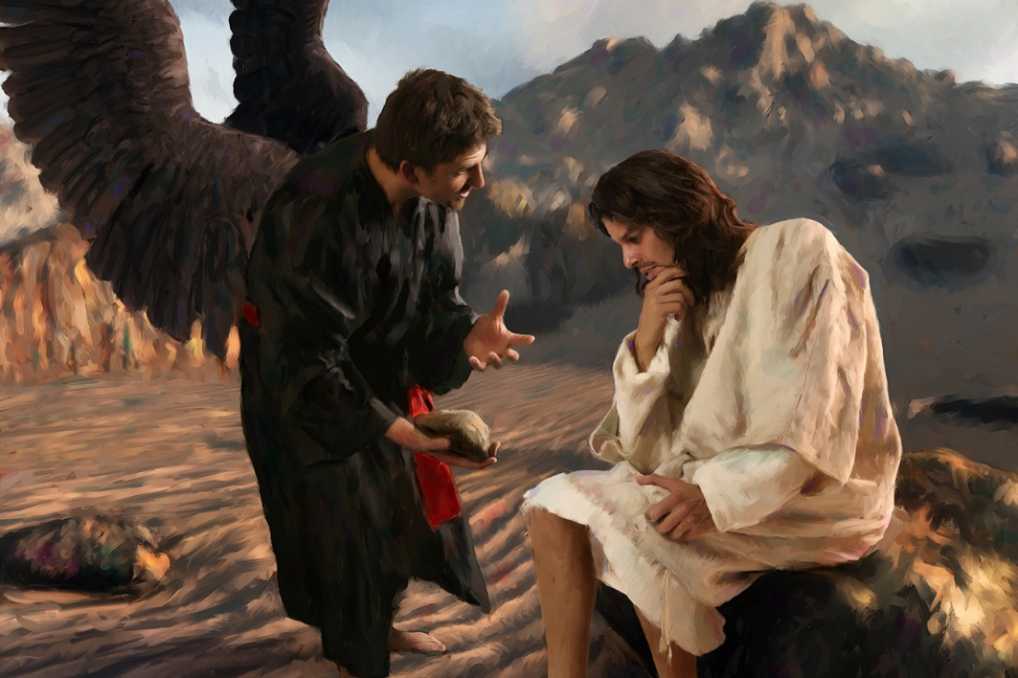

“If You truly are the Son of God,
command that these stones
be turned into bread… “

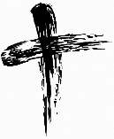
May the PENANCES we do this LENT
be offered to bring PEACE in the Holy Land!

Most Rev. Timothy C. Senior, Bishop of Harrisburg
Rev. Dominic M. DiBiccaro, Pastor
Deacon Steve Huete, Pastoral Associate

Mass Schedule, Intentions, and Events
Please Pray for these in need:
Jeanie Kline & the Kline Family, Dick & Deb Deardorff, Jacob Long, Shell Edwards, Corona Naylor, Chris & Mary Rebscher, John Baker, Ginny Hoctor, Janet Hodge, Brenda Wolf, Sr. Thelma Steiger HSF, Sr. Miriam Ukeritis CSJ , Peter Hackney, Lucas Christiansen, Dale Kaplan, Jerry Smith, Wade Sprankle, Dulcie Perry, Ron Formosa, Gavin Crumbacker, Anna Kane, Sherry Dennis & Family, Remi Peters, Terry Ahn, K. Grance, Lori McFadden & Family, Mike & Lisa Poole, Mervin Weikert, Chastity Rudisill, Mary Ellen Wilson, Terry & Bernie Cabana, Ed & Aggie Sherensky & Family, Bob Raffensberger, Jerry & Ginny Miller, Adeline Lienard, Kaylee Henry, Nancy Wuller, Dr. Mike Colli, Mrs. Kelly Kump, Gabriel Singer, Sharon McCormley, Ron Thumma, Joe Wisotzkey, Leo Hockensmith, Erika McKissick, Jean "Heather" O'Shea, Scott Moore & Sally Moore, Mary Wyatt, Amy Weatherup, Sophia Joy Ernst, Deacon Richard Wentzel, Deacon Frank Enderle, Paul & Carolyn Topper, Kathleen Thompson, Rachel Wonders, Amy Edwards, Jean O’Connor, Jen Baldwin, Ursula Kaley, Deb Bennet, Larry Endy, Laura Lee, Marwa Abdelrahman, Donna Singley, Tim McGinn, Jane Kump, Peggy Neiderer, Chris Kimple, Robert Riquet, Gene & Jo-Ann McDannell, Bob Doxzen, Kimberly Mears, Gabriella Angello, Paul Angello, Mark & Kate Morrow, Mark Morris, Linda Fogleman, Paul Knight, George & Barbara Erstila, Jeff Carpenter, Lana & Nelson Harmon, Diane Slothour, Sue McDannell, Larry Schneider, Joe & Lisa Grasel, Ange Pena, Julie Barnhart, Shaffer Family, Heather & Emma Dickerson, Brad Peabody, Paul Ward, Aiden Tyler Schneider, Dorothy Vega, Karrie McCall & daughter, George Shahid, Denise Navlyt, Drew Schneider & Family, Ida Bloomfield, Janie Singley, Mary Beth Greenstreet, Rick Benedict, Jan Patla, Kathey Fogleman, Sam Sheffler, Kate Hemmis, Bill & Mary Lou Graham, Andy Graham, Joanna Hodges, John Varones, Joan O’Sullivan, Martha Klinger, Lisa Dionne Lauretti, Jim Gleason, Sue Gustafson, Joe & Michelle Cleary, Kim Johnson, Helen Mills, Kathy Haber, Haley Detman, Joe Durovey, Bev Smith, Donald Sheppard, Linda Mumaugh, Alison Haring, Janet Hartman, Edward Johnson, Angela Galeone, Juliete Lang, Chris MacBeth, Harry Graham, Donald Howard, Armond Binni, Elizabeth Stansky, Pat Johnson, Chris Morris, Faud Doaney, Patrick Glass, Helen Lagasse, Nancy Kewisnek, Bill & Maureen Collins, Rosemary McGilloway, Anji Eisenhart, Monica Manner, Denny Borbonus, Dr. Paul Scarlata, Mary Hawthorne, Ed Washington, Josh Kempinski, Nancy Baltzey, Spencer Propts, Karlton Smith & Cheryl Sobun, James & Marylyn Sobun, Marlene Webster, Yvette Stoklosa, Andy Consiglio, Bill & Michelle Cloonan, Nelson Salem, Bill & Deb McClintock, nursing home residents & shut-ins, the victims of war, violence, disease, disaster, & all private intentions.
Also in your prayers, please remember all our men
& women currently serving in our Armed Forces:

Lt. Col. Nathan Jeffcoat – US Marine Corps
Lt. Joseph Cleary – US Navy
Michael C. Kenney IV – US Coast Guard
Lt. Joshua Kimple – US Army
Lt. Sarah Fogleman, M.D. – US Navy
A1C Ian Bellinger ‒ PA Air National Guard

PRAYER CHAIN: Contact the Office

for the Week of February 17 to February 25, 2024

SATURDAY, Feb. 17 – Vigil 1ST SUNDAY OF LENT

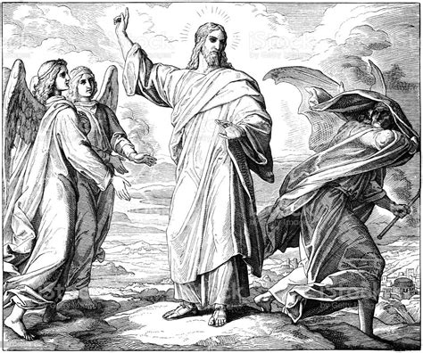
Gn 9:8-15 / 1 Pt 3:18-22 / Mk 1:12-15
5:00PM + Joseph Keller

SUNDAY, Feb. 18 – 1ST SUNDAY OF LENT

Gn 9:8-15 / 1 Pt 3:18-22 / Mk 1:12-15

8:00AM ⁓ People of the Parish
10:30AM + Jim and Delores Gilbert

MONDAY, February 19 (Lenten Weekday)
Lv 19:1-2, 11-18 / Mt 25:31-46
Parish Office CLOSED

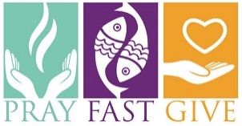
Tuesday, February 20 (Lenten Weekday)
Is 55:10-11 / Mt 6:7-15

8AM – 3PM ~ Office Open

10:00AM + Joseph Deardorff

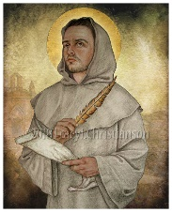
Wednesday, February 21 – St. Peter Damian, Bishop
Jon 3:1-10 / Lk 11:29-32 & Doctor of the Church

8AM – 3PM ~ Office Open
6 – 6:45 Confessions
7:00PM + Paul Topper
7:40 Adoration & Rosary; 8PM Benediction
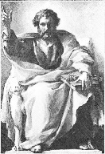
Thursday, February 22 – THE CHAIR OF ST. PETER
1 Pt 5:1-4 / Mt 16:13-19

8AM – 3PM ~ Office Open
10:00AM + Marie Kalp
Friday, February 23 – St. Polycarp, Bishop & Martyr  7:00  PM  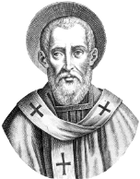  Ez 18:21-28 / Mt 5:20-26  10:00AM + Russ Clark  Parish Office CLOSED | THE LORD

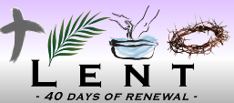
SATURDAY, Feb. 24 (Lenten Weekday)
MORNING: Dt 26:16-19 / Mt 5:43-48

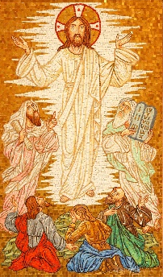
SATURDAY, Feb. 24 – Vigil 2nd SUNDAY OF LENT

Gn 22:1-2, 9a, 10-13, 15-18/Rom 8:31b-34/Mk 9:2-10
5:00PM + Timothy Heller

SUNDAY, Feb. 25 – 2nd SUNDAY OF LENT

Gn 22:1-2, 9a, 10-13, 15-18/Rom 8:31b-34/Mk 9:2-10
8:00AM + James Deardorff
10:30AM ⁓ People of the Parish
Sanctuary Candle for FEBRUARY is offered: In Loving Memory of Timothy & Andrew Heller from Martha Heller

Sunday Collection Summary for Feb. 10 & 11

Weekend Collections
Regular Offering $ 2,392.00
Ash Wednesday $ 350.00
Mary, Mother of God (add’l) $ 25.00
TOTAL OFFERINGS $ 2,767.00

‒ WEEKLY BUDGETARY NEEDS $ 4,494.00
+Overage or (Shortfall) for the week ($ 1,727.00)

Other Income
Cemetery Upkeep $ 245.00
Local Poor $ 30.00
Altar Flowers $ 75.00
Candles/Living Faith $ 71.00
Total Other Offerings $ 421.00

IN/OUT (No affect to budgeted income)
Stewardship of Faith Bookcase/Table $ 91.00

Diocesan Second Collections
Churches in East Eur, Lat. Am., Africa $ 10.00
Society for the Propagation of the Faith $ 205.00
Poor Missions $ 753.97
Total Diocesan Offerings $ 968.97

2024 Hershey Park discount tickets are now available.
Pick up an Order Form in the Narthex of the Church, fill out and return with your payment. You may drop off it in the office. Or place in an envelope and drop in the collection basket (marked: “Hershey Park”). NO LATER THAN April 26th
Ticket Prices
Purchase before April 26th, 2024: $43.95
Regular price $87.80
Tickets valid April - January 1, 2025

Single-Use Meal Plan Prepaid Parking Passes
$19.06 regular price $19.06 $25.00 (pre-purchase only)

The New Creation: Scott Hahn Reflects

On the First Sunday of Lent

Lent bids us to return to the innocence of our Baptism. As Noah and his family were saved through the waters of the deluge, we were saved through the aters of Baptism, Saint Peter reminds us in today’s Epistle.

And God’s Covenant with Noah in today’s First Reading marked the start of a new world. But it also prefigured a new and greater covenant between God and His Creation (see Hosea 2:20; Isaiah 11:1–9).

We see that New Covenant and that New Creation begin in today’s Gospel.

Jesus is portrayed as the new Adam — the beloved Son of God (see Mark 1:11; Luke 3:38), living in harmony with the wild beasts (see Genesis 2:19–20), being served by Angels (see Ezekiel 28:12–14).

Like Adam, He too is tempted by the devil. But while Adam fell, giving reign to sin and death (see Romans 5:12–14, 17–20), Jesus is victorious.

This is The Good News, the “Gospel of God” that He proclaims. Through His Death, Resurrection, and Enthronement at the Right Hand of the Father, the world is once again made God’s Kingdom.

In the waters of Baptism, each of us entered the Kingdom of His beloved Son (see Colossians 1:13–14). We were made Children of God, new creations (see 2 Corinthians 5:7; Galatians 4:3–7).

But like Jesus, and Isra-el before Him, we have passed through the Baptismal Waters only to be driven into the wilderness — a world filled with afflictions and tests of our faithfulness (see 1 Corinthians 10:1–4, 9,13; Deuteronomy 8:2, 16).

We are led on this journey by Jesus. He is the Savior —The Way and The Truth we sing of in today’s Psalm (see John 14:6). He feeds us with the Bread of Angels (see Psalm 78:25; Wisdom 16:20), and cleanses our consciences in the Sacrament of Reconciliation.

As we begin this Holy Season, let us renew our Baptismal vows ‒ TO REPENT AND BELIEVE THE GOSPEL!

Readings: Genesis 9:8–15; Psalm 25:4–9
1 Peter 3:18–22; Mark 1:12–15

Joint Parish Council and Finance Council - February 6. 2024

• Father Dominic reported we will receive our rebate of $7,711.39 from the Diocesan Annual Campaign. The 2024 campaign sets a 10% increase for our parish goal at $32, 832. And he is confident we will again achieve it.

• Recent repairs include Loyola Center roof leak fixes, gas line solenoid replacement in the kitchen, double door replacement and a new blower motor for the air filtration unit in the church.

• Statistics on the average age of parishioners were presented and indicate that nearly 50% of our parish is over 66-years old.

• Deacon Steve Huete will be working on plans for a Parish Town Hall meeting after Easter.

• A proposal for carving an “Angel statue” from the remaining tree trunk in the Memory Garden was discussed. Father Dominic will be getting a quote from the sculptor and will include it in a parish vote for consensusl along with the charitable contribution proposal.

• A brief discussion was held regarding the status of the Theosis group. An effort to let parishioners know that help is available will be included in the church bulletin.

• PA State Police will be conducting a security check for the church on 2/21.

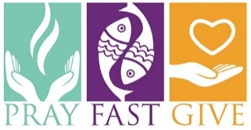
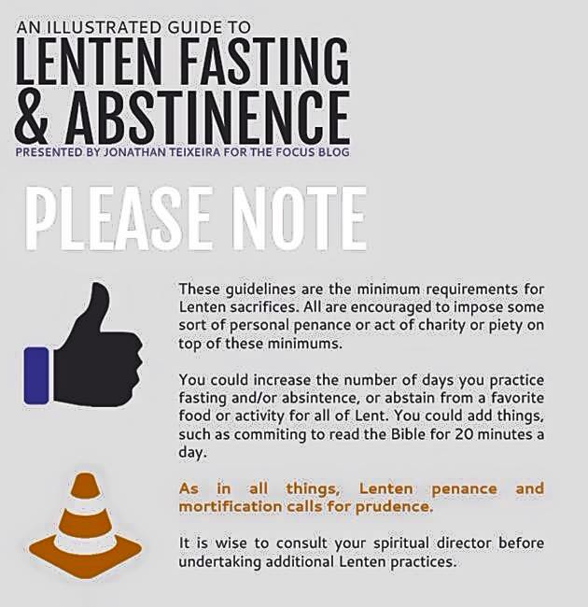

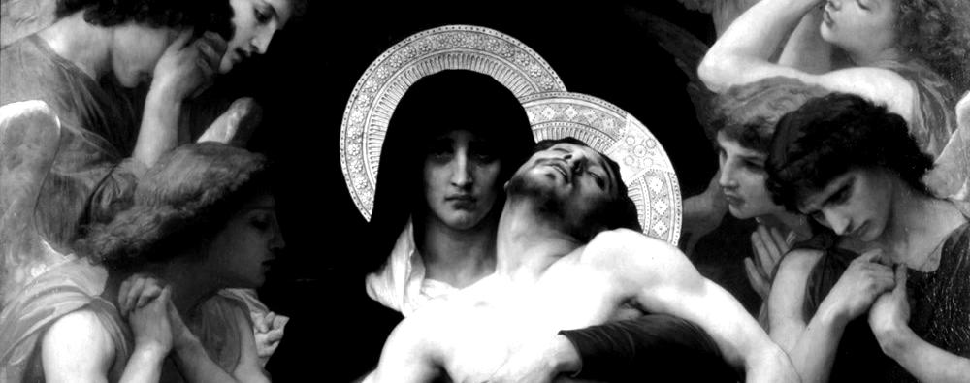

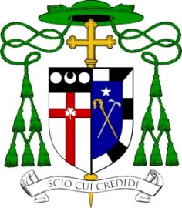
Office of the Bishop
DIOCESE OF HARRISBURG
4800 Union Deposit Road ≅ Harrisburg, PA 17111
Phone: (717) 657-4804 ≅ Fax: (717) 657-1370
Bishop's0ffice@hbgdiocese.org
www.hbgdiocese.org

Most Reverend Timothy C. Senior
12th Bishop of the Roman Catholic Diocese of Harrisburg, Pennsylvania
February 14, 2024
Dear Brothers and Sisters in Christ,

Lent is the Church's annual retreat when we are invited to focus on our relationship with Jesus Christ, to center our lives on Him, to deepen our knowledge of Him "in whom we have believed" and to "stir into flame the gift of God" that we have received (2 Timothy 1, 6-12). In his message for Lent 2024, Pope Francis recalls that Lent provides the context for renewing our faith and our friendship with Jesus. As our Jewish ancestors in faith journeyed for forty years in the desert from slavery to freedom, "Lent is the season of grace in which the desert can become once more - in the words of the Prophet Hosea - the place of our first love (Hosea 2, 16-17). God shapes His People; He enables us to leave our slavery behind and experience a Passover from death to life. Like a bridegroom, the LORD draws us once more to Himself, whispering words of love to our hearts."

During Lent, the Church calls us to three practices: prayer, fasting, and almsgiving. Prayer forms the foundation of our relationship with God. Throughout the Gospels, Jesus frequently goes off to a quiet place by Himself to pray. Amidst the noise and busyness of our daily lives, it can be a challenge to imitate the LORD in prayer. As on a retreat, Lent gives us the context to try harder, rising a little earlier or going to sleep a little later, making time to speak to Jesus from our hearts and to listen quietly for His Voice in return; to come to know Him more intimately - in whom we have believed.

Fasting is very popular these days, especially for those trying to lose weight or to regain a healthy lifestyle. The kind of fasting to which we are called during Lent is more than just physical deprivation. There is a spiritual intentionality that accompanies our fast, intentionally allowing ourselves to fast from those things that sometimes hold us captive in order to be truly free in Christ. Certainly, this includes food and drink, but it also includes attitudes and habits that weigh us down, sins to which we have grown indifferent, selfish actions that exclude others, and frenetic activity that prevents us from spending time with those who need us the most. Like so many aspects of our Catholic life, the outward fasting from food, drink, and other pleasurable activities is but a sign of what ought to be happening inside: growth in self-control, compassion, and selflessness.

Finally, in almsgiving we do more than simply give things to those in need, we are called to discern carefully to ensure that our giving genuinely comes from our need and not our excess. Surely it is a good practice to give away extra clothing, household goods, and children's games. Most of us have too much stuff as it is. After that, real almsgiving happens, when we sacrifice something we want to give to a person in true need. In this way, our giving is truly a gift of ourselves to others.

Prayer, fasting and almsgiving in these Lenten days can not only help us discover an interior renewal of our friendship with Jesus, centering our lives on Him, but can also stir into flame the gifts we have received to look outward -- to live our faith more vibrantly; to be more visibly Catholic Christian. When Christians live their faith visibly and are not ashamed of who they are in Jesus Christ, we become God's instruments; instruments of peace and communion, building bridges and drawing people together. Since my first homily as your bishop, Pope Francis' words from his encyclical "Fratelli Tutti" have given us a vision for everyone in our Diocese. He writes the words we can take to heart, "it is my desire that, in this our time, by acknowledging the dignity of each human person we can contribute to the rebirth of a universal aspiration to fraternity... . Let us dream then, as a single human family, as fellow travelers sharing the same flesh, as children of the same earth which is our common home, each of us bringing the richness of his or her beliefs and convictions, each of us with his or her own voice, brothers and sisters all."

And so, we go together into the desert of Lent and, through prayer, fasting and almsgiving, leave behind whatever enslaves us and open our hearts to renewed freedom in Jesus Christ. Please join me in praying that these Lenten days will be a time of renewal for everyone in our Diocese. When Easter comes, may we all experience the joy and hope of the transformative grace of Easter.

Sincerely in Christ,
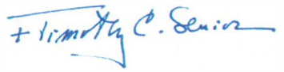

Most Reverend Timothy C. Senior
Bishop of Harrisburg
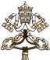
Message of the Holy Father Francis for Lent 2024, 01.02.2024
Through the Desert God Leads us to Freedom
Dear brothers and sisters!
When our God reveals himself, his message is always one of freedom: “I am the LORD your God, who brought you out of the land of Egypt, out of the house of slavery” (Ex 20:2). These are the first words of the Decalogue given to Moses on Mount Sinai. Those who heard them were quite familiar with the exodus of which God spoke: the experience of their bondage still weighed heavily upon them. In the desert, they received the “Ten Words” as a thoroughfare to freedom. We call them “commandments”, in order to emphasize the strength of the love by which God shapes his people. The call to freedom is a demanding one. It is not answered straightaway; it has to mature as part of a journey. Just as Israel in the desert still clung to Egypt – often longing for the past and grumbling against the LORD and Moses – today too, God’s people can cling to an oppressive bondage that it is called to leave behind. We realize how true this is at those moments when we feel hopeless, wandering through life like a desert and lacking a promised land as our destination. Lent is the season of grace in which the desert can become once more – in the words of the Prophet Hosea – the place of our first love (cf. Hos 2:16-17). God shapes his people, he enables us to leave our slavery behind and experience a Passover from death to life. Like a bridegroom, the LORD draws us once more to himself, whispering words of love to our hearts.
The exodus from slavery to freedom is no abstract journey. If our celebration of Lent is to be concrete, the first step is to desire to open our eyes to reality. When the LORD calls out to Moses from the burning bush, he immediately shows that he is a God who sees and, above all, hears: “I have observed the misery of my people who are in Egypt; I have heard their cry on account of their taskmasters. Indeed I know their sufferings, and I have come down to deliver them from the Egyptians, and to bring them up out of that land to a good and broad land, a land flowing with milk and honey” (Ex 3:7-8). Today too, the cry of so many of our oppressed brothers and sisters rises to heaven. Let us ask ourselves: Do we hear that cry? Does it trouble us? Does it move us? All too many things keep us apart from each other, denying the fraternity that, from the beginning, binds us to one another.
During my visit to Lampedusa, as a way of countering the globalization of indifference, I asked two questions, which have become more and more pressing: “Where are you?” (Gen 3:9) and “Where is your brother?” (Gen 4:9). Our Lenten journey will be concrete if, by listening once more to those two questions, we realize that even today we remain under the rule of Pharaoh. A rule that makes us weary and indifferent. A model of growth that divides and robs us of a future. Earth, air and water are polluted, but so are our souls. True, Baptism has begun our process of liberation, yet there remains in us an inexplicable longing for slavery. A kind of attraction to the security of familiar things, to the detriment of our freedom.
In the Exodus account, there is a significant detail: it is God who sees, is moved and brings freedom; Israel does not ask for this. Pharaoh stifles dreams, blocks the view of heaven, makes it appear that this world, in which human dignity is trampled upon and authentic bonds are denied, can never change. He put everything in bondage to himself. Let us ask: Do I want a new world? Am I ready to leave behind my compromises with the old? The witness of many of my brother bishops and a great number of those who work for peace and justice has increasingly convinced me that we need to combat a deficit of hope that stifles dreams and the silent cry that reaches to heaven and moves the heart of God. This “deficit of hope” is not unlike the nostalgia for slavery that paralyzed Israel in the desert and prevented it from moving forward. An exodus can be interrupted: how else can we explain the fact that humanity has arrived at the threshold of universal fraternity and at levels of scientific, technical, cultural, and juridical development capable of guaranteeing dignity to all, yet gropes about in the darkness of inequality and conflict.
God has not grown weary of us. Let us welcome Lent as the great season in which he reminds us: “I am the LORD your God, who brought you out of the land of Egypt, out of the house of slavery” (Ex 20:2). Lent is a season of conversion, a time of freedom. Jesus himself, as we recall each year on the first Sunday of Lent, was driven into the desert by the Spirit in order to be tempted in freedom.

For forty days, he will stand before us and with us: the incarnate Son. Unlike Pharaoh, God does not want subjects, but sons and daughters. The desert is the place where our freedom can mature in a personal decision not to fall back into slavery. In Lent, we find new criteria of justice and a community with which we can press forward on a road not yet taken.
This, however, entails a struggle, as the book of Exodus and the temptations of Jesus in the desert make clear to us. The voice of God, who says, “You are my Son, the Beloved” (Mk 1:11), and “You shall have no other gods before me” (Ex 20:3) is opposed by the enemy and his lies. Even more to be feared than Pharaoh are the idols that we set up for ourselves; we can consider them as his voice speaking within us. To be all-powerful, to be looked up to by all, to domineer over others: every human being is aware of how deeply seductive that lie can be. It is a road well-travelled. We can become attached to money, to certain projects, ideas or goals, to our position, to a tradition, even to certain individuals. Instead of making us move forward, they paralyze us. Instead of encounter, they create conflict. Yet there is also a new humanity, a people of the little ones and of the humble who have not yielded to the allure of the lie. Whereas those who serve idols become like them, mute, blind, deaf and immobile (cf. Ps 114:4), the poor of spirit are open and ready: a silent force of good that heals and sustains the world.
It is time to act, and in Lent, to act also means to pause. To pause in prayer, in order to receive the word of God, to pause like the Samaritan in the presence of a wounded brother or sister. Love of God and love of neighbour are one love. Not to have other gods is to pause in the presence of God beside the flesh of our neighbour. For this reason, prayer, almsgiving and fasting are not three unrelated acts, but a single movement of openness and self-emptying, in which we cast out the idols that weigh us down, the attachments that imprison us. Then the atrophied and isolated heart will revive. Slow down, then, and pause! The contemplative dimension of life that Lent helps us to rediscover will release new energies. In the presence of God, we become brothers and sisters, more sensitive to one another: in place of threats and enemies, we discover companions and fellow travelers. This is God’s dream, the Promised Land to which we journey once we have left our slavery behind.
The Church’s synodal form, which in these years we are rediscovering and cultivating, suggests that Lent is also a time of communitarian decisions, of decisions, small and large, that are countercurrent. Decisions capable of altering the daily lives of individuals and entire neighbourhoods, such as the ways we acquire goods, care for creation, and strive to include those who go unseen or are looked down upon. I invite every Christian community to do just this: to offer its members moments set aside to rethink their lifestyles, times to examine their presence in society and the contribution they make to its betterment. Woe to us if our Christian penance were to resemble the kind of penance that so dismayed Jesus. To us too, he says: “Whenever you fast, do not look dismal, like the hypocrites, for they disfigure their faces so as to show others that they are fasting” (Mt 6:16). Instead, let others see joyful faces, catch the scent of freedom and experience the love that makes all things new, beginning with the smallest and those nearest to us. This can happen in every one of our Christian communities.
To the extent that this Lent becomes a time of conversion, an anxious humanity will notice a burst of creativity, a flash of new hope. Allow me to repeat what I told the young people whom I met in Lisbon last summer: “Keep seeking and be ready to take risks. At this moment in time, we face enormous risks; we hear the painful plea of so many people. Indeed, we are experiencing a third world war fought piecemeal. Yet let us find the courage to see our world, not as being in its death throes but in a process of giving birth, not at the end but at the beginning of a great new chapter of history. We need courage to think like this” (Address to University Students, 3 August 2023). Such is the courage of conversion, born of coming up from slavery. For faith and charity take hope, this small child, by the hand. They teach her to walk, and at the same time, she leads them forward.^{[1]}
I bless all of you and your Lenten journey.
Given in Rome at the Basilica of Saint John Lateran, 3 December 2023, First Sunday of Advent.

^{[1]} Cf. CH. PÉGUY, The Portico of the Mystery of the Second Virtue

