Sacrament of the Sick
Anointing of the Sick should be given if an individual is gravely ill or near death. If possible, the Sacrament should also be administered for serious illness, before major surgery or when one is initially hospitalized.

Sacrament of Holy Matrimony
Diocesan policy requires 12 months of preparation for Marriage. Contact the parish as soon as possible after engagement. No venue reservations or other arrangements should be made prior to consultation with the pastor.

Sacrament of Penance
Wednesday ~ 6:00 – 6:45PM; or by appointment.

Sacrament of Baptism
Parents must be registered members of the parish and attend a Baptism preparation class prior to the Baptism if this is your first child baptized. Requirements for godparents are established by the Catholic Church. Please call the parish office for Information and to register your child for Baptism.

Parish Registration
All Catholics should be registered in their local parish. Please contact the parish office to obtain registration forms, or if you are uncertain of the parish where you should register.

Parish Staff & Ministries Directory
stignatiusofloyola@hbgdiocese.org | Office: 717-677-8012
Financial Manager ~ Richard Deardorff ~ 717- 677-8012 or 717-420-3464 (cell)
rdeardorff@hbgdiocese.org
Director of Religious Education ~ Deacon Steve Huete ~ shuete@hbgdiocese.org
Parish Secretary ~ Kristen DiDio ~ kdidio@hbgdiocese.org
Buildings & Grounds ~ Donnie Althoff ~ 717-677-8012
Music Ministry ~ Phil Mobley ~ 717-677-8012
Parish Council Members
Phil Mobley – Chair 571-236-7580 pmmobley@gmail.com
Bicky Redman – Vice Chair 677-8592 feetintheair7@gmail.com
Joanne Riedel - Secretary 398-2021 sterj221@aol.com
Kathi Allwein 677-8984 allweint@comcast.net
Charlie Baker 677-9536 dcbake@embarqmqil.com
Kathy Dietsch 352-4558 kdiet2@juno.com
Dr. BobTernes rjtmd46@gmail.com

Finance Council Members
Richard Deardorff (Ex Officio)
Greg Ernst - Chair
Christy Hemler - Secretary
Ali Morris
Terri Pendlelton
Bill Pulig

Altar Flowers
OCIA
Order of Christian Initiation for Adults
Contact Fr. Dominic

Soup Kitchen
Please send donations
directly to the
“Gettysburg Soup Kitchen”

Website Development
Kristen DiDio
Life After Loss
Dodie Huete

Prayer Chain
CONTACT THE PARISH OFFICE

Picnic Co-Chairs
Wally Kane
Mark Schur

Pro-Life Ministry
Jeanette Backus
Knights of Columbus
SK Bob Ternes
- Grand Knight

CONTACT THE PARISH OFFICE

Bereavement Ministry
Ginny Bittle / Dodie Huete

Catholic Communications/EWTN
Anna Kane

Cemetery
CONTACT THE PARISH OFFICE
THEOSIS Ministry
Kathy Dietsch 717-352-4558
Bicky Redman 717-677-8592

Diocese of Harrisburg Youth Protection Program
www.YouthProtectionHBG.com

Abuse Reporting Contact Information:
First – Call the toll-free PA Child Abuse Hotline at 800-932-0313
Then – Call the Diocesan toll-free hotline at 800-626-1608

“If one member suffers,
all suffer together with it.” (1 Cor 12:26)

St. Ignatius Loyola RC Church

1095 Church Road, Orrtanna, Pennsylvania 17353
www.stignatiusofloyola.org | Office: 717-677-8012

November 19, 2023: 33rd SUNDAY IN ORDINARY TIME

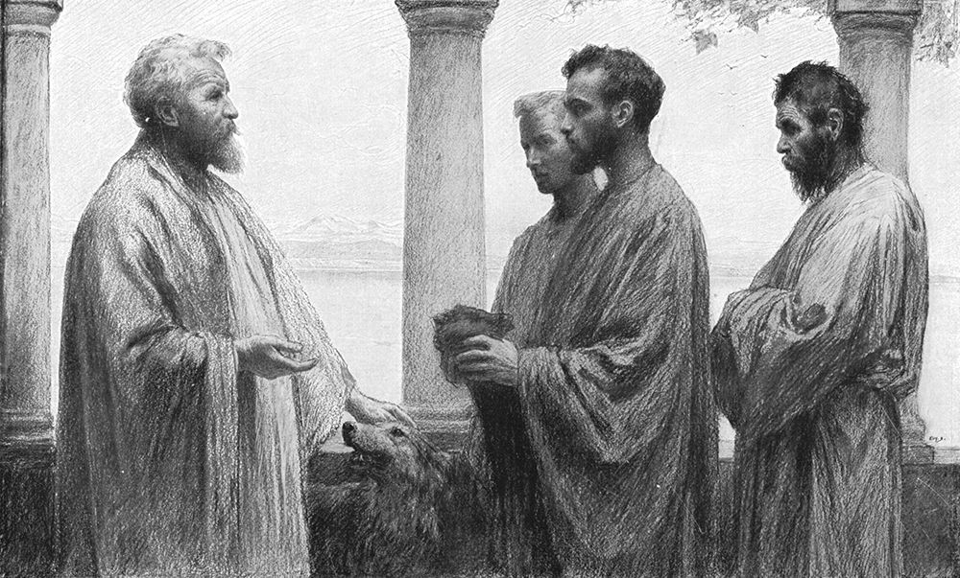

“Well done, my good and faithful servant.
Come share your Master’s Joy!”

PLEASE Pray to END THE KILLING in the Holy Land!

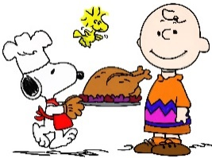

Most Rev. Timothy C. Senior, Bishop of Harrisburg
Rev. Dominic M. DiBiccaro, Pastor
Deacon Steve Huete, Pastoral Associate

Monday, 5PM/6:30PM
Mass Schedule, Intentions, and Events
Please Pray for these in need:
Jeanie Kline & the Kline Family, Dick & Deb Deardorff, John Baker, Ginny Hoctor, Brenda Wolf, Peter Hackney, Lucas Christiansen, Dale Kaplan, Jerry Smith, Wade Sprankle, Dulcie Perry, Ron Formosa, Gavin Crumbacker, Anna Kane, Sherry Dennis & Family, Remi Peters, Terry Ahn, K. Grance, Lori McFadden & Family, Mike & Lisa Poole, Mervin Weikert, Chastity Rudisill, Mary Ellen Wilson, Terry & Bernie Cabana, Ed & Aggie Sherensky & Family, Bob Raffensberger, Jerry & Ginny Miller, Adeline Lienard, Kaylee Henry, Nancy Wuller, Dr. Mike Colli, Mrs. Kelly Kump, Gabriel Singer, Sharon McCormley, Ron Thumma, Joe Wisotzkey, Leo Hockensmith, Erika McKissick, Jean "Heather" O'Shea, Scott Moore & Sally Moore, Mary Wyatt, Jim & Joyce Deardorff, Amy Weatherup, Sophia Joy Ernst, Deacon Richard Wentzel, Deacon Frank Enderle, Paul & Carolyn Topper, Kathleen Thompson, Rachel Wonders, Amy Edwards, Jean O’Connor, Jen Baldwin, Ursula Kaley, Deb Bennet, Larry Endy, Laura Lee, Marwa Abdelrahman, Donna Singley, Tim McGinn, Jane Kump, Peggy Neiderer, Chris Kimple, Robert Riquet, Gene & Jo-Ann McDannell, Bob Doxzen, Kimberly Mears, Gabriella Angello, Paul Angello, Mark & Kate Morrow, Mark Morris, Linda Fogleman, Paul Knight, George & Barbara Erstila, Jeff Carpenter, Lana & Nelson Harmon, Diane Slothour, Sue McDannell, Larry Schneider, Joe & Lisa Grasel, Ange Pena, Julie Barnhart, the Shaffer Family, Heather & Emma Dickerson, Brad Peabody, Paul Ward, Aiden Tyler Schneider, Dorothy Vega, Karrie McCall & daughter, George Shahid, Denise Navlyt, Drew Schneider & Family, Ida Bloomfield, Janie Singley, Mary Beth Greenstreet, Rick Benedict, Jan Patla, Kathey Fogleman, Sam Sheffler, Kate Hemmis, Bill & Mary Lou Graham, Andy Graham, Joanna Hodges, John Varones, Joan O’Sullivan, Martha Klinger, Lisa Dionne Lauretti, Jim Gleason, Sue Gustafson, Joe & Michelle Cleary, Kim Johnson, Helen Mills, Kathy Haber, Haley Detman, Joe Durovey, Bev Smith, Donald Sheppard, Linda Mumaugh, Alison Haring, Janet Hartman, Edward Johnson, Angela Galeone, Juliete Lang, Chris MacBeth, Harry Graham, Donald Howard, Armond Binni, Elizabeth Stansky, Pat Johnson, Chris Morris, Faud Doaney, Patrick Glass, Helen Lagasse, Nancy Kewisnek, Bill & Maureen Collins, Rosemary McGilloway, Anji Eisenhart, Monica Manner, Denny Borbonus, Dr. Paul Scarlata, Mary Hawthorne, Ed Washington, Josh Kempinski, Nancy Baker Baltzey, Spencer Propts, Karlton Smith & Cheryl Sobun, James & Marylyn Sobun, Marlene Webster, Yvette Stoklosa, Andy Consiglio, Bill & Michelle Cloonan, Nelson Salem, Bill & Deb McClintock, nursing home residents & shut-ins, the victims of war, violence, disease, disaster, & all private intentions.
Also in your prayers, please remember all our men
& women currently serving in our Armed Forces:

Lt. Col. Nathan Jeffcoat – US Marine Corps
Lt. Joseph Cleary – US Navy
Michael C. Kenney IV – US Coast Guard
Lt. Joshua Kimple – US Army
Lt. Sarah Fogleman, M.D. – US Navy
A1C Ian Bellinger ‒ PA Air National Guard

PRAYER CHAIN: Contact the Office

for the Week of November 18 to November 26, 2023

SATURDAY, Nov. 18 - VIGIL 33rd SUNDAY OT

Prv 31:10-13, 19-20, 30-31/1 Thes 5:1-6/Mt 25:14-30
5:00PM + James Bucci

SUNDAY,Nov. 19 – 33rd SUNDAY IN OT

Prv 31:10-13, 19-20, 30-31/1 Thes 5:1-6/Mt 25:14-30
8:00AM + Bobbi Strasbaugh

10:30AM ⁓ People of the Parish

Monday, November 20 (Weekday in OT)
1 Mc 1:10-15, 41-43, 54-57, 62-63 / Lk 18:35-43
Parish Office Closed
Doors Open
5PM
Bingo Starts
6:30PM

Tuesday, November 21 – Presentation of the Blessed Virgin Mary
2 Mc 6:18-31 / Lk 19:1-10

8AM – 3PM ~ Office Open

10:00AM + Mikael McTighe

“Something More” Group will NOT be meeting until further notice

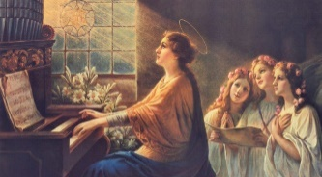
Wednesday, Nov. 22 – St. Cecilia, Virgin
2 Mc 7:1, 20-31 / Lk 19:11-28 & Martyr
11AM: Mature Spirituality Group
7:00PM + Dr. Hari Gnanasekeram
6 to 6:45PM - Confessions; 7:40PM - Adoration & Benediction

Thursday, Nov. 23 – St. Clement I, Pope and Martyr; St. Columban,
1 Mc 2:15-29 / Lk 19:41-44 Abbot; Bl. Miguel Agustín Pro,
Parish Office CLOSED Priest & Martyr
9:00AM +Fr. Jim Dolan

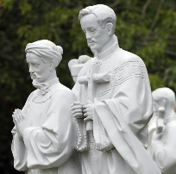  Friday, Nov. 24 – St. Andrew Dũng-Lạc, Priest, &  1 Mc 4:36-37, 52-59 / Lk 19:45-48 Companions,  10:00AM + ALL SOULS Martyrs  Parish Office CLOSED | THE LORD

SATURDAY, Nov. 25 – St. Catherine of Alexandria,

MORNING: 1 Mc 6:1-13 / Lk 20:27-40 Virgin & Martyr

SATURDAY, Nov. 25 - VIGIL OF CHRIST THE KING

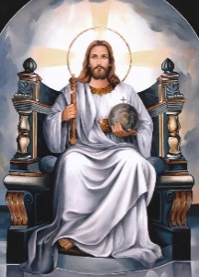
Ez 34:11-12, 15-17/1 Cor 15:20-26, 28/Mt 25:31-46
5:00PM + ALL SOULS

SUNDAY,Nov. 26 – CHRIST THE KING

Ez 34:11-12, 15-17/1 Cor 15:20-26, 28/Mt 25:31-46
8:00AM ⁓ People of the Parish
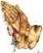
10:30AM + Phillip Sanzano
Sanctuary Candle offered for NOVEMBER: In Loving Memory of Marilyn Cole from Kenneth Cole

Settling Accounts: Scott Hahn Reflects

on the Thirty-Third Sunday in Ordinary Time

The day of the LORD is coming, St. Paul warns in today’s Epistle. What matters isn’t the time or the season, but what the LORD finds us doing with the new life, the graces He has given to us.

This is at the heart of Jesus’ parable in today’s Gospel. Jesus is the Master. Having died, risen, & ascended into Heaven, He appears to have gone away for a long time.

By our Baptism, He has entrusted to each of us a portion of His “possessions,” a share in His Divine Life (see 2 Peter 1:4). He has given us talents and responsibilities according to the measure of our faith (Romans 12:3–8).

We are to be like the worthy wife in today’s First Reading and the faithful man we sing of in today’s Psalm. Like them, we should walk in the “fear of the LORD” — in reverence, awe, and thanksgiving for His marvelous gifts. This is the beginning of Wisdom (see Acts 9:31; Proverbs 1:7).

This is not the “fear” of the useless servant in today’s parable. His is the fear of a slave cowering before a cruel master, the fear of one who refuses the relationship that God calls us to.

God has called us to be trusted servants, fellow workers (see 1 Corinthians 3:9), using our talents to serve one another and His Kingdom as good stewards of His grace (see 1 Peter 4:10). In this, we each have a different part to play.

Though the good servants in today’s parable were given different numbers of talents, each “doubled” what he was given. And each earned the same reward for his faithfulness — greater responsibilities and a share of the Master’s joy!

So let us resolve again in this Eucharist to make much of what we’ve been given, to do ALL FOR THE GLORY OF GOD (see 1 Corinthians 10:31). That we, too, may approach our Master with confidence and love, when He comes to settle accounts.

Readings: Proverbs 31:10–13, 19–20, 30–31:
Psalm 128:1–5: 1 Thessalonians 5:1–6;
Matthew 25:14–30

Sunday Collection Summary for Nov. 11 & 12

Weekend Collections
Regular Offering $ 2,751.00
All Saints $ 15.00
All Souls $ 110.00
Christ the King $ 70.00
TOTAL OFFERINGS $ 2,946.00

‒ WEEKLY BUDGETARY NEEDS $ 4,494.00
+Overage or (Shortfall) for the week $ (1,548.00)

Other Income
Christmas Flowers $ 25.00
Thanksgiving $ 80.00
Total Other Offerings $ 105.00

Diocesan Second Collections
Matthew 25 $ 145.00
Total Diocesan Offerings $ 145.00

OCTOBER, 2023 UPDATE
DAC St. Ignatius Loyola Parish

Parish Goal for 2023: $29,847.61
Total Paid: $35,274.00
Outstanding Pledges: $1,250.00
Total Committed: $36,524.00
Overgoal to be rebated: $5,426.39
% toward goal cash rec’d: 118.18%
Average per donor: $414.99
Number of Donors: 85
Registered Households: 202
Percentage of Participation: 42.08%

2023 Diocesan Annual Campaign - DIOCESE

Total Diocesan Goal: $7,339,815.00
Total Paid to Date: $6,598,150.11
Total Pledged: $1,385,336.47
Total Committed: $6,923,276.23
Pledge Balance: $325,029.12
% toward goal 94.32%
Number of Donors: 16,731
Number of Gifts: 29,784
Average/Donor: $374.68
Percentage of Participation: 25.54%

POPE FRANCIS’ PRAYER INTETNION
FOR THE MONTH OF NOVEMBER
~ For the Pope
We pray for the Holy Father; as he fulfills his mission, may he continue to accompany the flock entrusted to him, with the help of the Holy Spirit.

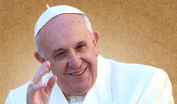

What Did Pope St. Paul VI Mean by Saying

“The Smoke of Satan Has Entered The Church”?
By Gelsomino Del Guercio - published on 07/06/18

A letter unpublished until last year adds some clarity on the Pope's torment.

It’s the beginning of the 1970s: times of unrest in the world and in the Church. It’s the period immediately after the Second Vatican Council. Pope [St.] [St.] Paul VI writes a letter that will remain unpublished until 2018, when its content is revealed in the book The Barque of Paul (“La barca di Paolo“), by Fr. Leonardo Sapienza, regent of the Pontifical Household.

It’s June 29, 1972. [St.] Paul VI has a clearer and clearer impression that there is something deep and negative that is increasingly afflicting the Church. The path towards secularization and the lack of internal unity are becoming two great problems for the Church throughout the world.

The Pope, concerned, writes:

“… We would say that, through some mysterious crack—no, it’s not mysterious; through some crack, the smoke of Satan has entered the Church of God. There is doubt, uncertainty, problems, unrest, dissatisfaction, confrontation.

“The Church is no longer trusted. We trust the first pagan prophet we see who speaks to us in some newspaper, and we run behind him and ask him if he has the formula for true life. I repeat, doubt has entered our conscience. And it entered through the windows that should have been open to the light: science.”

Storm clouds

The post-conciliar wounds make themselves felt:

“… It was thought that, after the Council, sunny days would come for the history of the Church. Nevertheless, what came were days of clouds, of storms, of darkness, of searching, of uncertainty … We tried to dig abysses instead of covering them …”

Terror and ecstasy

The fact that the Pope was concerned is also shown by another thought that he’d written eight days earlier, on June 21, 1972. The title alone is disturbing: “Terror and ecstasy.”

Perhaps the LORD
called me to this service
not for me to adopt any attitude,
or so that I would govern and save the Church from its difficulties,
but so that I would suffer something for the Church,
and so it be made clear that it is Him, and no one else,
who guides it and saves it.

June 21, 1963: exactly nine years before writing that thought, Cardinal Giovanni Montini* had been elected Pope. He wrote this about it:

“… I hope that all believe me when I say that not only did I never aspire, nor even formulate the hypothesis of being elected to this formidable office …”

Years later, during the turbulent year of 1968, in a conversation with his friend the French writer Jean Guitton, the Pope said:

“… I had the terror and the ecstasy of having been elected …”

Once he accepted the weight of the pontificate, [St.] Paul VI consecrated all his strength to it, in the midst of uncountable obstacles.

The responsibility of the Vicar of Christ is terribly heavy, because it is the office of the shepherd called to give his life for his sheep. Let us always pray for Peter’s Successor and for the Church, under the clouds of the tempest.

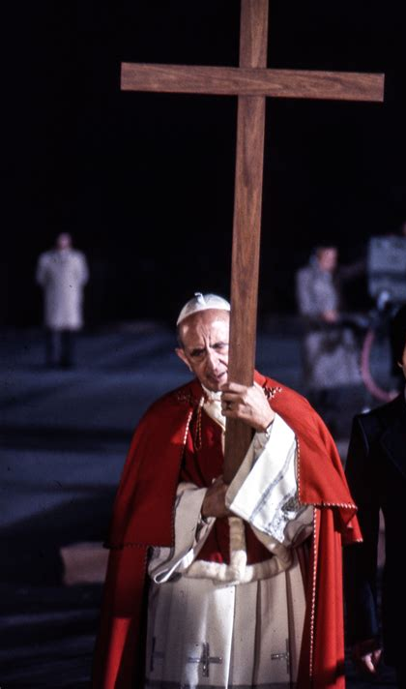
*Papacy  began | 21 June 1963 (18 days after the death of Pope St. John XXIII)
Born | Giovanni Battista Enrico Antonio Maria Montini  26 September 1897  Concesio, Brescia, Lombardy, Kingdom of Italy
Died | 6 August 1978 (aged 80) – Succeeded by Bl. John Paul I who was elected Bishop of  Castel Gandolfo, Italy Rome on 26 August 1978

Canonized | 14 October 2018  Saint Peter's Square, Vatican City  by Pope Francis
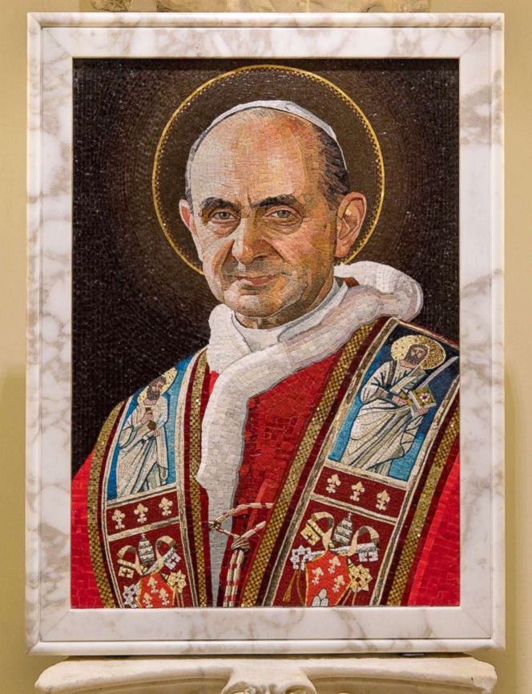

Pope Saint Paul VI … PRAY FOR US!
November is the Month of the
HOLY SOULS IN PURGATORY
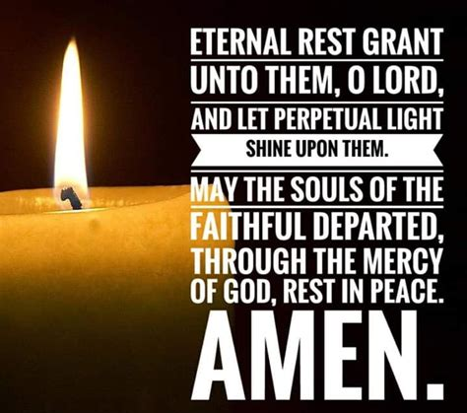

A great big THANK YOU from Council #14035 for all the recent DONATIONS to our big Fall events over the past few weeks.
We had a very successful Breakfast for Veterans, raising $642 that will be donated to the PA Wounded Warriors. Also, $1,000 was donated to SCAAP for the “Food For Families” program (where they turn each $1 donated into $3 worth of food!)

WE REMEMBER IN OUR PRAYERS ALL THOSE WHO DONATED SO GENEROUSLY OF THEIR TIME, TALENT,

AND TREASURE TO OUR CHARTERED EFFORTS IN HELPING THOSE IN NEED.
+
+ Vivat Jesu! +

SAVE THE DATE: Tuesday, November 28, at Corpus Christi Parish Center, Chambersburg, there will be a presentation from 6:30 to 8:30PM. By Father Stephen Logue, talking on “End-of-Life Issues: Things You Need to Know and Consider”. Please call the Parish Office at 717-264-6317 or email dmccarty@corpuschristichbg.org to register for this informative event.

Let Us Pray Mother Angelica's
Prayer for EWTN

ewtnmissionaries.com | 205.795.5771

Intercessory Prayer is the first and foundational plank of the EWTN Media Missionaries.

As a fundamental part of our MM prayers, we are asked to pray Mother Angelica’s Prayer for EWTN on a regular basis and in particular to pray it in concert the First Friday of each month.

If you have a moment to stop what you're doing, save this for later, or see the prayer in the online Devotional Guide; then pray this prayer with someone you love today or, if possible, right now as Media Missionaries!

"O, God, Lord of Heaven and earth, You alone have accomplished all we have done. May this first Catholic network be a tribute to the beauty of Your Church. May Your Son, the Eternal Word, be glorified through this work of Your Hands. Bless all the programs that will issue forth from its facilities.

Just as Your Word issued forth from You, LORD Father, may that same Word touch each heart that listens to this network. Let Your Spirit work with freedom through every teacher who proclaims Your Truth and Your Church.

Bestow upon this network the power to inspire men to seek holiness of heart, zeal for the extension of Your Church, courage to seek after justice and human rights, and patience to endure persecution. Amen."

⁓ Mother Angelica offered this prayer at the launch of EWTN, August 15, 1981.

