Sacrament of the Sick
Anointing of the Sick should be given if an individual is gravely ill or near death. If possible, the Sacrament should also be administered for serious illness, before major surgery or when one is initially hospitalized.

Sacrament of Holy Matrimony
Diocesan policy requires 12 months of preparation for Marriage. Contact the parish as soon as possible after engagement. No venue reservations or other arrangements should be made prior to consultation with the pastor.

Sacrament of Penance
Wednesday ~ 6:00 – 6:45PM; or by appointment.

Sacrament of Baptism
Parents must be registered members of the parish and attend a Baptism preparation class prior to the Baptism if this is your first child baptized. Requirements for godparents are established by the Catholic Church. Please call the parish office for Information and to register your child for Baptism.

Parish Registration
All Catholics should be registered in their local parish. Please contact the parish office to obtain registration forms, or if you are uncertain of the parish where you should register.

Parish Staff & Ministries Directory
stignatiusofloyola@hbgdiocese.org
Financial Manager ~ Richard Deardorff ~ 717- 677-8012 or 717-420-3464 (cell)
rdeardorff@hbgdiocese.org
Director of Religious Education ~ Deacon Steve Huete ~ shuete@hbgdiocese.org
Administrative Assistant ~ Kristen DiDio ~ kdidio@hbgdiocese.org
Buildings & Grounds ~ JB Groff ~ 717-677-8012
Music Ministry ~ Phil Mobley ~ 717-677-8012
Parish Council Members
*Walt Wilson – Chair 401-0570 (h) wwilson1198@comcast.net
Joanne Riedel - Secretary 398-2021 (h) sterj221@aol.com
Kathi Allwein 677-8984 (h) allweint@comcast.net
*Donnie Althoff 339-6527 (c) dalthoff53@gmail.com
Charlie Baker 677-9536 (h) dcbake@embarqmqil.com
*Jim Bittle 677-6711 (h) ginnybittle@comcast.net
Mike McTighe 729-6239 (c) mike0432@aol.com

Finance Council Members
Richard Deardorff (Ex Officio)
Greg Ernst - Chair
Alix Haller
Christy Hemler - Secretary
Terri Pendlelton
Bill Pulig

Altar Flowers
Prayer Chain
Lynne Mobley at LMOBLEY509@gmail.com
or 703-876-4901.

Soup Kitchen
Please send donations directly to “Soup Kitchen”

Website Development
Kristen DiDio
Life After Loss
Dodie Huete

OCIA
Contact Fr. Dominic

Picnic Co-Chairpersons
John Neiderer
Wally Kane

Pro-Life Ministry
OPEN – Contact office if you are interested

Knights of Columbus
SK Bob Ternes
- Grand Knight
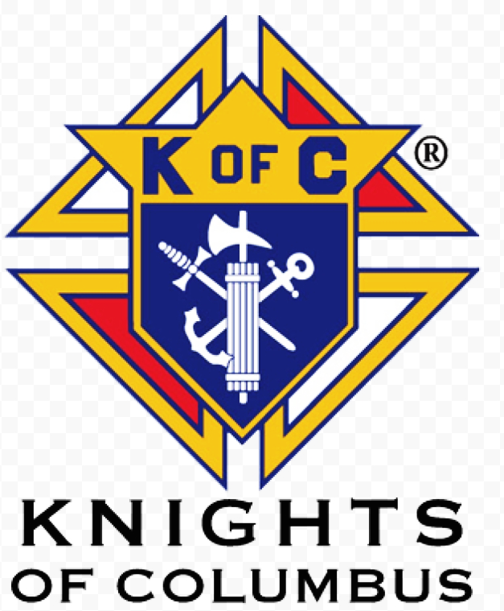

Judy Wilson / Janice Meligakas

Bereavement Ministry
Ginny Bittle / Dodie Huete

Catholic Communications/EWTN
Open - Contact office if you are interested

Cemetery
Contact Parish Office
THEOSIS Ministry
Kathy Dietsch 717-352-4558
Bicky Redman 717-677-8592

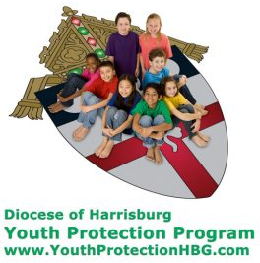
Diocese of Harrisburg Youth Protection Program
www.YouthProtectionHBG.com

Abuse Reporting Contact Information:
First – Call the toll-free PA Child Abuse Hotline at 800-932-0313
Then – Call the Diocesan toll-free hotline at 800-626-1608

“If one member suffers,
all suffer together with it.” (1 Cor 12:26)

St. Ignatius Loyola RC Church

1095 Church Road, Orrtanna, Pennsylvania 17353
www.stignatiusofloyola.org

MAY 14, 2023: SIXTH SUNDAY OF EASTER
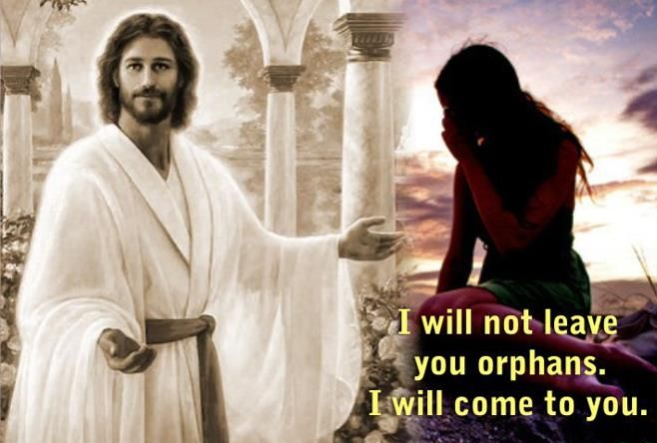

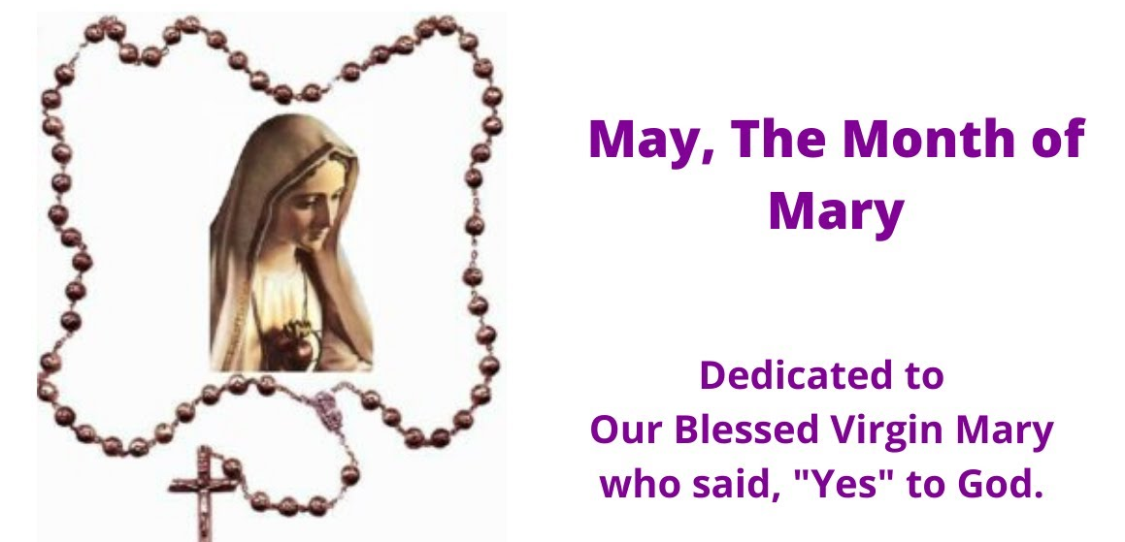
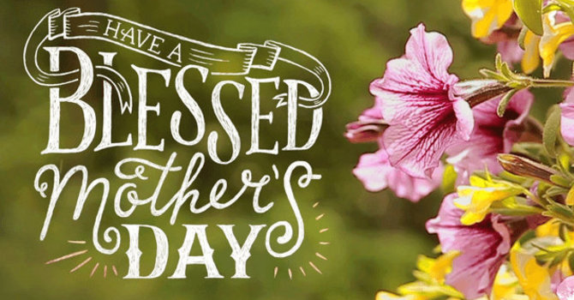

Most Reverend Ronald W. Gainer, Apostolic Administrator
Rev. Dominic M. DiBiccaro, Pastor / Deacon Steve Huete, Pastoral Associate
Mass Schedule, Intentions, and Events
Please Pray for:
Coronavirus victims and those who are ill, Jeanie Kline & the Kline Family, Mervin Weikert, Chastity Rudisill, Mary Ellen Wilson, Terry & Bernie Cabana, Ed & Aggie Sherensky and Family ,Bob Raffensberger Jerry & Ginny Miller, Adeline Lienard, Kaylee Henry, Chuck & Nancy Wuller, Dr. Mike Colli, Mrs. Kelly Kump, Kevin & Brittany Groff, Gabriel Singer, Sharon McCormley, Ron Thumma, Joe Wisotzkey, Leo Hockensmith, Erika McKissick, Jean "Heather" O'Shea, Scott Moore and Sally Moore, Mary Wyatt, Jim & Joyce Deardorff, Brandon & Michelle Gilbert, Amy Weatherup, Sophia Joy Ernst, Deacon Richard Wentzel, Deacon Frank Enderle, Kathleen Thompson, Deb & Kathy McLintock and Family, Rachel Wonders, Amy Edwards, Jean O’Connor, Art Lazar, Sr., Mark & Michelle Huete, Paul Angello, Jen Baldwin, Ursula Kaley, Deb Bennet, Fr. Bill Sullivan, Fr. Chet Snyder, John Larry Endy, Mary Beth McCarthy, Laura Lee, Marwa Abdelrahman, Cathy Gates, Donna Singley, Jack Ryff, Tim McGinn, Jane Kump, Gary, Bill, Jerry, Andy, Colleen, Baby Addie, Peggy Neiderer, Chris Kimple, Robert Riquet, Gene & Jo-Ann McDannell, Bob Doxzen, Kimberly Mears, Gabriella Angello, Mark & Kate Morrow, Mark Morris, Linda Fogleman, Paul Knight, George & Barbara Erstila, Jeff Carpenter, Lana & Nelson Harmon, Cole & Connor, Diane Slothour, Sue McDannell, Larry Schneider, Joe & Lisa Grasel, Ange Pena, Julie Barnhart, the Shaffer Family, Heather & Emma Dickerson, Brad Pabody, Paul Ward, Aiden Tyler Schneider, Dorothy Vega, Karrie McCall & daughter, George Shahid, Denise Navlyt, Drew Schneider & Family, Ida Bloomfield, Linda McDannell, Janie Singley, Mary Beth Greenstreet, Rick Benedict, Jan Patla, Kathe Fogleman, Sam Sheffler, Kate Hemmis, Bill & Mary Lou Graham, Joanna Hodges, John Varones, Joan O’Sullivan, Martha Klinger, Lisa Dionne Lauretti, Sue Orndorff, Jim Gleason, Sue Gustafson, Joe & Michelle Cleary, Kim Johnson, Helen Mills, Kathy Haber, Haley Detman, Joe Durovey, Bev Smith, Donald Sheppard, Linda Mumaugh, Alison Haring, Janet Hartman, Edward Johnson, Angela Galeone, Juliete Lang, Chris MacBeth, Harry Graham, Donald Howard, Armond Binni, Elizabeth Stansky, Pat Johnson, Chris Morris, Faud Doaney, Wilson & Rae Harman, Patrick Glass, Helen Lagasse, Nancy Kewisnek, Andy Graham, Bill & Maureen Collins, Rosemary McGilloway, Anji Eisenhart, Monica Manner, Denny Borbonus, Dr. Paul Scarlata, Mary Hawthorne, Ed Washington, Josh Kempinski, Nancy Baker Baltzey, Spencer Propts, Karlton Smith & Cheryl Sobun, James & Marylyn Sobun, Marlene Webster, Yvette Stoklosa, Andy Consiglio, Bill & Michelle Cloonan, Nelson Salem, Janet Shunnarah, George Shunnarah, Bill & Deb McClintock nursing home residents & shut-ins, the victims of war, violence, disease, disaster, & all private intentions.
Also in your prayers, please remember all
our men and women currently serving in
our Armed Forces:
Maj. Nathan Jeffcoat – US Marine Corps
Lt. Joseph Cleary – US Navy
Michael C. Kenney IV – US Coast Guard
Lt. Joshua Kimple – US Army
Lt. Sarah Fogleman, M.D. – US Navy

PRAYER CHAIN: Contact Lynne Mobley at 703-876-4901 or LMOBLEY509@gmail.com

for the Week of May 13 to May 21, 2023

SATURDAY, May 13 – VIGIL MASS 6th SUNDAY OF EASTER

Acts 8:5-8, 14-17/1 Pt 3:15-18/Jn 14:15-21
4:30PM Recitation of the Holy Rosary
5:00PM - Special Int. for Jeanie Kline

SUNDAY, May 14 – 6th SUNDAY EASTER

Acts 8:5-8, 14-17/1 Pt 3:15-18/Jn 14:15-21

8:00AM - Private Intention
10:30AM ~ People of the Parish

Monday, May 15 - St. Isadore the Farmer
Acts 16:11-15 / Jn 15:26—16:4a
Parish Office Closed

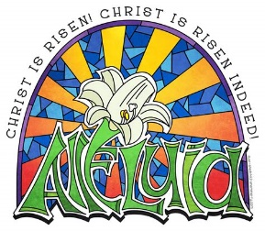
Tuesday, May 16 (Easter Weekday)
Acts 16:22-34 / Jn 16:5-11
8:00AM - 3:00 PM ~ Office Open
10:00AM + Private Intention

11AM: “Something More” Faith Group
Wednesday, May 17 - VIGIL OF THE ASCENSION OF THE LORD
Acts 1:1-11 / Eph 1:17-23 / Mt 28:16-20

8:00AM - 3:00 PM ~ Office Open

11AM: Senior Spirituality Group NO Confessions; NO Adoration
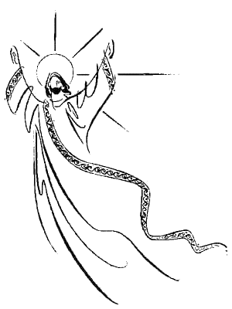
7:00PM + Sue Ann Osterman and Family

Thursday, May 18 – ASCENSION OF THE LORD
Acts 1:1-11 / Eph 1:17-23 / Mt 28:16-20
Office CLOSED
10:00AM ⁓ People of the Parish
7:00PM + Sara C. Smith-Sneeringer

Friday, May 19 (Easter Weekday)  Acts 18:9-18 / Jn 16:20-23 | THE LORD
Parish Office CLOSED
10:00AM + Rev. Carl J. Steffan

SATURDAY, May 20 – St. Bernardine of Siena, Priest

MORNING: Acts 18:23-28 / Jn 16:23b-28

SATURDAY, May 20 – VIGIL MASS 7th SUNDAY OF EASTER

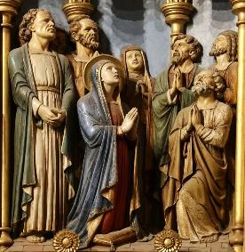
Acts 1:12-14 / 1 Pt 4:13-16 / Jn 17:1-11a
4:30PM Recitation of the Holy Rosary
5:00PM - Private Intention

SUNDAY, May 21 – 7th SUNDAY EASTER

Acts 1:12-14 / 1 Pt 4:13-16 / Jn 17:1-11a

8:00AM + John and Louise Strasbaugh
10:30AM ~ People of the Parish
Sanctuary Candle offered for MAY: In Loving Memory of Marilyn Cole from Ken Cole and Family
Sunday Collection Summary

First British baby with DNA from 3 people is born after IVF procedure

By Tyler Arnold | CNA Newsroom, May 10, 2023

The first baby born in the United Kingdom with DNA from three parents was born after doctors performed a revolutionary IVF procedure designed to prevent rare but dangerous mitochondrial diseases.

The news that “less than five” children have been born in the U.K. through this process as of late April was first reported by The Guardian. This is the first time the Human Fertilisation and Embryology Authority (HFEA) has confirmed any children in the country being born through this process. The HFEA avoided disclosing the exact number of babies to protect privacy.

The Parliament of the United Kingdom has approved two methods for altering the DNA of an embryo by including genetic material from a third person. The procedure is only permitted for couples who have a strong likelihood of passing down a dangerous mitochondrial disorder. The two techniques are maternal spindle transfer (MST) and pronuclear transfer (PNT).

The first birth of a baby with DNA from three parents took place in Mexico in 2016 after doctors performed the procedure using the sperm and egg of a Jordanian couple.

Both methods create a child who has two genetic mothers and one genetic father. The PNT method also requires the destruction of embryos. The MST process does not necessarily require the destruction of embryos, but researchers did destroy embryos as part of the researching process.

Through MST, nuclear genetic material is removed from the mother’s eggs and transferred to donated eggs that have had their nuclear genetic material removed before being fertilized with the father’s sperm. Through PNT, the mother’s eggs are first fertilized with the father’s sperm in a lab and then the nuclear genetic material is transferred to donated eggs that have had their nuclear genetic material removed.

“Mitochondrial donation treatment offers families with severe inherited mitochondrial illness the possibility of a healthy child,” the HFEA said in a statement. “The HFEA oversees a robust framework which ensures that mitochondrial donation is provided in a safe and ethical manner.”

As of May 10 the HFEA Statutory Approvals Committee has approved this treatment for 32 patients.

“All applications for treatment are assessed on an individual basis against the tests set out in the law and only after independent advice from experts,” the HFEA statement read. “These are still early days for mitochondrial donation treatment and the HFEA continues to review clinical and scientific developments. … We understand that the team at Newcastle hopes to publish information of their mitochondrial treatment programme in peer reviewed journals shortly.”

When Parliament was considering the initial research in 2015, it faced opposition from the Catholic Bishops’ Conference of England and Wales, which accused Parliament of approving the methods too hastily and objected to the destruction of human embryos in the treatment process.

“There are also serious ethical objections to this procedure which involves the destruction of human embryos as part of the process,” a statement read at the time. “The human embryo is a new human life, and it should be respected and protected from the moment of conception.”

May 6 and 7
Weekend Collection
Regular Offering $ 4,859.00
Local Poor $ 120.00
Ascension $ 90.00
Candles $ 55.00
TOTAL OFFERINGS $ 5,124.00

‒WEEKLY BUDGETARY NEEDS $ 5,819.68
+Overage or (Shortfall) for the week ($ 695.68)

Diocesan Second Collections
Pentecost $ 150.00
Catholic Home Missions $ 100.00
TOTAL DIOCESAN OFFERINGS $ 250.00

Honoring Mothers is a Catholic Practice

Mother's Day has been celebrated as a national holiday in the United States on the second Sunday of May since 1914. But Catholics have been celebrating a sort of mother's day since the first few centuries of the Church. The fourth Sunday of Lent, or Laetare Sunday, traditionally was a time to return to your “mother church” (home parish) and leave an offering.

Also known as “Mothering Sunday,” it naturally evolved into honoring your mother as well. And devotion to Mary, the Mother of God and our spiritual mother, in the month of May, gives this holiday depth for Catholics that goes far beyond giving flowers or candy on Mother's Day.

"God, Creator and LORD of the universe, chose to put Himself — tiny, needy and helpless — into the nurturing and watchful hands of a human mother. Since then, every act of mothering — both physical and spiritual — in every time and every corner of the world recollects Mary’s."

In Catholic tradition, the month of May is dedicated to Mary. Chosen by God above all other women, Mary's faith and obedience paved the way for the Incarnation. Her example teaches us faith, obedience, humility, and most of all, how to love. According to St. Thomas of Villanova, "If in this world any creature ever loved God with whole heart, with whole soul, and with whole mind, she was the creature.”

At the Foot of the Cross, her Heart broke for Jesus, yet she accepted God's Will not only for her Son, but for herself in her new role as mother to us all. (John 19:25-27) As we honor our earthly mothers this month, let's honor our Heavenly Mother as well. Those devoted to her are always led to her Son. For her wise counsel will be repeated in every part of the globe by THE Faithful of His Spotless Bride, until He Returns, "Do whatever he tells you." (John 2:5)

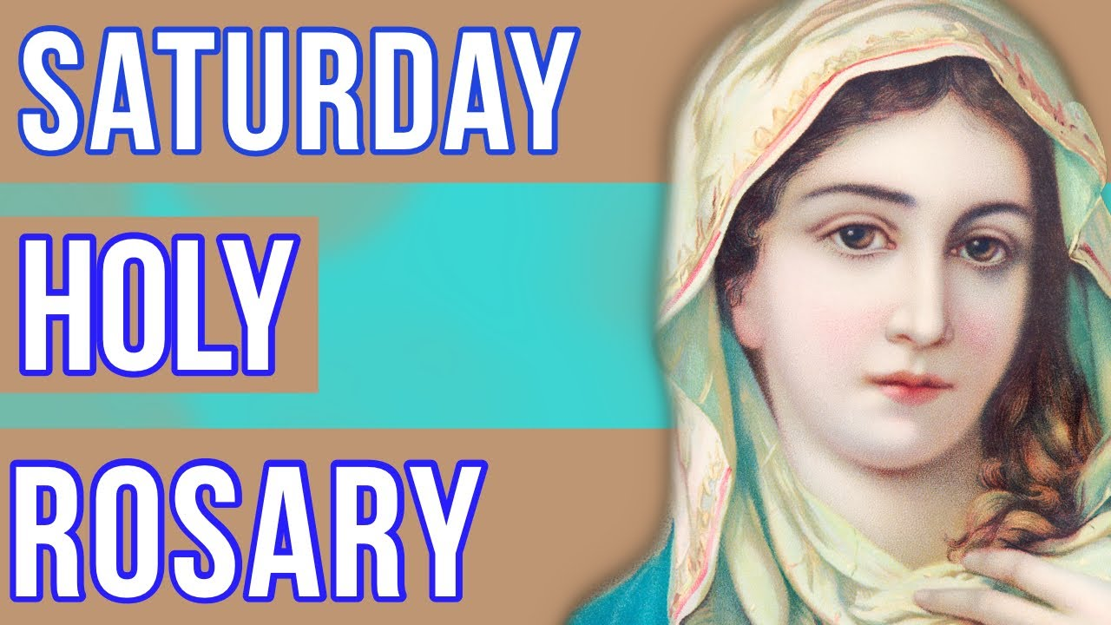

Will be recited before the
5PM Vigil Mass
at 4:30PM.

Back by popular demand!
Sr. Thelma Steiger, Hermit of St. Francis, Ph.D
presents a morning conference on:
Woman, I AM thirsty.
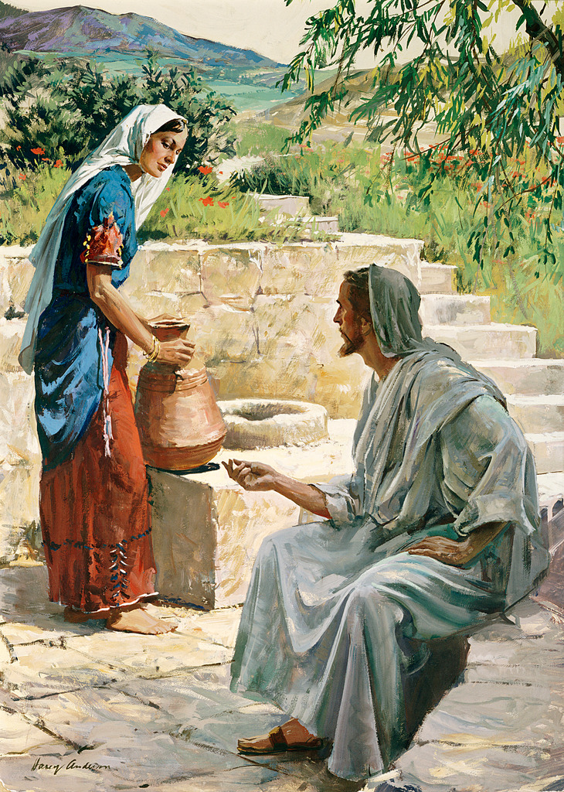

“If you knew the gift of God and who is saying to you, ‘Give me a drink,’ you would have asked Him and he would have given you Living Water.” (John 4:10)

Saturday, May 20, 2023, 9:30AM to Noon
Lower Loyola Social Hall
(with light refreshments)
Everyone is welcome! Bring a friend!
The Holy Father, Pope Francis’ Prayer Intentions for 2023
Entrusted to His Worldwide Prayer Network

MAY ⁓ FOR CHURCH MOVEMENTS AND GROUPS
We pray that Church movements and groups may rediscover their mission of evangelization each day, placing their own charisms at the service of needs in the world.

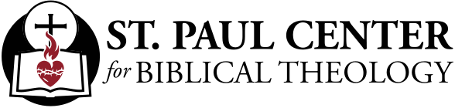

Alive in the Spirit : Scott Hahn Reflects

on the Sixth Sunday of Easter

Jesus will not leave us alone. He won’t make us Children of God in Baptism only to leave us “orphans,” He assures us in today’s Gospel (see Romans 8:14–17).

He asks the Father to give us His Spirit, to dwell with us and keep us united in the life He shares with the Father.
We see the promised gift of His Spirit being conferred in today’s First Reading.

The scene from Acts apparently depicts a primitive Confirmation rite. Philip, one of the first deacons (see Acts 6:5), proclaims the Gospel in the non-Jewish city of Samaria. The Samaritans accept the Word of God (see Acts 17:11; 1 Thessalonians 2:13) and are baptized.

It remains for the Apostles to send their representatives, Peter and John, to pray and lay hands on the newly Baptized — that they might receive the Holy Spirit. This is the origin of our Sacrament of Confirmation (see Acts 19:5–6), by which the grace of Baptism is completed, and believers are sealed with the Spirit promised by the LORD.

We remain in this grace so long as we love Christ and keep His Commandments. And, strengthened in the Spirit whom Jesus said would be our Advocate, we are called to bear witness to our salvation — to the tremendous deeds that God has done for us in the Name of His Son.

In today’s Psalm, we celebrate our liberation. As He changed the sea into dry land to free the captive Isra-elites, Christ suffered that He might lead us to God, as we hear in today’s Epistle.

This is the reason for our hope — the hope that sustains us in the face of a world that cannot accept His Truth, the hope that sustains us when we are maligned and defamed for His Name’s sake.

Put to death in the flesh, He was brought to life in the Spirit, St. Paul tells us today. And as He Himself promises: “Because I live . . . you will live!”

Readings: Acts 8:5–8, 14–17; Psalm 66:1–7, 16, 20; 1 Peter 3:15–18; John 14:15–21

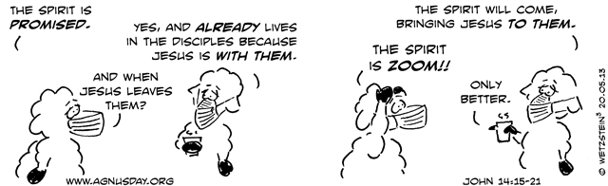

Coronation Ceremony Marks Turning Point in

Catholic-Anglican Relations

By Elise Allen, Senior Correspondent | May 6, 2023

ROME – When King Charles III and his wife, Queen Consort Camila, are crowned on Saturday, the event will mark a historic juncture in Catholic-Anglican relations, as it will be the first time a Catholic bishop has participated in the ceremony in four centuries.

In a May 5 statement, the Archdiocese of Westminster in the UK, overseen by Cardinal Vincent Nichols, called Saturday’s coronation “an historic occasion for the nation, and also for the Catholic community.”

“For the first time in over 400 years, a Catholic Archbishop will take part in a Coronation in this country,” the statement said, referring to the fact that Nichols has not only been invited to attend the ceremony, but he will also give a blessing.

Other Catholic representatives at the coronation will be Vatican Secretary of State Italian Cardinal Pietro Parolin and the newly-appointed apostolic nuncio to Great Britain, Spanish Archbishop Miguel Maury Buendía, as well as Archbishop Mark O’Toole of Cardiff, Bishop Hugh Gilbert of Aberdeen, Scotland, and the Archbishop of Armagh and Primate of All Ireland, Eamon Martin.

In a May 5 tweet, Nichols said he was “privileged” to take part in the coronation ceremony, saying he’ll be standing beside the Archbishop of Canterbury and other Christian leaders “to invoke God’s blessing on His Majesty the King.”

In a May 2 tweet, British Ambassador to the Holy See Chris Trott said, “We are thrilled that Cardinal Parolin will represent Pope Francis at the Coronation,” noting that the last cardinal to do so “would probably have been Reginald Pole. In 1553.”
King Charles ascended to the throne last fall following the death of his mother, Queen Elizabeth II, who had reigned for 70 years, setting a historical record by becoming England’s longest reigning monarch. She had just celebrated her Platinum Jubilee when she passed away at the age of 94.

Charles will be formally crowned in an Anglican ceremony presided over the Archbishop of Canterbury, Justin Welby, at Westminster Abbey in London on May 6.

Historical tensions between Catholics and Anglicans date back to 1534, when Henry VIII broke away from the Catholic Church and declared himself head of the Church of England. However, Nichols and many other observers have said that rift and the tensions that ensued finally faded during Queen Elizabeth II’s time on the throne.

Her 70-year reign spanned seven different pontificates, beginning with Pope Pius XII. She met with Pope Francis in 2014. The last pope to meet her in the United Kingdom was Benedict XVI during his visit in 2010.

When Queen Elizabeth II was crowned in 1953, the religious landscape of the country was drastically different, and tensions between Catholics and Anglicans were more acute.

According to the Archdiocese of Westminster’s statement, in 1953, “it would not have been permitted for any Catholic to enter a Protestant church, let alone to take part in a Coronation service. This significant step is the fruit of decades of ecumenical relations.”

In the lead up to Saturday’s coronation, churches throughout the United Kingdom were invited to hold a triduum of prayer, of sorts, for King Charles from May 3-5. Nichols invited Catholics to participate by offering up their daily tasks, and through formal prayers such as the Rosary and the Mass.

The three-day prayer initiative closed Friday evening when, per the request of the bishops of England and Wales, each Catholic community was asked to offer a special Mass in the King’s honor prior to Saturday’s coronation ceremony.
Nichols and the Presidents of Churches Together in England urged Christians of all confessions to join in the moment of prayer, calling it “a moment of great importance and joy for this nation.”

The Archdiocese of Westminster’s statement Friday quoted Nichols as saying the coronation ceremony would be symbolic, “because it respects our history, it builds on our history, and it complements the history, both in this way, and with the presence and greeting of the faith leaders from the other major religions now present in this country.”

Despite the fact that the coronation is an Anglican ceremony, Nichols said there are still traces of Catholicism, and pointed to three specific moments he said highlight the “profoundly Christian nature” of the event.

The first is that the King observe a moment of silent prayer, he said, saying, “I’ve been told this is his way of expressing his first allegiance which is to Almighty God. And then, that having been done, he can accept the allegiance of others.”

For the first time in a coronation ceremony, following the Constitutional Oath, the King will pray out loud in his own name, representing a ‘public moment’ in the service.

Nichols said the second moment is the anointing of the King, which he called a “tangible expression of the gift of the Holy Spirit, which goes back to Old Testament times,” and is something “which is precious and in these coronation settings is intimate and therefore private.”

This part of the ceremony will take place behind a screen, and the oil used to anoint King Charles was blessed in Jerusalem. At this point in the ceremony, Welby will anoint the King on his head, hands, and breast, an act that also reflects the Catholic act of anointing in the sacraments of Baptism, Holy Orders, and the Anointing of the Sick.

A third aspect of the ceremony with Catholic connotations is when the King and Queen Consort will receive communion, Nichols said.

In reference to the oath Charles will swear to uphold the Protestant succession while Catholic prelates are participating in the ceremony, Nichols said the oath is a constitutional act, reflecting “our desire for continuity,” and is important for the “stability and constitutional maturity” of the country, as the King is a constitutional monarch.

In addition to the Catholic representation at the coronation, the leaders of other faith traditions, including Buddhists, Hindus, Jews, Muslims and Sikh leaders, have also been invited to attend.

The presence of other Christian leaders and leaders of other faith communities has been broadly hailed as part of the King’s commitment to maintaining the way of life in a country that is drastically more religiously diverse than when his mother took the throne in the 1950s.

Seventy years ago, more than 80 percent of England was Christian, yet secularism and mass migration over the elapsing decades have changed that. According to Fortune Magazine, the number of Christians in England is now less than half, with the latest census figures saying 37 percent state they have no religion, while 6.5 percent declare themselves Muslim, and 1.7 percent Hindu.

This change is felt most acutely in London, where more than a quarter of citizens adhere to a non-Christian faith.

In a famous interview in the 1990s, while still in his role as the Prince of Wales, Charles made the historic statement that he would like to be known as “the defender of faith,” marking a small but deeply significant diversion from the British monarch’s historic title as, “defender of the faith,” meaning Christianity and, specifically, the Church of England.

His emphasis on religious diversity has been hailed as especially important in an increasingly diverse nation where clashes between different faith communities such as Hindus and Muslims are still happening, where antisemitism has been a political issue, and where historic differences between Catholics and Protestants can still be felt in Northern Ireland.

In addition to sending Parolin as his representative from Rome, Pope Francis has also gifted King Charles relics of what are believed to be the True Cross on which Christ was crucified, which will be included in a new processional Cross of Wales to be used at the Charles’s coronation.

In his statement Friday, Nichols said he sees the diverse participation in Saturday’s coronation as part of Charles’s commitment to openness with regard to all faiths and their free expression in British society, alongside the country’s Christian roots.

Referring to the Archbishop of Canterbury’s suggestion during the ceremony that people pledge their allegiance to the King, Nichols said it is an invitation, not a command.

“It’s a lovely invitation and I hope people will take it up in their own way to express that they wish King Charles God’s blessing, and they wish him well in his spirit of service which he brings to this coronation,” he said.

