Sacrament of the Sick
Anointing of the Sick should be given if an individual is gravely ill or near death. If possible, the Sacrament should also be administered for serious illness, before major surgery or when one is initially hospitalized.

Sacrament of Holy Matrimony
Diocesan policy requires 12 months of preparation for Marriage. Contact the parish as soon as possible after engagement. No venue reservations or other arrangements should be made prior to consultation with the pastor.

Sacrament of Penance
Wednesday ~ 6:00 – 6:45PM; or by appointment.

Sacrament of Baptism
Parents must be registered members of the parish and attend a Baptism preparation class prior to the Baptism if this is your first child baptized. Requirements for godparents are established by the Catholic Church. Please call the parish office for Information and to register your child for Baptism.

Parish Registration
All Catholics should be registered in their local parish. Please contact the parish office to obtain registration forms, or if you are uncertain of the parish where you should register.

Parish Staff & Ministries Directory
stignatiusofloyola@hbgdiocese.org | Office: 717-677-8012
Financial Manager ~ Richard Deardorff ~ 717- 677-8012 or 717-420-3464 (cell)
rdeardorff@hbgdiocese.org
Director of Religious Education ~ Deacon Steve Huete ~ shuete@hbgdiocese.org
Parish Secretary ~ Kristen DiDio ~ kdidio@hbgdiocese.org
Buildings & Grounds ~ Donnie Althoff ~ 717-677-8012
Music Ministry ~ Phil Mobley ~ 717-677-8012
Parish Council Members
Phil Mobley – Chair 571-236-7580 pmmobley@gmail.com
Bicky Redman – Vice Chair 677-8592 feetintheair7@gmail.com
Joanne Riedel - Secretary 398-2021 sterj221@aol.com
Kathi Allwein 677-8984 allweint@comcast.net
Charlie Baker 677-9536 dcbake@embarqmqil.com
Mike McTighe 729-6239 mike0432@aol.com
Dr. BobTernes rjtmd46@gmail.com

Finance Council Members
Richard Deardorff (Ex Officio)
Greg Ernst - Chair
Alix Haller
Christy Hemler - Secretary
Terri Pendlelton
Bill Pulig

Altar Flowers
Prayer Chain
Lynne Mobley at LMOBLEY509@gmail.com
or 703-876-4901

Soup Kitchen
Please send donations directly to “Soup Kitchen”

Website Development
Kristen DiDio
Life After Loss
Dodie Huete

OCIA
Contact Fr. Dominic

Picnic Co-Chairpersons
John Neiderer
Wally Kane

Pro-Life Ministry
Jeanette Backus
Knights of Columbus
SK Bob Ternes
- Grand Knight

Judy Wilson / Janice Meligakes

Bereavement Ministry
Ginny Bittle / Dodie Huete

Catholic Communications/EWTN
Open - Contact office if you are interested

Cemetery
Contact Parish Office
THEOSIS Ministry
Kathy Dietsch 717-352-4558
Bicky Redman 717-677-8592

Diocese of Harrisburg Youth Protection Program
www.YouthProtectionHBG.com

Abuse Reporting Contact Information:
First – Call the toll-free PA Child Abuse Hotline at 800-932-0313
Then – Call the Diocesan toll-free hotline at 800-626-1608

“If one member suffers,
all suffer together with it.” (1 Cor 12:26)

St. Ignatius Loyola RC Church

1095 Church Road, Orrtanna, Pennsylvania 17353
www.stignatiusofloyola.org | Office: 717-677-8012

September 3, 2023: 22nd SUNDAY IN ORDINARY TIME
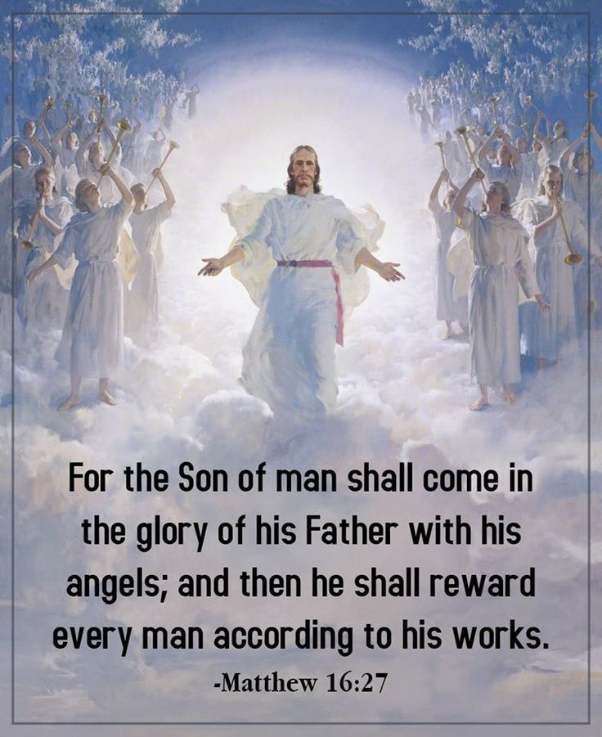

Most Rev. Timothy C. Senior, Bishop of Harrisburg
Rev. Dominic M. DiBiccaro, Pastor
Deacon Steve Huete, Pastoral Associate

Mass Schedule, Intentions, and Events
Please Pray for:
Those who are ill, Jeanie Kline & the Kline Family, Brenda Wolf, Wade Sprankle, Dulcie Perry, Ron Formosa, Gavin Crumbacker, Anna Kane, Sherry Dennis and Family, Remi Peters, Christy Hemler, Terry Ahn, K. Grance, Lori McFadden & Family, Mike & Lisa Poole, Mervin Weikert, Chastity Rudisill, Mary Ellen Wilson, Terry & Bernie Cabana, Ed & Aggie Sherensky and Family, Bob Raffensberger, Jerry & Ginny Miller, Adeline Lienard, Kaylee Henry, Nancy Wuller, Dr. Mike Colli, Mrs. Kelly Kump, Gabriel Singer, Sharon McCormley, Ron Thumma, Joe Wisotzkey, Leo Hockensmith, Erika McKissick, Jean "Heather" O'Shea, Scott Moore and Sally Moore, Mary Wyatt, Jim & Joyce Deardorff, Amy Weatherup, Sophia Joy Ernst, Deacon Richard Wentzel, Deacon Frank Enderle, Kathleen Thompson, Deb & Kathy McLintock and Family, Rachel Wonders, Amy Edwards, Jean O’Connor, Paul Angello, Jen Baldwin, Ursula Kaley, Deb Bennet, Fr. Bill Sullivan, Larry Endy, Laura Lee, Marwa Abdelrahman, Donna Singley, Tim McGinn, Jane Kump, Peggy Neiderer, Chris Kimple, Robert Riquet, Gene & Jo-Ann McDannell, Bob Doxzen, Kimberly Mears, Gabriella Angello, Paul Angello, Mark & Kate Morrow, Mark Morris, Linda Fogleman, Paul Knight, George & Barbara Erstila, Jeff Carpenter, Lana & Nelson Harmon, Diane Slothour, Sue McDannell, Larry Schneider, Joe & Lisa Grasel, Ange Pena, Julie Barnhart, the Shaffer Family, Heather & Emma Dickerson, Brad Pabody, Paul Ward, Aiden Tyler Schneider, Dorothy Vega, Karrie McCall & daughter, George Shahid, Denise Navlyt, Drew Schneider & Family, Ida Bloomfield, Linda McDannell, Janie Singley, Mary Beth Greenstreet, Rick Benedict, Jan Patla, Kathe Fogleman, Sam Sheffler, Kate Hemmis, Bill & Mary Lou Graham, Joanna Hodges, John Varones, Joan O’Sullivan, Martha Klinger, Lisa Dionne Lauretti, Sue Orndorff, Jim Gleason, Sue Gustafson, Joe & Michelle Cleary, Kim Johnson, Helen Mills, Kathy Haber, Haley Detman, Joe Durovey, Bev Smith, Donald Sheppard, Linda Mumaugh, Alison Haring, Janet Hartman, Edward Johnson, Angela Galeone, Juliete Lang, Chris MacBeth, Harry Graham, Donald Howard, Armond Binni, Elizabeth Stansky, Pat Johnson, Chris Morris, Faud Doaney, Wilson & Rae Harman, Patrick Glass, Helen Lagasse, Nancy Kewisnek, Andy Graham, Bill & Maureen Collins, Rosemary McGilloway, Anji Eisenhart, Monica Manner, Denny Borbonus, Dr. Paul Scarlata, Mary Hawthorne, Ed Washington, Josh Kempinski, Nancy Baker Baltzey, Spencer Propts, Karlton Smith & Cheryl Sobun, James & Marylyn Sobun, Marlene Webster, Yvette Stoklosa, Andy Consiglio, Bill & Michelle Cloonan, Nelson Salem, Bill & Deb McClintock, nursing home residents & shut-ins, the victims of war, violence, disease, disaster, & all private intentions.
Also in your prayers, please remember all our men
And women currently serving in our Armed Forces:
Maj. Nathan Jeffcoat – US Marine Corps
Lt. Joseph Cleary – US Navy
Michael C. Kenney IV – US Coast Guard
Lt. Joshua Kimple – US Army
Lt. Sarah Fogleman, M.D. – US Navy
A1C Ian Bellinger ‒ PA Air National Guard

PRAYER CHAIN: Contact Lynne Mobley at 703-876-4901 or LMOBLEY509@gmail.com

for the Week of September 2 to September 10, 2023

SATURDAY, September 2 – VIGIL 22nd SUNDAY OT

Jer 20:7-9 / Rom 12:1-2 / Mt 16:21-27
5:00PM + Joan & Eugene Schott

SUNDAY, September 3 – 22nd SUNDAY IN OT

Jer 20:7-9 / Rom 12:1-2 / Mt 16:21-27
8:00AM ⁓ People of the Parish
10:30AM + Claudia Collins

Monday, September 4 (Weekday in OT)
1 Thes 4:13-18 / Lk 4:16-30
Parish Office Closed
NO MASS

Tuesday, September 5 (Weekday in OT)
1 Thes 5:1-6, 9-11 / Lk 4:31-37

8:00AM – 3:00PM ~ Office Open

10:00AM + James Bucci

NO “Something More” Group
Parish Council 6:30PM

Wednesday, September 6 (Weekday in OT)
Col 1:1-8 / Lk 4:38-44

8AM – 3PM ~ Office Open
11AM: Mature Spirituality Group
7:00PM + Douglas Hugonin
6–6:45PM Confessions heard; 7:40PM Adoration & Benediction

Thursday, September 7 (Weekday in OT)
Col 1:9-14 / Lk 5:1-11

8AM – 3PM ~ Office Open

10:00AM ‒ Special Intention for Christian Rebscher III

Friday, September 8 - The Nativity of the BVM  Mi 5:1-4a or Rom 8:28-30 / Mt 1:18-23  10:00AM + Elizabeth Alexandra Mary Windsor  Parish Office CLOSED | THE LORD

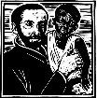

SATURDAY, September 9 – St. Peter Claver, Priest

MORNING: Col 1:21-23 / Lk 6:1-5

SATURDAY, Sept. 9 – VIGIL 23rd SUNDAY OT

Ez 33:7-9 / Rom 13:8-10 / Mt 18:15-20
5:00PM + Dominic DeToma

SUNDAY, Sept. 10 – 23rd SUNDAY IN OT

Ez 33:7-9 / Rom 13:8-10 / Mt 18:15-20
8:00AM ⁓ People of the Parish
10:30AM ‒ Private Intention
Sanctuary Candle offered for SEPTEMBER: In Honor of Richard, Emma Carey, children & grandchildren

Sunday Collection Summary
August 26 and 27 (Picnic Weekend)

Weekend Collections
Regular Offering $ 2,779.08
Candles $ 21.50
Assumption (additional) $ 20.00
TOTAL OFFERINGS $ 2,820.58

‒ WEEKLY BUDGETARY NEEDS $ 4,494.00
+ Overage or (Shortfall) for the week ($ 1,673.42)

Other Income
Local Poor $ 10.00
Parish Picnic (additional) $ 60.00
Miscellaneous Refund $ 49.29
Individual Contribution $25,000.00
Total Other Offerings $25,119.29

Diocesan Second Collections
Peter’s Pence $ 10.00
World Mission Sunday $ 10.00
TOTAL DIOCESAN OFFERINGS $ 20.00

+ + + + + + + + + + + + + + + + + + + + + + + + + + +
Sunday Collection Summary
August 19 and 20

Weekend Collections
Regular Offering $ 2,347.00
Candles $ 98.00
Assumption (additional) $ 335.00
TOTAL OFFERINGS $ 2,780.00

‒ WEEKLY BUDGETARY NEEDS $ 4,494.00
+ Overage or (Shortfall) for the week ($ 1,714.00)

Other Income
Parish Picnic (additional) $ 395.00
Picnic Raffle Tickets $ 355.00
Individual Contribution $ 5,000.00
Total Other Offerings $ 5,750.00

============================================================
Survivor Mass

A Mass for Hope & Healing will be celebrated by Bishop Timothy Senior on
Tuesday, Sept. 19, 7PM at Saint Catherine Labouré Church, 4000 Derry St., in Harrisburg. During this Mass, we will pray for, and with, survivors of clerical sexual abuse.
All are encouraged to attend.

Knights of Columbus Council 14035

VOCATIONS BREAKFAST

coming Sunday, September 17th after all Masses down in

the Social Hall

FREE-WILL OFFERING!

As many of you know, the original use of the proceeds from this year’s Buchanan valley Picnic was hoped to be a joint parish/community donation to aid
our brothers and sisters suffering from the horrific wildfires in Maui.
Since that effort of charity has been disrupted, there have been a few inquiries from compassionate souls still disposed to support their struggle for monumental and ongoing relief.

So, unless there is a Special Collection for Disaster Relief authorized by the USCCB or the Diocese of Harrisburg, THERE WILL BE NO DONATION MADE IN THE NAME OF THE PARISH.

Therefore, it is strongly suggested that anyone of kind heart still wanting to do so, to donate the funds DIRECTLY THROUGH THE HAWAII CATHOLIC COMMUNITY FOUNDATION (HCCF).
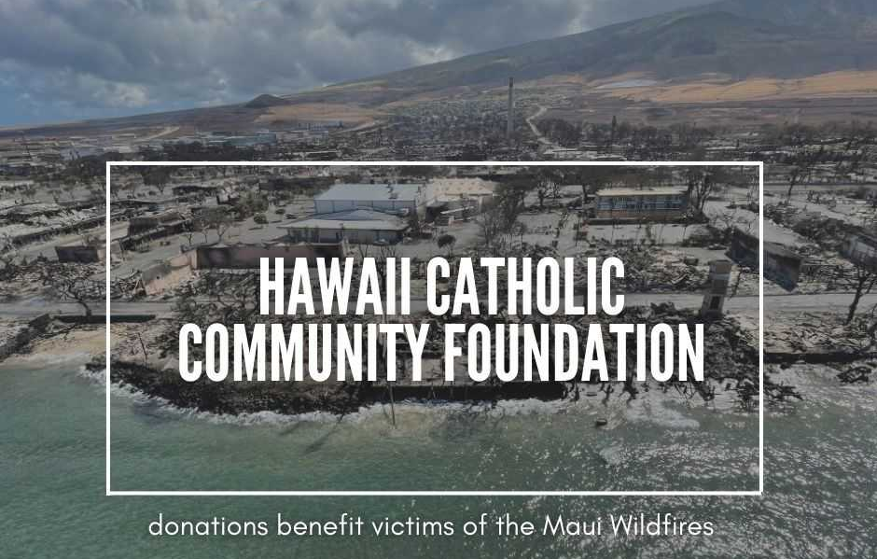

This Foundation was established to support the parishes and school communities in the Diocese of Honolulu. Bishop Larry Silva, Bishop of Honolulu, has set up a dedicated webpage for donations to go directly to HCCF to support the relief efforts for those affected
by the devastation in Maui.

You can make a tax-deductible contribution by visiting the following link:

https://tinyurl.com/MauiCatholic

Donations may also be made directly by going onto the Diocesan webpage of the Diocese of Honolulu and click on the HCCF link there. Every donation, no matter the amount, will play a crucial role in helping to rebuild lives and restore hope for the fire victims and their families.
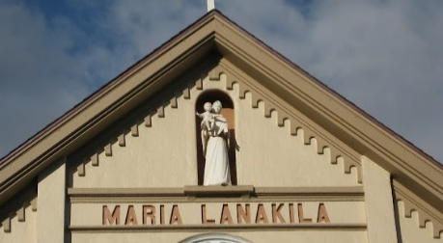
We place what is left of our humble attempt under the intercession of Maria Lanakila, (Mary, Our Lady of Victory)
whose church remained standing after the fires of hell tried – but failed – to destroy her and all who hope in her!

As the Master has taught us, “Whatever you did for the least of my brethren, YOU DID IT FOR ME.”
The Holy Father, Pope Francis’ Prayer Intentions for 2023
Entrusted to His Worldwide Prayer Network

SEPTEMBER ⁓ FOR PEOPLE LIVING ON THE MARGINS
We pray for those persons living on the margins of society, in inhumane life conditions; may they not be overlooked by institutions, and never considered of lesser importance.

For Your Life: Scott Hahn Reflects

on the Twenty-second Sunday in Ordinary Time

Today’s First Reading catches the Prophet Jeremiah in a moment of weakness. His intimate lamentation contains some of the strongest language of doubt found in the Bible. Following God’s Call, he feels abandoned. Preaching His Word has brought him only derision and reproach.

But God does not deceive — and Jeremiah knows this. God tests the just (see Jeremiah 20:11–12) and disciplines His Children through their sufferings and trials (see Hebrews 12:5–7).

What Jeremiah learns is what Jesus states explicitly in today’s Gospel. To follow Him is to take up a cross, to deny yourself — your priorities, preferences, and comforts. It is to be willing to give it all up, even life itself, for the sake of His Gospel. As St. Paul says in today’s Epistle, we have to join ourselves to the Passion of Christ, to offer our bodies — indeed, our whole being — as “living sacrifices” to God.

By His Cross, Jesus has shown us what Isra-el’s sacrifices of animals were meant to teach: we owe to God all that we have.

God’s kindness is a greater good than life itself, as we sing in today’s Psalm. The only thanks we can offer is our spiritual worship, giving our lives to the service of His Will (see Hebrews 10:3–11; Psalm 50:14, 23).

Peter doesn’t yet get this in today’s Gospel. As it was for Jeremiah, the Cross is a stumbling block for Peter (see 1 Corinthians 1:23). This is our natural temptation, as well: to refuse to believe that our sufferings play a necessary part in God’s Plan.

That’s how people think, Jesus tells us today. But we are called to the renewal of our minds — to think as God thinks, to will what He Wills.

In the Holy Mass, we once again offer ourselves as perfect and pleasing sacrifices of praise (see Hebrews 13:15). We bless Him as we live, confident that we will find our lives in losing them, that with the riches of His Banquet our souls will be satisfied.

Readings: Jeremiah 20:7–9; Psalm 63:2–6, 8–9; Romans 12:1–2; Matthew 16:21–27

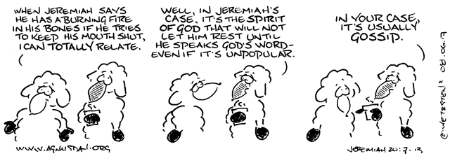

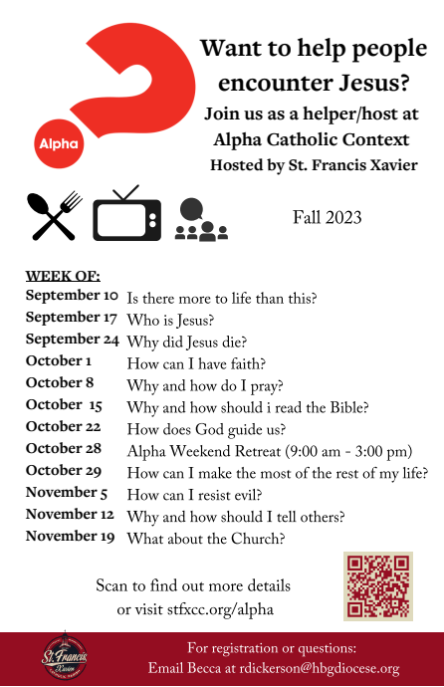
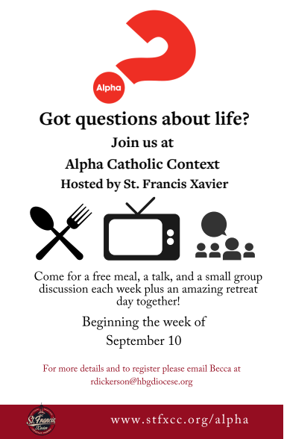

NEW FROM THE “SOMETHING MORE” FAITH GROUP THIS FALL!

Beginning Tuesday, September 12th, 11AM,

in the Upper Loyola Conference Room.

BOOKS PROVIDED! NO CHARGE!!

EVERYONE WELCOME!!!
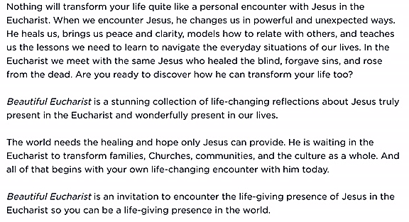

PLEASE JOIN US FOR A
SPECIAL PRESENTATION BY
SISTER THELMA STEIGER, HSF

The Eucharist:
From Gift to Giving

St. Ignatius Loyola Parish
1095 Church Road, Orrtanna, PA 17353

Saturday, September 9, 2023
10:00 A.M. to 12:00 Noon

EVERYONE IS INVITED!
Light Refreshments Will Be Served.

FREE-WILL OFFERING FOR THE TAU HERMITAGE
