Sacrament of Penance
Wednesday ~ 6:00 - 7:00 pm; or by appointment.

Sacrament of the Sick
Anointing of the Sick should be given if an individual is gravely ill or near death. If possible, the Sacrament should also be administered before major surgery or when one is initially hospitalized.

Sacrament of Holy Matrimony
Diocesan policy requires 12 months of preparation for Marriage. Contact the parish as soon as possible after engagement. No arrangements should be made prior to consultation with the pastor.

Sacrament of Baptism
Parents must be registered members of the parish and attend a Baptism preparation class prior to the Baptism if this is your first child baptized. Requirements for godparents are established by the Catholic Church. Please call the parish office for Information and to register your child for Baptism.

Parish Registration
All Catholics should be registered in their local parish. Please contact the parish office to obtain registration forms, or if you are uncertain of the parish where you should register.

Parish Staff & Ministries Directory
stignatiusofloyola@hbgdiocese.org
Financial Manager ~ Richard Deardorff ~ 717- 677-8012 or 717-420-3464 (cell)
rdeardorff@hbgdiocese.org
Director of Religious Education ~ Deacon Steve Huete ~ shuete@hbgdiocese.org
Administrative Assistant ~ Kristen DiDio ~ kdidio@hbgdiocese.org
Buildings & Grounds ~ JB Groff ~ 717-677-8012
Music Ministry ~ Phil Mobley ~ 717-677-8012
Parish Council Members
Kathleen Allwein
Donnie Althoff
Charlie Baker
Jim Bittle
Mike McTighe
Joanne Riedel - Secretary
Walt Wilson - Chair

Finance Council Members
Richard Deardorff (Ex Officio)
Greg Ernst - Chair
Alix Haller
Christy Hemler - Secretary
Terri Pendlelton
Bill Pulig

Altar Flowers
Prayer Chain
Lynne Mobley at LMOBLEY509@gmail.com
or 703-876-4901.

Soup Kitchen
Please send donations directly to “Soup Kitchen”

Website Development
Kristen DiDio
Life After Loss
Dodie Huete

OCIA
Contact Fr. Dominic

Picnic Co-Chairpersons
John Neiderer
Wally Kane

Pro-Life Ministry
OPEN – Contact office if you are interested

Knights of Columbus
SK Bob Ternes
- Grand Knight

Covid-19 Task Force
Walt Wilson - Coordinator
Health Advisors:
Dr. Robert Ternes and
Joanne Cochran
(Keystone Health System)

OPEN - Contact office if you are interested

Bereavement Ministry
Ginny Bittle

Catholic Communications/EWTN
Open - Contact office if you are interested

Cemetery
Contact Parish Office
THEOSIS Ministry
Kathy Dietsch 717-352-4558
Bicky Redman 717-677-8592

Diocese of Harrisburg Youth Protection Program
www.YouthProtectionHBG.com

Abuse Reporting Contact Information:
First – Call the toll-free PA Child Abuse Hotline at 800-932-0313
Then – Call the Diocesan toll-free hotline at 800-626-1608

“If one member suffers,
all suffer together with it.” (1 Cor 12:26)

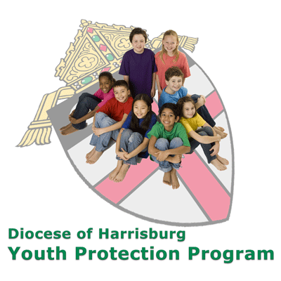

St. Ignatius Loyola RC Church

1095 Church Road, Orrtanna, Pennsylvania 17353
www.stignatiusofloyola.org

February 12, 2023: 5th SUNDAY in Ordinary Time

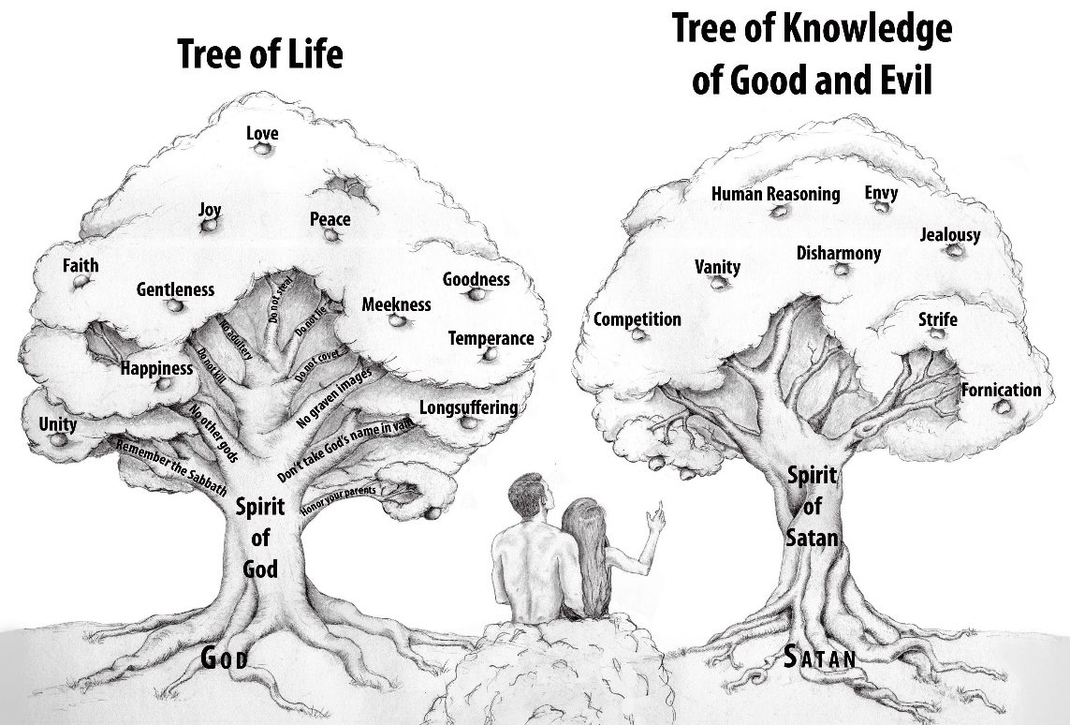

Most Reverend Ronald W. Gainer, Bishop of Harrisburg;
Rev. Dominic M. DiBiccaro, Pastor / Deacon Steve Huete, Pastoral Associate
Mass Schedule, Intentions, and Events
Please Pray for:
Coronavirus victims and those who are ill, Jim & Jeanie Kline, Mrs. Kelly Kump, Kevin and Brittany Groff, Gabriel Singer, Bill Henry, Sharon McCormley, Ron Thumma, Joe Wisotzkey, Leo Hockensmith, Erika McKissick, Jean "Heather" O'Shea, Scott Moore and Sally Moore, Mary Wyatt, Jim & Joyce Deardorff, Brandon & Michelle Gilbert, Amy Weatherup, Sophia Joy Ernst, Mary & Chuck Irwin, Deacon Richard Wentzel, Deacon Frank Enderle, Marie Kalp, Kathleen Thompson, Deb & Kathy McLintock and Family, Rachel Wonders, Amy Edwards, Jean O’Connor, Art Lazar, Sr., Mark & Michelle Huete, Paul Angello, Jen Baldwin, Ursula Kaley, Deb Bennet, Fr. Bill Sullivan, Fr. Chet Snyder, John Larry Endy, Mary Beth McCarthy, Laura Lee, Marwa Abdelrahman, Cathy Gates, Donna Singley, Jack Ryff, Tim McGinn, Jane Kump, Gary, Bill, Jerry, Andy, Colleen, Baby Addie, Peggy Neiderer, Chris Kimple, Robert Riquet, Gene & Jo-Ann McDannell, Bob Doxzen, Kimberly Mears, Gabriella Angello, Mark & Kate Morrow, Mark Morris, Linda Fogleman, Paul Knight, George & Barbara Erstila, Jeff Carpenter, Lana & Nelson Harmon, Cole & Connor, Diane Slothour, Sue McDannell, Larry Schneider, Joe & Lisa Grasel, Ange Pena, Julie Barnhart, the Shaffer Family, Heather & Emma Dickerson, Brad Pabody, Adeline Lienard, Robbie, Michael & daughter, Paul Ward, Aiden Tyler Schneider, Dorothy Vega, Karrie McCall & daughter, George Shahid, Denise Navlyt, Drew Schneider & Family, Ida Bloomfield, Linda McDannell, Janie Singley, Mary Beth Greenstreet, Rick Benedict, Jan Patla, Kathe Fogleman, Sam Sheffler, Kate Hemmis, Bill & Mary Lou Graham, Joanna Hodges, John Varones, Joan O’Sullivan, Martha Klinger, Lisa Dionne Lauretti, Sue Orndorff, Jim Gleason, Sue Gustafson, Joe & Michelle Cleary, Kim Johnson, Helen Mills, Kathy Haber, Haley Detman, Joe Durovey, Bev Smith, Donald Sheppard, Linda Mumaugh, Alison Haring, Janet Hartman, Edward Johnson, Angela Galeone, Juliete Lang, Chris MacBeth, Harry Graham, Donald Howard, Armond Binni, Elizabeth Stansky, Pat Johnson, Chris Morris, Faud Doaney, Wilson and Rae Harman, Patrick Glass, Helen Lagasse, Nancy Kewisnek, Andy Graham, Bill & Maureen Collins, Rosemary McGilloway, Anji Eisenhart, Monica Manner, Denny Borbonus, Dr. Paul Scarlata, Mary Hawthorne, Ed Washington, Josh Kempinski, Nancy Baker Baltzey, Spencer Propts, Karlton Smith & Cheryl Sobun, James & Marylyn Sobun, Marlene Webster, Yvette Stoklosa, Andy Consiglio, Bill & Michelle Cloonan, Nelson Salem, Janet Shunnarah, George Shunnarah, Bill & Deb McClintock, Mary Pekich, nursing home residents & shut-ins, the victims of war, violence, disease, disaster, & all private intentions.

Also In your prayers, please remember all our men and women currently serving in our Armed Forces:
Maj. Nathan Jeffcoat – US Marine Corps
Lt. Alexandra Jeffcoat – US Navy
Lt. Joseph Cleary – US Navy
Michael C. Kenney IV – US Coast Guard
Lt. Joshua Kimple – US Army
and Lt. Sarah Fogleman, M.D. – US Navy
PRAYER CHAIN: Contact Lynne Mobley at
LMOBLEY509@gmail.com or 703-876-4901.

for the Week of January 28 ~ February 5, 2023

SATURDAY, February 11-VIGIL MASS 6th SUNDAY ORDINARY TIME

Sir 15:15-20/1 Cor 2:6-10/Mt 5:17-37 or 5:20-22a, 27-28, 33-34a, 37
5:00PM + Mary and Claude Mobley
SUNDAY, February 12 –6th SUNDAY OF OT

Sir 15:15-20/1 Cor 2:6-10/Mt 5:17-37
8:00AM + Helen, Jim, and Henry Kimple
10:30AM ~ People of the Parish

Monday, February 13 (Weekday in OT)
Gn 4:1-15, 25 / Mk 8:11-13
Parish Office Closed

Tuesday, February 14 – Sts. Cyril, Monk, and Methodius, Bishop
Gn 6:5-8; 7:1-5, 10 / Mk 8:14-21 (St. Valentinius - Traditional)
8:00AM - 3:00 PM ~ Office Open
10:00AM +Catherine Gates and +Thomas Long

11:00AM: “Something More” Faith Group

Wednesday, February 15 (Weekday in OT)
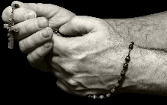
Gn 8:6-13, 20-22 / Mk 8:22-26

8:00AM - 3:00 PM ~ Office Open

10:00AM: Senior Spirituality Group
*ROSARY FOR EARTHQUAKE
VICTIMS during ADORATION
7:00PM + Deceased Members of K of C Council #14035
Confessions heard from 6-6:45PM; with Adoration* 7:40–8PM
Thursday, February 16 (Weekday in OT)
Gn 9:1-13/Mk 8:27-33
8:00AM - 3:00 PM ~ Office Open
10:00AM +Margaret Gracyalny

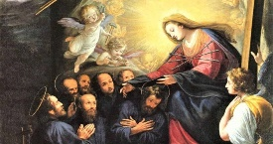
Friday, February 17 -Seven Holy Founders of
Gn 11:1-9/Mk 8:34—9:1 the Servite Order
10:00AM +Charles C. Speitel, Jr.
Parish Office CLOSED

Saturday, February 18 (Weekday in OT)

MORNING: Heb 11:1-7 / Mk 9:2-13

SATURDAY, February 18-VIGIL MASS 7th SUNDAY ORDINARY TIME

Lv 19:1-2, 17-18 / 1 Cor 3:16-23 / Mt 5:38-48
5:00PM + Jim and Delores Gilbert
SUNDAY, February 19 –7th SUNDAY OF OT

Lv 19:1-2, 17-18 / 1 Cor 3:16-23 / Mt 5:38-48
8:00AM + Janice Heffner
10:30AM ~ People of the Parish

Sanctuary candle offered for FEBRUARY: In loving memory of Donald Redding from Edna Redding
Sunday Collection Summary
Collection Summary for the Month of January 2023 (5 Weeks)

Weekend Collections
Sunday Offering $ 16,718.66
Candles/Living Faith $ 277.80

Parish Second Collections
Thanksgiving $ 10.00
Christ the King $ 10.00
Ash Wednesday $ 15.00
Cemetery Upkeep $ 1,630.00
Local Poor $ 25.00
Holy Day: Immaculate Conception $ 5.00
Mary Mother of God $ 175.00
TOTAL OFFERINGS $ 18,866.46

― TOTAL BUDGETARY NEEDS $ 23,278.68
+(Overage) or (Shortfall) for the month ($ 4,412.22)

Other Income
Cemetery Lot Sales $ 720.00
Individual Contributions $ 10,800.00
Additional Christmas Income $ 680.00
Stewardship Bookcase $ 112.00
Memorial (Redding) $ 370.00
Total Other Income $ 12,682.00

Diocesan Second Collections
Retirement Religious $ 10.00
Ch Eastern Europe $ 887.69
Matthew 25 $ 5.00
Poor Missions in US $ 45.00
Propagation of Faith $ 10.00
TOTAL DIOCESAN OFFERINGS $ 957.69

February 4 & 5

Weekend Collection
Regular Offering $ 3,675.00
Candles $ 88.05
Cemetery Upkeep $ 55.00
Ash Wednesday $ 15.00
Altar Flowers $ 50.00
Local Poor $ 20.00
TOTAL OFFERINGS $ 3,903.05

― WEEKLY BUDGETARY NEEDS $ 5,819.68
+Overage or (Shortfall) for the week ($ 1,916.63)

Other Income
Memorial (Redding) $ 100.00

Diocesan Second Collections
Propagation of Faith $ 610.00
Poor Missions US $ 235.00
TOTAL DIOCESAN OFFERINGS $ 845.00

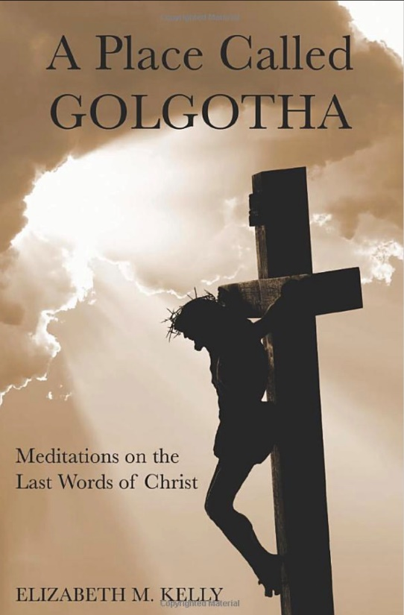

The Tuesday Morning Book Group has ended the “Something More” series and is kicking off a new book study featuring the book reviewed on pages 49-53 of the February issue of Word Among Us. “A Place Called Golgotha” is designed to enrich your prayer times, especially during the upcoming season of Lent. Author Elizabeth Kelly offers insights into Jesus’ words on the Cross. It is also of note that Ms. Kelly will be the keynote speaker at the Harrisburg Diocese Women’s Conference April 15, 2023.
The study will run every Tuesday after Mass from February 21 to April 11 (but no meeting on April 4 during Holy Week). WE HOPE YOU CAN JOIN US IN THIS EXCITING APPROACH TO DEEPENING OUR FAITH!
The book can be purchased from Amazon or directly from Word Among Us at www.wau.org. Please contact Judy Wilson 717-443-3139 or jwilson3882@comcast.net for further details or with any questions.

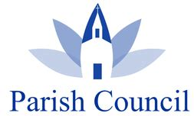
February 11 – Hot Chicken Sandwich Dinner
February 12 – World Marriage Day (Blessing @ Masses)
February 12 – 2nd Collection: Black & Indian Missions
February 22 – ASH WEDNESDAY (Lent begins!)
February 27 – 2023 PICNIC Kick-Off Meeting

March 11 – Lenten Mini Retreat w/Sr.Thelma Steiger

Benedict XVI describes ‘Protestantization’ of the Eucharist

in posthumous publication

By Hannah Brockhaus, Catholic News Agency | Rome Newsroom, Feb 8, 2023

In a 2018 essay published after his death, Pope Benedict XVI said a Protestant-like understanding of the Eucharist and strong calls for intercommunion are often found together.

Commenting on the current situation of Eucharistic life in the Catholic Church, the late pope emeritus said: “One process of great impact is the almost complete disappearance of the Sacrament of Penance.”

There is also the understanding of Communion as merely “a supper,” he added. “In such a situation of a very advanced Protestantization of the understanding of the Eucharist, intercommunion appears natural.”

Benedict’s essay on the Eucharist is part of a series of texts the pope emeritus wrote after his resignation in 2013. The essays, letters, and reflections have been collected into a single volume, “What Is Christianity?,” which was published in Italian last month.

According to Vatican journalist Sandro Magister, Benedict XVI had arranged for the writings to be published after his death.
The Italian magazine L’Espresso published an excerpt of one the essays, a 17-page text on “the meaning of Communion,” which was finished in June 2018, when the Church in Germany was debating intercommunion: whether Protestant spouses of Catholics could receive the Eucharist at Mass.

In his essay, Benedict recalled other moments in Germany’s history when there were calls for intercommunion and said that today, sometimes those same calls are based more on outside forces than on the desire for unity in Christ.

“Especially during the years of the war, in the evangelical camp a division developed between the Third Reich and what were called the ‘deutsche Christen,’ Christian-Germans, on one side, and the ‘bekennende Kirche,’ or the confessing Church, on the other,” he explained.

The split led to a new accord between evangelical Christians and the Catholic Church, he said. “One result was a push in favor of common Eucharistic Communion between the confessions. In this situation there grew the desire for a single Body of the LORD that today, however, risks losing its strong religious foundation and, in an externalized Church, is determined more by political and social forces than by the interior search for the LORD.”

The pope emeritus described another time, shortly after the reunification of Germany, when a Eucharistic act, drinking from the chalice, was used “as an essentially political act in which the unity of all Germans became manifest.”

“Thinking back on it, still today I feel anew with great force the estrangement of faith that came from this. And when presidents of the Federal Republic of Germany, who at the same time were presidents of the synods of their Church, have regularly called aloud for interconfessional Eucharistic Communion, I see how the demand for a common loaf and chalice may serve other purposes,” he said.

Benedict XVI also noted a growing support, starting from Protestant exegesis [interpretation], for the opinion that Jesus’ meals with sinners prepared the way for the Last Supper, in which he instituted the Eucharist.

It is argued that the Last Supper, then, is only understood on the basis of Jesus’ other meals in the New Testament, “but [it] is not so,” he said.

“The offering of the Body and Blood of Jesus Christ has no direct connection with the meals with sinners,” the pope emeritus explained, adding that “Jesus celebrated Passover with His family, that is to say with the Apostles, who had become His new family.”

“Thus he complied with a precept according to which pilgrims who went to Jerusalem could join together in companies called ‘chaburot,’” he said. “The Christians continued this tradition. They are His ‘chaburah,’ His family, which He has formed from His company of pilgrims who travel the road of the Gospel along with Him through the land of history.”

“Thus celebrating the Eucharist in the ancient Church was from the beginning linked to the community of believers and with this to strict conditions of access,” he said.

Benedict, in the essay, also comments on the language used by Catholics and Protestants. “In the ecclesial communities arising from the Reformation, the celebrations of the Sacrament are called ‘Supper,’” he said.

“In the Catholic Church the celebration of the Sacrament of the Body and Blood of Christ is called ‘Eucharist.’ This is not a casual, purely linguistic distinction. In the distinction of the denominations there is manifested instead a profound difference tied to the [very] understanding of the Sacrament itself.”

The Holy Father, Pope Francis’ Prayer Intentions for 2023
Entrusted to His Worldwide Prayer Network
FEBRUARY ~ For parishes
We pray that parishes, placing communion at the centre, may increasingly become communities of faith, fraternity, and welcome towards those most in need.

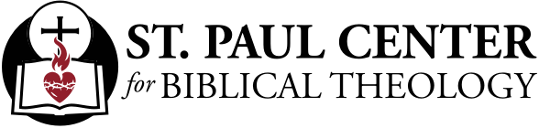

Affair of the Heart: Scott Hahn Reflects

on the Sixth Sunday in Ordinary Time

Jesus tells us in the Gospel this week that He has come not to abolish but to “fulfill” the Law of Moses and the teachings of the Prophets.

His Gospel reveals the deeper meaning and purpose of the Ten Commandments and the moral Law of the Old Testament. But His Gospel also transcends the Law. He demands a morality far greater than that accomplished by the most pious of Jews: the scribes and Pharisees.

Outward observance of the Law is not enough. It is not enough that we do not murder, commit adultery, divorce, or lie.

The law of the New Covenant is a law that God writes on the heart (see Jeremiah 31:31–34). The heart is the seat of our motivations, the place from which our words and actions proceed (see Matthew 6:21; 15:18–20).

Jesus this week calls us to train our hearts, to master our passions and emotions. And Jesus demands the full obedience of our hearts (see Romans 6:17). He calls us to love God with all our hearts and to do His Will from the heart (see Matthew 22:37; Ephesians 6:6).

God never demands more than what we are capable of doing. That is the message of this week’s First Reading. It is up to us to choose life over death, to choose the waters of Eternal Life over the fires of ungodliness and sin.

By His Life, Death, and Resurrection, Jesus has shown us that it is possible to keep His Commandments. In Baptism, He has given us His Spirit, that His Law might be fulfilled in us (Romans 8:4).

The Wisdom of the Gospel surpasses all the wisdom of this age that is passing away, St. Paul tells us in the Epistle. The revelation of this wisdom fulfills God’s Plan from before all ages. Let us trust in this Wisdom and live by His Kingdom Law.

As we do in this week’s Psalm, let us pray that we grow in being better able to live His Gospel and to seek the Father with all our heart.

Readings: Sirach 15:15–20; Psalm 119:1–2, 4–5, 17–18, 33–34; 1 Corinthians 2:6–10; Matthew 5:17–37

THEOSIS: Faith In Action!

Our personal journeys are not always easy and we all need someone to lend a hand at some point along the way, in a confidential environment. This could be something as simple as transport to the hospital, doctor visits, grocery store, minor repairs such as a broken lock, or the installation of a light bulb. There are individuals right here available to support our parish families with such tasks.If you are interested in sharing some time, either by giving assistance or receiving it, please call: Bicky Redman at 717-677-8592 or Kathy Dietsch at 717-352-4558.

In the course of a marriage relationship, a couple will experience family and personal transition times, a variety of life developments, stages that are affected by the age of children, economic and job changes, failures and disappointments, opportunities and celebrations. Times of change and rebuilding can be difficult and upsetting, as well as exciting and challenging. Couples who understand and accept life and marriage as a process, and who have managed this process before, will be affirmed in their growth. They can face new issues and challenges with confidence and hope. Indeed, growth and change are ongoing with marriage.

A dedicated life of faith is vital in this process, and an abiding trust in the Holy Spirit is necessary to help guide married couples through the storms that will often occur. This life of PRAYER, WORSHIP, and CHARITY – for each other and to others – may teach these virtues to children whom they may have been blessed, or will be, for the Glory of Your Name and the Salvation of Souls!
A Prayer for After an Earthquake

LORD, at times such as this,
Pierce, too, our hearts with compassion,
we who watch from afar,
as the poorest on that side of the earth
find only misery upon misery.
Move us to act swiftly this day,
to give generously every day,
to work for justice always,
and to pray unceasingly for those without hope.

And once the shaking has ceased,
the images of destruction have stopped filling the news,
and our thoughts return to life’s daily rumblings,
let us not forget that we are all Your Children
and they, our brothers and sisters.
We are ALL the Work of Your Hands.

For though the mountains leave their place
and the hills be tossed to the ground,
Your Love shall never leave us;
and Your promise of peace will never be shaken.

Our help is in the Name of the LORD,
~ who made Heaven and earth.

Blessed be the Name of the LORD,
~ now and for ever! Amen.

~ Diana Macalintal, 2010, Diocese of San Jose, CA
when we realize that the ground beneath our feet
is not as solid as we had imagined,
we plead for Your Mercy!

As the things men have built crumble about us,
we know too well how small we truly are
on this ever-changing,
ever-moving, fragile planet we call home.
Yet You have promised never to abandon us.
And so we trust that You will not forget
those in Turkey and Syria now.

Today, so many people there are afraid.
They wait in fear of the next tremor.
They hear the cries of the injured amid the rubble.
They roam the streets in shock at what they see.
And they fill the dusty air with wails of grief
and the names of their beloved dead and missing.
Comfort them, LORD, in this disaster.

Be their Rock when the earth refuses to stand still,
and shelter them under Your Wings
when homes no longer exist.
Embrace in Your Arms
those who died so suddenly.
Console the hearts of those who mourn,
and ease the pain of bodies on the brink of death.
