Sacrament of the Sick
Anointing of the Sick should be given if an individual is gravely ill or near death. If possible, the Sacrament should also be administered for serious illness, before major surgery or when one is initially hospitalized.

Sacrament of Holy Matrimony
Diocesan policy requires 12 months of preparation for Marriage. Contact the parish as soon as possible after engagement. No venue reservations or other arrangements should be made prior to consultation with the pastor.

Sacrament of Penance
Wednesday ~ 6:00 – 6:45PM; or by appointment.

Sacrament of Baptism
Parents must be registered members of the parish and attend a Baptism preparation class prior to the Baptism if this is your first child baptized. Requirements for godparents are established by the Catholic Church. Please call the parish office for Information and to register your child for Baptism.

Parish Registration
All Catholics should be registered in their local parish. Please contact the parish office to obtain registration forms, or if you are uncertain of the parish where you should register.

Parish Staff & Ministries Directory
stignatiusofloyola@hbgdiocese.org
Financial Manager ~ Richard Deardorff ~ 717- 677-8012 or 717-420-3464 (cell)
rdeardorff@hbgdiocese.org
Director of Religious Education ~ Deacon Steve Huete ~ shuete@hbgdiocese.org
Administrative Assistant ~ Kristen DiDio ~ kdidio@hbgdiocese.org
Buildings & Grounds ~ JB Groff ~ 717-677-8012
Music Ministry ~ Phil Mobley ~ 717-677-8012
Parish Council Members
*Walt Wilson – Chair 401-0570 (h) wwilson1198@comcast.net
Joanne Riedel - Secretary 398-2021 (h) sterj221@aol.com
Kathi Allwein 677-8984 (h) allweint@comcast.net
*Donnie Althoff 339-6527 (c) dalthoff53@gmail.com
Charlie Baker 677-9536 (h) dcbake@embarqmqil.com
*Jim Bittle 677-6711 (h) ginnybittle@comcast.net
Mike McTighe 729-6239 (c) mike0432@aol.com

Finance Council Members
Richard Deardorff (Ex Officio)
Greg Ernst - Chair
Alix Haller
Christy Hemler - Secretary
Terri Pendlelton
Bill Pulig

Altar Flowers
Prayer Chain
Lynne Mobley at LMOBLEY509@gmail.com
or 703-876-4901

Soup Kitchen
Please send donations directly to “Soup Kitchen”

Website Development
Kristen DiDio
Life After Loss
Dodie Huete

OCIA
Contact Fr. Dominic

Picnic Co-Chairpersons
John Neiderer
Wally Kane

Pro-Life Ministry
OPEN – Contact office if you are interested

Knights of Columbus
SK Bob Ternes
- Grand Knight
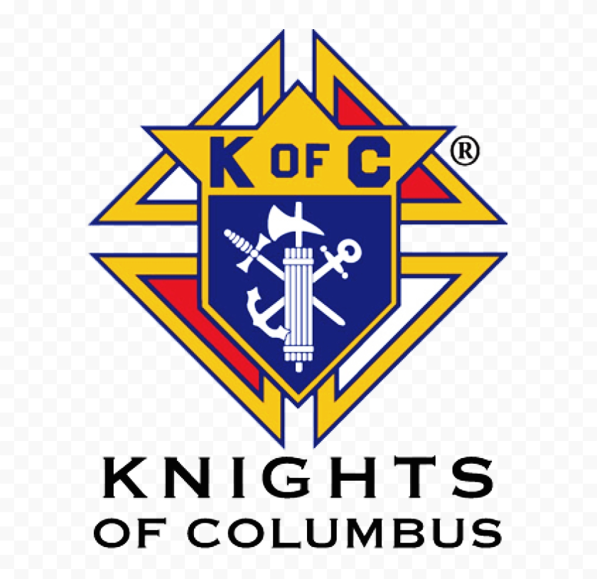

Judy Wilson / Janice Meligakas

Bereavement Ministry
Ginny Bittle / Dodie Huete

Catholic Communications/EWTN
Open - Contact office if you are interested

Cemetery
Contact Parish Office
THEOSIS Ministry
Kathy Dietsch 717-352-4558
Bicky Redman 717-677-8592

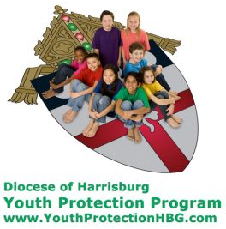
Diocese of Harrisburg Youth Protection Program
www.YouthProtectionHBG.com

Abuse Reporting Contact Information:
First – Call the toll-free PA Child Abuse Hotline at 800-932-0313
Then – Call the Diocesan toll-free hotline at 800-626-1608

“If one member suffers,
all suffer together with it.” (1 Cor 12:26)

St. Ignatius Loyola RC Church

1095 Church Road, Orrtanna, Pennsylvania 17353
www.stignatiusofloyola.org

MAY 21, 2023: SEVENTH SUNDAY OF EASTER
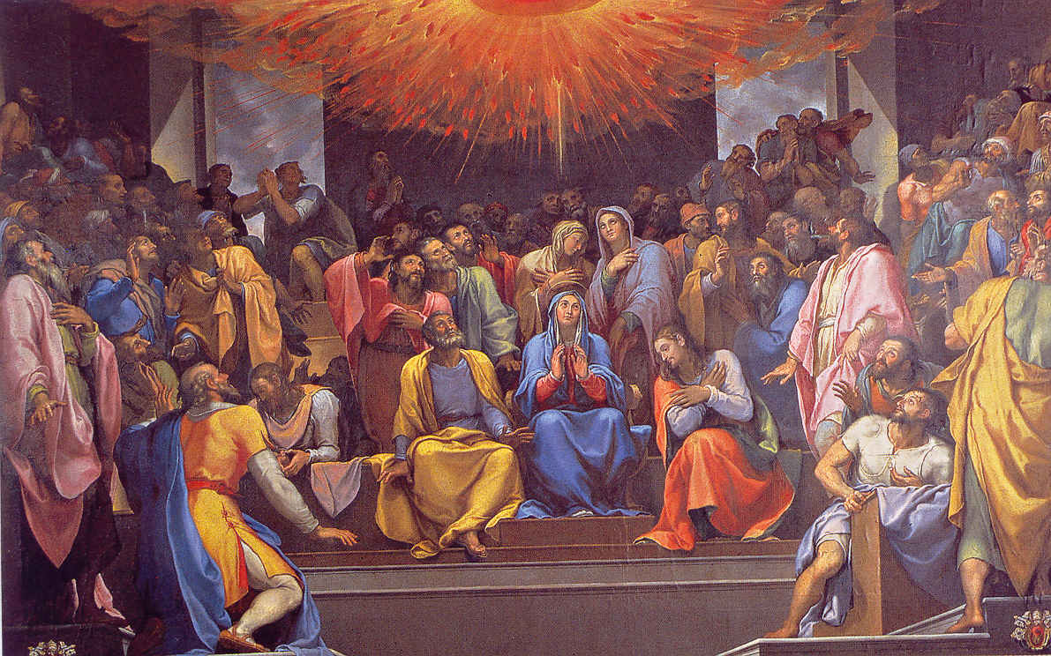

The Apostles, with the Church, gather around Mother Mary in the Upper Room, waiting for the Holy Spirit, promised by the LORD.
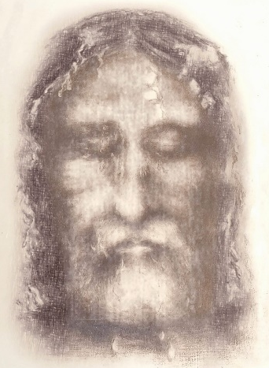
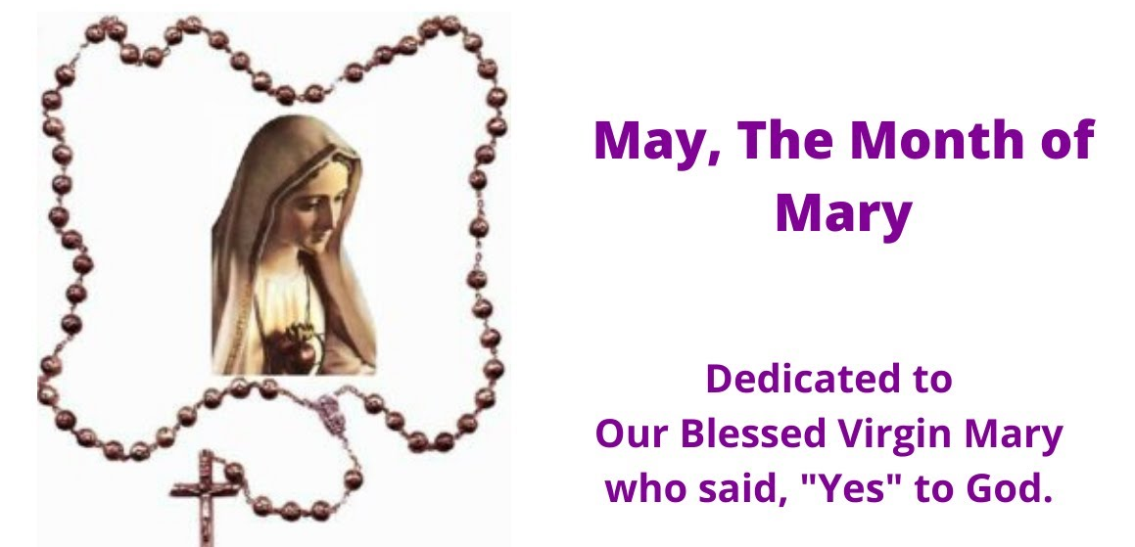
3D image of Jesus made from the Shroud of Turin

Most Reverend Ronald W. Gainer, Apostolic Administrator
Rev. Dominic M. DiBiccaro, Pastor / Deacon Steve Huete, Pastoral Associate
Mass Schedule, Intentions, and Events
Please Pray for:
Those who are ill, Jeanie Kline & the Kline Family, Lori McFadden & Family, Mervin Weikert, Chastity Rudisill, Mary Ellen Wilson, Terry & Bernie Cabana, Ed & Aggie Sherensky and Family ,Bob Raffensberger Jerry & Ginny Miller, Adeline Lienard, Kaylee Henry, Chuck & Nancy Wuller, Dr. Mike Colli, Mrs. Kelly Kump, Kevin & Brittany Groff, Gabriel Singer, Sharon McCormley, Ron Thumma, Joe Wisotzkey, Leo Hockensmith, Erika McKissick, Jean "Heather" O'Shea, Scott Moore and Sally Moore, Mary Wyatt, Jim & Joyce Deardorff, Brandon & Michelle Gilbert, Amy Weatherup, Sophia Joy Ernst, Deacon Richard Wentzel, Deacon Frank Enderle, Kathleen Thompson, Deb & Kathy McLintock and Family, Rachel Wonders, Amy Edwards, Jean O’Connor, Art Lazar, Sr., Mark & Michelle Huete, Paul Angello, Jen Baldwin, Ursula Kaley, Deb Bennet, Fr. Bill Sullivan, Fr. Chet Snyder, John Larry Endy, Mary Beth McCarthy, Laura Lee, Marwa Abdelrahman, Cathy Gates, Donna Singley, Jack Ryff, Tim McGinn, Jane Kump, Gary, Bill, Jerry, Andy, Colleen, Baby Addie, Peggy Neiderer, Chris Kimple, Robert Riquet, Gene & Jo-Ann McDannell, Bob Doxzen, Kimberly Mears, Gabriella Angello, Mark & Kate Morrow, Mark Morris, Linda Fogleman, Paul Knight, George & Barbara Erstila, Jeff Carpenter, Lana & Nelson Harmon, Cole & Connor, Diane Slothour, Sue McDannell, Larry Schneider, Joe & Lisa Grasel, Ange Pena, Julie Barnhart, the Shaffer Family, Heather & Emma Dickerson, Brad Pabody, Paul Ward, Aiden Tyler Schneider, Dorothy Vega, Karrie McCall & daughter, George Shahid, Denise Navlyt, Drew Schneider & Family, Ida Bloomfield, Linda McDannell, Janie Singley, Mary Beth Greenstreet, Rick Benedict, Jan Patla, Kathe Fogleman, Sam Sheffler, Kate Hemmis, Bill & Mary Lou Graham, Joanna Hodges, John Varones, Joan O’Sullivan, Martha Klinger, Lisa Dionne Lauretti, Sue Orndorff, Jim Gleason, Sue Gustafson, Joe & Michelle Cleary, Kim Johnson, Helen Mills, Kathy Haber, Haley Detman, Joe Durovey, Bev Smith, Donald Sheppard, Linda Mumaugh, Alison Haring, Janet Hartman, Edward Johnson, Angela Galeone, Juliete Lang, Chris MacBeth, Harry Graham, Donald Howard, Armond Binni, Elizabeth Stansky, Pat Johnson, Chris Morris, Faud Doaney, Wilson & Rae Harman, Patrick Glass, Helen Lagasse, Nancy Kewisnek, Andy Graham, Bill & Maureen Collins, Rosemary McGilloway, Anji Eisenhart, Monica Manner, Denny Borbonus, Dr. Paul Scarlata, Mary Hawthorne, Ed Washington, Josh Kempinski, Nancy Baker Baltzey, Spencer Propts, Karlton Smith & Cheryl Sobun, James & Marylyn Sobun, Marlene Webster, Yvette Stoklosa, Andy Consiglio, Bill & Michelle Cloonan, Nelson Salem, Janet Shunnarah, George Shunnarah, Bill & Deb McClintock nursing home residents & shut-ins, the victims of war, violence, disease, disaster, & all private intentions.
Also in your prayers, please remember all
our men and women currently serving in
our Armed Forces:
Maj. Nathan Jeffcoat – US Marine Corps
Lt. Joseph Cleary – US Navy
Michael C. Kenney IV – US Coast Guard
Lt. Joshua Kimple – US Army
Lt. Sarah Fogleman, M.D. – US Navy

PRAYER CHAIN: Contact Lynne Mobley at 703-876-4901 or LMOBLEY509@gmail.com

for the Week of May 20 to May 28, 2023

SATURDAY, May 20 – VIGIL MASS 7th SUNDAY OF EASTER

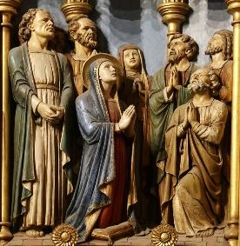
Acts 1:12-14 / 1 Pt 4:13-16 / Jn 17:1-11a
4:30PM Recitation of the Holy Rosary
5:00PM - Private Intention

SUNDAY, May 21 – 7th SUNDAY EASTER

Acts 1:12-14 / 1 Pt 4:13-16 / Jn 17:1-11a

8:00AM + John and Louise Strasbaugh
10:30AM ~ People of the Parish
Monday, May 22 – St. Rita of Cascia, Religious
Acts 19:1-8 / Jn 16:29-33
Parish Office Closed

Tuesday, May 23 (Easter Weekday)
Acts 20:17-27 / Jn 17:1-11a
8:00AM - 3:00 PM ~ Office Open
7:00PM + Michael Kane

11AM: “Something More” Faith Group
Wednesday, May 24 (Easter Weekday)
Acts 20:28-38 / Jn 17:11b-19

8:00AM - 3:00 PM ~ Office Open

11AM: Senior Spirituality Group
7:00PM + Rev. James W. Dolan
Confessions: 6 - 6:45PM; Adoration: 7:40 - 8PM (Rosary during)
† St. Bede the Venerable, Priest &
Doctor of the Church;
† St. Gregory VII, Pope;
† St. Mary Magdalene de’ Pazzi,
Virgin
Thursday, May 25
Acts 22:30; 23:6-11 / Jn 17:20-26

8:00AM - 3:00 PM ~ Office Open

10:00AM – Private Intention

Friday, May 26 – St. Philip Neri, Priest  Acts 25:13b-21 / Jn 21:15-19 | THE LORD
Parish Office CLOSED
10:00AM – Sec. Int. for Amy Weatherup

SATURDAY, May 27 – St. Augustine of Canterbury, Bishop

MORNING: Acts 28:16-20, 30-31 / Jn 21:20-25

SATURDAY, May 27 – VIGIL MASS SUNDAY OF PENTECOST

Gn 11:1-9 or Ex 19:3-8a, 16-20b or Ez 37:1-14 or Jl 3:1-5 / Rom 8:22-27 / Jn 7:37-39
4:30PM Recitation of the Holy Rosary
5:00PM - Spec. Int. for Mark & Penny Schur’s
30th Wedding Anniversary
SUNDAY, May 28 – SUNDAY OF PENTECOST

Acts 2:1-11 / 1 Cor 12:3b-7, 12-13 / Jn 20:19-23

8:00AM + Marie Trimmer
10:30AM ~ People of the Parish

Sanctuary Candle offered for MAY: In Loving Memory of Marilyn Cole from Ken Cole and Family
Sunday Collection Summary
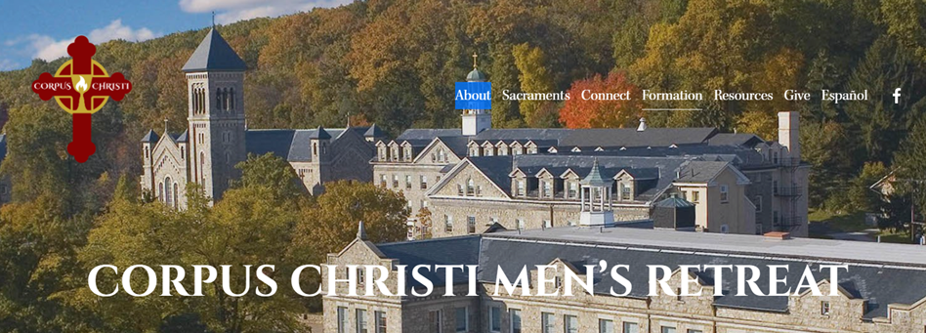

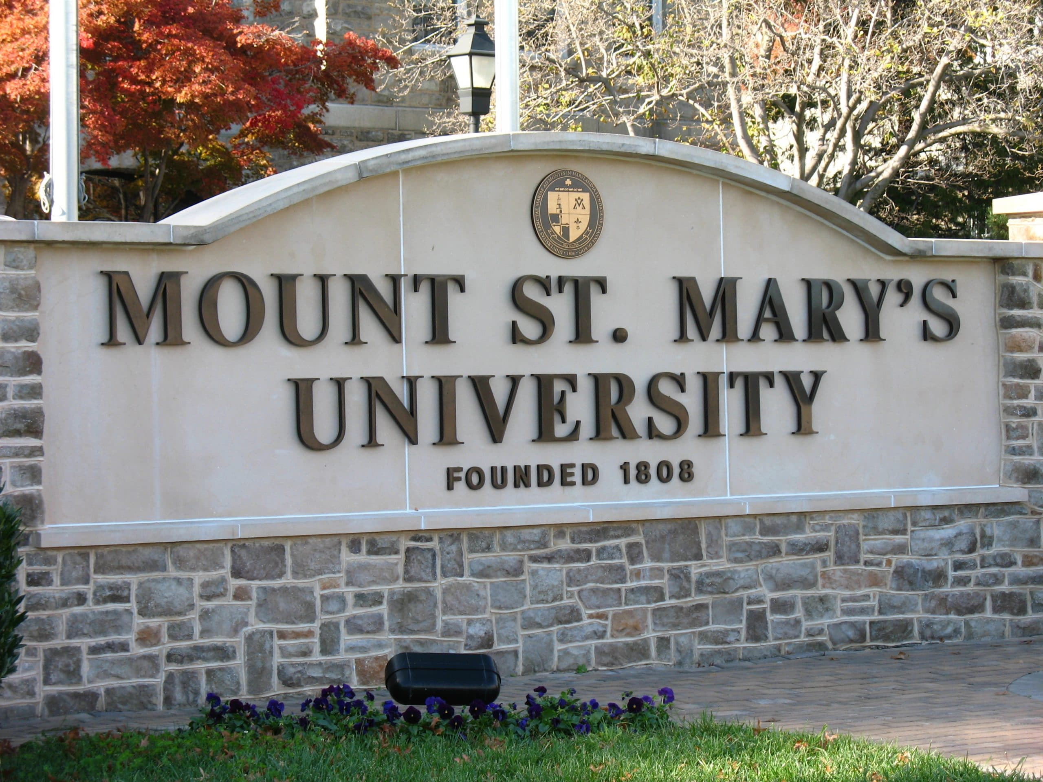

THE 45TH ANNUAL MEN'S RETREAT, sponsored by Corpus Christi Parish, will be held on the August 4-6 weekend on the beautiful campus of Mount St. Mary's University, Emmitsburg, Md. It is open to all men in the Diocese, age 14 and older. MARK YOUR CALENDAR NOW, so you'll remember this weekend to renew your spirit, and His Love in your life. Monsignor William King, Washington, D.C., will lead us this year. Reservations require a minimum $60 deposit and should be made early to ensure a room is held for you.

For more details see: DEACON STEVE HUETE

ATTENTION: PARISH WOMEN:
Father’s Day is coming soon. Why not consider a memorable gift to that man in your life? A weekend to "unwind" and refresh his life as a Catholic, while attending the 45th annual Corpus Christi Men's Retreat, August 4-6 on the beautiful campus of Mt. St. Mary's University, Emmitsburg, MD.

Your gift could be the deposit ($60), or the entire cost ($200). He'll enjoy 2 nights' lodging, 6 meals, and hear a great inspiring, speaker,
Monsignor William King,

May 13 and 14

Weekend Collection
Regular Offering $ 3,861.00
Altar Flowers $ 6.00
Ascension $ 195.00
Candles $ 36.00
Easter (Additional) $ 20.00

Parish Second Collection
Local Poor $ 1,109.00
TOTAL OFFERINGS $ 5,227.00

‒ WEEKLY BUDGETARY NEEDS $ 5,819.68
+Overage or (Shortfall) for the week ($ 592.68)

Other Income
Cemetery Lot $ 100.00
Stewardship Bookcase $ 103.00
Individual Contribution $ 1,000.00
Total Other Offerings $ 1,203.00

Diocesan Second Collections
Pentecost (Helps Future Priests & Sick Priests) $ 170.00
TOTAL DIOCESAN OFFERINGS $ 170.00
Collection Summary for the Month of:
April 2023
Number of Collection Weeks in the Month 5

Weekend Collections
Sunday Offering $ 12,027.00
Alter Flowers $ 50.00
Candles $ 330.06
Easter $ 6,433.00
Holy Thursday $ 941.00
Easter Flowers $ 70.00
TOTAL OFFERINGS $ 19,851.06

‒MONTHLY BUDGETARY NEEDS $ 23,278.68
+Overage or (Shortfall) for the month ($ 3,427.62)

Other Income
Individual Contributions $ 5,000.00
Stewardship Bookcase $ 160.00
Cemetery Lot $ 2,000.00
Bingo (Gross) $ 5,728.40
Total Other Income $ 12,888.40

Diocesan Second Collections
Catholic Home Missions $ 1,008.00
Catholic Relief Services $ 90.00
Holy Land (Good Friday) $ 1,234.00
TOTAL DIOCESAN OFFERINGS $ 2,332.00

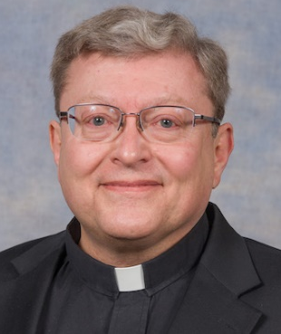

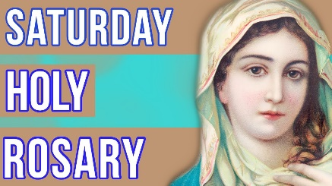
Will be recited before the 5PM Vigil Mass
at 4:30PM. AND…
during the Adoration period on Wednesday evenings.

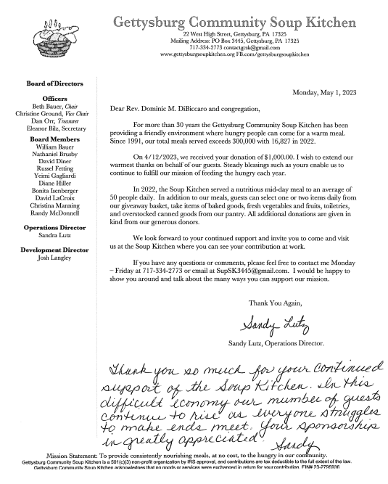

The Holy Father, Pope Francis’ Prayer Intentions for 2023
Entrusted to His Worldwide Prayer Network

MAY ⁓ FOR CHURCH MOVEMENTS AND GROUPS
We pray that Church movements and groups may rediscover their mission of evangelization each day, placing their own charisms at the service of needs in the world.

Knowing God: Scott Hahn Reflects

on the Seventh Sunday of Easter

Jesus has been taken up into Heaven as we begin today’s First Reading. His disciples — including the Apostles and Mary — return to the Upper Room where He celebrated the Last Supper (see Luke 22:12).

There, they devote themselves with one accord to prayer, awaiting the Spirit that He promised would come upon them (see Acts 1:8).

The unity of the early Church at Jerusalem is a sign of the oneness that Christ prays for in today’s Gospel. The Church is to be a communion on earth that mirrors the glorious Union of Father, Son, and Spirit in the Trinity.

Jesus has proclaimed God’s Name to His brethren (see Hebrews 2:12; Psalm 22:23). The Prophets had foretold this revelation: a New Covenant by which all flesh would have knowledge of the LORD (see Jeremiah 31:33–34; Habakkuk 2:14).

By the New Covenant made in His Blood and remembered in every Eucharist, we know God as our Father. This is the Eternal Life that Jesus promises. And this is the Light and Salvation we sing of in today’s Psalm.

As God made Light to shine out of darkness when the world began, He has enlightened us in Baptism, making us new creations (see 2 Corinthians 5:17), giving us knowledge of the Glory of God in the Face of Christ (see Hebrews 10:32; 2 Corinthians 4:6).

Our new life is a gift of “the Spirit of glory,” we hear in today’s Epistle (see John 7:38–39). Made one in His Name, we are given a new name — “Christians” — a name used only here and in two other places in the Bible (see Acts 11:16; 26:28). We are to glorify God, though we will be insulted and suffer because of this Name.

But as we share in His Sufferings, we know we will overcome (see Revelation 3:12) and rejoice when His Glory is once more revealed. And we will dwell in the House of the LORD all the days of our lives!

Readings: Acts 1:12—14; Psalm 27:1, 4, 7—8; 1 Peter 4:13—16; John 17:1—11
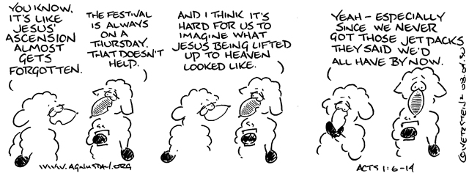

Catholics at the U.S.-Mexico border:

‘Too many people to help, but someone has to’

By Peter Pinedo | Washington D.C., May 15, 2023

As the political debate rages over how to manage a new surge of migrants, Catholics like Rosario Reynolds living along the U.S.-Mexico border face a more personal dilemma: how to respond to desperate new arrivals they encounter in their communities and churches every day.

Reynolds, a 64-year-old public school teacher for deaf students in El Paso, Texas, told CNA that she doesn’t know what the right response to the border crisis is on a government level.

But as Catholics, she firmly believes, “we have a responsibility to help.”

Reynolds and her husband, Michael, have done what they can. She taught a deaf migrant American Sign Language. He drove a young man across the state to reunite him with his brother and U.S. sponsor.

“The family reunion was so beautiful. It was just the right thing to do, what we did,” she said. “I feel like that was what God was calling us to do.”

Yet there is only so much Reynolds feels she can do in the face of such incredible need.

Last year, 2.76 million migrants crossed the U.S.-Mexico border, according to U.S. government estimates — the most ever recorded in U.S. history.

Authorities expect the crisis to only worsen now because of last week’s expiration of Title 42, a health law that allowed migrants to be automatically turned back at the border.

In Washington, D.C., in a narrow 219-213 vote, the U.S. House of Representatives on May 11 passed the Secure the Border Act of 2023, which mandates the completion of a border wall and other measures aimed at ramping up border security.

The measure has very little chance of passing in the majority Democrat Senate and President Joe Biden has already vowed to veto it. The United States Conference of Catholic Bishops (USCCB) strongly condemned the bill, calling it “extreme” and its passage “beyond justification.”
Meanwhile, Texas Gov. Greg Abbott and Florida Gov. Ron DeSantis, both of whom are Catholic, have issued emergency orders and deployed troops to enforce border security.

On Friday, the U.S. bishops representing border dioceses from San Diego to Brownsville issued a statement emphasizing the need to respond to the crisis with “a humanitarian heart that beats with fraternal compassion for those in need.”

“Daily, we witness the human consequences of migration, both its blessings and its challenges,” the bishops said. “We are each bound by a universal call to serve one another and to protect the sanctity of human life in all its forms.”

But acting on that call is a daily challenge for border residents like Reynolds, who fears many of the migrants who will come will not be able to find the help and care they are hoping for.

“It’s going to impact the city greatly, and also those coming over,” she said. “I don’t think the city is prepared to receive them. Yes, there are shelters in place, there are different federal, local, and state help in place, but it’s not enough.”

Though many migrants come across genuinely looking for a better life, it is impossible to differentiate these from criminals and cartel members looking to take advantage of others’ generosity.

Raul Cruz, who has spent significant amounts of time at the border as a volunteer with national humanitarian aid group United Cajun Navy, told CNA that some residents who have offered a helping hand have been taken advantage of.

“I was talking to a gentleman a little while ago, he’s a property owner [in Reynosa], he’s trying to help out these immigrants by letting them stay on his property, but even he said, ‘You know what, I try to give them water, I try to do stuff for them, but if I don’t watch it, they’ll steal my broom, they’ll steal my sandals, they’ll steal anything that’s there,’” shared Cruz. “That’s just that one person, and he’s trying to help them out and they’re still stealing from him.”

In large part, these communities along the border are primarily Hispanic, majority Catholic, and though they have by in large responded with incredible generosity, they are by no means wealthy.

The median household income in El Paso, one of the largest cities on the southern border and one of those most heavily impacted by the migrant crisis, is about $51,000, well below the national average household income, according to the most recent data from the U.S. Census Bureau.

“This is one of the poorest sectors of the United States,” Father Raphael Garcia, an El Paso parish priest, told CNA.

Despite the region’s relative poverty, Garcia said, “I think it’s very much part of the people’s DNA, it’s part of the people’s consciousness that migration is a reality and that family separation is painful, and so I think the people here are very much aware and sensitive and very welcoming to people who are migrating and fleeing violence and injustice.”

Garcia told CNA that his parish, Sacred Heart in downtown El Paso, responded to the need by opening a migrant shelter last December.

Though it can house about 120, Sacred Heart made headlines last Monday, as a viral video showed hundreds of migrants camping out all around the church. The shelter has been regularly filled over capacity with around 1,200 arriving at its doors when the video was taken.

