Sacrament of the Sick
Anointing of the Sick should be given if an individual is gravely ill or near death. If possible, the Sacrament should also be administered for serious illness, before major surgery or when one is initially hospitalized.

Sacrament of Holy Matrimony
Diocesan policy requires 12 months of preparation for Marriage. Contact the parish as soon as possible after engagement. No venue reservations or other arrangements should be made prior to consultation with the pastor.

Sacrament of Penance
Wednesday ~ 6:00 – 6:45PM; or by appointment.

Sacrament of Baptism
Parents must be registered members of the parish and attend a Baptism preparation class prior to the Baptism if this is your first child baptized. Requirements for godparents are established by the Catholic Church. Please call the parish office for Information and to register your child for Baptism.

Parish Registration
All Catholics should be registered in their local parish. Please contact the parish office to obtain registration forms, or if you are uncertain of the parish where you should register.

Parish Staff & Ministries Directory
stignatiusofloyola@hbgdiocese.org | Office: 717-677-8012
Financial Manager ~ Richard Deardorff ~ 717- 677-8012 or 717-420-3464 (cell)
rdeardorff@hbgdiocese.org
Director of Religious Education ~ Deacon Steve Huete ~ shuete@hbgdiocese.org
Parish Secretary ~ Kristen DiDio ~ kdidio@hbgdiocese.org
Buildings & Grounds ~ Donnie Althoff ~ 717-677-8012
Music Ministry ~ Phil Mobley ~ 717-677-8012
Parish Council Members
Phil Mobley – Chair 571-236-7580 pmmobley@gmail.com
Bicky Redman – Vice Chair 677-8592 feetintheair7@gmail.com
Joanne Riedel - Secretary 398-2021 sterj221@aol.com
Kathi Allwein 677-8984 allweint@comcast.net
Charlie Baker 677-9536 dcbake@embarqmqil.com
Mike McTighe 729-6239 mike0432@aol.com
Dr. BobTernes rjtmd46@gmail.com

Finance Council Members
Richard Deardorff (Ex Officio)
Greg Ernst - Chair
Alix Haller
Christy Hemler - Secretary
Terri Pendlelton
Bill Pulig

Altar Flowers
Prayer Chain
Lynne Mobley at LMOBLEY509@gmail.com
or 703-876-4901

Soup Kitchen
Please send donations directly to “Soup Kitchen”

Website Development
Kristen DiDio
Life After Loss
Dodie Huete

OCIA
Contact Fr. Dominic

Picnic Co-Chairpersons
John Neiderer
Wally Kane

Pro-Life Ministry
Jeanette Backus
Knights of Columbus
SK Bob Ternes
- Grand Knight

Judy Wilson / Janice Meligakes

Bereavement Ministry
Ginny Bittle / Dodie Huete

Catholic Communications/EWTN
Open - Contact office if you are interested

Cemetery
Contact Parish Office
THEOSIS Ministry
Kathy Dietsch 717-352-4558
Bicky Redman 717-677-8592

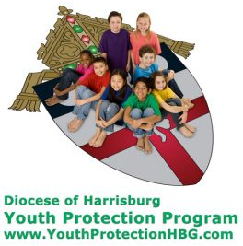
Diocese of Harrisburg Youth Protection Program
www.YouthProtectionHBG.com

Abuse Reporting Contact Information:
First – Call the toll-free PA Child Abuse Hotline at 800-932-0313
Then – Call the Diocesan toll-free hotline at 800-626-1608

“If one member suffers,
all suffer together with it.” (1 Cor 12:26)

St. Ignatius Loyola RC Church

1095 Church Road, Orrtanna, Pennsylvania 17353
www.stignatiusofloyola.org | Office: 717-677-8012

August 27, 2023: 21st SUNDAY IN ORDINARY TIME

Most Rev. Timothy C. Senior, Bishop of Harrisburg
Rev. Dominic M. DiBiccaro, Pastor
Deacon Steve Huete, Pastoral Associate

Mass Schedule, Intentions, and Events
Please Pray for:
Those who are ill, Jeanie Kline & the Kline Family, Brenda Wolf, Wade Sprankle, Dulcie Perry, Ron Formosa, Gavin Crumbacker, Anna Kane, Sherry Dennis and Family, Remi Peters, Christy Hemler, Terry Ahn, K. Grance, Lori McFadden & Family, Mike & Lisa Poole, Mervin Weikert, Chastity Rudisill, Mary Ellen Wilson, Terry & Bernie Cabana, Ed & Aggie Sherensky and Family, Bob Raffensberger, Jerry & Ginny Miller, Adeline Lienard, Kaylee Henry, Nancy Wuller, Dr. Mike Colli, Mrs. Kelly Kump, Gabriel Singer, Sharon McCormley, Ron Thumma, Joe Wisotzkey, Leo Hockensmith, Erika McKissick, Jean "Heather" O'Shea, Scott Moore and Sally Moore, Mary Wyatt, Jim & Joyce Deardorff, Amy Weatherup, Sophia Joy Ernst, Deacon Richard Wentzel, Deacon Frank Enderle, Kathleen Thompson, Deb & Kathy McLintock and Family, Rachel Wonders, Amy Edwards, Jean O’Connor, Paul Angello, Jen Baldwin, Ursula Kaley, Deb Bennet, Fr. Bill Sullivan, Larry Endy, Laura Lee, Marwa Abdelrahman, Donna Singley, Tim McGinn, Jane Kump, Peggy Neiderer, Chris Kimple, Robert Riquet, Gene & Jo-Ann McDannell, Bob Doxzen, Kimberly Mears, Gabriella Angello, Paul Angello, Mark & Kate Morrow, Mark Morris, Linda Fogleman, Paul Knight, George & Barbara Erstila, Jeff Carpenter, Lana & Nelson Harmon, Diane Slothour, Sue McDannell, Larry Schneider, Joe & Lisa Grasel, Ange Pena, Julie Barnhart, the Shaffer Family, Heather & Emma Dickerson, Brad Pabody, Paul Ward, Aiden Tyler Schneider, Dorothy Vega, Karrie McCall & daughter, George Shahid, Denise Navlyt, Drew Schneider & Family, Ida Bloomfield, Linda McDannell, Janie Singley, Mary Beth Greenstreet, Rick Benedict, Jan Patla, Kathe Fogleman, Sam Sheffler, Kate Hemmis, Bill & Mary Lou Graham, Joanna Hodges, John Varones, Joan O’Sullivan, Martha Klinger, Lisa Dionne Lauretti, Sue Orndorff, Jim Gleason, Sue Gustafson, Joe & Michelle Cleary, Kim Johnson, Helen Mills, Kathy Haber, Haley Detman, Joe Durovey, Bev Smith, Donald Sheppard, Linda Mumaugh, Alison Haring, Janet Hartman, Edward Johnson, Angela Galeone, Juliete Lang, Chris MacBeth, Harry Graham, Donald Howard, Armond Binni, Elizabeth Stansky, Pat Johnson, Chris Morris, Faud Doaney, Wilson & Rae Harman, Patrick Glass, Helen Lagasse, Nancy Kewisnek, Andy Graham, Bill & Maureen Collins, Rosemary McGilloway, Anji Eisenhart, Monica Manner, Denny Borbonus, Dr. Paul Scarlata, Mary Hawthorne, Ed Washington, Josh Kempinski, Nancy Baker Baltzey, Spencer Propts, Karlton Smith & Cheryl Sobun, James & Marylyn Sobun, Marlene Webster, Yvette Stoklosa, Andy Consiglio, Bill & Michelle Cloonan, Nelson Salem, Bill & Deb McClintock, nursing home residents & shut-ins, the victims of war, violence, disease, disaster, & all private intentions.
Also in your prayers, please remember all
our men and women currently serving in
our Armed Forces:
Maj. Nathan Jeffcoat – US Marine Corps
Lt. Joseph Cleary – US Navy
Michael C. Kenney IV – US Coast Guard
Lt. Joshua Kimple – US Army
Lt. Sarah Fogleman, M.D. – US Navy

PRAYER CHAIN: Contact Lynne Mobley at 703-876-4901 or LMOBLEY509@gmail.com

for the Week of August 26 to September , 2023

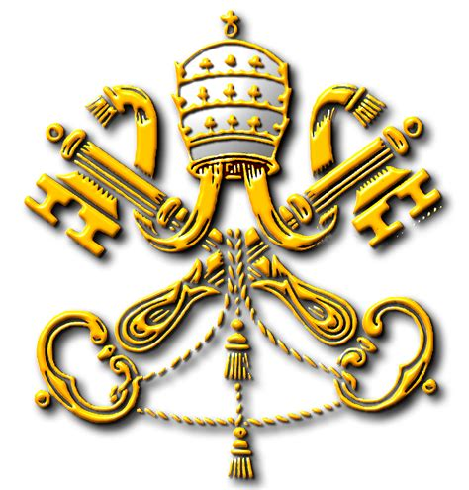
SATURDAY, August 26 – VIGIL 21st SUNDAY OT

Is 22:19-23 / Rom 11:33-36 / Mt 16:13-20
5:00PM + Marilyn Cole

SUNDAY, August 27 – 21st SUNDAY IN OT

Is 22:19-23 / Rom 11:33-36 / Mt 16:13-20
8:00AM ⁓ People of the Parish
10:30AM + Richard Sherensky

Monday, August 28–St. Augustine, Bishop & Doctor
1 Thes 1:1-5, 8b-10 / Mt 23:13-22 of the Church
Parish Office Closed

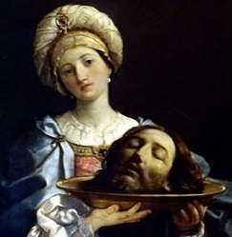
Tuesday, August 29 - The Passion of Saint John
1 Thes 2:1-8 / Mk 6:17-29 the Baptizer

8:00AM – 3:00PM ~ Office Open

10:00AM + Larry Dennis
11AM: “Something More” Group

Wednesday, August 30 (Weekday in OT)
1 Thes 2:9-13 / Mt 23:27-32

8AM – 3PM ~ Office Open
11AM: Mature Spirituality Group
7:00PM + Geraldine Fauser
6 – 6:45PM: Confessions heard; 7:40PM: Adoration

Thursday, August 31 (Weekday in OT)
1 Thes 3:7-13 / Mt 24:42-51

8AM – 3PM ~ Office Open

10:00AM ‒ Spec. Int. for Gavin Crumbacker

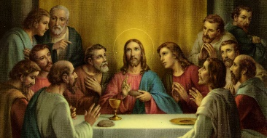  Friday, September 1 (Weekday in OT)  1 Thes 4:1-8 / Mt 25:1-13  Parish Office CLOSED  10:00AM + Mickie Schneider | THE LORD

SATURDAY, September 2 (Weekday in OT)
MORNING: 1 Thes 4:9-11 / Mt 25:14-30

SATURDAY, September 2 – VIGIL 22nd SUNDAY OT

Jer 20:7-9 / Rom 12:1-2 / Mt 16:21-27
5:00PM + Joan & Eugene Schott

SUNDAY, September 3 – 22nd SUNDAY IN OT

Jer 20:7-9 / Rom 12:1-2 / Mt 16:21-27
8:00AM ⁓ People of the Parish
10:30AM + Claudia Collins
Sanctuary Candle offered for SEPTEMBER: In Honor of Richard, Emma Carey, children & grandchildren

he Holy Father, Pope Francis’ Prayer Intentions for 2023
Entrusted to His Worldwide Prayer Network
AUGUST ⁓ FOR WORLD YOUTH DAY

We pray the continued graces from World Youth Day in Lisbon, Portugal, will help young people to live and witness the Gospel in their own lives.

STEWARDSHIP NOTE: Due to the early bulletin deadline, BOTH COLLECTIONS of August 19/20 and August 26/27 will be published next week.

Oh, the Depths!: Scott Hahn Reflects

on the Twentyfirst Sunday in Ordinary Time

“Oh, the depth of the riches and wisdom and knowledge of God!” St. Paul exclaims in today’s Epistle. Today’s Psalm, too, takes up the triumphant note of joy and thanksgiving. Why? Because in the Gospel, the Heavenly Father reveals the mystery of His Kingdom to Peter.

With Peter, we rejoice that Jesus is the anointed Son promised to David, the one prophesied to build God’s Temple and reign over an everlasting Kingdom (see 2 Samuel 7).

What Jesus calls “my Church” is the Kingdom promised to David’s son (see Isaiah 9:1–7). As we hear in today’s First Reading, Isaiah foretold that the keys to David’s Kingdom would be given to a new master, who would rule as father to God’s People.

Jesus, the root and offspring of David, alone holds the Kingdom’s Keys (see Rev. 1:18; 3:7; 22:16). In giving those Keys to Peter, Jesus fulfills that prophecy, establishing Peter ‒ and all who succeed him ‒ as holy father of His Church.

His Church, too, is the new house of God — the “spiritual temple” founded on the “rock” of Peter, and built up out of the living stones of individual believers (see 1 Peter 2:5).

Abraham was called “the rock” from which the children of Isra-el were hewn (see Isaiah 51:1–2). And Peter becomes the rock from which God raises up new Children of God (see Matthew 3:9).

The word Jesus uses — “church” (ekklesia in Greek) — was used in the Greek translation of the Old Testament for the “assembly” of God’s Children after the Exodus (see Deuteronomy 18:16; 31:30).

His Church is the “assembly of the firstborn” (see Hebrews 12:23; Exodus 4:23–24), established by Jesus’ exodus (see Luke 9:31). Like the Isra-elites, we are baptized in water, led by the Rock, and fed with spiritual food (see 1 Corinthians 10:1–5).

Gathered at His Altar, in the presence of Angels, we sing His praise and give thanks to His Holy Name.

Readings: Isaiah 22:15, 19–23; Psalm 138:1–3, 6, 8; Romans 11:33–36; Matthew 16:13–20

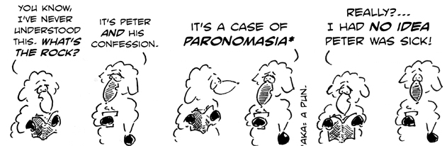

*Paronomasia: word play, pun

