Sacrament of the Sick
Anointing of the Sick should be given if an individual is gravely ill or near death. If possible, the Sacrament should also be administered for serious illness, before major surgery or when one is initially hospitalized.

Sacrament of Holy Matrimony
Diocesan policy requires 12 months of preparation for Marriage. Contact the parish as soon as possible after engagement. No venue reservations or other arrangements should be made prior to consultation with the pastor.

Sacrament of Penance
Wednesday ~ 6:00 – 6:45PM; or by appointment.

Sacrament of Baptism
Parents must be registered members of the parish and attend a Baptism preparation class prior to the Baptism if this is your first child baptized. Requirements for godparents are established by the Catholic Church. Please call the parish office for Information and to register your child for Baptism.

Parish Registration
All Catholics should be registered in their local parish. Please contact the parish office to obtain registration forms, or if you are uncertain of the parish where you should register.

Parish Staff & Ministries Directory
stignatiusofloyola@hbgdiocese.org | Office: 717-677-8012
Financial Manager ~ Richard Deardorff ~ 717- 677-8012 or 717-420-3464 (cell)
rdeardorff@hbgdiocese.org
Director of Religious Education ~ Deacon Steve Huete ~ shuete@hbgdiocese.org
Parish Secretary ~ Kristen DiDio ~ kdidio@hbgdiocese.org
Buildings & Grounds ~ Donnie Althoff ~ 717-677-8012
Music Ministry ~ Phil Mobley ~ 717-677-8012
Parish Council Members
Phil Mobley – Chair 571-236-7580 pmmobley@gmail.com
Bicky Redman – Vice Chair 677-8592 feetintheair7@gmail.com
Joanne Riedel - Secretary 398-2021 sterj221@aol.com
Kathi Allwein 677-8984 allweint@comcast.net
Charlie Baker 677-9536 dcbake@embarqmqil.com
Kathy Dietsch 352-4558 kdiet2@juno.com
Dr. BobTernes rjtmd46@gmail.com

Finance Council Members
Richard Deardorff (Ex Officio)
Greg Ernst - Chair
Christy Hemler - Secretary
Ali Morris
Terri Pendlelton
Bill Pulig

Altar Flowers
OCIA
Order of Christian Initiation for Adults
Contact Fr. Dominic

Soup Kitchen
Please send donations
directly to the
“Gettysburg Soup Kitchen”

Website Development
Kristen DiDio
Life After Loss
Dodie Huete

Prayer Chain
CONTACT THE PARISH OFFICE

Picnic Co-Chairs
Wally Kane
Mark Schur

Pro-Life Ministry
Jeanette Backus
Knights of Columbus
SK Bob Ternes
- Grand Knight

CONTACT THE PARISH OFFICE

Bereavement Ministry
Ginny Bittle / Dodie Huete

Catholic Communications/EWTN
Anna Kane

Cemetery
CONTACT THE PARISH OFFICE
THEOSIS Ministry
Kathy Dietsch 717-352-4558
Bicky Redman 717-677-8592

Diocese of Harrisburg Youth Protection Program
www.YouthProtectionHBG.com

Abuse Reporting Contact Information:
First – Call the toll-free PA Child Abuse Hotline at 800-932-0313
Then – Call the Diocesan toll-free hotline at 800-626-1608

“If one member suffers,
all suffer together with it.” (1 Cor 12:26)

St. Ignatius Loyola RC Church

St. Ignatius Loyola Roman Catholic Church
1095 Church Road, Orrtanna, Pennsylvania 17353
www.stignatiusofloyola.org | Office: 717-677-8012

February 11, 2024: SIXTH SUNDAY IN ORDINARY TIME
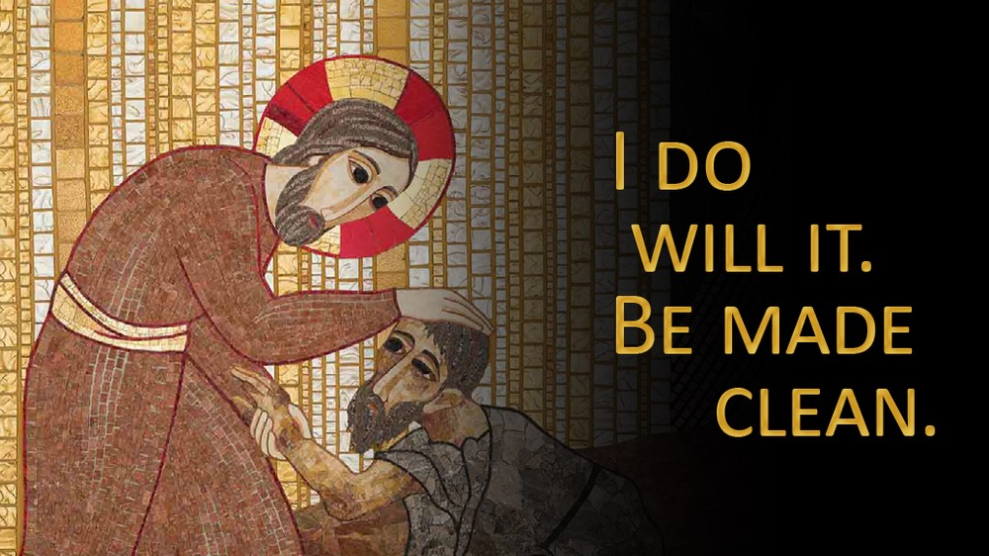

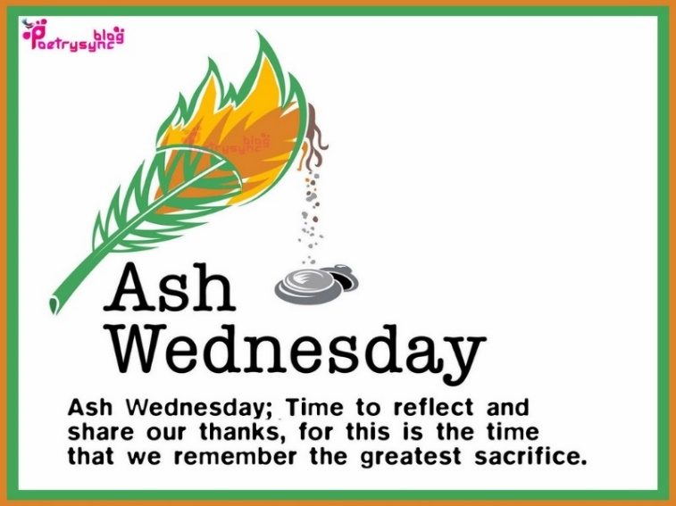

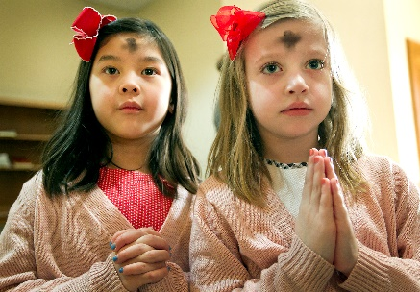
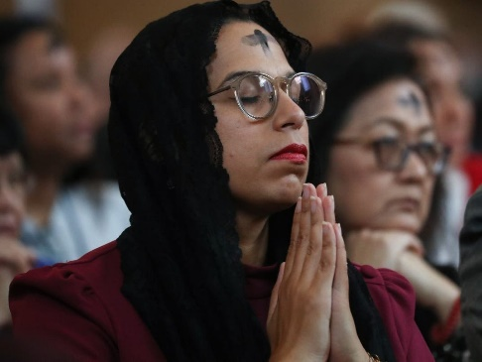

_________________________________________________
May the Holy Name of JESUS be invoked
to bring PEACE in the Holy Land!
Most Rev. Timothy C. Senior, Bishop of Harrisburg
Rev. Dominic M. DiBiccaro, Pastor
Deacon Steve Huete, Pastoral Associate

Mass Schedule, Intentions, and Events
Please Pray for these in need:
Jeanie Kline & the Kline Family, Dick & Deb Deardorff, Jacob Long, Shell Edwards, Corona Naylor, Chris & Mary Rebscher, John Baker, Ginny Hoctor, Janet Hodge, Brenda Wolf, Sr. Thelma Steiger HSF, Sr. Miriam Ukeritis CSJ , Peter Hackney, Lucas Christiansen, Dale Kaplan, Jerry Smith, Wade Sprankle, Dulcie Perry, Ron Formosa, Gavin Crumbacker, Anna Kane, Sherry Dennis & Family, Remi Peters, Terry Ahn, K. Grance, Lori McFadden & Family, Mike & Lisa Poole, Mervin Weikert, Chastity Rudisill, Mary Ellen Wilson, Terry & Bernie Cabana, Ed & Aggie Sherensky & Family, Bob Raffensberger, Jerry & Ginny Miller, Adeline Lienard, Kaylee Henry, Nancy Wuller, Dr. Mike Colli, Mrs. Kelly Kump, Gabriel Singer, Sharon McCormley, Ron Thumma, Joe Wisotzkey, Leo Hockensmith, Erika McKissick, Jean "Heather" O'Shea, Scott Moore & Sally Moore, Mary Wyatt, Amy Weatherup, Sophia Joy Ernst, Deacon Richard Wentzel, Deacon Frank Enderle, Paul & Carolyn Topper, Kathleen Thompson, Rachel Wonders, Amy Edwards, Jean O’Connor, Jen Baldwin, Ursula Kaley, Deb Bennet, Larry Endy, Laura Lee, Marwa Abdelrahman, Donna Singley, Tim McGinn, Jane Kump, Peggy Neiderer, Chris Kimple, Robert Riquet, Gene & Jo-Ann McDannell, Bob Doxzen, Kimberly Mears, Gabriella Angello, Paul Angello, Mark & Kate Morrow, Mark Morris, Linda Fogleman, Paul Knight, George & Barbara Erstila, Jeff Carpenter, Lana & Nelson Harmon, Diane Slothour, Sue McDannell, Larry Schneider, Joe & Lisa Grasel, Ange Pena, Julie Barnhart, Shaffer Family, Heather & Emma Dickerson, Brad Peabody, Paul Ward, Aiden Tyler Schneider, Dorothy Vega, Karrie McCall & daughter, George Shahid, Denise Navlyt, Drew Schneider & Family, Ida Bloomfield, Janie Singley, Mary Beth Greenstreet, Rick Benedict, Jan Patla, Kathey Fogleman, Sam Sheffler, Kate Hemmis, Bill & Mary Lou Graham, Andy Graham, Joanna Hodges, John Varones, Joan O’Sullivan, Martha Klinger, Lisa Dionne Lauretti, Jim Gleason, Sue Gustafson, Joe & Michelle Cleary, Kim Johnson, Helen Mills, Kathy Haber, Haley Detman, Joe Durovey, Bev Smith, Donald Sheppard, Linda Mumaugh, Alison Haring, Janet Hartman, Edward Johnson, Angela Galeone, Juliete Lang, Chris MacBeth, Harry Graham, Donald Howard, Armond Binni, Elizabeth Stansky, Pat Johnson, Chris Morris, Faud Doaney, Patrick Glass, Helen Lagasse, Nancy Kewisnek, Bill & Maureen Collins, Rosemary McGilloway, Anji Eisenhart, Monica Manner, Denny Borbonus, Dr. Paul Scarlata, Mary Hawthorne, Ed Washington, Josh Kempinski, Nancy Baltzey, Spencer Propts, Karlton Smith & Cheryl Sobun, James & Marylyn Sobun, Marlene Webster, Yvette Stoklosa, Andy Consiglio, Bill & Michelle Cloonan, Nelson Salem, Bill & Deb McClintock, nursing home residents & shut-ins, the victims of war, violence, disease, disaster, & all private intentions.
Also in your prayers, please remember all our men
& women currently serving in our Armed Forces:

Lt. Col. Nathan Jeffcoat – US Marine Corps
Lt. Joseph Cleary – US Navy
Michael C. Kenney IV – US Coast Guard
Lt. Joshua Kimple – US Army
Lt. Sarah Fogleman, M.D. – US Navy
A1C Ian Bellinger ‒ PA Air National Guard

PRAYER CHAIN: Contact the Office

for the Week of February 10 to February 18, 2024

SATURDAY, Feb. 10 – Vigil 6th SUNDAY IN ORDINARY TIME

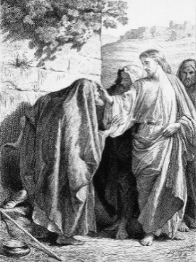
Lv 13:1-2, 44-46/1 Cor 10:31—11:1/Mk 1:40-45
5:00PM + Robert MacBeth

SUNDAY, Feb. 11 – 6th SUNDAY IN OT

Lv 13:1-2, 44-46/1 Cor 10:31—11:1/Mk 1:40-45

8:00AM + Diane Kump Stapleton
10:30AM ⁓ People of the Parish

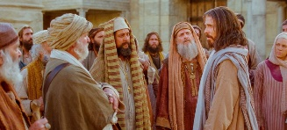
MONDAY, February 12 (Weekday in OT)
Jas 1:1-11 / Mk 8:11-13
Parish Office CLOSED

Tuesday, February 13 (Weekday in OT)
Jas 1:12-18 / Mk 8:14-21

8AM – 3PM ~ Office Open

10:00AM + Mary Redman

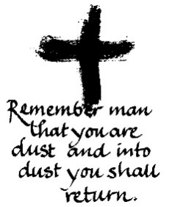
Wednesday, February 14 – ASH WEDNESDAY
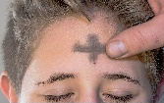
Jl 2:12-18 / 2 Cor 5:20—6:2 / Mt 6:1-6, 16-18

8AM – 3PM ~ Office Open
10:00AM + Arlene Backhus
7:00PM - Spec. Int. for Pat & Sharon McCormley
NO Confessions; NO Adoration

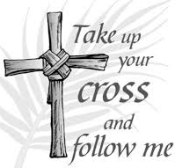
Thursday, February 15 (Weekday After Ash Wednesday)
Dt 30:15-20 / Lk 9:22-25

8AM – 3PM ~ Office Open
10:00AM + Janet Hodge
Friday, February 16 (Weekday After Ash Wednesday)  7:00  PM  Is 58:1-9a / Mt 9:14-15  10:00AM + Richard DiFeo  Parish Office CLOSED  7:00PM Stations of the Cross | THE LORD

SATURDAY, Feb. 17 – Seven Holy Founders of the Servite Order
MORNING: Is 58:9b-14 / Lk 5:27-32

SATURDAY, Feb. 17 – Vigil 1ST SUNDAY OF LENT

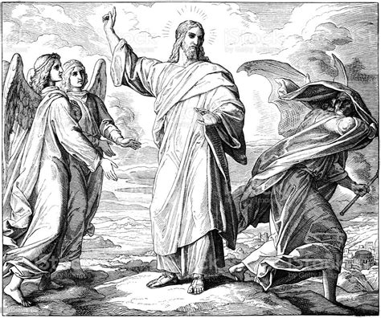
Gn 9:8-15 / 1 Pt 3:18-22 / Mk 1:12-15
5:00PM + Joseph Keller

SUNDAY, Feb. 18 – 1ST SUNDAY OF LENT

Gn 9:8-15 / 1 Pt 3:18-22 / Mk 1:12-15

8:00AM ⁓ People of the Parish
10:30AM + Jim and Delores Gilbert
Sanctuary Candle for FEBRUARY is offered: In Loving Memory of Timothy & Andrew Heller from Martha Heller

Sunday Collection Summary for Feb. 3 & 4

Weekend Collections
Regular Offering $ 3,375.00
Ash Wednesday $ 55.00
TOTAL OFFERINGS $ 3,430.00

‒ WEEKLY BUDGETARY NEEDS $ 4,494.00
+Overage or (Shortfall) for the week ($ 1,064.00)

Other Income
Cemetery Upkeep $ 170.00
Local Poor $ 35.00
Total Other Offerings $ 205.00

Diocesan Second Collections
Poor Missions $ 179.00
Society for the Propagation of the Faith $ 742.00
Total Diocesan Offerings $ 921.00

Sunday Collection Summary: January 2024 (4 Collection Weeks)

Weekend Collections
Regular Offering $ 12,066.26
Ash Wednesday $ 105.00
Christmas $ 50.00
Easter $ 35.00
Solemnity of Mary, Mother of God $ 177.00
TOTAL OFFERINGS $ 12,433.26

- MONTHLY BUDGETARY NEEDS $ 17,976.00
+Overage or (Shortfall) for the week ($ 5,542.74)

Other Income
Candles/Living Faith $ 222.93
Cemetery Annual Care $ 1,707.00
Easter Flowers $ 70.00
Individual Contributions $ 10,800.00
Local Poor $ 140.00
Memorial Contribution (Paul Topper) $ 300.00
Total Other Offerings $ 13,239.93

Diocesan Second Collections
Church in Eastern Europe & Africa $ 325.00
Poor Missions $ 115.00
Retirement for Religious $ 115.00
Total Diocesan Offerings $ 555.00
from
the
to all for the $500 donated to the

2024 Hershey Park discount tickets are available.
Pick up an Order Form in the Narthex of the Church, fill out and return with your payment. You may drop off it in the office. Or place in an envelope and drop in the collection basket (marked: “Hershey Park”). NO LATER THAN April 26th
Ticket Prices
Purchase before April 26th, 2024: $43.95
Regular price $87.80
Tickets valid April - January 1, 2025

Single-Use Meal Plan Prepaid Parking Passes
$19.06 regular price $19.06 $25.00 (pre-purchase only)

Made Clean: Scott Hahn Reflects

on the Sixth Sunday in Ordinary Time

In the Old Testament, leprosy is depicted as punishment for disobedience of God’s Commands (see Numbers 12:12–15; 2 Kings 5:27; 15:5).

Considered “unclean” ‒ unfit to worship or live with the Israelite s‒ lepers are considered “stillborn,” the living dead (see Numbers 12:12). Indeed, the requirements imposed on lepers in today’s First Reading — ripped garments, shaven head, covered beard — are signs of death, penance, and mourning (see Leviticus 10:6; Ezekiel 24:17).

So there’s more to the story in today’s Gospel than a miraculous healing.

When Elisha, invoking God’s Name, healed the leper, Naaman, it proved there was a prophet in Isra-el (see 2 Kings 5:8). Today’s healing reveals Jesus as far more than a great prophet ‒ He IS God ‒ visiting His People (see Luke 7:16).

Only God can cure leprosy and cleanse from sin (see 2 Kings 5:7), and only God has the power to bring about what He wills (see Isaiah 55:11; Wisdom 12:18). The Gospel scene has an almost sacramental quality about it.

Jesus stretches out His Hand — as God, by His outstretched Arm, performed mighty deeds to save the Isra-elites (see Exodus 14:6; Acts 4:30). His ritual sign is accompanied by a Divine word (“Be made clean”). And, like God’s word in Creation (“Let there be”), Jesus’ word “does” what He Commands (see Psalm 33:9).

The same thing happens when we show ourselves to the priest in the Sacrament of Penance. On our knees like the leper, we confess our sins to the LORD, as we sing in today’s Psalm. And through the outstretched arm and divine word spoken by His priest, the LORD takes away the guilt of our sin.

And, like the leper we should rejoice in the LORD and spread the good news of His mercy. We should testify to our healing by living changed lives. As St. Paul says in today’s Epistle, we should do even the littlest things for the glory of God and that others may be saved.

Readings: Leviticus 13:1–2, 44–46; Psalm 32:1–2, 5, 11
1 Corinthians 10:31–11:1; Mark 1:40–45

