Sacrament of the Sick
Anointing of the Sick should be given if an individual is gravely ill or near death. If possible, the Sacrament should also be administered for serious illness, before major surgery or when one is initially hospitalized.

Sacrament of Holy Matrimony
Diocesan policy requires 12 months of preparation for Marriage. Contact the parish as soon as possible after engagement. No venue reservations or other arrangements should be made prior to consultation with the pastor.

Sacrament of Penance
Wednesday ~ 6:00 – 6:45PM; or by appointment.

Sacrament of Baptism
Parents must be registered members of the parish and attend a Baptism preparation class prior to the Baptism if this is your first child baptized. Requirements for godparents are established by the Catholic Church. Please call the parish office for Information and to register your child for Baptism.

Parish Registration
All Catholics should be registered in their local parish. Please contact the parish office to obtain registration forms, or if you are uncertain of the parish where you should register.

Parish Staff & Ministries Directory
stignatiusofloyola@hbgdiocese.org | Office: 717-677-8012
Financial Manager ~ Richard Deardorff ~ 717- 677-8012 or 717-420-3464 (cell)
rdeardorff@hbgdiocese.org
Director of Religious Education ~ Deacon Steve Huete ~ shuete@hbgdiocese.org
Parish Secretary ~ Kristen DiDio ~ kdidio@hbgdiocese.org
Buildings & Grounds ~ Donnie Althoff ~ 717-677-8012
Music Ministry ~ Phil Mobley ~ 717-677-8012
Parish Council Members
Phil Mobley – Chair 571-236-7580 pmmobley@gmail.com
Bicky Redman – Vice Chair 677-8592 feetintheair7@gmail.com
Joanne Riedel - Secretary 398-2021 sterj221@aol.com
Kathi Allwein 677-8984 allweint@comcast.net
Charlie Baker 677-9536 dcbake@embarqmqil.com
Mike McTighe- R.I.P
Dr. BobTernes rjtmd46@gmail.com

Finance Council Members
Richard Deardorff (Ex Officio)
Greg Ernst - Chair
Christy Hemler - Secretary
Ali Morris
Terri Pendlelton
Bill Pulig

Altar Flowers
OCIA
Order of Christian Initiation for Adults
Contact Fr. Dominic

Soup Kitchen
Please send donations
directly to the
“Gettysburg Soup Kitchen”

Website Development
Kristen DiDio
Life After Loss
Dodie Huete

Prayer Chain
CONTACT THE PARISH OFFICE

Picnic Chairperson
Mark Schur

Pro-Life Ministry
Jeanette Backus
Knights of Columbus
SK Bob Ternes
- Grand Knight

Judy Wilson / Janice Meligakes

Bereavement Ministry
Ginny Bittle / Dodie Huete

Catholic Communications/EWTN
Anna Kane

Cemetery
CONTACT PARISH OFFICE
THEOSIS Ministry
Kathy Dietsch 717-352-4558
Bicky Redman 717-677-8592

Diocese of Harrisburg Youth Protection Program
www.YouthProtectionHBG.com

Abuse Reporting Contact Information:
First – Call the toll-free PA Child Abuse Hotline at 800-932-0313
Then – Call the Diocesan toll-free hotline at 800-626-1608

“If one member suffers,
all suffer together with it.” (1 Cor 12:26)

St. Ignatius Loyola RC Church

1095 Church Road, Orrtanna, Pennsylvania 17353
www.stignatiusofloyola.org | Office: 717-677-8012

October 8, 2023: 27th SUNDAY IN ORDINARY TIME
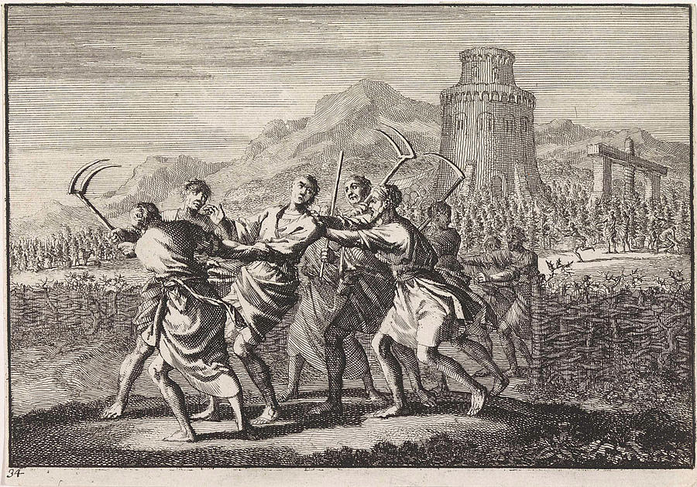

“ ‘This is the Heir. Come, let us kill Him and acquire His inheritance!’ … Therefore, I say to you, the Kingdom of God
will be taken away from you and given to people
that will produce its Fruit.”
Most Rev. Timothy C. Senior, Bishop of Harrisburg
Rev. Dominic M. DiBiccaro, Pastor
Deacon Steve Huete, Pastoral Associate

Mass Schedule, Intentions, and Events
Please Pray for:
Those who are ill, Jeanie Kline & the Kline Family, Brenda Wolf, Wade Sprankle, Dulcie Perry, Ron Formosa, Gavin Crumbacker, Anna Kane, Sherry Dennis and Family, Remi Peters, Christy Hemler, Terry Ahn, K. Grance, Lori McFadden & Family, Mike & Lisa Poole, Mervin Weikert, Chastity Rudisill, Mary Ellen Wilson, Terry & Bernie Cabana, Ed & Aggie Sherensky and Family, Bob Raffensberger, Jerry & Ginny Miller, Adeline Lienard, Kaylee Henry, Nancy Wuller, Dr. Mike Colli, Mrs. Kelly Kump, Gabriel Singer, Sharon McCormley, Ron Thumma, Joe Wisotzkey, Leo Hockensmith, Erika McKissick, Jean "Heather" O'Shea, Scott Moore and Sally Moore, Mary Wyatt, Jim & Joyce Deardorff, Amy Weatherup, Sophia Joy Ernst, Deacon Richard Wentzel, Deacon Frank Enderle, Kathleen Thompson, Deb & Kathy McLintock and Family, Rachel Wonders, Amy Edwards, Jean O’Connor, Paul Angello, Jen Baldwin, Ursula Kaley, Deb Bennet, Larry Endy, Laura Lee, Marwa Abdelrahman, Donna Singley, Tim McGinn, Jane Kump, Peggy Neiderer, Chris Kimple, Robert Riquet, Gene & Jo-Ann McDannell, Bob Doxzen, Kimberly Mears, Gabriella Angello, Paul Angello, Mark & Kate Morrow, Mark Morris, Linda Fogleman, Paul Knight, George & Barbara Erstila, Jeff Carpenter, Lana & Nelson Harmon, Diane Slothour, Sue McDannell, Larry Schneider, Joe & Lisa Grasel, Ange Pena, Julie Barnhart, the Shaffer Family, Heather & Emma Dickerson, Brad Peabody, Paul Ward, Aiden Tyler Schneider, Dorothy Vega, Karrie McCall & daughter, George Shahid, Denise Navlyt, Drew Schneider & Family, Ida Bloomfield, Janie Singley, Mary Beth Greenstreet, Rick Benedict, Jan Patla, Kathey Fogleman, Sam Sheffler, Kate Hemmis, Bill & Mary Lou Graham, Joanna Hodges, John Varones, Joan O’Sullivan, Martha Klinger, Lisa Dionne Lauretti, Jim Gleason, Sue Gustafson, Joe & Michelle Cleary, Kim Johnson, Helen Mills, Kathy Haber, Haley Detman, Joe Durovey, Bev Smith, Donald Sheppard, Linda Mumaugh, Alison Haring, Janet Hartman, Edward Johnson, Angela Galeone, Juliete Lang, Chris MacBeth, Harry Graham, Donald Howard, Armond Binni, Elizabeth Stansky, Pat Johnson, Chris Morris, Faud Doaney, Patrick Glass, Helen Lagasse, Nancy Kewisnek, Andy Graham, Bill & Maureen Collins, Rosemary McGilloway, Anji Eisenhart, Monica Manner, Denny Borbonus, Dr. Paul Scarlata, Mary Hawthorne, Ed Washington, Josh Kempinski, Nancy Baker Baltzey, Spencer Propts, Karlton Smith & Cheryl Sobun, James & Marylyn Sobun, Marlene Webster, Yvette Stoklosa, Andy Consiglio, Bill & Michelle Cloonan, Nelson Salem, Bill & Deb McClintock, nursing home residents & shut-ins, the victims of war, violence, disease, disaster, & all private intentions.
Also in your prayers, please remember all our men
And women currently serving in our Armed Forces:

Maj. Nathan Jeffcoat – US Marine Corps
Lt. Joseph Cleary – US Navy
Michael C. Kenney IV – US Coast Guard
Lt. Joshua Kimple – US Army
Lt. Sarah Fogleman, M.D. – US Navy .
A1C Ian Bellinger ‒ PA Air National Guard

PRAYER CHAIN: Contact the
Parish Office

for the Week of October 7 to October 15, 2023

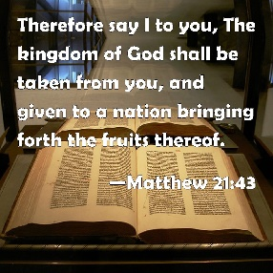
SATURDAY, Oct. 7- VIGIL 27th SUNDAY OT

Is 5:1-7 / Phil 4:6-9 / Mt 21:33-43
5:00PM + Pope Pius X!!

SUNDAY, October 8 – 27th SUNDAY IN OT

Is 5:1-7 / Phil 4:6-9 / Mt 21:33-43
8:00AM + Clara Redding
10:30AM ⁓ People of the Parish

Monday, October 9 – St. Denis, Bishop, & Companions, Martyrs;
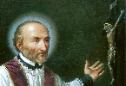
Jon 1:1—2:2, 11 / Lk 10:25-37 St. John Leonardi, Priest
Parish Office Closed
NO MASS

Tuesday, October 10 (Weekday in OT)
Jon 3:1-10 / Lk 10:38-42

8:00AM – 3:00PM ~ Office Open

10:00AM + Joan and Eugene Schott

11AM “Something More” Group

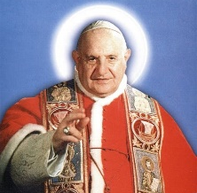
Wednesday, October 11 - Saint John XXIII, Pope
Jon 4:1-11 / Lk 11:1-4

8AM – 3PM ~ Office Open
11AM: Mature Spirituality Group
7:00PM + Art Lazar, Sr.
6 - 6:45PM Confessions heard; 7:40PM Adoration & Benediction

Thursday, October 12 (Weekday in OT)
Mal 3:13-20b / Lk 11:5-13
8AM – 3PM ~ Office Open
10:00AM + Evelyn Grace Topper

Friday,October 13 (Weekday in OT)  Jl 1:13-15; 2:1-2 / Lk 11:15-26  10:00AM + Margaret Gracyalny  Parish Office CLOSED | THE LORD

SATURDAY,Ocotber 14-St. Callistus I, Pope & Martyr

MORNING: Jl 4:12-21 / Lk 11:27-28

SATURDAY, Oct. 14- VIGIL 28th SUNDAY OT

Is 25:6-10a/Phil 4:12-14, 19-20/Mt 22:1-14
4:30PM Recitation of the Holy Rosary
5:00PM + Sara Keller

SUNDAY, Oct.15 – 28th SUNDAY IN OT

Is 25:6-10a/Phil 4:12-14, 19-20/Mt 22:1-14
8:00AM + Thomas Wolf
10:30AM ⁓ People of the Parish
Sanctuary Candle offered for OCTOBER: John Louise and Bobbi Strasbaugh from Theresa & Gary Cowan

Living on the Vine: Scott Hahn Reflects

on the Twenty-seventh Sunday in Ordinary Time

In today’s Gospel Jesus returns to the Old Testament symbol of the vineyard to teach about Israel, the Church, and the kingdom of God.

And the symbolism of today’s First Reading and Psalm is readily understood.

God is the owner and the House of Isra-el is the vineyard. A cherished vine, Isra-el was plucked from Egypt and transplanted in a fertile land specially spaded and prepared by God, hedged about by the city walls of Jerusalem, watched over by the towering Temple. But the vineyard produced no good grapes for the wine, a symbol for the holy lives God wanted for His People. So God allowed His vineyard to be overrun by foreign invaders, as the Isaiah foresees in the First Reading.

Jesus picks up the story where Isaiah leaves off, even using Isaiah’s words to describe the vineyard’s wine press, hedge, and watchtower. Isra-el’s religious leaders, the tenants in His parable, have learned nothing from Isaiah or Isra-el’s past. Instead of producing good fruits, they’ve killed the owner’s servants, thePprophets sent to gather the harvest of faithful souls.

In a dark foreshadowing of His own Crucifixion outside Jerusalem, Jesus says the tenants’ final outrage will be to seize the owner’s son, and to kill him outside the vineyard walls.

For this, the vineyard, which Jesus calls the Kingdom of God, will be taken away and given to new tenants — the leaders of the Church, who will produce its fruit.

We are each a vine in the LORD’s vineyard, grafted onto the True Vine of Christ (see John 15:1–8), called to bear fruits of the righteousness in Him (see Philippians 1:11) and to be the “first fruits” of a new creation (see James 1:18).

We need to take care that we don’t let ourselves be overgrown with the thorns and briars of worldly anxiety. As today’s Epistle advises, we need to fill our hearts and minds with noble intentions and virtuous deeds, rejoicing always that the LORD is near.

Readings: Isaiah 5:1–7; Psalm 80:9, 12–16, 19–20; Philippians 4:6–9; Matthew 21:33–43

NO COLLECTION REPORT
DUE TO THE EARLY BULLETIN DEADLINE. BOTH COLLECTIONS WILL BE PUBLISHED NEXT WEEK.

The Holy Father, Pope Francis’ Prayer Intention for October 2023

OCTOBER ~ For the Synod
We pray for the Church, that She may adopt listening and dialogue as a lifestyle at every level, and allow Herself to be guided by the Holy Spirit towards the peripheries of the world.

The message for this October’s Pontifical Prayer Intention is an invitation to place ourselves before the LORD in an attitude of listening and dialogue. The concept of the Church as “on the way,” and its missionary vocation can be thought of as a sort of “road movie”: Imagine looking out an automobile window, we see places and people from different countries – from the Vatican to Cambodia, passing through Africa, the Middle East, North America – capturing scenes from daily life. That car represents the Church; its gas, the “power of the Holy Spirit,” which, in the words of Pope Francis, must lead the Church “towards the world’s peripheries.” Letting herself be guided by the Holy Spirit requires listening together. For this reason, the Pope also clarifies that in this start of the Ordinary General Assembly of the Synod, “nothing ends here. Rather, we are continuing an ecclesial journey here,” so as to reap the fruits of mutual listening between brothers and sisters, everyone together at the service of Christ’s Mission. Pope Francis also uses the example of the disciples on the way to Emmaus and asks us to be like them, “listening to the LORD who always comes to meet us.”

