Sacrament of the Sick
Anointing of the Sick should be given if an individual is gravely ill or near death. If possible, the Sacrament should also be administered for serious illness, before major surgery or when one is initially hospitalized.

Sacrament of Holy Matrimony
Diocesan policy requires 12 months of preparation for Marriage. Contact the parish as soon as possible after engagement. No venue reservations or other arrangements should be made prior to consultation with the pastor.

Sacrament of Penance
Wednesday ~ 6:00 – 6:45PM; or by appointment.

Sacrament of Baptism
Parents must be registered members of the parish and attend a Baptism preparation class prior to the Baptism if this is your first child baptized. Requirements for godparents are established by the Catholic Church. Please call the parish office for Information and to register your child for Baptism.

Parish Registration
All Catholics should be registered in their local parish. Please contact the parish office to obtain registration forms, or if you are uncertain of the parish where you should register.

Parish Staff & Ministries Directory
stignatiusofloyola@hbgdiocese.org | Office: 717-677-8012
Financial Manager ~ Richard Deardorff ~ 717- 677-8012 or 717-420-3464 (cell)
rdeardorff@hbgdiocese.org
Director of Religious Education ~ Deacon Steve Huete ~ shuete@hbgdiocese.org
Parish Secretary ~ Kristen DiDio ~ kdidio@hbgdiocese.org
Buildings & Grounds ~ Donnie Althoff ~ 717-677-8012
Music Ministry ~ Phil Mobley ~ 717-677-8012
Parish Council Members
Phil Mobley – Chair 571-236-7580 pmmobley@gmail.com
Bicky Redman – Vice Chair 677-8592 feetintheair7@gmail.com
Joanne Riedel - Secretary 398-2021 sterj221@aol.com
Kathi Allwein 677-8984 allweint@comcast.net
Charlie Baker 677-9536 dcbake@embarqmqil.com
Kathy Dietsch 352-4558 kdiet2@juno.com
Dr. BobTernes rjtmd46@gmail.com

Finance Council Members
Richard Deardorff (Ex Officio)
Greg Ernst - Chair
Christy Hemler - Secretary
Ali Morris
Terri Pendlelton
Bill Pulig

Altar Flowers
OCIA
Order of Christian Initiation for Adults
Contact Fr. Dominic

Soup Kitchen
Please send donations
directly to the
“Gettysburg Soup Kitchen”

Website Development
Kristen DiDio
Life After Loss
Dodie Huete

Prayer Chain
CONTACT THE PARISH OFFICE

Picnic Co-Chairs
Wally Kane
Mark Schur

Pro-Life Ministry
Jeanette Backus
Knights of Columbus
SK Bob Ternes
- Grand Knight
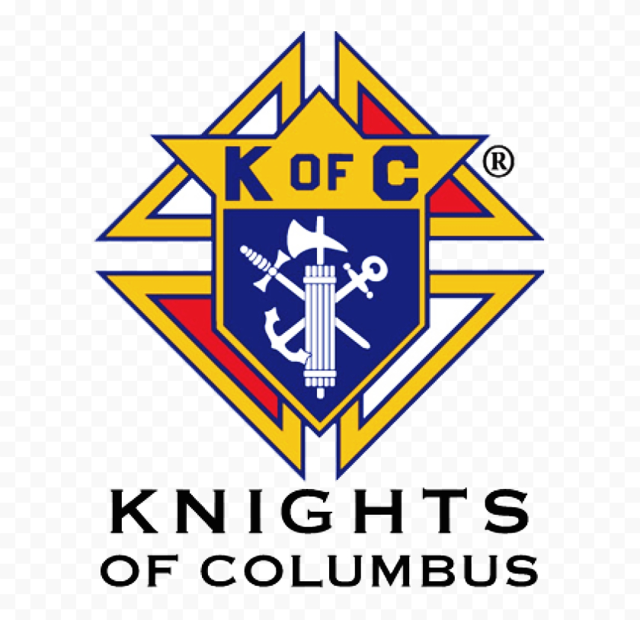

CONTACT THE PARISH OFFICE

Bereavement Ministry
Ginny Bittle / Dodie Huete

Catholic Communications/EWTN
Anna Kane

Cemetery
CONTACT THE PARISH OFFICE
THEOSIS Ministry
Kathy Dietsch 717-352-4558
Bicky Redman 717-677-8592

Diocese of Harrisburg Youth Protection Program
www.YouthProtectionHBG.com

Abuse Reporting Contact Information:
First – Call the toll-free PA Child Abuse Hotline at 800-932-0313
Then – Call the Diocesan toll-free hotline at 800-626-1608

“If one member suffers,
all suffer together with it.” (1 Cor 12:26)

St. Ignatius Loyola RC Church

1095 Church Road, Orrtanna, Pennsylvania 17353
www.stignatiusofloyola.org | Office: 717-677-8012

November 12, 2023: 32nd SUNDAY IN ORDINARY TIME
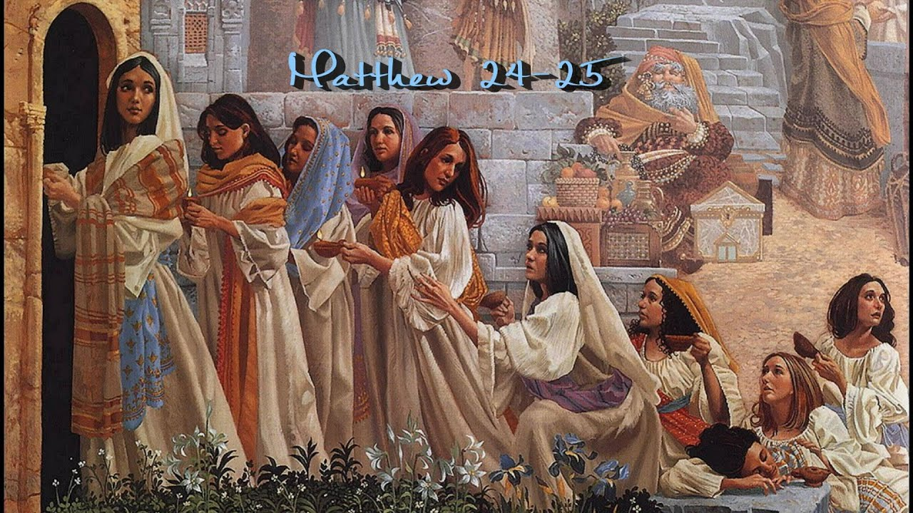

“ ‘LORD, LORD, open the door us!’
But He said in reply, ‘Amen, I say to you,
I do not know you.’ Therefore, stay awake,
for you know neither the day nor the hour.”

PLEASE Pray to END THE KILLING in the Holy Land

Most Rev. Timothy C. Senior, Bishop of Harrisburg
Rev. Dominic M. DiBiccaro, Pastor
Deacon Steve Huete, Pastoral Associate

Mass Schedule, Intentions, and Events
Please Pray for these in need:
Jeanie Kline & the Kline Family, Dick & Deb Deardorff, John Baker, Ginny Hoctor, Brenda Wolf, Dale Kaplan, Jerry Smith, Wade Sprankle, Dulcie Perry, Ron Formosa, Gavin Crumbacker, Anna Kane, Sherry Dennis & Family, Remi Peters, Terry Ahn, K. Grance, Lori McFadden & Family, Mike & Lisa Poole, Mervin Weikert, Chastity Rudisill, Mary Ellen Wilson, Terry & Bernie Cabana, Ed & Aggie Sherensky & Family, Bob Raffensberger, Jerry & Ginny Miller, Adeline Lienard, Kaylee Henry, Nancy Wuller, Dr. Mike Colli, Mrs. Kelly Kump, Gabriel Singer, Sharon McCormley, Ron Thumma, Joe Wisotzkey, Leo Hockensmith, Erika McKissick, Jean "Heather" O'Shea, Scott Moore & Sally Moore, Mary Wyatt, Jim & Joyce Deardorff, Amy Weatherup, Sophia Joy Ernst, Deacon Richard Wentzel, Deacon Frank Enderle, Kathleen Thompson, Deb & Kathy McLintock & Family, Rachel Wonders, Amy Edwards, Jean O’Connor, Jen Baldwin, Ursula Kaley, Deb Bennet, Larry Endy, Laura Lee, Marwa Abdelrahman, Donna Singley, Tim McGinn, Jane Kump, Peggy Neiderer, Chris Kimple, Robert Riquet, Gene & Jo-Ann McDannell, Bob Doxzen, Kimberly Mears, Gabriella Angello, Paul Angello, Mark & Kate Morrow, Mark Morris, Linda Fogleman, Paul Knight, George & Barbara Erstila, Jeff Carpenter, Lana & Nelson Harmon, Diane Slothour, Sue McDannell, Larry Schneider, Joe & Lisa Grasel, Ange Pena, Julie Barnhart, the Shaffer Family, Heather & Emma Dickerson, Brad Peabody, Paul Ward, Aiden Tyler Schneider, Dorothy Vega, Karrie McCall & daughter, George Shahid, Denise Navlyt, Drew Schneider & Family, Ida Bloomfield, Janie Singley, Mary Beth Greenstreet, Rick Benedict, Jan Patla, Kathey Fogleman, Sam Sheffler, Kate Hemmis, Bill & Mary Lou Graham, Joanna Hodges, John Varones, Joan O’Sullivan, Martha Klinger, Lisa Dionne Lauretti, Jim Gleason, Sue Gustafson, Joe & Michelle Cleary, Kim Johnson, Helen Mills, Kathy Haber, Haley Detman, Joe Durovey, Bev Smith, Donald Sheppard, Linda Mumaugh, Alison Haring, Janet Hartman, Edward Johnson, Angela Galeone, Juliete Lang, Chris MacBeth, Harry Graham, Donald Howard, Armond Binni, Elizabeth Stansky, Pat Johnson, Chris Morris, Faud Doaney, Patrick Glass, Helen Lagasse, Nancy Kewisnek, Andy Graham, Bill & Maureen Collins, Rosemary McGilloway, Anji Eisenhart, Monica Manner, Denny Borbonus, Dr. Paul Scarlata, Mary Hawthorne, Ed Washington, Josh Kempinski, Nancy Baker Baltzey, Spencer Propts, Karlton Smith & Cheryl Sobun, James & Marylyn Sobun, Marlene Webster, Yvette Stoklosa, Andy Consiglio, Bill & Michelle Cloonan, Nelson Salem, Bill & Deb McClintock, nursing home residents & shut-ins, the victims of war, violence, disease, disaster, & all private intentions.
Also in your prayers, please remember all our men
& women currently serving in our Armed Forces:

Lt. Col. Nathan Jeffcoat – US Marine Corps
Lt. Joseph Cleary – US Navy
Michael C. Kenney IV – US Coast Guard
Lt. Joshua Kimple – US Army
Lt. Sarah Fogleman, M.D. – US Navy .
A1C Ian Bellinger ‒ PA Air National Guard
-------------------------------------------------------------------------------------------------------------------------------------------------
PRAYER CHAIN: Contact the
Parish Office

for the Week of November 11 to November 19, 2023

SATURDAY, Nov. 11 - VIGIL 32nd SUNDAY OT

Wis 6:12-16 / 1 Thes 4:13-18 / Mt 25:1-13
5:00PM + Deceased Veterans of the Parish

SUNDAY,Nov. 12 – 32nd SUNDAY IN OT

Wis 6:12-16 / 1 Thes 4:13-18 / Mt 25:1-13
8:00AM + Nolan Patrick Gilbert

10:30AM ⁓ People of the Parish

Monday, November 13 – St. Frances Xavier Cabrini,
Wis 1:1-7 / Lk 17:1-6 Virgin
Parish Office Closed

Tuesday, November 14 (Weekday in OT)
Wis 2:23—3:9 / Lk 17:7-10

8AM – 3PM ~ Office Open

10:00AM + Ray Deardorff

11AM: “Something More” Group
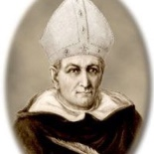
Wednesday, November 15 – St. Albert the Great, Bishop and
Wis 6:1-11 / Lk 17:11-19 Doctor
11AM: Mature Spirituality Group of the Church
7:00PM + SK Raymond Haber
6 to 6:45PM - Confessions; 7:40PM - Adoration & Benediction

Thursday, November 16 – St. Margaret of Scotland; St. Gertrude,
Wis 7:22b—8:1 / Lk 17:20-25 Virgin
8AM – 3PM ~ Office Open
10:00AM + ALL SOULS

Friday, November 17 – St. Elizabeth of Hungary, Religious  Wis 13:1-9 / Lk 17:26-37  10:00AM + Jack Ryff  Parish Office CLOSED | THE LORD

SATURDAY, Nov. 18 - Dedication Basilicas of Sts. Peter & Paul,

MORNING: Wis 18:14-16; 19:6-9 / Lk 18:1-8 Apostles

St. Rose Philippine Duchesne, Virgin

SATURDAY, Nov. 18 - VIGIL 33rd SUNDAY OT

Prv 31:10-13, 19-20, 30-31/1 Thes 5:1-6/Mt 25:14-30
5:00PM + James Bucci

SUNDAY,Nov. 19 – 33rd SUNDAY IN OT

Prv 31:10-13, 19-20, 30-31/1 Thes 5:1-6/Mt 25:14-30
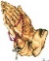
8:00AM + Bobbi Strasbaugh
10:30AM ⁓ People of the Parish
Sanctuary Candle offered for NOVEMBER: In Loving Memory of Marilyn Cole from Kenneth Cole

Members of the Wedding: Scott Hahn Reflects

on the Thirty-Second Sunday in Ordinary Time

According to marriage customs of Jesus’ day, a bride was first “betrothed” to her husband but continued for a time to live with her family. Then, at the appointed hour some months later, the groom would come to claim her, leading her family and bridal party to the wedding feast that would celebrate and inaugurate their new life together.

This is the background to the “Parable of the Last Judgment” we hear in today’s Gospel.

In the parable’s symbolism, Jesus is the Bridegroom (see Mark 2:19). In this, He fulfills God’s ancient promise to join Himself forever to His Chosen People as a husband cleaves to his bride (see Hosea 2:16–20). The virgins of the bridal party represent us, the members of the Church.

We were “betrothed” to Jesus in Baptism (see 2 Corinthians 11:2; Ephesians 5:25–27) and are called to lives of holiness and devotion until He comes again to lead us to the Heavenly Wedding Feast at the end of time (see Revelation 19:7–9; 21:1–4).

As St. Paul warns in today’s Epistle, Jesus is coming again, though we know not the day nor the hour!

We need to keep vigil throughout the dark night of this time in which our Bridegroom seems long delayed. We need to keep our souls’ “lamps” filled with the oil of perseverance and desire for God — virtues that are extolled in today’s First Reading and Psalm.

We are to seek Him in love, meditating upon His kindness, calling upon His Name, striving to be ever more worthy of Him, to be found without spot or blemish when He comes.

If we do this, we will be counted as wise and the oil for our lamps will not run dry (see 1 Kings 17:16). We will perceive the Bridegroom, the Wisdom of God (see Proverbs 8:12–21, 35; 9:1–6), hastening toward us, beckoning us to the Table He has prepared, the rich Banquet which will satisfy our souls.

Readings: Wisdom 6:12–16; Psalm 63:2–8;
1 Thessalonians 4:13–17; Matthew 25:1–13

Sunday Collection Summary for Nov. 4 & 5

Weekend Collections
Regular Offering $ 4,810.00
Candles/Living Faith $ 173.78
All Saints $ 60.00
Christ the King $ 155.00
TOTAL OFFERINGS $ 5,198.78

‒ WEEKLY BUDGETARY NEEDS $ 4,494.00
+Overage or (Shortfall) for the week + $ 704.78

Other Income
Local Poor $ 25.00
Christmas Flowers $ 50.00
Thanksgiving $ 205.00
Total Other Offerings $ 280.00

Diocesan Second Collections
World Mission Sunday $ 55.00
Matthew 25 $ 120.00
Peter’s Pence $ 25.00
Total Diocesan Offerings $ 200.00

Collection Summary for Month of OCTOBER

Weekend Collections – 5 Weeks
Regular Offering $ 18,732.00
All Saints $ 212.00
CK, CC, IC, MMOG (other Holy Days) $ 120.00
Candles/Living Faith $ 102.75
TOTAL OFFERINGS $ 19,166.75

‒ MONTHLY BUDGETARY NEEDS $ 22,470.00
+Overage or (Shortfall) for the month ($ 3,303.25)

Other Income
Local Poor $ 625.00
Altar Flowers $ 500.00
Thanksgiving $ 40.00
Christmas $ 30.00
Christmas Flowers $ 20.00
Individual Contribution $ 5,000.00
Cemetery Lot Sales $ 1,800.00
Total Other Offerings $ 8,015.00

Diocesan Second Collections
World Mission Sunday $ 1,170.00
Matthew 25 $ 55.00
Retirement Fund for Religious $ 30.00
Total Diocesan Offerings $ 1,255.00

POPE FRANCIS’ PRAYER INTETNION
FOR THE MONTH OF NOVEMBER
~ For the Pope
We pray for the Holy Father; as he fulfills his mission, may he continue to accompany the flock entrusted to him, with the help of the Holy Spirit.

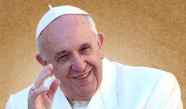

Christianity growing despite world’s worst persecutions,

new report says

By Peter Pinedo | Washington, D.C. Newsroom, Nov 8, 2023

A new report from a Christian advocacy group says that Christianity continues to thrive and grow despite brutal repression and attempts by governments, groups, and individuals across the world to quash the faith.
The 2023 “Persecutors of the Year” report was released this month by the advocacy group International Christian Concern (ICC).

ICC’s report sheds light on the suffering of hundreds of millions of Christians in 10 of the most heavily persecuted countries in the world. Despite these persecutions, the report said that the faith is growing in some of the world’s most persecutory countries such as Iran, China, and Nigeria.

Iran

According to the report, the Islamic Republic of Iran has “one of the fastest-growing churches in the world.”

Christians currently make up only a small minority in Iran, numbering somewhere between 500,000 and 800,000, according to ICC’s report. Though the government, ruled by Grand Ayatollah Ali Khamenei, enforces strict adherence to Sharia law, ICC’s report said that hundreds of thousands of Iranians “from all different kinds of walks of life” have converted to Christianity.

Christian religious expression in the country is heavily restricted and converts to Christianity from Islam face arrest, torture, and execution.

Iran’s Islamic Revolutionary Guard Corps (IRGC), which is at the vanguard of the government’s attempt to extinguish the light of the faith in Iran, “is merciless in its efforts to stamp out Christianity,” according to the report.

Additionally, ICC said that a “skewed” justice system targets Christians for practicing their faith and keeps them in “exceptionally harsh conditions,” including “extreme torture.”

Joseph Daniel, ICC’s Middle East regional manager, said in the report that “for more than 40 years the Iranian regime has persecuted Iranian Christians through banning Farsi-language Bibles, imprisoning church leaders, and falsely accusing converts to Christianity as national security threats.”

“But through it all,” Daniel continued, “God is working a miracle, and the underground Iranian church continues to grow rapidly.”

China

In China, the report said that the Chinese Communist Party (CCP) “requires that citizens worship the state, co-opting every religious structure possible into a mouthpiece of CCP propaganda.”

Despite the government’s attempts to control all religious expression and worship, the report said that Christianity in China, lived out primarily in underground church communities, is “rapidly growing.”

Under the leadership of Chinese President Xi Jinping, the penalties for living out one’s Christian faith have continued to increase. Amid the persecution, the report said that there are now 70 million to 100 million “underground Christians” who have refused to follow the CCP’s mandate to “worship the state,” choosing instead to risk their lives by following Christ.

Nigeria

According to ICC, Nigeria is “arguably the most dangerous place to be a Christian in the world today.”

Though Nigeria is nearly 50% Christian, the country’s approximately 100 million Christians live under constant threat of torture, kidnapping, and execution.

Acts of extreme violent persecution are a regular occurrence for Nigerian Christians, according to the report. The hardships Christians face in the country are due to a combination of extremist groups and government targeting.

Radical Islamist groups such as Boko Haram, the ISIS offshoot Islamic State West Africa Province, and the Fulani herdsmen continue to prey on the country’s large Christian population, despite government promises and claims that religious targeting has been solved in the country.

The persecution has continued for decades now with no signs of improvement in 2023. ICC President Jeff King said in the report that the government’s inaction to Christian persecution amounts to “aiding and abetting” the “genocide” of Christians in the country.

Though King said that the violence “will only worsen unless the international community steps in,” the report also said that Christianity in Nigeria continues to grow in regional pockets.

CNA reported earlier this year that despite the escalating persecution, Nigeria has by far the highest Mass attendance in the world.

Ninety-four percent of Catholics in Nigeria say they attend Mass at least weekly, according to a study by the Center for Applied Research in the Apostolate.

Bishop Wilfred Anagbe of the Diocese of Makurdi in Nigeria’s Benue state told CNA in June that “the blood of the martyrs is the seed of Christianity.”

“Persecution has been part and parcel of the life of a Catholic,” Anagbe said. “But then it doesn’t stop the faith of the people.”

“We constantly keep on praying,” Anagbe said. “God will surely hear our prayers. So, that’s why the Mass is so important and why we pray. We have to trust God in the midst of this crisis.”

‘The resilience of the body of Christ’

ICC also highlighted the plight of Christians enduring persecutions in North Korea, India, Pakistan, Eritrea, Algeria, Indonesia, and Azerbaijan as well as some of the leading persecutory groups and individuals such as the Taliban, Jinping, and North Korean dictator Kim Jong Un.

While the purpose of ICC’s annual report is to bring attention to the suffering of Christians across the world, King said that it also “unveils the resilience of the body of Christ.”

King noted that “our brothers and sisters are murdered, imprisoned, or tortured the world over, simply for identifying as a follower of Jesus,” but he pointed out that these believers “hold onto and even thrive in their faith while enduring unimaginable pain.”

Peter Pinedo is a DC Correspondent for CNA. A graduate of Franciscan University, Peter previously worked for Texas Right to Life. He is a first lieutenant in the U.S. Army Reserve.
November is the Month of the
HOLY SOULS IN PURGATORY
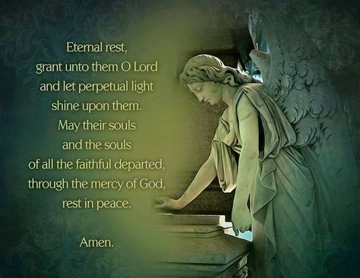

-----------------------------------------------------------------------------------------------------

SUMMARY OF PARISH COUNCIL MEETING ̶ October 10, 2023

- The Parish Council Meeting was called to order at 6:30 p.m. on 10 October 2023.Father Dominic opened with a Scripture Reading. All members of the council were present with excused absences of Richard Deardorff and Dr. Robert Ternes. Guests included Kathy Dietsch, and Dodie Huete.

- The council remembered the soul of Mike McTighe as a member of the council and faithful servant of the parish. A prayer was said for him. Father Dominic appointed Kathy Dietsch to fulfill the remainder of Mike’s term on the council.

- The council asked Father Dominic for the need of assistance within the parish. He responded with the need for volunteers to assist with lighting candles for mass preparation, someone with computer skills for publishing the weekly bulletin, lectors, four Catechists, extraordinary ministers, and greeters before mass.

- Old Business: Work will continue to set an agenda for a Parish Town Hall meeting.

- The Areas of Mission effort for the Parish will begin with work on evangelization and outreach to former members of the Parish.

- Other ideas for the Area of Mission include soup get togethers, events with other local parishes, and support for seasonal migrant workers.

- New Business: The Coffee and Donuts between Sunday Masses was mentioned as an excellent opportunity for fellowship with the parishioners, even if they do not have children attending the religion classes.

- Sister Thelma’s recent presentation in the Loyola Center went very well. The council is considering a way to honor her work that has connected many parishioners with her heartfelt talks over the past years.

Next Meeting for Parish Council will be November 14, 2023 at 6:30 p.m.
Save the Date!
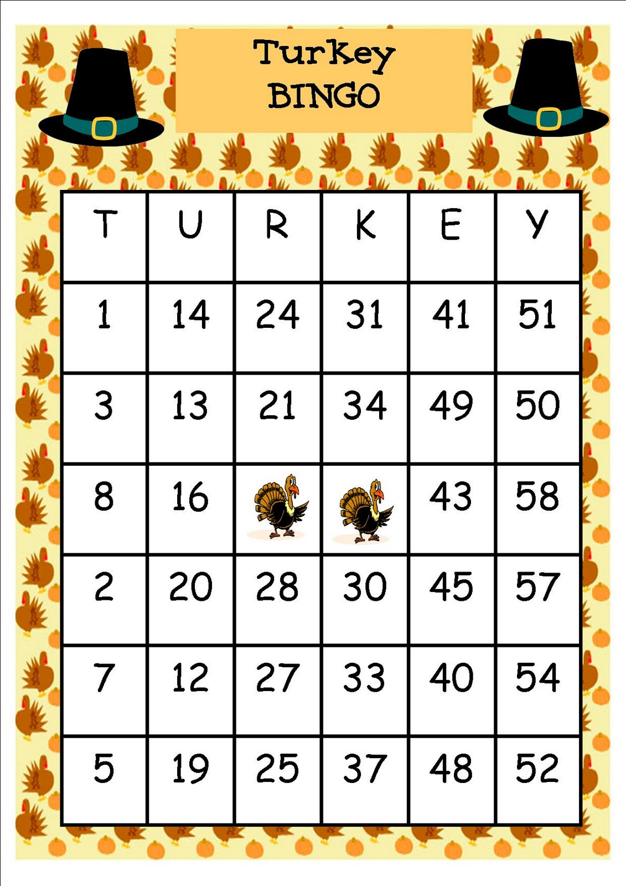
This Year’s Turkey Bingo – MONDAY, Novemeber 20, 2023.
Doors will open at 5PM and bingo will begin at 6:30PM.
Come down for the FOOD, FUN, and FROZEN TURKEYS, too!

Bring your daubers, trolls, and happy faces!

