Pope Francis: Wrath is a vice that is ‘pervasive,’ ‘dark’
By Matthew Santucci | Rome Newsroom, Jan 31, 2024
Pope Francis dedicated his Jan. 31 general audience to the subject of wrath, characterizing it as a vice that is “pervasive” and “particularly dark.”
In his opening remarks, the Holy Father observed that wrath is an inherently physical vice, as it is “perhaps the easiest to detect from a physical point of view” because “one who is consumed by wrath” has a particular difficulty in “hid[ing] this impulse.”
“You can recognize it from the movements of his body, his aggressiveness, his labored breathing, his grim and frowning expression. In its most acute manifestation, wrath is a vice that concedes no respite,” the pope said to the faithful gathered in the Paul VI Audience Hall on Wednesday morning.
Aside from its physical manifestations, Francis noted that the vice stems from a perceived “injustice suffered,” which, in turn, permits it to be “unleashed not against the offender but against the first unfortunate victim,” making it something that “destroys human relationships.”
“It expresses the incapacity to accept the diversity of others, especially when their life choices diverge from our own,” the Holy Father continued. An antidote to this vice can be found in the Letter of St. Paul to the Ephesians, where Paul “recommends to Christians to face up to the problem straight away and to attempt reconciliation.”
“Do not let the sun go down on your anger,” the pope said, quoting from the epistle (Eph 4:26). Francis underscored this point by urging that the faithful seek reconciliation and not let anger consume us or let it become a rumination.
“If some misunderstanding arises during the day, and two people can no longer understand each other, perceiving themselves as far apart, the night cannot be handed over to the devil,” the Holy Father said. “The vice would keep us awake at night, brooding over our reasons and the unaccountable mistakes that are never ours and always the other’s.”
Expanding on how vice factors into the the nexus of human relations, the pope presented the LORD’s Prayer as a testament to not only the supreme power of forgiveness but also one where Jesus “makes us pray for our human relations, which are a minefield: a plane that is never in perfect equilibrium.” The pope said: “Men do not stay together if they do not also practice the art of forgiveness, as far as this is humanly possible.”
“Wrath is countered by benevolence, openness of heart, meekness, and patience,” he argued.
However, the Holy Father also noted that anger reflects a basic humanity, noting that “the passions are to some extent unconscious, they happen, they are life experiences.”
While acknowledging that “we are not responsible for the onset of wrath,” the pope said we are, however, responsible “for its development.”
The pope further acknowledged the existence of righteous, or “holy” indignation.
“If a person were never to anger, if he did not become indignant at an injustice, if he did not feel something quivering in his gut at the oppression of the weak, it would mean he was not human, much less a Christian,” the pope observed.
Jesus, in fact, showcased this justifiable indignation when he cast the merchants out of the Temple, though he “never responded to evil with evil.”
“He performed a strong and prophetic action, dictated not by wrath but by zeal for the house of the LORD.”

Pennsylvania Supreme Court opens the door to public funding for abortion

By Jonah McKeown | CNA Staff, Jan 30, 2024

The Supreme Court of Pennsylvania on Monday revived a 2019 lawsuit brought by a number of abortion providers in the state that challenges, on discrimination grounds, a longtime state law barring public funding for most abortions.

In a 219-page ruling Jan. 29, the state high court reversed an earlier dismissal of the lawsuit, sending it back to the Commonwealth Court, one of the state’s two appellate courts.

At issue is Pennsylvania’s Abortion Control Act, in place since the 1980s, which restricts the use of state and federal funds for abortion except “when necessary to avert the death of the mother” or in cases of rape or incest.

The abortion providers bringing the lawsuit had argued, among other things, that Pennsylvania’s policies regarding the use of federal funds unfairly singled out women, since “there is no medical condition specific to men for which medical assistance denies coverage.”

The Commonwealth Court had previously dismissed the lawsuit in 2021 on the grounds that it was bound by Pennsylvania Supreme Court precedent; the state Supreme Court had previously upheld the abortion restrictions in 1985.

The majority ruling this week found that Pennsylvania’s law barring public funds for most abortions “discriminates against those women who choose to exercise their fundamental right to terminate a pregnancy” and that abortion providers have standing to sue the state over the policy.

The ruling does not immediately change abortion policy in Pennsylvania. Rather, the state Supreme Court ruling sends the case back to the Commonwealth Court for further review. Abortion is presently legal in Pennsylvania up to 24 weeks in pregnancy, or later in pregnancy if the life of the mother is at risk.

Seventeen states use public state funds to pay for abortions, despite a federal policy known as the Hyde Amendment that since 1976 has prohibited the use of federal tax dollars to pay for abortion. States that want to pay for abortions through their Medicaid program could do so using their own funds and are not reimbursed by the federal government.

The Pennsylvania Catholic Conference, which advocates for policy in the state on behalf of the Catholic bishops, said it is working on a formal response to the state Supreme Court’s ruling.
In a brief statement to CNA on Tuesday, Eric Failing, the Conference’s executive director, noted that it is “a complex case with a lot of decisions so we are going through it very carefully.”

Jonah McKeown is a staff writer and podcast producer for Catholic News Agency. He holds a Master’s Degree from the University of Missouri School of Journalism and has worked as a writer, as a producer for public radio, and as a videographer. He is based in St. Louis.

WHYF Holy Family Radio January 2024 Update
The end of 2023 was a challenging time for Holy Family Radio. As we begin 2024, I am reminded of Proverbs16:3 –
Entrust your works to the LORD, and your plans will succeed.
We are committed to this important apostolate and know that we can count on you for you continuing prayers and financial support.
I hope that everyone had a great Christmas and that a wonderful New Year is in store for you. We at Holy Family Radio are very grateful to our listeners for their support during our computer crisis last month. We were able to purchase a new automation computer, with minimal time off the air, thanks to several of our generous and devoted supporters. As we have said many times, without you, there would be no Holy Family Radio!
It is with much hope and optimism that we enter the New Year. We have many challenges to overcome, but with your continued support, we will be successful in our modernization efforts, meet our monthly expenses and continue to grow our listener and support base. Successfully doing those things will enable us to continue our mission of evangelization in the Central PA region. Getting the Good News of Christ out to as many people as possible is our goal!
You can help us to meet that goal with your continued financial support and your prayers. God bless all of you in the New Year and may Christ be in your heart, always!
Russ Fry, Community Relations Coordinator
Rfry@720WHYF.com

“Join in the Worldwide Mission of Jesus”

First Sunday in February
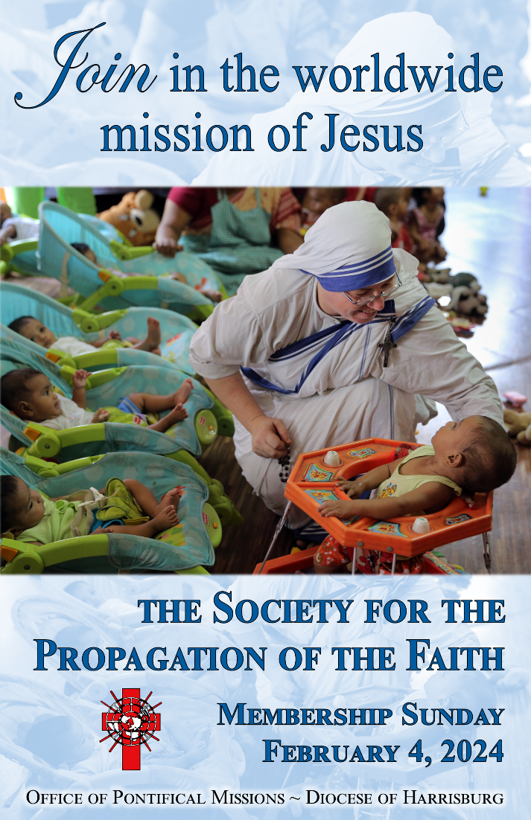

On the 1st Sunday in February, parishes throughout our Diocese are invited to make a special pledge to the worldwide Mission of Jesus, through the Society for the Propagation of the Faith.

At Baptism, we are called to be a missionary, to share our faith and pass on the Good News of Jesus among the mission poor. Through the Propagation of the Faith, we can reach out to the peoples of the world by providing prayers and financial assistance to missionary priests, religious Sisters and Brothers, and lay catechists.

This year’s theme is Join in the Worldwide Mission of Jesus. Missionaries have been spreading Christ’s love and His Gospel since He ascended back to His heavenly Father. As His followers, Jesus commanded us to make disciples of all nations, and today’s missionaries continue to fulfill that mandate. However, they need a strong support system of spiritual prayerful care and financial stability. As God’s people, we must be good “senders” in the Great Commission by our prayers and sacrifices.

Membership in the Society for the Propagation of Faith is vitally important for the ongoing support of missions in over 1,150 dioceses around the world. The Society’s members enable Christ’s mission to continue with strong convictions, zealous ambitions, and energetic apostolic work.

Membership envelopes are included in your February collections envelope packet. Thank you for your generosity!
Sacrament of the Sick
Anointing of the Sick should be given if an individual is gravely ill or near death. If possible, the Sacrament should also be administered for serious illness, before major surgery or when one is initially hospitalized.

Sacrament of Holy Matrimony
Diocesan policy requires 12 months of preparation for Marriage. Contact the parish as soon as possible after engagement. No venue reservations or other arrangements should be made prior to consultation with the pastor.

Sacrament of Penance
Wednesday ~ 6:00 – 6:45PM; or by appointment.

Sacrament of Baptism
Parents must be registered members of the parish and attend a Baptism preparation class prior to the Baptism if this is your first child baptized. Requirements for godparents are established by the Catholic Church. Please call the parish office for Information and to register your child for Baptism.

Parish Registration
All Catholics should be registered in their local parish. Please contact the parish office to obtain registration forms, or if you are uncertain of the parish where you should register.

Parish Staff & Ministries Directory
stignatiusofloyola@hbgdiocese.org | Office: 717-677-8012
Financial Manager ~ Richard Deardorff ~ 717- 677-8012 or 717-420-3464 (cell)
rdeardorff@hbgdiocese.org
Director of Religious Education ~ Deacon Steve Huete ~ shuete@hbgdiocese.org
Parish Secretary ~ Kristen DiDio ~ kdidio@hbgdiocese.org
Buildings & Grounds ~ Donnie Althoff ~ 717-677-8012
Music Ministry ~ Phil Mobley ~ 717-677-8012
Parish Council Members
Phil Mobley – Chair 571-236-7580 pmmobley@gmail.com
Bicky Redman – Vice Chair 677-8592 feetintheair7@gmail.com
Joanne Riedel - Secretary 398-2021 sterj221@aol.com
Kathi Allwein 677-8984 allweint@comcast.net
Charlie Baker 677-9536 dcbake@embarqmqil.com
Kathy Dietsch 352-4558 kdiet2@juno.com
Dr. BobTernes rjtmd46@gmail.com

Finance Council Members
Richard Deardorff (Ex Officio)
Greg Ernst - Chair
Christy Hemler - Secretary
Ali Morris
Terri Pendlelton
Bill Pulig

Altar Flowers
OCIA
Order of Christian Initiation for Adults
Contact Fr. Dominic

Soup Kitchen
Please send donations
directly to the
“Gettysburg Soup Kitchen”

Website Development
Kristen DiDio
Life After Loss
Dodie Huete

Prayer Chain
CONTACT THE PARISH OFFICE

Picnic Co-Chairs
Wally Kane
Mark Schur

Pro-Life Ministry
Jeanette Backus
Knights of Columbus
SK Bob Ternes
- Grand Knight

CONTACT THE PARISH OFFICE

Bereavement Ministry
Ginny Bittle / Dodie Huete

Catholic Communications/EWTN
Anna Kane

Cemetery
CONTACT THE PARISH OFFICE
THEOSIS Ministry
Kathy Dietsch 717-352-4558
Bicky Redman 717-677-8592

Diocese of Harrisburg Youth Protection Program
www.YouthProtectionHBG.com

Abuse Reporting Contact Information:
First – Call the toll-free PA Child Abuse Hotline at 800-932-0313
Then – Call the Diocesan toll-free hotline at 800-626-1608

“If one member suffers,
all suffer together with it.” (1 Cor 12:26)

St. Ignatius Loyola RC Church

1095 Church Road, Orrtanna, Pennsylvania 17353
www.stignatiusofloyola.org | Office: 717-677-8012

February 4, 2024: FIFTH SUNDAY IN ORDINARY TIME
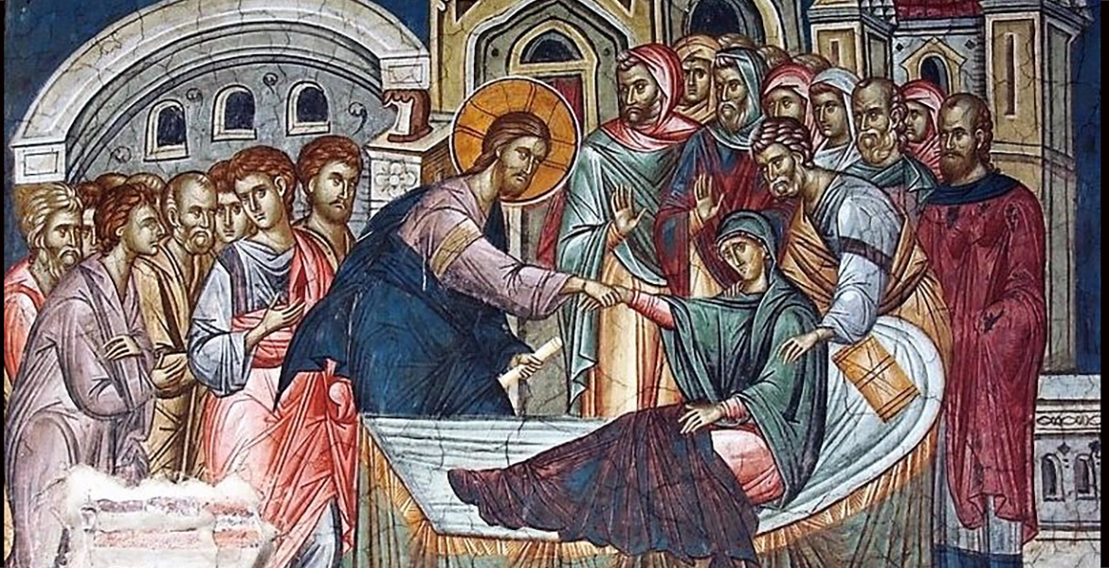

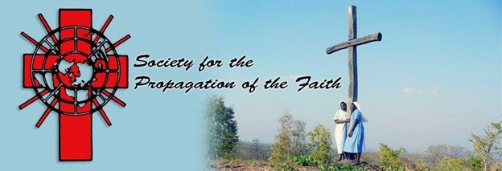

MEMBERSHIP SUNDAY
May the Holy Name of JESUS be invoked
to bring PEACE in the Holy Land!
Most Rev. Timothy C. Senior, Bishop of Harrisburg
Rev. Dominic M. DiBiccaro, Pastor
Deacon Steve Huete, Pastoral Associate

Mass Schedule, Intentions, and Events
Please Pray for these in need:
Jeanie Kline & the Kline Family, Dick & Deb Deardorff, Shell Edwards, Corona Naylor, Chris & Mary Rebscher, John Baker, Ginny Hoctor, Janet Hodge, Brenda Wolf, Sr. Thelma Steiger HSF, Sr. Miriam Ukeritis CSJ , Peter Hackney, Lucas Christiansen, Dale Kaplan, Jerry Smith, Wade Sprankle, Dulcie Perry, Ron Formosa, Gavin Crumbacker, Anna Kane, Sherry Dennis & Family, Remi Peters, Terry Ahn, K. Grance, Lori McFadden & Family, Mike & Lisa Poole, Mervin Weikert, Chastity Rudisill, Mary Ellen Wilson, Terry & Bernie Cabana, Ed & Aggie Sherensky & Family, Bob Raffensberger, Jerry & Ginny Miller, Adeline Lienard, Kaylee Henry, Nancy Wuller, Dr. Mike Colli, Mrs. Kelly Kump, Gabriel Singer, Sharon McCormley, Ron Thumma, Joe Wisotzkey, Leo Hockensmith, Erika McKissick, Jean "Heather" O'Shea, Scott Moore & Sally Moore, Mary Wyatt, Amy Weatherup, Sophia Joy Ernst, Deacon Richard Wentzel, Deacon Frank Enderle, Paul & Carolyn Topper, Kathleen Thompson, Rachel Wonders, Amy Edwards, Jean O’Connor, Jen Baldwin, Ursula Kaley, Deb Bennet, Larry Endy, Laura Lee, Marwa Abdelrahman, Donna Singley, Tim McGinn, Jane Kump, Peggy Neiderer, Chris Kimple, Robert Riquet, Gene & Jo-Ann McDannell, Bob Doxzen, Kimberly Mears, Gabriella Angello, Paul Angello, Mark & Kate Morrow, Mark Morris, Linda Fogleman, Paul Knight, George & Barbara Erstila, Jeff Carpenter, Lana & Nelson Harmon, Diane Slothour, Sue McDannell, Larry Schneider, Joe & Lisa Grasel, Ange Pena, Julie Barnhart, Shaffer Family, Heather & Emma Dickerson, Brad Peabody, Paul Ward, Aiden Tyler Schneider, Dorothy Vega, Karrie McCall & daughter, George Shahid, Denise Navlyt, Drew Schneider & Family, Ida Bloomfield, Janie Singley, Mary Beth Greenstreet, Rick Benedict, Jan Patla, Kathey Fogleman, Sam Sheffler, Kate Hemmis, Bill & Mary Lou Graham, Andy Graham, Joanna Hodges, John Varones, Joan O’Sullivan, Martha Klinger, Lisa Dionne Lauretti, Jim Gleason, Sue Gustafson, Joe & Michelle Cleary, Kim Johnson, Helen Mills, Kathy Haber, Haley Detman, Joe Durovey, Bev Smith, Donald Sheppard, Linda Mumaugh, Alison Haring, Janet Hartman, Edward Johnson, Angela Galeone, Juliete Lang, Chris MacBeth, Harry Graham, Donald Howard, Armond Binni, Elizabeth Stansky, Pat Johnson, Chris Morris, Faud Doaney, Patrick Glass, Helen Lagasse, Nancy Kewisnek, Bill & Maureen Collins, Rosemary McGilloway, Anji Eisenhart, Monica Manner, Denny Borbonus, Dr. Paul Scarlata, Mary Hawthorne, Ed Washington, Josh Kempinski, Nancy Baltzey, Spencer Propts, Karlton Smith & Cheryl Sobun, James & Marylyn Sobun, Marlene Webster, Yvette Stoklosa, Andy Consiglio, Bill & Michelle Cloonan, Nelson Salem, Bill & Deb McClintock, nursing home residents & shut-ins, the victims of war, violence, disease, disaster, & all private intentions.
Also in your prayers, please remember all our men
& women currently serving in our Armed Forces:

Lt. Col. Nathan Jeffcoat – US Marine Corps
Lt. Joseph Cleary – US Navy
Michael C. Kenney IV – US Coast Guard
Lt. Joshua Kimple – US Army
Lt. Sarah Fogleman, M.D. – US Navy
A1C Ian Bellinger ‒ PA Air National Guard

PRAYER CHAIN: Contact the Office

for the Week of February 3 to February 11, 2024

SATURDAY, Feb. 3 – Vigil 5th SUNDAY IN ORDINARY TIME

Jb 7:1-4, 6-7/1 Cor 9:16-19, 22-23/Mk 1:29-39
5:00PM + Zack McCormley

SUNDAY, Feb. 4 – 5th SUNDAY IN OT

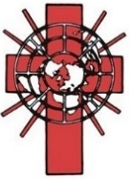
Jb 7:1-4, 6-7/1 Cor 9:16-19, 22-23/Mk 1:29-39

8:00AM ⁓ People of the Parish
10:30AM + Jeanne Crossland

MEMBERSHIP SUNDAY

MONDAY, February 5 – St. Agatha, Virgin
1 Kgs 8:1-7, 9-13 / Mk 6:53-56 & Martyr
Parish Office CLOSED

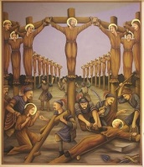
Tuesday, February 6 – St. Paul Miki & Companions,
1 Kgs 8:22-23, 27-30 / Mk 7:1-13 Martyrs

8AM – 3PM ~ Office Open

10:00AM + Ron Zemsky

Wednesday, February 7 (Weekday in OT)
Mark 7:14-23
1 Kgs 10:1-10 / Mk 7:14-23

8AM – 3PM ~ Office Open
7:00PM + Jack Ryff
6 – 6:45 Confessions; 7:40 Adoration; 8PM Benediction

Thursday, February 8 – St. Jerome Emiliani; St. Josephine Bakhita,
1 Kgs 11:4-13 / Mk 7:24-30 Virgin

8AM – 3PM ~ Office Open
10:00AM - Private Intention
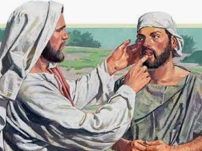  Friday, February 9 (Weekday in OT)  1 Kgs 11:29-32; 12:19 / Mk 7:31-37  10:00AM + Mona Knox Bailey  Parish Office CLOSED | THE LORD

SATURDAY, Feb. 10 – St. Scholastica, Virgin
MORNING: 1 Kgs 12:26-32; 13:33-34/Mk 8:1-10

SATURDAY, Feb. 11 – Vigil 6th SUNDAY IN ORDINARY TIME

Lv 13:1-2, 44-46/1 Cor 10:31—11:1/Mk 1:40-45
5:00PM + Robert MacBeth
SUNDAY, Feb. 4 – 6th SUNDAY IN OT

Lv 13:1-2, 44-46/1 Cor 10:31—11:1/Mk 1:40-45

8:00AM + Diane Kump Stapleton
10:30AM ⁓ People of the Parish

Sanctuary Candle for FEBRUARY is offered: In Loving Memory of Timothy & Andrew Heller from Martha Heller

Sunday Collection Summary for Jan. 27 & 28

Weekend Collections
Regular Offering $ 3,412.26
Ash Wednesday $ 50.00
Easter $ 35.00
TOTAL OFFERINGS $ 3,797.26

- WEEKLY BUDGETARY NEEDS $ 4,494.00
+Overage or (Shortfall) for the week ($ 696.74)

Other Income
Candles/Living Faith $ 46.23
Cemetery Upkeep $ 1,292.00
Individual Contributions $ 10,800.00
Local Poor $ 75.00
Memorial Contribution (Paul Topper) $ 300.00
Total Other Offerings $ 12,213.23

Diocesan Second Collections
Church in Eastern Europe & Africa $ 75.00
Poor Missions $ 50.00
Society for the Propagation of the Faith $ 55.00
Total Diocesan Offerings $ 180.00
FY 2023-24 SIX-MONTH FINANCIAL SUMMARY

NET SURPLUS / (DEFICIT) +$16,610.18
In the first half of the current fiscal year (July – December 2023), St. Ignatius Loyola Parish maintained a positive financial position. Year-to-date Operating Income significantly exceeds the budget by $69,055. Although Sunday & Holy Day Collections are below expectations by $11,474, Other Contributions are well above by $59,448. However, Operating Expenses also exceed the budget, but by a much lesser amount: $22,467. Most expense categories are reasonably within expectations except Supplies, which is much higher due to the unanticipated maintenance projects.

Capital Expenditures are significantly higher than expected, by $112,706. Entering the fiscal year, payments for the windows renovation and gutter work were expected, even though they were covered by Savings as noted above (#4); which also the Unbudgeted Expenses of restoring the wooden doors of the church, installing security cameras, updating emergency lighting, and repairing the Loyola Center roof. Considering the age of the physical plant, it is possible that additional capital expenses will occur.

Our Cash Account is +$16,610 greater than at the beginning of the fiscal year. This Cash Account, ad our Savings, are in a very healthy position, so that whatever fiscal challenges occur in the coming 6 months, the parish is able to meet them.

Raised to Serve: Scott Hahn Reflects

on the Fifth Sunday in Ordinary Time

In today’s First Reading, Job describes the futility of life before Christ.

His lament reminds us of the curse of toil and death placed upon Adam following his Original Sin (see Genesis 3:17–19). Men and women are like slaves seeking shade, unable to find rest. Their lives are like the wind that comes and goes.

But, as we sing in today’s Psalm, He who created the stars promised to heal the brokenhearted and gather those lost in exile from Him (see Isaiah 11:12; 61:1). We see this promise fulfilled in today’s Gospel.

Simon (Peter)’s mother-in-law is like Job’s toiling, hopeless humanity. She is laid low by affliction but too weak to save herself.

But as God promised to take His Chosen People by the hand (see Isaiah 42:6), Jesus grasps her by the hand and helps her up. The word translated “help” is actually Greek for “raising up.” The same verb is used when Jesus commands the young daughter of the synagogue official to arise (see Mark 5:41–42). It’s used again to describe His own Resurrection (see Mark 14:28; 16:7).

What Jesus has done for Simon’s mother-in-law, He has done for all humanity — raised all of us who lay dead through our sins (see Ephesians 2:5).

Notice all the words of totality and completeness in the Gospel. The whole town gathers; all the sick are brought to Him. He drives out demons in the whole of Galilee. Everyone is looking for Christ.

We too have found Him! By our Baptism, He healed and raised us to live in His Presence (see Hosea 6:1–2).

Like Simon’s mother-in-law, there is only one way we can thank Him for the new life He has given us. We must rise to serve Him and His Gospel.

Our lives must be our thanksgiving, as St. Paul describes in today’s Epistle. We must tell everyone The Good News, the purpose for which Jesus has come — that others, too, may have a share in this Salvation.

Readings: Job 7:1–4, 6–7; Psalm 147:1–6
1 Corinthians 9:16–19, 22–23; Mark 1:29–39

Although this information is open to the parish, it is PROPRIETARY and CONFIDENTIAL. So please be prudent in disposing of this bulletin.

EXPENSES
Salaries and Benefits $70,420.34
Repairs and Maintenance 40,575.94
Utilities 11,196.95
Supplies 25,034.63
Business Expenses 1,900.00
Fundraising Expenses 24,411.08
Local Poor and Donations 2,992.74
Other Operating Expenses ⁶ 28,275.28
TOTAL OPERATING EXP. $204,806.96

Capital Expenditures:
Building ⁷ $145,178.76
Equipment ⁸ 1,380.49
Improvements ⁹ 6,152.00
TOTAL NON-OPERATING EXP. $152,711.25

TOTAL EXPENSES $357,518.21

⁶ Includes insurance, telephone/internet, school assessments, property taxes, computer support, etc.
⁷ Church window renovation; cemetery statue;
church doors; security cameras; emergency lighting; Loyola Center roof repairs
⁸ Security camera system
⁹ Remove trees in picnic grove

INCOME
Sunday & Holy Day Collect’s. $104,361.51
Picnic and Other Fundraising 51,750.75
Cemetery 5,570.00
Local Poor 2,914.00
Votive Candles and Pamphlets 2,173.57
DAC refunds ¹ 0.00
Other Contributions ² 73,001.77
Other Income ³ 3,830.32
TOTAL OPERATING INCOME $243,601.92

Withdrawal from Savings
Building ⁴ $128,416.47
Operations ⁵ 2,110.00
TOTAL NON-OPERATING INC. $130,526.47

TOTAL INCOME $374,128.39

¹ The Diocesan Annual Campaign rebate of about $7,511 will be paid in February.
² Memorials, flowers, individual & group contributions
³ Refunds, votive candles, fees, interest, sales, etc.
⁴ Savings used for windows restoration; cemetery statue; church doors; security cameras; emergency lighting; Loyola center roof repairs
⁵ Cemetery headstones repair

