Sacrament of the Sick
Anointing of the Sick should be given if an individual is gravely ill or near death. If possible, the Sacrament should also be administered for serious illness, before major surgery or when one is initially hospitalized.

Sacrament of Holy Matrimony
Diocesan policy requires 12 months of preparation for Marriage. Contact the parish as soon as possible after engagement. No venue reservations or other arrangements should be made prior to consultation with the pastor.

Sacrament of Penance
Wednesday ~ 6:00 – 6:45PM; or by appointment.

Sacrament of Baptism
Parents must be registered members of the parish and attend a Baptism preparation class prior to the Baptism if this is your first child baptized. Requirements for godparents are established by the Catholic Church. Please call the parish office for Information and to register your child for Baptism.

Parish Registration
All Catholics should be registered in their local parish. Please contact the parish office to obtain registration forms, or if you are uncertain of the parish where you should register.

Parish Staff & Ministries Directory
stignatiusofloyola@hbgdiocese.org
Financial Manager ~ Richard Deardorff ~ 717- 677-8012 or 717-420-3464 (cell)
rdeardorff@hbgdiocese.org
Director of Religious Education ~ Deacon Steve Huete ~ shuete@hbgdiocese.org
Parish Secretary ~ Kristen DiDio ~ kdidio@hbgdiocese.org
Buildings & Grounds ~ Donnie Althoff ~ 717-677-8012
Music Ministry ~ Phil Mobley ~ 717-677-8012
Parish Council Members
Phil Mobley – Chair 571-236-7580 pmmobley@gmail.com
Bicky Redman – Vice Chair 677-8592 feetintheair7@gmail.com
Joanne Riedel - Secretary 398-2021 sterj221@aol.com
Kathi Allwein 677-8984 allweint@comcast.net
Charlie Baker 677-9536 dcbake@embarqmqil.com
Mike McTighe 729-6239 mike0432@aol.com
Dr. BobTernes rjtmd46@gmail.com

Finance Council Members
Richard Deardorff (Ex Officio)
Greg Ernst - Chair
Alix Haller
Christy Hemler - Secretary
Terri Pendlelton
Bill Pulig

Altar Flowers
Prayer Chain
Lynne Mobley at LMOBLEY509@gmail.com
or 703-876-4901

Soup Kitchen
Please send donations directly to “Soup Kitchen”

Website Development
Kristen DiDio
Life After Loss
Dodie Huete

OCIA
Contact Fr. Dominic

Picnic Co-Chairpersons
John Neiderer
Wally Kane

Pro-Life Ministry
Jeanette Backus
Knights of Columbus
SK Bob Ternes
- Grand Knight
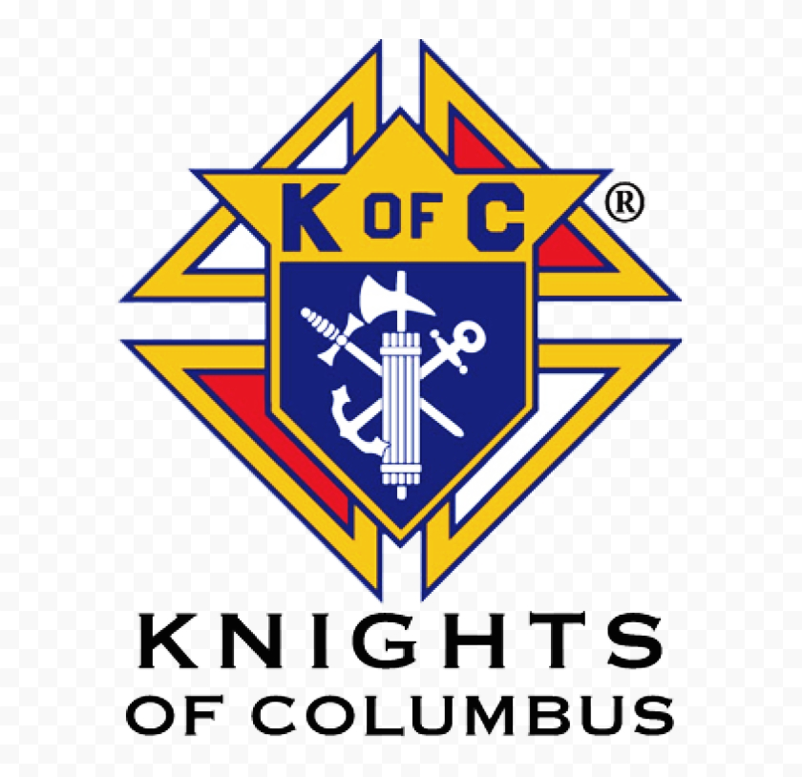

Judy Wilson / Janice Meligakes

Bereavement Ministry
Ginny Bittle / Dodie Huete

Catholic Communications/EWTN
Open - Contact office if you are interested

Cemetery
Contact Parish Office
THEOSIS Ministry
Kathy Dietsch 717-352-4558
Bicky Redman 717-677-8592

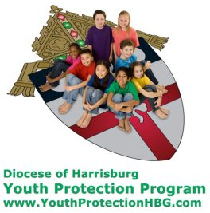
Diocese of Harrisburg Youth Protection Program
www.YouthProtectionHBG.com

Abuse Reporting Contact Information:
First – Call the toll-free PA Child Abuse Hotline at 800-932-0313
Then – Call the Diocesan toll-free hotline at 800-626-1608

“If one member suffers,
all suffer together with it.” (1 Cor 12:26)

St. Ignatius Loyola RC Church

1095 Church Road, Orrtanna, Pennsylvania 17353
www.stignatiusofloyola.org

JULY 23, 2023: 16th SUNDAY IN ORDINARY TIME

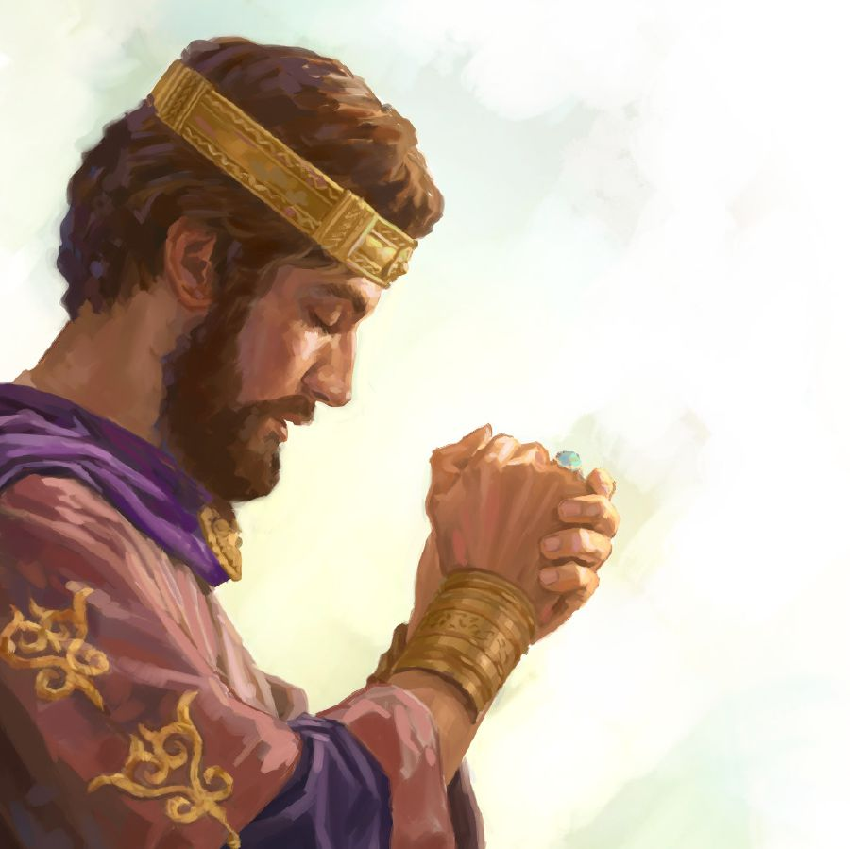

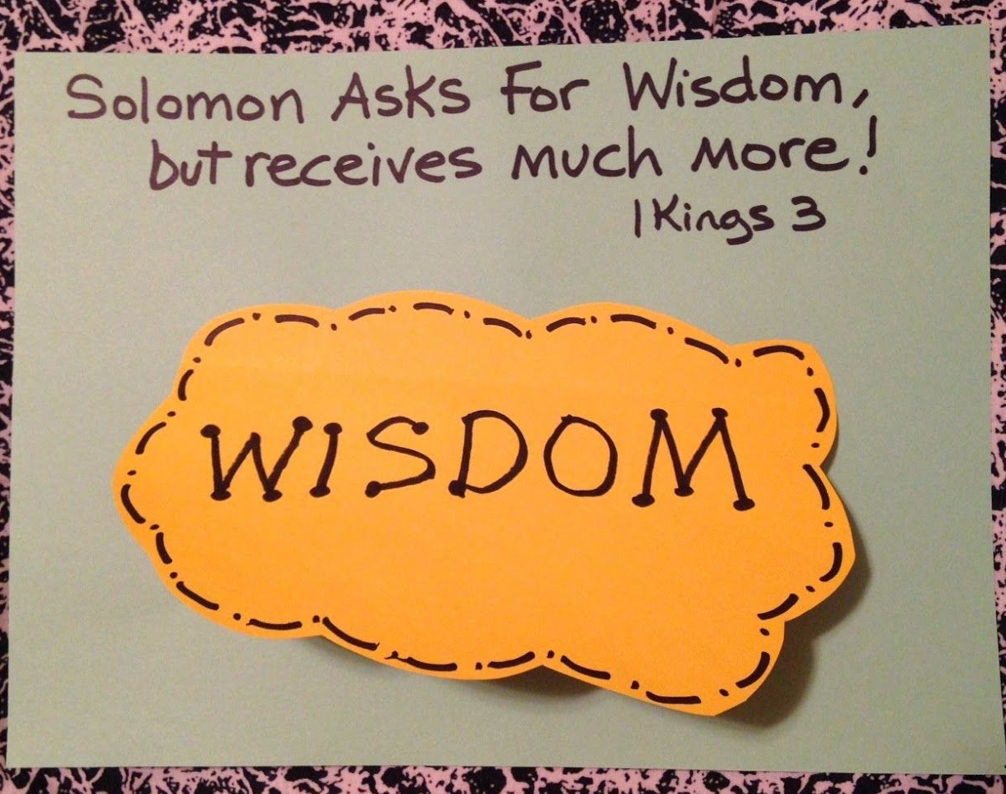

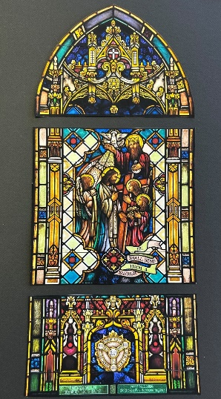
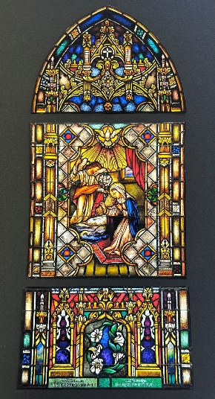
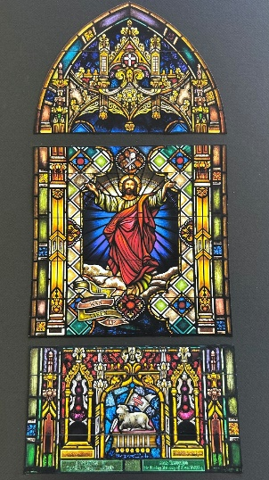
Bishop Timothy Senior
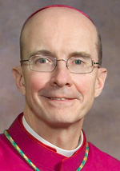
blesses our 3 newly
restored stain-glass
windows!

Most Rev. Timothy C. Senior, Bishop of Harrisburg
Rev. Dominic M. DiBiccaro, Pastor
Deacon Steve Huete, Pastoral Associate

Mass Schedule, Intentions, and Events
Please Pray for:
Those who are ill, Jeanie Kline & the Kline Family, Gavin Crumbacker, Sherry Dennis and Family, Remi Peters, Christy Hemler, Terry Ahn, K. Grance, Lori McFadden & Family, Mike & Lisa Poole, Mervin Weikert, Chastity Rudisill, Mary Ellen Wilson, Terry & Bernie Cabana, Ed & Aggie Sherensky and Family, Bob Raffensberger, Jerry & Ginny Miller, Adeline Lienard, Kaylee Henry, Nancy Wuller, Dr. Mike Colli, Mrs. Kelly Kump, Kevin & Brittany Groff, Gabriel Singer, Sharon McCormley, Ron Thumma, Joe Wisotzkey, Leo Hockensmith, Erika McKissick, Jean "Heather" O'Shea, Scott Moore and Sally Moore, Mary Wyatt, Jim & Joyce Deardorff, Brandon & Michelle Gilbert, Amy Weatherup, Sophia Joy Ernst, Deacon Richard Wentzel, Deacon Frank Enderle, Kathleen Thompson, Deb & Kathy McLintock and Family, Rachel Wonders, Amy Edwards, Jean O’Connor, Art Lazar, Sr., Paul Angello, Jen Baldwin, Ursula Kaley, Deb Bennet, Fr. Bill Sullivan, Larry Endy, Mary Beth McCarthy, Laura Lee, Marwa Abdelrahman, Cathy Gates, Donna Singley, Jack Ryff, Tim McGinn, Jane Kump, Peggy Neiderer, Chris Kimple, Robert Riquet, Gene & Jo-Ann McDannell, Bob Doxzen, Kimberly Mears, Gabriella Angello, Mark & Kate Morrow, Mark Morris, Linda Fogleman, Paul Knight, George & Barbara Erstila, Jeff Carpenter, Lana & Nelson Harmon, Diane Slothour, Sue McDannell, Larry Schneider, Joe & Lisa Grasel, Ange Pena, Julie Barnhart, the Shaffer Family, Heather & Emma Dickerson, Brad Pabody, Paul Ward, Aiden Tyler Schneider, Dorothy Vega, Karrie McCall & daughter, George Shahid, Denise Navlyt, Drew Schneider & Family, Ida Bloomfield, Linda McDannell, Janie Singley, Mary Beth Greenstreet, Rick Benedict, Jan Patla, Kathe Fogleman, Sam Sheffler, Kate Hemmis, Bill & Mary Lou Graham, Joanna Hodges, John Varones, Joan O’Sullivan, Martha Klinger, Lisa Dionne Lauretti, Sue Orndorff, Jim Gleason, Sue Gustafson, Joe & Michelle Cleary, Kim Johnson, Helen Mills, Kathy Haber, Haley Detman, Joe Durovey, Bev Smith, Donald Sheppard, Linda Mumaugh, Alison Haring, Janet Hartman, Edward Johnson, Angela Galeone, Juliete Lang, Chris MacBeth, Harry Graham, Donald Howard, Armond Binni, Elizabeth Stansky, Pat Johnson, Chris Morris, Faud Doaney, Wilson & Rae Harman, Patrick Glass, Helen Lagasse, Nancy Kewisnek, Andy Graham, Bill & Maureen Collins, Rosemary McGilloway, Anji Eisenhart, Monica Manner, Denny Borbonus, Dr. Paul Scarlata, Mary Hawthorne, Ed Washington, Josh Kempinski, Nancy Baker Baltzey, Spencer Propts, Karlton Smith & Cheryl Sobun, James & Marylyn Sobun, Marlene Webster, Yvette Stoklosa, Andy Consiglio, Bill & Michelle Cloonan, Nelson Salem, Bill & Deb McClintock nursing home residents & shut-ins, the victims of war, violence, disease, disaster, & all private intentions.
Also in your prayers, please remember all
our men and women currently serving in
our Armed Forces:
Maj. Nathan Jeffcoat – US Marine Corps
Lt. Joseph Cleary – US Navy
Michael C. Kenney IV – US Coast Guard
Lt. Joshua Kimple – US Army
Lt. Sarah Fogleman, M.D. – US Navy

PRAYER CHAIN: Contact Lynne Mobley at 703-876-4901 or LMOBLEY509@gmail.com

for the Week of July 29 to August 6, 2023

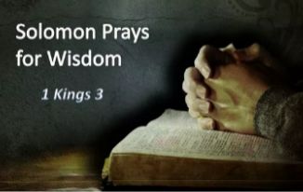
SATURDAY, July 29 –VIGIL MASS 17TH SUNDAY IN ORD.TIME

1 Kgs 3:5, 7-12/Rom 8:28-30/Mt 13:44-52
5:00PM +Fr. William Whelan (4th Pastor)

SUNDAY, July 30 – 17TH SUNDAY IN OT

1 Kgs 3:5, 7-12/Rom 8:28-30/Mt 13:44-52
8:00AM + Donald & Catherine Kimple, Kelly Kimple Kahn
10:30AM ⁓ People of the Parish
Principal Celebrant: Bishop Timothy Senior
Monday, July 31 – St. Ignatius of Loyola (PARISH PATRONAL FEAST)
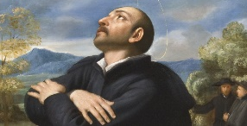
10:00AM ⁓ People of the Parish
Ex 32:15-24, 30-34 / Mt 13:31-35
Parish Office Closed

Tuesday, August 1 – St. Alphonsus Liguori, Bishop and Doctor of
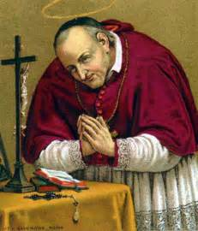
Ex 33:7-11; 34:5b-9, 28 / Mt 13:36-43 the Church

8:00AM - 3:00 PM ~ Office Open
10:00AM + Frances Joyce

“Something More” Group
Wednesday, August 2 – St. Eusebius of Vercelli, Bishop; and
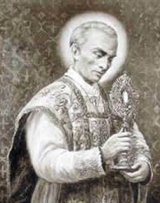
Ex 34:29-35 / Mt 13:44-46 St. Peter Julian Eymard, Priest

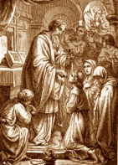
8:00AM – 3:00PM ~ Office Open
10AM: Mature Spirituality Group
7:00PM + Harry Bowmaster
Confessions 6 - 6:45PM; Adoration 7:40PM

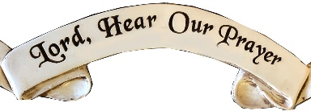
Thursday, August 3 (Weekday in OT)
Ex 40:16-21, 34-38 / Mt 13:47-53

8:00AM – 3:00PM ~ Office Open
10:00AM + Rev. Carl J. Steffen
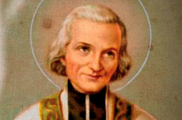  Friday, August 4 – St. John Vianney, Priest  Lv 23:1, 4-11, 15-16, 27, 34b-37 / Mt 13:54-58  Parish Office CLOSED | THE LORD
10:00AM + Spec. Int. Sue Cadwallader & Lambert Rosenbaum

SATURDAY, August 5 – Dedication Basilica of Saint Mary Major
MORNING: Lv 25:1, 8-17 / Mt 14:1-12

SATURDAY, Aug. 5 –VIGIL TRANSFIGURATION OF THE LORD

Dn 7:9-10, 13-14 / 2 Pt 1:16-19 / Mt 17:1-9
CO-OP
5:00PM +George & Mary Dambrauskas

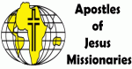
SUNDAY, August 6 – TRANSFIGURATION OF THE LORD
Dn 7:9-10, 13-14 / 2 Pt 1:16-19 / Mt 17:1-9
8:00AM + Jim, Helen, & Henry Kimple
10:30AM ⁓ People of the Parish
Sanctuary Candle offered for AUGUST: In Loving Memory of Teresa Redding from Edna Redding.
Sunday Collection Summary
July 22 and 23
Weekend Collections
Regular Offering $ 1,953.00
Candles $ 50.00
Altar Flowers $ 25.00
TOTAL OFFERINGS $ 2,028.00

‒WEEKLY BUDGETARY NEEDS $ 4,494.00
+Overage or (Shortfall) for the week ($ 2,466.00)

Other Income
Local Poor (additional) $ 285.00
Parish Picnic $ 220.00
Picnic Raffle Tickets $ 155.00
Sale of Equipment $ 250.00

Memorial (Larry Dennis) $ 50.00
Total Other Offerings $ 960.00

Pope Francis speaks to young people ahead

of World Youth Day in ‘Popecast’

Boston, Mass., July 25, 2023

Ahead of next week’s World Youth Day in Lisbon, Portugal, Pope Francis responded to the prerecorded questions and struggles of young people in Vatican News’ newly produced podcast, dubbed the “Popecast.” The podcast, which is produced in Italian, released its second episode Tuesday with the Holy Father. The first podcast was released in March on the 10th anniversary of Pope Francis’ papal election.

In the episode, Pope Francis responded to [one contributor named] Giona’s account of a personal struggle with transgenderism. “God loves us just as we are,” the Holy Father said, adding that “the Lord always accompanies us, always. Even if we are sinners, he draws near to help us,” Vatican News reported. The pope said: “Do not give up, keep striving ahead.”

To [another] woman named Arianna who explained how she suffers from bipolar disorder, which has at times caused suicidal thoughts, but who feels “saved by God,” the pope encouraged her to listen to the guidance of health professionals. He added that everyone has wounds from different causes, which include sin. Our wounds require us to rely on God’s love & mercy, he said. The Holy Father responded to Arianna’s recording reminding her to “always look ahead, not to lose sight of the horizon… and the horizon is God.”

A young man named Giuseppe shared his experience of leaving college, finding himself spending much of his time playing video games with others online, according to the outlet. Living his life online can become “aseptic” and isolated, the Holy Father said, adding that human contact is important.

The Holy Father also heard the regrets of Edward and Valerij, who both came from difficult family situations, which led to a life of crime resulting in juvenile detention, the outlet reported. Pope Francis encouraged them to not allow mistakes to impede their lives, adding that the “human story goes on with its successes and its failures.” The Holy Father told them to remember that Jesus is always with them and ready “to take you by the hand, to help lift you up.” It is our responsibility to acknowledge our mistakes so God can help us change our lives, he said.

Then a religion teacher, Valeria, said in her recorded message that her students voice their desire for a more transparent and youthful Church that is closer to the people, according to the outlet. The pope noted that it’s important for the Church to walk together with the people. The Church can become too closed in on itself and risk division, he added. He said that what makes the Church great is its diversity and unity.

The Holy Father also made comments aimed at Argentinian youth, from his native country, and encouraged them to better their society by rising to the occasion, the outlet reported. He concluded the “Popecast” by urging the young people in the recordings to take part in World Youth Day. He said that they would find it fulfilling, with its community, celebration, hope, and joy.

COURTESY ANNOUNCEMENT
Corpus Christi Church
“Cruise-In”
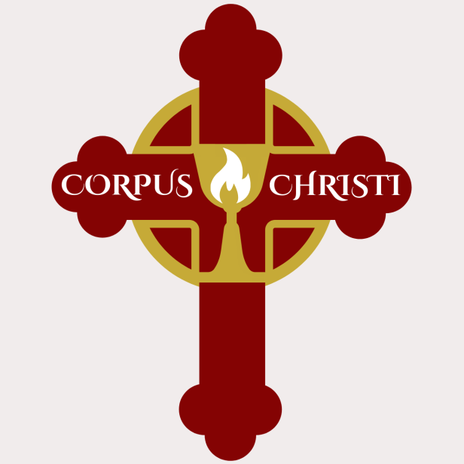
Friday,
August 18, 2023

279 N. 2nd Street Chambersburg, PA 17201
5:00 pm to 8:30 pm
*** Rain or Shine ***

DJ playing tunes of the times!

Food and drinks available!

• 50/50 Drawing
• Door Prizes
• Chance Raffles
Registration: $10.00
(includes one ticket for
Door Prizes)

Dash plaques to the
first 50 participants

For more info: Call 717-263-9541 or email rramsey@corpuschristichbg.org

PLEASE WELCOME THE MISSIONARY FROM THE APOSTLES OF JESUS, FR. RICHARD O’NYAMWARMO, AJ, NEXT WEEK AS OUR 2023 MISSIONARY CO-OP PARTNER!

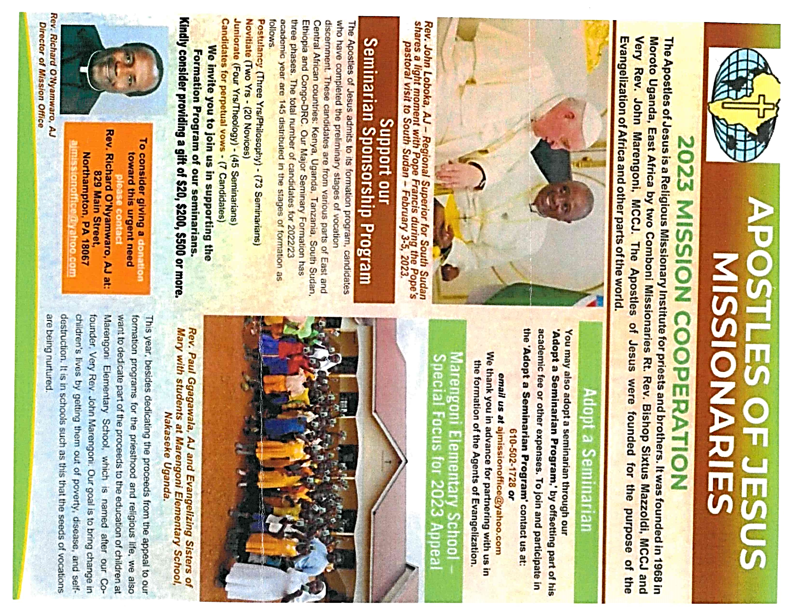

The Holy Father, Pope Francis’ Prayer Intentions for 2023
Entrusted to His Worldwide Prayer Network
AUGUST ⁓ FOR WORLD YOUTH DAY

We pray the World Youth Day in Lisbon will help young people to live and witness the Gospel in their own lives.

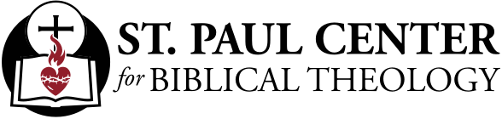

Treasures of the Kingdom: Scott Hahn Reflects

on the Seventeenth Sunday of Ordinary Time

What is your new life in Christ worth to you?

Do you love His words more than gold and silver, as we sing in today’s Psalm? Would you, like the characters in the Gospel today, sell all that you have in order to possess the Kingdom He promises to us? If God were to grant any wish, would you follow Solomon’s example in today’s First Reading — asking not for a long life or riches, but for Wisdom to know God’s ways and to desire His Will?

The background for today’s Gospel, as it has been for the past several weeks, is the rejection of Jesus’ preaching by Isra-el. The Kingdom of Heaven has come into their midst; yet, many cannot see that Jesus is the fulfillment of God’s Promises, a gift of Divine Compassion given so that they — and we — might live.

We, too, must ever discover the Kingdom anew. We are called to find it as a treasure, a pearl of great price. By comparison with the Kingdom, we must count all else as rubbish (see Philippians 3:8). And we must be willing to give up all that we have — all our priorities and plans — in order to gain it.

Jesus’ Gospel discloses what St. Paul, in today’s Epistle, calls the purpose of God’s Plan (see Ephesians 1:4): for Jesus be the firstborn of many brothers.

His words give understanding to the simple, the childlike. As Solomon does today, we must humble ourselves before God, giving ourselves to His service. Let our prayer be for an understanding heart, one that desires only to do His Will.

We are called to love God, to delight in His Law, and to forsake every false way. And we are to conform ourselves daily ever more closely to the image of His Son.

If we do this, we can approach His Altar as a pleasing sacrifice, confident that all things work for the good — that we whom He has justified will also be glorified!

Readings: 1 Kings 3:5, 7–12; Psalm 119:57, 72, 76–77, 127–130; Romans 8:28–30; Matthew 13:44–52

World Youth Day and Converting Everyone to Christ

Bishop Robert Barron | July 13, 2023

You have probably heard by now that a statement made by Bishop Américo Aguiar has caused
quite a stir. Aguiar is the auxiliary bishop of Lisbon, Portugal, and he is the chief coordinator of
the upcoming World Youth Day. Moreover, he was, in a very surprising move, just named a
cardinal by Pope Francis. So he is a man of considerable weight—which is one reason why
his remarks have gotten so much attention. He commented, in reference to the international gathering over which
he is presiding, “We want it to be normal for a young Catholic Christian to say and bear witness to who he is or for a young Muslim, Jew, or of another religion to also have no problem saying who he is and bearing witness to it, and for a young person who has no religion to feel welcome and to perhaps not feel strange for thinking in a different way.” The observation that excited the most wonderment and opposition was this: “We don’t want to convert the young people to Christ or to the Catholic Church or anything like that at all.” I will admit that the remark of his that disturbed me the most, however, was this one: “That we all understand that differences are a richness and the world will be objectively better if we are capable of placing in the hearts of all young people this certainty,” implying that fundamental disagreement on matters of religion is good in itself, indeed what God actively desires. Lots of Catholics around the world have been, to put it mildly, puzzled by the cardinal-elect’s musings.

In the wake of the controversy, Bishop Aguiar, to be fair, has walked back his statements quite a bit, insisting that he meant only to criticize the aggressive, brow-beating manner of sharing the faith that goes by the unlovely name of “proselytizing.” (I must say that this clarification still does nothing to explain his straightforward assertion that he does not want to convert young people to Christ or to the Catholic Church.) But for the moment, I will let that go and take him at his word. Nevertheless, I would like to address a wider cultural issue that his intervention raises—namely, the simple fact that most people in the West would probably consider his original sentiments uncontroversial.

Behind so much of the language of tolerance, acceptance, and non-judgmentalism in regard to religion is the profound conviction that religious truth is unavailable to us and that it finally doesn’t matter what one believes as long as one subscribes to certain ethical principles. Provided one is a decent person, who cares if he or she is a devout Christian, Buddhist, Jew, or Muslim—or nonbeliever? And if that is the case, then why wouldn’t we see the variety of religions as a positive, one more expression of the diversity that so beguiles the contemporary culture? And given this epistemological indifferentism, wouldn’t any attempt at “conversion” be nothing more than arrogant aggression?

As I have been arguing for years, and pace the current cultural consensus, the Catholic Church places an enormous emphasis on doctrinal correctness. It most assuredly thinks that religious truth is available to us and that having it (or not having it) matters immensely. It does not hold that “being a nice person” is somehow sufficient, either intellectually or morally; otherwise, it would never have spent centuries hammering out its creedal statements with technical precision. And it most certainly does maintain that evangelization is its central, pivotal, most defining work. St. Paul himself said, “Woe to me if I do not evangelize” (1 Cor. 9:16); and Pope St. Paul VI declared that the Church is nothing but a mission to spread the Gospel. Neither the first-century St. Paul nor the twentieth-century St. Paul thought for a moment that evangelizing is tantamount to imperialism or that religious “diversity” is somehow an end in itself. Rather, both wanted the whole world to be brought under the Lordship of Jesus Christ. This is precisely why every institution, every activity, every program of the Church is dedicated, finally, to announcing Jesus. Some years ago, when I was an auxiliary bishop in California, I was in dialogue with the board members of a Catholic high school. When I commented that the purpose of the school was, ultimately, evangelization, many of them balked and said, “If we emphasize that, we’ll alienate most of our students and their parents.” My response was, “Well, then you should close the school. Who needs one more secular STEM academy?”
Needless to say, I was never invited back to address that board! But I didn’t care. When any Catholic institution, ministry, or outreach forgets its evangelical purpose, it has lost its soul.

The same goes for World Youth Day. One of Pope St. John Paul II’s greatest contributions to the Church, World Youth Day has always had, inescapably, an evangelical élan. It delighted the great Polish pope that so many of the young people of the world, in all of their diversity, came together at these gatherings, but if you had told him that the true purpose of the event was to celebrate difference and make everyone feel comfortable with who they are, and that you had no interest in converting anyone to Christ, you would have gotten a look to stop a train.
I’m scheduled to give five presentations at World Youth Day in Lisbon, and I would like to assure Bishop Aguiar that every single one of them is designed to evangelize

Pope Francis’ WYD 2023 Schedule 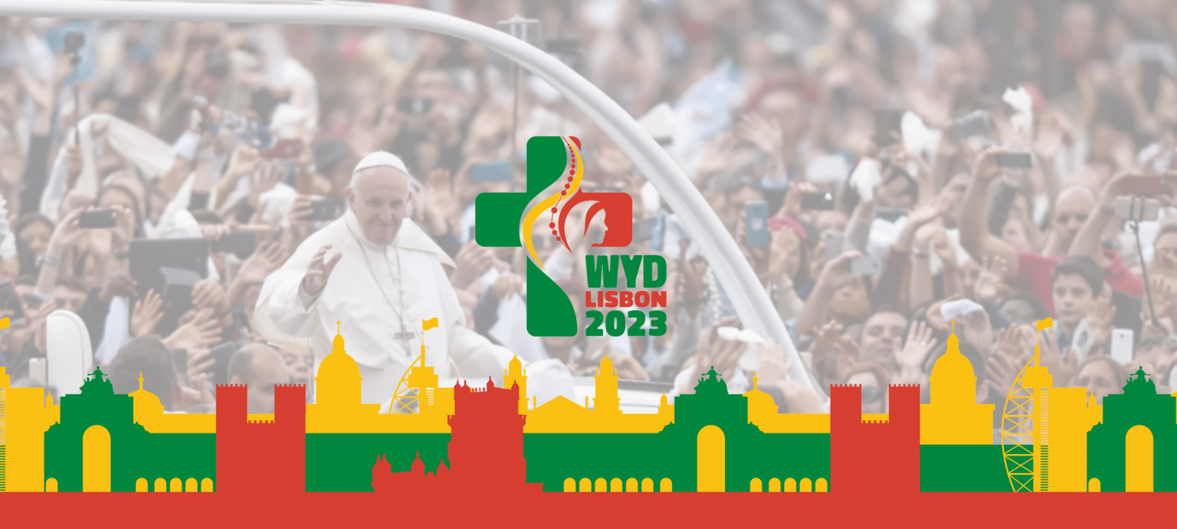

Wednesday 2 August: arrival in Portugal
The Pope will depart at 7.50 am on Wednesday 2 August from Rome's Fiumicino airport and arrive at 10 am at the Figo Maduro air base in Lisbon. Immediately afterwards, he will be greeted at the National Palace in Belèm by the President of the Republic Marcelo Rebelo de Sousa. Also in the Belèm district, in the cultural centre, he will meet the authorities, civil society and the diplomatic corps. At 4.45 p.m. in the Apostolic Nunciature, he will meet with the Prime Minister and at 5.30 p.m., in the famous Monastery dos Jerònimos, he will celebrate Vespers with bishops, priests, deacons, consecrated men and women, seminarians and pastoral workers.

Thursday 3 August: welcoming ceremony for the WYD
On Thursday morning, Pope Francis will meet the students on the premises of the Universidade Catòlica Portuguesa. Then he will leave Lisbon for nearby Cascais, where he will greet the young people of Scholas Occurentes who have their headquarters there. In the afternoon he will return to the Portuguese capital for the welcoming ceremony of WYD, which will take place at the Edward VII Park.

Friday 4 August: Way of the Cross with young people
Some young people from WYD will receive the Sacrament of Reconciliation from the Pope in the "so Impèrio" square in Belèm on the morning of Friday 4 August. At around 9.45 am, Francis himself will go to the "de Serafina" parish centre to meet with representatives of some assistance and charity centres. At 12 noon there will be lunch with young people in the Apostolic Nunciature, while at 6 pm the Pontiff will preside over the Stations of the Cross with young people in Edward VII Park.

Saturday 5 August: visit to Fatima and WYD vigil
The Shrine of Our Lady of Fatima will be visited by the Pope on the morning of Saturday 5 August. Francis will leave Lisbon by helicopter for the Fatima Stadium at 8.00 am and at 9.30 am will pray the Holy Rosary with the sick young people at the Chapel of Apparitions. Around noon, he is scheduled to return to the capital. Two appointments are scheduled: at 6 pm the usual private meeting with members of the Society of Jesus at the Colégio de S. João de Brito and at 8.45 pm, as mentioned, the vigil with young people will take place in Tejo Park.

Sunday 6 August: Holy Mass and the return to the Vatican
The concluding Mass for World Youth Day will be celebrated by the Pope again in Tejo Park on Sunday 6 August at 9 a.m. In the afternoon there will be a meeting with the WYD volunteers at the 'passeio marìtimo' in Algès, before the farewell ceremony at the Figo Maduro airbase. The Pope's return flight to Rome will leave at 6.15 p.m. and arrive at Fiumicino airport at 10.15 p.m.

