Sacrament of the Sick
Anointing of the Sick should be given if an individual is gravely ill or near death. If possible, the Sacrament should also be administered for serious illness, before major surgery or when one is initially hospitalized.

Sacrament of Holy Matrimony
Diocesan policy requires 12 months of preparation for Marriage. Contact the parish as soon as possible after engagement. No venue reservations or other arrangements should be made prior to consultation with the pastor.

Sacrament of Penance
Wednesday ~ 6:00 – 6:45PM; or by appointment.

Sacrament of Baptism
Parents must be registered members of the parish and attend a Baptism preparation class prior to the Baptism if this is your first child baptized. Requirements for godparents are established by the Catholic Church. Please call the parish office for Information and to register your child for Baptism.

Parish Registration
All Catholics should be registered in their local parish. Please contact the parish office to obtain registration forms, or if you are uncertain of the parish where you should register.

Parish Staff & Ministries Directory
stignatiusofloyola@hbgdiocese.org | Office: 717-677-8012
Financial Manager ~ Richard Deardorff ~ 717- 677-8012 or 717-420-3464 (cell)
rdeardorff@hbgdiocese.org
Director of Religious Education ~ Deacon Steve Huete ~ shuete@hbgdiocese.org
Parish Secretary ~ Kristen DiDio ~ kdidio@hbgdiocese.org
Buildings & Grounds ~ Donnie Althoff ~ 717-677-8012
Music Ministry ~ Phil Mobley ~ 717-677-8012
Parish Council Members
Phil Mobley – Chair 571-236-7580 pmmobley@gmail.com
Bicky Redman – Vice Chair 677-8592 feetintheair7@gmail.com
Joanne Riedel - Secretary 398-2021 sterj221@aol.com
Kathi Allwein 677-8984 allweint@comcast.net
Charlie Baker 677-9536 dcbake@embarqmqil.com
Kathy Dietsch 352-4558 kdiet2@juno.com
Dr. BobTernes rjtmd46@gmail.com

Finance Council Members
Richard Deardorff (Ex Officio)
Greg Ernst - Chair
Christy Hemler - Secretary
Ali Morris
Terri Pendlelton
Bill Pulig

Altar Flowers
OCIA
Order of Christian Initiation for Adults
Contact Fr. Dominic

Soup Kitchen
Please send donations
directly to the
“Gettysburg Soup Kitchen”

Website Development
Kristen DiDio
Life After Loss
Dodie Huete

Prayer Chain
CONTACT THE PARISH OFFICE

Picnic Co-Chairs
Wally Kane
Mark Schur

Pro-Life Ministry
Jeanette Backus
Knights of Columbus
SK Bob Ternes
- Grand Knight
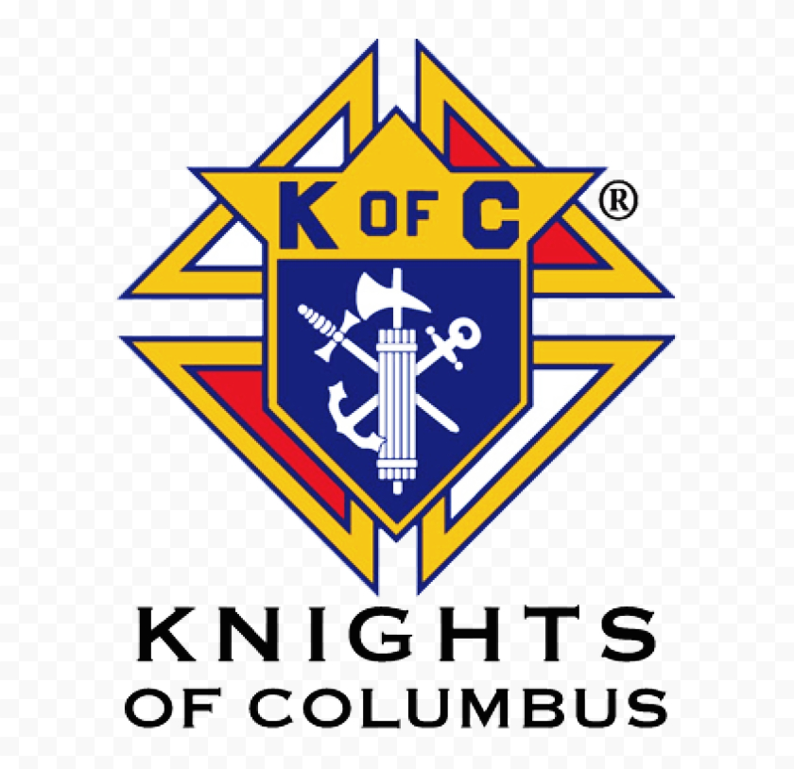

CONTACT THE PARISH OFFICE

Bereavement Ministry
Ginny Bittle / Dodie Huete

Catholic Communications/EWTN
Anna Kane

Cemetery
CONTACT THE PARISH OFFICE
THEOSIS Ministry
Kathy Dietsch 717-352-4558
Bicky Redman 717-677-8592

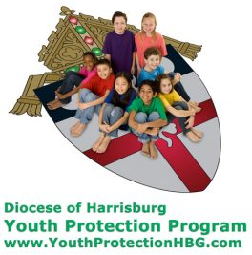
Diocese of Harrisburg Youth Protection Program
www.YouthProtectionHBG.com

Abuse Reporting Contact Information:
First – Call the toll-free PA Child Abuse Hotline at 800-932-0313
Then – Call the Diocesan toll-free hotline at 800-626-1608

“If one member suffers,
all suffer together with it.” (1 Cor 12:26)

St. Ignatius Loyola RC Church

1095 Church Road, Orrtanna, Pennsylvania 17353
www.stignatiusofloyola.org | Office: 717-677-8012

November 5, 2023: 31st SUNDAY IN ORDINARY TIME
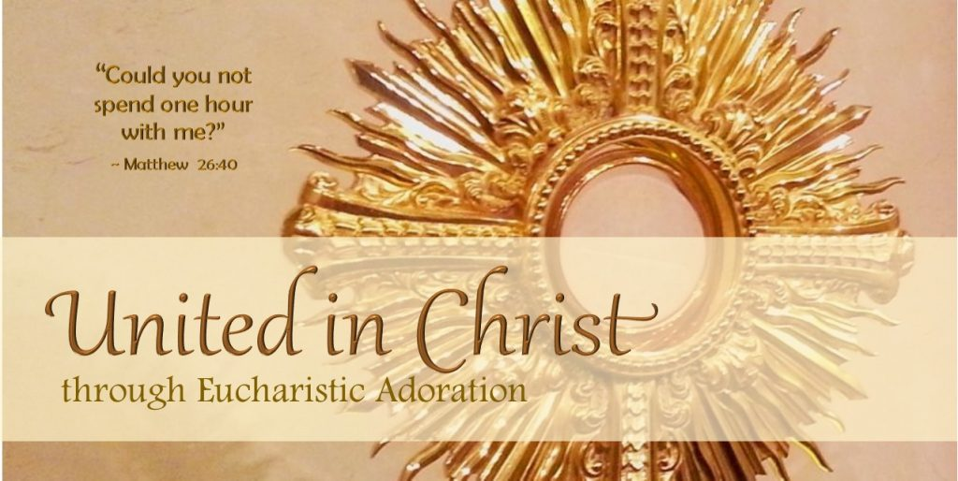

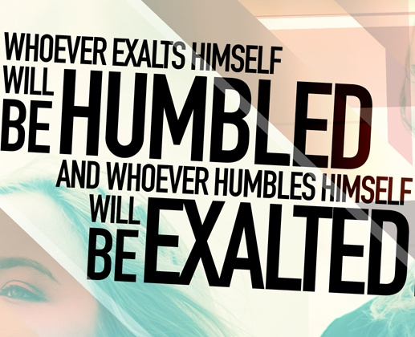

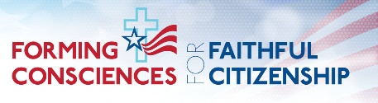

PLEASE Pray to END THE KILLING in the Holy Land

Most Rev. Timothy C. Senior, Bishop of Harrisburg
Rev. Dominic M. DiBiccaro, Pastor
Deacon Steve Huete, Pastoral Associate

Mass Schedule, Intentions, and Events
Please Pray for these in need:
Jeanie Kline & the Kline Family, Dick & Deb Deardorff, John Baker, Ginny Hoctor, Brenda Wolf, Jerry Smith, Wade Sprankle, Dulcie Perry, Ron Formosa, Gavin Crumbacker, Anna Kane, Sherry Dennis & Family, Remi Peters, Terry Ahn, K. Grance, Lori McFadden & Family, Mike & Lisa Poole, Mervin Weikert, Chastity Rudisill, Mary Ellen Wilson, Terry & Bernie Cabana, Ed & Aggie Sherensky & Family, Bob Raffensberger, Jerry & Ginny Miller, Adeline Lienard, Kaylee Henry, Nancy Wuller, Dr. Mike Colli, Mrs. Kelly Kump, Gabriel Singer, Sharon McCormley, Ron Thumma, Joe Wisotzkey, Leo Hockensmith, Erika McKissick, Jean "Heather" O'Shea, Scott Moore & Sally Moore, Mary Wyatt, Jim & Joyce Deardorff, Amy Weatherup, Sophia Joy Ernst, Deacon Richard Wentzel, Deacon Frank Enderle, Kathleen Thompson, Deb & Kathy McLintock & Family, Rachel Wonders, Amy Edwards, Jean O’Connor, Jen Baldwin, Ursula Kaley, Deb Bennet, Larry Endy, Laura Lee, Marwa Abdelrahman, Donna Singley, Tim McGinn, Jane Kump, Peggy Neiderer, Chris Kimple, Robert Riquet, Gene & Jo-Ann McDannell, Bob Doxzen, Kimberly Mears, Gabriella Angello, Paul Angello, Mark & Kate Morrow, Mark Morris, Linda Fogleman, Paul Knight, George & Barbara Erstila, Jeff Carpenter, Lana & Nelson Harmon, Diane Slothour, Sue McDannell, Larry Schneider, Joe & Lisa Grasel, Ange Pena, Julie Barnhart, the Shaffer Family, Heather & Emma Dickerson, Brad Peabody, Paul Ward, Aiden Tyler Schneider, Dorothy Vega, Karrie McCall & daughter, George Shahid, Denise Navlyt, Drew Schneider & Family, Ida Bloomfield, Janie Singley, Mary Beth Greenstreet, Rick Benedict, Jan Patla, Kathey Fogleman, Sam Sheffler, Kate Hemmis, Bill & Mary Lou Graham, Joanna Hodges, John Varones, Joan O’Sullivan, Martha Klinger, Lisa Dionne Lauretti, Jim Gleason, Sue Gustafson, Joe & Michelle Cleary, Kim Johnson, Helen Mills, Kathy Haber, Haley Detman, Joe Durovey, Bev Smith, Donald Sheppard, Linda Mumaugh, Alison Haring, Janet Hartman, Edward Johnson, Angela Galeone, Juliete Lang, Chris MacBeth, Harry Graham, Donald Howard, Armond Binni, Elizabeth Stansky, Pat Johnson, Chris Morris, Faud Doaney, Patrick Glass, Helen Lagasse, Nancy Kewisnek, &y Graham, Bill & Maureen Collins, Rosemary McGilloway, Anji Eisenhart, Monica Manner, Denny Borbonus, Dr. Paul Scarlata, Mary Hawthorne, Ed Washington, Josh Kempinski, Nancy Baker Baltzey, Spencer Propts, Karlton Smith & Cheryl Sobun, James & Marylyn Sobun, Marlene Webster, Yvette Stoklosa, Andy Consiglio, Bill & Michelle Cloonan, Nelson Salem,
Bill & Deb McClintock, nursing home residents & shut-ins, the victims of war, violence, disease, disaster, & all private intentions.
Also in your prayers, please remember all our men
& women currently serving in our Armed Forces:

Lt. Col. Nathan Jeffcoat – US Marine Corps
Lt. Joseph Cleary – US Navy
Michael C. Kenney IV – US Coast Guard
Lt. Joshua Kimple – US Army
Lt. Sarah Fogleman, M.D. – US Navy .
A1C Ian Bellinger ‒ PA Air National Guard
-------------------------------------------------------------------------------------------------------------------------------------------------
PRAYER CHAIN: Contact the
Parish Office

for the Week of October 28 to November 5, 2023

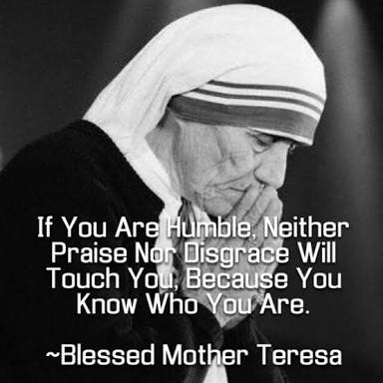

SATURDAY, Nov. 4 - VIGIL 31st SUNDAY OT

Mal 1:14b—2:2b, 8-10 / 1 Thes 2:7b-9, 13 / Mt 23:1-12
5:00PM + Marilyn Cole

SUNDAY,Nov. 5 – 31st SUNDAY IN OT

Mal 1:14b—2:2b, 8-10 / 1 Thes 2:7b-9, 13 / Mt 23:1-12
8:00AM + Joan and Eugene Schott
10:30AM ⁓People of the Parish

Noon to 7PM: Exposition & Adoration of the Blessed Sacrament
TURN BACK CLOCKS !

7PM Vespers (Solemn Evening Prayer)

Monday, November 6 (Weekday in OT)
Rom 11:29-36 / Lk 14:12-14 Parish Office Closed
11:00 MASS - Spec. Int. for Richard Deardorff & Family

Noon to 7PM: Exposition & Adoration of the Blessed Sacrament

7PM Vespers (Solemn Evening Prayer)

Tuesday, November 7 (Weekday in OT)
Rom 12:5-16b / Lk 14:15-24

8:00AM – 3:00PM ~ Office Open

11:00AM + Ruth Ann Robinson

Noon to 7PM: Exposition & Adoration of the Blessed Sacrament

7PM: 40 Hrs. CLOSING Vespers NO “Something More” Group
Wednesday, November 8 (Weekday in OT)
Rom 13:8-10 / Lk 14:25-33
11AM: Mature Spirituality Group
7:00PM + Alan Vincent Castro
6 to 6:45PM - Confessions; 7:40PM - Adoration & Benediction

Thursday, November 9 – Dedication of the Lateran Basilica
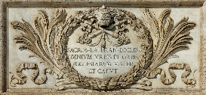
Ez 47:1-2, 8-9, 12/1 Cor 3:9c-11, 16-17/Jn 2:13-22
8AM – 3PM ~ Office Open
10:00AM + ALL SOULS

Friday, November 10 – St. Leo the Great, Pope &  Rom 5:14-21 / Lk 16:1-8 Doctor of the Church  10:00AM - Spec. Int. for the Gavet Family  Parish Office CLOSED | THE LORD

SATURDAY, Nov. 11 - St. Martin of Tours, Bishop

MORNING: Rom 16:3-9, 16, 22-27/Lk 16:9-15

SATURDAY, Nov. 11 - VIGIL 32nd SUNDAY OT

Wis 6:12-16 / 1 Thes 4:13-18 / Mt 25:1-13
5:00PM + Deceased Veterans of the Parish

SUNDAY,Nov. 12 – 32nd SUNDAY IN OT

Wis 6:12-16 / 1 Thes 4:13-18 / Mt 25:1-13
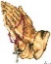
8:00AM + Nolan Patrick Gilbert
10:30AM ⁓ People of the Parish
Sanctuary Candle offered for NOVEMBER: In Loving Memory of Marilyn Cole from Kenneth Cole
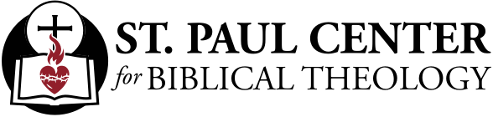

Calling the Fathers: Scott Hahn Reflects

on the Thirty-First Sunday in Ordinary Time

Though they were Moses’ successors, the Pharisees and scribes exalted themselves, making their mastery of the Law a badge of social privilege. Worse, they had lorded the Law over the people (see Matthew 20:25). Like the priests Malachi condemns in today’s First Reading, they caused many to falter and be closed off from God.

In a word, Isra-el’s leaders failed to be good spiritual fathers of God’s People. Moses was a humble father figure, preaching the Law but also practicing it — interceding and begging God’s mercy and forgiveness of the people’s sins (see Exodus 32:9–14; Psalm 90).

And Jesus reminds us today that all fatherhood — in the family or in the people of God — comes from the Father in Heaven (see Ephesians 3:15).

He doesn’t mean we’re to literally call no man “father.” He Himself referred to Isra-el’s founding fathers (see John 7:22); the Apostles taught about natural fatherhood (see Hebrews 12:7–11), and described themselves as “spiritual fathers” (see 1 Corinthians 4:14–16).

The fatherhood of the Apostles and their successors, the Church’s priests and bishops, is a spiritual paternity given to raise us as God’s Children. Our fathers give us new life in Baptism and feed us the “spiritual milk” of the Gospel and the Eucharist (see 1 Peter 2:2–3). That’s why St. Paul, in today’s Epistle, can also compare himself to a nursing mother.

God’s Fatherhood likewise transcends all human notions of fatherhood and motherhood. Perhaps that’s why the Psalm chosen for today includes one of the rare biblical images of God’s maternal care (see Isaiah 66:13).

His only Son has shown us the Father (see John 14:9) coming to gather His Children as a hen gathers her young (see Matthew 23:37). We’re all brothers and sisters, our LORD tells us today. And all of us — even our spiritual fathers — are to trust in Him, humbly, like children on our mothers’ laps.

Readings: Malachi 1:14-2:2, 8-10; Psalm 131:1-3; 1 Thessalonians 2:7-9, 13; Matthew 23:1-12

Sunday Collection Summary for Oct. 21 & 22

Weekend Collections
Regular Offering $ 2,654.00
CK, C, CC ,IC, MMOG (other Holy Days) $ 120.00
TOTAL OFFERINGS $ 2,774.00

‒ WEEKLY BUDGETARY NEEDS $ 4,494.00
+Overage or (Shortfall) for the week ($ 1,720.00)

Other Income
Local Poor $ 10.00
Christmas Flowers $ 20.00
Thanksgiving $ 15.00
Total Other Offerings $ 45.00

Diocesan Second Collections
World Mission Sunday $ 835.00
Matthew 25 $ 20.00
Retirement for Religious $ 30.00
Total Diocesan Offerings $ 885.00

Sunday Collection Summary for Oct. 28 & 29

Weekend Collections
Regular Offering $ 2,776.00
All Saints $ 82.00
Christ the King $ 30.00
Candles/Living Faith $ 15.00
TOTAL OFFERINGS $ 2,903 .00

‒ WEEKLY BUDGETARY NEEDS $ 4,494.00
+Overage or (Shortfall) for the week ($ 1,591.00)

Other Income
Thanksgiving $ 25.00
Individual Contribution $ 5,000.00
Cemetery Lot Sales $ 600.00
Total Other Offerings $ 5,625.00

Diocesan Second Collections
World Mission Sunday $ 10.00
Matthew 25 $ 35.00
Total Diocesan Offerings $ 45.00

POPE FRANCIS’ PRAYER INTETNION
FOR THE MONTH OF NOVEMBER
~ For the Pope
We pray for the Holy Father; as he fulfills his mission, may he continue to accompany the flock entrusted to him, with the help of the Holy Spirit.

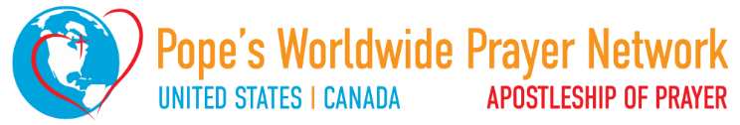

Letter of the
XVI Ordinary General Assembly
of the Synod of Bishops
to the People of God
XVI General Ordinary
Assembly of the
Synod of Bishops
Dear sisters, dear brothers,
As the proceedings of the first session of the 16th Ordinary General Assembly of the Synod of Bishops draw to a close, we want to thank God with all of you for the beautiful and enriching experience we have lived. We lived this blessed time in profound communion with all of you. We were supported by your prayers, bearing with you your expectations, your questions, as well as your fears. As Pope Francis requested two years ago, a long process of listening and discernment was initiated, open to all the People of God, no one being excluded, to “journey together” under the guidance of the Holy Spirit, missionary disciples engaged in the following of Jesus Christ.
The session in which we have been gathered in Rome since 30 September is an important phase of this process. In many ways it has been an unprecedented experience. For the first time, at Pope Francis’ invitation, men and women have been invited, in virtue of their baptism, to sit at the same table to take part, not only in the discussions, but also in the voting process of this Assembly of the Synod of Bishops. Together, in the complementarity of our vocations, our charisms and our ministries, we have listened intensely to the Word of God and the experience of others. Using the conversation in the Spirit method, we have humbly shared the wealth and poverty of our communities from every continent, seeking to discern what the Holy Spirit wants to say to the Church today. We have thus also experienced the importance of fostering mutual exchanges between the Latin tradition and the traditions of Eastern Christianity. The participation of fraternal delegates from other Churches and Ecclesial Communities deeply enriched our discussions.
Our assembly took place in the context of a world in crisis, whose wounds and scandalous inequalities resonated painfully in our hearts, infusing our work with a particular gravity, especially since some of us come from countries where war rages. We prayed for the victims of deadly violence, without forgetting all those who have been forced by misery and corruption to take the dangerous road of migration. We assured our solidarity and commitment alongside the women and men all over the world who are working to build justice and peace.
At the invitation of the Holy Father, we made significant room for silence to foster mutual listening and a desire for communion in the Spirit among us. During the opening ecumenical vigil, we experienced how the thirst for unity increases in the silent contemplation of the crucified Christ. In fact, the cross is the only cathedra of the One who, having given himself for the salvation of the world, entrusted His disciples to His Father, so that “they may all be one” (John 17:21). Firmly united in the hope brought by His Resurrection, we entrusted to Him our common home where the cries of the earth and the poor are becoming increasingly urgent: “Laudate Deum!” (“Praise God!”), as Pope Francis reminded us at the beginning of our work.
Day by day, we felt the pressing call to pastoral and missionary conversion. For the Church’s vocation is to proclaim the Gospel not by focusing on itself, but by placing itself at the service of the infinite love with which God loved the world (cf. John 3:16). When homeless people near St. Peter’s Square were asked about their expectations regarding the Church on the occasion of this synod, they replied: “Love!”.
This love must always remain the ardent heart of the Church, a Trinitarian and Eucharistic love, as the Pope recalled on October 15, midway through our assembly, invoking the message of Saint Thérèse of the Child Jesus.
It is “trust” that gives us the audacity and inner freedom that we experienced, not hesitating to freely and humbly express our convergences, differences, desires and questions.
And now? We hope that the months leading to the second session in October 2024 will allow everyone to concretely participate in the dynamism of missionary communion indicated by the word “synod”. This is not about ideology, but about an experience rooted in the apostolic tradition. As the Pope reminded us at the beginning of this process, “communion and mission can risk remaining somewhat abstract, unless we cultivate an ecclesial praxis that expresses the concreteness of synodality (...) encouraging real involvement on the part of each and all” (October 9, 2021). There are multiple challenges and numerous questions: the synthesis report of the first session will specify the points of agreement we have reached, highlight the open questions, and indicate how our work will proceed.
To progress in its discernment, the Church absolutely needs to listen to everyone, starting with the poorest. This requires a path of conversion on its part, which is also a path of praise: “I thank you, Father, Lord of heaven and earth, that you have hidden these things from the wise and understanding and revealed them to little children” (Luke 10:21)! It means listening to those who have been denied the right to speak in society or who feel excluded, even by the Church; listening to people who are victims of racism in all its forms – in particular in some regions to indigenous peoples whose cultures have been scorned. Above all, the Church of our time has the duty to listen, in a spirit of conversion, to those who have been victims of abuse committed by members of the ecclesial body, and to commit herself concretely and structurally to ensuring that this does not happen again.
The Church also needs to listen to the laity, women and men, all called to holiness by virtue of their baptismal vocation: to the testimony of catechists, who in many situations are the first proclaimers of the Gospel; to the simplicity and vivacity of children, the enthusiasm of youth, to their questions, and their pleas; to the dreams, the wisdom and the memory of elderly people. The Church needs to listen to families, to their educational concerns, to the Christian witness they offer in today's world. She needs to welcome the voice of those who want to be involved in lay ministries and to participate in discernment and decision-making structures.
To progress further in synodal discernment, the Church particularly needs to gather even more the words and experience of the ordained ministers: priests, the primary collaborators of the bishops, whose sacramental ministry is indispensable for the life of the whole body; deacons, who, through their ministry, signify the care of the entire Church for the most vulnerable. She also needs to let herself be questioned by the prophetic voice of consecrated life, the watchful sentinel of the Spirit’s call. She also needs to be attentive to all those who do not share her faith but are seeking the truth, and in whom the Spirit, who “offers everyone the possibility of being associated with this paschal mystery” (Gaudium et Spes 22, 5), is also present and operative.
“The world in which we live, and which we are called to love and serve, even with its contradictions, demands that the Church strengthen cooperation in all areas of her mission. It is precisely this path of synodality which God expects of the Church of the third millennium” (Pope Francis, October 17, 2015). We do not need to be afraid to respond to this call. Mary, Mother of the Church, the first on the journey, accompanies our pilgrimage. In joy and in sorrow, she shows us her Son and invites us to trust. And He, Jesus, is our only hope!
Vatican City, October 25, 2023

in Honor of our VETERANS,

Sunday, November 12th,after Masses

FREE-WILL OFFERING

Proceeds benefit:

And Veterans eat FREE!

By being a neighbour, like the Good Samaritan (cf. Lk 10:25-37), we come to understand the heart of our Christian vocation: to imitate Jesus Christ, who came to serve, not to be served (cf. Mk 10:45).

This missionary activity does not arise simply from our own abilities, plans and projects, nor from our sheer willpower or our efforts to practice the virtues; it is the result of a profound experience in the company of Jesus. Only then can we testify to a Person, a Life, and thus become “Apostles”. Only then can we regard ourselves as “sealed, even branded, by this mission of bringing light, blessing, enlivening, raising, healing and freeing” (Evangelii Gaudium, 273).

The Gospel icon of this experience is that of the two disciples journeying to Emmaus. After their encounter with the risen Jesus, they said to each other, “Were not our hearts burning within us while he was talking to us on the road, while he was opening the Scriptures to us?” ( Lk 24:32). In those disciples, we can see what it means to have “hearts on fire, feet on the move”. [3] This is also my fervent hope for the coming World Youth Day in Lisbon, to which I joyfully look forward, with its motto: “Mary arose and went with haste” ( Lk 1:39). May every man and woman feel called to arise and go in haste, with hearts on fire.

Called together and convened
The evangelist Mark relates the moment when Jesus called to himself twelve disciples, each by name. He appointed them to be with him and to be sent out to proclaim the message, to heal infirmities and to cast out demons (cf. Mk 3:13-15). The LORD thus laid the foundations of his new community. The Twelve were people from different social classes and trades; none of them was a person of influence. The Gospels speak too of other callings, like that of the 72 disciples whom Jesus sent out two by two (cf. Lk 10:1).

The Church is an Ecclesia, the Greek word for an assembly of persons called and convened, in order to form the community of missionary disciples of Jesus Christ committed to sharing love among themselves (cf. Jn 13:34; 15:12) and spreading that love to all others, so that God’s Kingdom may come.

Within the Church, all of us are servants, in accordance with the variety of our vocations, charisms and ministries. Our common vocation to give ourselves in love develops and finds concrete expression in the life of lay men and women, devoted to raising a family as a small domestic church and working as a leaven of the Gospel to renew the different sectors of society; in the testimony of consecrated women and men who are completely committed to God for the sake of their brothers and sisters as a Prophetic sign of the Kingdom of God; in ordained ministers – deacons, priests and bishops – placed at the service of preaching, prayer and fostering the communion of the holy People of God. Only in relation with all the others, does any particular vocation in the Church fully disclose its true nature and richness. Viewed in this light, the Church is a vocational “symphony”, with every vocation united yet distinct, in harmony and joined together in “going forth” to radiate throughout the world the new life of the Kingdom of God.

Grace and mission: a gift and a task
Dear brothers and sisters, vocation is a gift and a task, a source of new life and true joy. May the initiatives of prayer and of activity associated with this Day strengthen an awareness of vocation within our families, our parish communities, our communities of consecrated life, and our ecclesial associations and movements. The Spirit of the risen LORD dispels our apathy and grants us the gifts of sympathy and empathy. In this way, he enables us to live each day born anew as children of the God who is love (cf. 1 Jn 4:16) and in turn to offer that love to others. To bring life everywhere, especially in places of exclusion and exploitation, poverty and death, in order to enlarge the spaces of love, [4] so that God may reign ever more fully in this world.

May the prayer that Saint Paul VI composed for the first World Day of Vocations, 11 April 1964, accompany us on our journey:

“O Jesus, divine Shepherd of souls, you called the Apostles and made them fishers of men. Continue to draw to yourself ardent and generous souls from among the young, in order to make them your followers and your ministers. Give them a share in your thirst for the redemption of all… Open before them the horizons of the entire world… By responding to your call, may they prolong your mission here on earth, build up your Mystical Body which is the Church, and be ‘the salt of the earth’ and ‘the light of the world’ (Mt 5:13)”.

May the Virgin Mary watch over you and protect you. With my blessing.
Rome, Saint John Lateran, 30 April 2023, Fourth Sunday of Easter.

-----------------------------------------------------------------------------------
[1] Final Document of the XV Ordinary General Assembly of the Synod of Bishops (2018): “Young People, the Faith and Vocational Discernment, No. 78.
[2] Manuscript B, written during her last retreat (September 1896), Oeuvres completes, Paris, 1992, p. 226.
[3] Cf. Message for World Mission Day 2023 (6 January 2023).
[4]“ Dilatentur spatia caritatis”: SAINT AUGUSTINE , Sermo 69: PL 5, 440-441.
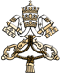
MESSAGE OF HIS HOLINESS POPE FRANCIS
FOR THE 2023 WORLD DAY OF PRAYER FOR VOCATIONS

Vocation: Grace and Mission

Dear brothers and sisters, dear young people!

This is now the sixtieth time that we are celebrating the World Day of Prayer for Vocations, established by Saint Paul VI in 1964, during the Second Vatican Ecumenical Council. This providential initiative seeks to assist the members of the People of God, as individuals and as communities, to respond to the call and mission that the LORD entrusts to each of us in today’s world, amid its afflictions and its hopes, its challenges and its achievements.

This year I would ask you, in your reflection and prayer, to take as your guide the theme “Vocation: Grace and Mission”. This Day is a precious opportunity for recalling with wonder that the LORD’s call is grace, complete gift, and at the same time a commitment to bring the Gospel to others. We are called to a faith that bears witness, one that closely connects the life of grace, as experienced in the sacraments and ecclesial communion, to our apostolate in the world. Led by the Spirit, Christians are challenged to respond to existential peripheries and human dramas, ever conscious that the mission is God’s work; it is not carried out by us alone, but always in ecclesial communion, together with our brothers and sisters, and under the guidance of the Church’s pastors. For this has always been God’s dream: that we should live with him in a communion of love.

“Chosen before the creation of the world”
The Apostle Paul opens before us a remarkable horizon: in Christ, God the Father “chose us before the foundation of the world to be holy and blameless in his sight in love. He destined us for adoption as his children through Jesus Christ, according to the good pleasure of his will” (Eph 1:4-5). These words allow us to glimpse life at its fullest: God has “conceived” us in his image and likeness and desires us to be his sons and daughters. We were created by love, for love and with love, and we are made for love.

In the course of our lives, this call, which is part of the fibre of our being and the secret of our happiness, comes to us by the work of the Holy Spirit in ever new ways. It enlightens our minds, strengthens our wills, fills us with amazement and sets our hearts afire. At times, the Spirit comes to us in completely unexpected ways. So it was for me when, on 21 September 1953, as I was on my way to an annual school celebration, I was led to stop by a church and go to confession. That day changed my life and left a mark that has endured to the present day. God’s call to the gift of self tends to make itself known gradually: in our encounter with situations of poverty, in moments of prayer, when we see a clear witness to the Gospel, or read something that opens our minds. When we hear God’s word and sense that it is spoken directly to us, in the advice given by a fellow brother or sister, in moments of sickness or sorrow… In all the ways he calls us, God shows infinite creativity.

The LORD’s initiative and his gracious gift call for a response on our part. Vocation is “the interplay between divine choice and human freedom”, [1] a dynamic and exciting relationship between God and the human heart. The gift of vocation is like a divine seed that springs up in the soil of our existence, opens our hearts to God and to others, so that we can share with them the treasure we ourselves have found. This is the fundamental structure of what we mean by vocation: God calls us in love and we, in gratitude, respond to him in love. We realize that we are beloved sons and daughters of the one Father, and we come to see ourselves as brothers and sisters of one another. Saint Therese of the Child Jesus, when at last she “saw” this clearly, exclaimed, “At last I have found my calling: my call is love. Indeed, I have found my proper place in the Church… In the heart of the Church, my Mother, I will be love”. [2]

“I am a mission on this earth”
God’s call, we said, includes a “sending”. There is no vocation without mission. There is no happiness and full self-realization unless we offer others the new life that we have found. God’s call to love is an experience that does not allow us to remain silent. Saint Paul says, “Woe to me if I do not proclaim the gospel!” (1 Cor 9:16). And the First Letter of John begins with the words, “What we have heard and seen, looked at and touched – the Word made flesh – we declare also to you, so that our joy may be complete” (cf. 1:1-4).

Five years ago, in the Apostolic Exhortation Gaudete et Exsultate, I spoke to every baptized person, saying, “You need to see the entirety of your life as a mission” (No. 23). Yes, because each and every one of us is able to say: “I am a mission on this earth; that is the reason why I am here in this world” (Evangelii Gaudium, 273).

Our shared mission as Christians is to bear joyful witness wherever we find ourselves, through our actions and words, to the experience of being with Jesus and members of his community, which is the Church. That mission finds expression in works of material and spiritual mercy, in a welcoming and gentle way of life that reflects closeness, compassion and tenderness, in contrast to the culture of waste and indifference.
Please join us for our Annual
40 Hour Eucharistic Devotions

2022 – 2025

Sunday, Monday, and Tuesday
November 5, 6, and 7, 2023
11AM: The Holy Mass followed by Exposition (Mon. & Tues.)
Noon: Exposition and Adoration after Mass until
7PM: Solemn Evening Prayer & Benediction

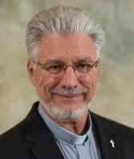
Guest Homilist: Deacon Dan Signore
Assigned to St. Marks Parish
in Greencastle, Pennsylvania

NOTE: The LORD will be exposed from Noon until 7PM each day and we are seeking adorers to spend at least one-half hour in His Sacramental Presence during those periods. See the SIGN-UP SHEET in the church. Please prayerfully consider keeping our LORD company for just a little while so that He is never left alone!

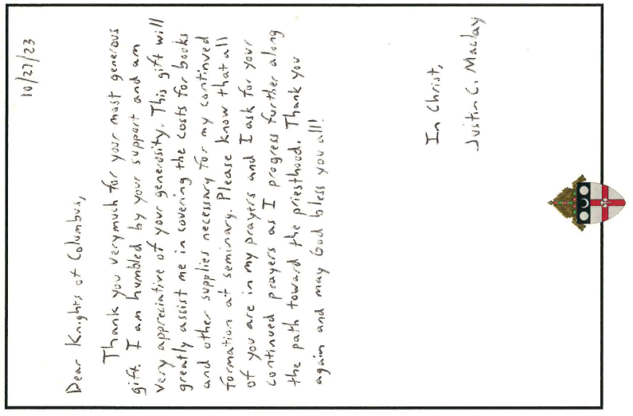

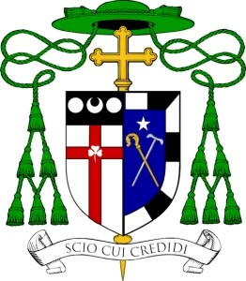
Office of the Bishop
DIOCESE OF HARRISBURG
4800 Union Deposit Road ≅ Harrisburg, PA 17111
Phone: (717) 657-4804 ≅ Fax: (717) 657-1370
Bishop's0ffice@hbgdiocese.org
www.hbgdiocese.org

Most Reverend Timothy C. Senior
12th Bishop of the Roman Catholic Diocese of Harrisburg, Pennsylvania

"For I know the plans I have for you, " declares the LORD, "plans to prosper you and
not to harm you, plans to give you hope and a future. " ⁓Jeremiah 29:11

As we begin National Vocations Awareness Week, celebrated November 5th-11th, these words remind us that all people have a call, a vocation, from God. Life is a precious gift, given to us by God, and we are here for a reason. The Prophet's words are an affirmation that God invites us to collaborate with Him so that, through us, He can affect the lives of others.

When we think of a vocation, black collars and veils may quickly come to mind. But vocations take many paths; doctors, teachers, nurses, scientists, those who are married or single, and yes, those in the priesthood, permanent diaconate, or consecrated or religious life, are all forms of a vocation. Pope Francis said in his message on the World Day of Prayer for Vocations that, "This Day is a precious opportunity for recalling with wonder that the LORD's call is grace, complete gift, and at the same time a commitment to bring the Gospel to others. We are called to a faith that bears witness, one that closely connects the life of grace, as experienced in the Sacraments and ecclesial communion, to our apostolate in the world."

Through our vocations, whether that is a call to the priesthood, religious life, marriage, consecrated life, the diaconate or single life, we are all called to let go of ourselves, setting aside what we want, in order to do the work the LORD has called us to.

In my short time as the Bishop of Harrisburg, I have spoken to and witnessed the faithfulness of our wonderful priests, deacons, seminarians, and religious brothers and sisters. These men and women speak freely of the joy and graces they have received from God by following the call, the vocation, He placed on their hearts.

As daughters and sons of Christ, each of us have a call to holiness and a specific vocation to make us a witness to God's Love, which may be a call to the priesthood or consecrated life. During this National Vocations Awareness Week, I encourage the faithful of the Diocese to spend a little extra time with our LORD, discerning what your vocation may be. I also ask all people of the Diocese to continue praying for vocations to the priesthood and consecrated life.

My God bless you, your families, the clergy and religious of our Diocese, and may He guide us as we discern His plan for our lives.

Sincerely in Christ,
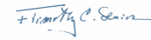

Most Reverend Timothy C. Senior
Bishop of Harrisburg

