Sacrament of the Sick
Anointing of the Sick should be given if an individual is gravely ill or near death. If possible, the Sacrament should also be administered for serious illness, before major surgery or when one is initially hospitalized.

Sacrament of Holy Matrimony
Diocesan policy requires 12 months of preparation for Marriage. Contact the parish as soon as possible after engagement. No venue reservations or other arrangements should be made prior to consultation with the pastor.

Sacrament of Penance
Wednesday ~ 6:00 – 6:45PM; or by appointment.

Sacrament of Baptism
Parents must be registered members of the parish and attend a Baptism preparation class prior to the Baptism if this is your first child baptized. Requirements for godparents are established by the Catholic Church. Please call the parish office for Information and to register your child for Baptism.

Parish Registration
All Catholics should be registered in their local parish. Please contact the parish office to obtain registration forms, or if you are uncertain of the parish where you should register.

Parish Staff & Ministries Directory
stignatiusofloyola@hbgdiocese.org | Office: 717-677-8012
Financial Manager ~ Richard Deardorff ~ 717- 677-8012 or 717-420-3464 (cell)
rdeardorff@hbgdiocese.org
Director of Religious Education ~ Deacon Steve Huete ~ shuete@hbgdiocese.org
Parish Secretary ~ Kristen DiDio ~ kdidio@hbgdiocese.org
Buildings & Grounds ~ Donnie Althoff ~ 717-677-8012
Music Ministry ~ Phil Mobley ~ 717-677-8012
Parish Council Members
Phil Mobley – Chair 571-236-7580 pmmobley@gmail.com
Bicky Redman – Vice Chair 677-8592 feetintheair7@gmail.com
Joanne Riedel - Secretary 398-2021 sterj221@aol.com
Kathi Allwein 677-8984 allweint@comcast.net
Charlie Baker 677-9536 dcbake@embarqmqil.com
Kathy Dietsch 352-4558 kdiet2@juno.com
Dr. BobTernes rjtmd46@gmail.com

Finance Council Members
Richard Deardorff (Ex Officio)
Greg Ernst - Chair
Christy Hemler - Secretary
Ali Morris
Terri Pendlelton
Bill Pulig

Altar Flowers
OCIA
Order of Christian Initiation for Adults
Contact Fr. Dominic

Soup Kitchen
Please send donations
directly to the
“Gettysburg Soup Kitchen”

Website Development
Kristen DiDio
Life After Loss
Dodie Huete

Prayer Chain
CONTACT THE PARISH OFFICE

Picnic Co-Chairs
Wally Kane
Mark Schur

Pro-Life Ministry
Jeanette Backus
Knights of Columbus
SK Bob Ternes
- Grand Knight

CONTACT THE PARISH OFFICE

Bereavement Ministry
Ginny Bittle / Dodie Huete

Catholic Communications/EWTN
Anna Kane

Cemetery
CONTACT THE PARISH OFFICE
THEOSIS Ministry
Kathy Dietsch 717-352-4558
Bicky Redman 717-677-8592

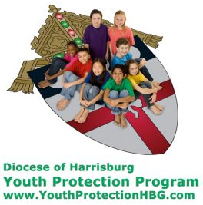
Diocese of Harrisburg Youth Protection Program
www.YouthProtectionHBG.com

Abuse Reporting Contact Information:
First – Call the toll-free PA Child Abuse Hotline at 800-932-0313
Then – Call the Diocesan toll-free hotline at 800-626-1608

“If one member suffers,
all suffer together with it.” (1 Cor 12:26)

St. Ignatius Loyola RC Church

1095 Church Road, Orrtanna, Pennsylvania 17353
www.stignatiusofloyola.org | Office: 717-677-8012

October 22, 2023: 29th SUNDAY IN ORDINARY TIME
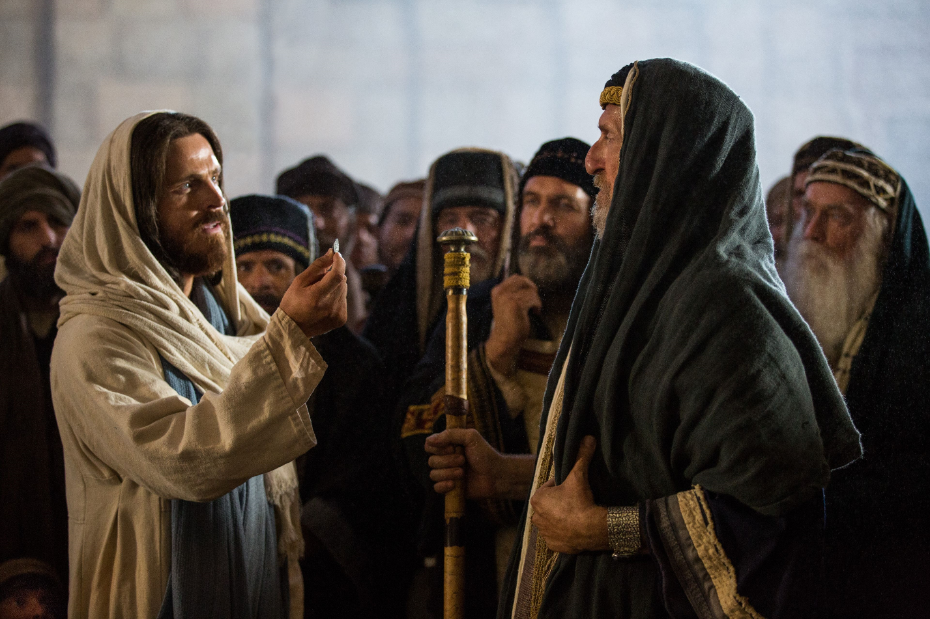

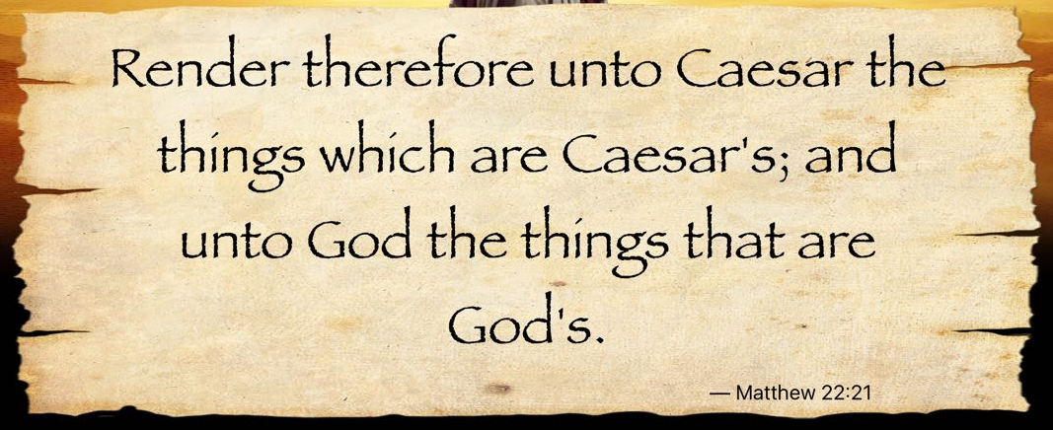

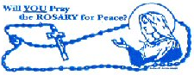

October is RESPECT LIFE Month of the HOLY ROSARY

Most Rev. Timothy C. Senior, Bishop of Harrisburg
Rev. Dominic M. DiBiccaro, Pastor
Deacon Steve Huete, Pastoral Associate

Mass Schedule, Intentions, and Events
Please Pray for these in need:
Jeanie Kline & the Kline Family, Dick & Deb Deardorff, John Baker, Ginny Hoctor, Brenda Wolf, Jerry Smith, Wade Sprankle, Dulcie Perry, Ron Formosa, Gavin Crumbacker, Anna Kane, Sherry Dennis & Family, Remi Peters, Terry Ahn, K. Grance, Lori McFadden & Family, Mike & Lisa Poole, Mervin Weikert, Chastity Rudisill, Mary Ellen Wilson, Terry & Bernie Cabana, Ed & Aggie Sherensky & Family, Bob Raffensberger, Jerry & Ginny Miller, Adeline Lienard, Kaylee Henry, Nancy Wuller, Dr. Mike Colli, Mrs. Kelly Kump, Gabriel Singer, Sharon McCormley, Ron Thumma, Joe Wisotzkey, Leo Hockensmith, Erika McKissick, Jean "Heather" O'Shea, Scott Moore & Sally Moore, Mary Wyatt, Jim & Joyce Deardorff, Amy Weatherup, Sophia Joy Ernst, Deacon Richard Wentzel, Deacon Frank Enderle, Kathleen Thompson, Deb & Kathy McLintock & Family, Rachel Wonders, Amy Edwards, Jean O’Connor, Jen Baldwin, Ursula Kaley, Deb Bennet, Larry Endy, Laura Lee, Marwa Abdelrahman, Donna Singley, Tim McGinn, Jane Kump, Peggy Neiderer, Chris Kimple, Robert Riquet, Gene & Jo-Ann McDannell, Bob Doxzen, Kimberly Mears, Gabriella Angello, Paul Angello, Mark & Kate Morrow, Mark Morris, Linda Fogleman, Paul Knight, George & Barbara Erstila, Jeff Carpenter, Lana & Nelson Harmon, Diane Slothour, Sue McDannell, Larry Schneider, Joe & Lisa Grasel, Ange Pena, Julie Barnhart, the Shaffer Family, Heather & Emma Dickerson, Brad Peabody, Paul Ward, Aiden Tyler Schneider, Dorothy Vega, Karrie McCall & daughter, George Shahid, Denise Navlyt, Drew Schneider & Family, Ida Bloomfield, Janie Singley, Mary Beth Greenstreet, Rick Benedict, Jan Patla, Kathey Fogleman, Sam Sheffler, Kate Hemmis, Bill & Mary Lou Graham, Joanna Hodges, John Varones, Joan O’Sullivan, Martha Klinger, Lisa Dionne Lauretti, Jim Gleason, Sue Gustafson, Joe & Michelle Cleary, Kim Johnson, Helen Mills, Kathy Haber, Haley Detman, Joe Durovey, Bev Smith, Donald Sheppard, Linda Mumaugh, Alison Haring, Janet Hartman, Edward Johnson, Angela Galeone, Juliete Lang, Chris MacBeth, Harry Graham, Donald Howard, Armond Binni, Elizabeth Stansky, Pat Johnson, Chris Morris, Faud Doaney, Patrick Glass, Helen Lagasse, Nancy Kewisnek, &y Graham, Bill & Maureen Collins, Rosemary McGilloway, Anji Eisenhart, Monica Manner, Denny Borbonus, Dr. Paul Scarlata, Mary Hawthorne, Ed Washington, Josh Kempinski, Nancy Baker Baltzey, Spencer Propts, Karlton Smith & Cheryl Sobun, James & Marylyn Sobun, Marlene Webster, Yvette Stoklosa, &y Consiglio, Bill & Michelle Cloonan, Nelson Salem, Bill & Deb McClintock, nursing home residents & shut-ins, the victims of war, violence, disease, disaster, & all private intentions.
Also in your prayers, please remember all our men
& women currently serving in our Armed Forces:

Lt. Col. Nathan Jeffcoat – US Marine Corps
Lt. Joseph Cleary – US Navy
Michael C. Kenney IV – US Coast Guard
Lt. Joshua Kimple – US Army
Lt. Sarah Fogleman, M.D. – US Navy .
A1C Ian Bellinger ‒ PA Air National Guard

PRAYER CHAIN: Contact the
Parish Office

for the Week of October 21 to October 29, 2023

SATURDAY, Oct. 21- VIGIL 29th SUNDAY OT

Is 45:1, 4-6 / 1 Thes 1:1-5b / Mt 22:15-21
4:30PM Recitation of the Holy Rosary
5:00PM + Larry Dennis

SUNDAY, Oct.22 – 29th SUNDAY IN OT

Is 45:1, 4-6 / 1 Thes 1:1-5b / Mt 22:15-21
8:00AM ⁓ People of the Parish
10:30AM + Bill Rollins WORLD MISSION SUNDAY

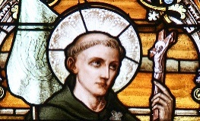
Monday, October 23 – St. John of Capistrano,
Rom 4:20-25 / Lk 12:13-21 Priest
Parish Office Closed
NO MASS

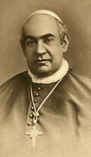
Tuesday, October 24 – St. Anthony Mary Claret, Bishop
Rom 5:12, 15b, 17-19, 20b-21 / Lk 12:35-38

8:00AM – 3:00PM ~ Office Open

10:00AM + Larry Dennis

NO “Something More” Group this week

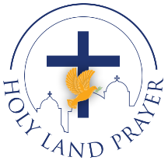
Wednesday, October 25 (Weekday in OT)
Rom 6:12-18 / Lk 12:39-48

8AM – 3PM ~ Office Open
11AM: Mature Spirituality Group
7:00PM + Michael A. & Linda L. Ciavarella, Sr.
6 - 6:45PM Confessions; 7:40PM Adoration, Rosary, Benediction

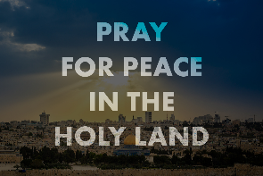
Thursday, October 26 (Weekday in OT)
Rom 6:19-23 / Lk 12:49-53
8AM – 3PM ~ Office Open
10:00AM + Jean Dillon Eisenhart

Friday, October 27 (Weekday in OT)  Rom 7:18-25a / Lk 12:54-59  10:00AM + Star Wiskeman  Parish Office CLOSED | THE LORD

SATURDAY, October 28 – STS. SIMON and JUDE,

MORNING: Eph 2:19-22 / Lk 6:12-16 APOSTLES

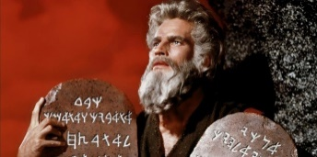
SATURDAY, Oct. 28- VIGIL 30th SUNDAY OT

Ex 22:20-26 / 1 Thes 1:5c-10 / Mt 22:34-40
4:30PM Recitation of the Holy Rosary
5:00PM + Fr. Carl Steffen

SUNDAY, Oct.29 – 30th SUNDAY IN OT

Ex 22:20-26 / 1 Thes 1:5c-10 / Mt 22:34-40
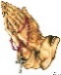
8:00AM + Larry Dennis
10:30AM ⁓ People of the Parish
Sanctuary Candle offered for OCTOBER: John Louise and Bobbi Strasbaugh from Theresa & Gary Cowan

Caesar and the King: Scott Hahn Reflects

on the Twenty-ninth Sunday in Ordinary Time

The LORD is King over all the earth, as we sing in today’s Psalm. Governments rise and fall by His permission, with no authority but that given from above (see John 19:11; Romans 13:1).

In effect, God says to every ruler what He tells King Cyrus in today’s First Reading: “I have called you . . . though you knew Me not.”

The LORD raised up Cyrus to restore the Isra-elites from exile, and to rebuild Jerusalem (see Ezra 1:1–4). Throughout salvation history, God has used foreign rulers for the sake of His Chosen People. Pharaoh’s heart was hardened to reveal God’s power (see Romans 9:17). Invading armies were used to punish Isra-el’s sins (see 2 Maccabees 6:7–16).

The Roman occupation during Jesus’ time was, in a similar way, a judgment on Isra-el’s unfaithfulness. Jesus’ famous words in today’s Gospel, “repay to Caesar what belongs to Caesar,” are a pointed reminder of this. And they call us, too, to keep our allegiances straight.

The LORD alone is our King. His Kingdom is not of this world (see John 18:36) but it begins here in His Church, which tells of His glory among all peoples. Citizens of Heaven (see Philippians 3:20), we are called to be a light to the world (see Matthew 5:14) — working in faith, laboring in love, and enduring in hope, as today’s Epistle counsels.

We owe the government a concern for the common good and obedience to laws — unless they conflict with God’s Commandments as interpreted by the Church (see Acts 5:29).

But we owe God everything. The coin bears Caesar’s image. But we bear God’s own Image (see Genesis 1:27). We owe Him our very lives — all our heart, mind, soul, and strength — offered as a living sacrifice of love (see Romans 12:1–2).

We should pray for our leaders, that like Cyrus they do God’s Will (see 1 Timothy 2:1–2) — until from the rising of the sun to its setting, all humanity knows that Jesus is LORD!

Readings: Isaiah 45:1,4–6; Psalm 96:1,3–5, 7–10
1 Thessalonians 1:1–5; Matthew 22:15–21

Sunday Collection Summary for Oct. 14 & 15

Weekend Collections
Regular Offering $ 2,910.00
Candles/Living Faith $ 29.75
All Saints Day $ 30.00
TOTAL OFFERINGS $ 2,969.75

‒ WEEKLY BUDGETARY NEEDS $ 4,494.00
+Overage or (Shortfall) for the week ($1,524.25)

Other Income
Cemetery Lot Sales $ 1,200.00
Local Poor $ 100.00
Total Other Offerings $ 1,300.00

Diocesan Second Collections
World Mission Sunday $ 50.00
Total Diocesan Offerings $ 50.00

Our Forty Hour Eucharistic Devotions will take place this year on Sunday, Monday, and Tuesday: November 5, 6, and 7.

WE ARE IN NEED OF ADORERS FROM NOON UNTIL 7PM EACH OF THOSE 3 DAYS. THERE IS A SIGN-UP SHEET IN THE CHURCH. PLEASE PRAYERFULLY CONSIDER SPENDING AT LEAST ONE-HALF HOUR WITH OUR LORD IN HIS EUCHARTIC PRESENCE -- GIVING THANKS AND OFFERING UP YOUR NEEDS AND INTENTIONS.

*** LET’S NOT LEAVE JESUS ALONE! ***

Put your faith into action: Practice civil dialogue.

In their statement on Forming Consciences for Faithful Citizenship, the U.S. Catholic bishops remind Catholics that we are called to engage in charitable, respectful and civil dialogue during election season. In a culture that is dominated by “partisan attacks, sound bites and media hype,” the Church calls for “a different kind of political engagement” (no. 14). Join our Catholic witness for civil dialogue by learning more and taking the pledge for civility at CivilizeIt.org. You can take the pledge individually or as a group and invite others to take the pledge too. Visit FaithfulCitizenship.org to access resources on civil dialogue and on how our faith calls us to engage during election season and beyond.

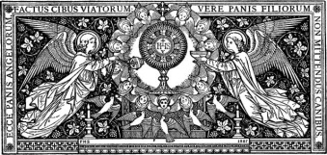

Pope Francis announces prayer vigil, day of fasting for peace in Israel-Hamas war
By Matthew Santucci | Vatican City, Oct 18, 2023
Pope Francis at the end of his general audience on Wednesday morning announced another day of prayer and fasting for an end to the Israel-Hamas war.
“I have decided to call for a day of fasting and prayer on Friday, Oct. 27,” the pope said.
It will be “a day of penance to which I invite sisters and brothers of the various Christian denominations, those belonging to other religions, and all those who have at heart the cause of peace in the world, to join in as they see fit,” the Holy Father continued.
The vigil will take place at 6 p.m. in St. Peter’s Square, where the faithful will join the pope to participate in “an hour of prayer in a spirit of penance to implore peace in our time, peace in this world. I ask all the particular Churches to participate by arranging similar activities involving the people of God,” the pope said.
The Holy Father’s announcement comes after the Catholic Latin patriarch of Jerusalem, Cardinal Pierbattista Pizzaballa, called for a global day of prayer and fasting, which was held on Oct. 17, “to deliver to God the Father our thirst for peace, justice, and reconciliation.”
The Holy Father’s announcement was preceded by his renewed appeal for peace in the Holy Land.
“Our thoughts turn to Palestine and Israel,” the pope said. “The number of victims is rising and the situation in Gaza is desperate. Please, let everything possible be done to avoid a humanitarian disaster. The possible widening of the conflict is disturbing, while so many war fronts are already open in the world. May weapons be silenced, and let us heed the cry for peace of the poor, the people, the children.”
“Brothers and sisters, war does not solve any problem: It sows only death and destruction, foments hate, proliferates revenge. War cancels out the future, it cancels out the future. I urge believers to take just one side in this conflict: that of peace. But not in words — in prayer, with total dedication,” he concluded.
The Holy Father’s comments come as the death toll continues to rise in the conflict-ridden area. The United Nations issued a press release on Tuesday evening stating that “a staggering” 4,200 people have been killed and “over 1 million people [have been] displaced in just 10 days.”
Israel was blamed by Hamas after a Tuesday evening blast at the Al-Ahli Baptist Hospital in Gaza City left an estimated death toll of nearly 500, according to the Palestinian health ministry. The Israeli government has denied these allegations, blaming it instead on Hamas. Several Arab states have joined Hamas in condemning Israel.
An immediate wave of anger and condemnation spread across the Middle East, with some calls for further protests and even “a day of rage,” Al-Jazeera reported.
This escalation and mounting humanitarian crisis comes as U.S. President Joe Biden arrived in Israel Wednesday morning to engage in high-level talks with Prime Minister Benjamin Netanyahu.
---------------------------------------------------------------------------------------------------------------------------------------
Matthew Santucci has recently started in EWTN's Vatican bureau. He grew up in Connecticut and has been living in Rome since 2020. He has a B.A. in History from Fordham and an M.A. in International Relations from Luiss Guido Carli.
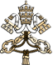
MESSAGE OF HIS HOLINESS POPE FRANCIS
FOR WORLD MISSION DAY 2023

Hearts on fire, feet on the move (cf. Lk 24:13-35)
Dear brothers and sisters!

For this year’s World Mission Sunday, I have chosen a theme inspired by the story of the disciples on the way to Emmaus, in the Gospel of Luke (cf. 24:13-35): “Hearts on fire, feet on the move”. Those two disciples were confused and dismayed, but their encounter with Christ in the word and in the breaking of the bread sparked in them the enthusiastic desire to set out again towards Jerusalem and proclaim that the LORD had truly risen. In the Gospel account, we perceive this change in the disciples through a few revealing images: their hearts burned within them as they heard the Scriptures explained by Jesus, their eyes were opened as they recognized him and, ultimately, their feet set out on the way. By meditating on these three images, which reflect the journey of all missionary disciples, we can renew our zeal for evangelization in today’s world.

1. Our hearts burned within us “when he explained the Scriptures to us”. In missionary activity, the word of God illumines and transforms hearts.

On the road from Jerusalem to Emmaus, the hearts of the two disciples were downcast, as shown by their dejected faces, because of the death of Jesus, in whom they had believed (cf. v. 17). Faced with the failure of the crucified Master, their hopes that he was the Messiah collapsed (cf. v. 21).

Then, “as they were talking and discussing together, Jesus himself drew near and walked with them” (v. 15). As when he first called the disciples, so now, amid their bewilderment, the LORD takes the initiative; he approaches them and walks alongside them. So too, in his great mercy, he never tires of being with us, despite all our failings, doubts, weaknesses, and the dismay and pessimism that make us become “foolish and slow of heart” (v. 25), men and women of little faith.

Today, as then, the Risen LORD remains close to his missionary disciples and walks beside them, particularly when they feel disoriented, discouraged, fearful of the mystery of iniquity that surrounds them and seeks to overwhelm them. So, “let us not allow ourselves to be robbed of hope!” (Evangelii Gaudium, 86). The LORD is greater than all our problems, above all if we encounter them in our mission of proclaiming the Gospel to the world. For in the end, this mission is his and we are nothing more than his humble co-workers, “useless servants” (cf. Lk 17:10).

I desire to express my closeness in Christ to all the men and women missionaries in the world, especially to those enduring any kind of hardship. Dear friends, the Risen LORD is always with you. He sees your generosity and the sacrifices you are making for the mission of evangelization in distant lands. Not every day of our lives is serene and unclouded, but let us never forget the words of the LORD Jesus to his friends before his Passion: “In the world you will have tribulations, but be courageous: I have conquered the world!” (Jn 16:33).

After listening to the two disciples on the road to Emmaus, the risen Jesus, “beginning with Moses and all the prophets, explained to them what was said in all the Scriptures concerning himself” (Lk 24:27). The hearts of the disciples thrilled, as they later confided to each other: “Were not our hearts burning within us while he spoke to us on the way and opened the Scriptures to us?” (v. 32). Jesus is himself the living Word, who alone can make our hearts burn within us, as he enlightens and transforms them.

In this way, we can better understand Saint Jerome’s dictum that “ignorance of the Scriptures is ignorance of Christ” (Commentary on Isaiah, Prologue). “Without the LORD to introduce us, it is impossible to understand sacred Scripture in depth; yet the opposite is equally true: without sacred Scripture, the events of Jesus’ mission and of his Church in the world remain indecipherable” (Aperuit Illis,
1). It follows that knowledge of Scripture is important for the Christian life, and even more so for the preaching of Christ and his Gospel. Otherwise, what are you passing on to others if not your own ideas and projects? A cold heart can never make other hearts burn!
So let us always be willing to let ourselves be accompanied by the Risen LORD as he explains to us the meaning of the Scriptures. May he make our hearts burn within us; may he enlighten and transform us, so that we can proclaim his mystery of salvation to the world with the power and wisdom that come from his Spirit.
2. Our eyes were “opened and recognized him” in the breaking of the bread. Jesus in the Eucharist is the source and summit of the mission.
The fact that their hearts burned for the word of God prompted the disciples of Emmaus to ask the mysterious Wayfarer to stay with them as evening drew near. When they gathered around the table, their eyes were opened and they recognized him when he broke the bread. The decisive element that opened the eyes of the disciples was the sequence of actions performed by Jesus: he took the bread, blessed it, broke it and gave it to them. Those were the usual gestures of the head of a Jewish household, but, performed by Jesus Christ with the grace of the Holy Spirit, they renewed for his two table companions the sign of the multiplication of the loaves and above all that of the Eucharist, the sacrament of the sacrifice of the cross. Yet at the very moment when they recognized Jesus in the breaking of the bread, “he vanished from their sight” (Lk 24:31). Here we can recognize an essential reality of our faith: Christ, who breaks the bread, now becomes the bread broken, shared with the disciples and consumed by them. He is seen no longer, for now he has entered the hearts of the disciples, to make them burn all the more, and this prompts them to set out immediately to share with everyone their unique experience of meeting the Risen LORD. The risen Christ, then, is both the one who breaks the bread and, at the same time, the bread itself, broken for us. It follows that every missionary disciple is called to become, like Jesus and in him, through the working of the Holy Spirit, one who breaks the bread and one who is broken bread for the world.
Here it should be remembered that breaking our material bread with the hungry in the name of Christ is already a work of Christian mission. How much more so is the breaking of the Eucharistic bread, which is Christ himself, a work of mission par excellence, since the Eucharist is the source and summit of the life and mission of the Church.
As Pope Benedict XVI pointed out: “We cannot keep to ourselves the love we celebrate in the Sacrament [of the Eucharist]. By its very nature, it asks to be communicated to everyone. What the world needs is the love of God, to encounter Christ and believe in him. For this reason the Eucharist is not only the source and summit of the life of the Church; it is also the source and summit of her mission: ‘An authentically Eucharistic Church is a missionary Church’” (Sacramentum Caritatis, 84).
In order to bear fruit we must remain united to Jesus (cf. Jn 15:4-9). This union is achieved through daily prayer, particularly in Eucharistic adoration, as we remain in silence in the presence of the LORD, who remains with us in the Blessed Sacrament. By lovingly cultivating this communion with Christ, the missionary disciple can become a mystic in action. May our hearts always yearn for the company of Jesus, echoing the ardent plea of the two disciples of Emmaus, especially in the evening hours: “Stay with us, LORD!” (cf. Lk 24:29).
3. Our feet set out on the way, with the joy of telling others about the Risen Christ. The eternal youth of a Church that is always going forth.
After their eyes were opened and they recognized Jesus “in the breaking of the bread”, the disciples “set out without delay and returned to Jerusalem” (cf. Lk 24:33).
This setting out in haste, to share with others the joy of meeting the LORD, demonstrates that “the joy of the Gospel fills the heart and the whole life of those who meet Jesus. Those who allow themselves to be saved by him are freed from sin, from sadness, from inner emptiness, from isolation. With Jesus Christ, joy is always born and reborn” (Evangelii Gaudium, 1). One cannot truly encounter the risen Jesus without being set on fire with enthusiasm to tell everyone about him. Therefore, the primary and principal resource of the mission are those persons who have come to know the risen Christ in the Scriptures and in the Eucharist, who carry his fire in their heart and his light in their gaze. They can bear witness to the life that never dies, even in the most difficult of situations and in the darkest of moments.
The image of “feet setting out” reminds us once more of the perennial validity of the missio ad gentes, the mission entrusted to the Church by the risen LORD to evangelize all individuals and peoples, even to the ends of the earth. Today more than ever, our human family, wounded by so many situations of injustice, so many divisions and wars, is in need of the Good News of peace and salvation in Christ. I take this opportunity to reiterate that “everyone has the right to receive the Gospel. Christians have the duty to announce it without excluding anyone, not as one who imposes a new obligation, but as one who shares a joy, signals a beautiful horizon, offers a desirable banquet” (Evangelii Gaudium, 14). Missionary conversion remains the principal goal that we must set for ourselves as individuals and as a community, because “missionary outreach is paradigmatic for all the Church’s activity” (ibid., 15).
As the Apostle Paul confirms, the love of Christ captivates and impels us (cf. 2 Cor 5:14). This love is two-fold: the love of Christ for us, which calls forth, inspires and arouses our love for him. A love that makes the Church, in constantly setting out anew, ever young. For all her members are entrusted with the mission of proclaiming the Gospel of Christ, in the conviction that “he died for all, so that those who live should no longer live for themselves, but for him who died for them and was raised again” (v. 15). All of us can contribute to this missionary movement: with our prayers and activities, with material offerings and the offering of our sufferings, and with our personal witness. The Pontifical Mission Societies are the privileged means of fostering this missionary cooperation on both the spiritual and material levels. For this reason, the collection taken on World Mission Sunday is devoted to the Pontifical Society for the Propagation of the Faith.
The urgency of the Church’s missionary activity naturally calls for an ever closer missionary cooperation on the part of all her members and at every level. This is an essential goal of the synodal journey that the Church has undertaken, guided by the key words: communion, participation, mission. This journey is certainly not a turning of the Church in upon herself; nor is it a referendum about what we ought to believe and practice, nor a matter of human preferences. Rather, it is a process of setting out on the way and, like the disciples of Emmaus, listening to the risen LORD. For he always comes among us to explain the meaning of the Scriptures and to break bread for us, so that we can, by the power of the Holy Spirit, carry out his mission in the world.
Just as the two disciples of Emmaus told the others what had taken place along the way (cf. Lk 24:35), so too our proclamation will be a joyful telling of Christ the LORD, his life, his passion, his death and resurrection, and the wonders that his love has accomplished in our lives.
So let us set out once more, illumined by our encounter with the risen LORD and prompted by his Spirit. Let us set out again with burning hearts, with our eyes open and our feet in motion. Let us set out to make other hearts burn with the word of God, to open the eyes of others to Jesus in the Eucharist, and to invite everyone to walk together on the path of peace and salvation that God, in Christ, has bestowed upon all humanity.
Our Lady of the Way, Mother of Christ’s missionary disciples and Queen of Missions, pray for us!
Rome, Saint John Lateran, 6 January 2023, Solemnity of the Epiphany of the LORD.

