Sacrament of the Sick
Anointing of the Sick should be given if an individual is gravely ill or near death. If possible, the Sacrament should also be administered for serious illness, before major surgery or when one is initially hospitalized.

Sacrament of Holy Matrimony
Diocesan policy requires 12 months of preparation for Marriage. Contact the parish as soon as possible after engagement. No venue reservations or other arrangements should be made prior to consultation with the pastor.

Sacrament of Penance
Wednesday ~ 6:00 – 6:45PM; or by appointment.

Sacrament of Baptism
Parents must be registered members of the parish and attend a Baptism preparation class prior to the Baptism if this is your first child baptized. Requirements for godparents are established by the Catholic Church. Please call the parish office for Information and to register your child for Baptism.

Parish Registration
All Catholics should be registered in their local parish. Please contact the parish office to obtain registration forms, or if you are uncertain of the parish where you should register.

Parish Staff & Ministries Directory
stignatiusofloyola@hbgdiocese.org | Office: 717-677-8012
Financial Manager ~ Richard Deardorff ~ 717- 677-8012 or 717-420-3464 (cell)
rdeardorff@hbgdiocese.org
Director of Religious Education ~ Deacon Steve Huete ~ shuete@hbgdiocese.org
Parish Secretary ~ Kristen DiDio ~ kdidio@hbgdiocese.org
Buildings & Grounds ~ Donnie Althoff ~ 717-677-8012
Music Ministry ~ Phil Mobley ~ 717-677-8012
Parish Council Members
Phil Mobley – Chair 571-236-7580 pmmobley@gmail.com
Bicky Redman – Vice Chair 677-8592 feetintheair7@gmail.com
Joanne Riedel - Secretary 398-2021 sterj221@aol.com
Kathi Allwein 677-8984 allweint@comcast.net
Charlie Baker 677-9536 dcbake@embarqmqil.com
Kathy Dietsch 352-4558 kdiet2@juno.com
Dr. BobTernes rjtmd46@gmail.com

Finance Council Members
Richard Deardorff (Ex Officio)
Greg Ernst - Chair
Christy Hemler - Secretary
Ali Morris
Terri Pendlelton
Bill Pulig

Altar Flowers
OCIA
Order of Christian Initiation for Adults
Contact Fr. Dominic

Soup Kitchen
Please send donations
directly to the
“Gettysburg Soup Kitchen”

Website Development
Kristen DiDio
Life After Loss
Dodie Huete

Prayer Chain
CONTACT THE PARISH OFFICE

Picnic Co-Chairs
Wally Kane
Mark Schur

Pro-Life Ministry
Jeanette Backus
Knights of Columbus
SK Bob Ternes
- Grand Knight

CONTACT THE PARISH OFFICE

Bereavement Ministry
Ginny Bittle / Dodie Huete

Catholic Communications/EWTN
Anna Kane

Cemetery
CONTACT THE PARISH OFFICE
THEOSIS Ministry
Kathy Dietsch 717-352-4558
Bicky Redman 717-677-8592

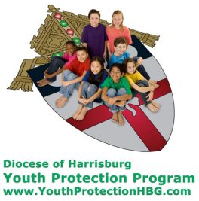
Diocese of Harrisburg Youth Protection Program
www.YouthProtectionHBG.com

Abuse Reporting Contact Information:
First – Call the toll-free PA Child Abuse Hotline at 800-932-0313
Then – Call the Diocesan toll-free hotline at 800-626-1608

“If one member suffers,
all suffer together with it.” (1 Cor 12:26)

St. Ignatius Loyola RC Church

St. Ignatius Loyola Roman Catholic Church
1095 Church Road, Orrtanna, Pennsylvania 17353
www.stignatiusofloyola.org | Office: 717-677-8012

March 10, 2024: FOURTH SUNDAY OF LENT
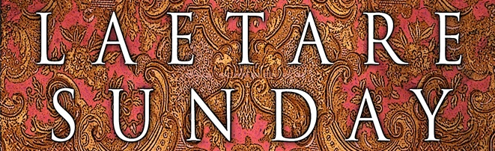

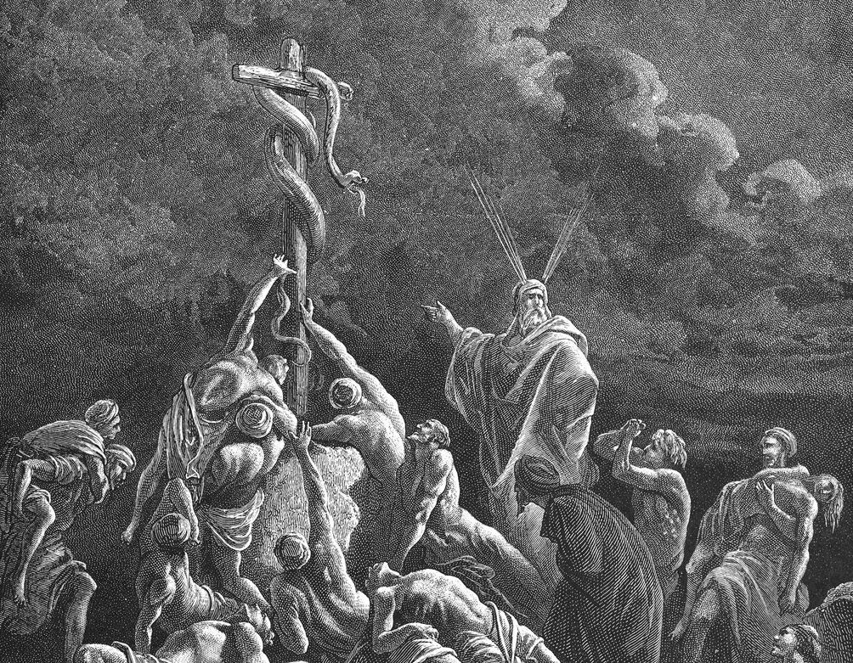

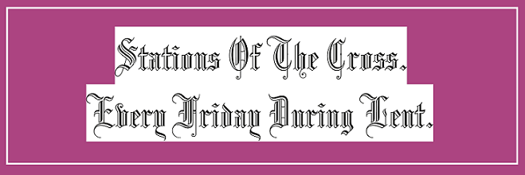

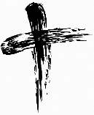
May the PENANCES we do this LENT
be offered to bring PEACE in the Holy Land!

Most Rev. Timothy C. Senior, Bishop of Harrisburg
Rev. Dominic M. DiBiccaro, Pastor
Deacon Steve Huete, Pastoral Associate

Mass Schedule, Intentions, and Events
Please Pray for these in need:
Jeanie Kline & the Kline Family, Dick & Deb Deardorff, Fred Dietsch, Greg Ernst, Jacob Long, Shell Edwards, Corona Naylor, Chris & Mary Rebscher, John Baker, Ginny Hoctor, Brenda Wolf, Sr. Thelma Steiger HSF, Sr. Miriam Ukeritis CSJ , Peter Hackney, Lucas Christiansen, Dale Kaplan, Jerry Smith, Dulcie Perry, Ron Formosa, Gavin Crumbacker, Anna Kane, Sherry Dennis & Family, Remi Peters, Terry Ahn, K. Grance, Lori McFadden & Family, Mike & Lisa Poole, Mervin Weikert, Chastity Rudisill, Mary Ellen Wilson, Terry & Bernie Cabana, Ed & Aggie Sherensky & Family, Bob Raffensberger, Jerry & Ginny Miller, Adeline Lienard, Kaylee Henry, Nancy Wuller, Dr. Mike Colli, Mrs. Kelly Kump, Gabriel Singer, Sharon McCormley, Ron Thumma, Joe Wisotzkey, Leo Hockensmith, Erika McKissick, Jean "Heather" O'Shea, Scott Moore & Sally Moore, Mary Wyatt, Amy Weatherup, Sophia Joy Ernst, Deacon Richard Wentzel, Deacon Frank Enderle, Carolyn Topper, Kathleen Thompson, Rachel Wonders, Amy Edwards, Jean O’Connor, Jen Baldwin, Ursula Kaley, Deb Bennet, Larry Endy, Laura Lee, Marwa Abdelrahman, Donna Singley, Tim McGinn, Jane Kump, Peggy Neiderer, Chris Kimple, Robert Riquet, Gene & Jo-Ann McDannell, Bob Doxzen, Kimberly Mears, Gabriella Angello, Paul Angello, Mark & Kate Morrow, Mark Morris, Linda Fogleman, Paul Knight, George & Barbara Erstila, Jeff Carpenter, Lana & Nelson Harmon, Diane Slothour, Sue McDannell, Larry Schneider, Joe & Lisa Grasel, Ange Pena, Julie Barnhart, Shaffer Family, Heather & Emma Dickerson, Brad Peabody, Paul Ward, Aiden Tyler Schneider, Dorothy Vega, Karrie McCall & daughter, George Shahid, Denise Navlyt, Drew Schneider & Family, Ida Bloomfield, Janie Singley, Mary Beth Greenstreet, Rick Benedict, Jan Patla, Kathey Fogleman, Sam Sheffler, Kate Hemmis, Bill & Mary Lou Graham, Andy Graham, Joanna Hodges, John Varones, Joan O’Sullivan, Martha Klinger, Lisa Dionne Lauretti, Jim Gleason, Sue Gustafson, Joe & Michelle Cleary, Kim Johnson, Helen Mills, Kathy Haber, Haley Detman, Joe Durovey, Bev Smith, Donald Sheppard, Linda Mumaugh, Alison Haring, Janet Hartman, Edward Johnson, Angela Galeone, Juliete Lang, Chris MacBeth, Harry Graham, Donald Howard, Armond Binni, Elizabeth Stansky, Pat Johnson, Chris Morris, Faud Doaney, Patrick Glass, Helen Lagasse, Nancy Kewisnek, Bill & Maureen Collins, Rosemary McGilloway, Anji Eisenhart, Monica Manner, Denny Borbonus, Dr. Paul Scarlata, Mary Hawthorne, Ed Washington, Josh Kempinski, Nancy Baltzey, Spencer Propts, Karlton Smith & Cheryl Sobun, James & Marylyn Sobun, Marlene Webster, Yvette Stoklosa, Andy Consiglio, Bill & Michelle Cloonan, Nelson Salem, Bill & Deb McClintock, nursing home residents & shut-ins, the victims of war, violence, disease, disaster, & all private intentions.
Also in your prayers, please remember all our men
& women currently serving in our Armed Forces:

Lt. Col. Nathan Jeffcoat – US Marine Corps
Lt. Joseph Cleary – US Navy
Michael C. Kenney IV – US Coast Guard
Lt. Joshua Kimple – US Army
Lt. Sarah Fogleman, M.D. – US Navy
A1C Ian Bellinger ‒ PA Air National Guard

PRAYER CHAIN: Contact the Office

for the Week of March 9 to March 17, 2024

SATURDAY, March 9 – Vigil 4th SUNDAY OF LENT

2 Chr 36:14-16, 19-23/Eph 2:4-10/Jn 3:14-21
5:00PM + Henry “Hap” Schneider
SUNDAY, March 10 – 4th SUNDAY OF LENT

2 Chr 36:14-16, 19-23/Eph 2:4-10/Jn 3:14-21
8:00AM + Dr. Bruce Foster
10:30AM + The Persecuted Church and
Modern-Day Christian Martyrs
MONDAY, March 11 (Lenten Weekday)
Is 65:17-21 / Jn 4:43-54
Parish Office CLOSED

TUESDAY, March 12 (Lenten Weekday)
Ez 47:1-9, 12 / Jn 5:1-16

8AM – 3PM ~ Office Open

10:00AM + Mickey Ann Balog
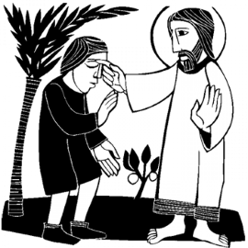
WEDNESDAY, March 13 (Lenten Weekday)
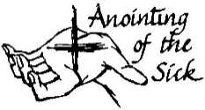
Is 49:8-15 / Jn 5:17-30

8AM – 3PM ~ Office Open
7:00PM + Mona Knox Bailey
ANOINTING OF THE SICK WITHIN MASS
NO Confessions; NO Adoration
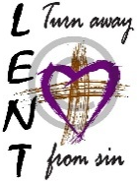
THURSDAY, March 14 (Lenten Weekday)
Ex 32:7-14 / Jn 5:31-47

8AM – 3PM ~ Office Open
10:00AM ⁓ People of the Parish
FRIDAY, March 15 (Lenten Weekday)  Wis 2:1a, 12-22 / Jn 7:1-2, 10, 25-30  7:00  PM  10:00AM + Janet Hodge  Parish Office CLOSED  7:00PM Stations of the Cross | THE LORD

SATURDAY, March 16 (Lenten Weekday)
MORNING: Jer 11:18-20 / Jn 7:40-53
Penance Service St. Mary’s, Fairfield, 11AM

SATURDAY, March 16 – Vigil 5th SUNDAY OF LENT

Jer 31:31-34/Heb 5:7-9/Jn 12:20-33
5:00PM + Everlyn Grace Topper,
+ Daniel Eugene Topper, and
+ Paul Topper
SUNDAY, March 17 – 5th SUNDAY OF LENT

Jer 31:31-34/Heb 5:7-9/Jn 12:20-33
8:00AM + Marie Trimmer
10:30AM ⁓ The People of the Parish
The Sanctuary Candle for MARCH is offered: In Loving Memory of Marilyn Cole from Kenneth Cole

Sunday Collection Summary for February
4 Collection Weeks
Weekend Collections
Regular Offering $ 13,018.75
Ash Wednesday $ 1,303.00
Christmas $ 50.00
Easter $ 240.00
Good Friday $ 105.00
Holy Thursday $ 60.00
Solemnity of Mary, Mother of God $ 45.00
TOTAL OFFERINGS $ 14,821.75

- MONTHLY BUDGETARY NEEDS $ 17,976.00
+Overage or (Shortfall) for the month ($ 3,154.25)

Other Income
Altar Flowers $ 672.00
Candles/Living Faith $ 242.00
Cemetery Annual Care $ 465.00
Cemetery Lot Sales $ 1,200.00
Individual Contributions $ 5,000.00
Local Poor $ 1,714.00
Refunds/Rebates $ 260.00
Total Other Offerings $ 9,553.00

Diocesan Second Collections
Catholic Home Missions $ 25.00
Catholic Relief Services $ 35.00
Church in East EU, Lat Am & Africa $ 45.00
Poor Missions $ 1,142.97
Soc.for the Propagation of the Faith $ 1,072.00
Total Diocesan Offerings $ 2,319.97

Sunday Collection Summary for March 2 & 3

Weekend Collections
Regular Offering $ 3,654.00
Easter $ 75.00
Good Friday $ 60.00
Holy Thursday $ 40.00
TOTAL OFFERINGS $ 3,829.00

- WEEKLY BUDGETARY NEEDS $ 4,494.00
+Overage or (Shortfall) for the week ($ 665.00)

Other Income
Altar Flowers $ 750.00
Local Poor $ 135.00
Total Other Offerings $ 885.00

Diocesan Second Collections
Catholic Relief Services $ 135.00
Poor Missions $ 20.00
Soc.for the Propagation of the Faith $ 80.00
Total Diocesan Offerings $ 235.00

Living the Light: Scott Hahn Reflects

on the Fourth (Laetare) Sunday of Lent

The Sunday readings in Lent have been showing us the high points of salvation history — God’s Covenant with Creation in the time of Noah; His promises to Abraham; the Law He gave to Isra-el at Sinai.

In today’s First Reading, we hear of the destruction of the kingdom established by God’s final Old Testament Covenant — the Covenant with David (see 2 Samuel 7; Psalm 89:3).

His Chosen People abandoned the Law that He gave them. For their sins, the Temple was destroyed, and they were exiled in Babylon. We hear their sorrow and repentance in the exile lament we sing as today’s Psalm.

But we also hear how God, in His mercy, gathered them back, even anointing a pagan king to shepherd them and rebuild the Temple (see Isaiah 44:28–45:1, 4).

God is rich in mercy, as today’s Epistle teaches. He promised that David’s kingdom would last forever, that David’s “son” would be His Son and rule all nations (see 2 Samuel 7:14–15; Psalm 2:7–9). In Jesus, God keeps that Promise (see Revelation 22:16).

Moses lifted up the serpent as a sign of salvation (see Wisdom 16:6–7; Numbers 21:9). Now Jesus is lifted up on the Cross, to draw all people to Himself (see John 12:32).

Those who refuse to believe in this sign of the Father’s love condemn themselves — as the Isra-elites in their infidelity brought judgment upon themselves.

But God did not leave Isra-el in exile, and He does not want to leave any of us dead in our transgressions. We are God’s handiwork, saved to live as His people in the light of His Truth.

Midway through this season of repentance, let us again behold the Pierced One (see John 19:37) and rededicate ourselves to living the “good works” that God has prepared us for.

Readings: 2 Chronicles 36:14–16, 19–23;
Psalms 137:1–6; Ephesians 2:4–10; John 3:14–21

Similar to its counterpart in the House, the proposed bill will be retroactive and is scheduled to automatically expire on
April 1, 2025.
According to USA Today, lawmakers aim to get the bill to the governor’s desk to be signed into law by Wednesday. Alabama Gov. Kay Ivey, a Republican, has not yet signaled whether she intends to sign the bill.

What is IVF?
IVF is a fertility treatment in which doctors fuse sperm and eggs to create human embryos and implant them in the mother’s womb without a sexual act. Embryos that are intended to be implanted later are frozen. Undesired embryos are routinely destroyed or used for scientific research, which kills those preborn children.
This has led to the killing of millions of human embryos and 1 million embryos being kept frozen in labs indefinitely.
The Catholic Church is staunchly opposed to IVF because it separates the marriage act from procreation and destroys embryonic human life.

Snead slams Alabama legislature's 'panicked reaction'
Speaking with “EWTN News in Depth” on Friday, Carter Snead, director of Notre Dame’s de Nicola Center for Ethics and Culture said the bill's passage indicates a “very strange, panicked reaction” from Alabama lawmakers who are now on the cusp of providing “blanket immunity to an entire industry in the state of Alabama without any kind of nuance, without any complexity, without any subtlety.”
Snead said that the IVF protections enshrined by the bill are “unjust” to both unborn babies and IVF patients.
“It’s strange to single out one industry, one aspect of medicine, for this kind of civil and criminal immunity,” the Alabama native added.
“It’s unjust from the perspective that it singles out in vitro embryonic human beings and it puts them beyond the protections of the law. It’s also unjust to the families … because there are people who want to build their family using IVF, and now there’s nothing they could do if someone in the IVF context tortuously harms or destroys their unborn child, so long as the unborn child has not yet been transferred to her mother’s uterus.”
In an earlier email referenced on X, Snead lamented that “For a state legislature that has courageously defended the intrinsic equal dignity of every human being regardless of age, size, location, condition of dependence, or social status, this is a shocking error in judgment.”

What does the Church in Alabama have to say?
As both Democrats and Republicans rush to support IVF, Donald Carlson, a representative for the Diocese of Birmingham, told CNA that the Catholic response to IVF is very “straightforward.”
“Human life begins at conception and that life has to be protected in all its forms,” Carlson said.
Carlson said the diocese would not condone the legislation because it contrasts with clear Catholic teaching on IVF.
Birmingham Bishop Steven Raica, Carlson noted, recently called the longing for children “a truly noble desire” but said that “while the in vitro fertilization industry presents itself as the only solution for couples yet unable to have children, the practice is fraught with many unintended consequences and unfettered risks that often are overlooked.”
“That’s really his thoughts on this,” Carlson said. “Bishop Raica encourages couples to continue in their journey towards fulfilling their dreams to have a family and to seek ethical ways to accomplish that goal.”
CATECHISM OF THE CATHOLIC CHURCH
SECOND EDITION
PART THREE CHAPTER TWO
LIFE IN CHRIST "YOU SHALL LOVE YOUR NEIGHBOR AS
YOURSELF"

SECTION TWO ARTICLE 6
THE TEN COMMANDMENTS THE SIXTH COMMANDMENT

You shall not commit adultery.¹¹³

You have heard that it was said, "You shall not commit adultery." But I say to you that every one who looks at a woman lustfully has already committed adultery with her in his heart.¹¹⁴

The gift of a child

2373 Sacred Scripture and the Church's traditional practice see in large families a sign of God's blessing and the parents' generosity.¹⁶³

2374 Couples who discover that they are sterile suffer greatly. "What will you give me," asks Abraham of God, "for I continue childless?"¹⁶⁴ And Rachel cries to her husband Jacob, "Give me children, or I shall die!"¹⁶⁵

2375 Research aimed at reducing human sterility is to be encouraged, on condition that it is placed "at the service of the human person, of his inalienable rights, and his true and integral good according to the design and will of God."¹⁶⁶

2376 Techniques that entail the dissociation of husband and wife, by the intrusion of a person other than the couple (donation of sperm or ovum, surrogate uterus), are gravely immoral. These techniques (heterologous artificial insemination and fertilization) infringe the child's right to be born of a father and mother known to him and bound to each other by marriage. They betray the spouses' "right to become a father and a mother only through each other."¹⁶⁷

2377 Techniques involving only the married couple (homologous artificial insemination and fertilization) are perhaps less reprehensible, yet remain morally unacceptable. They dissociate the sexual act from the procreative act. The act which brings the child into existence is no longer an act by which two persons give themselves to one another, but one that "entrusts the life and identity of the embryo into the power of doctors and biologists and establishes the domination of technology over the origin and destiny of the human person. Such a relationship of domination is in itself contrary to the dignity and equality that must be common to parents and children."¹⁶⁸ "Under the moral aspect procreation is deprived of its proper perfection when it is not willed as the fruit of the conjugal act, that is to say, of the specific act of the spouses' union . . . . Only respect for the link between the meanings of the conjugal act and respect for the unity of the human being make possible procreation in conformity with the dignity of the person."¹⁶⁹

2378 A child is not something owed to one, but is a gift. The "supreme gift of marriage" is a human person. A child may not be considered a piece of property, an idea to which an alleged "right to a child" would lead. In this area, only the child possesses genuine rights: the right "to be the fruit of the specific act of the conjugal love of his parents," and "the right to be respected as a person from the moment of his conception."¹⁷⁰

2379 The Gospel shows that physical sterility is not an absolute evil. Spouses who still suffer from infertility after exhausting legitimate medical procedures should unite themselves with the Lord's Cross, the source of all spiritual fecundity. They can give expression to their generosity by adopting abandoned children or performing demanding services for others.

Experts warn of ‘inhumane’ treatment of embryos,

‘evil’ circumstances surrounding IVF
Feb. 29, 2024. | By Kate Quiñones | CNA Staff, Mar 2, 2024
A Catholic moral theologian this week warned that in vitro fertilization (IVF) “separates the things that God wanted to be together” while another expert spoke out against the “inhumane” treatment of the hundreds of thousands of human embryos produced by IVF.
The Alabama Supreme Court has sparked a national debate on the ethics surrounding IVF following the court’s recent decision that ruled embryos are considered children under state law.
“EWTN Pro-Life Weekly” anchor Prudence Robertson spoke to Emma Waters, a researcher at the Heritage Foundation, about the ethical implications of IVF and its effects on marriage and society.
“In a normal in vitro fertilization process, clinicians will create anywhere between 15 to 20 embryos at a time,” Waters explained.
Embryos are then tested for genetic issues, and parents have the opportunity to choose the sex of the baby, she explained. After this, wanted embryos are either implanted into the intended mother or frozen for a later time.
But unwanted embryos are “routinely destroyed or donated to science, where they’re also later destroyed after having inhumane testing done to them,” Waters pointed out.
Because of the high cost of IVF, which averages about $19,000, many couples choose to discontinue the process, resulting in the embryonic children being destroyed.
Nearly 80,000 infants born were conceived through such alternatives to sex, according to the most recent data from 2020. But reports say that between 400,000 and 1.5 million frozen embryonic children are preserved in laboratories in the U.S. today.
Father Ezra Sullivan, OP, a professor of moral theology and psychology at the University of St. Thomas Aquinas in Rome, told Robertson that the Church is outspoken against the mass “production of children” through IVF.
When asked what might be done about the thousands upon thousands of embryonic children now in existence in labs throughout the U.S., Sullivan called it an “irresolvably evil” situation.
“Should we try to allow parents to conceive these children, since they already exist?” he asked. “Should we baptize them — and in that moment of baptism, the embryo, unfortunately, cannot survive?”
“There’s no definitive resolution because it’s a situation that John Paul II would say is irresolvably evil,” he continued. “There’s no way to solve it without some kind of moral problem arising.”
IVF has “totally upended society’s understanding” of what it means to procreate, Waters said.
Children “can be created at will by any adults who simply have the right parts whether they come from themselves or they come through sperm and egg donation,” she explained.
Sullivan, meanwhile, noted that IVF “breaks apart” the “marital bond” because it creates a child “outside of the marital act, within a hospital or laboratory.”
“The issue of IVF is sensitive because a lot of people are having trouble conceiving in this time, ” he said. “But ultimately the Church says that we want to go the natural route.”

IVF separates ‘the things God wanted to be together’
While “conception is difficult” for a variety of reasons, Sullivan noted that IVF “separates the things that God wanted to be together: love and marriage, conception, procreation in the very marital act.”
“One of the difficulties that we need to accept as human beings is that we’re weak, we’re imperfect,” Sullivan noted. “And sometimes when, for instance, we have trouble conceiving, sometimes that’s our body’s way of saying that maybe we need to find another way to give life to the world, another way to serve others.”
The Alabama ruling stemmed from a lawsuit filed by three couples after their IVF-created embryos were accidentally destroyed at the lab where they were stored.
During the discussion of the issue on “EWTN Pro-Life Weekly,” Dr. Joseph Meaney, president of the National Catholic Bioethics Center, defended the Alabama ruling.
Meaney said the decision “recognizes that human life begins at conception” and that “children should be protected no matter where they are, in their mother’s womb or in the laboratory.”
“In fact, it points out that the in vitro fertilization process kills huge numbers of children at the embryonic stage,” he said.

The ruling limited the protection of these embryos to legal protection against cases where clinics were negligent. But the Alabama Legislature has since defined protections for IVF after three clinics in the state paused their in vitro services.
In the wake of the controversy, several top contenders for the 2024 U.S. presidential election have voiced their support for IVF.
Donald Trump came out strongly against the Alabama Supreme Court ruling on social media, saying he supports IVF “in every state in America.”
Trump’s lone remaining rival for the 2024 GOP presidential nomination, former South Carolina Gov. Nikki Haley, told CNN’s Jake Tapper that she conceived her son through artificial insemination. She said that “Alabama needs to go back and look at the law” that fueled the court’s decision.
President Joe Biden, meanwhile, told EWTN White House correspondent Owen Jensen this week that he disagreed with the Catholic Church’s position on IVF.

Alabama Senate passes IVF protection bill amid Catholic outcry
By Peter Pinedo | Washington, D.C. Newsroom, Mar 1, 2024

The Alabama Senate unanimously passed a bill granting immunity to in vitro fertilization (IVF) providers in cases of death or injury to unborn babies during the IVF process.

The Republican-majority Senate passed the bill in a 32-0 vote on Friday, just over a week after the Alabama Supreme Court ruled that unborn babies conceived through IVF are human children protected under the state’s Wrongful Death of a Minor Act.

Introduced by 10 Republican state senators, the bill bypasses the state’s Wrongful Death of a Minor Act to ensure that “no action, suit, or criminal prosecution shall be brought or maintained against any individual or entity providing goods or services related to in vitro fertilization.”
[Article continues OVER]

