Sacrament of the Sick
Anointing of the Sick should be given if an individual is gravely ill or near death. If possible, the Sacrament should also be administered for serious illness, before major surgery or when one is initially hospitalized.

Sacrament of Holy Matrimony
Diocesan policy requires 12 months of preparation for Marriage. Contact the parish as soon as possible after engagement. No venue reservations or other arrangements should be made prior to consultation with the pastor.

Sacrament of Penance
Wednesday ~ 6:00 – 6:45PM; or by appointment.

Sacrament of Baptism
Parents must be registered members of the parish and attend a Baptism preparation class prior to the Baptism if this is your first child baptized. Requirements for godparents are established by the Catholic Church. Please call the parish office for Information and to register your child for Baptism.

Parish Registration
All Catholics should be registered in their local parish. Please contact the parish office to obtain registration forms, or if you are uncertain of the parish where you should register.

Parish Staff & Ministries Directory
stignatiusofloyola@hbgdiocese.org | Office: 717-677-8012
Financial Manager ~ Richard Deardorff ~ 717- 677-8012 or 717-420-3464 (cell)
rdeardorff@hbgdiocese.org
Director of Religious Education ~ Deacon Steve Huete ~ shuete@hbgdiocese.org
Parish Secretary ~ Kristen DiDio ~ kdidio@hbgdiocese.org
Buildings & Grounds ~ Donnie Althoff ~ 717-677-8012
Music Ministry ~ Phil Mobley ~ 717-677-8012
Parish Council Members
Phil Mobley – Chair 571-236-7580 pmmobley@gmail.com
Bicky Redman – Vice Chair 677-8592 feetintheair7@gmail.com
Joanne Riedel - Secretary 398-2021 sterj221@aol.com
Kathi Allwein 677-8984 allweint@comcast.net
Charlie Baker 677-9536 dcbake@embarqmqil.com
Mike McTighe 729-6239 mike0432@aol.com
Dr. BobTernes rjtmd46@gmail.com

Finance Council Members
Richard Deardorff (Ex Officio)
Greg Ernst - Chair
Alix Haller
Christy Hemler - Secretary
Terri Pendlelton
Bill Pulig

Altar Flowers
Prayer Chain
Lynne Mobley at LMOBLEY509@gmail.com
or 703-876-4901

Soup Kitchen
Please send donations directly to “Soup Kitchen”

Website Development
Kristen DiDio
Life After Loss
Dodie Huete

OCIA
Contact Fr. Dominic

Picnic Co-Chairpersons
John Neiderer
Wally Kane

Pro-Life Ministry
Jeanette Backus
Knights of Columbus
SK Bob Ternes
- Grand Knight

Judy Wilson / Janice Meligakes

Bereavement Ministry
Ginny Bittle / Dodie Huete

Catholic Communications/EWTN
Open - Contact office if you are interested

Cemetery
Contact Parish Office
THEOSIS Ministry
Kathy Dietsch 717-352-4558
Bicky Redman 717-677-8592

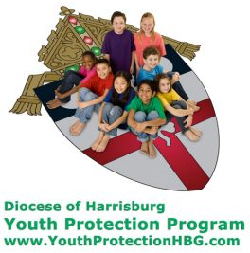
Diocese of Harrisburg Youth Protection Program
www.YouthProtectionHBG.com

Abuse Reporting Contact Information:
First – Call the toll-free PA Child Abuse Hotline at 800-932-0313
Then – Call the Diocesan toll-free hotline at 800-626-1608

“If one member suffers,
all suffer together with it.” (1 Cor 12:26)

St. Ignatius Loyola RC Church

1095 Church Road, Orrtanna, Pennsylvania 17353
www.stignatiusofloyola.org | Office: 717-677-8012

August 13, 2023: 19th SUNDAY IN ORDINARY TIME
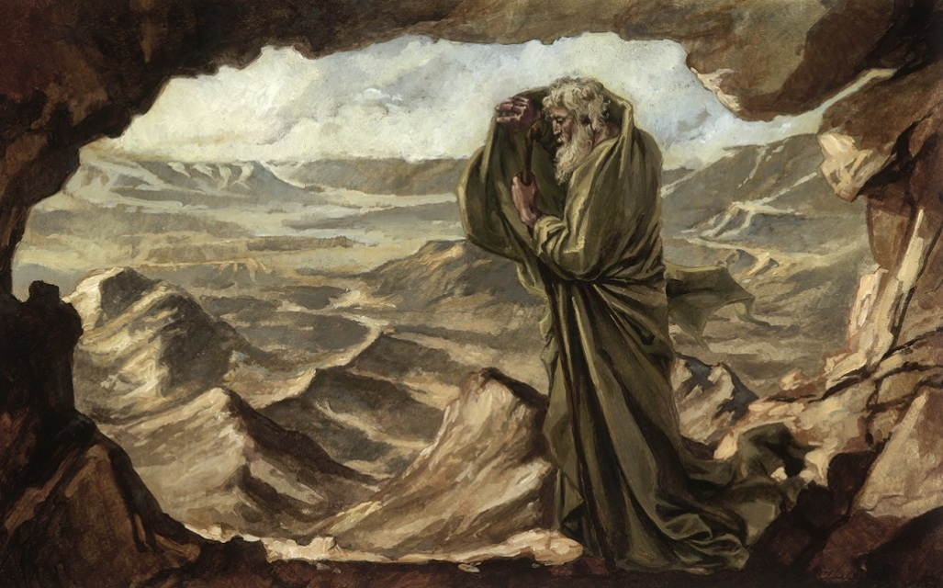

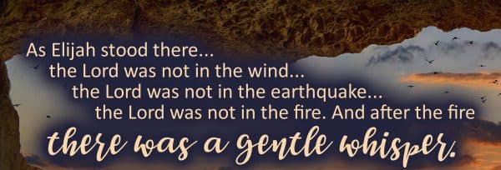

SEE INSIDE: Pope Francis Concludes WORLD YOUTH DAY 2023
Bishop Senior Enjoys His Visit to Bless New Windows
Most Rev. Timothy C. Senior, Bishop of Harrisburg
Rev. Dominic M. DiBiccaro, Pastor
Deacon Steve Huete, Pastoral Associate

*** Tuesday, August 15 ***
Mass Schedule, Intentions, and Events
Please Pray for:
Those who are ill, Jeanie Kline & the Kline Family, Brenda Wolf, Wade Sprankle, Dulcie Perry, Ron Formosa, Gavin Crumbacker, Anna Kane, Sherry Dennis and Family, Remi Peters, Christy Hemler, Terry Ahn, K. Grance, Lori McFadden & Family, Mike & Lisa Poole, Mervin Weikert, Chastity Rudisill, Mary Ellen Wilson, Terry & Bernie Cabana, Ed & Aggie Sherensky and Family, Bob Raffensberger, Jerry & Ginny Miller, Adeline Lienard, Kaylee Henry, Nancy Wuller, Dr. Mike Colli, Mrs. Kelly Kump, Gabriel Singer, Sharon McCormley, Ron Thumma, Joe Wisotzkey, Leo Hockensmith, Erika McKissick, Jean "Heather" O'Shea, Scott Moore and Sally Moore, Mary Wyatt, Jim & Joyce Deardorff, Amy Weatherup, Sophia Joy Ernst, Deacon Richard Wentzel, Deacon Frank Enderle, Kathleen Thompson, Deb & Kathy McLintock and Family, Rachel Wonders, Amy Edwards, Jean O’Connor, Art Lazar, Sr., Paul Angello, Jen Baldwin, Ursula Kaley, Deb Bennet, Fr. Bill Sullivan, Larry Endy, Laura Lee, Marwa Abdelrahman, Donna Singley, Tim McGinn, Jane Kump, Peggy Neiderer, Chris Kimple, Robert Riquet, Gene & Jo-Ann McDannell, Bob Doxzen, Kimberly Mears, Gabriella Angello, Paul Angello, Mark & Kate Morrow, Mark Morris, Linda Fogleman, Paul Knight, George & Barbara Erstila, Jeff Carpenter, Lana & Nelson Harmon, Diane Slothour, Sue McDannell, Larry Schneider, Joe & Lisa Grasel, Ange Pena, Julie Barnhart, the Shaffer Family, Heather & Emma Dickerson, Brad Pabody, Paul Ward, Aiden Tyler Schneider, Dorothy Vega, Karrie McCall & daughter, George Shahid, Denise Navlyt, Drew Schneider & Family, Ida Bloomfield, Linda McDannell, Janie Singley, Mary Beth Greenstreet, Rick Benedict, Jan Patla, Kathe Fogleman, Sam Sheffler, Kate Hemmis, Bill & Mary Lou Graham, Joanna Hodges, John Varones, Joan O’Sullivan, Martha Klinger, Lisa Dionne Lauretti, Sue Orndorff, Jim Gleason, Sue Gustafson, Joe & Michelle Cleary, Kim Johnson, Helen Mills, Kathy Haber, Haley Detman, Joe Durovey, Bev Smith, Donald Sheppard, Linda Mumaugh, Alison Haring, Janet Hartman, Edward Johnson, Angela Galeone, Juliete Lang, Chris MacBeth, Harry Graham, Donald Howard, Armond Binni, Elizabeth Stansky, Pat Johnson, Chris Morris, Faud Doaney, Wilson & Rae Harman, Patrick Glass, Helen Lagasse, Nancy Kewisnek, Andy Graham, Bill & Maureen Collins, Rosemary McGilloway, Anji Eisenhart, Monica Manner, Denny Borbonus, Dr. Paul Scarlata, Mary Hawthorne, Ed Washington, Josh Kempinski, Nancy Baker Baltzey, Spencer Propts, Karlton Smith & Cheryl Sobun, James & Marylyn Sobun, Marlene Webster, Yvette Stoklosa, Andy Consiglio, Bill & Michelle Cloonan, Nelson Salem, Bill & Deb McClintock, nursing home residents & shut-ins, the victims of war, violence, disease, disaster, & all private intentions.
Also in your prayers, please remember all
our men and women currently serving in
our Armed Forces:
Maj. Nathan Jeffcoat – US Marine Corps
Lt. Joseph Cleary – US Navy
Michael C. Kenney IV – US Coast Guard
Lt. Joshua Kimple – US Army
Lt. Sarah Fogleman, M.D. – US Navy

PRAYER CHAIN: Contact Lynne Mobley at 703-876-4901 or LMOBLEY509@gmail.com

for the Week of August 12 to August 20, 2023

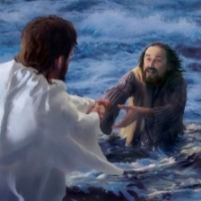
SATURDAY, August 12 – VIGIL 19th SUNDAY OT

1 Kgs 19:9a, 11-13a / Rom 9:1-5 / Mt 14:22-33
5:00PM +Teresa Quigley

SUNDAY, August 13 – 19th SUNDAY IN OT

1 Kgs 19:9a, 11-13a / Rom 9:1-5 / Mt 14:22-33
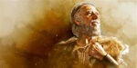
8:00AM + Marie Trimmer
10:30AM ⁓ People of the Parish
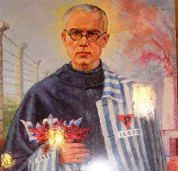
Monday, August 14 – St. Maximilian Kolbe, Priest
Dt 10:12-22 / Mt 17:22-27 & Martyr
Parish Office Closed
7:00PM VIGIL OF THE ASSUMPTION +Larry Dennis

Tuesday, August 15 – ASSUMPTION OF THE BL. VIRGIN MARY
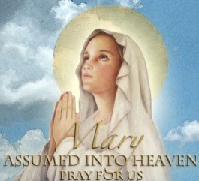
Rv 11:19a; 12:1-6a, 10ab/1 Cor 15:20-27/Lk 1:39-56

Parish Office CLOSED
10:00AM +Joan & Eugene Scott

NO “Something More” Group
7:00PM ⁓ People of the Parish
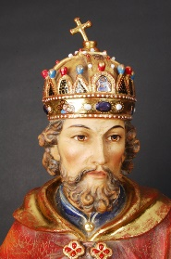
Wednesday, August 16 – St. Stephen of Hungary
Dt 34:1-12 / Mt 18:15-20

8:00AM – 3:00PM ~ Office Open
10:00AM + James Bucci
11AM: Mature Spirituality Group
NO Confessions; NO Adoration; NO Evening Mass
7PM – Bishop Senior’s Deanery Episcopal Mass at Corpus Christi

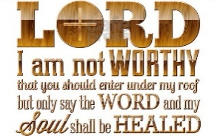
Thursday, August 17 (Weekday in OT)
Jos 3:7-10a, 11, 13-17 / Mt 18:21—19:1

8:00AM – 3:00PM ~ Office Open
10:00AM + Jack Ryff
Friday, August 18 (Weekday in OT)  Jos 24:1-13 / Mt 19:3-12  Parish Office CLOSED | THE LORD
10:00AM + Ruth Ann Robinson

SATURDAY, August 19 – St. John Eudes, Priest
MORNING: Jos 24:14-29 / Mt 19:13-15

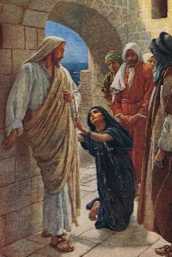
SATURDAY, August 19 – VIGIL 20th SUNDAY OT

Is 56:1, 6-7 / Rom 11:13-15, 29-32 / Mt 15:21-28
5:00PM + Brenda Althoff

SUNDAY, August 20 – 20th SUNDAY IN OT

Is 56:1, 6-7 / Rom 11:13-15, 29-32 / Mt 15:21-28
8:00AM ⁓ People of the Parish
10:30AM + Angie Rendina
Sanctuary Candle offered for AUGUST: In Loving Memory of Teresa Redding from Edna Redding.
Collection Summary for the Month of JULY 2023
Number of Collection Weeks in the Month: 5

Weekend Collections
Sunday Offerings $ 17,392.00
Alter Flowers $ 1,085.67
Candles $ 164.00
TOTAL OFFERINGS $ 18,641.67

‒TOTAL BUDGETARY NEEDS $ 22,470.00
+(Overage) or (Shortfall) for the month ($ 3,828.33)

Other Income
Assumption Holy Day (additional) $ 35.00
Individual Contributions $ 5,000.00
Stewardship Bookcase/Table $ 172.00
Cemetery Lot Sales $ 1,500.00
Local Poor $ 2,012.00
Rebate (Aero Energy “Houses of Worship”) $ 634.68
Memorial Offering $ 350.00
Parish Picnic $ 540.00
Picnic Raffle Tickets $ 3,180.00
Sale of Equipment - cooler $ 250.00
Total Other Income $ 13,673.68

Sunday Collection Summary
August 5 and 6
Weekend Collections
Regular Offering*(see Missionary CO-OP) $ - 0 -
Candles $ 154.00
TOTAL OFFERINGS $ 154.00

‒WEEKLY BUDGETARY NEEDS $ 4,494.00
+Overage or (Shortfall) for the week ($ 4,340.00)

Other Income
Assumption $ 5.00
Parish Picnic $ 120.00
Picnic Raffle Tickets $ 270.00
Memorial (Willma Watz) $ 240.00
Memorial Jack Ryff $ 25.00
Total Other Offerings $ 660.00

Diocesan Collection
*Missionary CO-OP (Apostles of Jesus) $ 5,844.00

St. Ignatius Loyola Parish Orrtanna 2023 DAC Update as of June 30
Parish Goal for 2023: $ 29,847.61
Total Paid: $ 33,009.00
Outstanding Pledges: $ 2,130.00
Total Committed: $ 35,139.00
Over/(under)goal in cash: $ 3,161.39
% toward goal cash rec’d: 110.59%
Average per donor: $392.96
Number of Donors: 84
Registered Households: 205
Percentage of Participation: 40.98%

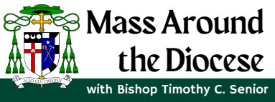
All the Faithful are invited to Mass,
celebrated by Bishop Timothy C.
Senior, as he begins his pastoral
ministry. For our Franklin Deanery,
Mass will be celebrated on Wednesday,
August 16, at Corpus Christi Church, at
7PM. Visit the Diocesan website for
more details on the Mass schedule,
including those that will be live streamed.

Please NOTE: that because of the Deanery Episcopal Mass on WEDNESDAY, AUGUST 16th, The evening Mass will be MOVED TO 10AM here at St. Ignatius. AND…there will be NO CONFESSIONS nor ADORATION that evening as well.

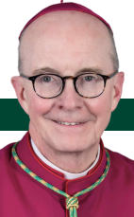

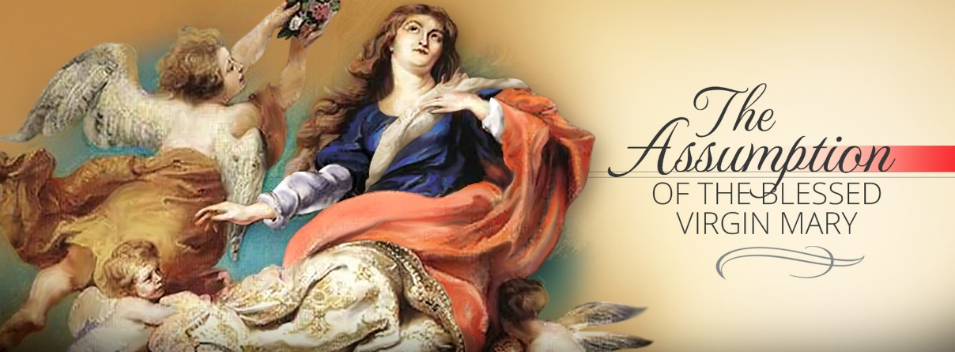

What does Solemnity of the Assumption celebrate?

On August 15, the Church celebrates, as a Holy Day of Obligation, the fact that Mary, the Mother of God, was assumed into Heaven at the end of her earthly life.

The Catechism of the Catholic Church (CCC 974) teaches, “The Most Blessed Virgin Mary, when the course of her earthly life was completed, was taken up body and soul into the glory of heaven, where she already shares in the glory of her Son's Resurrection, anticipating the resurrection of all members of his Body.”

What happened in the Assumption of Mary?

CCC 966 “Finally the Immaculate Virgin, preserved free from all stain of original sin, when the course of her earthly life was finished, was taken up body and soul into heavenly glory, and exalted by the Lord as Queen over all things, so that she might be the more fully conformed to her Son, the Lord of lords and conqueror of sin and death” (Pope Pius XII, Munificentissimus Deus). The Assumption of the Blessed Virgin is a singular participation in her Son's Resurrection and an anticipation of the resurrection of other Christians: In giving birth you kept your virginity; in your Dormition you did not leave the world, O Mother of God, but were joined to the source of Life. You conceived the living God and, by your prayers, will deliver our souls from death (Byzantine Liturgy, Troparion, Feast of the Dormition).

What does the Assumption of Mary teach us?

In a homily for the Assumption, Pope St. John Paul II said, “Taken up into Heaven, Mary shows us the way to God, the way to Heaven, the way to life. She shows it to her children baptized in Christ and to all people of good will. She opens this way especially to the little ones and to the poor, those who are dear to divine mercy. The Queen of the world reveals to individuals and to nations the power of the love of God….”

Is the Assumption of Mary in the Bible?

As with the dogma of her Immaculate Conception, the dogma of the Assumption isn’t explicitly stated in Scripture. This was dogmatically defined by Pope Pius XII in 1950 in his encyclical, Munificentissimus Deus, when he referred to many “holy writers who ... employed statements and various images and analogies of Sacred Scripture to illustrate and to confirm the doctrine of the Assumption....” He explained that he wasn’t manifesting a new doctrine but rather fulfilling his divine commission to “faithfully propose the revelation delivered through the Apostles.” The Church teaches that the dogma of the Assumption was at least implicitly present in Scripture and Apostolic Tradition and therefore is a legitimate sign of the “protection of the Spirit of Truth.”

In the encyclical, Pope Pius XII pointed to several Scripture passages that he believed illustrated the doctrine of the Assumption of Mary. Some of them include:

- “Arise, O Lord, and go to thy resting place, thou and the ark of thy might.” Psalm 132 (131):8
- [The Spouse of Canticles] that “coming up from the wilderness, like a column of smoke, perfumed with myrrh and frankincense” (Canticles 3:6)
- The Woman clothed with the Sun (Revelation 12)
- I will make the place of my feet glorious. (Isaiah 60:13)
- Who is that coming up from the wilderness, leaning upon her beloved? (Canticles 8:5)
The Holy Father, Pope Francis’ Prayer Intentions for 2023
Entrusted to His Worldwide Prayer Network
AUGUST ⁓ FOR WORLD YOUTH DAY

We pray the World Youth Day in Lisbon, Portugal, will help young people to live and witness the Gospel in their own lives.

Sinking Fear: Scott Hahn Reflects

on the Nineteenth Sunday in Ordinary Time

How do we find God in the storms and struggles of our lives, in the trials we encounter in trying to do His Will?

God commands Elijah in today’s First Reading to stand on the mountain and await His passing by. And in the Gospel, Jesus makes the disciples set out across the waters to meet Him.

In each case, the LORD makes Himself present amid frightening tumult — heavy winds and high waves, fire and earthquakes.

Elijah hides his face. Perhaps he remembers Moses, who met God on the same mountain, also amid fire, thunder, and smoke (see Deuteronomy 4:10–15; Exodus 19:17–19). God told Moses no one could see His face and live, so He sheltered Moses in the hollow of a rock, as He shelters Elijah in a cave (see Exodus 33:18–23).

The disciples, likewise, are too terrified to look on the Face of God. Today’s Gospel is a revelation of Jesus’ Divine Identity. Only God treads across the crest of the sea (see Job 9:8) and rules the raging waters (see Psalm 89:9–10).

And the words of assurance that Jesus speaks — “It is I” — are those God used to identify Himself to Moses (see Exodus 3:14; Isaiah 43:10).

Even Peter is too overcome by fear to imitate his LORD. His fears, Jesus tells him, are a sign of his lack of faith. And so it often is with us. Our fears make us doubt, make it hard to see His Glory dwelling in our midst.

Yet, we should know, as we sing in today’s Psalm, that His salvation is near to those who hope in Him. By faith we should know, as St. Paul asserts in today’s Epistle, that we are heirs to the Promises made to His Children, Isra-el.

We must trust that He whispers to us in the trials of our lives — that He who has called us to walk along the way of His steps will save us whenever we begin to sink.

Readings: 1 Kings 19:9, 11–13; Psalm 85:9–14; Romans 9:1–5; Matthew 14:22–33

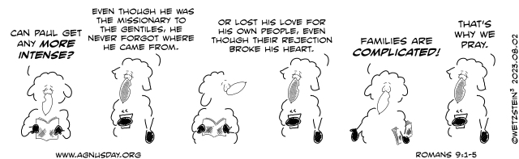

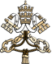
APOSTOLIC JOURNEY OF HIS HOLINESS POPE FRANCIS
to PORTUGAL
ON THE OCCASION OF THE XXXVII WORLD YOUTH DAY
(2 - 6 August 2023)
HOLY MASS FOR WORLD YOUTH DAY
HOMILY OF HIS HOLINESS

“Parque Tejo” (Lisbon)
Feast of the Transfiguration of the LORD
Sunday, 6 August 2023
________________________________________
After these exciting days, surely we feel like repeating the words of the Apostle Peter on the mount of the Transfiguration: “LORD, it is good for us to be here!” (Mt 17:4). Indeed, how good it has been to share this experience with Jesus, with one another, and to pray together with joyful hearts. Now, we can also ask an important question: What will we take back with us as we resume our daily lives?
I would like to answer this question with three verbs, drawing from the Gospel we have heard: to shine, to listen, and to be unafraid. What will we take back with us? I would respond with these three words: to shine, to listen, and to be unafraid
The first: to shine. Jesus is transfigured. The Gospel tells us: “his face shone like the sun” (Mt 17:2). Shortly before this, he had predicted his passion and death on the cross, shattering the disciples’ image of a powerful and worldly Messiah, and disappointing their expectations. Now, in order to help them embrace the loving plan that God has for each of us, Jesus takes three of the disciples, Peter, James, and John, and leads them up the mountain, where he is transfigured. Through this brilliant burst of light, Jesus prepares the disciples for the dark night of the Passion.
Dear young friends, today we too need something of this burst of light, so that it can fill us with hope as we face the many failures of each day and the darkness that assails us in life, and respond to them with the light of the resurrection of Jesus. For he is the light that never sets, the light that shines even in the dead of night. As the priest Ezra said, God has illumined our eyes (cf Ezra 9:8). Our God illumines: he illumines our vision, our hearts, our minds, our desire to do something with our lives. The LORD’s light always shines.
Yet, I would like to tell you that we do not radiate light by putting ourselves in the spotlight, for that type of light is blinding.
No, we cannot illumine others by projecting a perfect, well-ordered, refined image of ourselves, or by appearing to be powerful and successful, strong but without light. No, we radiate light – we shine – by welcoming Jesus into our hearts and learning to love as he does. To love like Jesus: that is what makes us shine, makes us do works of love. Friends, I am telling you the truth: whenever you do works of love, you become light. But the moment you stop loving others and become self-centered, you extinguish your light.
The second verb is to listen. On the mountain, a bright cloud overshadows the disciples. And what does it tell us, this cloud from which the Father speaks? “This is my Son, the Beloved… listen to him!” (Mt 17:5). Listen to him. To listen to Jesus, that is life’s secret. Listen to what Jesus is saying to you. “But I don’t know what he is saying to me”. Well, take the Gospels and read there what Jesus is saying, what he is saying to your heart. For he has the words of eternal life for us, he reveals that God is our Father, that God is love. He shows us the way of love. Listen to Jesus; otherwise, even if we set out with good intentions along paths that seem to be of love, in the end those paths will be seen as selfishness disguised as love. Be careful of selfishness disguised as love! Listen to Jesus, for he will show you which paths are those of love. Listen to him.
The first word: to shine, so be radiant; then, listen in order not to take the wrong path; finally the third word: to be unafraid. Do not be afraid. We often find these words in the Bible, in the Gospels: “Do not be afraid”. These were the last words spoken by Jesus to the disciples at the moment of the Transfiguration: “Do not be afraid!” (Mt 17:7).
As young people, you have experienced these days of joy – I was about to say of glory, and indeed our encounters have been a kind of glory. You have great dreams, but often fear that they may not come true; sometimes you think that you are not up to the challenge, which is a kind of pessimism that can overcome us at times. As young people, you may be tempted at this time to lose heart, to think you fall short, or to disguise your pain with a smile. As young people, you want to change the world – and it is very good that you want to change the world – you want to work for justice and peace. You devote all your life’s energy and creativity to this, but it still seems insufficient. Yet, the Church and the world need you, the young, as much as the earth needs rain. To all of you, dear young people, who are the present and the future, yes to all of you, Jesus now says: “Have no fear”, “Do not be afraid!”.
Now, in a brief moment of silence, each of you repeat these words, in your own heart: “Do not be afraid!”
Dear young people, I would like to look into the eyes of each of you and say: Do not be afraid. I will tell you something else, also very beautiful: it is no longer I, but Jesus himself who is now looking at you. He knows each of your hearts, each of your lives; he knows your joys, your sorrows, your successes and failures. He knows your heart. Today, he says to you, here in Lisbon, at this World Youth Day: “Have no fear, take heart, do not be afraid!”.

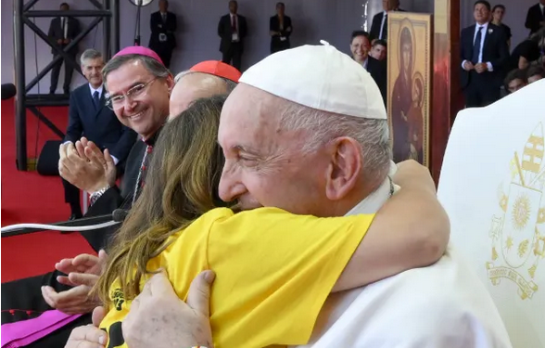
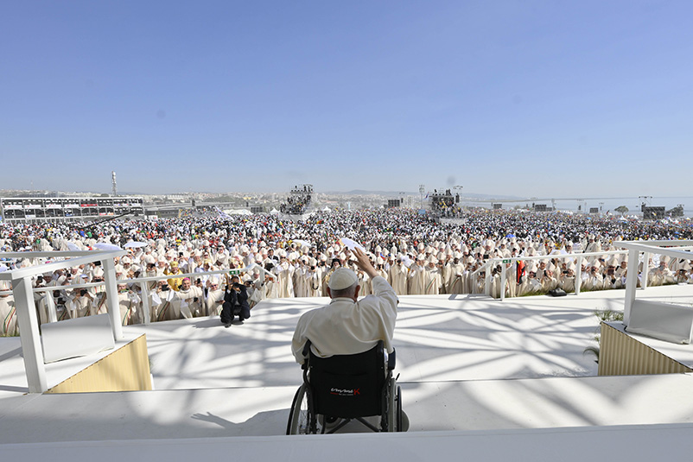

One particular photo from the meeting stood out
PAX VOBISCUM!
— a young volunteer gave the pope a warm embrace.

10. Another moving moment from the closing Mass of WYD was Pope Francis saying farewell to Lisbon by
praying at the feet of the pilgrim statue of Our Lady of Fátima, which was brought directly from the
sanctuary to the closing Mass. Pope Francis told the youth: “Dear young people, I would like to look
into the eyes of each one of you and tell you: Be not afraid, be not afraid!”
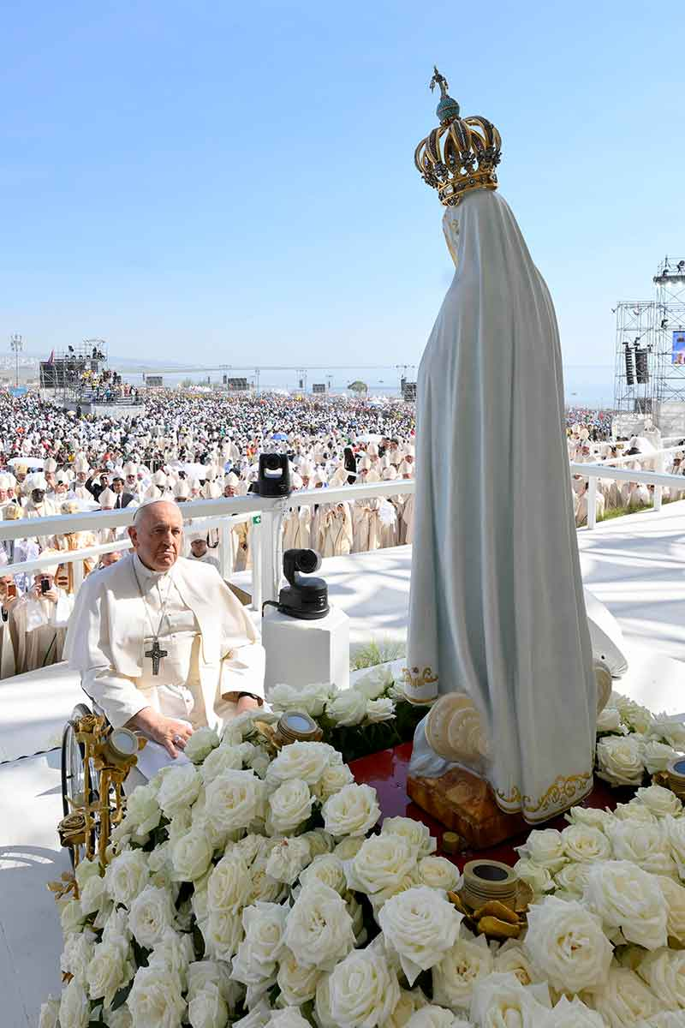

Francesca Pollio Fenton is the Social Media Manager for Catholic News Agency. She received her degree in Communications with an emphasis in Digital Media from the University of Colorado - Denver.
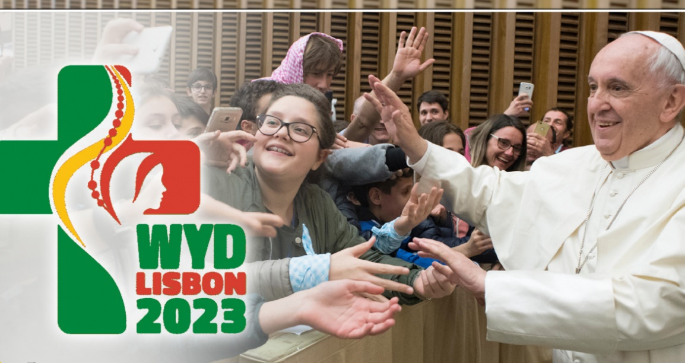

10 of the Most Touching Moments of World Youth Day 2023
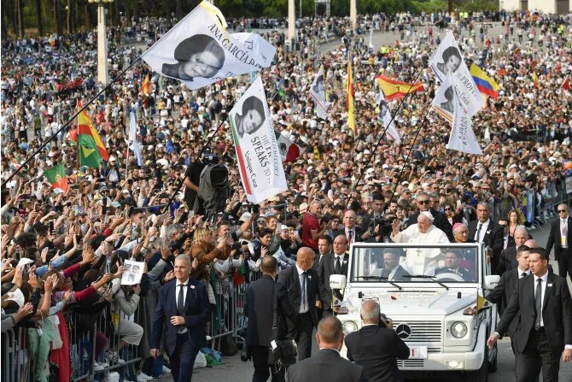

An estimated 200,000 people attended the pope's Rosary in Fatima, Portugal, on Aug. 5, 2023.

By Francesca Pollio Fenton | Denver, Colo., Aug 7, 2023

Now that the hundreds of thousands of pilgrims have left Lisbon, Portugal, and World Youth Day (WYD) has ended after days of inspiring and faith-filled events, we take a look back at some of the most moving moments of WYD.

- A picture taking social media by storm is of a disabled young man being lifted by his wheelchair high above the sea of WYD attendees.

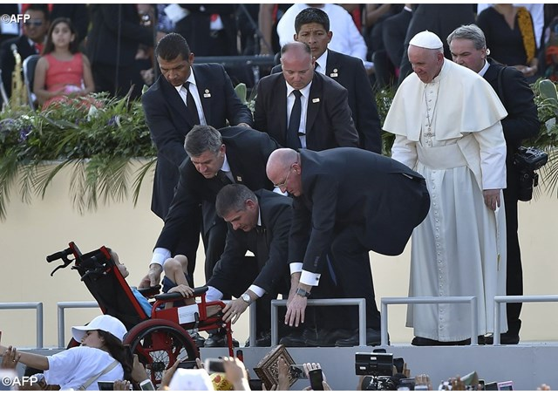
- A video of Pope Francis meeting a child in a
wheelchair captured the hearts of journalists in Lisbon.
You can see the young boy giving the Holy Father a
gift. At the end of the video, the two give one another
a high-five.

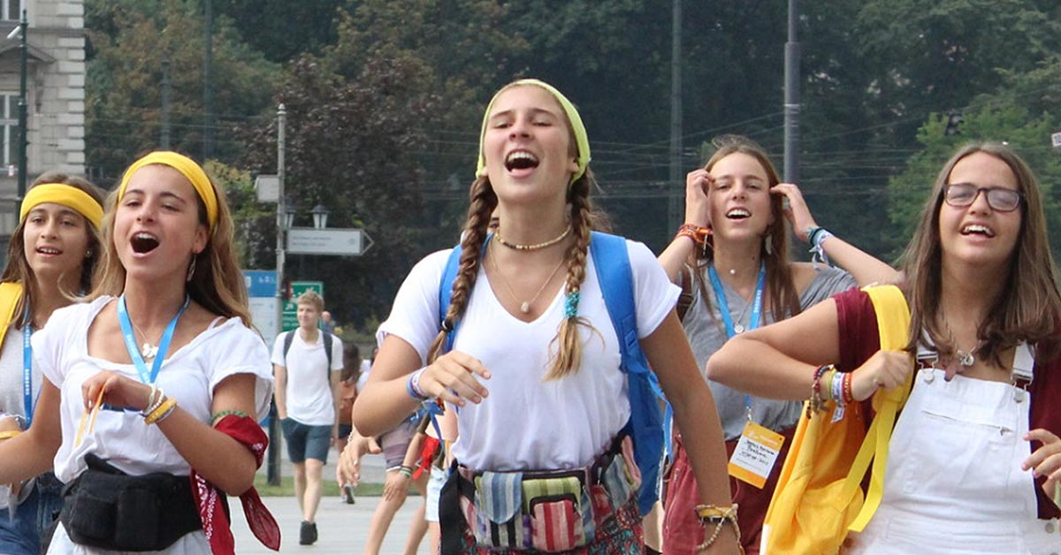
- The EWTN News team in Lisbon found a pair of sisters from Toronto, Canada, who were attending WYD for the first time. Twenty-one-year-old Aurora and 23-year-old Gloria shared that they found out about WYD being in Portugal before the start of the COVID-19 pandemic and, at that time, their mother encouraged them to attend. Their mother has since passed away and the sisters decided to attend the event in her honor.

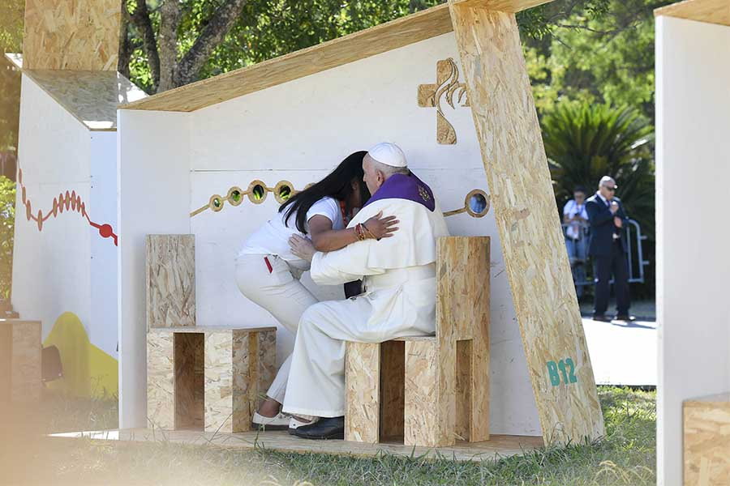
- As part of the WYD celebrations, pope Francis heard
the confessions of three young people in Reconciliation
Park on Aug. 4. He took about 10 minutes to hear the
private confessions of the young people. One heartwarming
photo from this experience was a young woman
being embraced by the Holy Father after her confession.

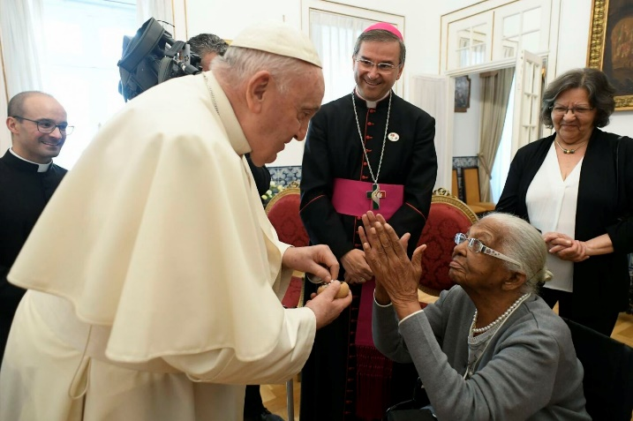
- On Aug. 4 at the nunciature in Lisbon, Pope Francis met with Maria da Conceição Brito Mendonça, a 106-year-old woman who was born on the day of the apparitions of Fátima, May 13, 1917.

- ACI Digital, CNA’s Portuguese-language news agency,
shared the beautiful story of Carlos Wilson da Silva, 30,
and Angélica Jesus Macedo, 35, who got engaged on Aug. 3
at the shrine of Fátima, Portugal. The engagement proposal
was a surprise for the bride and for everyone who was there.
“It’s very exciting, I didn’t imagine that he would ask me in
front of the shrine. And I am so devoted to Our Lady of Fátima,”
Angélica said. The couple is from Brazil, from Our Lady of the
Assumption Parish in Águas Claras. They attended WYD with
a group of 99 people.

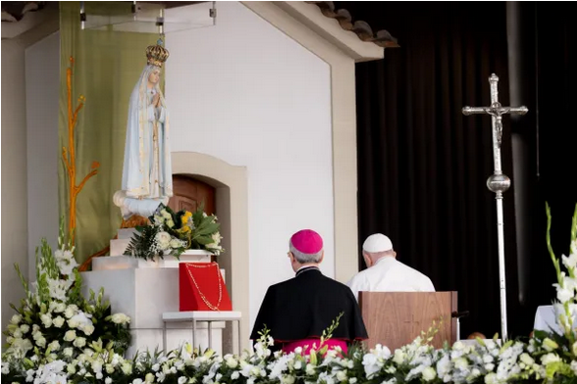
- Pope Francis paid a heartfelt visit to Fátima on Aug. 5. While he was there, he prayed the rosary with young people with disabilities and placed a bouquet of roses and a golden rosary at the feet of the statue of Our Lady of Fátima. “Dear brothers and sisters, today let us feel the presence of Mother Mary, the mother who will always tell us, ‘Do whatever Jesus tells you.’ She points us to Jesus,” the pope said.

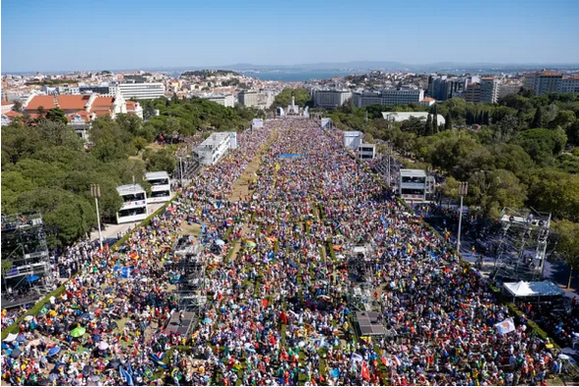
- In front of an estimated 800,000 people, Pope
Francis shared a powerful message to the youth during
the Stations of the Cross on Aug. 4. He said: “We’ve
all cried in life and continue to do so. Jesus is with us;
he cries with us and accompanies us in the darkness
that leads to tears. With tenderness, he wipes our tears.”

- Pope Francis ended WYD at a Mass with an estimated 1.5 million people. However, before he left, he had a public address with the nearly 25,000 volunteers who kept the international event running from start to finish.
