Sacrament of the Sick
Anointing of the Sick should be given if an individual is gravely ill or near death. If possible, the Sacrament should also be administered for serious illness, before major surgery or when one is initially hospitalized.

Sacrament of Holy Matrimony
Diocesan policy requires 12 months of preparation for Marriage. Contact the parish as soon as possible after engagement. No venue reservations or other arrangements should be made prior to consultation with the pastor.

Sacrament of Penance
Wednesday ~ 6:00 – 6:45PM; or by appointment.

Sacrament of Baptism
Parents must be registered members of the parish and attend a Baptism preparation class prior to the Baptism if this is your first child baptized. Requirements for godparents are established by the Catholic Church. Please call the parish office for Information and to register your child for Baptism.

Parish Registration
All Catholics should be registered in their local parish. Please contact the parish office to obtain registration forms, or if you are uncertain of the parish where you should register.

Parish Staff & Ministries Directory
stignatiusofloyola@hbgdiocese.org | Office: 717-677-8012
Financial Manager ~ Richard Deardorff ~ 717- 677-8012 or 717-420-3464 (cell)
rdeardorff@hbgdiocese.org
Director of Religious Education ~ Deacon Steve Huete ~ shuete@hbgdiocese.org
Parish Secretary ~ Kristen DiDio ~ kdidio@hbgdiocese.org
Buildings & Grounds ~ Donnie Althoff ~ 717-677-8012
Music Ministry ~ Phil Mobley ~ 717-677-8012
Parish Council Members
Phil Mobley – Chair 571-236-7580 pmmobley@gmail.com
Bicky Redman – Vice Chair 677-8592 feetintheair7@gmail.com
Joanne Riedel - Secretary 398-2021 sterj221@aol.com
Kathi Allwein 677-8984 allweint@comcast.net
Charlie Baker 677-9536 dcbake@embarqmqil.com
Kathy Dietsch 352-4558 kdiet2@juno.com
Dr. BobTernes rjtmd46@gmail.com

Finance Council Members
Richard Deardorff (Ex Officio)
Greg Ernst - Chair
Christy Hemler - Secretary
Ali Morris
Terri Pendlelton
Bill Pulig

Altar Flowers
OCIA
Order of Christian Initiation for Adults
Contact Fr. Dominic

Soup Kitchen
Please send donations
directly to the
“Gettysburg Soup Kitchen”

Website Development
Kristen DiDio
Life After Loss
Dodie Huete

Prayer Chain
CONTACT THE PARISH OFFICE

Picnic Co-Chairs
Wally Kane
Mark Schur

Pro-Life Ministry
Jeanette Backus
Knights of Columbus
SK Bob Ternes
- Grand Knight

CONTACT THE PARISH OFFICE

Bereavement Ministry
Ginny Bittle / Dodie Huete

Catholic Communications/EWTN
Anna Kane

Cemetery
CONTACT THE PARISH OFFICE
THEOSIS Ministry
Kathy Dietsch 717-352-4558
Bicky Redman 717-677-8592

Diocese of Harrisburg Youth Protection Program
www.YouthProtectionHBG.com

Abuse Reporting Contact Information:
First – Call the toll-free PA Child Abuse Hotline at 800-932-0313
Then – Call the Diocesan toll-free hotline at 800-626-1608

“If one member suffers,
all suffer together with it.” (1 Cor 12:26)

St. Ignatius Loyola RC Church

St. Ignatius Loyola Roman Catholic Church
1095 Church Road, Orrtanna, Pennsylvania 17353
www.stignatiusofloyola.org | Office: 717-677-8012

March 3, 2024: THIRD SUNDAY OF LENT
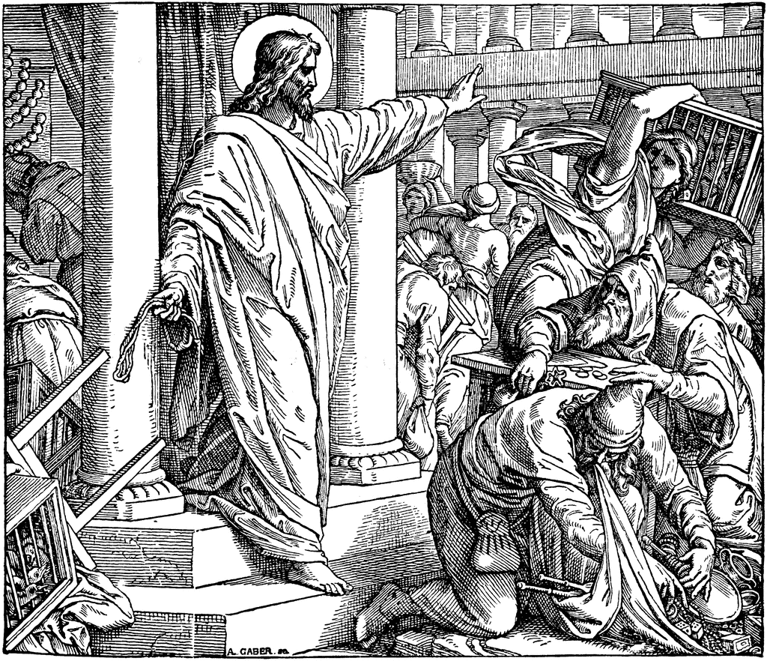

“Stop making my Father’s House
a marketplace!”

May the PENANCES we do this LENT
be offered to bring PEACE in the Holy Land!

Most Rev. Timothy C. Senior, Bishop of Harrisburg
Rev. Dominic M. DiBiccaro, Pastor
Deacon Steve Huete, Pastoral Associate

Mass Schedule, Intentions, and Events
Please Pray for these in need:
Jeanie Kline & the Kline Family, Dick & Deb Deardorff, Fred Dietsch, Greg Ernst, Jacob Long, Shell Edwards, Corona Naylor, Chris & Mary Rebscher, John Baker, Ginny Hoctor, Brenda Wolf, Sr. Thelma Steiger HSF, Sr. Miriam Ukeritis CSJ , Peter Hackney, Lucas Christiansen, Dale Kaplan, Jerry Smith, Dulcie Perry, Ron Formosa, Gavin Crumbacker, Anna Kane, Sherry Dennis & Family, Remi Peters, Terry Ahn, K. Grance, Lori McFadden & Family, Mike & Lisa Poole, Mervin Weikert, Chastity Rudisill, Mary Ellen Wilson, Terry & Bernie Cabana, Ed & Aggie Sherensky & Family, Bob Raffensberger, Jerry & Ginny Miller, Adeline Lienard, Kaylee Henry, Nancy Wuller, Dr. Mike Colli, Mrs. Kelly Kump, Gabriel Singer, Sharon McCormley, Ron Thumma, Joe Wisotzkey, Leo Hockensmith, Erika McKissick, Jean "Heather" O'Shea, Scott Moore & Sally Moore, Mary Wyatt, Amy Weatherup, Sophia Joy Ernst, Deacon Richard Wentzel, Deacon Frank Enderle, Carolyn Topper, Kathleen Thompson, Rachel Wonders, Amy Edwards, Jean O’Connor, Jen Baldwin, Ursula Kaley, Deb Bennet, Larry Endy, Laura Lee, Marwa Abdelrahman, Donna Singley, Tim McGinn, Jane Kump, Peggy Neiderer, Chris Kimple, Robert Riquet, Gene & Jo-Ann McDannell, Bob Doxzen, Kimberly Mears, Gabriella Angello, Paul Angello, Mark & Kate Morrow, Mark Morris, Linda Fogleman, Paul Knight, George & Barbara Erstila, Jeff Carpenter, Lana & Nelson Harmon, Diane Slothour, Sue McDannell, Larry Schneider, Joe & Lisa Grasel, Ange Pena, Julie Barnhart, Shaffer Family, Heather & Emma Dickerson, Brad Peabody, Paul Ward, Aiden Tyler Schneider, Dorothy Vega, Karrie McCall & daughter, George Shahid, Denise Navlyt, Drew Schneider & Family, Ida Bloomfield, Janie Singley, Mary Beth Greenstreet, Rick Benedict, Jan Patla, Kathey Fogleman, Sam Sheffler, Kate Hemmis, Bill & Mary Lou Graham, Andy Graham, Joanna Hodges, John Varones, Joan O’Sullivan, Martha Klinger, Lisa Dionne Lauretti, Jim Gleason, Sue Gustafson, Joe & Michelle Cleary, Kim Johnson, Helen Mills, Kathy Haber, Haley Detman, Joe Durovey, Bev Smith, Donald Sheppard, Linda Mumaugh, Alison Haring, Janet Hartman, Edward Johnson, Angela Galeone, Juliete Lang, Chris MacBeth, Harry Graham, Donald Howard, Armond Binni, Elizabeth Stansky, Pat Johnson, Chris Morris, Faud Doaney, Patrick Glass, Helen Lagasse, Nancy Kewisnek, Bill & Maureen Collins, Rosemary McGilloway, Anji Eisenhart, Monica Manner, Denny Borbonus, Dr. Paul Scarlata, Mary Hawthorne, Ed Washington, Josh Kempinski, Nancy Baltzey, Spencer Propts, Karlton Smith & Cheryl Sobun, James & Marylyn Sobun, Marlene Webster, Yvette Stoklosa, Andy Consiglio, Bill & Michelle Cloonan, Nelson Salem, Bill & Deb McClintock, nursing home residents & shut-ins, the victims of war, violence, disease, disaster, & all private intentions.
Also in your prayers, please remember all our men
& women currently serving in our Armed Forces:

Lt. Col. Nathan Jeffcoat – US Marine Corps
Lt. Joseph Cleary – US Navy
Michael C. Kenney IV – US Coast Guard
Lt. Joshua Kimple – US Army
Lt. Sarah Fogleman, M.D. – US Navy
A1C Ian Bellinger ‒ PA Air National Guard

PRAYER CHAIN: Contact the Office

for the Week of March 2 to March 10, 2024

SATURDAY, March 2-Vigil 3rd SUNDAY OF LENT

Ex 20:1-17 / 1 Cor 1:22-25 / Jn 2:13-25
5:00PM + Mary Redman

SUNDAY, March 3 – 3rd SUNDAY OF LENT

Ex 20:1-17 / 1 Cor 1:22-25 / Jn 2:13-25
8:00AM + Janice and Charles Heffner
10:30AM ⁓ People of the Parish

MONDAY, March 4 - St. Casimir
2 Kgs 5:1-15ab / Lk 4:24-3
Parish Office CLOSED

TUESDAY, March 5 (Lenten Weekday)
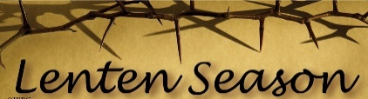
Dn 3:25, 34-43 / Mt 18:21-35
Parish Council 6:30

8AM – 3PM ~ Office Open

10:00AM + Bishop Nicholas Dattilo

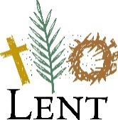
WEDNESDAY, March 6 (Lenten Weekday)
Dt 4:1, 5-9 / Mt 5:17-19

8AM – 3PM ~ Office Open
10:00AM + Paul Topper
Penance Service, Our Lady of the Visitation, Shippensburg, 7PM
NO Confessions; NO Adoration

THURSDAY, March 7 – Sts. Perpetua and
Jer 7:23-28 / Lk 11:14-23 Felicity, Martyrs

8AM – 3PM ~ Office Open
10:00AM + Loretta Southerland
FRIDAY, March 8 - St. John of God, Religious  7:00  PM  Hos 14:2-10 / Mk 12:28-34  10:00AM + Mike McTighe  Parish Office CLOSED | THE LORD

SATURDAY, March 9 – St. Frances of Rome,
MORNING: Hos 6:1-6 / Lk 18:9-14 Religious

SATURDAY, March 9 – Vigil 4th SUNDAY OF LENT

2 Chr 36:14-16, 19-23/Eph 2:4-10/Jn 3:14-21
5:00PM + Henry “Hap” Schneider
SUNDAY, March 10 – 4th SUNDAY OF LENT

2 Chr 36:14-16, 19-23/Eph 2:4-10/Jn 3:14-21
8:00AM + Dr. Bruce Foster
10:30AM + The Persecuted Church and
Modern-Day Christian Martyrs
The Sanctuary Candle for MARCH is offered: In Loving Memory of Marilyn Cole from Kenneth Cole

Sunday Collection Summary for Feb. 24 & 25

Weekend Collections
Regular Offering $ 3,173.75
Ash Wednesday $ 25.00
Christmas $ 50.00
Easter $ 240.00
Good Friday $ 105.00
Holy Thursday $ 60.00
TOTAL OFFERINGS $ 3,653.75

‒ WEEKLY BUDGETARY NEEDS $ 4,494.00
+Overage or (Shortfall) for the week($ 840.25)

Other Income
Altar Flowers $ 322.00
Candles/Living Faith $ 63.00
Individual Contributions $ 5,000.00
Local Poor $ 1,129.00
Total Other Offerings $ 6,514.00

Diocesan Second Collections
Catholic Home Missions $ 25.00
Catholic Relief Services $ 35.00
Poor Missions $ 15.00
Society for the Prop.of the Faith $ 10.00
Total Diocesan Offerings $ 85.00

LIFE IN CHRIST: A LENTEN DAY OF REFLECTION
at Corpus Christi Parish, Chambersburg

On Saturday, March 9, Corpus Christi will host a Lenten Day of Reflection over TWO SESSIONS.

The morning session will be "Death & Resurrection: Grief & Faith - Negotiating these Realities in the Lives of Believers," presented by Counselor Dodie Huete and her husband, our own Deacon Steve Huete. This session will focus on the Church’s teachings on death, the consolations of Heaven for the Faithful who have died, and how to deal with our grief for departed loved ones. It will be held in the parish hall conference room from 9:30 to 11:30AM.

Contact Diane McCarty at 717-264-6317, or at dmccarty@cburgcatholic.org by March 7 to register.

In the afternoon, the Corpus Christi Council of Catholic Women will hold a session on "Becoming What We Receive: Life in our Eucharistic LORD," with Karen Brusekwicz, MPS, as the keynote speaker. It will be also held in the parish hall conference room from 1:00 to 3:45PM.

Contact Kathy Wingert at 717-352-7354, or at kathywingert69@gmail.com by March 6 for this session.

All are welcome to attend one or both sessions!

These talks are anchored by Adoration of our Eucharistic LORD from 11:00 am to 4:30 pm.

Spiritual Sacrifice: Scott Hahn Reflects

On the Third Sunday of Lent

Jesus does not come to destroy the Temple, but to fulfill it (see Matthew 5:17) - to reveal its true purpose in God’s saving Plan.

He is the LORD the Prophets said would come — to purify the temple, banish the merchants, and make it a house of prayer for all peoples (see Zechariah 14:21; Malachi 3:1–5; Isaiah 56:7).

The God who made the heavens and the earth, who brought Isra-el out of slavery, does not dwell in sanctuaries made by human hands (see Acts 7:48; 2 Samuel 7:5).

Nor does He need offerings of oxen, sheep, or doves (see Psalm 50:7–13).

Notice in today’s First Reading that God did not originally command animal sacrifices — only that Isra-el heed His Commandments (see Jer 7:21–23; Amos 5:25).

His Law was a gift of Divine Wisdom, as we sing in today’s Psalm. It was a Law of Love (see Matthew 22:36–40), perfectly expressed in Christ’s self-offering on the Cross (see John 15:13).

This is the “sign” Jesus offers in the Gospel today — the sign that caused Jewish leaders to stumble, as St. Paul tells us in the Epistle.

Jesus’ Body — destroyed on the Cross and raised up three days later — is the new and true sanctuary. From the Temple of His Body, rivers of Living Water flow, the Spirit of grace that makes each of us a temple (see 1 Corinthians 3:16) and together builds us into a dwelling place of God (see Ephesians 2:22).

In the Eucharist we participate in His offering of His Body and Blood. This is the worship in Spirit and in truth that the Father desires (see John 4:23–24).

We are to offer praise as our sacrifice (see Psalm 50:14, 23). This means imitating Christ — offering our bodies — all our intentions and actions in every circumstance, for the love of God and the love of others (see Hebrews 10:5–7; Romans 12:1; 1 Peter 2:5).

Readings: Exodus 20:1–17; Psalm 19:8–11
1 Corinthians 1:22–25; John 2:13–25

