Sacrament of the Sick
Anointing of the Sick should be given if an individual is gravely ill or near death. If possible, the Sacrament should also be administered for serious illness, before major surgery or when one is initially hospitalized.

Sacrament of Holy Matrimony
Diocesan policy requires 12 months of preparation for Marriage. Contact the parish as soon as possible after engagement. No venue reservations or other arrangements should be made prior to consultation with the pastor.

Sacrament of Penance
Wednesday ~ 6:00 – 6:45PM; or by appointment.

Sacrament of Baptism
Parents must be registered members of the parish and attend a Baptism preparation class prior to the Baptism if this is your first child baptized. Requirements for godparents are established by the Catholic Church. Please call the parish office for Information and to register your child for Baptism.

Parish Registration
All Catholics should be registered in their local parish. Please contact the parish office to obtain registration forms, or if you are uncertain of the parish where you should register.

Parish Staff & Ministries Directory
stignatiusofloyola@hbgdiocese.org
Financial Manager ~ Richard Deardorff ~ 717- 677-8012 or 717-420-3464 (cell)
rdeardorff@hbgdiocese.org
Director of Religious Education ~ Deacon Steve Huete ~ shuete@hbgdiocese.org
Administrative Assistant ~ Kristen DiDio ~ kdidio@hbgdiocese.org
Buildings & Grounds ~ JB Groff ~ 717-677-8012
Music Ministry ~ Phil Mobley ~ 717-677-8012
Parish Council Members
*Walt Wilson – Chair 401-0570 (h) wwilson1198@comcast.net
Joanne Riedel - Secretary 398-2021 (h) sterj221@aol.com
Kathi Allwein 677-8984 (h) allweint@comcast.net
*Donnie Althoff 339-6527 (c) dalthoff53@gmail.com
Charlie Baker 677-9536 (h) dcbake@embarqmqil.com
*Jim Bittle 677-6711 (h) ginnybittle@comcast.net
Mike McTighe 729-6239 (c) mike0432@aol.com

Finance Council Members
Richard Deardorff (Ex Officio)
Greg Ernst - Chair
Alix Haller
Christy Hemler - Secretary
Terri Pendlelton
Bill Pulig

Altar Flowers
Prayer Chain
Lynne Mobley at LMOBLEY509@gmail.com
or 703-876-4901.

Soup Kitchen
Please send donations directly to “Soup Kitchen”

Website Development
Kristen DiDio
Life After Loss
Dodie Huete

OCIA
Contact Fr. Dominic

Picnic Co-Chairpersons
John Neiderer
Wally Kane

Pro-Life Ministry
OPEN – Contact office if you are interested

Knights of Columbus
SK Bob Ternes
- Grand Knight

Covid-19 Task Force
Walt Wilson - Coordinator
Health Advisors:
Dr. Robert Ternes and
Joanne Cochran
(Keystone Health System)

OPEN - Contact office if you are interested

Bereavement Ministry
Ginny Bittle / Dodie Huete

Catholic Communications/EWTN
Open - Contact office if you are interested

Cemetery
Contact Parish Office
THEOSIS Ministry
Kathy Dietsch 717-352-4558
Bicky Redman 717-677-8592

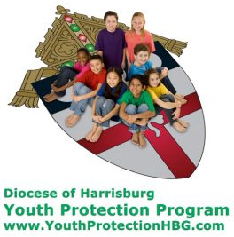
Diocese of Harrisburg Youth Protection Program
www.YouthProtectionHBG.com

Abuse Reporting Contact Information:
First – Call the toll-free PA Child Abuse Hotline at 800-932-0313
Then – Call the Diocesan toll-free hotline at 800-626-1608

“If one member suffers,
all suffer together with it.” (1 Cor 12:26)

St. Ignatius Loyola RC Church

1095 Church Road, Orrtanna, Pennsylvania 17353
www.stignatiusofloyola.org

April 30, 2023: FOURTH SUNDAY OF EASTER
“GOOD SHEPHERD (VOCATIONS) SUNDAY”

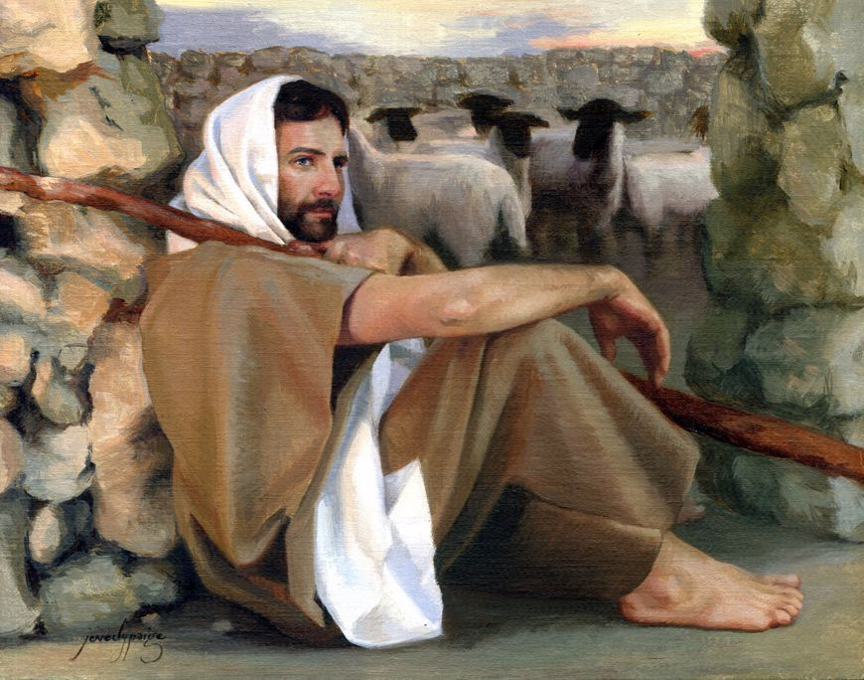
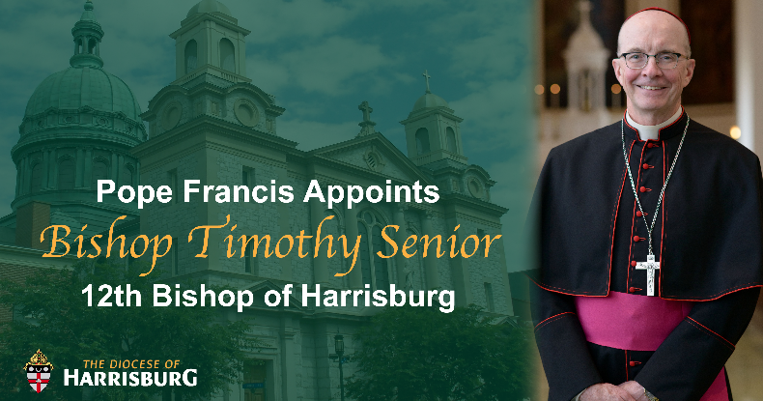
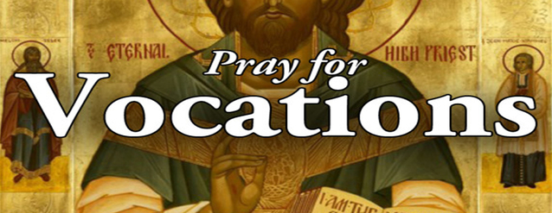

Most Reverend Ronald W. Gainer, Apostolic Administrator
Rev. Dominic M. DiBiccaro, Pastor / Deacon Steve Huete, Pastoral Associate
Mass Schedule, Intentions, and Events
Please Pray for:
Coronavirus victims and those who are ill, Jeanie Kline and the Kline Family, Ed & Aggie Sherensky and Family ,Bob Raffensberger Jerry & Ginny Miller, Adeline Lienard, Kaylee Henry, Chuck & Nancy Wuller, Dr. Mike Colli, Mrs. Kelly Kump, Kevin & Brittany Groff, Gabriel Singer, Sharon McCormley, Ron Thumma, Joe Wisotzkey, Leo Hockensmith, Erika McKissick, Jean "Heather" O'Shea, Scott Moore and Sally Moore, Mary Wyatt, Jim & Joyce Deardorff, Brandon & Michelle Gilbert, Amy Weatherup, Sophia Joy Ernst, Deacon Richard Wentzel, Deacon Frank Enderle, Kathleen Thompson, Deb & Kathy McLintock and Family, Rachel Wonders, Amy Edwards, Jean O’Connor, Art Lazar, Sr., Mark & Michelle Huete, Paul Angello, Jen Baldwin, Ursula Kaley, Deb Bennet, Fr. Bill Sullivan, Fr. Chet Snyder, John Larry Endy, Mary Beth McCarthy, Laura Lee, Marwa Abdelrahman, Cathy Gates, Donna Singley, Jack Ryff, Tim McGinn, Jane Kump, Gary, Bill, Jerry, Andy, Colleen, Baby Addie, Peggy Neiderer, Chris Kimple, Robert Riquet, Gene & Jo-Ann McDannell, Bob Doxzen, Kimberly Mears, Gabriella Angello, Mark & Kate Morrow, Mark Morris, Linda Fogleman, Paul Knight, George & Barbara Erstila, Jeff Carpenter, Lana & Nelson Harmon, Cole & Connor, Diane Slothour, Sue McDannell, Larry Schneider, Joe & Lisa Grasel, Ange Pena, Julie Barnhart, the Shaffer Family, Heather & Emma Dickerson, Brad Pabody, Paul Ward, Aiden Tyler Schneider, Dorothy Vega, Karrie McCall & daughter, George Shahid, Denise Navlyt, Drew Schneider & Family, Ida Bloomfield, Linda McDannell, Janie Singley, Mary Beth Greenstreet, Rick Benedict, Jan Patla, Kathe Fogleman, Sam Sheffler, Kate Hemmis, Bill & Mary Lou Graham, Joanna Hodges, John Varones, Joan O’Sullivan, Martha Klinger, Lisa Dionne Lauretti, Sue Orndorff, Jim Gleason, Sue Gustafson, Joe & Michelle Cleary, Kim Johnson, Helen Mills, Kathy Haber, Haley Detman, Joe Durovey, Bev Smith, Donald Sheppard, Linda Mumaugh, Alison Haring, Janet Hartman, Edward Johnson, Angela Galeone, Juliete Lang, Chris MacBeth, Harry Graham, Donald Howard, Armond Binni, Elizabeth Stansky, Pat Johnson, Chris Morris, Faud Doaney, Wilson & Rae Harman, Patrick Glass, Helen Lagasse, Nancy Kewisnek, Andy Graham, Bill & Maureen Collins, Rosemary McGilloway, Anji Eisenhart, Monica Manner, Denny Borbonus, Dr. Paul Scarlata, Mary Hawthorne, Ed Washington, Josh Kempinski, Nancy Baker Baltzey, Spencer Propts, Karlton Smith & Cheryl Sobun, James & Marylyn Sobun, Marlene Webster, Yvette Stoklosa, Andy Consiglio, Bill & Michelle Cloonan, Nelson Salem, Janet Shunnarah, George Shunnarah, Bill & Deb McClintock, Mary Pekich, nursing home residents & shut-ins, the victims of war, violence, disease, disaster, & all private intentions.
Also in your prayers, please remember all
our men and women currently serving in
our Armed Forces:
Maj. Nathan Jeffcoat – US Marine Corps
Lt. Joseph Cleary – US Navy
Michael C. Kenney IV – US Coast Guard
Lt. Joshua Kimple – US Army
Lt. Sarah Fogleman, M.D. – US Navy

PRAYER CHAIN: Contact Lynne Mobley at
703-876-4901 or LMOBLEY509@gmail.com

for the Week of April 29 to May 7, 2023

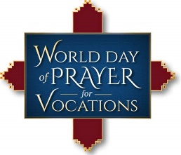
SATURDAY, April 29 – VIGIL MASS 4th SUNDAY OF EASTER

Acts 2:14a, 36-41 / 1 Pt 2:20b-25 / Jn 10:1-10
5:00PM + Clara Redding

SUNDAY, April 30 – 4th SUNDAY OF EASTER

Acts 2:14a, 36-41 / 1 Pt 2:20b-25 / Jn 10:1-10

8:00AM + Donald Kimple
10:30AM ~ People of the Parish

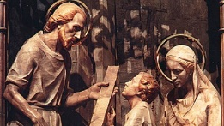
Monday, May 1 – ST. JOSPEH, THE WORKER
Gn 1:26—2:3 / Mt 13:54-58
Parish Office Closed
10:00am – Spec. Int. for Bishop-Elect Timothy C. Senior

Tuesday, May 2 – St. Athanasius, Bishop & Doctor of the Church
Acts 11:19-26 / Jn 10:22-30
8:00AM - 3:00 PM ~ Office Open
10:00AM + Bishop Joseph P. McFadden
(10 Year Anniversary)

11AM: “Something More” Faith Group
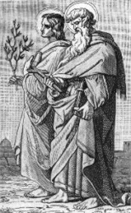
Wednesday, May 3 – STS. PHILIP AND JAMES, APOSTLES
1 Cor 15:1-8 /J n 14:6-14

8:00AM - 3:00 PM ~ Office Open

11AM: Senior Spirituality Group
Confessions heard from 6 to 6:45PM
Adoration at 7:40PM - Holy Rosary for Vocations
7:00PM + SK Ray Haber
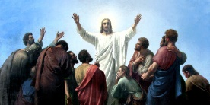
Thursday, May 4 (Easter Weekday)
Acts 13:13-25 / Jn 13:16-20
8:00AM - 3:00 PM ~ Office Open
10:00AM + Dominic “Buddy” & Anne (Onufrak) DiBiccaro

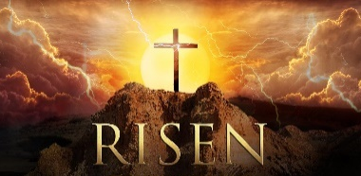
Friday, May 5 (Easter Weekday) | THE LORD
Acts 13:26-33 / Jn 14:1-6
Parish Office CLOSED
10:00AM + Jim Kline

SATURDAY, May 6 (Easter Weekday)

MORNING: Acts 13:44-52 / Jn 14:7-14

SATURDAY, May 6 – VIGIL MASS 5th SUNDAY

Acts 6:1-7 / 1 Pt 2:4-9/Jn 14:1-12 OF EASTER
5:00PM + Trish Weishaar

SUNDAY, May 7 – 5th SUNDAY OF EASTER

Acts 6:1-7 / 1 Pt 2:4-9 / Jn 14:1-12

8:00AM - Spec. Int. Kimple Family
10:30AM ~ People of the Parish
Sanctuary Candle offered for APRIL: In Loving Memory of Jim & Delores Gilbert from their loving Children
Sunday Collection Summary
This year marks the 60th Anniversary of the World Day of Prayer for Vocations on April 30, 2023.

Every year, World Day of Prayer for Vocations falls on Good Shepherd Sunday. We see in Jesus, the Good Shepherd, the heart of every calling. He says, “A good shepherd lays down his life for the sheep.” The mission of Jesus culminated in His self-sacrificing love. He gave Himself so that we might live. This is the great Mystery of Love present in the Eucharist: “This is My Body, given up for you. This is My Blood, poured out for you.” Everyone is called, and everyone has a vocation in the Church.

On this special day we continue to ask all to be generous in praying for and supporting vocations to the priesthood, consecrated life, and permanent diaconate.

Bishop Gainer has requested that every parish offer SPECIAL DEVOTIONS to “ask the Master of the Harvest to send out laborers for His harvest.” Because Jesus Himself told us that, “The harvest is abundant but the laborers are few.” (Mt. 9:37-38)

Here at St. Ignatius, we will be offering THE HOLY ROSARY FOR VOCATIONS during the Wednesday evening Adoration Period at the 7PM Mass on May 3. We hope you can join us!

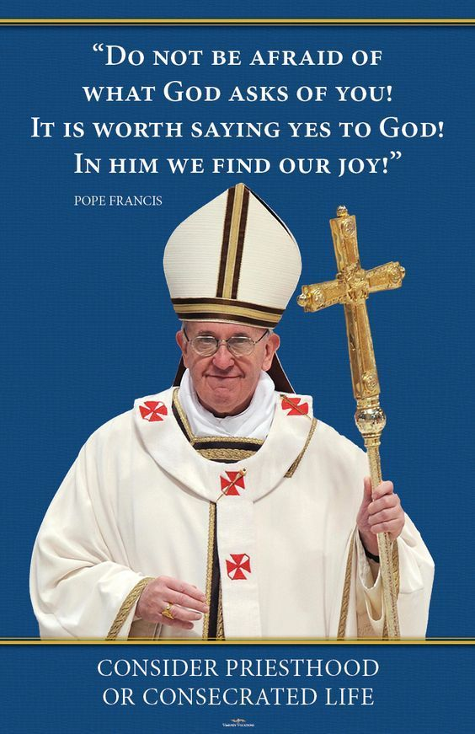

April 15/16 April 22/23
Weekend Collection
Regular Offering $ 2,062.00 $ 3,907.00
Candles $ 152.00
Easter (additional) $ 80.00
TOTAL OFFERINGS $ 2,214.00 $ 3,987.00

‒ WEEKLY BUDGETARY NEEDS $ 5,819.68 $ 5,819.68
+Overage or (Shortfall) for the week ($ 3,605.68) ($ 1,832.68)

Other Income
Individual Contribution $ 5,000.00
TOTAL OTHER OFFERINGS $ 5,000.00

Diocesan Second Collections
Stewardship Bookcase $ 160.00
Catholic Home Missions $ 100.00
Holy Land $ 10.00
TOTAL DIOCESAN OFFERINGS $ 160.00 $ 110.00
WHERE IS GOD CALLING YOU?
What are some of your God-given gifts and talents? Have you ever taken some time to reflect on that question? To help discern some of the gifts and talents with which our good and gracious that God has blessed you, consider taking a Discernment of Gifts Self-Assessment. The Catholic Diocese of Cleveland has one online that you can complete FOR FREE for yourself. Consider how you can utilize these gifts to help the Church and surrounding community. Maybe your strength is music or social justice. Perhaps you are skilled with computers or wood working. Think about joining Theosis to discover many ways in which you can help serve others. More importantly, try to find some downtime to just be quiet and listen …. perhaps the aHoly Spirit is call you to be an usher, Extraordinary Minister, or catechist, helping with Pro-Life Ministry, edit the bulletin, or one of the other ministries in need here at St. Ignatius Parish. May God Bless you and lead you as you continue in this life-long discernment process. https://www.dioceseofcleveland.org/files/assets/section-7-discernment-of-gifts.pdf

Caring for Our Common Home: Eucharistic Solidarity
April 11, 2023 | Stephanie Held

“As people of faith and goodwill, we should be united in showing mercy to the earth as our common home and cherishing the world in which we live as a place for sharing and communion.”
⁓ Pope Francis’ message for the World Day of Prayer for the Care of Creation (Sept. 1, 2016)

When I think of the Works of Mercy, I tend to think of individual actions like serving food at a soup kitchen, donating coats during the winter, or volunteering at a hospital. But as Pope Francis reminds us, “If we look at the works of mercy as a whole, we see that the object of mercy is human life itself and everything it embraces.” On the World Day of Prayer for the Care of Creation in 2016, Pope Francis introduced “Care for Our Common Home” to the traditional lists of both corporal and spiritual works of mercy. This was a clear call to reaffirm our Christian vocation to be stewards of creation.

‍Taking Care of Our Common Home
From the beginning, our Divine Creator gave us the responsibility to look after the world (Genesis 1:26-31). In his address, Pope Francis said caring for our common home “entails a loving awareness that we are not disconnected from the rest of creatures, but joined in a splendid universal communion.” This means recognizing our duty to care for our environment as an important way of expressing our love for God and our gratitude to him.

Furthermore, as Catholics, we worship a God who entered into the material world as part of creation. During Mass, we profess that Jesus “by the Holy Spirit, was incarnate of the Virgin Mary, and became man,” and we believe in his continued presence in our physical reality. This is especially true during Mass, when “fruit of the earth . . . fruit of the vine and work of human hands” become the Eucharist: the Body and Blood of Christ. This celebration, in which God is presented to us—most especially through the conversion of bread and wine—is the core of our Catholic faith.

‍Connecting the Eucharist with Creation
In Laudato Si no. 236, Pope Francis helps us understand the profound connection between the Eucharist and care for creation. “It is in the Eucharist that all that has been created finds its greatest exaltation . . . The Eucharist joins heaven and earth; it embraces and penetrates all creation . . . in the bread of the Eucharist, ‘creation is projected towards divinization, towards the holy wedding feast, towards unification with the Creator himself.’ Thus, the Eucharist is also a source of light and motivation for our concerns for the environment, directing us to be stewards of all creation.”

Here at St. Francis Catholic Worker House of Hospitality (come visit us in Chicago!), we are exploring different ways of living out our Eucharistic faith by caring for our common home.

The aim of the Catholic Worker movement, an American lay movement founded by Dorothy Day and Peter Maurin during the Great Depression, is to “live in accordance with the justice and charity of Jesus Christ.” As part of this legacy, we four Workers live in solidarity with the unhoused in our neighborhood, which also means living in solidarity with the land. We strive for our relationships with neighbors to be full of love and our relationship with the earth to be one of care.

Some of the concrete things we’ve done include adopting eco-friendly habits, gardening, and coordinating food rescue. We separate recycling and food waste from our trash and have three ways of composting it: a pick-up service, tumblers for yard waste, and vermiculture bins (i.e. using worms) to break down organic matter. Using this rich soil, we grow food to feed ourselves and the guests who come through our doors. Each week, we also pick up damaged or close-to-sell-by-date produce and pantry goods from local grocery stores which would normally be thrown away. Redistributing these donations helps nourish people.

‍Living in Solidarity with the World and Each Other
Looking to the future, we’ve joined an initiative called “Solidarity Gardens,” which is an effort of the larger neighborhood and church community to care for local green space. Our hope is to build a chicken coop in our yard this spring and start collecting our own eggs.

“Solidarity Gardens is our opportunity to build just that—solidarity—and cooperation among our community through the practice of caring for the earth,” said Renee Roden, a Catholic Worker at St. Francis House. “We see our chickens as an invitation to our community to unite around our shared needs: our need for food and the ability to provide that through local relationships rather than factory farms and alienating supply chains.”

Through living out “Care for Our Common Home,” I think it is possible for us to help cultivate a world that reverences the dignity of the person and the goodness of all creation. Our Eucharistic faith nourishes us in a profound way as we strive to live in solidarity with one another and with the beautiful world God has created for us.
The Holy Father, Pope Francis’ Prayer Intentions for 2023
Entrusted to His Worldwide Prayer Network

APRIL ⁓ For a culture of peace and non-violence
We pray for the spread of peace and non-violence, by decreasing the use of weapons by States and citizens.
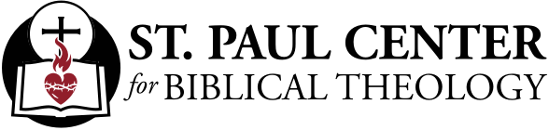

What Are We To Do?: Scott Hahn Reflects

on the Fourth Sunday of Easter

Easter’s Empty Tomb is a call to conversion.

By this Tomb, we should know for certain that God has made Jesus both LORD and Messiah, as St. Peter preaches in today’s First Reading.

He is the “LORD,” the Divine Son that David foresaw at God’s Right Hand (see Psalms 110:1, 3; 132:10–11; Acts 2:34). And He is the Messiah that God had promised to shepherd the scattered flock of the House of Isra-el (see Ezekiel 34:11–14, 23; 37:24).

As we hear in today’s Gospel, Jesus is that Good Shepherd, sent to a people who were like sheep without a shepherd (see Mark 6:34; Numbers 27:16–17). He calls not only to the Children of Isra-el but to all those far off from Him —to whomever the LORD wishes to hear His Voice.

The Call of the Good Shepherd leads to the restful waters of Baptism, to the Anointing Oil of Confirmation, and to the Table and overflowing Cup of the Eucharist, as we sing in today’s Psalm.

Again on this Sunday in Easter, we hear His Voice calling us His own. He should awaken in us the response of those who heard St. Peter’s preaching. “What are we to do?” they cried.

We have been baptized. But each of us goes astray like sheep, as we hear in today’s Epistle. We still need daily to repent, to seek forgiveness of our sins, to separate ourselves further from this corrupt generation.

We are called to follow in the footsteps of the Shepherd of our souls. By His Suffering He bore our sins in His Body to free us from sin. But His Suffering is also an example for us. From Him we should learn patience in our afflictions, to hand ourselves over to the Will of God.

Jesus has gone ahead, has driven us through the dark valley of evil and death. His Cross has become the narrow gate through which we must pass to reach His Empty Tomb — the verdant pastures of life abundant!

Readings: Acts 2:14, 36–41; Psalm 23:1–6; 1 Peter 2:20–25; John 10:1–10

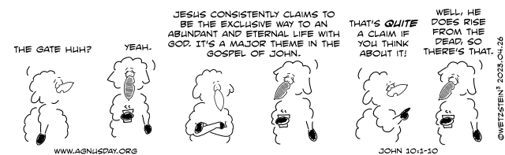

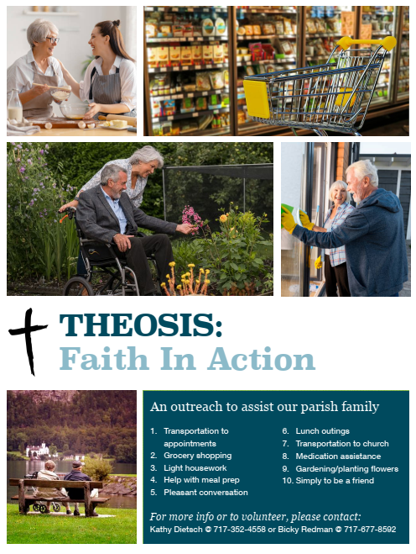

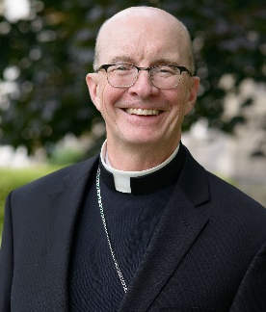
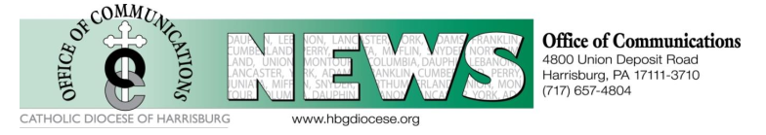

The Most Reverend Timothy C. Senior Named 12fth Bishop of Harrisburg

Bishop-designate Senior’s Mass of Installation will take place on Wednesday, June 21, 2023, in the Cathedral of Saint Patrick, Harrisburg

HARRISBURG, PA | Press Release, April 25, 2023 – Today, His Excellency, the Most Reverend Ronald W. Gainer, Eleventh Bishop of Harrisburg, announced that Pope Francis has named His Excellency, the Most Reverend Timothy C. Senior, as the Twelfth Bishop of Harrisburg. Bishop-designate Senior succeeds Bishop Gainer, who, in keeping with canon law, offered his resignation to the Holy Father when he turned 75 years of age in August of 2022. Bishop Senior’s Mass of Installation will be at 2 p.m. on Wednesday, June 21, 2023, at the Cathedral of Saint Patrick in Harrisburg.

“This is a joyous day for our clergy, staff, the people of the Diocese and for me personally. I have known Bishop Senior for well over 25 years and have full confidence that he will be a caring, faithful shepherd who will speak the truth with love and conviction, leading the Diocese of Harrisburg with the truths of the Church as a witness of Jesus Christ,” said Bishop Gainer. “I am grateful to our Holy Father in sending the Diocese of Harrisburg a man devoted to answering the call of the Gospel, who also has numerous skills in business, education, and human service administration. The Diocese of Harrisburg will be well cared for in the hands of Bishop Senior.”

Bishop Senior was ordained an Auxiliary Bishop of Philadelphia in July, 2009. He is currently Regional Bishop of Montgomery County and Philadelphia-South, as well as Chancellor of Saint Charles Borromeo Seminary. Prior to assuming these responsibilities, Bishop Senior served as Rector of Saint Charles Borromeo Seminary from 2012 to 2022, after having been the Moderator of the Curia of the Archdiocese of Philadelphia from 2009 to 2012. He served as Vicar for Clergy from 2004 to 2009. From 1992 to 2004, Bishop Senior served in the Archdiocesan Secretariat for Catholic Human Services, both as Deputy Secretary and then Secretary. A 1977 graduate of Lansdale Catholic High School, Lansdale, Pa., Bishop Senior is a classically trained pianist and the youngest of the three children of the late James H. and Elise Rothwell Senior.

He was ordained a priest of the Archdiocese of Philadelphia in 1985. He earned a Masters of Divinity and Master of Arts in Theology from Saint Charles Borromeo Seminary, served as an assistant pastor at a parish in Bucks County & taught religion in an Archdiocesan high school. He was then assigned to graduate studies at Boston College, earning his Masters in Social Work and Masters in Business Administration in 1992.

In 1998, he was named Honorary Chaplain to His Holiness, and in 2005, he was named a Prelate of Honor. In 2009, Bishop Senior was appointed Titular Bishop of Floriana and Auxiliary Bishop of Philadelphia, and was ordained a Bishop on July 31, 2009 by Cardinal Justin Rigali.

In responding to today’s announcement, Bishop Senior said, “I am profoundly grateful to Pope Francis for his confidence and trust in appointing me to serve the faithful of the Diocese of Harrisburg as their next bishop. Trusting in God’s will and the gifts of the Holy Spirit, I pray that I may be a faithful, holy, and worthy shepherd for the people of central Pennsylvania in service of Jesus Christ and for the good of His Church.”

Bishop Gainer has led the Diocese of Harrisburg since 2014 and plans to remain in the Diocese as our Bishop Emeritus.

The Diocese of Harrisburg was established on March 3, 1868. It covers 15 counties in south and central Pennsylvania, including: Adams, Columbia, Cumberland, Dauphin, Franklin, Juniata, Lancaster, Lebanon, Mifflin, Montour, Northumberland, Perry, Snyder, Union and York. The Diocese has 97 parishes and missions, 35 Catholic schools, and is home to approximately 201,000 registered Catholics.

