Sacrament of the Sick
Anointing of the Sick should be given if an individual is gravely ill or near death. If possible, the Sacrament should also be administered for serious illness, before major surgery or when one is initially hospitalized.

Sacrament of Holy Matrimony
Diocesan policy requires 12 months of preparation for Marriage. Contact the parish as soon as possible after engagement. No venue reservations or other arrangements should be made prior to consultation with the pastor.

Sacrament of Penance
Wednesday ~ 6:00 – 6:45PM; or by appointment.

Sacrament of Baptism
Parents must be registered members of the parish and attend a Baptism preparation class prior to the Baptism if this is your first child baptized. Requirements for godparents are established by the Catholic Church. Please call the parish office for Information and to register your child for Baptism.

Parish Registration
All Catholics should be registered in their local parish. Please contact the parish office to obtain registration forms, or if you are uncertain of the parish where you should register.

Parish Staff & Ministries Directory
stignatiusofloyola@hbgdiocese.org
Financial Manager ~ Richard Deardorff ~ 717- 677-8012 or 717-420-3464 (cell)
rdeardorff@hbgdiocese.org
Director of Religious Education ~ Deacon Steve Huete ~ shuete@hbgdiocese.org
Parish Secretary ~ Kristen DiDio ~ kdidio@hbgdiocese.org
Buildings & Grounds ~ Donnie Althoff ~ 717-677-8012
Music Ministry ~ Phil Mobley ~ 717-677-8012
Parish Council Members
Phil Mobley – Chair 571-236-7580 pmmobley@gmail.com
Bicky Redman – Vice Chair 677-8592 feetintheair7@gmail.com
Joanne Riedel - Secretary 398-2021 sterj221@aol.com
Kathi Allwein 677-8984 allweint@comcast.net
Charlie Baker 677-9536 dcbake@embarqmqil.com
Mike McTighe 729-6239 mike0432@aol.com
Dr. BobTernes rjtmd46@gmail.com

Finance Council Members
Richard Deardorff (Ex Officio)
Greg Ernst - Chair
Alix Haller
Christy Hemler - Secretary
Terri Pendlelton
Bill Pulig

Altar Flowers
Prayer Chain
Lynne Mobley at LMOBLEY509@gmail.com
or 703-876-4901

Soup Kitchen
Please send donations directly to “Soup Kitchen”

Website Development
Kristen DiDio
Life After Loss
Dodie Huete

OCIA
Contact Fr. Dominic

Picnic Co-Chairpersons
John Neiderer
Wally Kane

Pro-Life Ministry
Jeanette Backus
Knights of Columbus
SK Bob Ternes
- Grand Knight
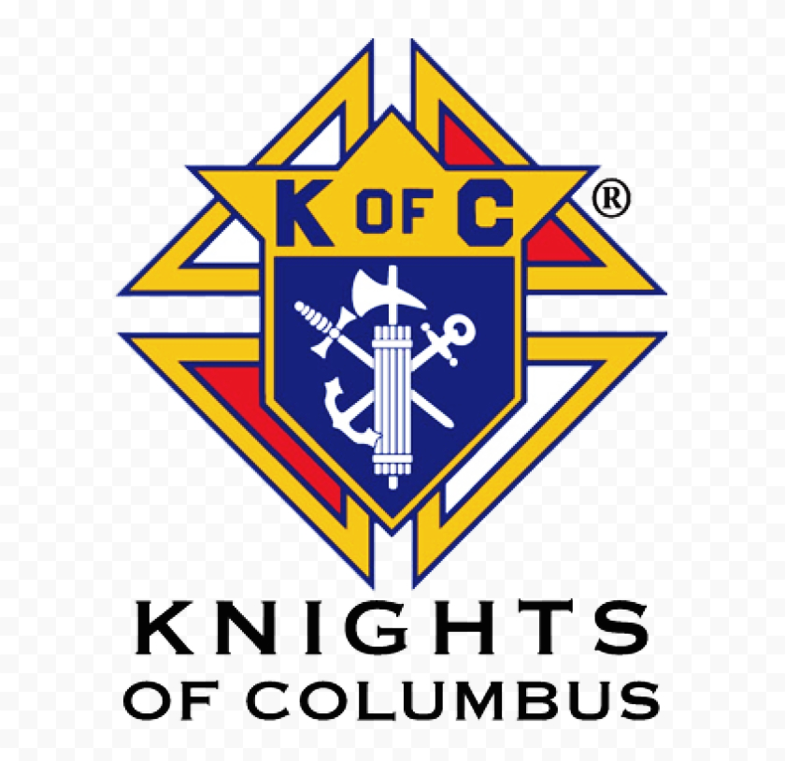

Judy Wilson / Janice Meligakes

Bereavement Ministry
Ginny Bittle / Dodie Huete

Catholic Communications/EWTN
Open - Contact office if you are interested

Cemetery
Contact Parish Office
THEOSIS Ministry
Kathy Dietsch 717-352-4558
Bicky Redman 717-677-8592

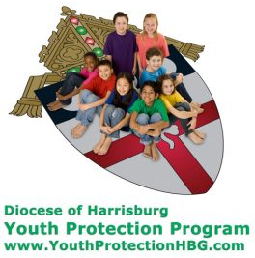
Diocese of Harrisburg Youth Protection Program
www.YouthProtectionHBG.com

Abuse Reporting Contact Information:
First – Call the toll-free PA Child Abuse Hotline at 800-932-0313
Then – Call the Diocesan toll-free hotline at 800-626-1608

“If one member suffers,
all suffer together with it.” (1 Cor 12:26)

St. Ignatius Loyola RC Church

1095 Church Road, Orrtanna, Pennsylvania 17353
www.stignatiusofloyola.org

JULY 23, 2023: 16th SUNDAY IN ORDINARY TIME

Next week , we WELCOME BISHOP SENIOR
⁓ Sunday, July 30, at the 10:30AM Mass ⁓
for the Blessing and Re-dedication of our
3 restored stain-glass windows!

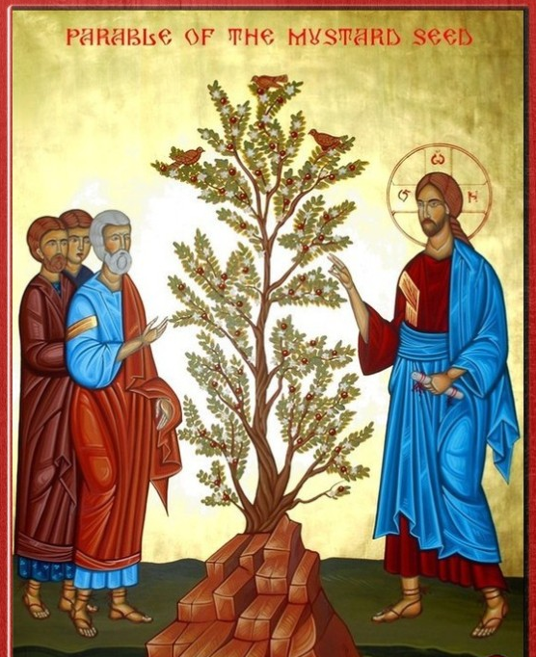

Most Rev. Timothy C. Senior, Bishop of Harrisburg
Rev. Dominic M. DiBiccaro, Pastor
Deacon Steve Huete, Pastoral Associate

Mass Schedule, Intentions, and Events
Please Pray for:
Those who are ill, Jeanie Kline & the Kline Family, Sherry Dennis and Family, Remi Peters, Christy Hemler, Terry Ahn, K. Grance, Lori McFadden & Family, Mike & Lisa Poole, Mervin Weikert, Chastity Rudisill, Mary Ellen Wilson, Terry & Bernie Cabana, Ed & Aggie Sherensky and Family, Bob Raffensberger, Jerry & Ginny Miller, Adeline Lienard, Kaylee Henry, Nancy Wuller, Dr. Mike Colli, Mrs. Kelly Kump, Kevin & Brittany Groff, Gabriel Singer, Sharon McCormley, Ron Thumma, Joe Wisotzkey, Leo Hockensmith, Erika McKissick, Jean "Heather" O'Shea, Scott Moore and Sally Moore, Mary Wyatt, Jim & Joyce Deardorff, Brandon & Michelle Gilbert, Amy Weatherup, Sophia Joy Ernst, Deacon Richard Wentzel, Deacon Frank Enderle, Kathleen Thompson, Deb & Kathy McLintock and Family, Rachel Wonders, Amy Edwards, Jean O’Connor, Art Lazar, Sr., Paul Angello, Jen Baldwin, Ursula Kaley, Deb Bennet, Fr. Bill Sullivan, Larry Endy, Mary Beth McCarthy, Laura Lee, Marwa Abdelrahman, Cathy Gates, Donna Singley, Jack Ryff, Tim McGinn, Jane Kump, Peggy Neiderer, Chris Kimple, Robert Riquet, Gene & Jo-Ann McDannell, Bob Doxzen, Kimberly Mears, Gabriella Angello, Mark & Kate Morrow, Mark Morris, Linda Fogleman, Paul Knight, George & Barbara Erstila, Jeff Carpenter, Lana & Nelson Harmon, Diane Slothour, Sue McDannell, Larry Schneider, Joe & Lisa Grasel, Ange Pena, Julie Barnhart, the Shaffer Family, Heather & Emma Dickerson, Brad Pabody, Paul Ward, Aiden Tyler Schneider, Dorothy Vega, Karrie McCall & daughter, George Shahid, Denise Navlyt, Drew Schneider & Family, Ida Bloomfield, Linda McDannell, Janie Singley, Mary Beth Greenstreet, Rick Benedict, Jan Patla, Kathe Fogleman, Sam Sheffler, Kate Hemmis, Bill & Mary Lou Graham, Joanna Hodges, John Varones, Joan O’Sullivan, Martha Klinger, Lisa Dionne Lauretti, Sue Orndorff, Jim Gleason, Sue Gustafson, Joe & Michelle Cleary, Kim Johnson, Helen Mills, Kathy Haber, Haley Detman, Joe Durovey, Bev Smith, Donald Sheppard, Linda Mumaugh, Alison Haring, Janet Hartman, Edward Johnson, Angela Galeone, Juliete Lang, Chris MacBeth, Harry Graham, Donald Howard, Armond Binni, Elizabeth Stansky, Pat Johnson, Chris Morris, Faud Doaney, Wilson & Rae Harman, Patrick Glass, Helen Lagasse, Nancy Kewisnek, Andy Graham, Bill & Maureen Collins, Rosemary McGilloway, Anji Eisenhart, Monica Manner, Denny Borbonus, Dr. Paul Scarlata, Mary Hawthorne, Ed Washington, Josh Kempinski, Nancy Baker Baltzey, Spencer Propts, Karlton Smith & Cheryl Sobun, James & Marylyn Sobun, Marlene Webster, Yvette Stoklosa, Andy Consiglio, Bill & Michelle Cloonan, Nelson Salem, Bill & Deb McClintock nursing home residents & shut-ins, the victims of war, violence, disease, disaster, & all private intentions.
Also in your prayers, please remember all
our men and women currently serving in
our Armed Forces:
Maj. Nathan Jeffcoat – US Marine Corps
Lt. Joseph Cleary – US Navy
Michael C. Kenney IV – US Coast Guard
Lt. Joshua Kimple – US Army
Lt. Sarah Fogleman, M.D. – US Navy

PRAYER CHAIN: Contact Lynne Mobley at 703-876-4901 or LMOBLEY509@gmail.com

for the Week of July 22 to July 30, 2023

SATURDAY, July 22 –VIGIL MASS 16TH SUNDAY IN ORD.TIME

Wis 12:13, 16-19 / Rom 8:26-27 / Mt 13:24-43
5:00PM ⁓ People of the Parish

SUNDAY, July 23 – 16TH SUNDAY IN OT

Wis 12:13, 16-19 / Rom 8:26-27 /

Mt 13:24-43
8:00AM + Donald Redding
10:30AM + Jim and Delores Gilbert
Monday, July 24 – St. Sharbel Makhlūf, Priest
Ex 14:5-18 / Mt 12:38-42
Parish Office Closed

Tuesday, July 25 - SAINT JAMES (the Elder), APOSTLE
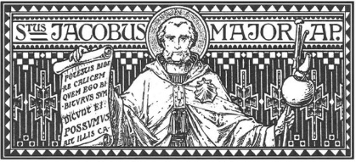
2 Cor 4:7-15 / Mt 20:20-28

8:00AM - 3:00 PM ~ Office Open
10:00AM + Geraldine Deardorff

“Something More” Group

Wednesday, July 26 – Sts. Joachim & Anne, Parents of BV Mary
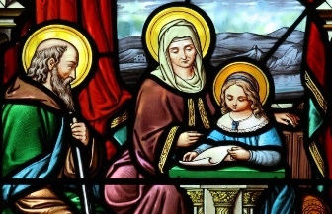
Ex 16:1-5, 9-15 / Mt 13:1-9

8:00AM – 3:00PM ~ Office Open
10AM: Mature Spirituality Group
7:00PM + Paul Young
Confessions 6 - 6:45PM; Adoration 7:40PM
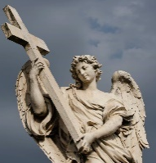
Thursday, July 27 (Weekday in OT)
Ex 19:1-2, 9-11, 16-20b / Mt 13:10-17

8:00AM – 3:00PM ~ Office Open
10:00AM + Sylvia Tobara
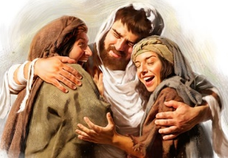  Friday, July 28 (Weekday in OT)  Ex 20:1-17 / Mt 13:18-23  Parish Office CLOSED | THE LORD
10:00AM + Beverly Bittle Black

SATURDAY, July 29 – Sts. Martha, Mary & Lazarus

MORNING: Ex 24:3-8 / Jn 11:19-27 or Lk 10:38-42

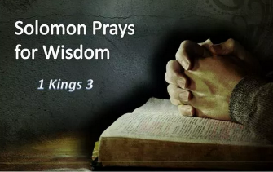
SATURDAY, July 29 –VIGIL MASS 17TH SUNDAY IN ORD.TIME

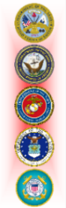
1 Kgs 3:5, 7-12/Rom 8:28-30/Mt 13:44-52
5:00PM +Fr. William Whelan (4th Pastor)

SUNDAY, July 30 – 17TH SUNDAY IN OT

1 Kgs 3:5, 7-12/Rom 8:28-30/Mt 13:44-52
8:00AM + Donald & Catherine Kimple, Kelly Kimple Kahn
10:30AM ⁓ People of the Parish
Principal Celebrant: Bishop Timothy Senior
Sanctuary Candle offered for JULY: In Loving Memory of Donald Redding from Edna Redding.
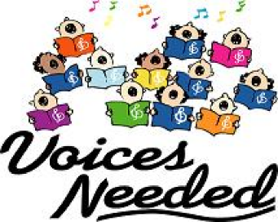
Sunday Collection Summary
July 15 and 16

Weekend Collections
Regular Offering $ 2,369.00
Candles $ 23.00
Altar Flowers $ 75.00
TOTAL OFFERINGS $ 2,467.00

‒ WEEKLY BUDGETARY NEEDS $ 4,494.00
+Overage or (Shortfall) for the week ($ 2,027.00)

Parish Second Collection
Local Poor $ 1,472.00

Other Income
Individual Contribution $ 5,000.00
Cemetery Lot Sales $ 1,500.00
Picnic Raffle Tickets $ 180.00
Memorial Offering $ 100.00
Total Other Offerings $ 6,780.00

The Church will celebrate World Day for Grandparents and the Elderly on July 23rd this year. In his message to the world, the Holy Father said: "Let us not abandon [grandparents and the elderly]. Their presence in families and communities is a precious one, for it reminds us that we share the same heritage and are part of a people committed to preserving its roots. From the elderly we received the gift of belonging to God's holy people. The Church, as well as society, needs them, for they entrust to the present the past that is needed to build the future. Let us honor them, neither depriving ourselves of their company nor depriving them of ours."

The Vatican Dicastery for Laity, Family and Life indicated two ways to celebrate the event in every diocese of the world: with a Mass dedicated to grandparents and the elderly, or with a visit to those who are alone. “A PLENARY INDULGENCE,” according to the statement, “is granted to those who perform these deeds.” Along with the usual Confession, Communion, and prayers for the Pope.

St. Ignatius Needs Your Voice

On July 30th at the 10:30 Mass, St Ignatius parish will be dedicating the newly renovated stain-glass windows and your voice can be part of the celebration. THE MUSIC MINISTRY IS WELCOMING ANYONE THAT IS INTERESTED IN BEING PART OF THE CHOIR AND SING TO WELCOME BOTH THE NEW BISHOP AND THE WINDOWS. We will be singing traditional hymns from the Breaking Bread Hymnal that relate to the stories represented in the windows. If you are interested, please come upstairs 20 minutes prior to that 10:30 Mass on 30 July ‒ or call Phil Mobley at 571-236-7580 before the 30,^{th} if you have any questions. All are invited and no auditions or practice is required!

LAST CHANCE TO DONATE!!!
at the Office or in the basket in the Narthex.

Coats will be purchased in October at Boscov’s and then donated to the Interfaith Shelter in Harrisburg,
and to SCCAP in Gettysburg.

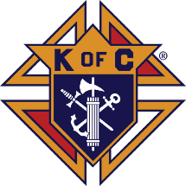

Do This in Remembrance of Me: The Liturgy of the Word

and the Liturgy of the Eucharist

Fr. Luke Spannagel | July 19, 2023

As we conclude the Liturgy of the Word and prepare to transition to the Liturgy of the Eucharist, it is a fitting time to reflect on how these main parts of the Mass are united and complement each other. We previously touched on this unity in our reflection on the homily. This time, we will hear from a couple of our recent popes. As The General Instruction of the Roman Missal states, “The Mass consists in some sense of two parts, namely the Liturgy of the Word and the Liturgy of the Eucharist, these being so closely interconnected that they form but one single act of worship. For in the Mass is spread the table both of God’s Word and of the Body of Christ, and from it the faithful are to be instructed and refreshed” (GIRM, 28, also cf. SC 56, 48, 51). Perhaps the two main parts of the Mass seem obvious, but how are they “so closely interconnected”? How are the Liturgy of the Word and the Liturgy of the Eucharist related? As two examples, they both strengthen us in understanding our faith and living it out in the world, and they both draw us deeper into true unity with Christ.

The Two Ways Our Lord Nourishes Us

Pope St. John Paul II reflected on how the unity of the Liturgy of the Word and Liturgy of the Eucharist goes back to the early Church: “We are well aware that from the earliest times the celebration of the Eucharist has been linked not only with prayer but also with the reading of Sacred Scripture and with singing by the whole assembly. As a result, it has long been possible to apply to the Mass the comparison, made by the Fathers, with the two tables, at which the Church prepares for her children the word of God and the Eucharist, that is, the bread of the Lord” (Dominicae Cenae, 10). This image of the two tables illustrates for us that we are fed in two main ways through the Mass: through the hearing of God’s word to us and through the true presence of Jesus in the Eucharist. As we have reflected before, through the Scriptures we come to know God as he reveals himself to us; we learn who we are as his people; and we learn how to live our lives in him and with one another. As we will see as we continue through the Mass, in the Eucharist we are nourished in a unique way through the true presence of Jesus and his dwelling with us through Holy Communion. Our Lord nourishes us in two wonderful ways!

Pope Benedict XVI, reflecting on these two tables of the Liturgy of the Word and Liturgy of the Eucharist, emphasizes the unity between them: “First of all, there is a need to reflect on the inherent unity of the rite of Mass. Both in catechesis and in the actual manner of celebration, one must avoid giving the impression that the two parts of the rite are merely juxtaposed… There is an intrinsic bond between the word of God and the Eucharist. From listening to the word of God, faith is born or strengthened (cf. Rom 10:17); in the Eucharist the Word made flesh gives himself to us as our spiritual food. Thus, ‘from the two tables of the word of God and the Body of Christ, the Church receives and gives the faithful the bread of life.’ Consequently it must constantly be kept in mind that the word of God, read and proclaimed by the Church in the liturgy, leads to the Eucharist as to its own connatural end” (Sacramentum Caritatis, 44).

‍Relationship and Unity

Pope Benedict’s words remind me of the way we grow in relationships. Typically, we first encounter others at a bit of a distance. Maybe we see them in a group, or we cross paths in some way. Next, there is usually a time when we are learning basics, such as names, family backgrounds, schools, or jobs. If the relationship continues to grow, we learn more about what a person thinks, likes, and hopes or dreams. Over time, a friendship grows and deepens, and with that depth comes greater love and intimacy. Of course, even with a depth of love, we know we still communicate with each other and continue to learn more. Our love helps us to understand each other more fully and our ongoing communication helps us deepen our love. This basic comparison helps me realize more concretely what I think the popes are teaching us: in the Mass, we encounter Jesus both through the Liturgy of the Word and through the Liturgy of the Eucharist. Both tables bless us with growing deeper in our relationship with him. Both lead us deeper in unity. Both invite us to share the fruits of that unity with one another. Both increase our hope for the perfect unity with Christ that awaits us in heaven. For now, a foretaste of the heavenly banquet is coming in the Liturgy of the Eucharist!

‍For Reflection:

1. How do you experience the Liturgy of the Word as nourishment? Pray with Ezekiel 3:1-3, in which the Lord instructs Ezekiel to eat a scroll. Meditate on the image of “tables” set for a feast as a way to awaken your “appetite” for worship as you prepare for Mass.

2. As Father Luke quoted, “the faithful are to be instructed and refreshed” (GIRM, 28) from the Liturgy of the Word and the Liturgy of the Eucharist. Prepare your heart to receive instruction and refreshment by asking the Lord to give you these graces every time you participate in Mass. After Mass, take time to reflect on the instruction and refreshment you have received, and give thanks to God.
The Holy Father, Pope Francis’ Prayer Intentions for 2023
Entrusted to His Worldwide Prayer Network
JULY ⁓ For a Eucharistic Life

We pray that Catholics may place the celebration of the Eucharist at the heart of their lives, transforming human relationships in a very deep way and opening to the encounter with God and all their brothers and sisters.
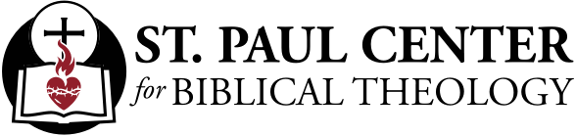

Of Wheat and Weeds: Scott Hahn Reflects

on the Sixteenth Sunday of Ordinary Time

God is always teaching His People, as we hear in today’s First Reading.

And what does He want us to know? That He has care for all of us; that though He is a God of justice, even those who defy and disbelieve Him may hope for His mercy if they turn to Him in repentance.

This Divine Teaching continues in the three parables that Jesus tells in the Gospel today. Each describes the emergence of the Kingdom of God from the seeds sown by His works and preaching. The Kingdom’s growth is hidden like the working of yeast in bread; it’s improbable, unexpected, as in the way the tall mustard tree grows from the smallest of seeds.

Again, this week’s readings sound a note of questioning: Why does God permit the evil to grow alongside the good? Why does He permit some to reject the Word of His Kingdom?

Because, as we sing in today’s Psalm, God is slow to anger and abounding in kindness. He is just, Jesus assures us — evildoers and those who cause others to sin will be thrown into the fiery furnace at the end of the age. But by His patience God is teaching us that above all He desires repentance and the gathering of all nations to worship Him and to glorify His Name.

Even though we don’t know how to pray as we ought, the Spirit will intercede for us, St. Paul promises in today’s Epistle. But first, we must turn and call upon Him. We must commit ourselves to letting the good seed of His Word bear fruit in our lives.

So, we should not be deceived or lose heart when we see weeds among the wheat — truth and holiness mixed with error, injustice, and sin.

For now, He makes His sun rise on the good and the bad (see Matthew 5:45). But the harvest draws near! Let’s work so that we might be numbered among the righteous children — who will shine like the sun in the Kingdom of the Father.

Readings: Wisdom 12:13, 16–19; Psalm 86:5–6, 9–10, 15–16; Romans 8:26–27; Matthew 13:24–43

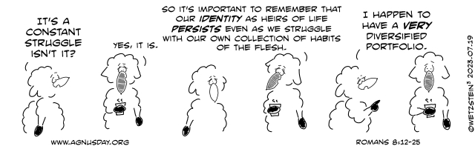

Catholic doctors turn to direct primary care

to practice medicine, faith

By Daniel Payne | Washington, D.C. Newsroom, Jul 18, 2023

As the medical model of “direct primary care” continues to grow in the U.S., a number of Catholic doctors are adopting it as a means to combine both the practice of medicine and the living out of their Catholic faith.

Direct primary care (DPC) is a subscription-based model of health care in which patients pay a monthly fee to a primary care provider. The fee, which is adjusted on the basis of family size, generally allows for unlimited doctors’ visits as well as reduced rates for services such as prescriptions and labs.

Most DPC offices are cash-pay; insurance is generally not accepted. Practitioners say the reductions in paperwork and administrative costs allow considerably more time for doctors to meet one-on-one with patients and provide a higher quality of service.

Industry data indicate that DPCs have increased hugely in the United States in recent years; one study found that from 2017 to 2021, “the number of active DPC clinicians per 100K people increased 159%,” compared with only 6% growth in standard primary care providers.

A small but growing number of Catholic doctors, meanwhile, are turning to DPC for both the higher quality of health care it allows them to offer and the freedom it allows for a more fulsome application of Catholic faith.

Dr. Patrick O’Connell, who runs Sentinel Primary Care in Raleigh, North Carolina, said he worked for about a decade in a local primary care network before beginning the transition to DPC.

“About eight to nine years ago I was feeling not only the intense productivity pressures that make it hard to do primary care well but also was seeing the cultural trends in health care that were going to make it even harder to be a faithful Catholic and keep my job,” he told CNA.

O’Connell said he was able to practice some moral discretion at his job, including regarding contraception, but that factors such as the Supreme Court’s redefinition of marriage, physician-assisted suicide, and “the gender ideology tsunami” were beginning to pose a threat to his faith.

“I could see that the day was coming when I would either have to compromise my faith or lose my job for not participating,” he said. “I didn’t like either option.”

The launch of his direct primary care practice led him to practice “authentically Catholic” medicine in a way he couldn’t before. Sentinel Primary eschews not only traditional insurance but also Medicare and Medicaid. The rejection of government-backed insurance lets O’Connell “maintain an arm’s length from much of the anti-Catholic agenda in health care that is imposed by the federal government.”

O’Connell acknowledged that “much of the time” his faith doesn’t explicitly factor into his day-to-day treatment of patients. “As I joke with people, it’s not like there’s the Catholic way to treat high blood pressure!” he said.

“However, it means that I’m not going to participate in gender ideology, that I’m going to approach care at the end of life from a Catholic perspective on the goodness of life, that I’m going to donate a portion of my medical care for people in a hard financial situation, etc.,” he said, noting that his practice serves “a good portion of charitable care.”

Dr. Angelique Pritchett is a family doctor at Gianna Family Care in Shawnee, Kansas.

Gianna offers “medical care truly aligned with Catholic Church teaching,” Pritchett told CNA. “[W]e do not prescribe artificial contraceptives, perform or refer for sterilizations, refer for abortions, support euthanasia, or offer or refer for artificial reproductive techniques (IVF, IUI, etc.).”

“We advise against sexual intercourse outside of the context of marriage, we consider homosexuality and transgenderism disordered, [and] we offer abortion pill reversal,” Pritchett said, adding that the practice offers NaPro Technology, a system of reproductive health that treats women’s fertility issues “without the use of artificial reproductive techniques and oral contraceptives, using natural procreative techniques.”

Local Church officials have been enthusiastic supporters of the practice, Pritchett said.

“We have the support of the archbishop, who has referred patients, advertised our clinic on his radio broadcast and in the diocesan newspaper, blessed our clinic at a public open house after its opening, and has even arranged for our membership fees to be covered for archdiocesan employees through their medical insurance,” she said.

The majority of the practice’s patients are Catholics, Pritchett noted, but the doctors also serve other Christian denominations as well as patients who lack medical insurance.

Dr. Michael Kloess, who runs Our Lady of Hope Clinic in Madison, Wisconsin, told CNA that he and a fellow doctor conceived of their practice in 2009, when direct primary care was still largely referred to as a “concierge service.”

“Our initial members were mostly Catholic,” Kloess said. “They were looking for a Catholic alternative, or a pro-life clinic, and so that initially was our support. It’s still largely Catholic supporters of the clinic, but it’s grown because now people understand what DPC means.”

As with many DPC clinics, Our Lady of Hope offers a wide variety of treatments for subscribers.

“We have labs, prescriptions, NaPro,” Kloess said. “I’m NaPro trained, and I provide a membership base for NaPro clients. But we also have the usual direct primary care clients - blood pressure, diabetes, cuts, scrapes, the usual things.”

“We provide prescription benefits like reduced-cost medicines, and we provide labs as part of memberships,” he said. “And we’ve contracted with an imaging company that can come in for reduced costs.”

Direct primary care offices with Catholic focuses have sprung up in locations as diverse as rural Virginia, northern California, and western Pennsylvania.

High health care costs and poor standards of care, meanwhile, may be poised to continue driving the trend in both secular and religious DPC models. One recent survey found that more than 80% of employees would sign up for a DPC model if their employer offered it.

O’Connell told CNA that in addition to allowing him the freedom to practice his faith, the charitable model by which he has structured his practice has allowed him to infuse a Catholic character into his work from start to finish.

The corporate entity of the practice is a 501(c)(3) nonprofit, he said, which gives him “much more selectivity in practice governance and hiring.”

The practice “has a statement of faith that all board members and employees have to assent to,” he said, “and which allows me to preserve the Catholic character of the practice.”

Kloess said his clinic offers a similar level of practical Catholic application. “We’re able to pray with staff and patients. We have the freedom to do that,” he said.

“Even beyond that, we are a hybrid clinic,” he added. “Our clinic supports visits for the uninsured. Sixty percent of our clinic is free care to the uninsured. We have the opportunity to witness our faith to all the patients that come in.”

Asked to what extent his Catholic faith informs the day-to-day operations of the clinic, Kloess said simply: “Everything.”

