Sacrament of the Sick
Anointing of the Sick should be given if an individual is gravely ill or near death. If possible, the Sacrament should also be administered for serious illness, before major surgery or when one is initially hospitalized.

Sacrament of Holy Matrimony
Diocesan policy requires 12 months of preparation for Marriage. Contact the parish as soon as possible after engagement. No venue reservations or other arrangements should be made prior to consultation with the pastor.

Sacrament of Penance
Wednesday ~ 6:00 – 6:45PM; or by appointment.

Sacrament of Baptism
Parents must be registered members of the parish and attend a Baptism preparation class prior to the Baptism if this is your first child baptized. Requirements for godparents are established by the Catholic Church. Please call the parish office for Information and to register your child for Baptism.

Parish Registration
All Catholics should be registered in their local parish. Please contact the parish office to obtain registration forms, or if you are uncertain of the parish where you should register.

Parish Staff & Ministries Directory
stignatiusofloyola@hbgdiocese.org | Office: 717-677-8012
Financial Manager ~ Richard Deardorff ~ 717- 677-8012 or 717-420-3464 (cell)
rdeardorff@hbgdiocese.org
Director of Religious Education ~ Deacon Steve Huete ~ shuete@hbgdiocese.org
Parish Secretary ~ Kristen DiDio ~ kdidio@hbgdiocese.org
Buildings & Grounds ~ Donnie Althoff ~ 717-677-8012
Music Ministry ~ Phil Mobley ~ 717-677-8012
Parish Council Members
Phil Mobley – Chair 571-236-7580 pmmobley@gmail.com
Bicky Redman – Vice Chair 677-8592 feetintheair7@gmail.com
Joanne Riedel - Secretary 398-2021 sterj221@aol.com
Kathi Allwein 677-8984 allweint@comcast.net
Charlie Baker 677-9536 dcbake@embarqmqil.com
Mike McTighe 729-6239 mike0432@aol.com
Dr. BobTernes rjtmd46@gmail.com

Finance Council Members
Richard Deardorff (Ex Officio)
Greg Ernst - Chair
Alix Haller
Christy Hemler - Secretary
Terri Pendlelton
Bill Pulig

Altar Flowers
Prayer Chain
Lynne Mobley at LMOBLEY509@gmail.com
or 703-876-4901

Soup Kitchen
Please send donations directly to “Soup Kitchen”

Website Development
Kristen DiDio
Life After Loss
Dodie Huete

OCIA
Contact Fr. Dominic

Picnic Co-Chairpersons
John Neiderer
Wally Kane

Pro-Life Ministry
Jeanette Backus
Knights of Columbus
SK Bob Ternes
- Grand Knight
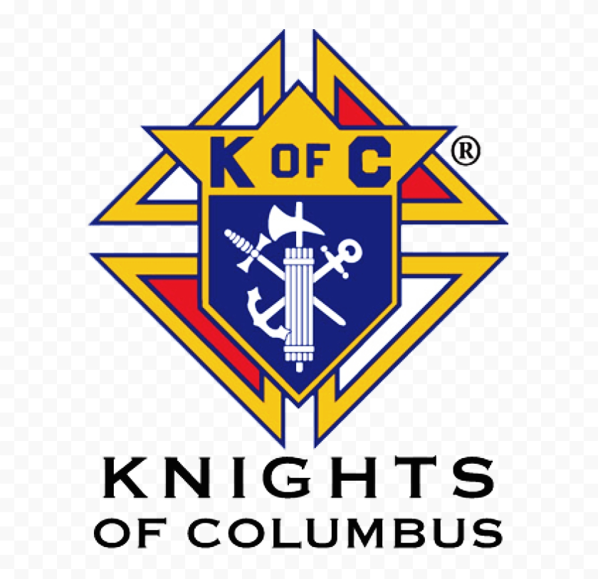

Judy Wilson / Janice Meligakes

Bereavement Ministry
Ginny Bittle / Dodie Huete

Catholic Communications/EWTN
Open - Contact office if you are interested

Cemetery
Contact Parish Office
THEOSIS Ministry
Kathy Dietsch 717-352-4558
Bicky Redman 717-677-8592

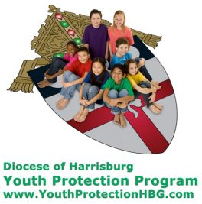
Diocese of Harrisburg Youth Protection Program
www.YouthProtectionHBG.com

Abuse Reporting Contact Information:
First – Call the toll-free PA Child Abuse Hotline at 800-932-0313
Then – Call the Diocesan toll-free hotline at 800-626-1608

“If one member suffers,
all suffer together with it.” (1 Cor 12:26)

St. Ignatius Loyola RC Church

1095 Church Road, Orrtanna, Pennsylvania 17353
www.stignatiusofloyola.org | Office: 717-677-8012

August 6, 2023: TRANSFIGURATION OF THE LORD
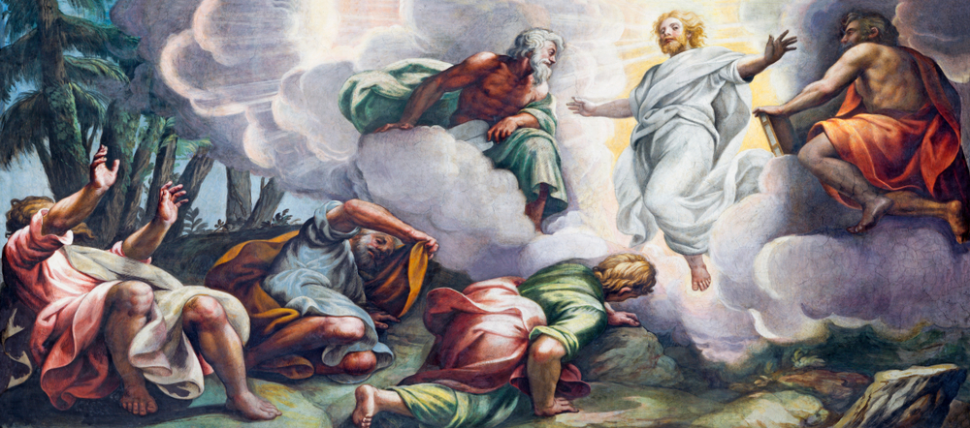
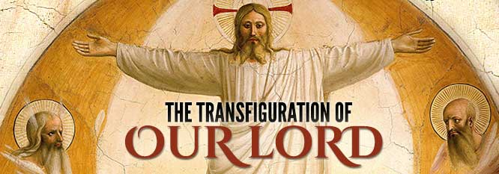

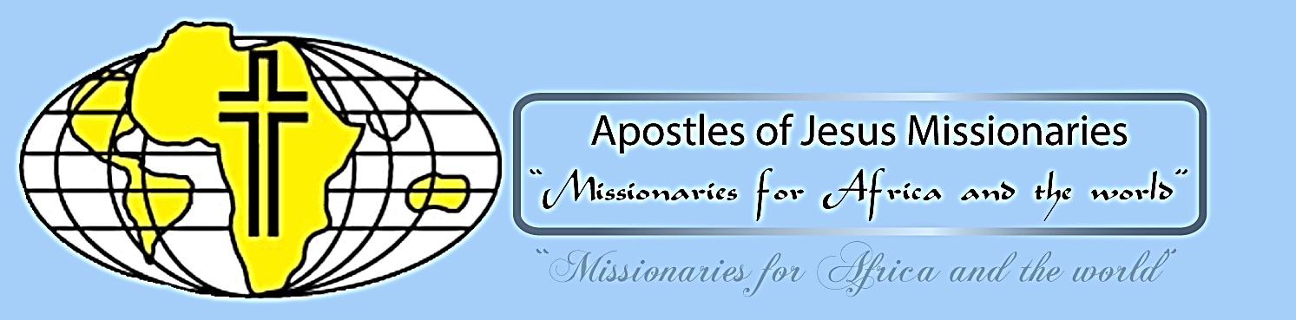

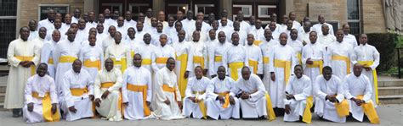
2023

Most Rev. Timothy C. Senior, Bishop of Harrisburg
Rev. Dominic M. DiBiccaro, Pastor
Deacon Steve Huete, Pastoral Associate

Mass Schedule, Intentions, and Events
Please Pray for:
Those who are ill, Jeanie Kline & the Kline Family, Brenda Wolf, Dulcie Perry, Ron Formosa, Gavin Crumbacker, Sherry Dennis and Family, Remi Peters, Christy Hemler, Terry Ahn, K. Grance, Lori McFadden & Family, Mike & Lisa Poole, Mervin Weikert, Chastity Rudisill, Mary Ellen Wilson, Terry & Bernie Cabana, Ed & Aggie Sherensky and Family, Bob Raffensberger, Jerry & Ginny Miller, Adeline Lienard, Kaylee Henry, Nancy Wuller, Dr. Mike Colli, Mrs. Kelly Kump, Kevin & Brittany Groff, Gabriel Singer, Sharon McCormley, Ron Thumma, Joe Wisotzkey, Leo Hockensmith, Erika McKissick, Jean "Heather" O'Shea, Scott Moore and Sally Moore, Mary Wyatt, Jim & Joyce Deardorff, Brandon & Michelle Gilbert, Amy Weatherup, Sophia Joy Ernst, Deacon Richard Wentzel, Deacon Frank Enderle, Kathleen Thompson, Deb & Kathy McLintock and Family, Rachel Wonders, Amy Edwards, Jean O’Connor, Art Lazar, Sr., Paul Angello, Jen Baldwin, Ursula Kaley, Deb Bennet, Fr. Bill Sullivan, Larry Endy, Mary Beth McCarthy, Laura Lee, Marwa Abdelrahman, Donna Singley, Tim McGinn, Jane Kump, Peggy Neiderer, Chris Kimple, Robert Riquet, Gene & Jo-Ann McDannell, Bob Doxzen, Kimberly Mears, Gabriella Angello, Mark & Kate Morrow, Mark Morris, Linda Fogleman, Paul Knight, George & Barbara Erstila, Jeff Carpenter, Lana & Nelson Harmon, Diane Slothour, Sue McDannell, Larry Schneider, Joe & Lisa Grasel, Ange Pena, Julie Barnhart, the Shaffer Family, Heather & Emma Dickerson, Brad Pabody, Paul Ward, Aiden Tyler Schneider, Dorothy Vega, Karrie McCall & daughter, George Shahid, Denise Navlyt, Drew Schneider & Family, Ida Bloomfield, Linda McDannell, Janie Singley, Mary Beth Greenstreet, Rick Benedict, Jan Patla, Kathe Fogleman, Sam Sheffler, Kate Hemmis, Bill & Mary Lou Graham, Joanna Hodges, John Varones, Joan O’Sullivan, Martha Klinger, Lisa Dionne Lauretti, Sue Orndorff, Jim Gleason, Sue Gustafson, Joe & Michelle Cleary, Kim Johnson, Helen Mills, Kathy Haber, Haley Detman, Joe Durovey, Bev Smith, Donald Sheppard, Linda Mumaugh, Alison Haring, Janet Hartman, Edward Johnson, Angela Galeone, Juliete Lang, Chris MacBeth, Harry Graham, Donald Howard, Armond Binni, Elizabeth Stansky, Pat Johnson, Chris Morris, Faud Doaney, Wilson & Rae Harman, Patrick Glass, Helen Lagasse, Nancy Kewisnek, Andy Graham, Bill & Maureen Collins, Rosemary McGilloway, Anji Eisenhart, Monica Manner, Denny Borbonus, Dr. Paul Scarlata, Mary Hawthorne, Ed Washington, Josh Kempinski, Nancy Baker Baltzey, Spencer Propts, Karlton Smith & Cheryl Sobun, James & Marylyn Sobun, Marlene Webster, Yvette Stoklosa, Andy Consiglio, Bill & Michelle Cloonan, Nelson Salem, Bill & Deb McClintock nursing home residents & shut-ins, the victims of war, violence, disease, disaster, & all private intentions.
Also in your prayers, please remember all
our men and women currently serving in
our Armed Forces:
Maj. Nathan Jeffcoat – US Marine Corps
Lt. Joseph Cleary – US Navy
Michael C. Kenney IV – US Coast Guard
Lt. Joshua Kimple – US Army
Lt. Sarah Fogleman, M.D. – US Navy

PRAYER CHAIN: Contact Lynne Mobley at 703-876-4901 or LMOBLEY509@gmail.com

for the Week of August 5 to August 13, 2023

SATURDAY, Aug. 5 –VIGIL TRANSFIGURATION OF THE LORD

Dn 7:9-10, 13-14 / 2 Pt 1:16-19 / Mt 17:1-9
CO-OP
5:00PM +George & Mary Dambrauskas

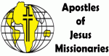
SUNDAY, August 6 – TRANSFIGURATION OF THE LORD
Dn 7:9-10, 13-14 / 2 Pt 1:16-19 / Mt 17:1-9
8:00AM + Jim, Helen, & Henry Kimple
10:30AM ⁓ People of the Parish

Monday, August 7 – St. Sixtus II, Pope, & Companions, Martyrs;
Nm 11:4b-15 / Mt 14:13-21 St. Cajetan, Priest
Parish Office Closed Holy Saints of God … PRAY OR US!

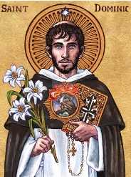
Tuesday, August 8 – St. Dominic, Priest
Nm 12:1-13 / Mt 14:22-36 or 15:1-2, 10-14

8:00AM - 3:00 PM ~ Office Open
10:00AM - Spec. Int. for Bernadette Bernardy

“Something More” Group
Wednesday, August 9 – St. Teresa Benedicta of the Cross, Virgin
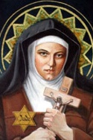
Nm 13:1-2, 25—14:1, 26-29a, 34-35 / Mt 15:21-28 &Martyr

8:00AM – 3:00PM ~ Office Open
10AM: Mature Spirituality Group
7:00PM + Chuck Wuller
Confessions 6 - 6:45PM; Adoration 7:40PM
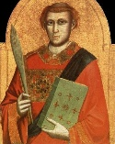
Thursday, August 10 – ST. LAWRENCE, DEACON
2 Cor 9:6-10 / Jn 12:24-26 & MARTYR

8:00AM – 3:00PM ~ Office Open
10:00AM - Spec. Int. for Deacon Steve & Dodie Huete & Family
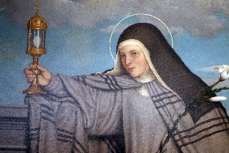  Friday, August 11 – St. Clare, Virgin  Dt 4:32-40 / Mt 16:24-28  Parish Office CLOSED | THE LORD
10:00AM + Linda Sluck

SATURDAY, August 12 – St. Jane Frances de Chantal,
MORNING: Dt 6:4-13 / Mt 17:14-20 Religious

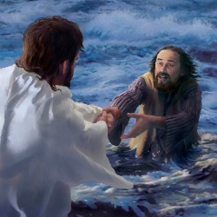
SATURDAY, August 12 – VIGIL 19th SUNDAY OT

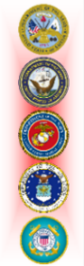
1 Kgs 19:9a, 11-13a / Rom 9:1-5 / Mt 14:22-33
5:00PM +Teresa Quigley

SUNDAY, August 13 – 19th SUNDAY IN OT

1 Kgs 19:9a, 11-13a / Rom 9:1-5 / Mt 14:22-33
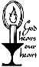
8:00AM + Marie Trimmer
10:30AM ⁓ People of the Parish
Sanctuary Candle offered for AUGUST: In Loving Memory of Teresa Redding from Edna Redding.
Sunday Collection Summary
July 29 and 30

Weekend Collections
Regular Offering $ 2,463.00
TOTAL OFFERINGS $ 2,463.00

‒WEEKLY BUDGETARY NEEDS $ 4,494.00
+Overage or (Shortfall) for the week ($ 2,031.00)

Other Income
Parish Picnic $ 35.00
Picnic Raffle Tickets $ 1,735.00
Stewardship Bookcase $ 172.00
Memorial (Larry Dennis) $ 200.00
Total Other Offerings $ 2,142.00

This is Pope Francis’ prayer

intention for August 2023

Pope Francis’ prayer intention for the month of August is for World Youth Day (WYD). The video promoting the pope’s prayer intention starts with a group of young people on a video chat saying that when they go to church they only see “old people.”

They then ask, “Is the Church only for old people?”

“The Church is not an old people’s club any more than it is a youth club,” the pope replied.

He added: “If it becomes something for old people, it will die.”

Pope Francis references St. John Paul II, who said: “If you live with young people you become young yourself.”

Another group of young people then asked Pope Francis why he chose the theme “Mary arose and went with haste” for this WYD.

He answered: “Because as soon as Mary knew she was going to be the mother of God, she didn’t stay there taking a selfie or showing off. The first thing she did was to set out on a journey, in haste, to serve; to help.”

“You too have to learn from her to set out on a journey to help others,” he said.

Pope Francis shared that he hopes to see “a seed for the world’s future” in Lisbon. “A world where love is at the center, where we can sense that we are sisters and brothers. We are at war; we need something else. A world that is not afraid of witnessing to the Gospel. A joyful world — because if we Christians have no joy, we are not credible, no one will believe us.”

The video concluded with a prayer: “Let us pray that the World Youth Day in Lisbon will help us young people to set out on the journey, witnessing to the Gospel with our own lives.”

Pope Francis’ prayer video is promoted by the Pope’s Worldwide Prayer Network, raising awareness of monthly papal prayer intentions.

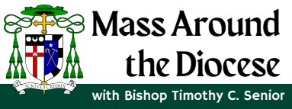
All the Faithful are invited to Mass,
celebrated by Bishop Timothy C.
Senior, as he begins his pastoral
ministry. For our Franklin Deanery,
Mass will be celebrated on Wednesday,
August 16, at Corpus Christi Church, at
7PM. Visit the Diocesan website for
more details on the Mass schedule,
including those that will be live streamed.

Please NOTE: that because of the Deanery Episcopal Mass on WEDNESDAY, AUGUST 16th, The evening Mass will be MOVED TO 10AM here at St. Ignatius. AND…there will be NO CONFESSIONS nor ADORATION that evening as well.

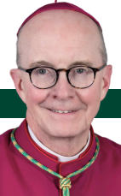

Do This in Remembrance of Me: The Liturgy of the Word

and the Liturgy of the Eucharist By Fr. Luke Spannagel | July 19, 2023

As we conclude the Liturgy of the Word and prepare to transition to the Liturgy of the Eucharist, it is a fitting time to reflect on how these main parts of the Mass are united and complement each other. We previously touched on this unity in our reflection on the homily. This time, we will hear from a couple of our recent popes. As The General Instruction of the Roman Missal states, “The Mass consists in some sense of two parts, namely the Liturgy of the Word and the Liturgy of the Eucharist, these being so closely interconnected that they form but one single act of worship. For in the Mass is spread the table both of God’s Word and of the Body of Christ, and from it the faithful are to be instructed and refreshed” (GIRM, 28, also cf. SC 56, 48, 51). Perhaps the two main parts of the Mass seem obvious, but how are they “so closely interconnected”? How are the Liturgy of the Word and the Liturgy of the Eucharist related? As two examples, they both strengthen us in understanding our faith and living it out in the world, and they both draw us deeper into true unity with Christ.

The Two Ways Our LORD Nourishes Us

Pope St. John Paul II reflected on how the unity of the Liturgy of the Word and Liturgy of the Eucharist goes back to the early Church: “We are well aware that from the earliest times the celebration of the Eucharist has been linked not only with prayer but also with the reading of Sacred Scripture and with singing by the whole assembly. As a result, it has long been possible to apply to the Mass the comparison, made by the Fathers, with the two tables, at which the Church prepares for her children the word of God and the Eucharist, that is, the Bread of the LORD” (Dominicae Cenae, 10). This image of the two tables illustrates for us that we are fed in two main ways through the Mass: through the hearing of God’s word to us and through the true presence of Jesus in the Eucharist. As we have reflected before, through the Scriptures we come to know God as he reveals himself to us; we learn who we are as his people; and we learn how to live our lives in him and with one another. As we will see as we continue through the Mass, in the Eucharist we are nourished in a unique way through the true presence of Jesus and his dwelling with us through Holy Communion. Our LORD nourishes us in two wonderful ways!

Pope Benedict XVI, reflecting on these two tables of the Liturgy of the Word and Liturgy of the Eucharist, emphasizes the unity between them: “First of all, there is a need to reflect on the inherent unity of the rite of Mass. Both in catechesis and in the actual manner of celebration, one must avoid giving the impression that the two parts of the rite are merely juxtaposed… There is an intrinsic bond between the word of God and the Eucharist. From listening to the word of God, faith is born or strengthened (cf. Rom 10:17); in the Eucharist the Word made flesh gives himself to us as our spiritual food. Thus, ‘from the two tables of the word of God and the Body of Christ, the Church receives and gives the faithful the bread of life.’ Consequently it must constantly be kept in mind that the word of God, read and proclaimed by the Church in the liturgy, leads to the Eucharist as to its own connatural end” (Sacramentum Caritatis, 44).

Relationship and Unity
Pope Benedict’s words remind me of the way we grow in relationships. Typically, we first encounter others at a bit of a distance. Maybe we see them in a group, or we cross paths in some way. Next, there is usually a time when we are learning basics, such as names, family backgrounds, schools, or jobs. If the relationship continues to grow, we learn more about what a person thinks, likes, and hopes or dreams. Over time, a friendship grows and deepens, and with that depth comes greater love and intimacy. Of course, even with a depth of love, we know we still communicate with each other and continue to learn more. Our love helps us to understand each other more fully and our ongoing communication helps us deepen our love. This basic comparison helps me realize more concretely what I think the popes are teaching us: in the Mass, we encounter Jesus both through the Liturgy of the Word and through the Liturgy of the Eucharist. Both tables bless us with growing deeper in our relationship with him. Both lead us deeper in unity. Both invite us to share the fruits of that unity with one another. Both increase our hope for the perfect unity with Christ that awaits us in heaven. For now, a foretaste of the heavenly banquet is coming in the Liturgy of the Eucharist!

‍For Reflection:
1. How do you experience the Liturgy of the Word as nourishment? Pray with Ezekiel 3:1-3, in which the LORD instructs Ezekiel to eat a scroll. Meditate on the image of “tables” set for a feast as a way to awaken your “appetite” for worship as you prepare for Mass.

2. As Father Luke quoted, “the faithful are to be instructed and refreshed” (GIRM, 28) from the Liturgy of the Word and the Liturgy of the Eucharist. Prepare your heart to receive instruction and refreshment by asking the LORD to give you these
graces every time you participate in Mass. After Mass, take time to reflect on the instruction and refreshment you have received. And GIVE THANKS TO GOD!

The Holy Father, Pope Francis’ Prayer Intentions for 2023
Entrusted to His Worldwide Prayer Network
AUGUST ⁓ FOR WORLD YOUTH DAY

We pray the World Youth Day in Lisbon, Portugal, will help young people to live and witness the Gospel in their own lives.

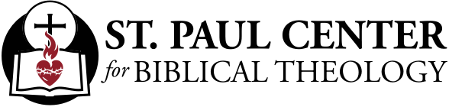

Majestic Voice: Scott Hahn Reflects

on the Transfiguration of the LORD

High on the holy mountain in today’s Gospel, the true identity of Jesus is fully revealed in His Transfiguration.

Standing between Moses and the Prophet Elijah, Jesus is the bridge that joins the Law of Moses to the Prophets and Psalms (see Luke 24:24–27). As Moses did, Jesus climbs a mountain with three named friends and beholds God’s Glory in a Cloud (see Exodus 24:1, 9, 15). As Elijah did, He hears God’s Voice on the mountain (see 1 Kings 19:8–19).

Elijah was prophesied to return as the herald of the Messiah and the LORD’s New Covenant (see Malachi 3:1, 23–24). Jesus is revealed today as that Messiah! By His Death and Resurrection, which He intimates today to the Apostles, He makes a New Covenant with all Creation.

The majestic Voice declares Jesus to be God’s own Beloved Son, in whom the Father is well pleased (see Psalm 2:7). God here gives us a glimpse of His inner life. In the Cloud of the Holy Spirit, the Father reveals His love for the Son, and invites us to share in that Love as His beloved sons and daughters.

Shadowed by the Clouds of Heaven, with His clothes dazzling white, Jesus is the Son of Man whom Daniel foresees being enthroned in today’s First Reading.

He is the King, the LORD of all the earth, as we sing in today’s Psalm. But is He truly the LORD of our hearts and minds?

The last word God speaks from Heaven today is a command — “Listen to Him” (see Deuteronomy 18:15–19). The Word of the LORD should be like a lamp shining in the darkness of our days, as Peter tells us in today’s Second Reading.

How well are we listening? Do we attend to His word each day?

Let us today rededicate ourselves to listening. Let us hear Him as the word of life, the bright morning star of divine life waiting to arise in our hearts (see Revelation 2:28; 22:16).

Readings: Daniel 7:9-10, 13-14; Psalm 97:1-2, 5-6, 9; 2 Peter 1:16-19; Matthew 17:1-9

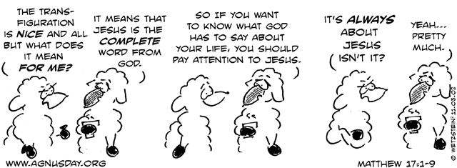

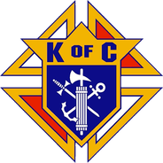
Supreme Knight Patrick Kelly to Knights’ convention:

Catholic men have ‘a duty to protect families’

By Peter Pinedo | Orlando, Fla., Aug 2, 2023

Addressing more than 2,000 Knights of Columbus Tuesday afternoon, Supreme Knight Patrick Kelly urged the assembled to stand strong as men of faith amid new challenges facing the Catholic Church today.

In his speech to Knights, along with several cardinals, bishops, priests, and religious at the 141st Supreme Convention at Orlando World Center Marriott in Orlando, Florida, Kelly emphasized the need for Catholic men to continue standing for the faith and for the weak and vulnerable.

In the face of what he called “new anti-Catholic bigotry,” Kelly said that Catholic men “have a duty to protect families,” most especially the widowed and orphaned.

Recalling the Knights’ principles of “first in faith and charity,” Kelly highlighted the order’s efforts in response to post-Dobbs attacks on unborn life, support for those affected by the war in Ukraine, and response to a growing “epidemic of loneliness” that has particularly impacted young men in America.

Inviting men to greatness

Kelly pointed out a 2023 study from the U.S. Surgeon General that “reported that we are living through an epidemic of loneliness and isolation.”

“I submit that the Knights of Columbus offers a cure,” Kelly said. “In this time of loneliness, we offer fraternity. In this era of isolation, we extend the hand of friendship. And in a world that offers apathy and anger, we invite men to lives of meaning and mission.”

“In this age of mediocrity, the Knights of Columbus invites men to greatness: to sacrifice themselves for the good of others; to commit to a higher call with a band of brothers; and to stand strong in the breach, side by side, instead of being swept away by the culture, one at a time,” he said.

Supporting Ukraine

Kelly emphasized the Knights of Columbus’ support for Ukrainians impacted by the ongoing war and pledged the Knights’ continued support.

“Within 36 hours of Russia’s invasion, we established the Ukraine Solidarity Fund,” Kelly said. “Eighteen months later, we have raised over $21 million. I cannot think of another time in our history when so many gave so much, so fast.”

He thanked all the Knights who have been a part of the order’s relief efforts in Ukraine, calling them “the hands and feet of Jesus Christ.”

“Ukraine is becoming a nation of heroes,” Kelly said.

Addressing Ukrainians whose lives have been upturned and devastated by the war, Kelly said: “You are not alone. We are with you. And the Knights of Columbus are not going anywhere.”
Peter Pinedo is a DC Correspondent for CNA. A graduate of Franciscan University, Peter previously worked for Texas Right to Life. He is a first lieutenant in the U.S. Army Reserve.

‘Stand for the truth because it’s right’

Recalling the recent Dodgers scandal, in which the Los Angeles Major League Baseball team honored an anti-Catholic hate group called the Sisters of Perpetual Indulgence with a “community hero award,” Kelly said that Catholic men are called to defend the faith even more vigorously in the face of such bigotry.

“I was shocked to see a professional baseball team honor an anti-Catholic hate group that masquerades as nuns,” Kelly said.

“This group mocks Our Lord and Our Lady in the foulest ways. And they insult the courageous women religious who have dedicated their lives to prayer and service. I can think of no more blatant example of the new anti-Catholic bigotry.”

While Catholics have taken criticism for their work upholding religious freedom and the sanctity of life, Kelly urged the Knights to never back down from defending the truth of the Catholic faith.

“There is nothing hateful about the sanctity of marriage, the reality of biological sex, or the humanity of the unborn child,” he said. “And the Knights of Columbus will never apologize for defending the truth.”

“We stand for the truth because it’s right — even when it leads to ridicule and scorn,” Kelly said.

Standing for life

Kelly acknowledged that “the fight for life is far from over” and that struggle has even grown in importance with new efforts to undermine the right to life in states across the country.

“Life will be on the ballot in many states over the next two years,” Kelly said.

“This November,” he went on, “Ohio will vote on whether to put the so-called right to abortion into its constitution. Radical activists are already pouring millions of dollars into this battle. They think it will be the beginning of the end of the pro-life movement. But we will prove them wrong.”

Highlighting the Knights’ Aid and Support After Pregnancy Program, Kelly shared how the Knights have supported pregnant and parenting mothers since the overturn of Roe v. Wade. Through the program and other efforts, the Knights have donated 1,745 ultrasound machines and raised $6 million for pregnancy resource centers and maternity homes across the country.

Rather than backing down from the fight for life after the overturn of Roe, Kelly urged Knights to stand stronger on the life issue than ever before.

Kelly said that the Knights remain dedicated to not only making abortion illegal but also unthinkable. He mentioned the Knights’ efforts to reach younger generations with the pro-life message, pointing out how the order teamed with the Sisters of Life to put on the first-ever “Life Fest,” which took place in January the morning of the national March for Life and was attended by more than 4,000 youth.

Our goal is the same,” he said, “win more hearts, change more minds, and enshrine the right to life in the laws of the land.”

“Think back to where we were, just a few years ago. The powers that be said Roe was settled law. They said it would never be overturned. But the pro-life movement kept the faith. And we carried the day,” Kelly said. “Since the end of Roe, nearly half of our states have taken new steps to protect life. And as I stand before you today, 14 states have ended abortion altogether — and more are on the way.”

