Sacrament of the Sick
Anointing of the Sick should be given if an individual is gravely ill or near death. If possible, the Sacrament should also be administered for serious illness, before major surgery or when one is initially hospitalized.

Sacrament of Holy Matrimony
Diocesan policy requires 12 months of preparation for Marriage. Contact the parish as soon as possible after engagement. No venue reservations or other arrangements should be made prior to consultation with the pastor.

Sacrament of Penance
Wednesday ~ 6:00 – 6:45PM; or by appointment.

Sacrament of Baptism
Parents must be registered members of the parish and attend a Baptism preparation class prior to the Baptism if this is your first child baptized. Requirements for godparents are established by the Catholic Church. Please call the parish office for Information and to register your child for Baptism.

Parish Registration
All Catholics should be registered in their local parish. Please contact the parish office to obtain registration forms, or if you are uncertain of the parish where you should register.

Parish Staff & Ministries Directory
stignatiusofloyola@hbgdiocese.org | Office: 717-677-8012
Financial Manager ~ Richard Deardorff ~ 717- 677-8012 or 717-420-3464 (cell)
rdeardorff@hbgdiocese.org
Director of Religious Education ~ Deacon Steve Huete ~ shuete@hbgdiocese.org
Parish Secretary ~ Kristen DiDio ~ kdidio@hbgdiocese.org
Buildings & Grounds ~ Donnie Althoff ~ 717-677-8012
Music Ministry ~ Phil Mobley ~ 717-677-8012
Parish Council Members
Phil Mobley – Chair 571-236-7580 pmmobley@gmail.com
Bicky Redman – Vice Chair 677-8592 feetintheair7@gmail.com
Joanne Riedel - Secretary 398-2021 sterj221@aol.com
Kathi Allwein 677-8984 allweint@comcast.net
Charlie Baker 677-9536 dcbake@embarqmqil.com
Kathy Dietsch 352-4558 kdiet2@juno.com
Dr. BobTernes rjtmd46@gmail.com

Finance Council Members
Richard Deardorff (Ex Officio)
Greg Ernst - Chair
Christy Hemler - Secretary
Ali Morris
Terri Pendlelton
Bill Pulig

Altar Flowers
OCIA
Order of Christian Initiation for Adults
Contact Fr. Dominic

Soup Kitchen
Please send donations
directly to the
“Gettysburg Soup Kitchen”

Website Development
Kristen DiDio
Life After Loss
Dodie Huete

Prayer Chain
CONTACT THE PARISH OFFICE

Picnic Co-Chairs
Wally Kane
Mark Schur

Pro-Life Ministry
Jeanette Backus
Knights of Columbus
SK Bob Ternes
- Grand Knight

CONTACT THE PARISH OFFICE

Bereavement Ministry
Ginny Bittle / Dodie Huete

Catholic Communications/EWTN
Anna Kane

Cemetery
CONTACT THE PARISH OFFICE
THEOSIS Ministry
Kathy Dietsch 717-352-4558
Bicky Redman 717-677-8592

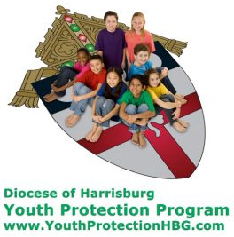
Diocese of Harrisburg Youth Protection Program
www.YouthProtectionHBG.com

Abuse Reporting Contact Information:
First – Call the toll-free PA Child Abuse Hotline at 800-932-0313
Then – Call the Diocesan toll-free hotline at 800-626-1608

“If one member suffers,
all suffer together with it.” (1 Cor 12:26)

St. Ignatius Loyola RC Church

1095 Church Road, Orrtanna, Pennsylvania 17353
www.stignatiusofloyola.org | Office: 717-677-8012

December 31, 2023: THE HOLY FAMILY

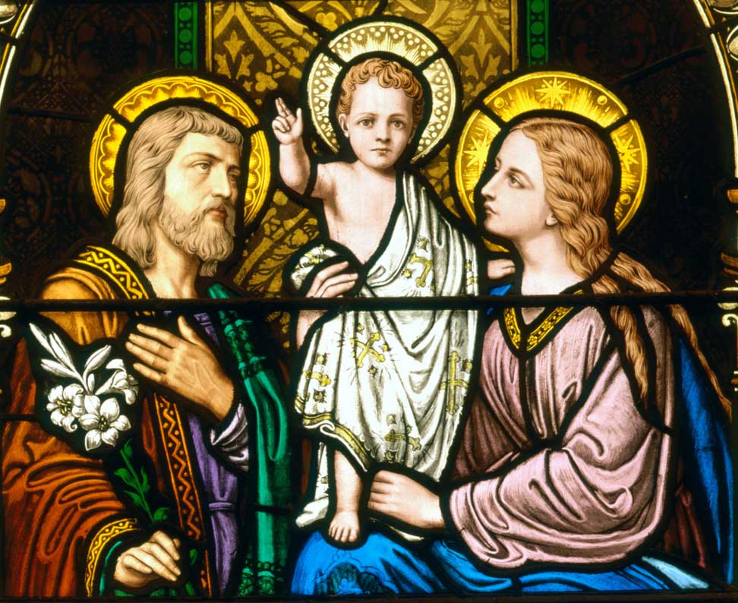

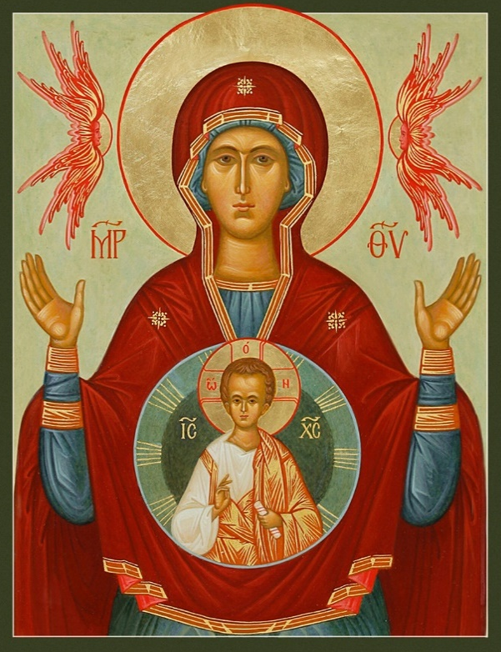

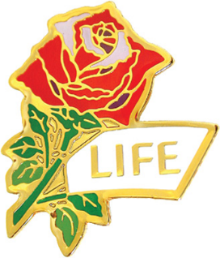

“The Most Holy Theotokas”

Jan. 1, 2024 - Solemnity of MARY, The MOTHER OF GOD
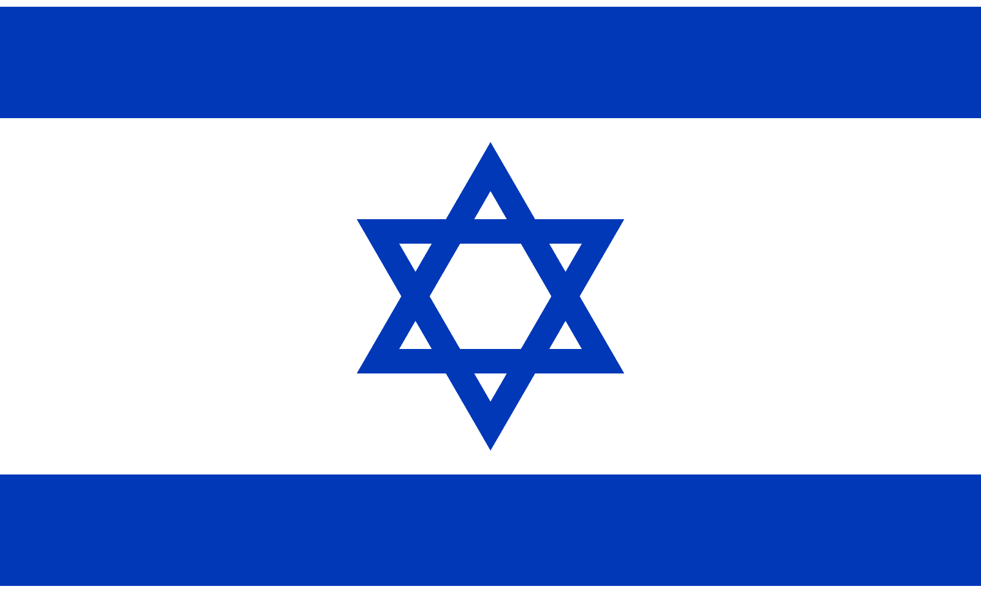
May the Blessed Hearts of the Holy Family
open hearts to make PEACE in the Holy Land!
Most Rev. Timothy C. Senior, Bishop of Harrisburg
Rev. Dominic M. DiBiccaro, Pastor
Deacon Steve Huete, Pastoral Associate

Mass Schedule, Intentions, and Events
Please Pray for these in need:
Jeanie Kline & the Kline Family, Dick & Deb Deardorff, Corona Naylor, Chris & Mary Rebscher, John Baker, Ginny Hoctor, Janet Hodge, Brenda Wolf, Sr. Thelma Steiger HSF, Sr. Miriam Ukeritis CSJ , Peter Hackney, Lucas Christiansen, Dale Kaplan, Jerry Smith, Wade Sprankle, Dulcie Perry, Ron Formosa, Gavin Crumbacker, Anna Kane, Sherry Dennis & Family, Remi Peters, Terry Ahn, K. Grance, Lori McFadden & Family, Mike & Lisa Poole, Mervin Weikert, Chastity Rudisill, Mary Ellen Wilson, Terry & Bernie Cabana, Ed & Aggie Sherensky & Family, Bob Raffensberger, Jerry & Ginny Miller, Adeline Lienard, Kaylee Henry, Nancy Wuller, Dr. Mike Colli, Mrs. Kelly Kump, Gabriel Singer, Sharon McCormley, Ron Thumma, Joe Wisotzkey, Leo Hockensmith, Erika McKissick, Jean "Heather" O'Shea, Scott Moore & Sally Moore, Mary Wyatt, Amy Weatherup, Sophia Joy Ernst, Deacon Richard Wentzel, Deacon Frank Enderle, Paul & Carolyn Topper, Kathleen Thompson, Rachel Wonders, Amy Edwards, Jean O’Connor, Jen Baldwin, Ursula Kaley, Deb Bennet, Larry Endy, Laura Lee, Marwa Abdelrahman, Donna Singley, Tim McGinn, Jane Kump, Peggy Neiderer, Chris Kimple, Robert Riquet, Gene & Jo-Ann McDannell, Bob Doxzen, Kimberly Mears, Gabriella Angello, Paul Angello, Mark & Kate Morrow, Mark Morris, Linda Fogleman, Paul Knight, George & Barbara Erstila, Jeff Carpenter, Lana & Nelson Harmon, Diane Slothour, Sue McDannell, Larry Schneider, Joe & Lisa Grasel, Ange Pena, Julie Barnhart, the Shaffer Family, Heather & Emma Dickerson, Brad Peabody, Paul Ward, Aiden Tyler Schneider, Dorothy Vega, Karrie McCall & daughter, George Shahid, Denise Navlyt, Drew Schneider & Family, Ida Bloomfield, Janie Singley, Mary Beth Greenstreet, Rick Benedict, Jan Patla, Kathey Fogleman, Sam Sheffler, Kate Hemmis, Bill & Mary Lou Graham, Andy Graham, Joanna Hodges, John Varones, Joan O’Sullivan, Martha Klinger, Lisa Dionne Lauretti, Jim Gleason, Sue Gustafson, Joe & Michelle Cleary, Kim Johnson, Helen Mills, Kathy Haber, Haley Detman, Joe Durovey, Bev Smith, Donald Sheppard, Linda Mumaugh, Alison Haring, Janet Hartman, Edward Johnson, Angela Galeone, Juliete Lang, Chris MacBeth, Harry Graham, Donald Howard, Armond Binni, Elizabeth Stansky, Pat Johnson, Chris Morris, Faud Doaney, Patrick Glass, Helen Lagasse, Nancy Kewisnek, Bill & Maureen Collins, Rosemary McGilloway, Anji Eisenhart, Monica Manner, Denny Borbonus, Dr. Paul Scarlata, Mary Hawthorne, Ed Washington, JoshKempinski, NancyBaltzey, Spencer Propts, Karlton Smith & Cheryl Sobun, James & Marylyn Sobun, Marlene Webster, Yvette Stoklosa, Andy Consiglio, Bill & Michelle Cloonan, Nelson Salem, Bill & Deb McClintock, nursing home residents & shut-ins, the victims of war, violence, disease, disaster, & all private intentions.
Also in your prayers, please remember all our men
& women currently serving in our Armed Forces:

Lt. Col. Nathan Jeffcoat – US Marine Corps
Lt. Joseph Cleary – US Navy
Michael C. Kenney IV – US Coast Guard
Lt. Joshua Kimple – US Army
Lt. Sarah Fogleman, M.D. – US Navy
A1C Ian Bellinger ‒ PA Air National Guard

PRAYER CHAIN: Contact the Office

for the Week of December 30 to January 7, 2024

SATURDAY, Dec. 30 – Vigil THE HOLY FAMILY OF JESUS, MARY

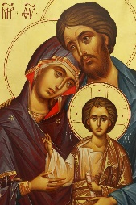
Gn 15:1-6; 21:1-3 / Heb 11:8, 11-12, 17-19 / Lk 2:22-40 & JOSEPH
5:00PM + Dominic “Buddy” DiBiccaro

SUNDAY, Dec. 31 – THE HOLY FAMILY

Gn 15:1-6; 21:1-3/Heb 11:8, 11-12, 17-19/Lk 2:22-40
8:00AM ⁓ People of the Parish
10:30AM +.Pope Benedict XVI
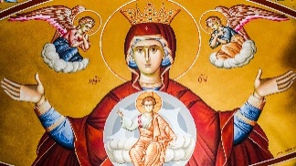
NO VIGIL MASS for Mary, Mother of God
(obligation is lifted this year)
MONDAY, January 1, 2024
SOLEMNITY of MARY, MOTHER OF GOD
Nm 6:22-27 / Gal 4:4-7 / Lk 2:16-21
10:00AM ⁓ People of the Parish
Parish Office CLOSED

Tuesday, January 2 – Sts. Basil the Great & Gregory Nazianzus,
1 Jn 2:22-28 / Jn 1:19-28 Bishops &

8AM – 3PM ~ Office Open Doctors of

10:00AM + Rev. John Acri the Church

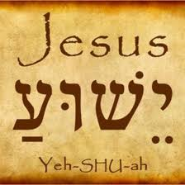
Wednesday, January 3 – The Most Holy Name
1 Jn 2:29—3:6 / Jn 1:29-34 of Jesus

8AM – 3PM ~ Office Open
7:00PM + Jack Ryff
6 – 6:45 Confessions; 7:40 Adoration; 8PM Benediction
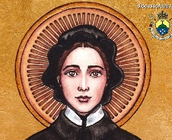
Thursday, January 4 – St. Elizabeth Ann Seton,
1 Jn 3:7-10 / Jn 1:35-42 Religious

8AM – 3PM ~ Office Open
10:00AM + James Shorb
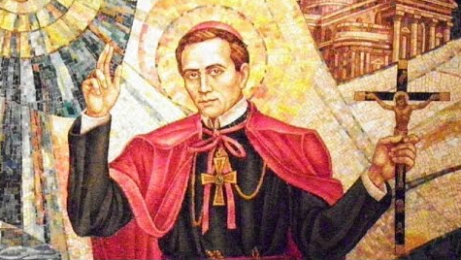  Friday, January 5 – St. John Neumann,  1 Jn 3:11-21 / Jn 1:43-51 Bishop  10:00AM + Anna Mera-Vellejos  Parish Office CLOSED | THE LORD

SATURDAY, January 6 - St. André Bessette, Religious
MORNING: 1 Jn 5:5-13 / Mk 1:7-11

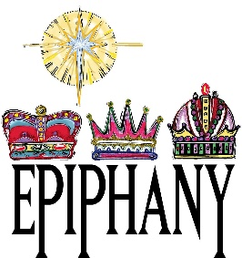
SATURDAY, Jan. 6– Vigil of THE EPIPHANY OF THE LORD

Is 60:1-6 / Eph 3:2-3a, 5-6 / Mt 2:1-12
Happy 55th Wedding Anniversary to
Chip & Kaye Boyer

Love! From your children & grandchildren

5:00PM + Spec. Int. Richard & Kaye Boyer
SUNDAY, Jan. 7 – EPIPHANY OF THE LORD

Is 60:1-6 / Eph 3:2-3a, 5-6 / Mt 2:1-12
8:00AM + Renee Brady
10:30AM ⁓ People of the Parish
Sanctuary Candle offered for JANUARY: For Richard & Deb Deardorff and Family

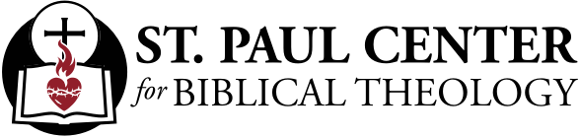

Our True Home: Scott Hahn Reflects

on the Feast of the Holy Family

Why did Jesus choose to become a baby born of a mother and father and to spend all but His last years living in an ordinary human family? In part, to reveal God’s Plan to make all people live as one “holy family” in His Church (see 2 Corinthians 6:16–18).

In the Holy Family of Jesus, Mary, and Joseph, God reveals our true home. We’re to live as His Children, “chosen ones, holy and beloved,” as the First Reading puts it. The family advice we hear in today’s readings — for mothers, fathers, and children — is all solid and practical. Happy homes are the fruit of our faithfulness to the LORD, we sing in today’s Psalm. But the Liturgy is inviting us to see more, to see how, through our family obligations and relationships, our families become heralds of the Family of God that He wants to create on earth.

Jesus shows us this in today’s Gospel. His obedience to His earthly parents flows directly from His obedience to the Will of His heavenly Father. Joseph and Mary aren’t identified by name, but three times are called His “parents” and are referred to separately as His “mother” and “father.” The emphasis is all on their familial ties to Jesus. But these ties are emphasized only so that Jesus, in the first words He speaks in Luke’s Gospel, can point us beyond that earthly relationship to the Fatherhood of God.

In what Jesus calls “My Father’s House,” every family finds its true meaning and purpose (see Ephesians 3:15). The Temple we read about in the Gospel today is God’s House, His Dwelling (see Luke 19:46). But it’s also an image of the Family of God, the Church (see Ephesians 2:19–22; Hebrews 3:3–6; 10:21).

In our families we’re to build up this household, this family, this living temple of God until He reveals His new dwelling among us and says of every person: “I shall be his God and he will be My son” (see Revelation 21:3, 7).

Readings: Sirach 3:2–6, 12–14; Psalm 128:1–2, 3, 4–5;
Colossians 3:12–21; Luke 2:22–40

Readings: Numbers 6:22–27; Psalm 67:2–3, 5–6, 8;
Galatians 4:4–7; Luke 2:16–21

Sunday Collection Summary for Dec. 23 & 24
and the Holy Day of Christmas

Weekend Collections
Regular Offering (4th Sun. of Advent) $ 2,677.00
Immaculate Conception $ 20.00
Solemnity of Mary, Mother of God $ 25.00
Thanksgiving $ 20.00
TOTAL OFFERINGS $ 7,773.00

‒ WEEKLY BUDGETARY NEEDS $ 4,494.00
+Overage or (Shortfall) for the week +$ 3,279.00

Christmas $ 5,051.00
Christmas (previous weeks) $ 1,195.00
TOTAL CHRISTMAS $ 6,246.00
‒ Christmas Budgeted Offering $ 6,000.00
+Overage/(Shortfall) for the Holy Day +$ 246.00

Other Income
Candles/Living Faith $ 153.50
Cemetery Annual Care $ 20.00
Christmas Flowers $ 160.00
Individual Contributions $ 5,000.00
Total Other Offerings $ 5,333.50

Diocesan Second Collections
Church in Eastern Europe & Africa $ 15.00
Retirement for Religious $ 5.00
Total Diocesan Offerings $ 20.00

Scott Hahn Reflects on Mary, The Mother of God
On this Holy Day, we give thanks to Mary, the Mother of God [the Holy Theotokas in Greek]. Her response to the Angel, born of a humble heart, brought us life and salvation in the Child conceived in her womb.

From before all ages, God had destined her for this decisive role in salvation history. She was to be the woman who in the fullness of time would bear God’s only Son, as Paul tells us in today’s Epistle.

In times past, God spoke to His chosen people, the Isra-elites, through Prophets (see Hebrews 1:1–2), and imparted His blessings upon them through His priests, as we hear in today’s First Reading.

But now, He has sent His Son to reveal His glory and His Kingdom, to make His way of salvation known to all nations, as we sing in today’s Psalm. In the Infant lying in the manger, God has shone His Face upon us (see John 14:8–9).

Jesus is made a child of Isra-el, an heir of God’s Covenant with Abraham, by His circumcision in today’s Gospel (see Genesis 17:1–14). And we have been made adopted sons and daughters by Baptism, which is the “circumcision” of Christ, the true circumcision (see Colossians 2:11; Philippians 3:3).

As Children of God, St. Paul says today, we are heirs of the Father’s blessings, which He promised to bestow on all peoples through the descendants of Abraham (see Genesis 12:3; 22:18; Galatians 3:14). This is the Blessing that Aaron imparted to Isra-el, the people descended from Abraham. And this blessing comes to us through Mary and the Child.

This is the good news of great joy that the shepherds make known in Bethlehem today (see Luke 2:10). Like the shepherds, we too should make haste today to find Jesus with Mary and Joseph, to glorify God for His blessings. And like Mary, we should keep His word and reflect upon it, letting it dwell richly in our hearts (Colossians 3:16).

Kenneth Swartz, Dominic DeToma, The Swartz family & DeToma family.
From: Lena Swartz

Deceased members of the Smith & MacBeth Families.
From: Donald & Diane MacBeth

Clara Redding, Mary Redding, George Lambert, Ted Fanwell, Louise Deardorff, Dennis Plunkert, Rosy Plunkert, Ken Mcdannell, & Betty MacBeth.
From: Brian & Pam Redding

Barbara & Darrel Gillin, Vicki & Freeman Showers, Jeff & Michelle Cramer; Marie, Calvin & Nita Cook, Catherine & Robert Wonders, Dorothy & Kenneth Gillin.
From: Mr. & Mrs. Cramer

Family & Friends
From: Winifred Schulteis

Mr. & Mrs. L. Blaine Sanders Sr., Mr & Mrs. Kermit E. Singley sr., Mr. Rick Gochenauer, & Mr. Mark A. Sanders Sr.
From: Mr. & Mrs. John Sanders

JoAnn Gallagher
From: Daniel Gallagher

Deceased members of the Finamore & Dunchak Families.
From: Irene Finamore

John & Betty Ernst, & James & Esther Delaney.
From: Greg & Peggy Ernst

The Kane family, Strasbaugh family, Beidel family, Staver family.
From: Angie Kane

Jerry Breier & Don Peron
From: Marilyn Peron

The Schur & Hartman Families
From: Mark & Penny Schur

Frank & Lois Bavetz
From: Christopher & Julie Monzi

Lloyd Coffman Sr., Pauline Coffman, Randy Coffman, Lloyd Coffman Jr., Jessie Carbaugh, Bobby Ellis, Barb Fissel, & Merle Bucher.
From: Mr. & Mrs. Charles Baker

William & Janette Rowe
From: Barbara Lee Molloy

Deceased members of the Kolleogy & Kime families.
From: Lou & Rhonda Kolleogy

Richard Hovelmann
From: Janice Meligakes

Betty Steinberger & Millie Morrison
From: Richard Steinberger

Anthony & Anna Gatto, Claude & Mary Mobley
From: Philip & Lynne Mobley

Bill Rollins, Bill Sr. & Dot Rollins, & Joseph Miller Family.
From: Kathleen Rollins

In memory of the deceased members of the Allwein &
McCleaf Families.
From: Mr. & Mrs. Thomas Allwein

George & Alice Bowling, Children; Robert, Elaine, & Wayne. Robert Kayhoe Jr., & Victor & Anna Re.
From: Arthur & Marie Re

Joseph Siko & Roberta Schwartz
From: Donnaleigh Siko

Dave & Jo Demichei
From: Diane Ebersole

Sam & Elsie Tarquino, Raymond & Maxine Minnich, Joseph & Rose Sperduto, & Robert Joseph Morris.
From: Mat & Ali Morris

James Cornell, The Cornell Family, The Kwisnek Family,
& the Borbanus Family.
From: Beth Cornell

Marian & Edward Grady
From: Marilyn Snyder

Timothy & Andrew Heller, Joseph & Sara Keller, Robert & Geneva Heller.
From: Martha Heller

The Vega & Rendina families
From: Dorothy Vega

Walter & Elizabeth Prucnal, Walterene Prucnal,
Joe & Nora Merrill.
From: Cynthia Merrill

Ron Grance, Effie & Don Heffner, Hedwig & Theodore Grance.
From: Catherine Grance

Mr. & Mrs. Dale Baker, Mr. & Mrs. Raymond Michael Baker.
From: John Baker

Jim & Delores Gilbert
From: All of their loving Children

Bernenda, Franklin Walter & Family, Margarette, Paul McDannell & Family,
Mary & John McKenrick, Bill Denderlan, Paul Larson, & Dean Speelman.
From: Carol & Bernie McDannell

Deceased members of John I Hall Family, Paul & Rosellen Martz, Johnny Hall.
From: Paul & Mary Ellen Hall
Mr. & Mrs. John A. Stossel, Mr. & Mrs. Robert Irr, Mr. & Mrs. Frank Pawloski, Mr. & Mrs. Josseph O’Rourke, & Mr. James Head.
From: Mr. & Mrs. John Stossel

Trish-Ann Weishaar
From: Ron Weishaar

Mary E. & John J. Wendland, Thomas, Pauline & Stanley Lesinski, Mary E. & Peter wendland, Irene & Christian Rebscher Jr.
From: Christian & Mary Rebscher III

OTHER DONORS:
Jim & Ginny Bittle Christian A. Rebscher Donny Althoff
Michelle Dominguez Patricia Johnson Bicky Redman
Mr. & Mrs. Formosa Ken Cole Cheryl Sobun & Karlton Smith
Mr. & Mrs. Collins Dean Martz Kathy & Steve Kane
Joan Mears Dennis Kump Bob & Linda Hockensmith
Christine McCarty Richard & Kaye Boyer The Dabney’s

The Different Meanings of Christmas Flowers

During Christmastime, we are often reminded of seasons past spent with those we love. Christmas flowers are the perfect selection for creating a beautifully personalized piece for the holiday season. Each flower and plant selection has a symbolic meaning that is as beautiful as the plant itself.

Poinsettia
Poinsettias are synonymous with the Christmas season. The vibrant leaves of the Poinsettia are known as bracts and come in shades of red, white and pink. Most people believe the star shape of the bract represents the Star of Bethlehem which guided the Wise Men to Jesus. A Poinsettia’s red leaves signify the Blood of Christ and its white leaves symbolize the purity of the Son of God.

Another legend of the Poinsettia tells the story of a young Mexican girl who brought Poinsettias to a church altar on Christmas Eve. She was too poor to buy a gift and felt ashamed of her plants. She placed her bouquet of weeds at the foot of the church’s nativity scene, when suddenly the bracts of the Poinsettia began to bloom, revealing a bright red shade. The congregation considered this a miracle and from then on referred to Poinsettias as "Flores de Noche Buena" or "Flowers of the Holy Night".

Holly
The red and green shades of the holly plant represent the two most popular colors of the holiday season. A Holly plant’s pointed green leaves are said to symbolize the crown of thorns worn by Jesus, while the red berries signify the Blood that He shed.

Christmas Rose
The Christmas Rose is associated with Jesus’ Birth and the story of a young shepherdess named Madelon. Madelon was saddened that she did not have a gift to offer Baby Jesus and, as she wept, an Angel appeared. While consoling Madelon, the Angel swept away snow to reveal a collection of white flowers with pink tips. This cluster of flowers would be Madelon’s gift to the newborn Christ-Child and thus, the tradition of the Christmas Rose was born.

Mistletoe
The story of this traditional Christmas flower dates back to the pagan druids of ancient Britain who used this plant during their winter celebrations. Because of its ability to stay green for periods of time without being rooted, the druids believed Mistletoe possessed magical powers that brought good luck and warded off evil spirits.

