Sacrament of Penance
Wednesday ~ 6:00 - 7:00 pm; or by appointment.

Sacrament of the Sick
Anointing of the Sick should be given if an individual is gravely ill or near death. If possible, the Sacrament should also be administered before major surgery or when one is initially hospitalized.

Sacrament of Holy Matrimony
Diocesan policy requires 12 months of preparation for Marriage. Contact the parish as soon as possible after engagement. No arrangements should be made prior to consultation with the pastor.

Sacrament of Baptism
Parents must be registered members of the parish and attend a Baptism preparation class prior to the Baptism if this is your first child baptized. Requirements for godparents are established by the Catholic Church. Please call the parish office for Information and to register your child for Baptism.

Parish Registration
All Catholics should be registered in their local parish. Please contact the parish office to obtain registration forms, or if you are uncertain of the parish where you should register.

Parish Staff & Ministries Directory
stignatiusofloyola@hbgdiocese.org
Financial Manager ~ Richard Deardorff ~ 717- 677-8012 or 717-420-3464 (cell)
rdeardorff@hbgdiocese.org
Director of Religious Education ~ Deacon Steve Huete ~ shuete@hbgdiocese.org
Administrative Assistant ~ Kristen DiDio ~ kdidio@hbgdiocese.org
Buildings & Grounds ~ JB Groff ~ 717-677-8012
Music Ministry ~ Phil Mobley ~ 717-677-8012
Parish Council Members
*Walt Wilson – Chair 401-0570 (h) wwilson1198@comcast.net
Joanne Riedel - Secretary 398-2021 (h) sterj221@aol.com
Kathi Allwein 677-8984 (h) allweint@comcast.net
*Donnie Althoff 339-6527 (c) dalthoff53@gmail.com
Charlie Baker 677-9536 (h) dcbake@embarqmqil.com
*Jim Bittle 677-6711 (h) ginnybittle@comcast.net
Mike McTighe 729-6239 (c) mike0432@aol.com

Finance Council Members
Richard Deardorff (Ex Officio)
Greg Ernst - Chair
Alix Haller
Christy Hemler - Secretary
Terri Pendlelton
Bill Pulig

Altar Flowers
Prayer Chain
Lynne Mobley at LMOBLEY509@gmail.com
or 703-876-4901.

Soup Kitchen
Please send donations directly to “Soup Kitchen”

Website Development
Kristen DiDio
Life After Loss
Dodie Huete

OCIA
Contact Fr. Dominic

Picnic Co-Chairpersons
John Neiderer
Wally Kane

Pro-Life Ministry
OPEN – Contact office if you are interested

Knights of Columbus
SK Bob Ternes
- Grand Knight

Covid-19 Task Force
Walt Wilson - Coordinator
Health Advisors:
Dr. Robert Ternes and
Joanne Cochran
(Keystone Health System)

OPEN - Contact office if you are interested

Bereavement Ministry
Ginny Bittle

Catholic Communications/EWTN
Open - Contact office if you are interested

Cemetery
Contact Parish Office
THEOSIS Ministry
Kathy Dietsch 717-352-4558
Bicky Redman 717-677-8592

Diocese of Harrisburg Youth Protection Program
www.YouthProtectionHBG.com

Abuse Reporting Contact Information:
First – Call the toll-free PA Child Abuse Hotline at 800-932-0313
Then – Call the Diocesan toll-free hotline at 800-626-1608

“If one member suffers,
all suffer together with it.” (1 Cor 12:26)

St. Ignatius Loyola RC Church

1095 Church Road, Orrtanna, Pennsylvania 17353
www.stignatiusofloyola.org

February 26, 2023: FIRST SUNDAY of LENT
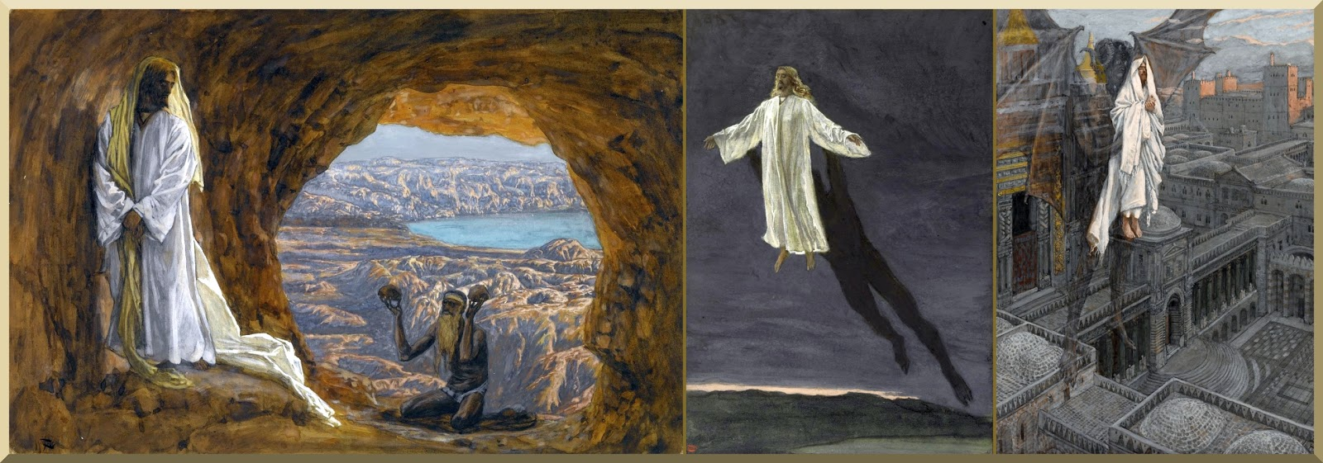
T
H
E

L
O
R
D

T
H
Y

G
O
D
!
Y
O
U

S
H
A
L
L

N
O
T

T
E
M
P
T

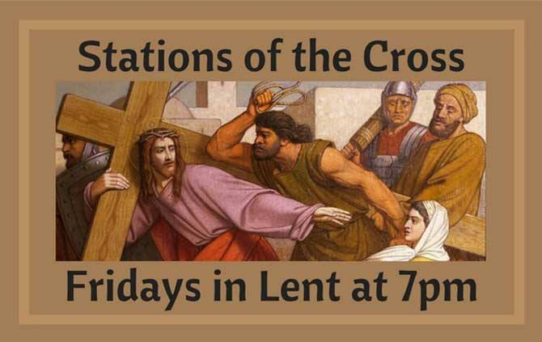

Most Reverend Ronald W. Gainer, Bishop of Harrisburg;
Rev. Dominic M. DiBiccaro, Pastor / Deacon Steve Huete, Pastoral Associate
Mass Schedule, Intentions, and Events
Please Pray for:
Coronavirus victims and those who are ill, Jim & Jeanie Kline, Chuck & Nancy Wuller, Dr. Mike Colli, Mrs. Kelly Kump, Kevin & Brittany Groff, Gabriel Singer, Sharon McCormley, Ron Thumma, Joe Wisotzkey, Leo Hockensmith, Erika McKissick, Jean "Heather" O'Shea, Scott Moore and Sally Moore, Mary Wyatt, Jim & Joyce Deardorff, Brandon & Michelle Gilbert, Amy Weatherup, Sophia Joy Ernst, Mary & Chuck Irwin, Deacon Richard Wentzel, Deacon Frank Enderle, Marie Kalp, Kathleen Thompson, Deb & Kathy McLintock and Family, Rachel Wonders, Amy Edwards, Jean O’Connor, Art Lazar, Sr., Mark & Michelle Huete, Paul Angello, Jen Baldwin, Ursula Kaley, Deb Bennet, Fr. Bill Sullivan, Fr. Chet Snyder, John Larry Endy, Mary Beth McCarthy, Laura Lee, Marwa Abdelrahman, Cathy Gates, Donna Singley, Jack Ryff, Tim McGinn, Jane Kump, Gary, Bill, Jerry, Andy, Colleen, Baby Addie, Peggy Neiderer, Chris Kimple, Robert Riquet, Gene & Jo-Ann McDannell, Bob Doxzen, Kimberly Mears, Gabriella Angello, Mark & Kate Morrow, Mark Morris, Linda Fogleman, Paul Knight, George & Barbara Erstila, Jeff Carpenter, Lana & Nelson Harmon, Cole & Connor, Diane Slothour, Sue McDannell, Larry Schneider, Joe & Lisa Grasel, Ange Pena, Julie Barnhart, the Shaffer Family, Heather & Emma Dickerson, Brad Pabody, Adeline Lienard, Paul Ward, Aiden Tyler Schneider, Dorothy Vega, Karrie McCall & daughter, George Shahid, Denise Navlyt, Drew Schneider & Family, Ida Bloomfield, Linda McDannell, Janie Singley, Mary Beth Greenstreet, Rick Benedict, Jan Patla, Kathe Fogleman, Sam Sheffler, Kate Hemmis, Bill & Mary Lou Graham, Joanna Hodges, John Varones, Joan O’Sullivan, Martha Klinger, Lisa Dionne Lauretti, Sue Orndorff, Jim Gleason, Sue Gustafson, Joe & Michelle Cleary, Kim Johnson, Helen Mills, Kathy Haber, Haley Detman, Joe Durovey, Bev Smith, Donald Sheppard, Linda Mumaugh, Alison Haring, Janet Hartman, Edward Johnson, Angela Galeone, Juliete Lang, Chris MacBeth, Harry Graham, Donald Howard, Armond Binni, Elizabeth Stansky, Pat Johnson, Chris Morris, Faud Doaney, Wilson & Rae Harman, Patrick Glass, Helen Lagasse, Nancy Kewisnek, Andy Graham, Bill & Maureen Collins, Rosemary McGilloway, Anji Eisenhart, Monica Manner, Denny Borbonus, Dr. Paul Scarlata, Mary Hawthorne, Ed Washington, Josh Kempinski, Nancy Baker Baltzey, Spencer Propts, Karlton Smith & Cheryl Sobun, James & Marylyn Sobun, Marlene Webster, Yvette Stoklosa, Andy Consiglio, Bill & Michelle Cloonan, Nelson Salem, Janet Shunnarah, George Shunnarah, Bill & Deb McClintock, Mary Pekich, nursing home residents & shut-ins, the victims of war, violence, disease, disaster, & all private intentions.
Also In your prayers, please remember all
our men and women currently serving in
our Armed Forces:
Maj. Nathan Jeffcoat – US Marine Corps
Lt. Alexandra Jeffcoat – US Navy
Lt. Joseph Cleary – US Navy
Michael C. Kenney IV – US Coast Guard
Lt. Joshua Kimple – US Army
Lt. Sarah Fogleman, M.D. – US Navy
PRAYER CHAIN: Contact Lynne Mobley at 703-876-4901 or
LMOBLEY509@gmail.com

for the Week of February 26 ~ March 5, 2023

SATURDAY, February 25 - VIGIL MASS 1st SUNDAY OF LENT

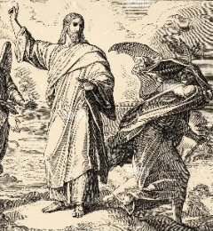
Gn 2:7-9; 3:1-7 / Rom 5:12-19 or 5:12, 17-19 / Mt 4:1-11
5:00PM + Timothy Heller

SUNDAY, February 26 – 1st SUNDAY OF LENT

Gn 2:7-9; 3:1-7 / Rom 5:12-19 / Mt 4:1-11
8:00AM ~ People of the Parish
10:30AM + Charles J. Greiner

Monday, February 27 – St. Gregory of Narek, Abbot & Doctor
Lv 19:1-2, 11-18 / Mt 25:31-46 of the Church
Parish Office Closed

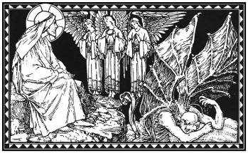
Tuesday, February 28 (Lenten Weekday)
Is 55:10-11 / Mt 6:7-15
8:00AM - 3:00 PM ~ Office Open
10:00AM + Nolan Patrick Gilbert

11:00AM:“Something More” Faith Group

Wednesday, March 1 (Lenten Weekday)
Jon 3:1-10 /L k 11:29-32

8:00AM - 3:00 PM ~ Office Open

11:00AM Senior Spirituality Group
7:00PM + David Redding
Confessions heard 6 to 6:45PM;
Adoration from 7:40 to 8PM
Thursday, March 2 (Lenten Weekday)
Est C:12, 14-16, 23-25 / Mt 7:7-12
8:00AM - 3:00 PM ~ Office Open
10:00AM + Joan and Eugene Schott

Friday, March 3 -St. Katharine Drexel,Virgin
Ez 18:21-28 / Mt 5:20-26
10:00AM + Sylvia Anna Tobara
Parish Office CLOSED
7:00PM

Saturday, March 4 – St. Casimir

MORNING: Dt 26:16-19 / Mt 5:43-48

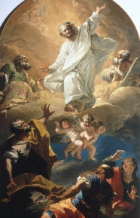
SATURDAY, March 4 - VIGIL MASS 2nd SUNDAY OF LENT

Gn 12:1-4a / 2 Tm 1:8b-10 / Mt 17:1-9
5:00PM + Joseph Keller
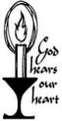
SUNDAY, March 5 – 2nd SUNDAY OF LENT

Gn 12:1-4a / 2 Tm 1:8b-10 / Mt 17:1-9 OF LENT
8:00AM + S.K. Ray Haber
10:30AM ~ People of the Parish
Sanctuary candle offered for FEBRUARY: In loving memory of Donald Redding from Edna Redding
Sunday Collection Summary

2023 HERSHEY PARK DISCOUNT TICKETS
ARE NOW AVAILABLE!
Pick up an Order Form in the Narthex of the Church, fill out and return with your payment. You may drop off in the office or place in an envelope and drop in the collection basket (marked Hershey Park, office)
NO LATER THAN MARCH 26th.
Ticket Prices
Purchase before March 26th, 2023: $42.95
(Regular price $85.80)
Tickets valid April - January 1, 2024
OR $40.95 (Regular price $85.80)

Single-Use Meal Plan Prepaid Parking Passes
$14.99 (reg. price $16.95) $20.00 (pre-purchase only)

February 18 & 19
and
February 22, Ash Wednesday

Weekend Collection
Regular Offering $ 3,256.00
Ash Wednesday $ 1,001.00
Local Poor $ 60.00
Candles $ 125.00
TOTAL OFFERINGS $ 4,442.00

‒ WEEKLY BUDGETARY NEEDS $ 5,819.68
+Overage or (Shortfall) for the week ($ 1,377.68)

Other Income
Sanctuary Candle $ 25.00
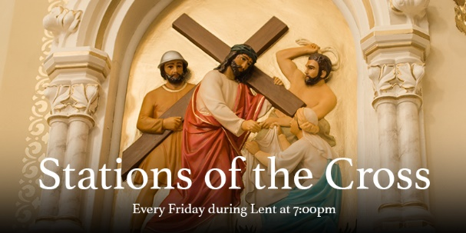
Individual Contribution $ 500.00
TOTAL OTHER OFFERINGS $ 525.00

Diocesan Second Collections
Propagation of Faith $ 95.00
Poor Missions US $ 62.00
TOTAL DIOCESAN OFFERINGS $ 157.00

Parish Council Meeting Summary
February 7, 2023
- After an opening prayer, the meeting was convened having two members excused. All Ex-officio members and four guests were present. Minutes of the January 10, 2023, meeting was approved.

- Discussed recent Gettysburg Times article about the renaming taking place within Federal jurisdictions where the term “squaw” is or has been used. The article states that it is considered an offensive slur by ingenious North American women. If this movement gains traction, its impact on our parish identity could be quite negative given the past behavior of contemporary media dealing with issues like this. Although this item is tabled for the moment, our parish may want to start reflecting on continuing to use this term identifying the secular icon, Mary Jemison to our Catholic parish identity. Food for thought!

- Eucharistic Revival materials were reviewed with brief discussion on starting parish level planning. More to follow.

- Discussed the need in conjunction with the Parish Finance Committee for developing a Parish Pastoral Plan focusing on the six mission areas (evangelization, education, pastoral, liturgy, social concerns and outreach, ecumenism and interfaith concerns) and coordinating those missions within routine council functions. More to follow.

- Established a Parish Council Executive Committee, consisting of the Pastor, Finance, Parish Council Chairs, Parish Council Vice Chair, Parish Council Secretary and Deacon Steve.

- Reviewed and discussed timeline for parish council member election, security grant status, progress on Theosis, the new parish mission program, bell ringing before Mass and December’s financial report.

- Input from guests included concerns about proposed land lease agreement, encouragement to plan for next parish wide meeting, suggestions on additional channels of communication with council members and a caution about any hasty effort to change our squaw Mary Jemison identity.

- Next meeting is March 14, 2023, at 6:30 PM in the community center conference room. (A copy of the full minutes is available for review in the Parish Office.)

February 27 – 2023 PICNIC Kick-Off Meeting,6:30PM
March 3 – Parish Lenten Fish Fry, 5PM to 7PM
March 11 – Lenten Mini Retreat w/Sr.Thelma Steiger
March 12 – DAYLIGHT SAVINGS TIME BEGINS!

March 12 – Parish Council Nominations Closes

March 18 – Diocesan Men’s Retreat

Monday,
February 27, 6:30pm,
down in the Social Hall

“You pray for the hungry.
Then you feed them.
That’s how prayer works.”
— Pope Francis

Food for Families ~ Faith in Action

DONATIONS BASKET IN NARTHEX

Make out any checks to: “Knights of Columbus #10435”

ALL PROCEEDS GO TO SCAAP (SOUTH CENTRAL COMMUNITY ACTION PROGRAM) IN GETTYSBURG
The Holy Father, Pope Francis’ Prayer Intentions for 2023
Entrusted to His Worldwide Prayer Network
FEBRUARY ~ For parishes
We pray that parishes, placing communion at the centre, may increasingly become communities of faith, fraternity, and welcome towards those most in need.

Tale of Two Adams: Scott Hahn Reflects

on the First Sunday of Lent

In today’s Liturgy, the destiny of the human race is told as the tale of two “types” of men — the first man, Adam, and the new Adam, Jesus (see 1 Corinthians 15:21–22; 45–59).

St. Paul’s argument in the Epistle is built on a series of contrasts between “one” or “one person” and “the many” or “all.” By one person’s disobedience, sin and condemnation entered the world, and death came to reign over all. By the obedience of another one, grace abounded, all were justified, and life came to reign for all.

This is the drama that unfolds in today’s First Reading and Gospel.

Formed from the clay of the ground and filled with the Breath of God’s own Spirit, Adam was a “son of God” (see Luke 3:38), created in His Image (see Genesis 5:1–3). Crowned with glory, he was given dominion over the world and the protection of His Angels (see Psalms 8:6–8; 91:11–13). He was made to worship God — to live not by bread alone but in obedience to every word that comes from the mouth of the Father.

Adam, however, put the LORD his God to the test. He gave in to the serpent’s temptation, trying to seize for himself all that God had already promised him. But in His hour of temptation, Jesus prevailed where Adam failed — and drove the devil away.

Still, we sin after the pattern of Adam’s transgression. Like Adam, we let sin in the door (see Genesis 4:7) when we entertain doubts about God’s promises, when we forget to call on Him in our hours of temptation.

But the grace won for us by Christ’s obedience means that sin is no longer our master.

As we begin this season of repentance, we can be confident in His compassion, that He will create in us a new heart (see Romans 5:5; Hebrews 8:10). As we do in today’s Psalm, we can sing joyfully of our salvation, renewed in His presence.

Readings: Genesis 2:7–9; 3:1–7; Psalm 51:3–6; 12–14, 17; Romans 5:12–19; Matthew 4:1–1

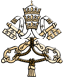
MESSAGE OF HIS HOLINESS POPE FRANCIS
FOR LENT 2023

Lenten Penance and the Synodal Journey
Dear brothers and sisters!

The Gospels of Matthew, Mark and Luke all recount the episode of the Transfiguration of Jesus. There we see the LORD’s response to the failure of His disciples to understand Him. Shortly before, there had been a real clash between the Master and Simon Peter, who, after professing his faith in Jesus as the Christ, the Son of God, rejected His prediction of the Passion and the Cross. Jesus had firmly rebuked him: “Get behind me, Satan! You are a scandal to Me, because you do not think according to God, but according to men!” (Mt 16:23). Following this, “six days later, Jesus took with Him Peter, James and John his brother and led them away to a high mountain” (Mt 17:1).

The Gospel of the Transfiguration is proclaimed every year on the Second Sunday of Lent. During this liturgical season, the LORD takes us with Him to a place apart. While our ordinary commitments compel us to remain in our usual places and our often repetitive and sometimes boring routines, during Lent we are invited to ascend “a high mountain” in the company of Jesus and to live a particular experience of spiritual discipline – ascesis – as God’s Holy People.

Lenten penance is a commitment, sustained by grace, to overcoming our lack of faith and our resistance to following Jesus on the Way of the Cross. This is precisely what Peter and the other disciples needed to do. To deepen our knowledge of the Master, to fully understand and embrace the mystery of His Salvation, accomplished in total self-giving inspired by love, we must allow ourselves to be taken aside by Him and to detach ourselves from mediocrity and vanity. We need to set out on the journey, an uphill path that, like a mountain trek, requires effort, sacrifice and concentration. These requisites are also important for the synodal journey to which, as a Church, we are committed to making. We can benefit greatly from reflecting on the relationship between Lenten penance and the synodal experience.

In his “retreat” on Mount Tabor, Jesus takes with Him three disciples, chosen to be witnesses of a unique event. He wants that experience of grace to be shared, not solitary, just as our whole life of faith is an experience that is shared. For it is in togetherness that we follow Jesus. Together too, as a pilgrim Church in time, we experience the liturgical year and Lent within it, walking alongside those whom the LORD has placed among us as fellow travelers. Like the ascent of Jesus and the disciples to Mount Tabor, we can say that our Lenten journey is “synodal”, since we make it together along the same path, as disciples of the one Master. For we know that Jesus is Himself the Way, and therefore, both in the liturgical journey and in the journey of the Synod, the Church does nothing other than enter ever more deeply and fully into the mystery of Christ the Saviour.

And so we come to its culmination. The Gospel relates that Jesus “was transfigured before them; His Face shone like the sun and His clothes became white as light” (Mt 17:2).This is the “summit”, the goal of the journey. At the end of their ascent, as they stand on the mountain heights with Jesus, the three disciples are given the grace of seeing Him in His glory, resplendent in supernatural light. That light did not come from without, but radiated from the LORD Himself. The Divine Beauty of this vision was incomparably greater than all the efforts the disciples had made in the ascent of Tabor.

During any strenuous mountain trek, we must keep our eyes firmly fixed on the path; yet the panorama that opens up at the end amazes us and rewards us by its grandeur. So too, the synodal process may often seem arduous, and at times we may become discouraged. Yet what awaits us at the end is undoubtedly something wondrous and amazing, which will help us to understand better God’s Will and our mission in the service of His Kingdom.

The disciples’ experience on Mount Tabor was further enriched when, alongside the transfigured Jesus, Moses and Elijah appeared, signifying respectively the Law and the Prophets (cf. Mt 17:3). The newness of Christ is at the same time the fulfilment of the ancient Covenant and Promises; it is inseparable from God’s history with His People and discloses its deeper meaning. In a similar way, the synodal journey is rooted in the Church’s tradition and at the same time open to newness. Tradition is a source of inspiration for seeking new paths and for avoiding the opposed temptations of immobility and improvised experimentation.

The Lenten journey of penance and the journey of the Synod alike have as their goal a transfiguration, both personal and ecclesial. A transformation that, in both cases, has its model in the Transfiguration of Jesus and is achieved by the grace of His Paschal Mystery. So that this transfiguration may become a reality in us this year, I would like to propose two “paths” to follow in order to ascend the mountain together with Jesus and, with Him, to attain the goal.

The first path has to do with the command that God the Father addresses to the disciples on Mount Tabor as they contemplate Jesus transfigured. The Voice from the Cloud says: “Listen to Him” (Mt 17:5). The first proposal, then, is very clear: we need to listen to Jesus. Lent is a time of grace to the extent that we listen to Him as He speaks to us. And how does He speak to us? First, in the word of God, which the Church offers us in the Liturgy. May that word not fall on deaf ears; if we cannot always attend Mass, let us study its daily biblical readings, even with the help of the internet. In addition to the Scriptures, the LORD speaks to us through our brothers and sisters, especially in the faces and the stories of those who are in need. Let me say something else, which is quite important for the synodal process: listening to Christ often takes place in listening to our brothers and sisters in the Church. Such mutual listening in some phases is the primary goal, but it remains always indispensable in the method and style of a synodal Church.

On hearing the Father’s Voice, the disciples “fell prostrate and were very much afraid. But Jesus came and touched them, saying, ‘Rise, and do not be afraid.’ And when the disciples raised their eyes, they saw no one else but Jesus alone” (Mt 17:6-8). Here is the second proposal for this Lent: do not take refuge in a religiosity made up of extraordinary events and dramatic experiences, out of fear of facing reality and its daily struggles, its hardships and contradictions. The light that Jesus shows the disciples is an anticipation of Easter glory, and that must be the goal of our own journey, as we follow “Him alone”. Lent leads to Easter: the “retreat” is not an end in itself, but a means of preparing us to experience the LORD’s Passion and Cross with faith, hope and love, and thus to arrive at the Resurrection. Also on the synodal journey, when God gives us the grace of certain powerful experiences of communion, we should not imagine that we have arrived – for there too, the LORD repeats to us: “Rise, and do not be afraid”. Let us go down, then, to the plain, and may the grace we have experienced strengthen us to be “artisans of synodality” in the ordinary life of our communities.

Dear brothers and sisters, may the Holy Spirit inspire and sustain us this Lent in our ascent with Jesus, so that we may experience His Divine Splendour and thus, confirmed in faith, persevere in our journey together with Him, Glory of His People and Light of the Nations.

Rome, Saint John Lateran, 25 January,
Feast of the Conversion of Saint Paul

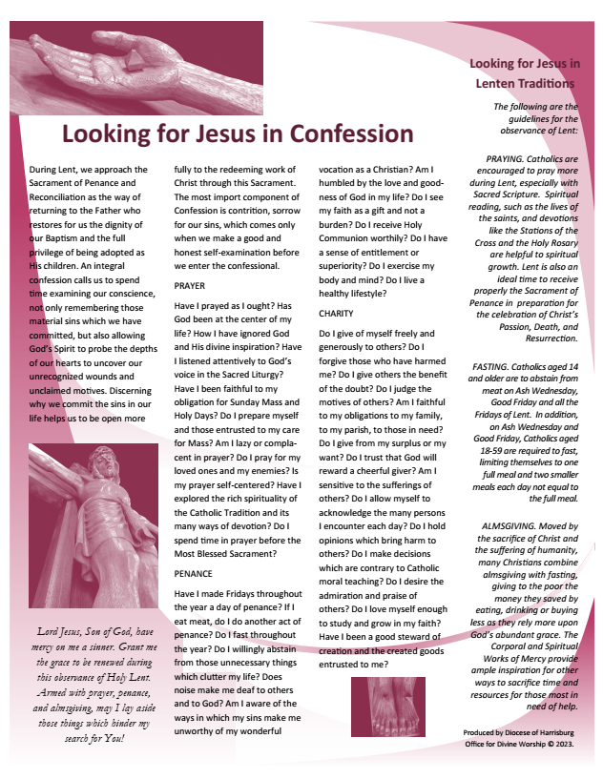
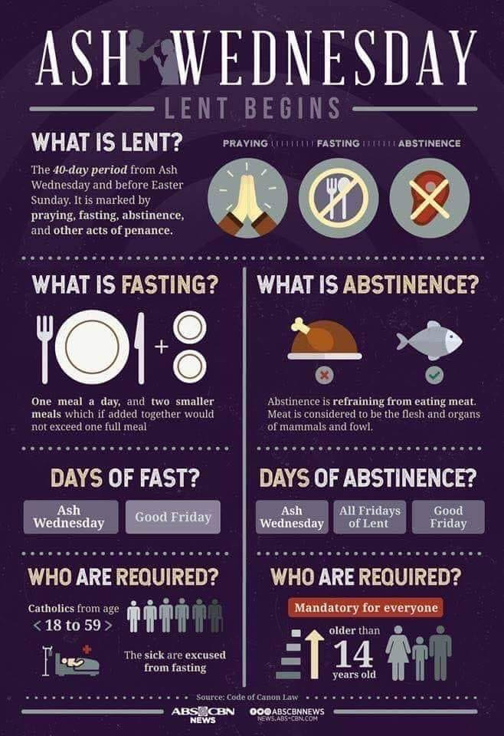

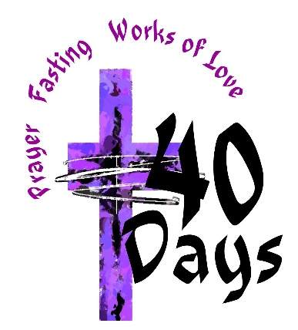
Lenten Mini- Retreat
with
Sr. Thelma Steiger, HSF
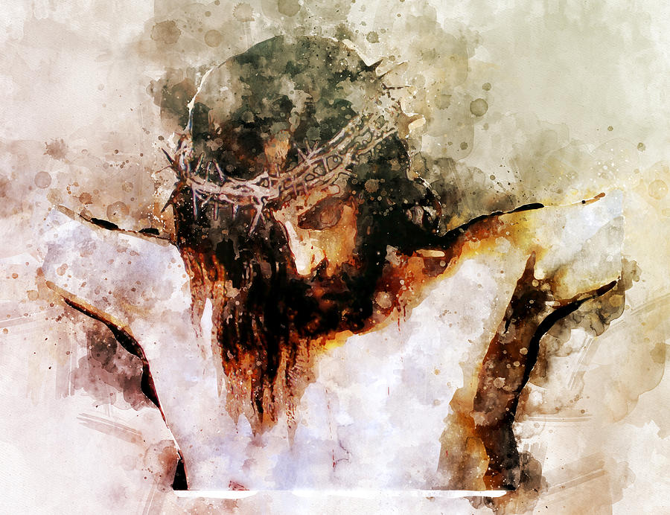
“Contemplating the Mysteries of Passiontide through the
Eyes of the Heart”

Saturday, March 11, 10AM to Noon
Down in the Parish Social Hall

Eucharistic Prayer Companion for First Sunday of Lent:

The Hunger for God

February 22, 2023 | Eucharistic Revival Team

This Eucharistic Meditation is designed to help you spend 30 minutes to an hour in meditation and silent prayer with Jesus during Eucharistic adoration. Even if you cannot be physically present in a church or adoration chapel with the Blessed Sacrament, you can unite yourself spiritually to the Eucharist as you spend this time in prayer.

THE GRACE I SEEK: to believe that Jesus longs to feed my soul with Himself

‍IN THE NAME OF THE FATHER, AND OF THE SON, AND OF THE HOLY SPIRIT. AMEN.

Jesus, the LORD of Life, has given Himself to you in the Eucharist. He is gazing upon you, His beloved child, with great love at this very moment. Pause for a few moments and wonder at His gift for you. Allow yourself to rest in His loving gaze. Thank Jesus for the gift of Himself in the Eucharist.

ASK FOR THE GRACE: Jesus, help me to believe You will satisfy every longing of my heart.

SCRIPTURE MEDITATION

‍Read slowly, 3-4 times. Allow the words of Scripture to wash over your mind and heart. Allow the Holy Spirit to speak to you through this passage.

‍“But the serpent said to the woman: ‘You certainly will not die! No, God knows well that the moment you eat of it your eyes will be opened and you will be like gods who know what is good and what is evil.’ The woman saw that the tree was good for food, pleasing to the eyes, and desirable for gaining wisdom. So she took some of its fruit and ate it; and she also gave some to her husband, who was with her, and he ate it.” (Genesis 3:4-6)

REFLECTION QUESTION

Allow yourself to sit with these questions for a while, being attentive to how the LORD is speaking in your heart.
What are the “fruits” your heart is hungering for? Are there times you have grasped at ways to satisfy this hunger in your heart, only to realize these things did not satisfy? Share these openly and honestly with the LORD.

SCRIPTURE MEDITATION

‍Read slowly, 3-4 times. Again, allow the words of Scripture to wash over your mind and heart. Let the Holy Spirit speak to you through this passage.

“The tempter approached and said to Him, ‘If you are the Son of God, command that these stones become loaves of bread.’ He said in reply, ‘It is written: One does not live on bread alone, but on every word that comes forth from the Mouth of God.’” (Matthew 4:3-4)

‍REFLECTION QUESTION

‍Allow yourself to sit with these questions for a while, being attentive to how the LORD is speaking in your heart.
Jesus desires to fulfill the deepest longings of our heart with Himself — His Body and His Blood. Gazing upon the Eucharist, ask Jesus to show you how He wants to satisfy the hunger of your heart. Beg Him to enter into that hunger with His Eucharistic Presence.
Remain in silence with the LORD. Allow Him to speak in the silence, in your heart. Receive His presence. If it helps, write down what you sense the LORD communicating to you during this time of prayer.

CLOSING PRAYER

‍Grant, Aalmighty God, through the yearly observances of holy Lent, that we may grow in understanding of the riches hidden in Christ and by worthy conduct pursue their effects. Through our LORD Jesus Christ, Yyour Son, who lives and reigns with You in the unity of the Holy Spirit, God, for ever and ever. (Collect, First Sunday of Lent)

‍SUNDAY MASS CONNECTION

At every Mass, Jesus offers Himself to the Father for us. We can always join our own offerings with Jesus at Mass. This Sunday, offer your deep desire for Jesus’ presence, trusting that He longs to feed you with Himself through the Eucharist.

