Sacrament of the Sick
Anointing of the Sick should be given if an individual is gravely ill or near death. If possible, the Sacrament should also be administered for serious illness, before major surgery or when one is initially hospitalized.

Sacrament of Holy Matrimony
Diocesan policy requires 12 months of preparation for Marriage. Contact the parish as soon as possible after engagement. No venue reservations or other arrangements should be made prior to consultation with the pastor.

Sacrament of Penance
Wednesday ~ 6:00 – 6:45PM; or by appointment.

Sacrament of Baptism
Parents must be registered members of the parish and attend a Baptism preparation class prior to the Baptism if this is your first child baptized. Requirements for godparents are established by the Catholic Church. Please call the parish office for Information and to register your child for Baptism.

Parish Registration
All Catholics should be registered in their local parish. Please contact the parish office to obtain registration forms, or if you are uncertain of the parish where you should register.

Parish Staff & Ministries Directory
stignatiusofloyola@hbgdiocese.org | Office: 717-677-8012
Financial Manager ~ Richard Deardorff ~ 717- 677-8012 or 717-420-3464 (cell)
rdeardorff@hbgdiocese.org
Director of Religious Education ~ Deacon Steve Huete ~ shuete@hbgdiocese.org
Parish Secretary ~ Kristen DiDio ~ kdidio@hbgdiocese.org
Buildings & Grounds ~ Donnie Althoff ~ 717-677-8012
Music Ministry ~ Phil Mobley ~ 717-677-8012
Parish Council Members
Phil Mobley – Chair 571-236-7580 pmmobley@gmail.com
Bicky Redman – Vice Chair 677-8592 feetintheair7@gmail.com
Joanne Riedel - Secretary 398-2021 sterj221@aol.com
Kathi Allwein 677-8984 allweint@comcast.net
Charlie Baker 677-9536 dcbake@embarqmqil.com
Kathy Dietsch 352-4558 kdiet2@juno.com
Dr. BobTernes rjtmd46@gmail.com

Finance Council Members
Richard Deardorff (Ex Officio)
Greg Ernst - Chair
Christy Hemler - Secretary
Ali Morris
Terri Pendlelton
Bill Pulig

Altar Flowers
OCIA
Order of Christian Initiation for Adults
Contact Fr. Dominic

Soup Kitchen
Please send donations
directly to the
“Gettysburg Soup Kitchen”

Website Development
Kristen DiDio
Life After Loss
Dodie Huete

Prayer Chain
CONTACT THE PARISH OFFICE

Picnic Co-Chairs
Wally Kane
Mark Schur

Pro-Life Ministry
Jeanette Backus
Knights of Columbus
SK Bob Ternes
- Grand Knight

CONTACT THE PARISH OFFICE

Bereavement Ministry
Ginny Bittle / Dodie Huete

Catholic Communications/EWTN
Anna Kane

Cemetery
CONTACT THE PARISH OFFICE
THEOSIS Ministry
Kathy Dietsch 717-352-4558
Bicky Redman 717-677-8592

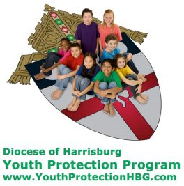
Diocese of Harrisburg Youth Protection Program
www.YouthProtectionHBG.com

Abuse Reporting Contact Information:
First – Call the toll-free PA Child Abuse Hotline at 800-932-0313
Then – Call the Diocesan toll-free hotline at 800-626-1608

“If one member suffers,
all suffer together with it.” (1 Cor 12:26)

St. Ignatius Loyola RC Church

1095 Church Road, Orrtanna, Pennsylvania 17353
www.stignatiusofloyola.org | Office: 717-677-8012

December 10, 2023: SECOND SUNDAY OF ADVENT

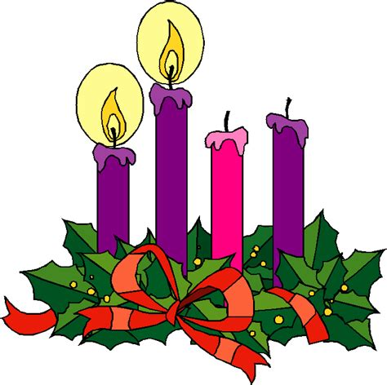

“Prepare the Way of the LORD,
make straight His Paths!”
December 21 Set up Tree & Manger in church,
11AM (after Mass) place Pointsettias & Finish Decorating

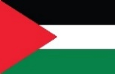
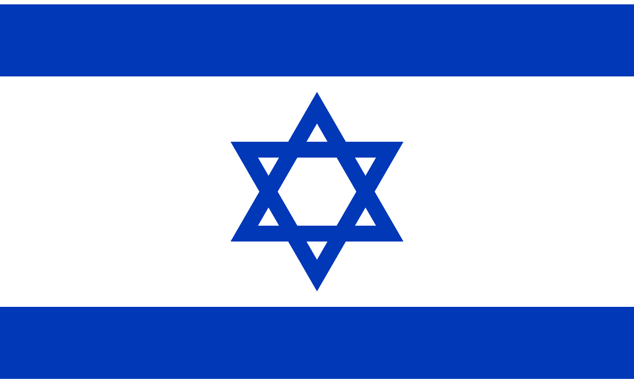
PLEASE! Pray to END THE KILLING in the Holy Land!

Most Rev. Timothy C. Senior, Bishop of Harrisburg
Rev. Dominic M. DiBiccaro, Pastor
Deacon Steve Huete, Pastoral Associate

Mass Schedule, Intentions, and Events
Please Pray for these in need:
Jeanie Kline & the Kline Family, Dick & Deb Deardorff, Chris & Mary Rebscher, John Baker, Ginny Hoctor, Brenda Wolf, Sr. Thelma Steiger HSF, Sr. Miriam Ukeritis CSJ , Peter Hackney, Lucas Christiansen, Dale Kaplan, Jerry Smith, Wade Sprankle, Dulcie Perry, Ron Formosa, Gavin Crumbacker, Anna Kane, Sherry Dennis & Family, Remi Peters, Terry Ahn, K. Grance, Lori McFadden & Family, Mike & Lisa Poole, Mervin Weikert, Chastity Rudisill, Mary Ellen Wilson, Terry & Bernie Cabana, Ed & Aggie Sherensky & Family, Bob Raffensberger, Jerry & Ginny Miller, Adeline Lienard, Kaylee Henry, Nancy Wuller, Dr. Mike Colli, Mrs. Kelly Kump, Gabriel Singer, Sharon McCormley, Ron Thumma, Joe Wisotzkey, Leo Hockensmith, Erika McKissick, Jean "Heather" O'Shea, Scott Moore & Sally Moore, Mary Wyatt, Amy Weatherup, Sophia Joy Ernst, Deacon Richard Wentzel, Deacon Frank Enderle, Paul & Carolyn Topper, Kathleen Thompson, Rachel Wonders, Amy Edwards, Jean O’Connor, Jen Baldwin, Ursula Kaley, Deb Bennet, Larry Endy, Laura Lee, Marwa Abdelrahman, Donna Singley, Tim McGinn, Jane Kump, Peggy Neiderer, Chris Kimple, Robert Riquet, Gene & Jo-Ann McDannell, Bob Doxzen, Kimberly Mears, Gabriella Angello, Paul Angello, Mark & Kate Morrow, Mark Morris, Linda Fogleman, Paul Knight, George & Barbara Erstila, Jeff Carpenter, Lana & Nelson Harmon, Diane Slothour, Sue McDannell, Larry Schneider, Joe & Lisa Grasel, Ange Pena, Julie Barnhart, the Shaffer Family, Heather & Emma Dickerson, Brad Peabody, Paul Ward, Aiden Tyler Schneider, Dorothy Vega, Karrie McCall & daughter, George Shahid, Denise Navlyt, Drew Schneider & Family, Ida Bloomfield, Janie Singley, Mary Beth Greenstreet, Rick Benedict, Jan Patla, Kathey Fogleman, Sam Sheffler, Kate Hemmis, Bill & Mary Lou Graham, Andy Graham, Joanna Hodges, John Varones, Joan O’Sullivan, Martha Klinger, Lisa Dionne Lauretti, Jim Gleason, Sue Gustafson, Joe & Michelle Cleary, Kim Johnson, Helen Mills, Kathy Haber, Haley Detman, Joe Durovey, Bev Smith, Donald Sheppard, Linda Mumaugh, Alison Haring, Janet Hartman, Edward Johnson, Angela Galeone, Juliete Lang, Chris MacBeth, Harry Graham, Donald Howard, Armond Binni, Elizabeth Stansky, Pat Johnson, Chris Morris, Faud Doaney, Patrick Glass, Helen Lagasse, Nancy Kewisnek, Bill & Maureen Collins, Rosemary McGilloway, Anji Eisenhart, Monica Manner, Denny Borbonus, Dr. Paul Scarlata, Mary Hawthorne, Ed Washington,JoshKempinski, NancyBaltzey, Spencer Propts, Karlton Smith & Cheryl Sobun, James & Marylyn Sobun, Marlene Webster, Yvette Stoklosa, Andy Consiglio, Bill & Michelle Cloonan, Nelson Salem, Bill & Deb McClintock, nursing home residents & shut-ins, the victims of war, violence, disease, disaster, & all private intentions.
Also in your prayers, please remember all our men
& women currently serving in our Armed Forces:

Lt. Col. Nathan Jeffcoat – US Marine Corps
Lt. Joseph Cleary – US Navy
Michael C. Kenney IV – US Coast Guard
Lt. Joshua Kimple – US Army
Lt. Sarah Fogleman, M.D. – US Navy
A1C Ian Bellinger ‒ PA Air National Guard

PRAYER CHAIN: Contact the Office

for the Week of December 9 to December 17, 2023

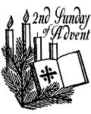
SATURDAY, Dec. 9 - VIGIL 2nd SUNDAY OF ADVENT

Is 40:1-5, 9-11 / 2 Pt 3:8-14 / Mk 1:1-8
5:00PM + Joan and Eugene Schott

SUNDAY, Dec. 10 – 2nd SUNDAY OF ADVENT

Is 40:1-5, 9-11 / 2 Pt 3:8-14 / Mk 1:1-8

8:00AM - Spec. Int. for Richard & Roxanne Dennis

10:30AM ⁓ People of the Parish

Monday, December 11 – St. Damasus I, Pope
Is 35:1-10 / Lk 5:17-26
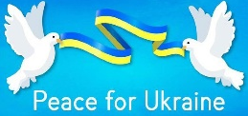
Parish Office Closed

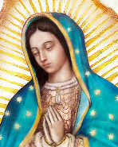
Tuesday, December 12 – OUR LADY OF GUADALUPE
Zec 2:14-17 / Lk 1:26-38

8AM – 3PM ~ Office Open

10:00AM + Ruth Ann Robinson
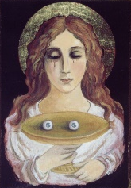
Wednesday, December 13 – St. Lucy, Virgin & Martyr
Is 40:25-31 / Mt 11:28-30
11AM: Mature Spirituality Group
10:00AM + Joanne Esham
NO Confessions; NO Adoration & NO Benediction
6:30PM Communal Penance Service, at OLV, Shippensburg

Thursday, December 14 – St. John of the Cross, Priest
Is 41:13-20 / Mt 11:11-15 & Doctor of the Church

8AM – 3PM ~ Office Open
10:00AM + Anthony Basile
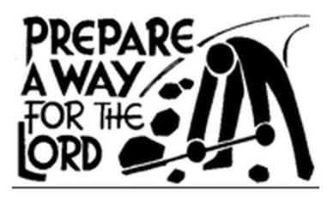  Friday, December 15 (Advent Weekday)  Is 48:17-19 / Mt 11:16-19  10:00AM + Jeanne Crossland  7:00PM ⁓ People of the Parish  Parish Office CLOSED | THE LORD

SATURDAY, December 16 (Advent Weekday)

MORNING: Sir 48:1-4, 9-11 / Mt 17:9a, 10-13
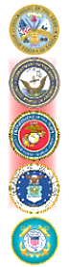

SATURDAY, Dec. 16 - VIGIL 3rd SUNDAY OF ADVENT

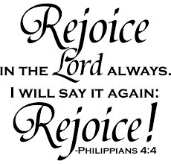
Is 61:1-2a, 10-11 / 1 Thes 5:16-24 / Jn 1:6-8, 19-28
5:00PM + Marilyn Cole

SUNDAY, Dec. 17 – 3rd SUNDAY OF ADVENT

Is 61:1-2a, 10-11 / 1 Thes 5:16-24 / Jn 1:6-8, 19-28
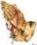
8:00AM - John, Louise, & Bobbi Strasbaugh

10:30AM ⁓ People of the Parish
Sanctuary Candle offered for DECEMBER: In Loving Memory of Donald Redding & Teresa Quigley

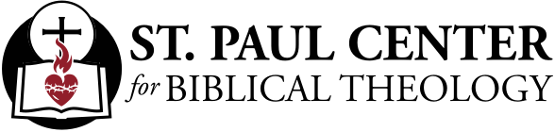

Straighten the Path: Scott Hahn Reflects

on the Second Sunday of Advent
Our God is coming. The time of exile — the long separation of humankind from God due to sin — is about to end. This is the good news proclaimed in today’s liturgy.
The Prophet Isaiah in today’s First Reading promises Isra-el’s future release and return from captivity and exile. But as today’s Gospel shows, Isra-el’s historic deliverance was meant to herald an even greater saving act by God — the Coming of Jesus to set Isra-el and all nations free from bondage to sin, to gather them up and carry them back to God.
God sent an Angel before Isra-el to lead them in their exodus toward the promised land (see Exodus 23:20). And He promised to send a messenger of the Covenant, Elijah, to purify the people and turn their hearts to the Father before the Day of the LORD (see Malachi 3:1–4).
John the Baptizer quotes these, as well as Isaiah’s prophecy, to show that all of Isra-el’s history looks forward to the revelation of Jesus. In Jesus, God has filled in the valley that divided sinful humanity from Himself. He has reached down from Heaven and made His glory to dwell on earth, as we sing in today’s Psalm.
He has done all this not for humanity in the abstract, but for each of us. The long History of Salvation has led us to this Eucharist, in which our God again comes and our salvation is near. And each of us must hear in today’s readings a personal call. Here is your God, Isaiah says. He has been patient with you, St. Peter says in today’s Epistle.
Like Jerusalem’s inhabitants in the Gospel, we have to go out to Him, repenting our sins, all the laziness and self-indulgence that make our lives a spiritual wasteland. We have to straighten out our lives so that everything we do leads us to Him.
Today, let us hear the beginning of the Gospel and again commit ourselves to lives of holiness and devotion.
Readings: Isaiah 40:1–5, 9–11; Psalm 85:9–14
2 Peter 3:8–14; Mark 1:1–8

Sunday Collection Summary for Dec. 2 & 3

Weekend Collections
Regular Offering $ 5,434.00
Christ the King $ 80.00
Christmas $ 255.00
Immaculate Conception $ 72.00
Solemnity of Mary, Mother of God $ 30.00
TOTAL OFFERINGS $ 5,871.00

‒ WEEKLY BUDGETARY NEEDS $ 4,494.00
+Overage or (Shortfall) for the week +$ 1,377.00

Other Income
Candles/Living Faith $ 55.50
Christmas Flowers $ 982.00
Individual Contribution $ 2,500.00
Local Poor $ 100.00
Total Other Offerings $ 3,637.50

Diocesan Second Collections
Retirement for Religious $ 325.00
Total Diocesan Offerings $ 325.00

St Ignatius of Loyola Parish Council Meeting November 14, 2023
- Father went over the summary of the Financial Report and stated that the parish is in good financial shape with just <$1,303> off the budget YTD.
- Father Dominic mentioned a water leak in the Loyola Building coming from A/C Unit on the roof will require extensive repairs.
- The Angel Tree (carving the trunk in the shape of an angel of the dead tree in Garden of the Unborn that was recently cut down) will be addressed next year.
- Concern was made in reference to someone possibly building on Church property. Father will check into it.
- The Finance Council proposed a motion in reference to the Parish and making donations in time of need. Following discussion, a motion was made for the Parish Council to accept. All in favor. A referendum will be held at a future date at all the Masses.
- Deacon Steve feels that the Parish Town Hall Meeting should be put on hold until after Easter.
- Details about the Posadas Event in Advent were provided by Marya Djalal. The event will take place on December 16, 2023, from 5:30 to 7:30 p.m. in Arendtsville. A flyer will be put in the bulletin. All St. Ignatuis parishioners are invited to attend.
- The Six Diocesan Mission Areas guidelines for Parish Council involvement will continue at future meetings.

Next meeting will be January 9, 2024, at 6:30 p.m.

POPE FRANCIS’ PRAYER INTENTION
FOR DECEMBER
We pray that people living with disabilities may be at the center of attention in society, and that institutions may offer inclusive programs which value their active participation.

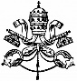

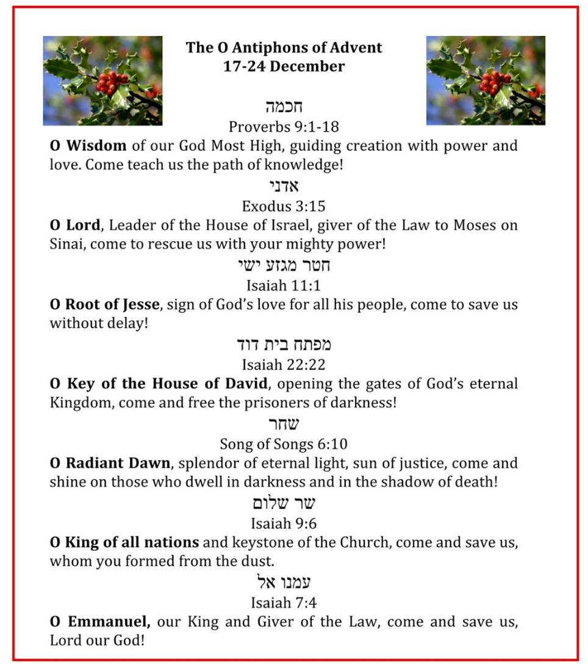

Everything you need to know about the Advent wreath
By Francesca Pollio Fenton | CNA Staff, Dec 3, 2023
During the holidays, Nativity scenes and Christmas trees decorate most Catholic homes, but what about Advent wreaths?
Advent wreaths are traditionally made from evergreen branches and have four candles. The four candles represent the four weeks of Advent — three candles are purple, and one is a rose color.
The purple represents prayer, penance, and preparation for the coming of Christ. Historically, Advent was known as a “little Lent,” which is why the penitential color of purple is used. During Lent, we prepare for the resurrection of Christ on Easter. Similarly, during Advent, we prepare for the coming of Christ, both on Christmas and at the second coming.
The rose candle is illuminated on the third Sunday of Advent, known as Gaudete Sunday. At Mass on the third Sunday, the priest also wears rose-colored vestments. Gaudete Sunday is a day for rejoicing and joy as the faithful draw near to the birth of Jesus, and it marks the midpoint of Advent.
“The progressive lighting of the candles represents the expectation and hope surrounding Our LORD’s coming into the world and the anticipation of his second coming to judge the living and the dead,” the USCCB says.
During the Advent season, the faithful will also notice a common theme in the Gospel readings. The readings focus on preparation or “making straight the path of the LORD,” penance, and fasting. All of these things remind us of the importance of preparing our hearts for the LORD and making room for his presence in our lives.

Did you know?
The Advent wreath originated from a pagan European tradition, which consisted of lighting candles during the winter to ask the sun god to return with his light and warmth.
The first missionaries took advantage of this tradition to evangelize the people and taught them that they should use a candlelit wreath as a way of preparing for Christ’s birth, to celebrate his nativity, and to beg Jesus to infuse his light in their souls.
The circle of the Advent wreath is a geometric design that has neither a beginning nor an end. It reminds us that God does not have a beginning or an end either, which reflects his unity and eternity. It is a sign of the unending love that the faithful should show the LORD and their neighbors, which must be constantly renewed and never stop.
The green color of the wreath represents hope and life. The Advent wreath reminds us that Christ is alive among us and that we must cultivate a life of grace, spiritual growth, and hope during Advent.

Bless your Advent wreath
The blessing of an Advent wreath takes place on the first Sunday of Advent or on the evening before.
When the blessing of the Advent wreath is celebrated in the home, it is appropriate that it be blessed by a parent or another member of the family. To bless your Advent wreath at home, follow our guide: “How to bless your Advent wreath at home.”

Pope Francis prays for victims of bombing of Catholic Mass in the Philippines
By Courtney Mares | Rome Newsroom, Dec 4, 2023
Pope Francis offered his condolences after at least four people were killed and 54 injured in a bombing at a Catholic Mass on Sunday in the Philippines.
The pope sent a condolence telegram on Dec. 3 expressing his spiritual closeness to all affected by the bombing of the 7 a.m. Mass held in a gymnasium on the campus of Mindanao State University in the southern Philippines.
Police in the Philippines said Monday that they had identified at least two suspects in the terrorist attack. The Islamic State claimed responsibility for the bombing in a telegram message on Dec. 3, a claim that the country’s military has said it is working to verify.
The attack took place in the city of Marawi, which, unlike the rest of the predominantly Catholic Philippines, has a significant Muslim majority. Marawi is located on the island of Mindanao, the second-largest island in the Philippines, and is home to several Islamist militant groups fighting against the Philippine government.
Bishop Edwin Angot de la Peña, the head of the territorial prelature of Marawi, has said that the victims were four Catholic students who were leaders and volunteers in the university’s Catholic community. The bishop added on Dec. 4 that out of the 54 people injured in the bombing, seven were still in the hospital in critical condition.
“They hit us in the heart, that is, during the Eucharist, the highest moment of our faith. There is so much fear now, but faith accompanies us and supports us. Even in this moment of tribulation, we feel the presence of the LORD,” de la Peña told Agenzia Fides, the information service of the Pontifical Mission Societies.
The bishop also commented on the prompt and widespread solidarity and closeness expressed by local Muslim communities in the wake of the attack.
“Even the first responders, who transported the injured to the hospital, and the doctors themselves, all people of the Muslim faith, gave us concrete help and have been spent on the injured. Others are supporting the families of the victims,” he said. “These gestures give us hope and tell us that this brutal and senseless violence will not have the last word, it will not succeed in demolishing the good works built over many years.”
The head of the Armed Forces of the Philippines, Romeo Brawner, has said that he suspects the bombing could have been a retaliatory attack for recent military operations against the local extremist groups, Dawlah Islamiyah-Maute and Abu Sayyaf, both of which have links to the Islamic State.
As a precaution after the bombing, de la Peña has asked local Catholics to stay home on the feast of the Immaculate Conception on Dec. 8. A statue of the Blessed Virgin Mary will still be carried through the streets Friday to mark the solemnity, but instead of the usual crowded procession, Catholics have been asked to place candles in their windows and pray the rosary at home.
“We entrust ourselves in a special way to the Virgin Mary,” the bishop said, noting that the attack took place on the first Sunday of Advent.
Pope Francis’ condolence telegram was addressed to de la Peña. Vatican Secretary of State Cardinal Pietro Parolin, who sent the telegram on the pope’s behalf, said Pope Francis “joins you in commending the souls of those who died to almighty God’s loving mercy, and he implores the divine gifts of healing and consolation upon the injured and bereaved.”
“With prayers that Christ, the Prince of Peace, will grant to all the strength to turn from violence and overcome every evil with good (cf. Rom 12:21), His Holiness cordially imparts his blessing as a pledge of strength and consolation in the LORD,” the telegram said.
The pope also said he was praying for the victims and their families in his Angelus message on Sunday.
Bishop Pablo Virgilio David, the president of the Catholic Bishops’ Conference of the Philippines and current bishop of Kalookan, reflected on the spiritual significance of the bombing victims’ deaths during the sacrifice of the Mass.
“We take comfort in the thought that they have participated in the passion of Christ, that their blood has been poured out as a libation like the blood of Christ. They professed their faith at that last Mass that they attended, especially in the ‘communion of the saints, the forgiveness of sins, the resurrection of the body, and the life everlasting,’” David said.

“Through the same Eucharist which we celebrated with them on this day of the LORD, we have united ourselves with them by the same faith that we profess, and in the same grace of baptism through which we participate in the life-giving death of Christ,” he said.

CBCP statement on Marawi blast December 3, 2023 | Manila, Philippines

It happened in the morning of the first Sunday of Advent, 3 December 2023. A group of Catholics was gathered together for the Eucharist to mark the beginning of a new liturgical season and to light the candle for the first Sunday of Advent. The perpetrators had chosen that very occasion to detonate a bomb, instantly killing three of our Catholic faithful and wounding ten others in the gymnasium of the Mindanao State University in Marawi City.

Surely, the killers who precipitated such a horrendous act of violence have their loved ones too. What would it take to get them to see in the families of their victims their own families?

Such violence should not only be denounced; it should also be renounced as a way of seeking redress by every peace-loving Filipino.

We have just celebrated “Red Wednesday” last November 29, to remember our fellow Christians who, for sheer love of their faith, have suffered from violence and persecution around the world. The casualties in this morning’s bombing are now counted among them. We take comfort in the thought that they have participated in the passion of Christ, that their blood has been poured out as a libation like the blood of Christ. They professed their faith at that last Mass that they attended, especially in the “communion of the saints, the forgiveness of sins, the resurrection of the body and the life everlasting.” Through the same Eucharist which we celebrated with them on this Day of the LORD, we have united ourselves with them by the same faith that we profess, and in the same grace of baptism through which we participate in the life-giving death of Christ.
We hope that the statement issued by the Mindanao State University can still touch the consciences of the perpetrators. It says, “Violence has no place in a civilized society, and it is particularly abhorrent in an institution of higher learning like MSU, a bulwark of peace, harmony, solidarity, reverence for life and humanity. This attack is an assault on our core values and our commitment to creating a safe and inclusive community for all.” We could not agree more. With them we reaffirm our unrelenting commitment to peace and our repudiation of violence.

We pray for the eternal repose of those who have died, and for the healing of those who have been injured. We unite ourselves spiritually with their families and draw strength and consolation from our faith in Christ who will “restore all things to himself, making peace by the blood of his cross…” (Col. 1:20)

+Pablo Virgilio S. David. Bishop of Kalookan
CBCP President

