Sacrament of the Sick
Anointing of the Sick should be given if an individual is gravely ill or near death. If possible, the Sacrament should also be administered for serious illness, before major surgery or when one is initially hospitalized.

Sacrament of Holy Matrimony
Diocesan policy requires 12 months of preparation for Marriage. Contact the parish as soon as possible after engagement. No venue reservations or other arrangements should be made prior to consultation with the pastor.

Sacrament of Penance
Wednesday ~ 6:00 – 6:45PM; or by appointment.

Sacrament of Baptism
Parents must be registered members of the parish and attend a Baptism preparation class prior to the Baptism if this is your first child baptized. Requirements for godparents are established by the Catholic Church. Please call the parish office for Information and to register your child for Baptism.

Parish Registration
All Catholics should be registered in their local parish. Please contact the parish office to obtain registration forms, or if you are uncertain of the parish where you should register.

Parish Staff & Ministries Directory
stignatiusofloyola@hbgdiocese.org | Office: 717-677-8012
Financial Manager ~ Richard Deardorff ~ 717- 677-8012 or 717-420-3464 (cell)
rdeardorff@hbgdiocese.org
Director of Religious Education ~ Deacon Steve Huete ~ shuete@hbgdiocese.org
Parish Secretary ~ Kristen DiDio ~ kdidio@hbgdiocese.org
Buildings & Grounds ~ Donnie Althoff ~ 717-677-8012
Music Ministry ~ Phil Mobley ~ 717-677-8012
Parish Council Members
Phil Mobley – Chair 571-236-7580 pmmobley@gmail.com
Bicky Redman – Vice Chair 677-8592 feetintheair7@gmail.com
Joanne Riedel - Secretary 398-2021 sterj221@aol.com
Kathi Allwein 677-8984 allweint@comcast.net
Charlie Baker 677-9536 dcbake@embarqmqil.com
Mike McTighe 729-6239 mike0432@aol.com
Dr. BobTernes rjtmd46@gmail.com

Finance Council Members
Richard Deardorff (Ex Officio)
Greg Ernst - Chair
Alix Haller
Christy Hemler - Secretary
Terri Pendlelton
Bill Pulig

Altar Flowers
Prayer Chain
Lynne Mobley at LMOBLEY509@gmail.com
or 703-876-4901

Soup Kitchen
Please send donations directly to “Soup Kitchen”

Website Development
Kristen DiDio
Life After Loss
Dodie Huete

OCIA
Contact Fr. Dominic

Picnic Co-Chairpersons
John Neiderer
Wally Kane

Pro-Life Ministry
Jeanette Backus
Knights of Columbus
SK Bob Ternes
- Grand Knight
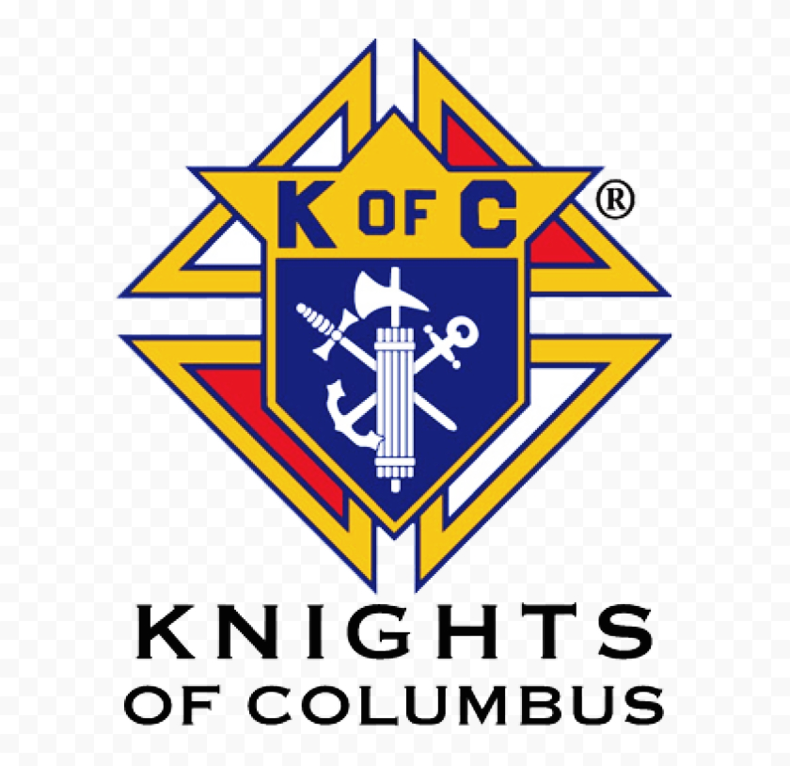

Judy Wilson / Janice Meligakes

Bereavement Ministry
Ginny Bittle / Dodie Huete

Catholic Communications/EWTN
Open - Contact office if you are interested

Cemetery
Contact Parish Office
THEOSIS Ministry
Kathy Dietsch 717-352-4558
Bicky Redman 717-677-8592

Diocese of Harrisburg Youth Protection Program
www.YouthProtectionHBG.com

Abuse Reporting Contact Information:
First – Call the toll-free PA Child Abuse Hotline at 800-932-0313
Then – Call the Diocesan toll-free hotline at 800-626-1608

“If one member suffers,
all suffer together with it.” (1 Cor 12:26)

St. Ignatius Loyola RC Church

1095 Church Road, Orrtanna, Pennsylvania 17353
www.stignatiusofloyola.org | Office: 717-677-8012

August 20, 2023: 20th SUNDAY IN ORDINARY TIME

Most Rev. Timothy C. Senior, Bishop of Harrisburg
Rev. Dominic M. DiBiccaro, Pastor
Deacon Steve Huete, Pastoral Associate

Mass Schedule, Intentions, and Events
Please Pray for:
Those who are ill, Jeanie Kline & the Kline Family, Brenda Wolf, Wade Sprankle, Dulcie Perry, Ron Formosa, Gavin Crumbacker, Anna Kane, Sherry Dennis and Family, Remi Peters, Christy Hemler, Terry Ahn, K. Grance, Lori McFadden & Family, Mike & Lisa Poole, Mervin Weikert, Chastity Rudisill, Mary Ellen Wilson, Terry & Bernie Cabana, Ed & Aggie Sherensky and Family, Bob Raffensberger, Jerry & Ginny Miller, Adeline Lienard, Kaylee Henry, Nancy Wuller, Dr. Mike Colli, Mrs. Kelly Kump, Gabriel Singer, Sharon McCormley, Ron Thumma, Joe Wisotzkey, Leo Hockensmith, Erika McKissick, Jean "Heather" O'Shea, Scott Moore and Sally Moore, Mary Wyatt, Jim & Joyce Deardorff, Amy Weatherup, Sophia Joy Ernst, Deacon Richard Wentzel, Deacon Frank Enderle, Kathleen Thompson, Deb & Kathy McLintock and Family, Rachel Wonders, Amy Edwards, Jean O’Connor, Paul Angello, Jen Baldwin, Ursula Kaley, Deb Bennet, Fr. Bill Sullivan, Larry Endy, Laura Lee, Marwa Abdelrahman, Donna Singley, Tim McGinn, Jane Kump, Peggy Neiderer, Chris Kimple, Robert Riquet, Gene & Jo-Ann McDannell, Bob Doxzen, Kimberly Mears, Gabriella Angello, Paul Angello, Mark & Kate Morrow, Mark Morris, Linda Fogleman, Paul Knight, George & Barbara Erstila, Jeff Carpenter, Lana & Nelson Harmon, Diane Slothour, Sue McDannell, Larry Schneider, Joe & Lisa Grasel, Ange Pena, Julie Barnhart, the Shaffer Family, Heather & Emma Dickerson, Brad Pabody, Paul Ward, Aiden Tyler Schneider, Dorothy Vega, Karrie McCall & daughter, George Shahid, Denise Navlyt, Drew Schneider & Family, Ida Bloomfield, Linda McDannell, Janie Singley, Mary Beth Greenstreet, Rick Benedict, Jan Patla, Kathe Fogleman, Sam Sheffler, Kate Hemmis, Bill & Mary Lou Graham, Joanna Hodges, John Varones, Joan O’Sullivan, Martha Klinger, Lisa Dionne Lauretti, Sue Orndorff, Jim Gleason, Sue Gustafson, Joe & Michelle Cleary, Kim Johnson, Helen Mills, Kathy Haber, Haley Detman, Joe Durovey, Bev Smith, Donald Sheppard, Linda Mumaugh, Alison Haring, Janet Hartman, Edward Johnson, Angela Galeone, Juliete Lang, Chris MacBeth, Harry Graham, Donald Howard, Armond Binni, Elizabeth Stansky, Pat Johnson, Chris Morris, Faud Doaney, Wilson & Rae Harman, Patrick Glass, Helen Lagasse, Nancy Kewisnek, Andy Graham, Bill & Maureen Collins, Rosemary McGilloway, Anji Eisenhart, Monica Manner, Denny Borbonus, Dr. Paul Scarlata, Mary Hawthorne, Ed Washington, Josh Kempinski, Nancy Baker Baltzey, Spencer Propts, Karlton Smith & Cheryl Sobun, James & Marylyn Sobun, Marlene Webster, Yvette Stoklosa, Andy Consiglio, Bill & Michelle Cloonan, Nelson Salem, Bill & Deb McClintock, nursing home residents & shut-ins, the victims of war, violence, disease, disaster, & all private intentions.
Also in your prayers, please remember all
our men and women currently serving in
our Armed Forces:
Maj. Nathan Jeffcoat – US Marine Corps
Lt. Joseph Cleary – US Navy
Michael C. Kenney IV – US Coast Guard
Lt. Joshua Kimple – US Army
Lt. Sarah Fogleman, M.D. – US Navy

PRAYER CHAIN: Contact Lynne Mobley at 703-876-4901 or LMOBLEY509@gmail.com

for the Week of August 19 to August 27, 2023

SATURDAY, August 19 – VIGIL 20th SUNDAY OT

Is 56:1, 6-7 / Rom 11:13-15, 29-32 / Mt 15:21-28
5:00PM + Brenda Althoff

SUNDAY, August 20 – 20th SUNDAY IN OT

Is 56:1, 6-7 / Rom 11:13-15, 29-32 / Mt 15:21-28
8:00AM ⁓ People of the Parish

Monday, August 21 – St. Pius X, Pope
Jgs 2:11-19 / Mt 19:16-22
Parish Office Closed

Tuesday, August 22 - The Queenship of the Blessed Virgin Mary
Jgs 6:11-24a / Mt 19:23-30

8:00AM – 3:00PM ~ Office Open
NO DAILY MASS

11AM: “Something More” Group

Wednesday, August 23 – St. Rose of Lima, Virgin
Jgs 9:6-15 / Mt 20:1-16
Picnic Work Night 5PM

8AM – 3PM ~ Office Open
11AM: Mature Spirituality Group
NO DAILY MASS
NO Confessions; NO Adoration;
NO Evening Mass

Thursday, August 24 – ST. BARTHOLOMEW, APOSTLE
Rv 21:9b-14 / Jn 1:45-51

8AM – 3PM ~ Office Open
NO DAILY MASS
Friday, August 25 – St. Louis; St. Joseph Calasanz, Priest  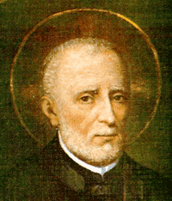  Ru 1:1, 3-6, 14b-16, 22 / Mt 22:34-40  Parish Office CLOSED | THE LORD
NO DAILY MASS

SATURDAY, August 26 (Weekday in OT)
MORNING: Ru 2:1-3, 8-11; 4:13-17/Mt 23:1-12

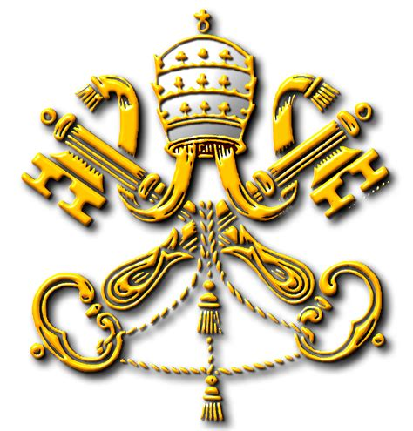
SATURDAY, August 26 – VIGIL 21st SUNDAY OT

Is 22:19-23 / Rom 11:33-36 / Mt 16:13-20
5:00PM + Marilyn Cole

SUNDAY, August 27 – 21st SUNDAY IN OT

Is 22:19-23 / Rom 11:33-36 / Mt 16:13-20
8:00AM ⁓ People of the Parish
10:30AM + Richard Sherensky
Sanctuary Candle offered for AUGUST: In Loving Memory of Teresa Redding from Edna Redding.
Sunday Collection Summary
August 12 and 13

Weekend Collection
Regular Offering $ 4,878.00
Candles $ 71.00
Altar Flowers $ 400.00
Assumption HOLY DAY $ 1,536.00
TOTAL OFFERINGS $ 6,885.00

‒ WEEKLY BUDGETARY NEEDS $ 4,494.00
+Overage or (Shortfall) for the week +$ 2,391.00

Sunday Second Collection
Parish Picnic $ 2,344.00

Other Income
Picnic Raffle Tickets $ 305.00
Cemetery Lots $ 2,150.00
Memorial (Larry Dennis) $ 50.00
Memorial (Jack Ryff) $ 250.00
Total Other Offerings $ 2,755.00

Diocesan Second Collections
Missionary CO-OP (Apostles of Jesus – add’l) $ 240.00

At the PCC … (cont.)

It brings to mind an interview I had back in 2019 with Democratic Rep. Jordan Harris of Philadelphia. We met in his district office and I have to admit I was a bit intimidated. He was a forceful speaker on the House floor and I was surprised that he had even agreed to an interview. But then he said something that has stuck with me ever since. He quoted the abolitionist and activist Frederick Douglass [1817 – 1895], who said “I would unite with anybody to do right and with nobody to do wrong.”
Harris is pro-choice as well. And while the sanctity of life is at the top of our list of values and pursuits, we cannot afford to ignore those who disagree with us on one or two issues. We’d be left to fend for ourselves.
The meeting with Rep. Harris went very well. And obviously left an impression on me.
“It’s difficult to dislike or hate somebody — I would say it’s impossible — once you get to know them,” Failing said. “Because what I think we’re always going to find is that we have more in common with folks than we may know and that they have more in common with us than they may know. That’s how friendship starts. We may not agree with everybody on every issue, but we’re all God’s children.’

At the PCC We Work With Everyone, Or At Least Try To Try To

August 01, 2023

It is always nice to hear from Catholics across Pennsylvania on social media in response to postings that we make on Twitter, Facebook, or Instagram. We offer several postings daily on a variety of topics, but especially on those dealing with the happenings in the state House and Senate. That’s our focus at the Pennsylvania Catholic Conference: we are the public relations arm of the Bishops across the State.

One of the comments that I have gotten in years past is to the effect of ‘why do you talk with that lawmaker when they are in favor of abortion?’

Well…we make it a point to work with everyone. Or at least try to.

“We work with Republicans. We work with Democrats,” said Eric Failing, the Executive Director of the PCC. “Sometimes up at the Capitol I’ll get asked ‘are you Republican or a Democrat?’ I tell them that “I don’t like to say I’m an ‘R’ or a ‘D.’ I’m a ‘C.’ I’m Catholic.

“We work with people on all sides of the issue on both sides of the aisle. When I first interviewed for the position, I talked to the bishops about this and they said something that has never left me. They said when you think of all the senators and all the representatives and all their staff….we shouldn’t think of them as from this party or that party. We should think of them as souls.”

One of our biggest allies in Harrisburg has been Democratic Senator Judy Schwank of Berks Co. She is firmly pro-choice, but has worked with us on a number of bills – most recently on Senate Bill 262, the Maternal Mortality Review Act SB 262. It will require the PA Department of Health to annually publish severe maternal morbidity date using hospital discharge information. It’s part of a package of bills aimed at addressing maternal morbidity and improving maternal health outcomes. It was just signed into law by [Governor Shapiro] a Democratic governor.

It can be intimidating when you hear certain lawmakers speaking passionately on the House and Senate floor, or in the press. You think to yourself, ‘they couldn’t possibly want to even meet with me, much less agree on anything.’ While sometimes that is true, it more often is not. Most lawmakers realize they have to work
with those on the other side of the aisle or the
other side of an issue to get things done.

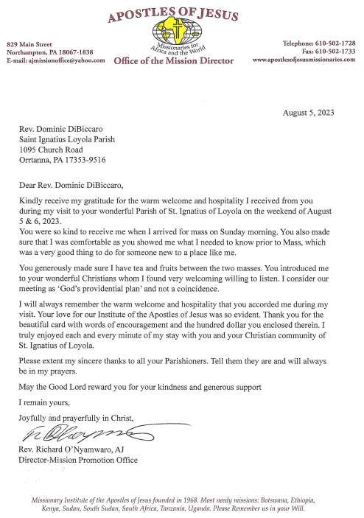
The Holy Father, Pope Francis’ Prayer Intentions for 2023
Entrusted to His Worldwide Prayer Network
AUGUST ⁓ FOR WORLD YOUTH DAY

We pray the World Youth Day in Lisbon, Portugal, will help young people to live and witness the Gospel in their own lives.

A Foreigner’s Faith: Scott Hahn Reflects

on the Twentieth Sunday in Ordinary Time

Most of us are the foreigners, the non-Israelites, about whom today’s First Reading prophesies.

Coming to worship the God of Isra-el, we stand in the line of faith epitomized by the Canaanite woman in today’s Gospel. Calling to Jesus as LORD and Son of David, this foreigner shows her great faith in God’s Covenant with Isra-el.

Jesus tests her faith three times. He refuses to answer her cry. Then, He tells her His mission is only to Israelites.

Finally, He uses “dog,” an epithet used to disparage non-Israelites (see Matthew 7:6). Yet she persists, believing that He alone offers salvation.

In this family drama, we see fulfilled Isaiah’s prophecy and the promise we sing of in today’s Psalm. In Jesus, God makes known among all the nations His Way and His Salvation (see John 14:6).

At the start of salvation history, God called Abraham (see Genesis 12:2). He chose his offspring, Isra-el, from all the nations on the face of the earth to build His Covenant Kingdom (see Deuteronomy 7:6–8; Isaiah 41:8).

In God’s plan, Abraham was to be the father of many nations (see Romans 4:16–17). Isra-el was to be the firstborn of a worldwide family of God, made up of all who believe what the Canaanite professes; that Jesus is LORD! (see Exodus 4:22–23; Romans 5:13–24)

Jesus came first to restore the Kingdom to Isra-el (see Acts 1:6; 13:46). But His ultimate mission was the reconciliation of the world, as St. Paul declares in today’s Epistle.

In the Holy Mass we join all peoples in doing Him homage. As Isaiah foretold, we come to His holy mountain, the heavenly Jerusalem, to offer sacrifice at His altar (see Hebrews 12:22–24, 28). With the Canaanite, we take our place at the Master’s Table to be fed as His Children.

Readings: Isaiah 56:1, 6–7; Psalm 67:2–3, 5, 6, 8; Romans 11:13–15, 29–32; Matthew 15:21–28

Historic Lahaina church miraculously

untouched by Maui wildfires that killed 80

By Rich Calder | August 12, 2023

Stunning video shows a historic Catholic church in Lahaina miraculously still standing and unscathed after devastating wildfires ripped through Maui — while the rest of the historic town was turned into an apocalyptical nightmare.

Maria Lanakila [Mary, Our Lady of Victory] Catholic Church, which opened in 1846, was captured in a video, posted on TikTok, standing tall and untouched.

When the camera pans around, the rest of the town — the largest tourist destination on Maui — looks like a smoldering hellscape of rubble.

Viewers hailed the jaw-dropping miracle as an act of God.

“A def sign from God,” one TikTok user wrote, adding, “he is with you. hold on and keep that faith. we are all praying for you.”

“Wow. God continues to give signs even during the storm,” another viewer commented.
Msgr. Terrence Watanabe, pastor of the nearby parish of St. Anthony’s, also expressed his shock at the apparent act of divine intervention.

“Basically what we know is the fact that all of Lahaina Town has been consumed by fire. It’s all gone. The church, Maria Lanakila [Our Lady of Victory], is still standing, as is the rectory,” he told The Pillar.

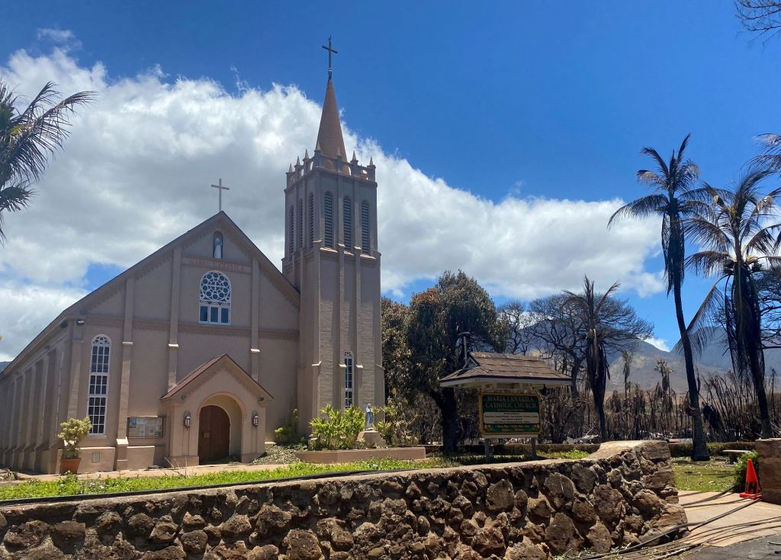

Maria Lanakila Catholic Church in Lahaina remains standing following horrific wildfires. Some are calling its saving an “act of God.”

Lahaina Church was saved . Jax was babtized here #mauifire #lahainahawaii #hawaiibrunoldsquad
Members of the church’s community also expressed their gratitude on Facebook, according to the Daily Mail.

“May She be the beacon of hope…to help the rest of the community,” parishioner Jeffrey Chang wrote.

“May she be the beacon of hope to the people of Lahaina!!!! Praise the Lord… upon this rock I will build my church!!! come and follow me…,” added Jeffrey Domdoma.

Over 50 people have died in the wake of the Maui wildfires that started late Tuesday.

“We’ve still got dead bodies floating on the seawall,” one Lahaina resident told Hawaii News Now. “They’ve been sitting there since last night.”

The wildfires, fanned by strong winds have burned multiple buildings, forced evacuations, and caused power outages in several communities.

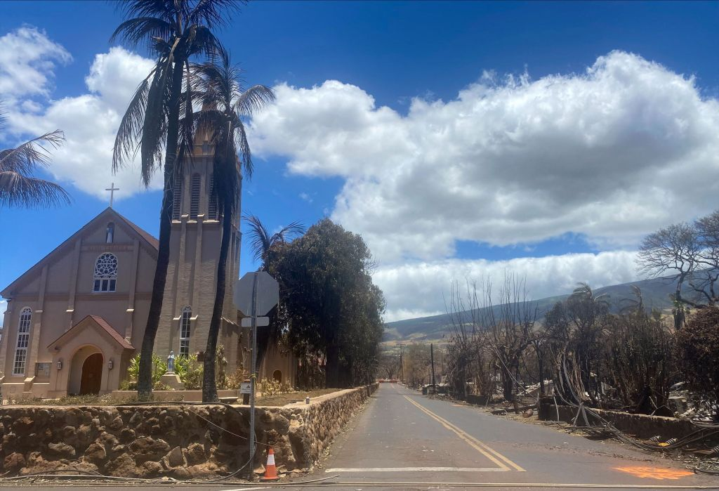

Maria Lanakila Catholic Church stands miraculously unscathed as properties surrounding it were destroyed by the deadly fires.

The National Weather Service said Hurricane Dora was partly to blame for the strong winds that knocked out power as night came. About 13,000 residents in Maui are without power, according to reports.

People are rushing to the ocean to escape the smoke and flames fanned by Hurricane Dora.

Fire crews in Maui are battling multiple fires in the popular tourist destination of West Maui and an inland, mountainous region. Firefighters have struggled to reach some areas that were cut off by downed trees and power lines.

In Lahaina, a total of 2,207 structures were damaged or destroyed and 2,170 acres have burned, according to the Pacific Disaster Center (PDC) and FEMA. The death toll from the catastrophic Maui wildfires climbed to 80 on Friday, becoming the deadliest natural disaster in Hawaii’s history — surpassing that of a tsunami that killed 61 people on the Big Island of Hawaii in 1960.

