Sacrament of the Sick
Anointing of the Sick should be given if an individual is gravely ill or near death. If possible, the Sacrament should also be administered for serious illness, before major surgery or when one is initially hospitalized.

Sacrament of Holy Matrimony
Diocesan policy requires 12 months of preparation for Marriage. Contact the parish as soon as possible after engagement. No venue reservations or other arrangements should be made prior to consultation with the pastor.

Sacrament of Penance
Wednesday ~ 6:00 – 6:45PM; or by appointment.

Sacrament of Baptism
Parents must be registered members of the parish and attend a Baptism preparation class prior to the Baptism if this is your first child baptized. Requirements for godparents are established by the Catholic Church. Please call the parish office for Information and to register your child for Baptism.

Parish Registration
All Catholics should be registered in their local parish. Please contact the parish office to obtain registration forms, or if you are uncertain of the parish where you should register.

Parish Staff & Ministries Directory
stignatiusofloyola@hbgdiocese.org | Office: 717-677-8012
Financial Manager ~ Richard Deardorff ~ 717- 677-8012 or 717-420-3464 (cell)
rdeardorff@hbgdiocese.org
Director of Religious Education ~ Deacon Steve Huete ~ shuete@hbgdiocese.org
Parish Secretary ~ Kristen DiDio ~ kdidio@hbgdiocese.org
Buildings & Grounds ~ Donnie Althoff ~ 717-677-8012
Music Ministry ~ Phil Mobley ~ 717-677-8012
Parish Council Members
Phil Mobley – Chair 571-236-7580 pmmobley@gmail.com
Bicky Redman – Vice Chair 677-8592 feetintheair7@gmail.com
Joanne Riedel - Secretary 398-2021 sterj221@aol.com
Kathi Allwein 677-8984 allweint@comcast.net
Charlie Baker 677-9536 dcbake@embarqmqil.com
Kathy Dietsch 352-4558 kdiet2@juno.com
Dr. BobTernes rjtmd46@gmail.com

Finance Council Members
Richard Deardorff (Ex Officio)
Greg Ernst - Chair
Christy Hemler - Secretary
Ali Morris
Terri Pendlelton
Bill Pulig

Altar Flowers
OCIA
Order of Christian Initiation for Adults
Contact Fr. Dominic

Soup Kitchen
Please send donations
directly to the
“Gettysburg Soup Kitchen”

Website Development
Kristen DiDio
Life After Loss
Dodie Huete

Prayer Chain
CONTACT THE PARISH OFFICE

Picnic Co-Chairs
Wally Kane
Mark Schur

Pro-Life Ministry
Jeanette Backus
Knights of Columbus
SK Bob Ternes
- Grand Knight
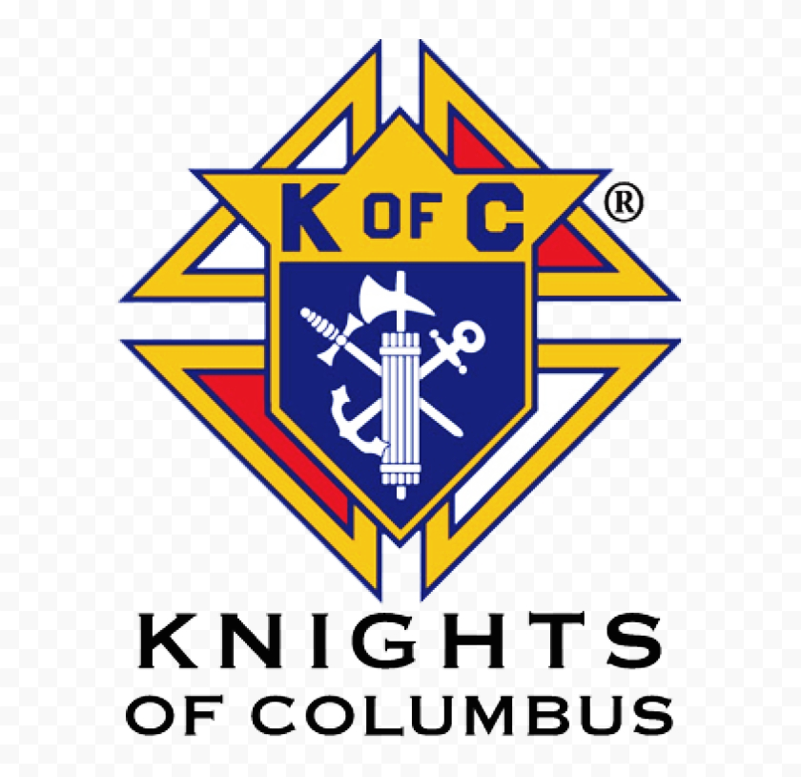

CONTACT THE PARISH OFFICE

Bereavement Ministry
Ginny Bittle / Dodie Huete

Catholic Communications/EWTN
Anna Kane

Cemetery
CONTACT THE PARISH OFFICE
THEOSIS Ministry
Kathy Dietsch 717-352-4558
Bicky Redman 717-677-8592

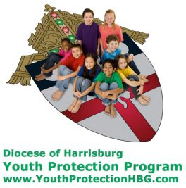
Diocese of Harrisburg Youth Protection Program
www.YouthProtectionHBG.com

Abuse Reporting Contact Information:
First – Call the toll-free PA Child Abuse Hotline at 800-932-0313
Then – Call the Diocesan toll-free hotline at 800-626-1608

“If one member suffers,
all suffer together with it.” (1 Cor 12:26)

St. Ignatius Loyola RC Church

1095 Church Road, Orrtanna, Pennsylvania 17353
www.stignatiusofloyola.org | Office: 717-677-8012

December 3, 2023: FIRST SUNDAY OF ADVENT

December 6 – 7PM, Healing Mass: Anointing of the Sick
December 17 – Set up Tree and Manger in church
December 20 – Place Pointsettias & Finish Decorating

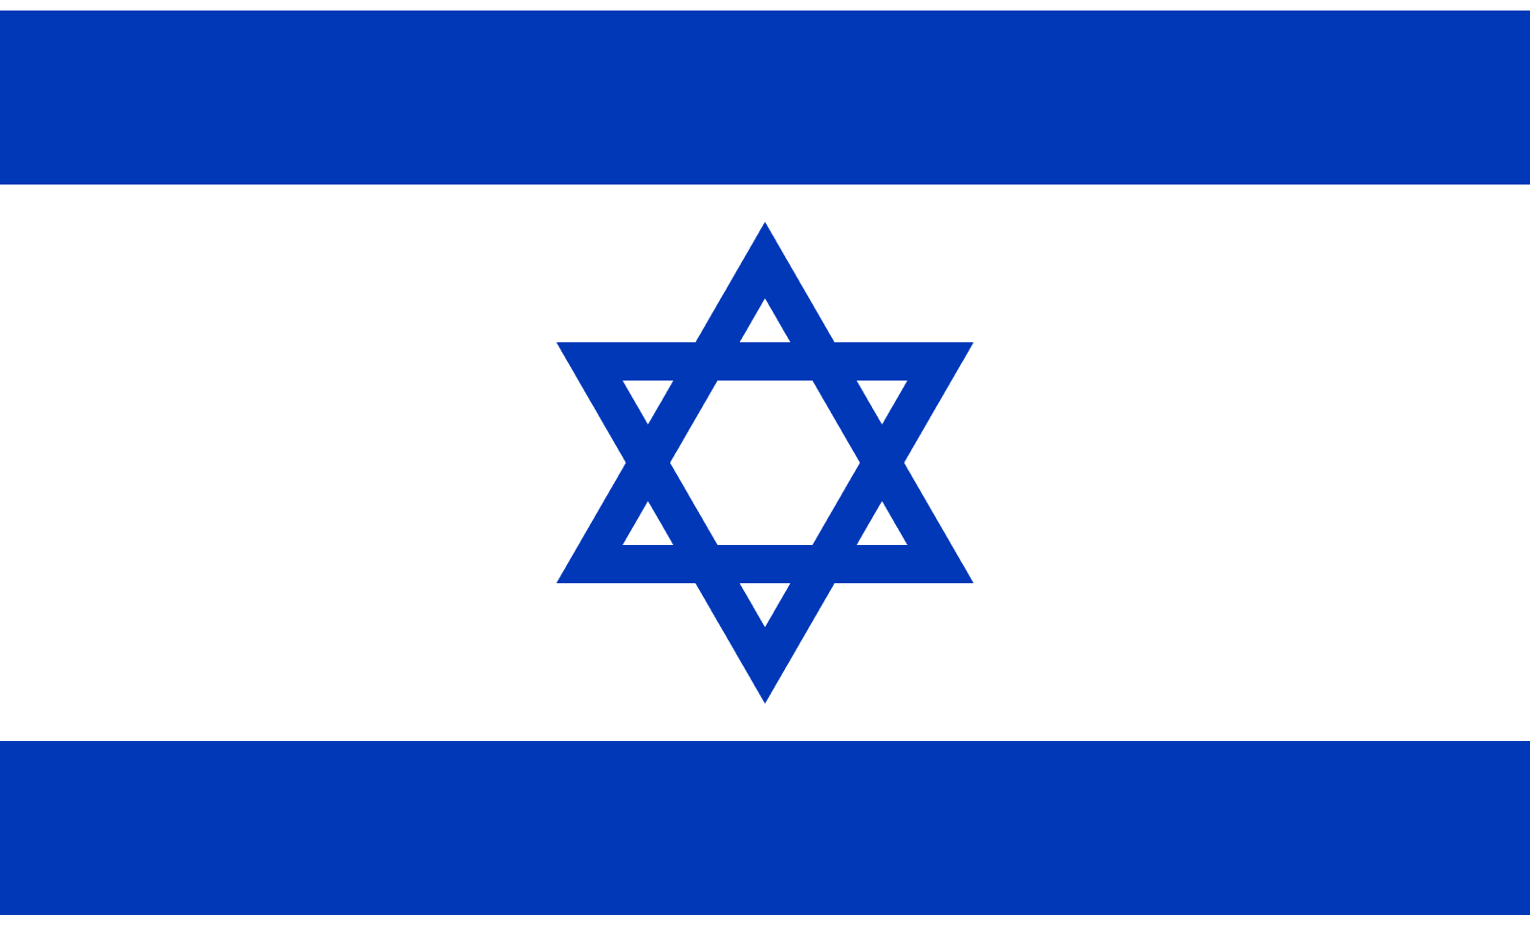
PLEASE Pray to END THE KILLING in the Holy Land!

Most Rev. Timothy C. Senior, Bishop of Harrisburg
Rev. Dominic M. DiBiccaro, Pastor
Deacon Steve Huete, Pastoral Associate

Mass Schedule, Intentions, and Events
Please Pray for these in need:
Jeanie Kline & the Kline Family, Dick & Deb Deardorff, John Baker, Ginny Hoctor, Brenda Wolf, Sr. Thelma Steiger HSF, Sr. Miriam Ukeritis CSJ , Peter Hackney, Lucas Christiansen, Dale Kaplan, Jerry Smith, Wade Sprankle, Dulcie Perry, Ron Formosa, Gavin Crumbacker, Anna Kane, Sherry Dennis & Family, Remi Peters, Terry Ahn, K. Grance, Lori McFadden & Family, Mike & Lisa Poole, Mervin Weikert, Chastity Rudisill, Mary Ellen Wilson, Terry & Bernie Cabana, Ed & Aggie Sherensky & Family, Bob Raffensberger, Jerry & Ginny Miller, Adeline Lienard, Kaylee Henry, Nancy Wuller, Dr. Mike Colli, Mrs. Kelly Kump, Gabriel Singer, Sharon McCormley, Ron Thumma, Joe Wisotzkey, Leo Hockensmith, Erika McKissick, Jean "Heather" O'Shea, Scott Moore & Sally Moore, Mary Wyatt, Jim & Joyce Deardorff, Amy Weatherup, Sophia Joy Ernst, Deacon Richard Wentzel, Deacon Frank Enderle, Paul & Carolyn Topper, Kathleen Thompson, Rachel Wonders, Amy Edwards, Jean O’Connor, Jen Baldwin, Ursula Kaley, Deb Bennet, Larry Endy, Laura Lee, Marwa Abdelrahman, Donna Singley, Tim McGinn, Jane Kump, Peggy Neiderer, Chris Kimple, Robert Riquet, Gene & Jo-Ann McDannell, Bob Doxzen, Kimberly Mears, Gabriella Angello, Paul Angello, Mark & Kate Morrow, Mark Morris, Linda Fogleman, Paul Knight, George & Barbara Erstila, Jeff Carpenter, Lana & Nelson Harmon, Diane Slothour, Sue McDannell, Larry Schneider, Joe & Lisa Grasel, Ange Pena, Julie Barnhart, the Shaffer Family, Heather & Emma Dickerson, Brad Peabody, Paul Ward, Aiden Tyler Schneider, Dorothy Vega, Karrie McCall & daughter, George Shahid, Denise Navlyt, Drew Schneider & Family, Ida Bloomfield, Janie Singley, Mary Beth Greenstreet, Rick Benedict, Jan Patla, Kathey Fogleman, Sam Sheffler, Kate Hemmis, Bill & Mary Lou Graham, Andy Graham, Joanna Hodges, John Varones, Joan O’Sullivan, Martha Klinger, Lisa Dionne Lauretti, Jim Gleason, Sue Gustafson, Joe & Michelle Cleary, Kim Johnson, Helen Mills, Kathy Haber, Haley Detman, Joe Durovey, Bev Smith, Donald Sheppard, Linda Mumaugh, Alison Haring, Janet Hartman, Edward Johnson, Angela Galeone, Juliete Lang, Chris MacBeth, Harry Graham, Donald Howard, Armond Binni, Elizabeth Stansky, Pat Johnson, Chris Morris, Faud Doaney, Patrick Glass, Helen Lagasse, Nancy Kewisnek, Bill & Maureen Collins, Rosemary McGilloway, Anji Eisenhart, Monica Manner, Denny Borbonus, Dr. Paul Scarlata, Mary Hawthorne, Ed Washington,JoshKempinski, NancyBaltzey, Spencer Propts, Karlton Smith & Cheryl Sobun, James & Marylyn Sobun, Marlene Webster, Yvette Stoklosa, Andy Consiglio, Bill & Michelle Cloonan, Nelson Salem, Bill & Deb McClintock, nursing home residents & shut-ins, the victims of war, violence, disease, disaster, & all private intentions.
Also in your prayers, please remember all our men
& women currently serving in our Armed Forces:

Lt. Col. Nathan Jeffcoat – US Marine Corps
Lt. Joseph Cleary – US Navy
Michael C. Kenney IV – US Coast Guard
Lt. Joshua Kimple – US Army
Lt. Sarah Fogleman, M.D. – US Navy
A1C Ian Bellinger ‒ PA Air National Guard

PRAYER CHAIN: Contact the Office

for the Week of December 2 to December 10, 2023

SATURDAY, Dec. 2 - VIGIL 1ST SUNDAY OF ADVENT

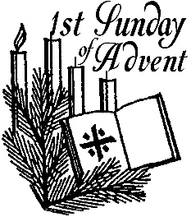
Is 63:16b-17, 19b; 64:2-7/1 Cor 1:3-9/Mk 13:33-37
5:00PM + James Bucci

SUNDAY, Dec. 3 – 1ST SUNDAY OF ADVENT

Is 63:16b-17, 19b; 64:2-7/1 Cor 1:3-9/Mk 13:33-37

8:00AM ⁓ People of the Parish

10:30AM + Rogene R. Blocher & Cora Jane Miller

Monday, December 4 – St. John Damascene, Priest & Doctor
Is 2:1-5 / Mt 8:5-11 of the Church
Parish Office Closed
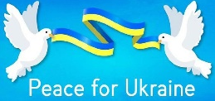

Tuesday, December 5 (Advent Weekday)
Is 11:1-10 / Lk 10:21-24

8AM – 3PM ~ Office Open

10:00AM + Geraldine Deardorff
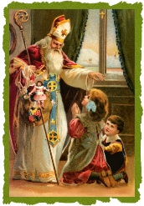
Wednesday, December 6 – St. Nicholas, Bishop
Is 25:6-10a / Mt 15:29-37
11AM: Mature Spirituality Group
7:00PM Mass w/ Anointing of the Sick + Jack Ryff
NO Confessions; NO Adoration & NO Benediction

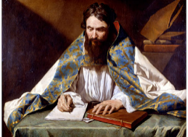
Thursday, December 7 – St. Ambrose, Bishop &
Is 26:1-6 / Mt 7:21, 24-27 Doctor

8AM – 3PM ~ Office Open of the Church
10:00AM + Star Wiskeman
7:00PM VIGIL OF THE IMMAC. CONCEPTION + Connie Canute
Friday, December 8 – IMMACULATE CONCEPTION  Gn 3:9-15, 20/Eph 1:3-6, 11-12/Lk 1:26-38 OF THE BVM  10:00AM + Keith Sharrah  7:00PM ⁓ People of the Parish  Parish Office CLOSED Patronal Feastday of the USA | THE LORD

SATURDAY, December 9 – St. Juan Diego Cuauhtlatoatzin

MORNING: Is 30:19-21, 23-26 / Mt 9:35—10:1, 5a, 6-8

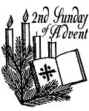
SATURDAY, Dec. 9 - VIGIL 2nd SUNDAY OF ADVENT

Is 40:1-5, 9-11 / 2 Pt 3:8-14 / Mk 1:1-8
5:00PM + Joan and Eugene Schott

SUNDAY, Dec. 10 – 2nd SUNDAY OF ADVENT

Is 40:1-5, 9-11 / 2 Pt 3:8-14 / Mk 1:1-8
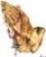
8:00AM - Spec. Int. for Richard & Roxanne Dennis
10:30AM ⁓ People of the Parish
Sanctuary Candle offered for DECEMBER: In Loving Memory of Donald Redding & Teresa Quigley

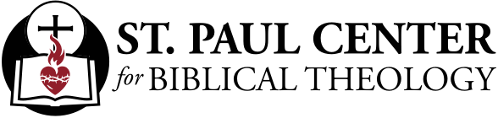

Watch for Him: Scott Hahn Reflects

on the First Sunday of Advent

The new Church year begins with a plea for God’s visitation. “Oh that You would rend the heavens and come down,” the Prophet Isaiah cries in today’s First Reading.

In today’s Psalm, too, we hear the anguished voice of Isra-el, imploring God to look down from His heavenly Throne — to save and shepherd His People.

Today’s readings are relatively brief. Their language and “message” are deceptively simple. But we should take note of the serious mood and penitential aspect of the Liturgy today as the people of Isra-el recognize their sinfulness, their failures to keep God’s Covenant, their inability to save themselves.

And in this Advent Season, we should see our own lives in the experience of Isra-el. As we examine our consciences, can’t we, too, find that we often harden our hearts, refuse His rule, wander from His ways, withhold our love from Him?

God is faithful, St. Paul reminds us in today’s Epistle. He is our Father. He has hearkened to the cry of His Children, coming down from Heaven for Isra-el’s sake ‒ and for ours ‒ to redeem us from our exile from God, to restore us to His Love.

In Jesus, we have seen the Father (see John 14:8–9). The Father has let His Face shine upon us. He is the Good Shepherd (see John 10:11–15) come to guide us to the heavenly Kingdom. No matter how far we have strayed, He will give us new life if we turn to Him, if we call upon His Holy Name, if we pledge anew never again to withdraw from Him.

As St. Paul says today, He has given us every spiritual gift — especially the Eucharist and Penance — to strengthen us as we await Christ’s Final Coming. He will keep us firm to the end — if we let Him.

So, in this season of repentance, we should heed the warning repeated three times by our LORD in today’s Gospel: be watchful, for we know not the hour when the Lord of the house will return.

Readings: Isaiah 63:16–17, 19; Psalm 80:2–3, 15–16, 18–19; 1 Corinthians 1:3–9; Mark 13:33–37

Sunday Collection Summary for Nov. 25 & 26

Weekend Collections
Regular Offering $ 2,960.00
Christmas $ 310.00
Immaculate Conception $ 75.00
Solemnity of Mary, Mother of God $ 40.00
TOTAL OFFERINGS $ 3,385.00

‒ WEEKLY BUDGETARY NEEDS $ 4,494.00
+Overage or (Shortfall) for the week ($ 1,109.00)

Other Income
Candles/Living Faith $ 149.01
Christmas Flowers $ 122.00
Thanksgiving $ 266.00
Individual Contributions $ 8,000.00
Total Other Offerings $ 8, 537.01

Diocesan Second Collections
Matthew 25 $ 25.00
Retirement for Religious $ 50.00
Total Diocesan Offerings $ 75.00

Sunday Collection Summary for NOVEMBER
Number of Collection Weeks: 4

Weekend Collections
Regular Offering $ 13,214.00
All Saints $ 75.00
All Souls $ 1,295.00
Christ the King $ 225.00
Christmas $ 310.00
Immaculate Conception $ 85.00
Solemnity of Mary, Mother of God $ 40.00
TOTAL OFFERINGS $ 15,244.00

‒ MONTHLY BUDGETARY NEEDS $ 22,470.00
+Overage or (Shortfall) for the month ($ 7,226 .00)

Other Income
Candles/Living Faith $ 322.79
Christmas Flowers $ 217.00
Local Poor $ 25.00
Thanksgiving $ 811.00
Individual Contribution $ 8,000.00
Total Other Offerings $ 1,375.79

Diocesan Second Collections
Matthew 25 $ 1,352.00
Peter’s Pence $ 25.00
Retirement for Religious $ 60.00
World Mission Sunday $ 115.00
Total Diocesan Offerings $ 1,552.00

POPE FRANCIS’ PRAYER INTENTION
FOR DECEMBER
We pray that people living with disabilities may be at the center of attention in society, and that institutions may offer inclusive programs which value their active participation.

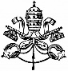

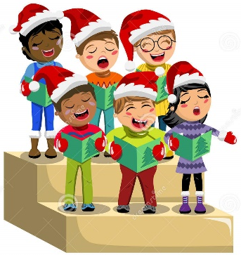

HOLIDAY CHOIR CONCERT
You are invited to an evening of Christmas Holiday choir songs presented by the Penn National Harmony Singers on Tuesday December 12, 2023.
The free concert will be held at 7:00 pm in the New Guilford Brethren in Christ (BIC) Church, located at 1575 Mont Alto Road, just south of Fayetteville.
Many of the holiday favorites will be sung as well as a few spiritual selections.
Put December 12th at 7:00 on your calendar and come to the New Guilford BIC to get a dose of Christmas and Holiday cheer in your ears.

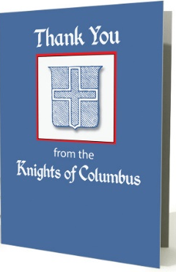

Monsignor Louis J. Yeager Council # 14035
Ignatius Saint Loyola Church

The Msgr. Yeager Council wishes to THANK all Saint Ignatius Loyola parishioners, fellow Brothers, and Fr. Dominic for their generosity in supporting the “Coats for Tots” program. THIS YEAR WAS A BANNER YEAR ESTABLISHING A NEW RECORD! Our Council was able to donate a total of 94 coats to the Diocesan Interfaith Homeless Shelter and the South Central Community Action Program (SCCAP Homeless Shelter) in Harrisburg & Gettysburg, PA, respectively. A total of sixty-three (63) new kids coats and thirty-one (31) new adult coats were given to these two shelters. Our Council wishes all of our parishioners a Blessed Merry Christmas and Happy New Year to all!

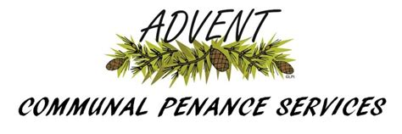

****************************************************************************************
St. Andrew's, Waynesboro
Wed., Dec. 13th at 6:00PM (NOTE: 10AM morning Mass here!)
++++++++++++++++++++++++++++++++++++++++++++++++++++++++++++++++
Our Lady of the Visitation, Shippensburg
Also on Wed., Dec. 13th at 6:30PM
+++++++++++++++++++++++++++++++++++++++++++++++++++++++++++++++
St. Rita's, Blue Ridge Summit
Sat., Dec. 16th at 11:00AM
++++++++++++++++++++++++++++++++++++++++++++++++++++++++++++++++
Corpus Christi, Chambersburg
Sun., Dec. 17th at 3:00PM
and Wed., Dec. 20th at 7:00PM (NOTE: 10AM morning Mass here!)
++++++++++++++++++++++++++++++++++++++++++++++++++++++++++++++++
St. Mark's, Greencastle
Tues., Dec. 19th at 6:30PM

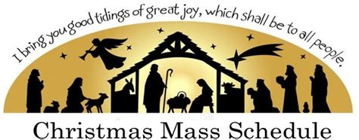

CHRISTMAS EVE MASS AT THE VIGIL
Sunday, December 24 at 8PM (NOTE: One Mass Only for Christmas Eve)

CHRISTMAS MASS DURING THE DAY
Monday, Decembner 25 at 9AM
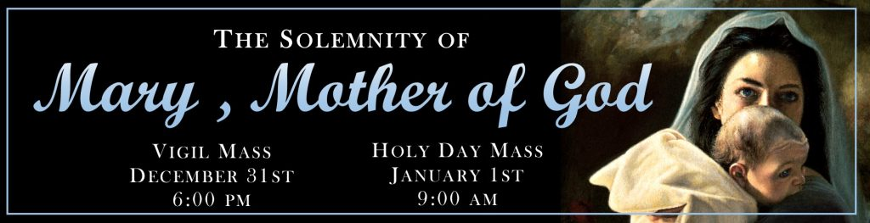

HOLY DAY MASS, Jan. 1st
Monday, 10AM
VIGIL MASS, Dec. 31st
NO MASS – Obligation Lifted

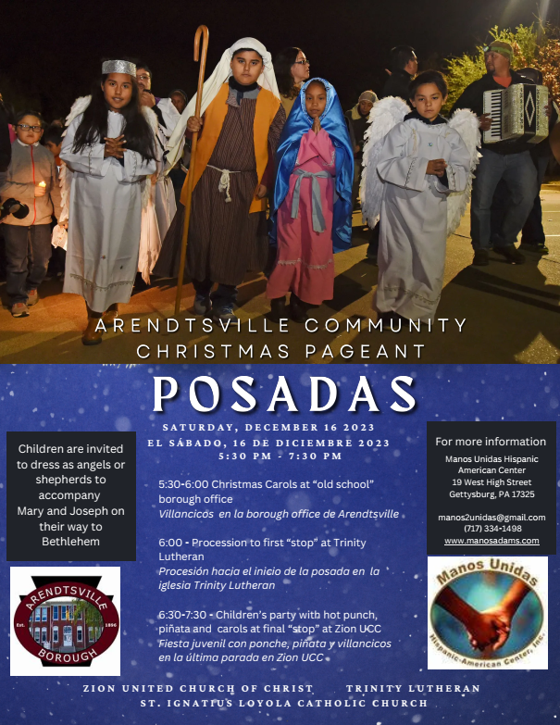

Pope to Orthodox Patriarch: ‘Bonds of Faith, Hope and Charity’ Unite Two Churches
By Matthew Santucci | Rome Newsroom, Nov 30, 2023

On the Feast of St. Andrew the Apostle, Pope Francis sent a message to Ecumenical Patriarch Bartholomew I of Constantinople expressing his “fraternal affection” and reflecting on the “deep bonds of faith, hope, and charity” between the two churches.

The pope opened the letter by focusing on the journey of reconciliation between the two churches, noting that the feast of St. Andrew precedes the historic meeting between Pope Paul VI and Ecumenical Patriarch Athenagoras in Jerusalem in January 1964.

“That encounter was a vital step forward in breaking down the barrier of misunderstanding, distrust, and even hostility that had existed for almost a millennium. It is noteworthy that today we remember not so much the words and statements of those two prophetic pastors but above all their warm embrace,” the pope said in his letter.

“The example of Pope Paul VI and Patriarch Athenagoras shows us that all authentic paths to the restoration of full communion among the Lord’s disciples are characterized by personal contact and time spent together,” Francis continued.

That meeting was an inflection point in the Catholic-Orthodox relationship, from one of estrangement to one of dialogue, as it was the first time since 1483 that a pope and an ecumenical patriarch met.

Pope Francis also noted that “it is highly significant that this journey of reconciliation, increasing closeness, and overcoming of obstacles still impeding full visible communion began with an embrace, a gesture that eloquently expresses the mutual recognition of ecclesial fraternity.”

Pope Francis every year sends a message on the feast of St. Andrew the Apostle to the ecumenical patriarch, who is the successor of St. Andrew and the “first among equals” in the Eastern Orthodox Church.

This year the pope expressed his “gratitude” and thanked the patriarch for his attendance at the ecumenical prayer vigil ahead of the opening of October’s Synod on Synodality. In a press release before the event, the Holy See said that the vigil was prepared in order to “emphasize the centrality of prayer in the synodal process, which is a spiritual process” and “underline the articulation between the synodal path and the ecumenical path.”

“Your personal support and that of the Ecumenical Patriarchate, expressed also through the participation of a fraternal delegate in the work of the assembly, are a great source of encouragement for the fruitful continuation of the ongoing synodal process in the Catholic Church,” Pope Francis said in his letter.

The prayer vigil was also attended by other religious leaders including Archbishop Justin Welby of Canterbury, Coptic Pope Tawadros II, and Pastor Anne Burghardt of the Lutheran World Federation.

In Instrumentum Laboris, the Vatican’s working document that guided Synod on Synodality discussions, the theme of ecumenism featured prominently.

“Indeed, both synodality and ecumenism are rooted in the baptismal dignity of the entire people of God. Together they invite renewed commitment to the vision of a missionary synodal Church. They are processes of listening and dialogue and invite us to grow in a communion that is not uniformity but unity in legitimate diversity. They highlight the need for a spirit of co-responsibility, since our decisions and actions at different levels affect all members of the body of Christ. They are spiritual processes of repentance, forgiveness, and reconciliation in a dialogue of conversion that can lead to a healing of memory,” the document reads.

Francis closed his Nov. 30 letter by writing that both churches are “in service to humanity, especially those affected by poverty, violence, and exploitation.” The Holy Father implored for peace.

“Let us fervently pray to God, our merciful Father, that the clamor of arms, which brings only death and destruction, may cease, and that government and religious leaders may always seek the path of dialogue and reconciliation,” he wrote.

