Sacrament of the Sick
Anointing of the Sick should be given if an individual is gravely ill or near death. If possible, the Sacrament should also be administered for serious illness, before major surgery or when one is initially hospitalized.

Sacrament of Holy Matrimony
Diocesan policy requires 12 months of preparation for Marriage. Contact the parish as soon as possible after engagement. No venue reservations or other arrangements should be made prior to consultation with the pastor.

Sacrament of Penance
Wednesday ~ 6:00 – 6:45PM; or by appointment.

Sacrament of Baptism
Parents must be registered members of the parish and attend a Baptism preparation class prior to the Baptism if this is your first child baptized. Requirements for godparents are established by the Catholic Church. Please call the parish office for Information and to register your child for Baptism.

Parish Registration
All Catholics should be registered in their local parish. Please contact the parish office to obtain registration forms, or if you are uncertain of the parish where you should register.

Parish Staff & Ministries Directory
stignatiusofloyola@hbgdiocese.org | Office: 717-677-8012
Financial Manager ~ Richard Deardorff ~ 717- 677-8012 or 717-420-3464 (cell)
rdeardorff@hbgdiocese.org
Director of Religious Education ~ Deacon Steve Huete ~ shuete@hbgdiocese.org
Parish Secretary ~ Kristen DiDio ~ kdidio@hbgdiocese.org
Buildings & Grounds ~ Donnie Althoff ~ 717-677-8012
Music Ministry ~ Phil Mobley ~ 717-677-8012
Parish Council Members
Phil Mobley – Chair 571-236-7580 pmmobley@gmail.com
Bicky Redman – Vice Chair 677-8592 feetintheair7@gmail.com
Joanne Riedel - Secretary 398-2021 sterj221@aol.com
Kathi Allwein 677-8984 allweint@comcast.net
Charlie Baker 677-9536 dcbake@embarqmqil.com
Kathy Dietsch 352-4558 kdiet2@juno.com
Dr. BobTernes rjtmd46@gmail.com

Finance Council Members
Richard Deardorff (Ex Officio)
Greg Ernst - Chair
Christy Hemler - Secretary
Ali Morris
Terri Pendlelton
Bill Pulig

Altar Flowers
OCIA
Order of Christian Initiation for Adults
Contact Fr. Dominic

Soup Kitchen
Please send donations
directly to the
“Gettysburg Soup Kitchen”

Website Development
Kristen DiDio
Life After Loss
Dodie Huete

Prayer Chain
CONTACT THE PARISH OFFICE

Picnic Chairperson
Mark Schur

Pro-Life Ministry
Jeanette Backus
Knights of Columbus
SK Bob Ternes
- Grand Knight

Judy Wilson / Janice Meligakes

Bereavement Ministry
Ginny Bittle / Dodie Huete

Catholic Communications/EWTN
Anna Kane

Cemetery
CONTACT PARISH OFFICE
THEOSIS Ministry
Kathy Dietsch 717-352-4558
Bicky Redman 717-677-8592

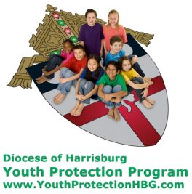
Diocese of Harrisburg Youth Protection Program
www.YouthProtectionHBG.com

Abuse Reporting Contact Information:
First – Call the toll-free PA Child Abuse Hotline at 800-932-0313
Then – Call the Diocesan toll-free hotline at 800-626-1608

“If one member suffers,
all suffer together with it.” (1 Cor 12:26)

St. Ignatius Loyola RC Church

1095 Church Road, Orrtanna, Pennsylvania 17353
www.stignatiusofloyola.org | Office: 717-677-8012

October 15, 2023: 28th SUNDAY IN ORDINARY TIME

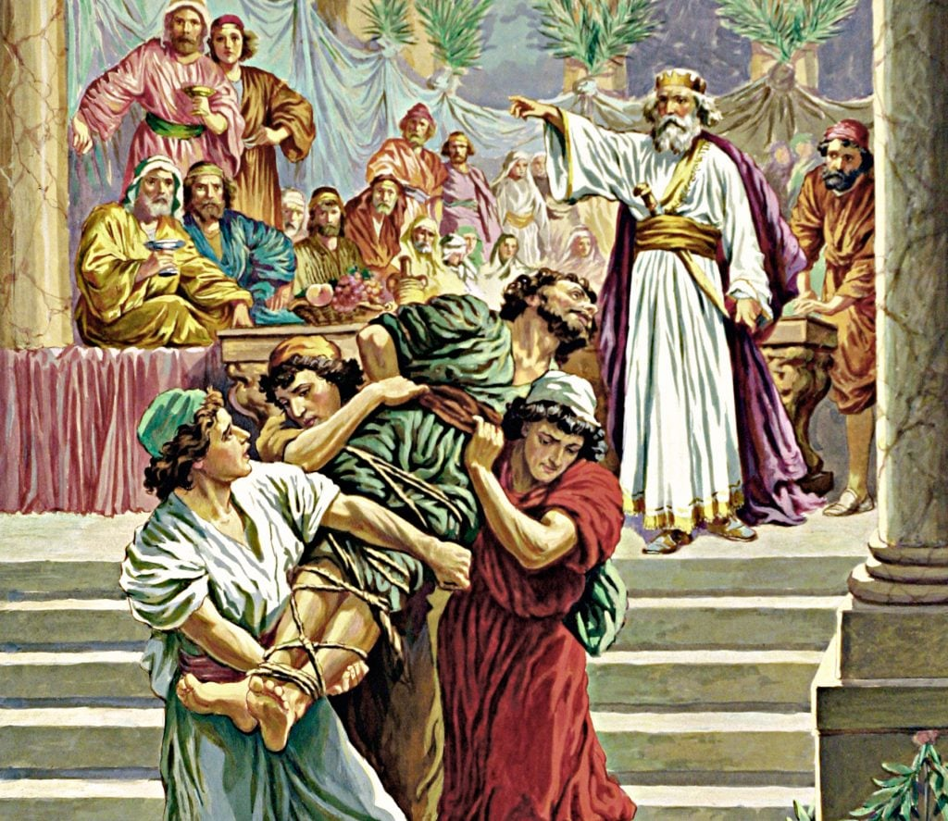

Most Rev. Timothy C. Senior, Bishop of Harrisburg
Rev. Dominic M. DiBiccaro, Pastor
Deacon Steve Huete, Pastoral Associate

Mass Schedule, Intentions, and Events
Please Pray for these in need:
Jeanie Kline & the Kline Family, Dick & Deb Deardorff, John Baker, Ginny Hoctor Brenda Wolf, Wade Sprankle, Dulcie Perry, Ron Formosa, Gavin Crumbacker, Anna Kane, Sherry Dennis & Family, Remi Peters, Christy Hemler, Terry Ahn, K. Grance, Lori McFadden & Family, Mike & Lisa Poole, Mervin Weikert, Chastity Rudisill, Mary Ellen Wilson, Terry & Bernie Cabana, Ed & Aggie Sherensky & Family, Bob Raffensberger, Jerry & Ginny Miller, Adeline Lienard, Kaylee Henry, Nancy Wuller, Dr. Mike Colli, Mrs. Kelly Kump, Gabriel Singer, Sharon McCormley, Ron Thumma, Joe Wisotzkey, Leo Hockensmith, Erika McKissick, Jean "Heather" O'Shea, Scott Moore & Sally Moore, Mary Wyatt, Jim & Joyce Deardorff, Amy Weatherup, Sophia Joy Ernst, Deacon Richard Wentzel, Deacon Frank Enderle, Kathleen Thompson, Deb & Kathy McLintock & Family, Rachel Wonders, Amy Edwards, Jean O’Connor, Jen Baldwin, Ursula Kaley, Deb Bennet, Larry Endy, Laura Lee, Marwa Abdelrahman, Donna Singley, Tim McGinn, Jane Kump, Peggy Neiderer, Chris Kimple, Robert Riquet, Gene & Jo-Ann McDannell, Bob Doxzen, Kimberly Mears, Gabriella Angello, Paul Angello, Mark & Kate Morrow, Mark Morris, Linda Fogleman, Paul Knight, George & Barbara Erstila, Jeff Carpenter, Lana & Nelson Harmon, Diane Slothour, Sue McDannell, Larry Schneider, Joe & Lisa Grasel, Ange Pena, Julie Barnhart, the Shaffer Family, Heather & Emma Dickerson, Brad Peabody, Paul Ward, Aiden Tyler Schneider, Dorothy Vega, Karrie McCall & daughter, George Shahid, Denise Navlyt, Drew Schneider & Family, Ida Bloomfield, Janie Singley, Mary Beth Greenstreet, Rick Benedict, Jan Patla, Kathey Fogleman, Sam Sheffler, Kate Hemmis, Bill & Mary Lou Graham, Joanna Hodges, John Varones, Joan O’Sullivan, Martha Klinger, Lisa Dionne Lauretti, Jim Gleason, Sue Gustafson, Joe & Michelle Cleary, Kim Johnson, Helen Mills, Kathy Haber, Haley Detman, Joe Durovey, Bev Smith, Donald Sheppard, Linda Mumaugh, Alison Haring, Janet Hartman, Edward Johnson, Angela Galeone, Juliete Lang, Chris MacBeth, Harry Graham, Donald Howard, Armond Binni, Elizabeth Stansky, Pat Johnson, Chris Morris, Faud Doaney, Patrick Glass, Helen Lagasse, Nancy Kewisnek, &y Graham, Bill & Maureen Collins, Rosemary McGilloway, Anji Eisenhart, Monica Manner, Denny Borbonus, Dr. Paul Scarlata, Mary Hawthorne, Ed Washington, Josh Kempinski, Nancy Baker Baltzey, Spencer Propts, Karlton Smith & Cheryl Sobun, James & Marylyn Sobun, Marlene Webster, Yvette Stoklosa, &y Consiglio, Bill & Michelle Cloonan, Nelson Salem, Bill & Deb McClintock, nursing home residents & shut-ins, the victims of war, violence, disease, disaster, & all private intentions.
Also in your prayers, please remember all our men
& women currently serving in our Armed Forces:

Lt. Col. Nathan Jeffcoat – US Marine Corps
Lt. Joseph Cleary – US Navy
Michael C. Kenney IV – US Coast Guard
Lt. Joshua Kimple – US Army
Lt. Sarah Fogleman, M.D. – US Navy .
A1C Ian Bellinger ‒ PA Air National Guard

PRAYER CHAIN: Contact the
Parish Office

for the Week of October 14 to October 22, 2023

SATURDAY, Oct. 14- VIGIL 28th SUNDAY OT

Is 25:6-10a/Phil 4:12-14, 19-20/Mt 22:1-14
4:30PM Recitation of the Holy Rosary
5:00PM + Sara Keller

SUNDAY, Oct.15 – 28th SUNDAY IN OT

Is 25:6-10a/Phil 4:12-14, 19-20/Mt 22:1-14
8:00AM + Thomas Wolf
10:30AM ⁓ People of the Parish

Monday, October 16 – St. Hedwig, Religious; St. Margaret Mary
Rom 1:1-7 / Lk 11:29-32 Alacoque, Virgin
Parish Office Closed
NO MASS

Tuesday, October 17 – St. Ignatius of Antioch, Bishop & Martyr
Rom 1:16-25 / Lk 11:37-41

8:00AM – 3:00PM ~ Office Open

10:00AM - Spec. Int. Christian A. Rebscher

11AM “Something More” Group

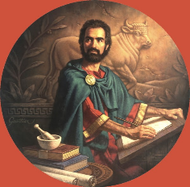
Wednesday, October 18 – ST. LUKE, APOSTLE
2 Tm 4:10-17b / Lk 10:1-9 & EVANGELIST

8AM – 3PM ~ Office Open
11AM: Mature Spirituality Group
7:00PM + Jack Ryff
6 - 6:45PM Confessions; 7:40PM Adoration, Rosary, Benediction

Thursday, October 19 – Sts. Jean de Brébeuf, Isaac Jogues, Priests
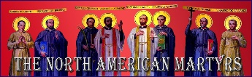
Rom 3:21-30 / Lk 11:47-54 & Companions, Martyrs
8AM – 3PM ~ Office Open
10:00AM + Mickie Schneider

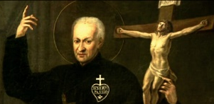  Friday, October 20 – St. Paul of the Cross, Priest  Rom 4:1-8 / Lk 12:1-7  10:00AM + John Dooly  Parish Office CLOSED | THE LORD

SATURDAY, October 21 (Weekday in OT)

MORNING: Rom 4:13, 16-18 / Lk 12:8-12

SATURDAY, Oct. 21- VIGIL 29th SUNDAY OT

Is 45:1, 4-6 / 1 Thes 1:1-5b / Mt 22:15-21
4:30PM Recitation of the Holy Rosary
5:00PM + Larry Dennis

SUNDAY, Oct.22 – 29th SUNDAY IN OT

Is 45:1, 4-6 / 1 Thes 1:1-5b / Mt 22:15-21
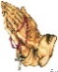
8:00AM ⁓ People of the Parish
10:30AM + Bill Rollins
Sanctuary Candle offered for OCTOBER: John Louise and Bobbi Strasbaugh from Theresa & Gary Cowan

Dressing for the Feast: Scott Hahn Reflects

on the Twenty-eighth Sunday in Ordinary Time

Our LORD’s parable in today’s Gospel is again a fairly straightforward outline of salvation history.

God is the king (see Matthew 5:35), Jesus the bridegroom (see Matthew 9:15), the feast is the salvation and eternal life that Isaiah prophesies in today’s First Reading. The Isra-elites are those first invited to the feast by God’s servants, the Prophets (see Isaiah 25:6). For refusing repeated invitations and even killing His Prophets, Isra-el has been punished, its city conquered by foreign armies.

Now, Jesus makes clear, God is sending new servants, His Apostles, to call not only Isra-elites, but all people — good and bad alike — to the Feast of His Kingdom. This an image of the Church, which Jesus elsewhere compares to a field sown with both wheat and weeds, and a fishing net that catches good fish and bad (see Matthew 13:24–43, 47–50).

We have all been called to this great Feast of Love in the Church, where, as Isaiah foretold, the veil that once separated the nations from the Covenants of Isra-el has been destroyed, where the dividing wall of enmity has been torn down by the Blood of Christ (see Ephesians 2:11–14).

As we sing in today’s Psalm, the LORD has led us to this feast, refreshing our souls in the Waters of Baptism, spreading the Table before us in the Eucharist. As St. Paul tells us in today’s Epistle, in the glorious riches of Christ we will find supplied whatever we need.

In the rich food of His Body and the choice wine of His Blood, we have a foretaste of the Eternal Banquet in the Heavenly Jerusalem, when God will destroy death forever (see Hebrews 12:22–24).

But are we dressed for the feast? Are we clothed in the garment of righteousness (see Revelation 19:7–8)? Not all who have been called will be chosen for Eternal Life, Jesus warns. Let us be sure that we’re living in a manner worthy of the invitation we’ve received (see Ephesians 4:1).

Readings: Isaiah 25:6–10; Psalm 23:1–6;
Philippians 4:12–14, 19–20; Matthew 22:1–14

Sunday Collection Summary for Sept.30 & Oct.1

Weekend Collections
Regular Offering $ 6,182.00
Candles $ 58.00
All Saints (Holy Day) $ 100.00
Flowers $ 500.00
TOTAL OFFERINGS $ 6,840.00

‒ WEEKLY BUDGETARY NEEDS $ 4,494.00
+Overage or (Shortfall) for the week +$ 2,346.00

Other Income
Local Poor $ 195.00
Total Other Offerings $ 195.00

Diocesan Second Collections
World Mission Sunday $ 165.00
Total Diocesan Offerings $ 165.00

Sunday Collection Summary for Oct. 7 & 8

Weekend Collections
Regular Offering $ 4,310.00
TOTAL OFFERINGS $ 4,310.00

‒ WEEKLY BUDGETARY NEEDS $ 4,494.00
+Overage or (Shortfall) for the week ($ 184.00)

Other Income
Local Poor $ 320.00
Total Other Offerings $ 320.00

Diocesan Second Collections
World Mission Sunday $ 110.00
Total Diocesan Offerings $ 110.00

Collection Summary for the Month of
September 2023
Number of Collection Weeks in the Month: 4

Weekend Collections
Sunday Offering $ 14,038.46
Candles $ 223.27
All Saints (Holy Day) $ 10.00
TOTAL OFFERINGS $ 14,271.73

‒ TOTAL BUDGETARY NEEDS $ 22,470.00
+(Overage) or (Shortfall) for the month ($ 8,198.27)

Other Income
Individual Contributions $ 5,849.10
Rebate (Aero Energy Houses of Worship) $ 183.86
Local Poor $ 132.00
Stewardship Bookcase $ 86.00
Parish Picnic (Additional) $ 40.00
Picnic Raffle Tickets (Additional) $ 378.00
Total Other Income $ 6,668.96

Diocesan Second Collections
Peter’s Pence $ 1,249.75
World Mission Sunday $ 5.00
TOTAL DIOCESAN OFFERINGS $ 1,254.75

Pope Francis calls for immediate release of Israeli hostages held by Hamas
By Courtney Mares | Vatican City, Oct 11, 2023

Pope Francis appealed for the immediate release of more than 100 hostages being held
by Hamas in Gaza on Wednesday and expressed concern for the safety of Palestinian
civilians living in the Gaza Strip.
“I pray for those families who saw a feast day transformed into a day of mourning, and I ask that the hostages be immediately released,” Pope Francis said on Oct. 11.
Some 130 Israeli hostages were taken by the militant Islamist group Hamas during its attack on Israel last weekend. The terrorist group has threatened to kill one hostage every time that Israel’s military bombs civilian targets in Gaza “without warning,” according to the Associated Press.
Speaking to thousands of people in St. Peter’s Square for his Wednesday morning audience, the pope underlined that “terrorism and extremism do not help to reach a solution to the conflict between Israelis and Palestinians, but they fuel hatred, violence, revenge, and only make both suffer.”
The pope said that he has been following “what is happening in Israel and Palestine with tears and apprehension.” After Hamas’ attack on Israel killed 1,000 people, the Israeli government vowed retaliation and launched airstrikes on the blockaded Gaza Strip.
Francis said: “It is the right of those who are attacked to defend themselves, but I am very worried about the total siege in which the Palestinians live in Gaza, where there have been many innocent victims.”
“The Middle East does not need war, but peace, a peace built on justice, dialogue, and the courage of fraternity,” he added.
The appeal was the second time that Pope Francis has spoken publicly about the war in Israel since the surprise attack last weekend.
On Sunday, the pope prayed for peace between Israel and Palestine and expressed sorrow that “violence has exploded even more ferociously” between the two, words that drew criticism from Israel’s Embassy to the Holy See, which issued a statement warning against “the use of linguistic ambiguities and terms that allude to a false symmetry.”
The pope also spoke over the telephone with a Catholic priest who serves the only Catholic Church in Gaza on Oct. 9, according to the news agency of the Italian bishops’ conference.

The priest, Father Gabriel Romanelli, who is currently stranded in Bethlehem, told ACI Prensa, CNA’s Spanish-language news partner, Oct. 9 that the situation “continues to be very bad” and that his Gaza parish is sheltering more than 80 Christians and Muslims amid Israeli airstrikes.

Families of the victims taken hostage by Hamas are desperately waiting to find out if their missing loved ones are safe. An American woman, Abbey Onn, whose five relatives in southern Israel were taken hostage, told CBS News that she had seen a video on social media on Sunday of her 12-year-old relative in the hands of Hamas.

“These are civilians who are being terrorized and we want them brought home,” she said.

“I continue to follow what is happening in Israel and Palestine with tears and apprehension: many
people killed, others injured. I pray for those families who have seen a feast day transformed into
a day of mourning, and I ask that the hostages be released immediately. It is the right of those
who are attacked to defend themselves, but I am very concerned about the total siege under
which the Palestinians are living in Gaza, where there have also been many innocent victims. Terrorism and extremism do not help reach a solution to the conflict between Israelis and Palestinians, but fuel hatred, violence, revenge, and only cause each to other suffer. The Middle East does not need war, but peace, a peace built on dialogue and the courage of fraternity.” ⁓General Audience, 11 October 2023, St. Peter’s Square

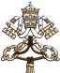

In the Holy Land, Franciscans are keeping doors to

holy sites open — for now

By Marinella Bandini | Jerusalem, Oct 11, 2023

On Saturday, Oct. 7, Israel suddenly found itself in a state of war. A barrage of rockets from the Gaza Strip and attacks by Hamas terrorists who infiltrated cities near the border resulted in the death of over 1,000 people. Among them were 11 American citizens as well as citizens from many other countries.

Since then in the southern part of the country, the alarm sirens warning of incoming missiles are relentless. Jerusalem, on the other hand, has fallen into an eerie silence, interrupted only by alerts on mobile phones and the roar of military aircraft. The city is semi-deserted, with most shops closed, except for those selling essential goods. Schools are closed, as are many offices. There is a desire to return to some semblance of normalcy, mixed with the fear of leaving home due to the threat of reprisals.

The only open doors seem to be those of the Franciscan sanctuaries, which, at the express request of the Custody of the Holy Land, remain open for now, primarily to allow ongoing pilgrimages to carry out their spiritual experience as best they can. These sites include the Church of the Holy Sepulcher in Jerusalem; the Basilica of the Agony (also called the Church of All Nations), located on the Mount of Olives in Jerusalem; the Basilica of the Nativity in Bethlehem; and the Basilica of the Annunciation in Nazareth.

The Franciscans are taking it day by day, continuing their service in the sanctuaries and welcoming the few remaining groups.
However, thoughts of the immediate future bring back the struggle of the pandemic years, with a decline in tourism and, consequently, in donations and offerings. The Custody itself, in a statement, has expressly asked people to “suspend pilgrimages and wait until the situation is safe again.”

The leaders of the Christian community in the Holy Land continue to appeal incessantly for peace and the cessation of hostilities.
Following the outbreak of the conflict, Cardinal Pierbattista Pizzaballa, patriarch of Jerusalem, signed a statement in which, in addition to calling for a de-escalation of the conflict, emphasized the importance of preserving the Status Quo regarding the holy sites. This is a set of rules that regulates access to and use of the main holy sites since the time of the Ottoman Empire.

The same concern was reiterated in a joint statement by the patriarchs and heads of Christian churches in Jerusalem. Christian religious leaders have raised their voices together “to advocate for the cessation of all violent and military activities” and “condemn any acts that target civilians.”

The Custody of the Holy Land issued a statement on Oct. 10 inviting all the faithful to “pray and fast for peace.” The Franciscan communities, the statement reads, “pray for all the victims, especially the civilians and the hostages. And for their families. Let us pray so that the hatred, anger, and fear that generate violence go out in hearts. Let us pray so that the international community fosters initiatives of mediation and peace, especially in protecting civilians.”

At the moment, there is no news of specific prayer initiatives, given the state of emergency that discourages gatherings. The patriarch himself has suspended official entry ceremonies into dioceses. However, at ordinary liturgies, there is a greater intensification of prayers for peace.

On Monday, Oct. 9, at the Church of the Holy Sepulcher, the daily procession of the Franciscans to the places of the passion, death, and resurrection of Jesus concluded with a specific prayer for peace in the Holy Land.

“For more than seven centuries, the Franciscans, in times of war or peace, of excavation or work, have visited every day the places of the passion of Jesus,” the president of the Holy Sepulcher, Brother Stéphane, explained to media after the prayer.
“Here, Christ has risen! Here, he has defeated the world! Today, we wanted our prayer to be particularly focused on asking for peace for this land, which is now being torn apart once again, so that everyone can live in this land in peace and in safety.”

Marinella Bandini was born and raised in Italy, has been a professional journalist since 2008. She works for several news agencies and online newspapers in the Catholic space. Currently based in Jerusalem, she collaborates with the Custody of the Holy Land.

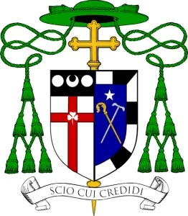
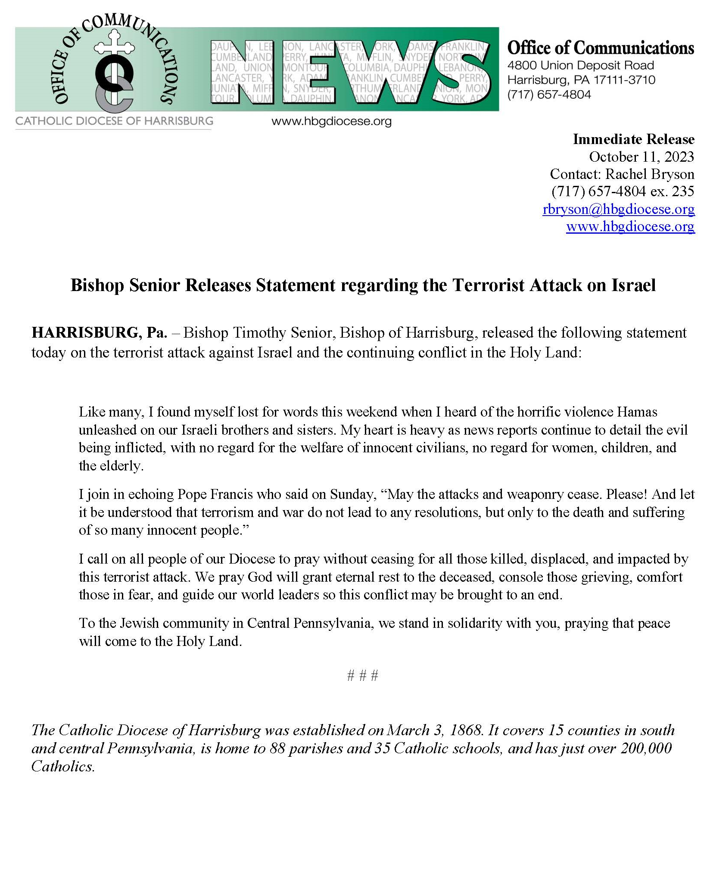
Prayer for the Holy Land
God of the Nations,
let not one more child or elder be sacrificed on altars of political expediency.
Keep safe all people from unjust leaders who would exploit
vulnerability for their own distorted ends.
Give wise discernment to those making decisions to pursue peace.
Provide them insight into fostering well-being, freedom, and thriving for all.
Teach all of us to resolve injustices with righteousness, not rockets.
Guard our hearts against retaliation, and give us hearts for love alone.
Strengthen our faith in You, O God of All Flesh,
even when we don’t have clear answers,
so that we may still offer ourselves nonviolently
for the cause of peace.
As believers in the God of Abraham,
the God of Isaac,
the God of Jacob,
the God of Moses,
the God of David,
and ... the God of Mohammed.

Yet, we as Christians understand You differently,
for You are the One True God in Three Divine Persons.

So we must place all our hopes, dreams, fears, and joys
in harmony with the Will of You, Father,
trusting in Your strong Right Hand, Our LORD Jesus Christ,
and consoled by the Care of the Holy Spirit.

For it is only You, Holy and Mighty One, Holy and Eternal One: the Almighty and Powerful God
who can heal the wounds of sin, division, oppression, and war, sown by the Evil one.

Because YOU ARE LOVE!
– which is always stronger than the hate of the Devil
The LOVE that lives and reigns for ever and ever. Amen.

God of Comfort,
send Your Spirit to encompass all those whose lives
are torn apart by violence and death in Israel and Palestine.
You are the Advocate of the oppressed
and the One whose eye is on the sparrow.
Let arms reach out in healing, rather than aggression.
Let hearts mourn rather than militarize.
God of Justice,
give strength to those whose long work for a just peace
might seem fruitless now. Strengthen their resolve.
Do not let them feel alone. Show us how to support their work
and bolster their courage. Guide religious leaders to model
unity and reconciliation across lines of division.
Guide political leaders to listen with their hearts as they seek peace and pursue it.
Help all people choose the rigorous path of just peace and disavow violence.
God of Love,
we lift up Palestine and Israel — its people, its land, its creatures.
War is a monster that consumes everything in its path.
Peace is a gift shared at meals of memory with Christians, Muslims, and Jews.
Let us burn incense, not children. Let us break bread, not bodies.
Let us plant olive groves, not cemeteries.
We beg for love and compassion to prevail
on all Your Holy Mountains.
God of Hope,
we lift up the cities of the region: Gaza City & Tel Aviv,
Ramallah and Ashkelon, Deir El Balah and Sderot,
so long divided, yet so filled with life and creativity.
Come again to breathe peace on Your Peoples
that all may recognize You.
God of Mercy,
even now work on the hearts of combatants
to choose life over death, reconciliation over retaliation,
restoration over destruction. Help us resist
antisemitism in all its forms,
especially in our own churches
All people, Israelis and Palestinians,
deserve to live in peace and unafraid, with a right to determine their future together.

