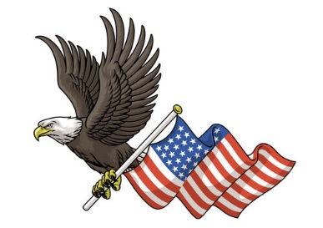
St. Ignatius Cemetery Veterans

WWII Era
War of 1812 Spanish American War Joseph E. Baker
George Cole Sr. Era Paul Joseph Baldwin
Hansen A. Oyler George C. Beard Jr.
Civil War Era Patrick J. Sweeney Charles Businda
Peter Adams Bryce Clark Cochran
William Baker WWI Era Albert A. Cole
William H. Baker John M. Baker Edward I. Cole
John Ball Lloyd F. Baker Gerald P. Cole
Lewis Brady George H. Betz Paul Clement Cole
John Hall Sr. Samuel Clapsadle John E. Day
Conrad Linn Armand Joseph Dillon Ray M. Deardorff
John A. Noel Albert C. Kane David L. Demichei
Jacob H. Peters George E. Kane Charles Dillon
Joseph M. Shorb Roland Kane John L. Dillon
John C. Steinberger Norman F. Knouse Daniel H. Doxzen Sr.
George Sterner William E. Kump William Robert Gates
John Strasbaugh Walter R. Leber John R. Finamore
William H. Taylor Ira Sharrah Donald Brady Hall
Peter A. Weiss Lawrence A. Steinberger Robert R. Hartzell Sr.
Vincent Wilders Paul I. Steinberger George H. Irvin
William I. Young Albert Strasbaugh Harold P. Irvin
Albert Edward Kane Jr.
Joseph L. Kane
Russell J. Kane
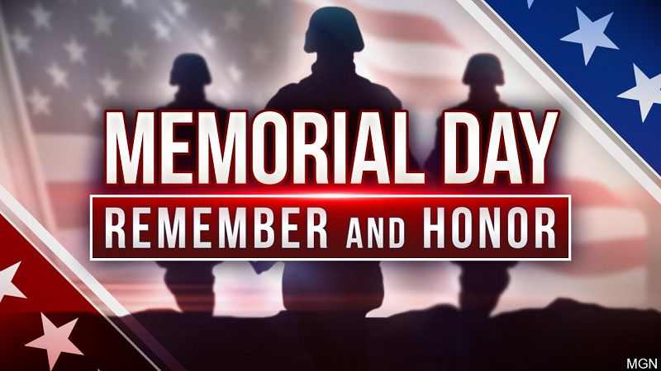
Ruth G. Kane
John Kimple
John B. Kump
Conrad W. Leber
Leroy J. McKenrick
Patrick C. McKenrick
Robert E. McKenrick
Cletus Ivan Miller
Robert O’Brien
Robert J. Oyler
Donald M. Redding
Bicknell H. Redman
Paul Robinson
John J. Sneeringer
Stanley Edward Sprankle
Edgar J. Steinberger
John E. Stover
Franklin E. Walter
Robert Watz
Joseph Louis Zmitrovich
Margaret Zmitrovich

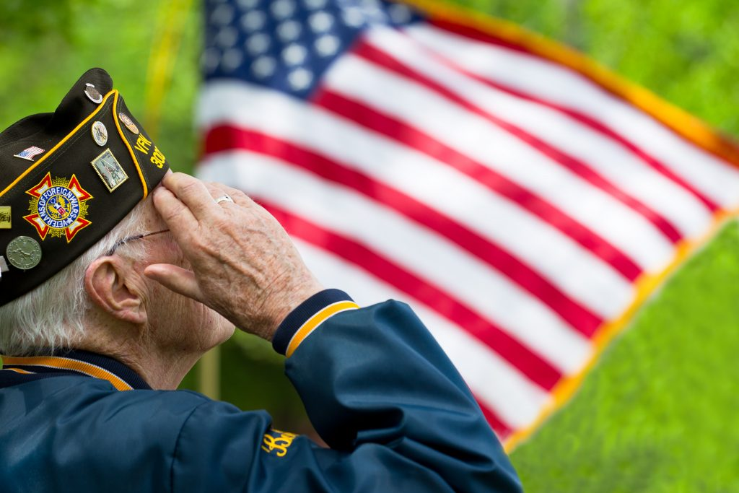
Korean Era
Henry Backhus
Melville Brandstetter Jr.
Richard C. Cole
Robert W. Cole
William Dillon
William D. Gibson Sr.
Frances Hall
John Albert Hall
Lawrence Hall Jr.
Charles Henry Heffner
Ivan Wayne Heller
George J. Hippensteel
John A. Hoctor Vietnam Era
Evan Eugene Hodge Kenneth R. Baker Sr.
Frank Johnson Thomas A. Baker
Fred J. Kane Frederick D. Berger Gulf War Era
Lawrence J. Kane Richard O. Carey Andrew Crossland
William H. Laur David G. Dionne Michael R. Gelwicks
Paul C. Maxwell Jr. Jack Gearity William Eric Hoyer
William McFadden Donald J Gracyalyn Clarence Stouter Jr.
Donald Newman Ronald T. Grance Steven Pacini
Dean A. Orner James J. Hayes
Robert M. Powell Timothy A. Heller
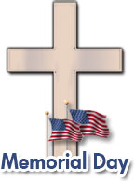
Robert B. Robinson Sr. Kermit Kane
Jess B Rosenberry Jr. Richard L. Kane
Barry Showers Fred A. Miller Sr.
George T. Steinberger Sr. William E. Minzer
Paul J. Strasbaugh Gerald J. Neiderer
James D. Strausbaugh John L. Parron
Kenneth D. Swartz William Rollins
Albert Valasko David Schmidt
Allen E. Weikert
Walter R. Wetzell
Patrick T. Wilkinson
Bernard A. Yannetti

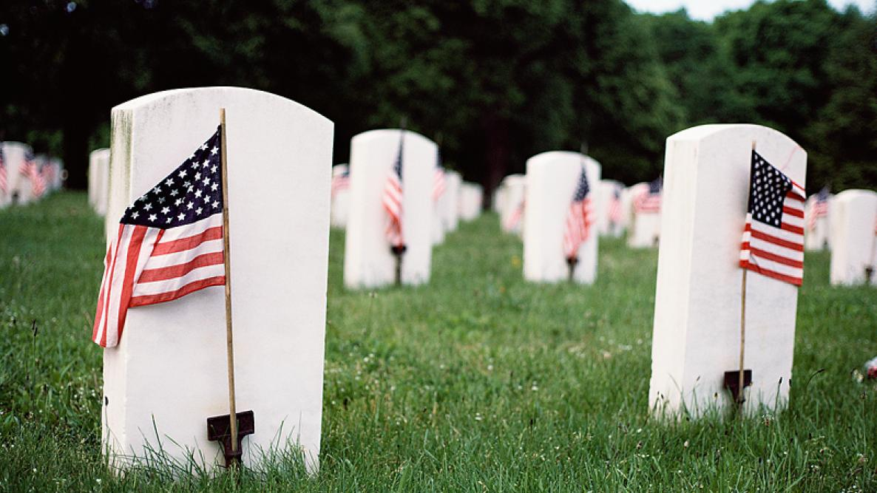
PRAYER FOR OUR DECEASED VETERANS

O God, by whose mercy the faithful departed
find rest, look kindly on Your departed Veterans
who gave their lives in service of our country.

Grant that through the Passion, Death, and
Resurrection of Your Son, they may share in the
joy of Your heavenly Kingdom and rejoice in
You with Your Saints forever.
We ask this through Christ our LORD.

Amen.

