Sacrament of the Sick
Anointing of the Sick should be given if an individual is gravely ill or near death. If possible, the Sacrament should also be administered for serious illness, before major surgery or when one is initially hospitalized.

Sacrament of Holy Matrimony
Diocesan policy requires 12 months of preparation for Marriage. Contact the parish as soon as possible after engagement. No venue reservations or other arrangements should be made prior to consultation with the pastor.

Sacrament of Penance
Wednesday ~ 6:00 – 6:45PM; or by appointment.

Sacrament of Baptism
Parents must be registered members of the parish and attend a Baptism preparation class prior to the Baptism if this is your first child baptized. Requirements for godparents are established by the Catholic Church. Please call the parish office for Information and to register your child for Baptism.

Parish Registration
All Catholics should be registered in their local parish. Please contact the parish office to obtain registration forms, or if you are uncertain of the parish where you should register.

Parish Staff & Ministries Directory
stignatiusofloyola@hbgdiocese.org | Office: 717-677-8012
Financial Manager ~ Richard Deardorff ~ 717- 677-8012 or 717-420-3464 (cell)
rdeardorff@hbgdiocese.org
Director of Religious Education ~ Deacon Steve Huete ~ shuete@hbgdiocese.org
Parish Secretary ~ Kristen DiDio ~ kdidio@hbgdiocese.org
Buildings & Grounds ~ Donnie Althoff ~ 717-677-8012
Music Ministry ~ Phil Mobley ~ 717-677-8012
Parish Council Members
Phil Mobley – Chair 571-236-7580 pmmobley@gmail.com
Bicky Redman – Vice Chair 677-8592 feetintheair7@gmail.com
Joanne Riedel - Secretary 398-2021 sterj221@aol.com
Kathi Allwein 677-8984 allweint@comcast.net
Charlie Baker 677-9536 dcbake@embarqmqil.com
Kathy Dietsch 352-4558 kdiet2@juno.com
Dr. BobTernes rjtmd46@gmail.com

Finance Council Members
Richard Deardorff (Ex Officio)
Greg Ernst - Chair
Christy Hemler - Secretary
Ali Morris
Terri Pendlelton
Bill Pulig

Altar Flowers
OCIA
Order of Christian Initiation for Adults
Contact Fr. Dominic

Soup Kitchen
Please send donations
directly to the
“Gettysburg Soup Kitchen”

Website Development
Kristen DiDio
Life After Loss
Dodie Huete

Prayer Chain
CONTACT THE PARISH OFFICE

Picnic Co-Chairs
Wally Kane
Mark Schur

Pro-Life Ministry
Jeanette Backus
Knights of Columbus
SK Bob Ternes
- Grand Knight

CONTACT THE PARISH OFFICE

Bereavement Ministry
Ginny Bittle / Dodie Huete

Catholic Communications/EWTN
Anna Kane

Cemetery
CONTACT THE PARISH OFFICE
THEOSIS Ministry
Kathy Dietsch 717-352-4558
Bicky Redman 717-677-8592

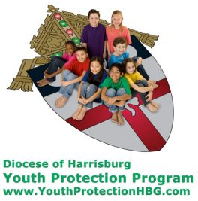
Diocese of Harrisburg Youth Protection Program
www.YouthProtectionHBG.com

Abuse Reporting Contact Information:
First – Call the toll-free PA Child Abuse Hotline at 800-932-0313
Then – Call the Diocesan toll-free hotline at 800-626-1608

“If one member suffers,
all suffer together with it.” (1 Cor 12:26)

St. Ignatius Loyola RC Church

St. Ignatius Loyola Roman Catholic Church
1095 Church Road, Orrtanna, Pennsylvania 17353
www.stignatiusofloyola.org | Office: 717-677-8012

March 24, 2024: PALM SUNDAY
OF THE PASSION OF THE LORD
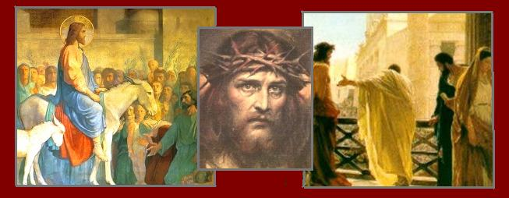

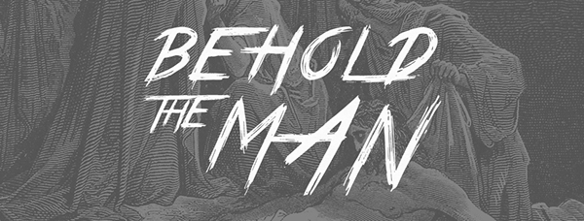

May the PRAYERS we offer this Holy Week,
through God’s Mercy, bring PEACE to the Holy Land!

Most Rev. Timothy C. Senior, Bishop of Harrisburg
Rev. Dominic M. DiBiccaro, Pastor
Deacon Steve Huete, Pastoral Associate

Mass Schedule, Intentions, and Events
Please Pray for these in need:
Jeanie Kline & the Kline Family, Dick & Deb Deardorff, Fred Dietsch, Terri Sanders, Greg Ernst, Jacob Long, Shell Edwards, Corona Naylor, Chris & Mary Rebscher, John Baker, Ginny Hoctor, Brenda Wolf, Sr. Thelma Steiger HSF, Sr. Miriam Ukeritis CSJ , Peter Hackney, Lucas Christiansen, Dale Kaplan, Jerry Smith, Dulcie Perry, Ron Formosa, Gavin Crumbacker, Anna Kane, Sherry Dennis & Family, Remi Peters, Terry Ahn, K. Grance, Lori McFadden & Family, Mike & Lisa Poole, Mervin Weikert, Chastity Rudisill, Mary Ellen Wilson, Terry & Bernie Cabana, Ed & Aggie Sherensky & Family, Bob Raffensberger, Jerry & Ginny Miller, Adeline Lienard, Kaylee Henry, Nancy Wuller, Dr. Mike Colli, Mrs. Kelly Kump, Gabriel Singer, Sharon McCormley, Ron Thumma, Joe Wisotzkey, Leo Hockensmith, Erika McKissick, Jean "Heather" O'Shea, Scott Moore & Sally Moore, Mary Wyatt, Amy Weatherup, Sophia Joy Ernst, Deacon Richard Wentzel, Deacon Frank Enderle, Carolyn Topper, Kathleen Thompson, Rachel Wonders, Amy Edwards, Jean O’Connor, Jen Baldwin, Ursula Kaley, Deb Bennet, Larry Endy, Laura Lee, Marwa Abdelrahman, Donna Singley, Tim McGinn, Jane Kump, Peggy Neiderer, Chris Kimple, Robert Riquet, Gene & Jo-Ann McDannell, Bob Doxzen, Kimberly Mears, Gabriella Angello, Paul Angello, Mark & Kate Morrow, Mark Morris, Linda Fogleman, Paul Knight, George & Barbara Erstila, Jeff Carpenter, Lana & Nelson Harmon, Diane Slothour, Sue McDannell, Larry Schneider, Joe & Lisa Grasel, Ange Pena, Julie Barnhart, Shaffer Family, Heather & Emma Dickerson, Brad Peabody, Paul Ward, Aiden Tyler Schneider, Dorothy Vega, Karrie McCall & daughter, George Shahid, Denise Navlyt, Drew Schneider & Family, Ida Bloomfield, Janie Singley, Mary Beth Greenstreet, Rick Benedict, Jan Patla, Kathey Fogleman, Sam Sheffler, Kate Hemmis, Bill & Mary Lou Graham, Andy Graham, Joanna Hodges, John Varones, Joan O’Sullivan, Martha Klinger, Lisa Dionne Lauretti, Jim Gleason, Sue Gustafson, Joe & Michelle Cleary, Kim Johnson, Helen Mills, Kathy Haber, Haley Detman, Joe Durovey, Bev Smith, Donald Sheppard, Linda Mumaugh, Alison Haring, Janet Hartman, Edward Johnson, Angela Galeone, Juliete Lang, Chris MacBeth, Harry Graham, Donald Howard, Armond Binni, Elizabeth Stansky, Pat Johnson, Chris Morris, Faud Doaney, Patrick Glass, Helen Lagasse, Nancy Kewisnek, Bill & Maureen Collins, Rosemary McGilloway, Anji Eisenhart, Monica Manner, Denny Borbonus, Dr. Paul Scarlata, Mary Hawthorne, Ed Washington, Josh Kempinski, Nancy Baltzey, Spencer Propts, Karlton Smith & Cheryl Sobun, James & Marylyn Sobun, Marlene Webster, Yvette Stoklosa, Andy Consiglio, Bill & Michelle Cloonan, Nelson Salem, Bill & Deb McClintock, nursing home residents & shut-ins, the victims of war, violence, disease, disaster, & all private intentions.
Also in your prayers, please remember all our men
& women currently serving in our Armed Forces:

Lt. Col. Nathan Jeffcoat – US Marine Corps
Lt. Joseph Cleary – US Navy
Michael C. Kenney IV – US Coast Guard
Lt. Joshua Kimple – US Army
Lt. Sarah Fogleman, M.D. – US Navy
A1C Ian Bellinger ‒ PA Air National Guard

PRAYER CHAIN: Contact the Office

for HOLY WEEK: March 23 to March 31, 2024

SATURDAY, March 23 – VIGIL of PALM SUNDAY
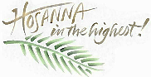
Mk 11:1-10/Is 50:4-7/Phil 2:6-11/Mk 14:1—15:47
5:00PM + Jack Hoctor

SUNDAY, March 24 – PALM SUNDAY OF
THE PASSION OF THE LORD

Mk 11:1-10/Is 50:4-7/Phil 2:6-11/Mk 14:1—15:47
8:00AM + Joseph Ziegler III
10:30AM ⁓ The People of the Parish
MONDAY, March 25 – Monday of Holy Week
Is 42:1-7 / Jn 12:1-11
Doors open at 5PM &
Bingo begins at 6:30PM

Parish Office CLOSED
CHRISM MASS: 4PM, St. Patrick’s Cathedral, Hbg.

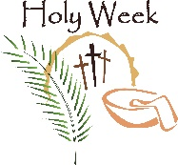
TUESDAY, March 26 – Tuesday of Holy Week
Is 49:1-6 / Jn 13:21-33, 36-38

8AM – 3PM ~ Office Open

10:00AM – Spec. Int. for Dick & Deb Deardorff
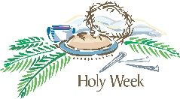
WEDNESDAY, March 27–Wednesday of Holy Week
Is 50:4-9a / Mt 26:14-25

8AM – 3PM ~ Office Open
7:00PM +Bob & Virginia Williams, +Dorothy Mugg, +Frank Cup
Additional Sacrament of Penance, starting at 5PM
Confessions 5–6:45PM; Adoration & Rosary 7:40PM; Benediction 8PM
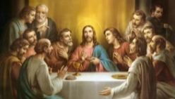
HOLY THURSDAY, March 28
Ex 12:1-8, 11-14 / 1 Cor 11:23-26 / Jn 13:1-15

8AM – 3PM ~ Office Open
7PM Evening Mass of the LORD’s Supper ⁓ People of the Parish

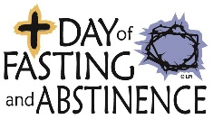  GOOD FRIDAY, March 29  NO MASS CELEBRATED WORLDWIDE  Is 52:13-53:12/Heb 4:14-16; 5:7-9/Jn 18:1-19:42  3:00PM Commemoration of Our LORD’s  Parish Office CLOSED PASSION  7:00PM Stations of the Cross | THE LORD

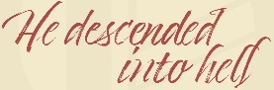
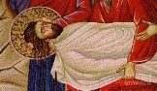
HOLY SATURDAY, March 30
NO MORNING MASS

SATURDAY, March 30 – EASTER VIGIL IN THE HOLY NIGHT

Gn 1:1 - 2:2 / Ex 14:15 - 15:1 / Is 55:1-11 / Bar 3:9-15, 32 - 4:4 /

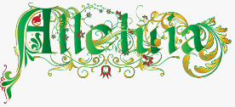
Rom 6:3-11 / Mark 16:1-7
8:00PM - Special Intention for Ursula Kaley

SUNDAY, March 31–THE RESURRECTION OF THE LORD

Acts 10:34a, 37-43 / Col 3:1-4 or 1 Cor 5:6b-8 / Jn 20:1-9

8:00AM + Jim and Delores Gilbert
10:30AM + Jim Kline, Sr.
The Sanctuary Candle for MARCH is offered: In Loving Memory of Marilyn Cole from Kenneth Cole

Sunday Collection Summary for March 16 & 17

Weekend Collections
Regular Offering $ 3,217.00
Easter $ 35.00
Good Friday $ 35.00
Holy Thursday $ 35.00
TOTAL OFFERINGS $ 3,322.00

‒ WEEKLY BUDGETARY NEEDS $ 4,494.00
+Overage or (Shortfall) for the week ($ 1,172.00)

Other Income
Altar Flowers $ 20.00
Burial Revenue $ 65.00
Cemetery Lot Sales $ 1,200.00
Total Other Offerings $ 1,285.00

Diocesan Second Collections
Catholic Home Missions $ 100.00
Catholic Relief Services $ 6,062.00
Total Diocesan Offerings $ 6,162.00
----------------------------------------------------------------------------------------------

The Knights of Columbus will once again sponsor an EASTER EGG HUNT on EASTER SUNDAY between the Masses at 9:15AM.
The hunt is open to all children & adults.

Decorated hard-boiled Easter eggs are needed! (Please drop off at the Office.)

P.S. There will be a visit by
the Paschal “Easter Bunny.”

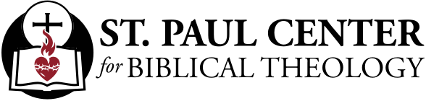

Darkness at Noon: Scott Hahn Reflects

on Palm Sunday of the Passion of the LORD

Crowned with thorns, our LORD is lifted up on the Cross, where He dies as “King of the Jews.” Notice how many times He is called “king” in today’s Gospel —mostly in scorn and mockery.

As we hear the long accounts of His Passion, at every turn we must remind ourselves — He suffered this cruel and unusual violence for us.

Christ is the Suffering Servant foretold by Isaiah in today’s First Reading. He re-enacts the agony described in today’s Psalm, and even dies with the first words of that Psalm on His lips (see Psalm 22:1).

Listen carefully for the echoes of this Psalm throughout today’s Gospel — as Jesus is beaten, His hands and feet are pierced; as His enemies gamble for His clothes, wagging their heads, mocking His faith in God’s Love, His faith that God will deliver Him.

Are we that much different from our LORD’s tormenters? Often, don’t we deny that He is King, refusing to obey His only Commands that we love Him and one another? Don’t we render Him mock tribute, pay Him lip service with our half-hearted devotions?

In the dark noon of Calvary, the veil in Jerusalem’s Temple was torn. It was a sign that by His Death, Jesus destroyed forever the barrier separating us from the Presence of God.

He was God and yet humbled Himself to come among us, we’re reminded in today’s Epistle. And despite our repeated failures, our frailty, Jesus still humbles Himself to come to us, offering us His Body and Blood in the Eucharist.

His enemies never understood: His Kingship isn’t of this world (see John 18:36). He wants to write His Law, His Rule of Life on our hearts and on our minds.

As we enter Holy Week, let us once more resolve to give Him dominion in our lives. Let us take up the cross He gives to us — and confess with all our hearts, minds, and strength that truly THIS IS THE SON OF GOD!

Readings: Isaiah 50:4–7; Psalm 22:8–9, 17–20, 23–24
Philippians 2:6–11; Mark 14:1–15:47

4. About an inch and a half away from
the "stem" of the Cross, bend this arm
of the palm back behind the palm so
that it is now facing to your left.
Make the bend at a good length
to form the right arm of the Cross.
5. Folding that same section at a point
that equals the length on the right side,
bend it on the left side and bring the
end forward over what is now the
front of the Cross.
6. From the very center of the Cross,
fold that arm up and to the upper
right (in a "northeast" direction) so
that it can wrap around where the
upright post of the Cross and the
right arm intersect.
7. Fold this down and to the left behind
the Cross...
8. ...and then fold it toward the right
so that it is parallel and under the
transverse arms of the Cross.

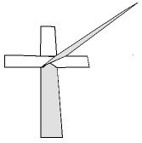
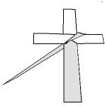
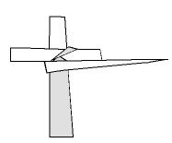

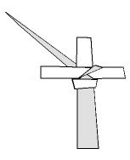 | 9. Bring it up behind the Cross again, this time  folding it up toward the "northwest" direction.
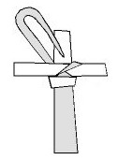 | 10. Tuck the tapered end into the  transverse section you made in step 7...
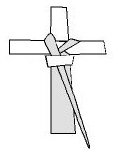 | 11. ...and pull through.
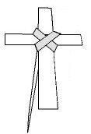 | 12. Turn the Cross over; this side will be the front. Trim the tapered end if necessary, remembering that the palm is a sacramental and any part you trim away should be kept and respected as a sacramental! Use that piece for burning during storms.

There Is Still Time to Receive a Plenary Indulgence during Lent
By Francesca Pollio Fenton | CNA Staff, March 20, 2024

Did you know that there are several ways you can gain a plenary indulgence during Lent? There are actually four ways you can receive one. Even though Lent is nearly over, there is still plenty of time for you to complete any, or all, of these.

First of all, what is a plenary indulgence?

A plenary indulgence is a grace granted by the Catholic Church through the merits of Jesus Christ to remove the temporal punishment due to sin. The indulgence cleanses a person of all temporal punishment due to sin. However, it must always be accompanied by a full detachment from sin.

How do we receive one during Lent?

The first way is to spend at least 30 minutes in Eucharistic adoration. Visiting the Blessed Sacrament is important all year round. So why not take part in this beautiful practice during Lent and receive some additional graces too?

If you’ve never been to adoration, or struggle to stay awake, try reading a couple of chapters from the Gospels, pray a Rosary, or really focus on being in Christ’s presence.

The next way is to take part in the Stations of the Cross, which is when we meditate on the LORD’s passion and death. Every Catholic church should have some kind of Stations of the Cross, whether they are simple or elaborate. Any will do!
However, there are a couple of things to keep in mind. The Holy See’s Manual of Indulgences, Fourth Edition, does state that there has to be 14 stations “representing the 14 stations of Jerusalem.”

The manual also reminds us that “progression from one station to the next is required.” Although, if there are too many people and moving would cause an inconvenience, it is sufficient that at least the one conducting the Way of the Cross move from station to station. In other words, if you attend the Stations of the Cross with many participants and everyone remains in the pews while the priest moves to each station, that is still valid.

This specific indulgence can even be gained once a day for those who can attend church daily and wish to perform the Stations of the Cross on their own.

The next way is by praying the Rosary “in a church or oratory, or in a family, a religious community, or an association of the faithful.”
The last way is by reading or listening to sacred Scripture. Just make sure you spend at least half an hour with the word of God and it counts.

All right, so you took part in one, or all four, of these ways. But, did you actually receive a plenary indulgence?

How do you know if you received one?

There are some conditions, like the fine print, that assure you receive your indulgence.

First, you must have complete detachment from all sin, even venial.

Then you have to go to Confession, receive holy Communion, and pray for the intentions of the pope. Sacramental Confession and receiving the Eucharist can happen up to about 20 days before or after the act performed to receive a plenary indulgence.

It is appropriate that Communion and the prayer take place on the same day that the work is completed. One Sacramental Confession is sufficient for several plenary indulgences. However, for each plenary indulgence one wishes to receive, a separate reception of the Eucharist and a separate prayer for the intentions of the Holy Father are required.

Once you have followed these steps, rest assured that you have received a plenary indulgence.
How to Make a Palm Cross
Palm Cross Drawings by S. A. Keith
www.christiancrafters.com
- Take a palm that is about 2 feet long and 1/2" wide (if it tapers at the top, this is good!). Hold the palm upright, so the tapered end points toward the ceiling.
- Then bend the top end down and toward you so that the bend is about 5 or 6 inches from the bottom of the palm.

3. About a third of the way from the bend you just made,
twist the section you've pulled down to the right, forming
a right angle

