Historic Windows Restored to Splendor

at St. Ignatius Church

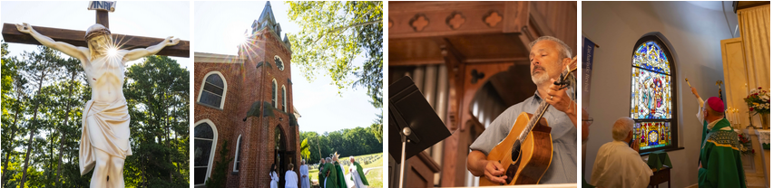

August 2, 2023

By Jen Reed, The Catholic Witness | (Photos by Chris Heisey, The Catholic Witness.)

The Catechism tells us that “Genuine sacred art draws man to adoration, to prayer, and to the love of God, Creator and Savior, the Holy One and Sanctifier” (CCC 2502).

The splendor of three newly-restored windows at the historic St. Ignatius Loyola Church in Buchanan Valley is serving as that vehicle toward praise and worship within the walls of the Old Jesuit Mission.

Cast in vivid hues of gold, red and blue, the restored windows illustrate in remarkable detail the Annunciation, the Ascension and the Holy Trinity, bringing new life to the once muted and weathered windows.

“St. Ignatius Church is a delicate place because of its age and the history of the parish, and, as such, we have to care for it in a gentle and reverent way,” Father Dominic DiBiccaro, pastor, told The Catholic Witness. Known as “The Old Jesuit Mission,” the church was dedicated more than 200 years ago under the patronage of St. Ignatius, the founder of the priests of the Society of Jesus, who tended to the mission chapel and the Catholics in Buchanan Valley in the 1700s.

On Sunday, July 30, the day before the parish’s patronal feast, Bishop Timothy Senior blessed the restored stained-glass windows during the celebration of Mass.

“St. Ignatius Church is certainly not just about its history; the faith is alive and well in this community,” he told the congregation.

“We’re here to grow in our faith and to give glory to God, because we recognize that our relationship with Jesus Christ is the center of our lives,” he said.

Following the homily, Bishop Senior blessed the three windows, which were restored to their original splendor by Willet Hauser Architectural Glass in Winona, Minnesota, over the course of 18 months. In the interim, the windows were replaced with temporary acrylic panes featuring digital images of the originals.

When the project was announced, parishioners made donations and offered memorial tributes to loved ones for the restoration. The original memorial plaques remain part of the windows.

Father DiBicarro expressed his hope that the windows will draw the faithful deeper into their faith and their relationship with Christ.

“We are in the middle of a Eucharistic Revival in the Church, and to have these visible signs of God’s love in our church helps raise our level of worship and connect us even more to Our Eucharistic Lord,”
he said.
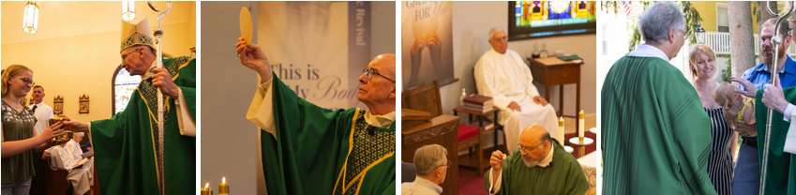

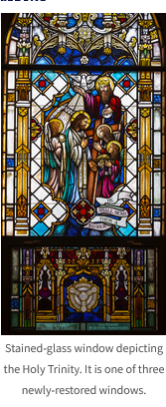
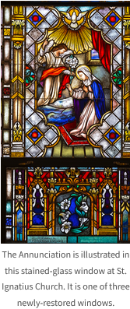

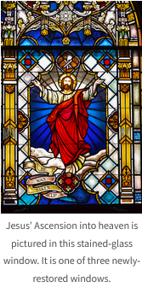

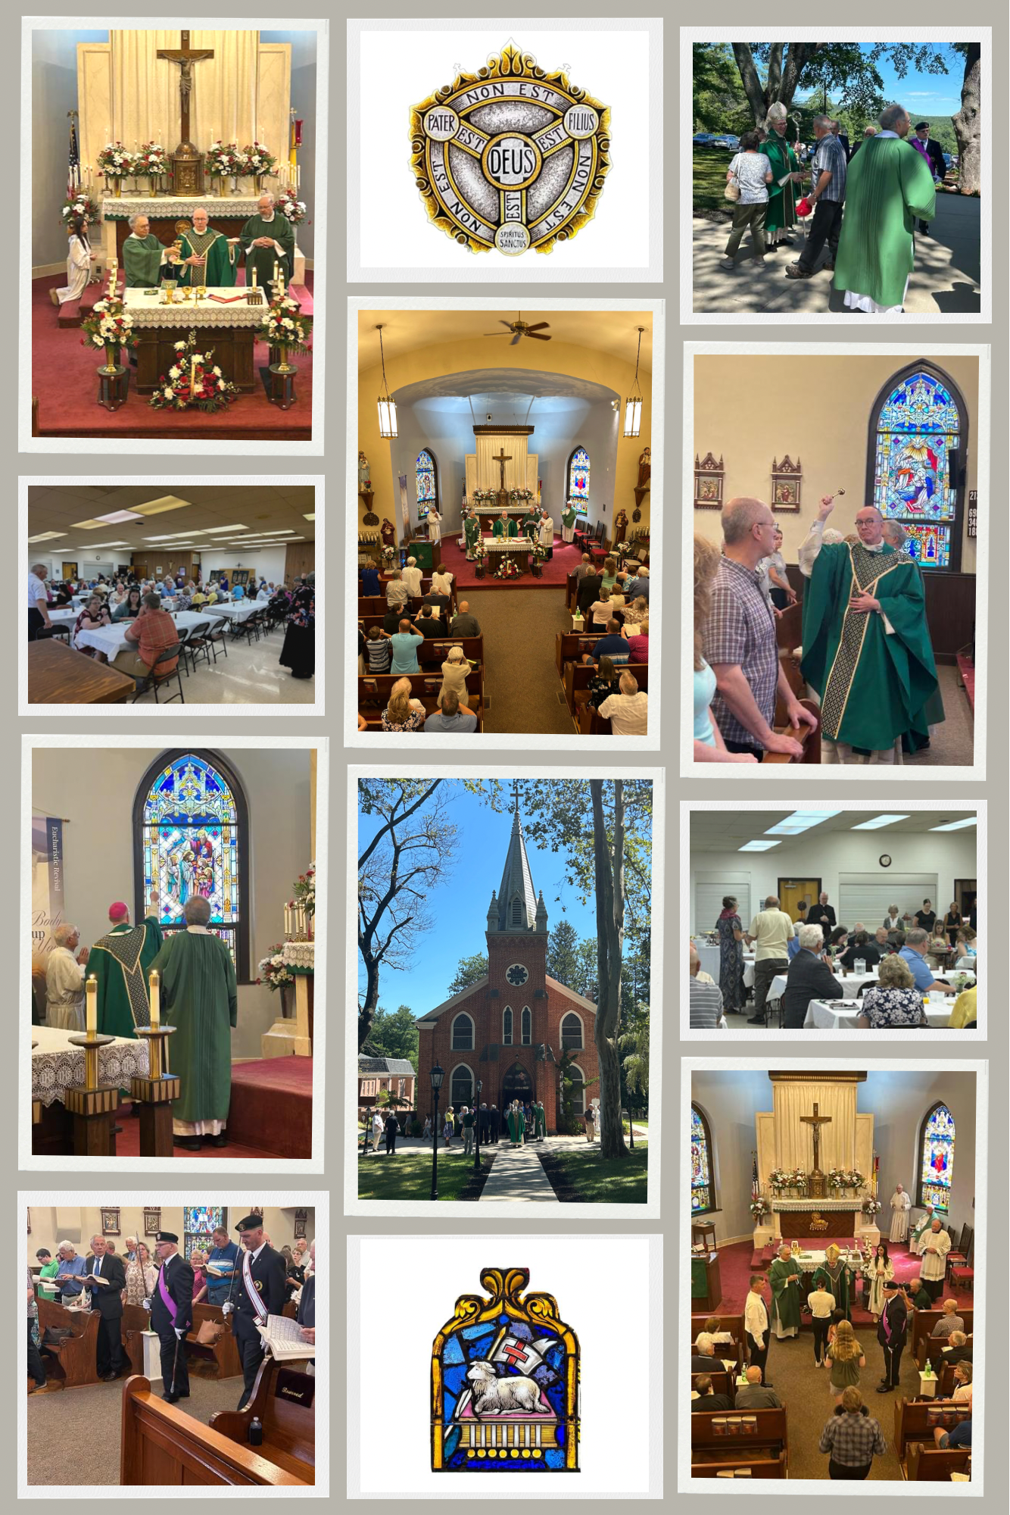

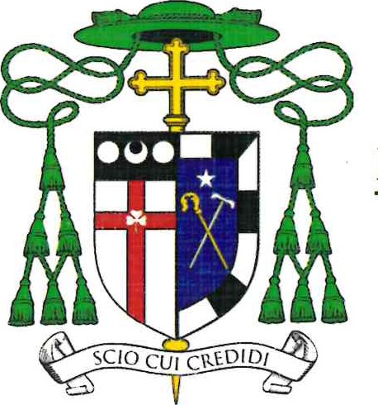
DIOCESE OF HARRISBURG OFFICE OF THE BISHOP
4800 Union Deposit Road I Harrisburg, PA 17111-3710
bishopsoffice@hbgdiocese.org | (717) 657-4804 ext. 354 | www.hbgdiocese.org

July 31, 2023

Reverend Dominic M. DiBiccaro
Saint Ignatius Parish
1095 Church Road
Orrtanna, PA 17353-9516

Dear Father DiBiccaro,

It was a grace to join you and so many of your parishioners for Mass on Sunday, July 30, 2023,
and to bless the newly restored stained glass windows in Saint Ignatius of Loyola Church. The celebration of the Mass was very inspiring. I was encouraged by the participation of those in
attendance, as well as their evident enthusiasm and love for their parish. The windows are
beautiful, as is the church and the rest of the parish campus.

The brunch following Mass was also delightful, as I had the opportunity to meet and speak with
many of your parishioners who were in attendance. I felt very much at home.

Be assured of my prayers for you and for all those entrusted to your pastoral care. God bless you
always.

Fraternally in Christ,

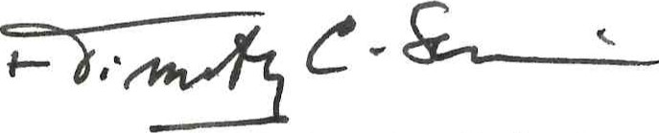
Most Reverend Timothy C. Senior
Bishop of Harrisburg

