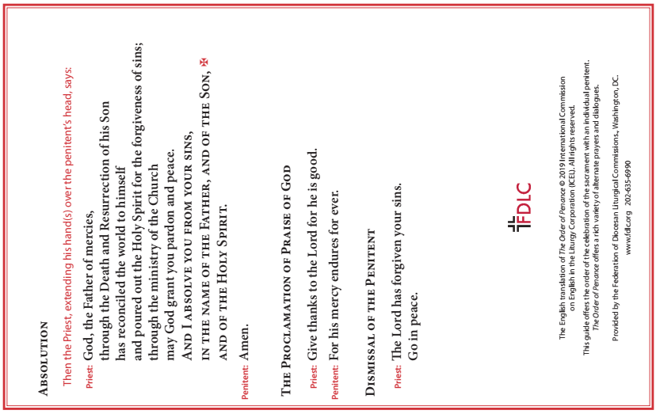

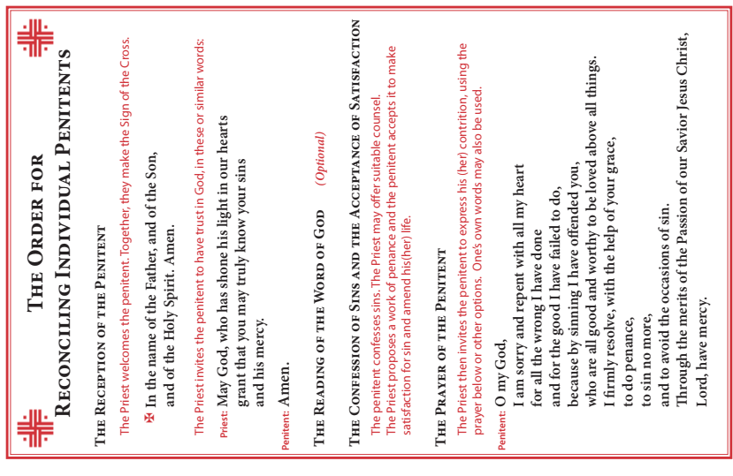

Understanding the
REVISED ORDER OF PENANCE

A new translation of the Order of Penance was approved by the Bishops of the United States on June 17, 2021 and confirmed by the Dicastery for Divine Worship and Discipline of the Sacraments on April 25, 2022. It may be used as of Ash Wednesday, February 22, 2023. It must be used beginning Divine Mercy Sunday, April 16, 2023.

“The sacrament of Penance is a whole consisting in three actions of the penitent and the priest’s absolution. The penitent’s acts are repentance, confession…and the intention to make reparation and do works of reparation” (Catechism of the Catholic Church [CCC], 1491). The Sacrament of Penance is both an act of Christ and an act of the Church. Christ accomplishes the work of reconciliation. He is the one who established the sacrament (see Mt 16:19 and Jn 20:19, 22-23); he is present in it; and he acts through it by bestowing the grace he merited for sinners through the saving work of his Paschal Mystery. The whole Church is involved in the ministry of reconciliation. The Sacrament of Penance is celebrated by the Church, it occurs in the context of the Church and, consequently, the effect of reconciliation is experienced through and by the whole Church. Accordingly, the Church acts as a priestly people whose members gather together, pray to God for his mercy, listen to the proclamation of the Word of God, examine their consciences, confess their sins, go to individual confession and receive absolution, praise God, and are sent forth.

It is through the liturgical action of the Sacrament of Penance that we receive a “new possibility to convert and to recover the grace of justification” and are restored to the state of innocence we first experienced at baptism when we turned away from Satan, sin, and death and toward Christ, light, and life (CCC, 1446 and 1480). Accordingly, the nature and effects of the Sacrament are more clearly expressed when it is celebrated according to these prescribed rites.

“To neglect the fullness of the liturgy of penance, even while observing the laws for valid celebration, still communicates grace, but it does not ‘most effectively dispose the faithful to receive this grace in a fruitful manner’” (Sacrosanctum Concilium, 59). The concern of the minister should always be not only that grace is given, but also that the recipient is disposed to the grace given, and that this grace is fully expressed and most fruitfully received” (USCCB Committee on Divine Worship, Newsletter, Volume LVIII, September 2022).
