Sacrament of the Sick
Anointing of the Sick should be given if an individual is gravely ill or near death. If possible, the Sacrament should also be administered for serious illness, before major surgery or when one is initially hospitalized.

Sacrament of Holy Matrimony
Diocesan policy requires 12 months of preparation for Marriage. Contact the parish as soon as possible after engagement. No venue reservations or other arrangements should be made prior to consultation with the pastor.

Sacrament of Penance
Wednesday ~ 6:00 – 6:45PM; or by appointment.

Sacrament of Baptism
Parents must be registered members of the parish and attend a Baptism preparation class prior to the Baptism if this is your first child baptized. Requirements for godparents are established by the Catholic Church. Please call the parish office for Information and to register your child for Baptism.

Parish Registration
All Catholics should be registered in their local parish. Please contact the parish office to obtain registration forms, or if you are uncertain of the parish where you should register.

Parish Staff & Ministries Directory
stignatiusofloyola@hbgdiocese.org
Financial Manager ~ Richard Deardorff ~ 717- 677-8012 or 717-420-3464 (cell)
rdeardorff@hbgdiocese.org
Director of Religious Education ~ Deacon Steve Huete ~ shuete@hbgdiocese.org
Administrative Assistant ~ Kristen DiDio ~ kdidio@hbgdiocese.org
Buildings & Grounds ~ JB Groff ~ 717-677-8012
Music Ministry ~ Phil Mobley ~ 717-677-8012
Parish Council Members
*Walt Wilson – Chair 401-0570 (h) wwilson1198@comcast.net
Joanne Riedel - Secretary 398-2021 (h) sterj221@aol.com
Kathi Allwein 677-8984 (h) allweint@comcast.net
*Donnie Althoff 339-6527 (c) dalthoff53@gmail.com
Charlie Baker 677-9536 (h) dcbake@embarqmqil.com
*Jim Bittle 677-6711 (h) ginnybittle@comcast.net
Mike McTighe 729-6239 (c) mike0432@aol.com

Finance Council Members
Richard Deardorff (Ex Officio)
Greg Ernst - Chair
Alix Haller
Christy Hemler - Secretary
Terri Pendlelton
Bill Pulig

Altar Flowers
Prayer Chain
Lynne Mobley at LMOBLEY509@gmail.com
or 703-876-4901.

Soup Kitchen
Please send donations directly to “Soup Kitchen”

Website Development
Kristen DiDio
Life After Loss
Dodie Huete

OCIA
Contact Fr. Dominic

Picnic Co-Chairpersons
John Neiderer
Wally Kane

Pro-Life Ministry
OPEN – Contact office if you are interested

Knights of Columbus
SK Bob Ternes
- Grand Knight

Covid-19 Task Force
Walt Wilson - Coordinator
Health Advisors:
Dr. Robert Ternes and
Joanne Cochran
(Keystone Health System)

OPEN - Contact office if you are interested

Bereavement Ministry
Ginny Bittle / Dodie Huete

Catholic Communications/EWTN
Open - Contact office if you are interested

Cemetery
Contact Parish Office
THEOSIS Ministry
Kathy Dietsch 717-352-4558
Bicky Redman 717-677-8592

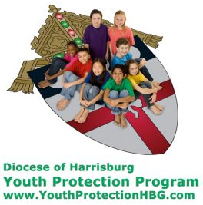
Diocese of Harrisburg Youth Protection Program
www.YouthProtectionHBG.com

Abuse Reporting Contact Information:
First – Call the toll-free PA Child Abuse Hotline at 800-932-0313
Then – Call the Diocesan toll-free hotline at 800-626-1608

“If one member suffers,
all suffer together with it.” (1 Cor 12:26)

St. Ignatius Loyola RC Church

1095 Church Road, Orrtanna, Pennsylvania 17353
www.stignatiusofloyola.org

April 16, 2023: SECOND SUNDAY OF EASTER or the
SUNDAY of DIVINE MERCY
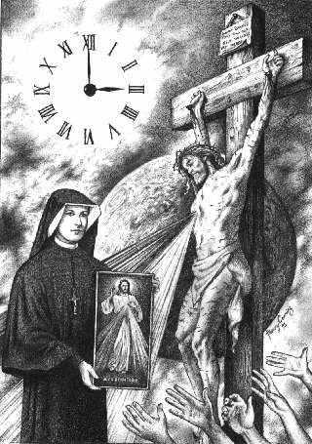

Please join us Sunday afternoon at the 3PM, the Hour of Divine Mercy, for Exposition of the Blessed Sacrament, recitation of the Chaplet of Divine Mercy, and the Sacrament of Penance afterward, in order to help satisfy the conditions for the PLENARY INDULGENCE offered by Holy Mother Church this day to all the Faithful.

Most Reverend Ronald W. Gainer, Bishop of Harrisburg;
Rev. Dominic M. DiBiccaro, Pastor / Deacon Steve Huete, Pastoral Associate
Mass Schedule, Intentions, and Events
Please Pray for:
Coronavirus victims and those who are ill, Jeanie Kline and the Kline Family, Bob Raffensberger Jerry & Ginny Miller, Adeline Lienard, Kaylee Henry, Chuck & Nancy Wuller, Dr. Mike Colli, Mrs. Kelly Kump, Kevin & Brittany Groff, Gabriel Singer, Sharon McCormley, Ron Thumma, Joe Wisotzkey, Leo Hockensmith, Erika McKissick, Jean "Heather" O'Shea, Scott Moore and Sally Moore, Mary Wyatt, Jim & Joyce Deardorff, Brandon & Michelle Gilbert, Amy Weatherup, Sophia Joy Ernst, Deacon Richard Wentzel, Deacon Frank Enderle, Kathleen Thompson, Deb & Kathy McLintock and Family, Rachel Wonders, Amy Edwards, Jean O’Connor, Art Lazar, Sr., Mark & Michelle Huete, Paul Angello, Jen Baldwin, Ursula Kaley, Deb Bennet, Fr. Bill Sullivan, Fr. Chet Snyder, John Larry Endy, Mary Beth McCarthy, Laura Lee, Marwa Abdelrahman, Cathy Gates, Donna Singley, Jack Ryff, Tim McGinn, Jane Kump, Gary, Bill, Jerry, Andy, Colleen, Baby Addie, Peggy Neiderer, Chris Kimple, Robert Riquet, Gene & Jo-Ann McDannell, Bob Doxzen, Kimberly Mears, Gabriella Angello, Mark & Kate Morrow, Mark Morris, Linda Fogleman, Paul Knight, George & Barbara Erstila, Jeff Carpenter, Lana & Nelson Harmon, Cole & Connor, Diane Slothour, Sue McDannell, Larry Schneider, Joe & Lisa Grasel, Ange Pena, Julie Barnhart, the Shaffer Family, Heather & Emma Dickerson, Brad Pabody, Paul Ward, Aiden Tyler Schneider, Dorothy Vega, Karrie McCall & daughter, George Shahid, Denise Navlyt, Drew Schneider & Family, Ida Bloomfield, Linda McDannell, Janie Singley, Mary Beth Greenstreet, Rick Benedict, Jan Patla, Kathe Fogleman, Sam Sheffler, Kate Hemmis, Bill & Mary Lou Graham, Joanna Hodges, John Varones, Joan O’Sullivan, Martha Klinger, Lisa Dionne Lauretti, Sue Orndorff, Jim Gleason, Sue Gustafson, Joe & Michelle Cleary, Kim Johnson, Helen Mills, Kathy Haber, Haley Detman, Joe Durovey, Bev Smith, Donald Sheppard, Linda Mumaugh, Alison Haring, Janet Hartman, Edward Johnson, Angela Galeone, Juliete Lang, Chris MacBeth, Harry Graham, Donald Howard, Armond Binni, Elizabeth Stansky, Pat Johnson, Chris Morris, Faud Doaney, Wilson & Rae Harman, Patrick Glass, Helen Lagasse, Nancy Kewisnek, Andy Graham, Bill & Maureen Collins, Rosemary McGilloway, Anji Eisenhart, Monica Manner, Denny Borbonus, Dr. Paul Scarlata, Mary Hawthorne, Ed Washington, Josh Kempinski, Nancy Baker Baltzey, Spencer Propts, Karlton Smith & Cheryl Sobun, James & Marylyn Sobun, Marlene Webster, Yvette Stoklosa, Andy Consiglio, Bill & Michelle Cloonan, Nelson Salem, Janet Shunnarah, George Shunnarah, Bill & Deb McClintock, Mary Pekich, nursing home residents & shut-ins, the victims of war, violence, disease, disaster, & all private intentions.
Also in your prayers, please remember all
our men and women currently serving in
our Armed Forces:
Maj. Nathan Jeffcoat – US Marine Corps
Lt. Joseph Cleary – US Navy
Michael C. Kenney IV – US Coast Guard
Lt. Joshua Kimple – US Army
Lt. Sarah Fogleman, M.D. – US Navy

PRAYER CHAIN: Contact Lynne Mobley at
703-876-4901 or LMOBLEY509@gmail.com

for the Week of April 15 to April 23, 2023

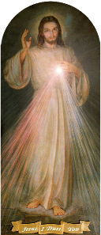
SATURDAY, April 15 – VIGIL FOR DIVINE MERCY SUNDAY

Acts 2:42-47 / 1 Pt 1:3-9 / Jn 20:19-31
8:00PM - Special Intention for the Kline Family

SUNDAY, April 16 - SUNDAY OF DIVINE MERCY

Acts 2:42-47 / 1 Pt 1:3-9 / Jn 20:19-31

5:00AM ~ People of the Parish
10:30AM + Jim and Delores Gilbert
3:00PM: Exposition, Chaplet of Divine Mercy, Confessions
A PLENARY INDULGENCE may be obtained on this day with Eucharist, Confession, Chaplet & Prayers for the Holy Father

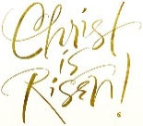
Monday, April 17 (Easter Weekday)

Acts 4:23-31 / Jn 3:1-8
Parish Office Closed

Tuesday, April 18 (Easter Weekday)
Acts 4:32-37 / Jn 3:7b-15
8:00AM - 3:00 PM ~ Office Open
10:00AM - Spec. Int. for June Bensinger

11AM: “Something More” Faith Group
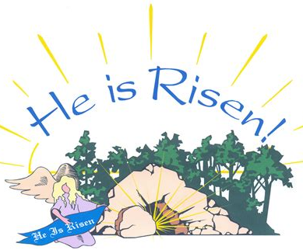
Wednesday, April 19 (Easter Weekday)
Acts 5:17-26 / Jn 3:16-21

8:00AM - 3:00 PM ~ Office Open

11AM: Senior Spirituality Group
Confessions heard from 6 to 6:45PM
Adoration at 7:40PM
7:00PM + Brenda Althoff
Thursday, April 20 (Easter Weekday)
Acts 5:27-33 / Jn 3:31-36
8:00AM - 3:00 PM ~ Office Open
10:00AM – Spec. Int. for Adeline Lienard

Friday, April 21- St. Anselm, Bishop and | PASSION OF THE LORD
Acts 5:34-42 / Jn 6:1-15 Doctor of the Church
Parish Office CLOSED
10:00AM + Mary Pekich

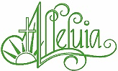

SATURDAY, April 22 (Easter Weekday)

MORNING: Acts 6:1-7 / Jn 6:16-21

SATURDAY, April 22 – VIGIL MASS 3rd SUNDAY OF EASTER

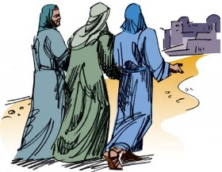
Acts 2:14, 22-33 / 1 Pt 1:17-21 / Lk 24:13-35
5:00PM +Anna Marie & +Robert Leo Topper

SUNDAY, April 23 – 3rd SUNDAY OF EASTER

Acts 2:14, 22-33 / 1 Pt 1:17-21 / Lk 24:13-35

8:00AM + Peg Hippensteel
10:30AM ~ People of the Parish
Sanctuary Candle offered for APRIL: In Loving Memory of Jim & Delores Gilbert from their loving Children
SUNDAY COLLECTION SUMMARY
Indulgences attached to devotions in honor of Divine Mercy
“O God, Your mercy knows no bounds and the Treasure of Your goodness is infinite..." (Prayer after the Te Deum Hymn)

"The paschal mystery is the culmination of this revealing and effecting of mercy, which is able to justify man, to restore justice in the sense of that salvific order which God willed from the beginning in man, and through man, in the world"

(His Holiness, Pope St. John Paul II, Encyclical Letter Dives in misericordia, n. 7).

"And so with provident pastoral sensitivity and in order to impress deeply on the souls of the faithful these precepts and teachings of the Christian faith, the Supreme Pontiff, John Paul II, moved by the consideration of the Father of Mercy, has willed that the Second Sunday of Easter be dedicated to recalling with special devotion these gifts of grace and gave this Sunday the name, "Sunday of the Divine Mercy."

(Congregation for Divine Worship and the Discipline of the Sacraments, Decree Misericors et miserator, 5 May 2000)

Plenary Indulgence (complete remission of all time in Purgatory built up so far due to sin)

I. The usual conditions for every Plenary Indulgence

- Sacramental Confession (preferably on the day, or within about 20 days before or after)
- Eucharistic Communion (preferably on the day, or the 8 days before or after)
- Prayer for the intentions of the Supreme Pontiff (certain prayers are not specified)

II. The specific conditions for this Indulgence

On the Sunday of Divine Mercy (April 16, 2023)
- in any church or chapel, in a spirit that is completely detached from the affection for a sin, even a venial sin, take part in the prayers and devotions held in honor of Divine Mercy
- OR, in the presence of the Blessed Sacrament exposed or reserved in the Tabernacle, recite the Our Father and the Creed, adding a devout prayer to the merciful LORD Jesus (e.g., Merciful Jesus, I trust in You!)

Partial Indulgence (partial remission of time in Purgatory)

A Partial Indulgence is granted to the faithful who, at least with a contrite heart, on the same day, pray to the merciful LORD Jesus a legitimately approved invocation. (e.g., Jesus I trust in You!, or My Jesus, mercy!)

Those who cannot go to church or the seriously ill
Conditions for a Plenary Indulgence (on the same day):
- Totally detesting any sin
- With the intention of fulfilling as soon as possible the three usual conditions of Confession, Communion & prayers for the Holy Father
- Recite the Our Father and the Creed before a devout image of Our Merciful LORD Jesus
- Pray a devout invocation to the Merciful LORD Jesus (e.g., Merciful Jesus, I trust in you!).

If it is impossible to do even this:
- With a spiritual intention, on the same day, unite with those carrying out the prescribed practice for obtaining the Indulgence in the usual way and
- Offer to the Merciful LORD a prayer & the sufferings of their illness & the difficulties of their lives, with the resolution to accomplish as soon as possible, the 3 conditions prescribed to obtain the indulgence.

Palm Sunday Easter
April 1&2 April 8&9
Weekend Collection
Regular Offering $ 4,037.00 $ 6,033.00
Candles $ 68.50
Altar Flowers $ 50.00
Easter Flowers (Additional) $ 68.00
Holy Thursday $ 140.00
Easter $ 320.00

TOTAL OFFERINGS $ 4,683.50 $ 6,033.00

‒ WEEKLY BUDGETARY NEEDS $ 4,655.74 $ 7,000.00
+ Overage or (Shortfall) for the week + $ 27.76 ($ 967.00

Other Income
Ham Bingo (Gross) $ 5,728.40
Candles $ 39.00
Easter Flowers (Additional) $ 2.00
Holy Thursday $ 801.00
Cemetery Lot Sales $ 2,000.00
TOTAL OTHER OFFERINGS $ 5,728.40 $ 2,842.00

Diocesan Second Collections
Catholic Relief Services $ 90.00
Catholic Home Missions $ 30.00 $ 215.00
Holy Land $ 145.00 $ 1,079.00
TOTAL DIOCESAN OFFERINGS $ 265.00 $ 1.294.00

A GREAT BIG THANK YOU
to Diane and Donnie MacBeth
& the whole HAM BINGO CREW
who worked so hard and helped make this year’s Easter Ham Bingo one of the Best EVER!!!
Through the Grace of God, and the support and generosity of those who were there,
WE RAISED $3,276.57

DIOCESE OF HARRISBURG (717) 657-4804
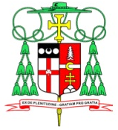
OFFICE OF THE BISHOP FAX (717) 657-1370
4800 Union Deposit Road
Harrisburg, Pennsylvania 17111-3710
Bishop'sOffice@hbgdiocese.org
www.hbgdiocese.org

April 5, 2023
Dear Brothers and Sisters in Christ,

This is the day the LORD has made; let us rejoice and be glad.

These words of celebration are heard through our Responsorial Psalm on Easter Sunday, and they are words of great hope in the gift Christ gave us through His Death and Resurrection. When I reflect on the Paschal Triduum, I often find myself deeply humbled by Christ’s great love for me, for us. On Good Friday, we recount the LORD’s Passion and Death, and the reason for His suffering.

Yet it was our infirmities that he bore,
our sufferings that he endured,
while we thought of him as stricken,
as one smitten by God and afflicted.
But he was pierced for our offenses,
crushed for our sins;
upon him was the chastisement that makes us whole,
by his stripes we were healed.
We had all gone astray like sheep,
each following his own way;
but the LORD laid upon him
the guilt of us all.

These words from Isaiah serve as a poignant reminder of what Christ accomplished through His Death and Resurrection. Christ did not just suffer and die to take away someone else’s sins; He suffered this agony and He paid the price so all people could share in His Everlasting Life.

Throughout our lives, we experience times when things weigh heavily on us. Maybe it is a job situation, financial stresses, challenges throughout our world, or even relational problems in our families. We all experience these concerns and these worries. Biblically, we would say these are crosses we bear, some small and some larger.

The Easter message is that our LORD not only wants to carry those crosses with us, but He also wants to lighten our burden. Whatever our weakness, even death itself, has been overcome because of His sacrifice on Good Friday. The Cross, which objectively is a sign of weakness and dishonor and death, has become an instrument of glory and new life. What we long for, what we were made for, is this new life, which is given to us through the Paschal Mystery. Whatever cross you are carrying, bring that to Christ, who will not only lighten your burden but transform your burden.

I pray that this Easter will bring all of us to the fullness of Christ’s Peace and Joy. Christ is Risen! Let us rejoice and be glad!
In Christ,
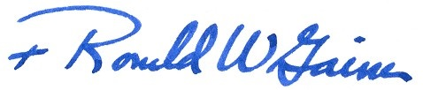

Most Reverend Ronald W. Gainer
Bishop of Harrisburg

The Holy Father, Pope Francis’ Prayer Intentions for 2023
Entrusted to His Worldwide Prayer Network

APRIL ⁓ For a culture of peace and non-violence
We pray for the spread of peace and non-violence, by decreasing the use of weapons by States and citizens.

His Mercy Endures: Scott Hahn Reflects

on Divine Mercy Sunday

We are children of Jesus’ Resurrection from the dead. Through this wondrous sign of His great Mercy, the Father of Jesus has given us new birth, as we hear in today’s Epistle.

Today’s First Reading sketches the “family life” of our first ancestors in the household of God (see 1 Peter 4:17). We see them doing what we still do — devoting themselves to the Apostles’ teaching, meeting daily to pray and celebrate “the Breaking of the Bread.”

The Apostles saw the LORD. He stood in their midst, He showed them His Hands and Sides. They heard His Blessing and received His Commission: to extend the Father’s Mercy to all peoples through the power and Spirit that He conferred upon them.

We must walk by faith and not by sight — we must believe and love what we have not seen (see 2 Corinthians 5:7). Yet, the invisible realities are made present for us through the devotions that the Apostles handed on.

Notice the experience of the Risen LORD in today’s Gospel is described in a way that evokes the Mass.

Both appearances take place on a Sunday. The LORD comes to be with His disciples. They rejoice, listen to His Word, and receive the gift of His forgiveness and peace. He offers His wounded Body to them in remembrance of His Passion. And they know and worship Him as their LORD and their God.

St. Thomas’ confession is a vow of faith in the New Covenant. As promised long before, in the Blood of Jesus we can now know the LORD as our God and be known as His People (see Hosea 2:20–25).

This confession is sung in the Heavenly Liturgy (see Revelation 4:11). And in every Mass on earth we renew our personal covenant and receive the blessings Jesus promised for those who have not seen but have believed.

In the Mass, God’s Mercy endures forever, as we sing in today’s Psalm. This is the Day the LORD has made —when the Victory of Easter is again made wonderful in our eyes!

Readings: Acts 2:42–47; Psalm 118:2–4, 13–15, 22–24; 1 Peter 1:3–9; John 20:19–31

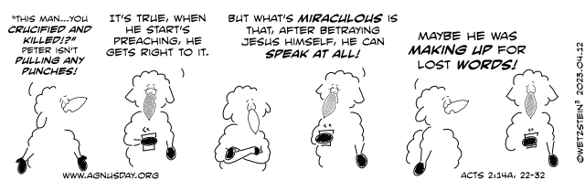

MEET YOUR 2023 PARISH COUNCIL NOMINEES

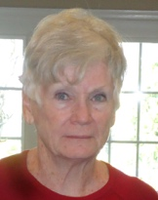
Kathy Dietsch was born and educated in northwestern Pennsylvania. After having been a
member of Catholic parishes with her husband, Fred, who was career military, throughout the
northern and southern states as well as overseas, they discovered St. Ignatius Parish in 2006
They both realized that St. Ignatius was unique in its spiritual family environment, its natural
beauty in the Valley, and it’s outgoing, friendly members. Though she and Fred have not been
here as long as many families, they have made it their permanent parish with both financial and
personal support. She previously served on the Parish Counsel in the early years and came to
know many of the families and the pastors who followed. She says, “Since nothing remains the same, and growth and change are essential to all ‘being’, I hope to be a part of the future planning of ‘life after COVID’ in our parish. I would hope to be a conduit between our pastor and the many and varied needs of the parishioners as we continue to grow as individuals and as a parish within our neighboring communities.” Her intent would be to help continue supporting those same unique qualities so that others may discover St. Ignatius Church and her families in Buchannan Valley.

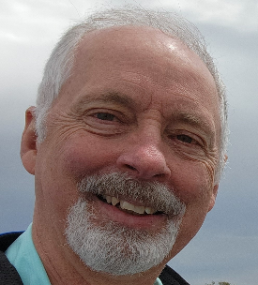
Philip M. Mobley was born and raised in Bucks County PA and was the fourth of five children.
He graduated from Central Bucks East High School and went on to Kutztown State College
where he earned a bachelor’s degree in Geography. He earned a teaching scholarship at the
University of Akron (Ohio), graduating with a Master of Arts. In 1980, Phil’s career took him to
Washington DC, where he served the Federal Government for 32 years, retiring in 2011.
During his time in Washington DC, he taught geography classes at several universities in the
D.C. metropolitan area. Phil married Lynne Gatto in 2008 and moved to the Fayetteville area in 2014 and started attending St Ignatius Parish where he offered his assistance with the music ministry. He was appointed to serve on the Parish Finance Committee and served for several years during the pandemic and has also been a faithful helper for many of the parish events. Phil enjoys hiking and biking the local area trails and building and flying model airplanes. He very much enjoys time spent with his three daughters and two grandchildren. As a member of the Parish Council, Phil says that “he will do his best to ensure the current and future development of the church ministries and serve the parish for THE GREATER GLORY OF GOD.”

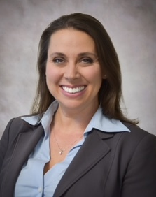
Ali Morris grew up in Franklin County, Pennsylvania, where her family were long-standing
Members of Corpus Christi Catholic Church in Chambersburg. She currently resides in
Arendtsville with her husband, Mat, and four daughters; they have been members of Saint
Ignatius Loyola Parish since 2007. Ali graduated Magna Cum Laude from the University of Mary
Washington in Fredericksburg, VA, with a degree in biology/chemistry. She has worked as a
scientist for the Commonwealth of Pennsylvania for over 20 years. During her career with the
Commonwealth, Ali has worked as an organic chemist, testing environmental samples such as
water, soil, air and fish tissues, for various contaminants of environmental or public health significance. She has been responsible for the development of regulations and policies that protect the public from exposure to harmful substances, presiding over public meetings, and testifying as an expert witness. She was recently involved in Pennsylvania's response to the train derailment in E. Palestine, Ohio, and is overseeing the transition from the Commonwealths' emergency response to the incident to a long-term monitoring and remediation effort that ensures any contamination to the air, water and soil does not persist in the environment, as a result of the accident. When she manages some free time, Ali enjoys gardening, exercising, taking pictures, and spending time with family.

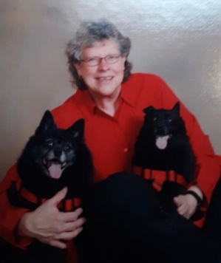
Bicky Redman has been a member of St. Ignatius Loyola Church her entire life. She has
Fond memories of all of the priests that have served St. Ignatius during that time, with her
earliest memory being dear Msgr. Yeager (and that wonderful twinkle in his eyes). She
considers herself blessed by all the many friendships that have graced her life at St. Ignatius.
Many of those friends, as well as her family members have since entered into Eternal Rest.
She looks forward to serving current members of St. Ignatius and hopes to make new friend-
ships along the way. Bicky retired at the end of 2021, after nearly 30 years as an environ-
mental planner with Adams County. She had previously worked in technical support and supervision for the Pfaltzgraff Company for 17 years. She envisions St. Ignatius Parish as a welcoming place for those seeking a spiritual home.

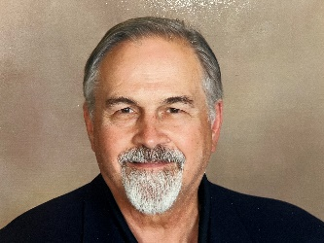
Robert Ternes was born in California is the eldest of six, and raised in a very Catholic
Family. He enjoyed 14 years of Catholic education. “Dr. Bob” earned his Medical
Degree from Temple University and has his internal medicine practice in Waynesboro.
He has been a member of St Ignatius of Loyola Parish for 10 years and has been
actively involved in a variety of Church activities, including “This Man is You” and
Knights of Columbus, as well as others. St Ignatius has been his spiritual home since the first Mass he attended. Its mission, its history, its parishioners and the challenges facing the Parish and the Church, both in the present and in the future, are very important to him. Bob would be honored to “participate in helping the Parish move forward, to survive these perilous times, and to prosper.”

Dorothy A. Vega was born and grew up in the Bronx, N.Y. She moved to Maryland
where she met her husband, Refugio, and raised two wonderful children, Cynthia and
David. Dorothy then moved to Pennsylvania in 1991 after the tragic loss of her dear
husband. She attended the Franklin County Vo-Tech LPN program and graduated with
a Nursing Degree. She was employed by Gettysburg Hospital for 25 years, finally retiring
in 2021. Dorothy previously served on Parish Council before the pandemic. Her
favorite pastimes include enjoying retirement, spending quality time with family and three amazing grandchildren, cooking, long walks in the woods, and playing with her cat, Tesla. She has been a long-time and faithful Parishioner here at St. Ignatius for 32 years.

The PARISH COUNCIL ELECTION to fill the 3 open seats will take place at all Masses on the weekend of April 29/30.

