Sacrament of the Sick
Anointing of the Sick should be given if an individual is gravely ill or near death. If possible, the Sacrament should also be administered for serious illness, before major surgery or when one is initially hospitalized.

Sacrament of Holy Matrimony
Diocesan policy requires 12 months of preparation for Marriage. Contact the parish as soon as possible after engagement. No venue reservations or other arrangements should be made prior to consultation with the pastor.

Sacrament of Penance
Wednesday ~ 6:00 – 6:45PM; or by appointment.

Sacrament of Baptism
Parents must be registered members of the parish and attend a Baptism preparation class prior to the Baptism if this is your first child baptized. Requirements for godparents are established by the Catholic Church. Please call the parish office for Information and to register your child for Baptism.

Parish Registration
All Catholics should be registered in their local parish. Please contact the parish office to obtain registration forms, or if you are uncertain of the parish where you should register.

Parish Staff & Ministries Directory
stignatiusofloyola@hbgdiocese.org
Financial Manager ~ Richard Deardorff ~ 717- 677-8012 or 717-420-3464 (cell)
rdeardorff@hbgdiocese.org
Director of Religious Education ~ Deacon Steve Huete ~ shuete@hbgdiocese.org
Parish Secretary ~ Kristen DiDio ~ kdidio@hbgdiocese.org
Buildings & Grounds ~ Donnie Althoff ~ 717-677-8012
Music Ministry ~ Phil Mobley ~ 717-677-8012
Parish Council Members
Phil Mobley – Chair 571-236-7580 pmmobley@gmail.com
Bicky Redman – Vice Chair 677-8592 feetintheair7@gmail.com
Joanne Riedel - Secretary 398-2021 sterj221@aol.com
Kathi Allwein 677-8984 allweint@comcast.net
Charlie Baker 677-9536 dcbake@embarqmqil.com
Mike McTighe 729-6239 mike0432@aol.com
Dr. BobTernes rjtmd46@gmail.com

Finance Council Members
Richard Deardorff (Ex Officio)
Greg Ernst - Chair
Alix Haller
Christy Hemler - Secretary
Terri Pendlelton
Bill Pulig

Altar Flowers
Prayer Chain
Lynne Mobley at LMOBLEY509@gmail.com
or 703-876-4901

Soup Kitchen
Please send donations directly to “Soup Kitchen”

Website Development
Kristen DiDio
Life After Loss
Dodie Huete

OCIA
Contact Fr. Dominic

Picnic Co-Chairpersons
John Neiderer
Wally Kane

Pro-Life Ministry
Jeanette Backus
Knights of Columbus
SK Bob Ternes
- Grand Knight

Judy Wilson / Janice Meligakes

Bereavement Ministry
Ginny Bittle / Dodie Huete

Catholic Communications/EWTN
Open - Contact office if you are interested

Cemetery
Contact Parish Office
THEOSIS Ministry
Kathy Dietsch 717-352-4558
Bicky Redman 717-677-8592

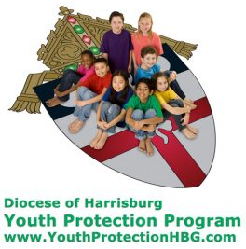
Diocese of Harrisburg Youth Protection Program
www.YouthProtectionHBG.com

Abuse Reporting Contact Information:
First – Call the toll-free PA Child Abuse Hotline at 800-932-0313
Then – Call the Diocesan toll-free hotline at 800-626-1608

“If one member suffers,
all suffer together with it.” (1 Cor 12:26)

St. Ignatius Loyola RC Church

1095 Church Road, Orrtanna, Pennsylvania 17353
www.stignatiusofloyola.org

JULY 16, 2023: 15th SUNDAY IN ORDINARY TIME
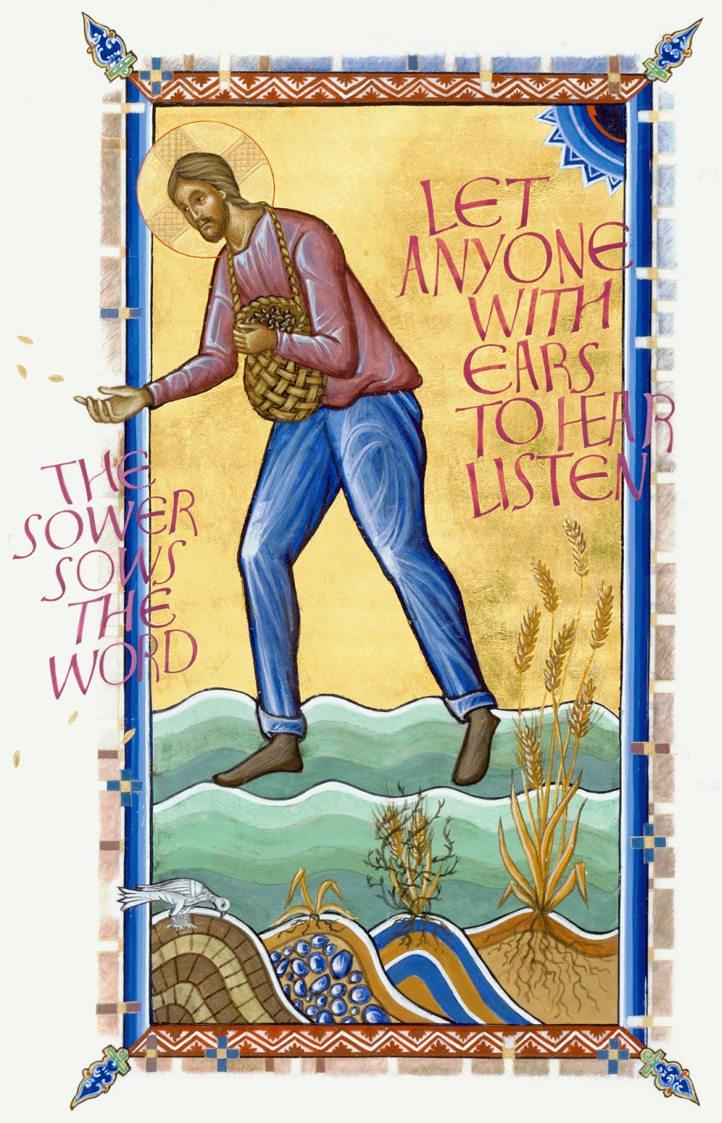

Most Rev. Timothy C. Senior, Bishop of Harrisburg
Rev. Dominic M. DiBiccaro, Pastor
Deacon Steve Huete, Pastoral Associate

Mass Schedule, Intentions, and Events
Please Pray for:
Those who are ill, Jeanie Kline & the Kline Family, Remi Peters, Christy Hemler, Terry Ahn, K. Grance, Lori McFadden & Family, Mike & Lisa Poole, Mervin Weikert, Chastity Rudisill, Mary Ellen Wilson, Terry & Bernie Cabana, Ed & Aggie Sherensky and Family, Bob Raffensberger, Jerry & Ginny Miller, Adeline Lienard, Kaylee Henry, Nancy Wuller, Dr. Mike Colli, Mrs. Kelly Kump, Kevin & Brittany Groff, Gabriel Singer, Sharon McCormley, Ron Thumma, Joe Wisotzkey, Leo Hockensmith, Erika McKissick, Jean "Heather" O'Shea, Scott Moore and Sally Moore, Mary Wyatt, Jim & Joyce Deardorff, Brandon & Michelle Gilbert, Amy Weatherup, Sophia Joy Ernst, Deacon Richard Wentzel, Deacon Frank Enderle, Kathleen Thompson, Deb & Kathy McLintock and Family, Rachel Wonders, Amy Edwards, Jean O’Connor, Art Lazar, Sr., Paul Angello, Jen Baldwin, Ursula Kaley, Deb Bennet, Fr. Bill Sullivan, Larry Endy, Mary Beth McCarthy, Laura Lee, Marwa Abdelrahman, Cathy Gates, Donna Singley, Jack Ryff, Tim McGinn, Jane Kump, Peggy Neiderer, Chris Kimple, Robert Riquet, Gene & Jo-Ann McDannell, Bob Doxzen, Kimberly Mears, Gabriella Angello, Mark & Kate Morrow, Mark Morris, Linda Fogleman, Paul Knight, George & Barbara Erstila, Jeff Carpenter, Lana & Nelson Harmon, Diane Slothour, Sue McDannell, Larry Schneider, Joe & Lisa Grasel, Ange Pena, Julie Barnhart, the Shaffer Family, Heather & Emma Dickerson, Brad Pabody, Paul Ward, Aiden Tyler Schneider, Dorothy Vega, Karrie McCall & daughter, George Shahid, Denise Navlyt, Drew Schneider & Family, Ida Bloomfield, Linda McDannell, Janie Singley, Mary Beth Greenstreet, Rick Benedict, Jan Patla, Kathe Fogleman, Sam Sheffler, Kate Hemmis, Bill & Mary Lou Graham, Joanna Hodges, John Varones, Joan O’Sullivan, Martha Klinger, Lisa Dionne Lauretti, Sue Orndorff, Jim Gleason, Sue Gustafson, Joe & Michelle Cleary, Kim Johnson, Helen Mills, Kathy Haber, Haley Detman, Joe Durovey, Bev Smith, Donald Sheppard, Linda Mumaugh, Alison Haring, Janet Hartman, Edward Johnson, Angela Galeone, Juliete Lang, Chris MacBeth, Harry Graham, Donald Howard, Armond Binni, Elizabeth Stansky, Pat Johnson, Chris Morris, Faud Doaney, Wilson & Rae Harman, Patrick Glass, Helen Lagasse, Nancy Kewisnek, Andy Graham, Bill & Maureen Collins, Rosemary McGilloway, Anji Eisenhart, Monica Manner, Denny Borbonus, Dr. Paul Scarlata, Mary Hawthorne, Ed Washington, Josh Kempinski, Nancy Baker Baltzey, Spencer Propts, Karlton Smith & Cheryl Sobun, James & Marylyn Sobun, Marlene Webster, Yvette Stoklosa, Andy Consiglio, Bill & Michelle Cloonan, Nelson Salem, Janet Shunnarah, George Shunnarah, Bill & Deb McClintock nursing home residents & shut-ins, the victims of war, violence, disease, disaster, & all private intentions.
Also in your prayers, please remember all
our men and women currently serving in
our Armed Forces:
Maj. Nathan Jeffcoat – US Marine Corps
Lt. Joseph Cleary – US Navy
Michael C. Kenney IV – US Coast Guard
Lt. Joshua Kimple – US Army
Lt. Sarah Fogleman, M.D. – US Navy

PRAYER CHAIN: Contact Lynne Mobley at 703-876-4901 or LMOBLEY509@gmail.com

for the Week of July 15 to July 23, 2023

SATURDAY, July 15 –VIGIL MASS 15TH SUNDAY IN ORD.TIME

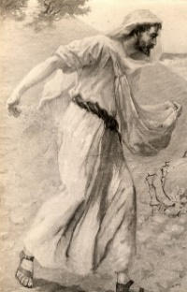
Is 55:10-11 / Rom 8:18-23 / Mt 13:1-23 or 13:1-9
5:00PM + Evelyn Grace Topper

SUNDAY, July 16 – 15TH SUNDAY IN OT

Is 55:10-11 / Rom 8:18-23 / Mt 13:1-23 or 13:1-9
8:00AM ⁓ People of the Parish
10:30AM + Salvatore Rendina, Jr.

Monday, July 17 (Weekday in OT)
Ex 1:8-14, 22 / Mt 10:34—11:1
Parish Office Closed

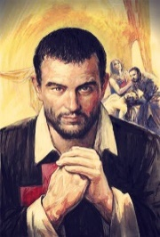
Tuesday, July 18 – St. Camillus de Lellis, Priest
Ex 2:1-15a / Mt 11:20-24

8:00AM - 3:00 PM ~ Office Open
10:00AM + Jean Dillon Eisenhart

“Something More” Group
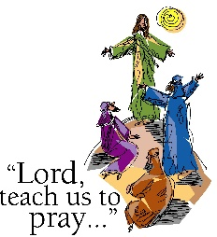
Wednesday, July 19 (Weekday in OT)
Ex 3:1-6, 9-12 / Mt 11:25-27

8:00AM - 3:00 PM ~ Office Open
10AM: Mature Spirituality Group
7:00PM + Janice Christiansen
Confessions heard 6 to 6:45PM; Adoration at 7:40PM

Thursday, July 20-St. Apollinaris, Bishop
Ex 3:13-20 / Mt 11:28-30 and Martyr

8:00AM – 3:00PM ~ Office Open
10:00AM + Anne Stinson Gillelan
Friday, July 21 – St. Lawrence of Brindisi, Priest & Doctor of the  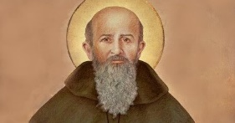  Ex 11:10—12:14/Mt 12:1-8 Church  Parish Office CLOSED | THE LORD
10:00AM + Harvey Fawber

SATURDAY, July 22 – St. Mary Magdalene

MORNING: Sg 3:1-4b / Jn 20:1-2, 11-18

SATURDAY, July 22 –VIGIL MASS 16TH SUNDAY IN ORD.TIME

Wis 12:13, 16-19 / Rom 8:26-27 / Mt 13:24-43
5:00PM ⁓ People of the Parish

SUNDAY, July 23 – 16TH SUNDAY IN OT

Wis 12:13, 16-19 / Rom 8:26-27 / Mt 13:24-43
8:00AM + Donald Redding
10:30AM + Jim and Delores Gilbert
Sanctuary Candle offered for JULY: In Loving Memory of Donald Redding from Edna Redding.
Sunday Collection Summary
July 8 and 9

Weekend Collections
Regular Offering $ 4,329.00
Candles $ 50.00
Altar Flowers $ 190.00
TOTAL OFFERINGS $ 4,569.00

- WEEKLY BUDGETARY NEEDS $ 4,494.00
+Overage or (Shortfall) for the week +$ 75.00

Other Income
Assumption (additional) $ 5.00
Local Poor $ 135.00
Parish Picnic $ 85.00
Rebate (Aero Energy Houses of Worship) $ 634.68
Picnic Raffle Tickets $ 220.00
Total Other Offerings $ 1,079.68

The Church will celebrate World Day for Grandparents and the Elderly on July 23rd this year. In his message to the world, the Holy Father said: "Let us not abandon [grandparents and the elderly]. Their presence in families and communities is a precious one, for it reminds us that we share the same heritage and are part of a people committed to preserving its roots. From the elderly we received the gift of belonging to God's holy people. The Church, as well as society, needs them, for they entrust to the present the past that is needed to build the future. Let us honor them, neither depriving ourselves of their company nor depriving them of ours."

St. Ignatius Needs Your Voice

On July 30th at the 10:30 Mass, St Ignatius parish will be dedicating the newly renovated stain-glass windows and your voice can be part of the celebration. THE MUSIC MINISTRY IS WELCOMING ANYONE THAT IS INTERESTED IN BEING PART OF THE CHOIR AND SING TO WELCOME BOTH THE NEW BISHOP AND THE WINDOWS. We will be singing traditional hymns from the Breaking Bread Hymnal that relate to the stories represented in the windows. If you are interested, please come upstairs 20 minutes prior to that 10:30 Mass on 30 July ‒ or call Phil Mobley at 571-236-7580 before the 30,^{th} if you have any questions. All are invited and no auditions or practice is required!

DONATIONS ACCEPTED JULY 9-23,
at the Office or in the basket in the Narthex.

Coats will be purchased in October at Boscov’s and then donated to the Interfaith Shelter in Harrisburg,
and to SCCAP in Gettysburg.

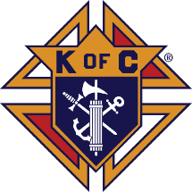

The Mass: ‘Do This in Remembrance of Me” ‒ Intercessions

July 11, 2023 | Fr. Luke Spannagel

We likely recognize the phrases “We pray to the LORD” and “LORD hear our prayer” from the General Intercessions at Mass. After the Creed, as a conclusion to the Liturgy of the Word, the community prays together, asking God for various needs. This part of the Mass has several names, including the Prayer of the Faithful, General Intercessions, Universal Prayer, or Petitions.

As the General Instruction of the Roman Missal teaches, “In the Universal Prayer or Prayer of the Faithful, the people respond in some sense to the Word of God which they have received in faith and, exercising the office of their baptismal Priesthood, offer prayers to God for the salvation of all. It is desirable that there usually be such a form of prayer in Masses celebrated with the people, so that petitions may be offered for holy Church, for those who govern with authority over us, for those weighed down by various needs, for all humanity, and for the salvation of the whole world” (GIRM, 69).

Of course, praying together as Christians has been part of our life from the beginning. As Charles Belmonte notes, “To pray for the needs of the Church and of the world is an early Christian custom. St. Paul admonishes Timothy, one of his disciples: ‘First of all, then, I ask that supplications, prayers, petitions, and thanksgivings be offered for everyone, for kings and for all in authority, that we may lead a quiet and tranquil life in all devotion and dignity.’ (1 Tim 2:1–2)” (Understanding the Mass, p. 104). Thus, it shouldn’t surprise us that this part of the Mass stretches all the way back to those earliest descriptions of the Mass, including the one by St. Justin Martyr (+165 AD).

The Church United in Prayer

The names “General Intercessions” and “Universal Prayer” instruct us on the composition of these prayers. They are prayed in a general way for wide-ranging needs, typically following a pattern of praying for the needs of the Church, for public authorities and the salvation of the world, for those burdened by any kind of difficulty, and for the local community. Often, the final intercession will include prayers for the deceased. While these prayers are envisioned to be “general,” the General Instruction of the Roman Missal does note that for a particular celebration like a Confirmation or a wedding, “the series of intentions may be concerned more closely with the particular occasion” (GIRM, 70). After the series of petitions, the Prayer of the Faithful ends with the concluding prayer said by the priest, asking God to accept our petitions.

As the name “Prayer of the Faithful” indicates, from the earliest times the baptized members of the congregation (the faithful) took part in this prayer (those who weren’t yet baptized were dismissed after the readings and homily so that they could further study and prepare to be received into the Church). In a wonderful way, the Prayer of the Faithful highlights one of the great privileges we have as God’s people: being able to join together in asking God for what we need. Having just listened to God’s Word and professed together our Faith through the Creed, we are then standing united together in faith as we ask God for what we need. Jesus has told us that our prayers are powerful when even two agree on what to pray for (Matthew 18:19). Just imagine how powerful our prayer is when the whole Church is joined together in union. It is amazing to think about!

For Reflection:

1. Take time to reflect on Matthew 18:19, which Father Luke alludes to above: “Again, [amen] I say to you, if two of you agree on earth about anything for which they are to pray, it shall be granted to them by my Heavenly Father.” Consider your experience of praying with others for particular needs, and bring these insights to your next participation in Mass.

2. Prepare your heart to enter fully into the Prayer of the Faithful, or Universal Prayer, by considering how you desire to pray for the world at this time. Listen attentively to the prayers of the congregation and unite your heart to this universal prayer.
The Holy Father, Pope Francis’ Prayer Intentions for 2023
Entrusted to His Worldwide Prayer Network
JULY ⁓ For a Eucharistic Life

We pray that Catholics may place the celebration of the Eucharist at the heart of their lives, transforming human relationships in a very deep way and opening to the encounter with God and all their brothers and sisters.

The Word’s Return : Scott Hahn Reflects

on the Fifteenth Sunday of Ordinary Time

Today’s readings, like last week’s, ask us to meditate on Israel’s response to God’s Word—and our own. Why do some hear the word of the kingdom, yet fail to accept it as a call to conversion and faith in Jesus? That question underlies today’s Gospel especially.

Again, we see, as we did last week, that the Kingdom’s mysteries are unfolded to those who open their hearts, making of them a rich soil in which the Word can grow and bear fruit.

As we sing in today’s Psalm, in Jesus, God’s Word has visited our land to water the stony earth of our hearts with the Living Waters of the Spirit (see John 7:38; Revelation 22:1).

The first fruit of the Word is the Spirit of love and adoption poured into our hearts in Baptism, making us Children of God, as St. Paul reminds us in today’s Epistle (see Romans 5:5; 8:15-16). In this, we are made a “new creation” (see 2 Corinthians 5:17), the first fruits of a new Heaven and a new earth (see 2 Peter 3:13).

Since the first humans rejected God’s Word, creation has been enslaved to futility (see Genesis 3:17–19; 5:29). But God’s Word does not go forth only to return to Him void, as we hear in today’s First Reading.

His Word awaits our response. We must show ourselves to be children of that Word. We must allow that Word to accomplish God’s Will in our lives. As Jesus warns today, we must take care lest the devil steals it away or lest it be choked by worldly concerns.

In the Eucharist, the Word gives Himself to us as “bread” to eat. He does so that we might be made fertile, yielding fruits of holiness.
And we await the crowning of the year, the great harvest of the LORD’s Day (see Mark 4:29; 2 Peter 3:10; Revelation 1:10) — when His Word will have achieved the end for which it was sent.

Readings: Isaiah 55:10–11; Psalm 65:10–14; Romans 8:18–23; Matthew 13:1–23

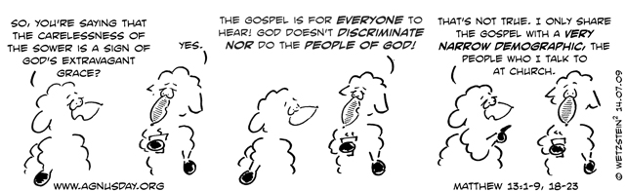

'Honour Grandparents': Pope's Message for

World Day of Grandparents and Elderly

With a call to honour and never abandon grandparents, Pope Francis issues Message for 3rd World Day for Grandparents and the Elderly on 23 July. The 86-year-old Pope instituted the Day in 2021, to be held the fourth Sunday in July, close to the feast of Jesus' grandparents, Saints Joachim and Anne.

By Deborah Castellano Lubov | 15 June 2023

"Let us honour them, neither depriving ourselves of their company nor depriving them of ours. May we never allow the elderly to be cast aside!"

This is Pope Francis' heartfelt invitation in his Message for the Third World Day for Grandparents and the Elderly, which the Church will celebrate on Sunday, 23 July. The text was published by the Vatican on Thursday.

The Church observes the World Day each year on the fourth Sunday in July, close to the feast of Jesus' grandparents, Saints Joachim and Anne. On the World Day, the Holy Father often presides over a Mass in St. Peter’s Basilica, and invites parishes, dioceses, associations and ecclesial communities from all over the world to celebrate the Day in their own pastoral context.

Pope Francis instituted this Day in 2021 since, he believes, grandparents are often forgotten, yet they "are the link between generations, passing on the experience of life and faith to the young."

'His Mercy is from age to age'

Pope Francis chose as this year's theme “His mercy is from age to age” (Lk 1:50), which he recalled, takes us back to the joyful meeting between the young Mary and her elderly relative Elizabeth (Lk 1:39-56). The Holy Spirit had descended upon Elizabeth, and had earlier, descended upon Mary, prompting her to respond with the Magnificat, in which she proclaimed that the Lord’s mercy is from generation to generation.

That same Spirit, the Pope observes in the Message, "blesses and accompanies every fruitful encounter between different generations: between grandparents and grandchildren, between young and old."

Bring joy to the elderly's hearts

The Pope expressed the delight that young people can offer older generations.

“God wants young people to bring joy to the hearts of the elderly, as Mary did to Elizabeth, and gain wisdom from their experiences. Yet, above all, the Lord wants us not to abandon the elderly...”

The Pope lamented how often they tragically are pushed aside.

This year, the World Day, the Pope recalled, takes place close to World Youth Day, stressing how maintaining quality connections with the older generations has priceless value for the young.

"The Lord," the Pope suggested, "trusts that young people, through their relationships with the elderly, will realize that they are called to cultivate memory and recognize the beauty of being part of a much larger history."

Become friends

Friendship with an older person, he said, can help the young "to see life not only in terms of the present and realize that not everything depends on them and their abilities."
For the elderly, on the other hand, he noted, the presence of a young person in their lives "can give them hope that their experience will not be lost and that their dreams can find fulfilment."

God's loving plan, the Pope expressed, spans past, present and future. "It embraces and connects the generations."

"It is greater than we are, yet includes each of us and calls us at every moment to keep pressing forward."

For the young, the Holy Father said, "this means being ready to break free from the fleeting present in which virtual reality can entrap us, preventing us from doing something productive." For the elderly, he continued, "it means not dwelling on the loss of physical strength and thinking with regret about missed opportunities. "

"Let us all look ahead!" the Pope said, insisting we must "allow ourselves to be shaped by God’s grace, which from generation to generation frees us from inertia and from dwelling on the past!"

Do not abandon them

In the meeting between Mary and Elizabeth, the Pope said, God points us toward the future that He is opening up before us.

The Holy Father encouraged everyone to reflect on that meeting, "to picture, like a snapshot, that embrace between the young Mother of God and the elderly mother of Saint John the Baptist, and to frame it in their minds and hearts as a radiant icon."

The Pope made another appeal for us to never forget or abandon the elderly. “Let us not abandon them.”

"Their presence in families and communities," the Pope highlighted, "is a precious one, for it reminds us that we share the same heritage and are part of a people committed to preserving its roots."

Church and society need elderly's gifts

"From the elderly we received the gift of belonging to God’s holy people. The Church, as well as society, needs them, for they entrust to the present the past that is needed to build the future.

The World Day for Grandparents and the Elderly, the Holy Father said, is meant "to be a small but precious sign of hope for them and for the whole Church."

The Holy Father renewed his invitation to everyone, and in a special way, dioceses, parishes, associations and communities, to celebrate this Day and to make it "the occasion of a joyful and renewed encounter between young and old." To the young who are preparing to meet in Lisbon or to celebrate World Youth Day in their own countries, the Pope asked that before they set out on their journey, that they visit their grandparents or an elderly person who lives alone.

“Their prayers will protect you and you will carry in your heart the blessing of that encounter.”

Great affection for elderly

The Holy Father also asked the elderly to accompany the young people about to celebrate World Youth Day with their prayers. "Those young people are God’s answer to your prayers, the fruits of all that you have sown, the sign that God does not abandon His people, but always rejuvenates them with the creativity of the Holy Spirit."

Before giving his blessing with "great affection," Pope Francis concluded by addressing grandparents and the elderly, praying that "the blessing of the embrace between Mary and Elizabeth come upon you and fill your hearts with peace."

