Sacrament of the Sick
Anointing of the Sick should be given if an individual is gravely ill or near death. If possible, the Sacrament should also be administered for serious illness, before major surgery or when one is initially hospitalized.

Sacrament of Holy Matrimony
Diocesan policy requires 12 months of preparation for Marriage. Contact the parish as soon as possible after engagement. No venue reservations or other arrangements should be made prior to consultation with the pastor.

Sacrament of Penance
Wednesday ~ 6:00 – 6:45PM; or by appointment.

Sacrament of Baptism
Parents must be registered members of the parish and attend a Baptism preparation class prior to the Baptism if this is your first child baptized. Requirements for godparents are established by the Catholic Church. Please call the parish office for Information and to register your child for Baptism.

Parish Registration
All Catholics should be registered in their local parish. Please contact the parish office to obtain registration forms, or if you are uncertain of the parish where you should register.

Parish Staff & Ministries Directory
stignatiusofloyola@hbgdiocese.org
Financial Manager ~ Richard Deardorff ~ 717- 677-8012 or 717-420-3464 (cell)
rdeardorff@hbgdiocese.org
Director of Religious Education ~ Deacon Steve Huete ~ shuete@hbgdiocese.org
Administrative Assistant ~ Kristen DiDio ~ kdidio@hbgdiocese.org
Buildings & Grounds ~ JB Groff ~ 717-677-8012
Music Ministry ~ Phil Mobley ~ 717-677-8012
Parish Council Members
*Walt Wilson – Chair 401-0570 (h) wwilson1198@comcast.net
Joanne Riedel - Secretary 398-2021 (h) sterj221@aol.com
Kathi Allwein 677-8984 (h) allweint@comcast.net
*Donnie Althoff 339-6527 (c) dalthoff53@gmail.com
Charlie Baker 677-9536 (h) dcbake@embarqmqil.com
*Jim Bittle 677-6711 (h) ginnybittle@comcast.net
Mike McTighe 729-6239 (c) mike0432@aol.com

Finance Council Members
Richard Deardorff (Ex Officio)
Greg Ernst - Chair
Alix Haller
Christy Hemler - Secretary
Terri Pendlelton
Bill Pulig

Altar Flowers
Prayer Chain
Lynne Mobley at LMOBLEY509@gmail.com
or 703-876-4901.

Soup Kitchen
Please send donations directly to “Soup Kitchen”

Website Development
Kristen DiDio
Life After Loss
Dodie Huete

OCIA
Contact Fr. Dominic

Picnic Co-Chairpersons
John Neiderer
Wally Kane

Pro-Life Ministry
OPEN – Contact office if you are interested

Knights of Columbus
SK Bob Ternes
- Grand Knight

Judy Wilson / Janice Meligakas

Bereavement Ministry
Ginny Bittle / Dodie Huete

Catholic Communications/EWTN
Open - Contact office if you are interested

Cemetery
Contact Parish Office
THEOSIS Ministry
Kathy Dietsch 717-352-4558
Bicky Redman 717-677-8592

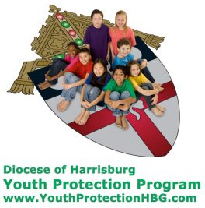
Diocese of Harrisburg Youth Protection Program
www.YouthProtectionHBG.com

Abuse Reporting Contact Information:
First – Call the toll-free PA Child Abuse Hotline at 800-932-0313
Then – Call the Diocesan toll-free hotline at 800-626-1608

“If one member suffers,
all suffer together with it.” (1 Cor 12:26)

St. Ignatius Loyola RC Church

1095 Church Road, Orrtanna, Pennsylvania 17353
www.stignatiusofloyola.org

MAY 7, 2023: FIFTH SUNDAY OF EASTER

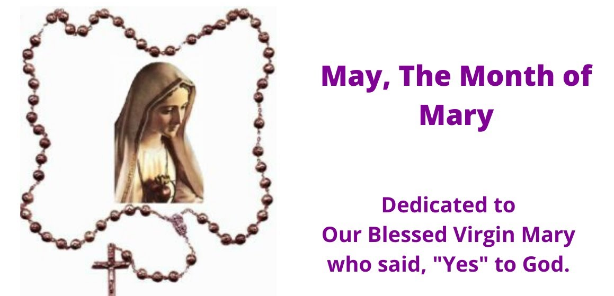
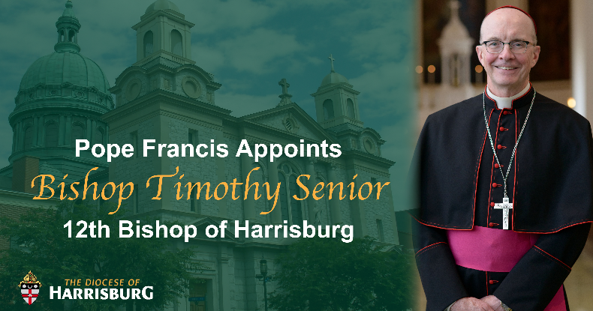

Most Reverend Ronald W. Gainer, Apostolic Administrator
Rev. Dominic M. DiBiccaro, Pastor / Deacon Steve Huete, Pastoral Associate
Mass Schedule, Intentions, and Events
Please Pray for:
Coronavirus victims and those who are ill, Jeanie Kline and the Kline Family, Mary Ellen Wilson, Terry & Bernie Cabana, Ed & Aggie Sherensky and Family ,Bob Raffensberger Jerry & Ginny Miller, Adeline Lienard, Kaylee Henry, Chuck & Nancy Wuller, Dr. Mike Colli, Mrs. Kelly Kump, Kevin & Brittany Groff, Gabriel Singer, Sharon McCormley, Ron Thumma, Joe Wisotzkey, Leo Hockensmith, Erika McKissick, Jean "Heather" O'Shea, Scott Moore and Sally Moore, Mary Wyatt, Jim & Joyce Deardorff, Brandon & Michelle Gilbert, Amy Weatherup, Sophia Joy Ernst, Deacon Richard Wentzel, Deacon Frank Enderle, Kathleen Thompson, Deb & Kathy McLintock and Family, Rachel Wonders, Amy Edwards, Jean O’Connor, Art Lazar, Sr., Mark & Michelle Huete, Paul Angello, Jen Baldwin, Ursula Kaley, Deb Bennet, Fr. Bill Sullivan, Fr. Chet Snyder, John Larry Endy, Mary Beth McCarthy, Laura Lee, Marwa Abdelrahman, Cathy Gates, Donna Singley, Jack Ryff, Tim McGinn, Jane Kump, Gary, Bill, Jerry, Andy, Colleen, Baby Addie, Peggy Neiderer, Chris Kimple, Robert Riquet, Gene & Jo-Ann McDannell, Bob Doxzen, Kimberly Mears, Gabriella Angello, Mark & Kate Morrow, Mark Morris, Linda Fogleman, Paul Knight, George & Barbara Erstila, Jeff Carpenter, Lana & Nelson Harmon, Cole & Connor, Diane Slothour, Sue McDannell, Larry Schneider, Joe & Lisa Grasel, Ange Pena, Julie Barnhart, the Shaffer Family, Heather & Emma Dickerson, Brad Pabody, Paul Ward, Aiden Tyler Schneider, Dorothy Vega, Karrie McCall & daughter, George Shahid, Denise Navlyt, Drew Schneider & Family, Ida Bloomfield, Linda McDannell, Janie Singley, Mary Beth Greenstreet, Rick Benedict, Jan Patla, Kathe Fogleman, Sam Sheffler, Kate Hemmis, Bill & Mary Lou Graham, Joanna Hodges, John Varones, Joan O’Sullivan, Martha Klinger, Lisa Dionne Lauretti, Sue Orndorff, Jim Gleason, Sue Gustafson, Joe & Michelle Cleary, Kim Johnson, Helen Mills, Kathy Haber, Haley Detman, Joe Durovey, Bev Smith, Donald Sheppard, Linda Mumaugh, Alison Haring, Janet Hartman, Edward Johnson, Angela Galeone, Juliete Lang, Chris MacBeth, Harry Graham, Donald Howard, Armond Binni, Elizabeth Stansky, Pat Johnson, Chris Morris, Faud Doaney, Wilson & Rae Harman, Patrick Glass, Helen Lagasse, Nancy Kewisnek, Andy Graham, Bill & Maureen Collins, Rosemary McGilloway, Anji Eisenhart, Monica Manner, Denny Borbonus, Dr. Paul Scarlata, Mary Hawthorne, Ed Washington, Josh Kempinski, Nancy Baker Baltzey, Spencer Propts, Karlton Smith & Cheryl Sobun, James & Marylyn Sobun, Marlene Webster, Yvette Stoklosa, Andy Consiglio, Bill & Michelle Cloonan, Nelson Salem, Janet Shunnarah, George Shunnarah, Bill & Deb McClintock nursing home residents & shut-ins, the victims of war, violence, disease, disaster, & all private intentions.
Also in your prayers, please remember all
our men and women currently serving in
our Armed Forces:
Maj. Nathan Jeffcoat – US Marine Corps
Lt. Joseph Cleary – US Navy
Michael C. Kenney IV – US Coast Guard
Lt. Joshua Kimple – US Army
Lt. Sarah Fogleman, M.D. – US Navy

PRAYER CHAIN: Contact Lynne Mobley at 703-876-4901 or LMOBLEY509@gmail.com

for the Week of May 6 to May 14, 2023

SATURDAY, May 6 – VIGIL MASS 5th SUNDAY

Acts 6:1-7 / 1 Pt 2:4-9/Jn 14:1-12 OF EASTER
5:00PM + Trish Weishaar

SUNDAY, May 7 – 5th SUNDAY OF EASTER

Acts 6:1-7 / 1 Pt 2:4-9 / Jn 14:1-12

8:00AM - Spec. Int. Kimple Family
10:30AM ~ People of the Parish

Monday, May 8 (Easter Weekday)
Acts 14:5-18 / Jn 14:21-26
Parish Office Closed

Tuesday, May 9 (Easter Weekday)
Acts 14:19-28 / Jn 14:27-31a
8:00AM - 3:00 PM ~ Office Open
10:00AM +Anne (Onufrak) DiBicccaro

11AM: “Something More” Faith Group
Wednesday, May 10 – St. John of Avila, Priest & Doctor
of the Church; St. Damien de Veuster, Priest
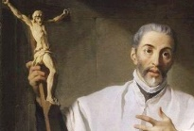
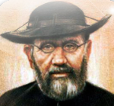
Acts 15:1-6 / Jn 15:1-8

8:00AM - 3:00 PM ~ Office Open

11AM: Senior Spirituality Group
Confessions heard from 6 to 6:45PM; Adoration at 7:40PM
7:00PM +Joan and Eugene Schott
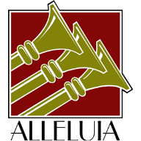
Thursday, May 11 (Easter Weekday)
Acts 15:7-21 / Jn 15:9-11
8:00AM - 3:00 PM ~ Office Open
10:00AM + Ruth Ann Robinson

Friday, May 12 – Sts. Nereus & Achilleus, Martyrs; St. Pancras,  M  a  r  t  y  r  Acts 15:22-31 / Jn 15:12-17 | THE LORD
Parish Office CLOSED
10:00AM +Tim & Wanda Timbers

SATURDAY, May 13 – Our Lady of Fatima

MORNING: Acts 16:1-10 / Jn 15:18-21

SATURDAY, May 13 – VIGIL MASS 6th SUNDAY OF EASTER

Acts 8:5-8, 14-17/1 Pt 3:15-18/Jn 14:15-21
4:30PM Recitation of the Holy Rosary
5:00PM - Special Int. for Jeanie Kline

SUNDAY, May 14 – 6th SUNDAY EASTER

Acts 8:5-8, 14-17/1 Pt 3:15-18/Jn 14:15-21

8:00AM - Private Intention
10:30AM ~ People of the Parish
Sanctuary Candle offered for MAY: In Loving Memory of Marilyn Cole from Ken Cole and Family
Sunday Collection Summary
Parish Council Meeting Summary
March 21, 2023

- After an opening prayer, the meeting was convened having three members excused. All Ex-officio members and three guests were present. Minutes of the February 7, 2023, meeting was approved.

- Jim Bittle provided a briefing on the site security assessment and grant report that he, Greg Ernest and Joanne Cochran have been working on. The Grant application is complete and has been submitted to PCCD Security Grant Fund for consideration.

- Discussed the Six Areas of Mission and reorganizing the Parish Council functioning along those Missions..

- Nominations of six parishioners to stand for election to fill the three vacancies on council were accepted. They are Kathy Dietsch, Bickey Redman, Ali Morris, Dorthey Vega, Phil Mobley and Dr. Bob Ternes.

- Discussed plans for Holy Week, installation of the three restored stained-glass windows and dedication, by Bishop Gainer and May Crowning service.

- Guests shared their views and concerns on statues in the church and on campus, clarity needed on collection dollars posted in the bulletin, and issues around the Mary Jemison statue and the “squaw word.

(A copy of the full minutes is available for review in the Parish Office.)
-----------------------------------------------------------------------------
Parish Council Meeting Summary
Scheduled for April 25, 2023

- Parish Council Meeting was not convened in April due to member scheduling issues, conflicts with other deanery liturgical obligations, and illnesses.
-----------------------------------------------------------------------------
Executive Session of Parish Council Mtg. Summary
May 2, 2023

- After an opening prayer, the meeting was convened having all members present. All Ex-officio members except for the Finance Manger were present. Minutes of the March 21, 2023, meeting was approved.

- Council members conducted the election ballot counting of the 145 ballots cast. Dorthey Vega, Ali Morris, and Kathy Dietsch were runners up to Becky Redman Phil Mobley and Dr. Bob Ternes who were elected for a 3-year term beginning July 2023.

- Discussed an orientation plan for the new members at the next meeting, A Blessing installation at the 8:00 AM Mass on June 11, 2023, election of a council chair and vice chair and strategic planning for the next fiscal year.

- Next Meeting is scheduled for June 6 at 6:30. This will be a closed meeting in order to accomplish the items mentioned above.

April 29 & 30

Weekend Collection
Regular Offering $ 2,021.00
Candles $ 70.56
TOTAL OFFERINGS $ 2,091.56

‒WEEKLY BUDGETARY NEEDS $ 5,819.68
+Overage or (Shortfall) for the week ($ 3,728.12)

Diocesan Second Collections
Catholic Home Missions $ 663.00
TOTAL DIOCESAN OFFERINGS $ 663.00
2023 Diocesan Annual Campaign
Updates as of May 1, 2023

Saint Ignatius Loyola Parish Orrtanna
Parish Goal for 2023: $29,847.61
Total Paid: $21,726.50
Outstanding Pledges: $3,812.50
Total Committed: $25,539.00
Over/(under)goal in cash: ($8,121.11)
Shortfall Payments: $0.00

% toward goal cash rec’d: 72.79%
Average per donor: $306.01
Number of Donors: 71
Registered Households: 205
Percentage of Participation: 34.63%

------------------------------------------------------------------------------------------------------------------------------------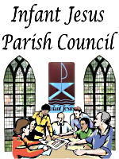
- Phil Mobley
- Bicky Redman
- Dr. Bob Ternes

For the Service and Ministry of:
Jim Bittle
Donnie Althoff
Walt Wilson

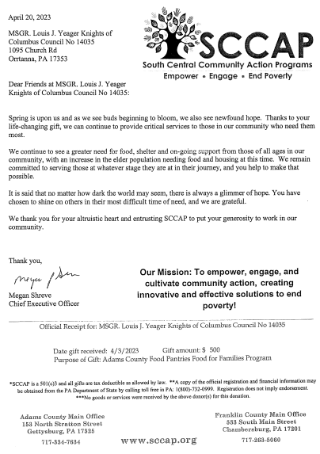

The Holy Father, Pope Francis’ Prayer Intentions for 2023
Entrusted to His Worldwide Prayer Network

MAY ⁓ FOR CHURCH MOVEMENTS AND GROUPS
We pray that Church movements and groups may rediscover their mission of evangelization each day, placing their own charisms at the service of needs in the world.

Building His House: Scott Hahn Reflects

on the Fifth Sunday of Easter

By His death, Resurrection, and Ascension, Jesus has gone ahead to prepare a place for us in His Father’s House.

His Father’s House is no longer a temple made by human hands. It is the spiritual house of the Church, built on the Living Stone of Christ’s Body.

As St. Peter interprets the Scriptures in today’s Epistle, Jesus is the “stone” destined to be rejected by men but made the precious cornerstone of God’s dwelling on earth (see Psalm 118:22; Isaiah 8:14; 28:16).

Each of us is called to be a living stone in God’s building (see 1 Corinthians 3:9, 16). In this edifice of the Spirit, we are to be “holy priests” offering up “spiritual sacrifices” — all our prayer, work and intentions — to God.

This is our lofty Calling as Christians. This is why Christ led us out of the darkness of sin and death just as Moses led the Isra-elites from bondage in Egypt.

God’s Covenant with Isra-el made them a royal and priestly people who were to announce His praises (see Exodus 19:6). By our faith in Christ’s New Covenant, we have been made heirs of this chosen race, called to glorify the Father in the “temple of our bodies” (see 1 Corinthians 6:19–20; Romans 12:1).

In today’s First Reading, we see the spiritual house of the Church being built up as the Apostles consecrate seven deacons so they can devote themselves more fully to the “ministry of the Word.”

The LORD’s Word is upright and all His works trustworthy, we sing in today’s Psalm. So we can trust Jesus when He tells us never to be troubled, but to believe that His Word and works come from the Father.

His Word continues its work in the world through the Church. We see its beginnings today in Jerusalem. It is destined to spread with influence and power (see Acts 19:20)and to become the imperishable seed by which every heart is born anew (see 1 Peter 1:23).

Readings: Acts 6:1–7; Psalm 33:1–2, 4–5, 18–19; 1 Peter 2:4–9; John 14:1–12

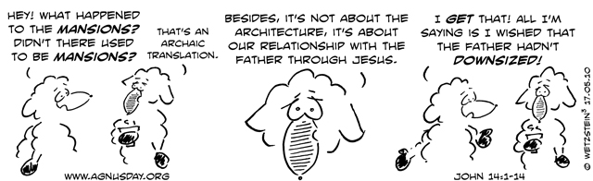

Why is May the Month of Mary?
The ways Mary is honored in May is as varied as the people who honor her.

By Marge Fenelon | May 1, 2020

It’s here. May, the month in which the earth springs into bloom (at least in the Northern Hemisphere) and we start thinking about planting gardens, family picnics and making vacation plans.

It’s also the Month of Mary.

Having gone to a Catholic grade school run by the Schoenstatt Sisters of Mary, my early childhood memories include honoring Mary during May – a practice I’ve continued all of my life and taught my children to do as well. It’s as natural and essential to me as my morning coffee (only far, far more joy-filled if you can even imagine that).

I know a number of Catholics who see May as the Month of Mary, and we all get the same question from time to time:

Why is May Mary’s month?

For centuries, the Catholic Church has set aside the entire month of Mary to honor Mary, Mother of God. Not just a day in May, mind you, but the entire month!

The custom spans both centuries and cultures, with roots going back as far as the Ancient Greeks. In early Greece, May was dedicated to Artemis, the goddess of fecundity.

In Ancient Rome, May was dedicated to Flora, the goddess of blooms, or blossoms. They celebrated ludi florals, or floral games, at the end of April and asked the intercession of Flora for all that blooms.

In medieval times, similar customs abounded, all centering around the practice of expelling winter, as May 1 was considered the start of new growth.

During this period, the tradition of Tricesimum, or “Thirty-Day Devotion to Mary,” came into being. Also called, “Lady Month,” the event was held from August 15-September 14 and is still observed in some areas.

The idea of a month dedicated specifically to Mary can be traced back to baroque times. Although it wasn’t always held during May, Mary Month included thirty daily spiritual exercises honoring Mary.
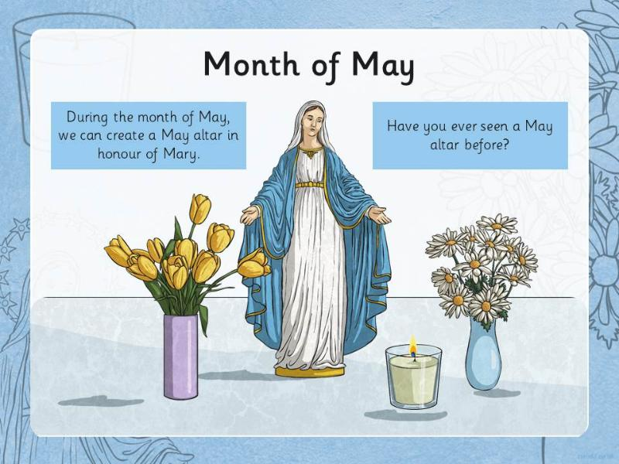
It was in this era that Mary’s Month and May were
combined, making May the Month of Mary with
special devotions organized on each day throughout
the month. This custom became especially widespread
during the nineteenth century and remains in practice
until today.

The ways Mary is honored in May is as varied as the
people who honor her.

It’s common for parishes have a daily recitation of the
Rosary during May, and many erect a special May altar
with a statue or picture of Mary as a reminder of Mary’s month.
Additionally, it’s a long-standing tradition to crown the statue of Mary during May – a custom known as May Crowning. Often, the crown is made of beautiful blossoms representing Mary’s beauty and virtue. It’s also a reminder to the faithful to strive to imitate our Blessed Mother’s virtue in our own lives.

May Crowning, in some areas, is a huge celebration and is usually done outside of Mass, although Mass may be celebrated before or after the actual crowning.

But May altars and crownings aren’t just “church” things. We can and should be doing the same in our homes. When we echo the customs and traditions of the Church in our homes – our domestic churches – we participate more fully in the life of the Church.

If you haven’t already, I encourage you to erect a prayer corner in your home. No matter how fancy or simple it is. The main point is that it’s a place designated for God, and more specifically, for spending time with him. Just as you need proper atmosphere to sleep, you also need proper atmosphere to pray.

For May, give Mary a special spot in your prayer corner. It can be a statue or picture, but place there some representation of our Blessed Mother. Make it appealing and a real tribute to her beauty and virtue.

Then, crown Mary. You can give her an actual or spiritual crown and you can make it a subtle gesture or ornate ceremony of your own device. The meaning is far more important than the action. You can do it in the beginning, at the end of May or anywhere in between.

Just do it.

Why?

Not because it’s a long-standing tradition in the Church, although it is. Not because there are any special graces connected to it, although there is.

No, do it because Mary is Mother – your mother, my mother, everyone’s mother – and because she cares for all of us day-in-and-day-out without fail, interceding for us in even the tiniest matters.

For that, she deserves an entire month in her honor.

Marge Fenelon is an award-winning Catholic author and journalist, blogger, and speaker. She’s a long-time correspondent for National Catholic Register, and the author of several books on Marian devotion and Catholic family life. She’s also a weekly contributor to Relevant Radio’s “Morning Air Show” and a popular guest on several other Catholic radio and television shows. Marge is an instructor for the Archdiocese of Milwaukee Deacon Wives Program.

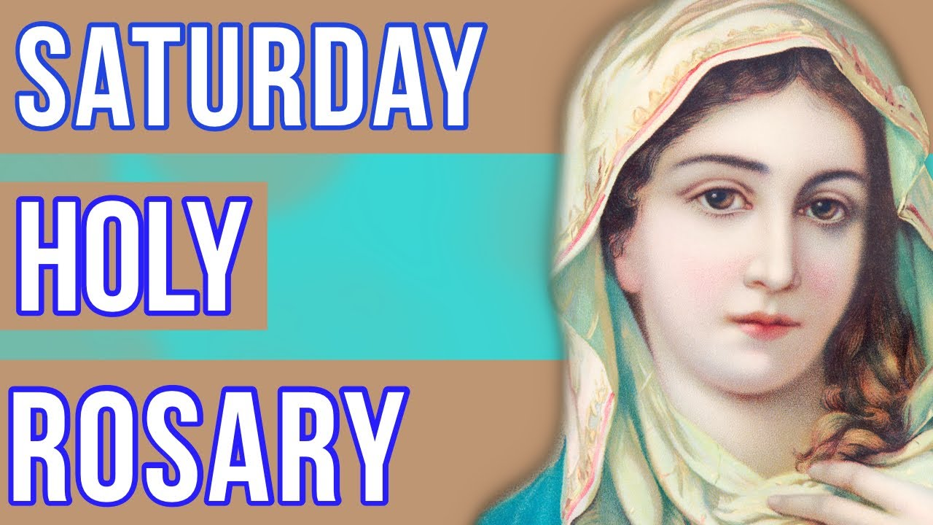

Will be recited before the
5PM Vigil Mass
at 4:30PM.

