Sacrament of Penance
Wednesday ~ 6:00 - 7:00 pm; or by appointment.

Sacrament of the Sick
Anointing of the Sick should be given if an individual is gravely ill or near death. If possible, the Sacrament should also be administered before major surgery or when one is initially hospitalized.

Sacrament of Holy Matrimony
Diocesan policy requires 12 months of preparation for Marriage. Contact the parish as soon as possible after engagement. No arrangements should be made prior to consultation with the pastor.

Sacrament of Baptism
Parents must be registered members of the parish and attend a Baptism preparation class prior to the Baptism if this is your first child baptized. Requirements for godparents are established by the Catholic Church. Please call the parish office for Information and to register your child for Baptism.

Parish Registration
All Catholics should be registered in their local parish. Please contact the parish office to obtain registration forms, or if you are uncertain of the parish where you should register.

Parish Staff & Ministries Directory
stignatiusofloyola@hbgdiocese.org
Financial Manager ~ Richard Deardorff ~ 717- 677-8012 or 717-420-3464 (cell)
rdeardorff@hbgdiocese.org
Director of Religious Education ~ Deacon Steve Huete ~ shuete@hbgdiocese.org
Administrative Assistant ~ Kristen DiDio ~ kdidio@hbgdiocese.org
Buildings & Grounds ~ JB Groff ~ 717-677-8012
Music Ministry ~ Phil Mobley ~ 717-677-8012
Parish Council Members
Kathleen Allwein
Donnie Althoff
Charlie Baker
Jim Bittle
Mike McTighe
Joanne Riedel - Secretary
Walt Wilson - Chair

Finance Council Members
Richard Deardorff (Ex Officio)
Greg Ernst - Chair
Alix Haller
Christy Hemler - Secretary
Terri Pendlelton
Bill Pulig

Prayer Chain
Lynne Mobley at LMOBLEY509@gmail.com
or 703-876-4901.

Soup Kitchen
Please send donations directly to “Soup Kitchen”

Website Development
Kristen DiDio
Life After Loss
Dodie Huete

OCIA
Contact Fr. Dominic

Picnic Co-Chairpersons
John Neiderer
Wally Kane

Pro-Life Ministry
OPEN – Contact office if you are interested

Knights of Columbus
SK Bob Ternes
- Grand Knight

Covid-19 Task Force
Walt Wilson - Coordinator
Health Advisors:
Dr. Robert Ternes and
Joanne Cochran
(Keystone Health System)

Altar Flowers
OPEN - Contact office if you are interested

Bereavement Ministry
Ginny Bittle

Catholic Communications/EWTN
Open - Contact office if you are interested

Cemetery
Contact Parish Office
Diocese of Harrisburg Youth Protection Program
www.YouthProtectionHBG.com

Abuse Reporting Contact Information:
First – Call the toll-free PA Child Abuse Hotline at 800-932-0313
Then – Call the Diocesan toll-free hotline at 800-626-1608

“If one member suffers,
all suffer together with it.” (1 Cor 12:26)

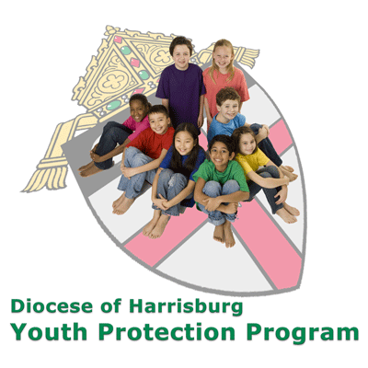

St. Ignatius Loyola RC Church

1095 Church Road, Orrtanna, Pennsylvania 17353
www.stignatiusofloyola.org

January 29, 2023: 4th SUNDAY in Ordinary Time

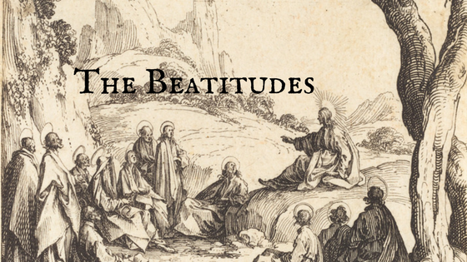

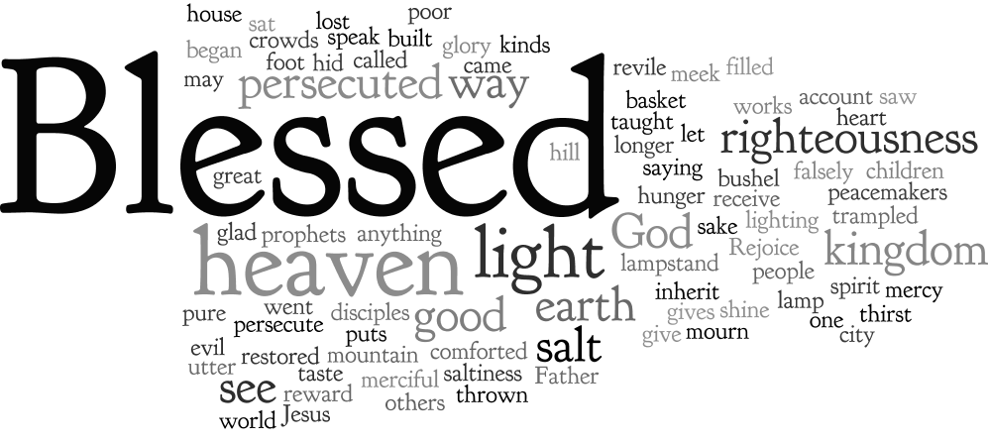

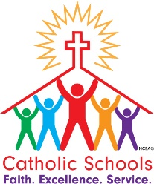

Most Reverend Ronald W. Gainer, Bishop of Harrisburg;
Rev. Dominic M. DiBiccaro, Pastor / Deacon Steve Huete, Pastoral Associate
Mass Schedule, Intentions, and Events
Please Pray for:
Coronavirus victims and those who are ill, Jim & Jeanie Kline, Mrs. Kelly Kump, Gabriel Singer, Bill Henry, Sharon McCormley, Ron Thumma, Joe Wisotzkey, Leo Hockensmith, Erika McKissick, Jean "Heather" O'Shea, Scott Moore and Sally Moore, Mary Wyatt, Jim & Joyce Deardorff, Brandon & Michelle Gilbert, Amy Weatherup, Sophia Joy Ernst, Mary & Chuck Irwin, Deacon Richard Wentzel, Deacon Frank Enderle, Marie Kalp, Kathleen Thompson, Deb & Kathy McLintock and Family, Rachel Wonders, Amy Edwards, Jean O’Connor, Art Lazar, Sr., Mark & Michelle Huete, Paul Angello, Jen Baldwin, Ursula Kaley, Deb Bennet, Fr. Bill Sullivan, Fr. Chet Snyder, John Larry Endy, Mary Beth McCarthy, Laura Lee, Marwa Abdelrahman, Cathy Gates, Donna Singley, Jack Ryff, Tim McGinn, Jane Kump, Gary, Bill, Jerry, Andy, Colleen, Baby Addie, Peggy Neiderer, Chris Kimple, Robert Riquet, Gene & Jo-Ann McDannell, Bob Doxzen, Kimberly Mears, Gabriella Angello, Mark & Kate Morrow, Mark Morris, Linda Fogleman, Paul Knight, George & Barbara Erstila, Jeff Carpenter, Lana & Nelson Harmon, Cole & Connor, Diane Slothour, Sue McDannell, Larry Schneider, Joe & Lisa Grasel, Ange Pena, Julie Barnhart, the Shaffer Family, Heather & Emma Dickerson, Brad Pabody, Adeline Lienard, Robbie, Michael & daughter, Paul Ward, Aiden Tyler Schneider, Dorothy Vega, Karrie McCall & daughter, George Shahid, Denise Navlyt, Drew Schneider & Family, Ida Bloomfield, Linda McDannell, Janie Singley, Mary Beth Greenstreet, Rick Benedict, Jan Patla, Kathe Fogleman, Sam Sheffler, Kate Hemmis, Bill & Mary Lou Graham, Joanna Hodges, John Varones, Joan O’Sullivan, Martha Klinger, Lisa Dionne Lauretti, Sue Orndorff, Jim Gleason, Sue Gustafson, Joe & Michelle Cleary, Kim Johnson, Helen Mills, Kathy Haber, Haley Detman, Joe Durovey, Bev Smith, Donald Sheppard, Linda Mumaugh, Alison Haring, Janet Hartman, Edward Johnson, Angela Galeone, Juliete Lang, Chris MacBeth, Harry Graham, Donald Howard, Armond Binni, Elizabeth Stansky, Pat Johnson, Chris Morris, Faud Doaney, Wilson and Rae Harman, Patrick Glass, Helen Lagasse, Nancy Kewisnek, Andy Graham, Bill & Maureen Collins, Rosemary McGilloway, Anji Eisenhart, Monica Manner, Denny Borbonus, Dr. Paul Scarlata, Mary Hawthorne, Ed Washington, Josh Kempinski, Nancy Baker Baltzey, Spencer Propts, Karlton Smith & Cheryl Sobun, James & Marylyn Sobun, Marlene Webster, Yvette Stoklosa, Andy Consiglio, Bill & Michelle Cloonan, Nelson Salem, Janet Shunnarah, George Shunnarah, Bill & Deb McClintock, Mary Pekich, nursing home residents & shut-ins, the victims of war, violence, disease, disaster, & all private intentions.

Also In your prayers, please remember all our men and women currently serving in our Armed Forces:
Maj. Nathan Jeffcoat – US Marine Corps
Lt. Alexandra Jeffcoat – US Navy
Lt. Joseph Cleary – US Navy
Michael C. Kenney IV – US Coast Guard
Lt. Joshua Kimple – US Army
and Lt. Sarah Fogleman, M.D. – US Navy

PRAYER CHAIN: Contact Lynne Mobley at LMOBLEY509@gmail.com or 703-876-4901.

for the Week of January 28 ~ February 5, 2023

SATURDAY, January 28-VIGIL MASS 4th SUNDAY ORDINARY TIME

Zep 2:3; 3:12-13/1 Cor 1:26-31 / Mt 5:1-12a
5:00PM +Robert Grab
SUNDAY, January 29 –4th SUNDAY OF OT

Zep 2:3; 3:12-13/1 Cor 1:26-31 / Mt 5:1-12a
8:00AM +Nolan Patrick Gilbert
10:30AM ~ People of the Parish

Monday, January 30 (Weekday in OT)
Heb 11:32-40 / Mk 5:1-20
Parish Office Closed

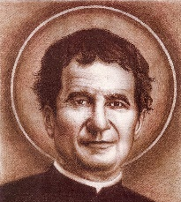
Tuesday, January 31 – St. John Bosco, Priest
Heb 12:1-4 / Mk 5:21-43
8:00AM - 3:00 PM ~ Office Open
10:00AM +Raymond Haber

11:00AM: “Something More” Faith Group

Wednesday, February 1 (Weekday in OT)
Heb 12:4-7, 11-15 / Mk 6:1-6

8:00AM - 3:00 PM ~ Office Open

10:00AM: Senior Spirituality Group
- - - - - - - - - - - - - - - - - - - - - - - - - - - - - - - - - - - - - - - - - - - - - -
7:00PM +Donald Redding
Confessions heard from 6-6:45PM; with Adoration 7:40–8PM
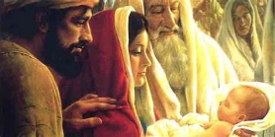
Thursday, February 2 – PRESENTATION OF THE LORD
Mal 3:1-4/Heb 2:14-18 / Lk 2:22-40
8:00AM - 3:00 PM ~ Office Open
10:00AM +Mickie Scneider

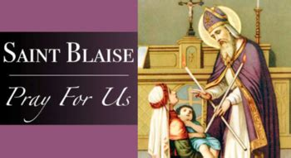
Friday, February 3 – St. Blaise, Bishop & Martyr
Heb 13:1-8 / Mk 6:14-29 St. Ansgar, Bishop
10:00AM +Barbara Jeanne Kaufman
Parish Office CLOSED

Saturday, February 4 (Weekday in OT)

MORNING: Heb 13:15-17, 20-21/Mk 6:30-34

SATURDAY, February 4-VIGIL MASS 5th SUNDAY ORDINARY TIME

Is 58:7-10 / 1 Cor 2:1-5 / Mt 5:13-16
5:00PM +Joan & Eugene Schott
SUNDAY, February 5 –5th SUNDAY OF OT

Is 58:7-10 / 1 Cor 2:1-5 / Mt 5:13-16
8:00AM ~ People of the Parish
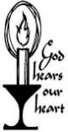
10:30AM ~ Special Intention
for the 65th Wedding
Anniversary of Bill & Mary Lou Graham

Sanctuary candle offered for JANUARY: In loving memory of Marilyn Cole from Ken Cole and Family
*** NOTE *** Due to the Winter storm this past week, the Sunday Collection Summary for the weekend of January 28 & 29 will be reported in next weeks’ bulletin.

Parish Council Meeting Summary
January 10, 2023

- After an opening prayer, the meeting was convened having all council members, Ex-officio members and two guests present. Minutes of the December 13, 2022, meeting was approved with two corrections.

- Father reported that due to the “bomb cyclone” on December 23, attendance at the Christmas Eve Mass was down, and lighter at the two Christmas Day Masses. Decorations will come down on February 3 and the Blessing of the Throats will take place on the weekend Masses of February 4. The parish’s contribution to the 2022 Diocesan Campaign had ZERO outstanding pledges, but with only 35% of our families participating. We have a new parish administrative assistant, Kristen DiDio. Also, a meeting is scheduled with our farm neighbor to discuss land use and any future agreement.

- Discussed how Parish Pastoral Council could become part of the annual budget development process for evaluating and recommending to the pastor and the Parish Finance Council fininical support to organizations. Currently, the parish provides donations to both Buchanan Valley and Fayetteville Fire Companies, 3 children’s lunch “backpack programs”: Johns Meals, Franklin Friends, and Ruth’s Harvest;, as well as to Holy Family Radio and Adams Rescue Mission. Also, proposed was restarting the ringing of the church bell prior to Sunday Masses and who would undertake that responsibility. Parishioners interested in assuming this ministry for the particular Mass they usually attend can let Dick Deardorff know.

- There will be three elected parish council positions that will need to be filled this upcoming year. A nominating committee was formed to identify and recruit candidates to fill these slots. Anyone interested in running for one of these positions should contact Fr. Dominic or the Council chair, Walt Wilson.

- The Parish Financial Manager gave a brief recap of November’s 2022 Budget Results Statement. Due to differences in the # of collection reporting weeks for each month, the combined +/- for the Oct./Nov. period was in the black.

- Dodie Huete (guest) reported that there was a good turnout for the “Life After Loss” Program despite a power outage. She also received a huge THANK YOU from Father and Council for her work in this very important parish ministry.

- Next meeting is February 7, 2023, at 6:30 PM in the community center conference room. Meetings are open to all Parishioners.
(A copy of the full minutes is available for review in the Parish Office.)

February 3 – Take down church Christmas decorations
February 5 – World Missions MEMBERSHIP SUNDAY
February 11 – Hot Chicken Sandwich Dinner
February 12 – 2nd Collection: Black & Indian Missions
February 22 – ASH WEDNESDAY (Lent begins!)

March 10 – Lenten Mini Retreat w/Sr.Thelma Steiger

Benedict XVI and the Eucharistic Revival: Part II
This is the SECOND in a three part series highlighting the Eucharistic legacy of Pope Benedict XVI. Part I focused on “The Eucharist is a Mystery to be Believed.” This week Dr. O’Malley emphasizes “The Eucharist Is a Mystery to Be Celebrated.”

January 10, 2023
by Dr. Tim O’Malley, PHD
‍

The Eucharist Is a Mystery to Be Celebrated

Of course, most of us experience (as Benedict XVI notes) the Eucharist not as a series of intellectual propositions but a concrete, religious practice. We go to Mass. But if there is anything that has the potential to rip apart the Church right now, it’s a discussion of the Mass.

Go into any parish in the United States, and you will find people with definite thoughts about how the Eucharist should be celebrated. It should include only chant, or it should never include chant. It should be done only in Latin or never in Latin. The priest should face the same direction as the people who are praying (toward the east) or the priest should face the people as he is praying. We should put up Altar rails again, or we should take them all down.

Benedict XVI had little patience with this kind of liturgical in-fighting. It once again misses what is happening in the Eucharistic mystery: the advent of Jesus Christ who comes, himself, to feed us with his Body and Blood as we remember and give thanks for what God has accomplished, living out through this prayer our primordial creatures made for praise. This is the mystery of love that we must actively participate in. Benedict XVI quotes from Vatican II on this point, reminding us that:

“…the Faithful ‘should be instructed by God’s word and nourished at the table of the LORD’s Body. They should give thanks to God. Offering the immaculate Victim, not only through the hands of the priest but also together with him, they should learn to make an offering of themselves. Through Christ, the Mediator, they should be drawn day by day into ever more perfect union with God and each other.’ ” (Sacramentum Caritatis, no. 52)

A Eucharistic Revival, therefore, will attend to the formation of the priest and the Faithful alike in this kind of active participation. Active participation is recognizing that what we pray at Mass is intended to lead us more deeply into union with God and one another. We listen to Sacred Scripture, chewing upon the sweet words of salvation in the assembly with one another. We each make the offering of the Eucharist. The priest does so in the person of Christ and the Church and the assembly as the baptized Faithful called to make their whole lives a return gift of love to the Father.

‍Active Participation

Active participation, therefore, is less about teaching people more things about the Mass—telling people things about things. It is instead a spiritual formation, fostering in us the kind of disposition that leads us into fruitful celebration of the Eucharist. We must learn to listen to the Scriptures in the silence of our hearts. We must cultivate an awareness in our lives of the places where we need God’s love to come to us. We must celebrate liturgies that lead us into this kind of participation, where the drama of salvation is at stake in the celebration of the Mass.

And yes, we need to reflect on the ways that God is acting among us in the Eucharistic rites, as Benedict XVI notes. We must undertake an education where each of us learn to live Faithfully what we celebrate in the rites (cf. Sacramentum Caritatis, no. 64). Again, let me be concrete. I am a dad and a professor, a husband and a friend. When I go to Mass or pause before the Eucharist in a quiet chapel, I do not participate in this worship apart from these relationships that define me as a person. I bring them along with me.

As a dad, I worry about my kids, whether they will pursue the good life rather than lead a life dedicated to pursuit of self-interest alone. I worry about whether as a husband my relationship with my wife reflects the love of Christ and the Church that is at the heart of the Sacrament. I worry about my students, the anxiety that seems to control their lives. This is what I bring to the Eucharistic Altar. All of this. I offer it back to the triune God. I pledge to make these spaces of worry in my life occasions of deeper conversion and love. Benedict XVI wanted this kind of active participation, and it’s precisely the kind of work we need to do to foster a Eucharistic Revival.

Reflection Questions:

1) How do you encounter Jesus Christ when you go to Mass? Are there concrete practices that you might adopt to participate more actively in the Mass?

2) Think about something that you want to offer up to God the next time you go to Mass. What is it? Remember what you want to offer at Mass when the priest exhorts you to lift up your hearts to the LORD.
Dr. Timothy P. O'Malley is the director of education at the McGrath Institute for Church Life and academic director of the Notre Dame Center for Liturgy. He holds a concurrent appointment in the Department of Theology at the University of Notre Dame.

The Holy Father, Pope Francis’ Prayer Intentions for 2023
Entrusted to His Worldwide Prayer Network
JANUARY ~ For educators
We pray that educators may be credible witnesses, teaching fraternity rather than competition, and helping the youngest and most vulnerable above all.

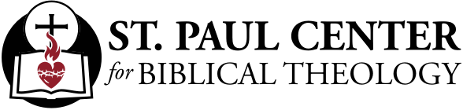

The Blessed Path: Scott Hahn Reflects

on the Fourth Sunday in Ordinary Time

In the readings since Christmas, Jesus has been revealed as the new royal son of David and Son of God. He is sent to lead a new exodus that brings Isra-el out of captivity to the nations and brings all the nations to God.

As Moses led Isra-el from Egypt through the sea to give them God’s Law on Mount Sinai, Jesus too has passed through the waters in baptism. Now, in today’s Gospel, He goes to the mountain to proclaim a new law — the Law of His Kingdom.

The Beatitudes mark the fulfillment of God’s Covenant promise to Abraham — that through his descendants all the nations of the world would receive God’s blessings (see Genesis 12:3; 22:18). Jesus is the son of Abraham (see Matthew 1:1). And through the wisdom He speaks today, He bestows the Father’s blessings upon “the poor in spirit.”

God has chosen to bless the weak and lowly, those foolish and despised in the eyes of the world, Paul says in today’s Epistle. The poor in spirit are those who know that nothing they do can merit God’s mercy and grace. These are the humble remnant in today’s First Reading, taught to seek refuge in the Name of the LORD.

The Beatitudes reveal the divine path and purpose for our lives. All our striving should be for these virtues — to be poor in spirit; meek and clean of heart; merciful and makers of peace; seekers of the righteousness that comes from living by the Law of Kingdom.

The path the LORD sets before us today is one of trials and persecution. But He promises comfort in our mourning and a great reward.

The Kingdom we have inherited is no earthly territory but the promised Land of Heaven. It is Zion where the LORD reigns forever. And, as we sing in today’s Psalm, its blessings are for those whose hope is in the LORD.

Readings: Zephaniah 2:3; 3:12-13; Psalm 146:6-10; 1 Corinthians 1:26-31; Matthew 5:1-12

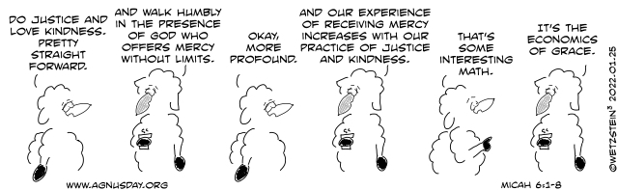

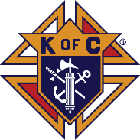
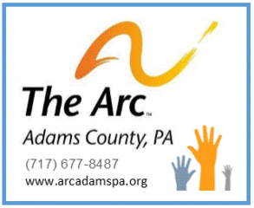

Advoca​cy & Protection
To Empower Citizens
with Intellectual and Developmental Disabilities
FREE-WILL OFFERING IN NARTHEX
The weekends of Jan.14/15, 21/22, & 28/29

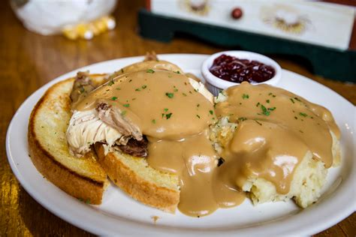

Saturday, February 11, 2023, from 4:30PM to 6:30PM
down in the Parish Sociol Hall

HOT CHICKEN SANDWICH with Mashed Potatoes,
Green Beans, Applesauce, Dessert, and Beverages!

Donation: $10.00
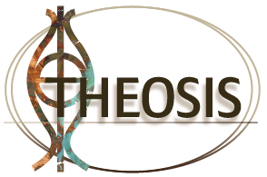

THEOSIS: Faith In Action!

Being part of St. Ignatius Loyola in Buchanan Valley is being part of a kind, generous and loving family. We often share participating at the Mass; we share the reception of the Holy Eucharist; we share food of the season; we share the summer picnic; we share the sorrow of loss and the joy of celebrations ... just as our immediate families do. Being part of St. Ignatius Loyola is about the love and caring we have for one another – to mirror the life of Christ, and to realize the Corporal Works of Mercy within our parish family.

We love our church in the valley, love the people who call this church their “home away from home” and who want to be part of this parish that can bring out the best in all of us, as family members should do. But for many of us, our birth families are scattered across the country and for some, around the world. For others, their family members have gone on before them.
So our personal journeys are not always easy and we all need someone to lend a hand at some point along the way, in a confidential environment. This could be something as simple as transport to the hospital, doctor visits, grocery store, minor repairs such as a broken lock, or the installation of a light bulb.
There are individuals right here available to support our parish families with such tasks. This helps us realize that our spiritual family is no less important than our birth families.
If you are interested in sharing some time, either by giving assistance or receiving it, please call: Bicky Redman at 717-677-8592
or Kathy Dietsch at 717-352-4558.

“God is always trying to give good things to us, but our hands are too full
to receive them.” ~ St. Augustine of Hippo (d. A.D. 430, Bishop & Doctor of the Church

